CLIMATE CHANGE IMPACT ON THE AGRICULTURE OF SUNDARBANS
Dr. Shweta, Assistant Professor, Department of Geography, Vasanta College for Women, Rajghat fort Varanasi
Dr. Anjana Singh, Associate Professor, Department of Geography, Vasanta College for Women, Rajghat fort Varanasi

ABSTRACT
Sundarbans is a mangrove area in the Ganges delta. Because of its coastal location it’s prone to numerous climate driven hazards. The present study assesses the climate variability changing the crop pattern of this low-lying agrarian ecosystem.
The effective area of agricultural land in Sundarbans is 3,15,500 ha. Nearly 62% of total cultivable land of this region is low lying and suffers from elevated salinity during dry season, from intrusion of saline water, capillary action, and increasingly acid sulphate build up. Soil drainage is generally inadequate and deep-water stagnation occurs in monsoon season. At present nearing 20% of the agricultural land in this region is multi cropped. In this region 9% of the farmers are classified as small farmers and 35% as marginal farmers.
Results revealed that, agriculture and fishing become increasingly unviable in the island, decrease food security, conglomerate battered by extreme weather events and salt water ingression, a sizeable number of farmers are turning into migrant labours or are forced to work in the hundreds of brick kilns that have mushroomed on both sides of the border. The findings of this study may be useful in implementation of adaptation and mitigation strategies for alleviating the environmental and livelihood threats of this fragile agrarian system.
Key words: Climate change, Increase Salinity, Food Security, Changing livelihood pattern, Migrant Labours.

INTRODUCTION

The Sundarbans is a cluster of low-lying islands. It is spread about 10,000 sq km across India and Bangladesh, of which 40% lies in India. The name Sundarbans is derived from the Heritiera fomes tree, one of the most abundantly growing mangrove trees that are locally called ‘Sundari’.
As per 2011 census conducted by the Government of India, there are approximately 4.37 million people living in and around the Sundarbans delta. In the absence of any industry, the vast majority of the local population in Indian Sundarbans is dependent on agriculture. Both landless as well as land owning people supplement their income by exploiting the mangrove forests, fishing, collecting and farming tiger prawn seeds in its waters, the latter particularly Causing large scale damage to marine biodiversity.
The Sundarbans is an innocent victim of accelerating global warming and climate change and faces a direct threat to its very existence. are: Global Warming, Changing Landscapes, Biodiversity Lost, Wildlife at Risk Rising Sea Level Increased Risk of Drought, Fire and Floods, Stronger Storms and Increased Storm, Damage More Heat-Related Illness and Disease, Economic Losses etc.

Objectives
The major objective of the study is to assess the current situation of agriculture with regarding climate change. Other major objectives of the study are
a) To study about the effect of major climatic changes in the villages,
b) To study the impact of climate changes over the change in cropping pattern, agricultural system, environment sustainability and sustainable livelihood.
c) Provide some important recommendation that would mitigate against the changing climatic condition.

Review Related Literature
The rate of warming over the past 50 years was almost double over the last 100 years (IPCC, 2007), which is largely attributed to anthropogenic influences. Over India, the mean maximum as well as minimum temperatures have increased by about 0.2°C per decade during the period 1971–2003, for the country as a whole (Kothawale and Rupa Kumar, 2005).
With regard to agriculture, climate variability has affected the crop productivity by altering the agro-ecological zones, intensifying droughts, floods, tropical cyclones, heavy rainfall events, hot extremes and heat waves or causing precipitation and temperature anomalies (Naresh Kumar et al., 2011; Revadekar et al., 2016; Rajeevan, 2013).

METHODOLOGY

For the purpose of writing this paper, we have reviewed and analysed secondary data, information and literature that is available in the public domain, including information available on official websites of several Governmental agencies, scientific data and reports. Reproduction of data and scientific analysis in this paper is only to the extent of reiterating the unique challenges faced by the Sundarbans delta and we do not intend to infringe any existing copyright and we do not claim copyright over publicly available data.

RESULTS AND DISCUSSION

Location and Administrative Setup
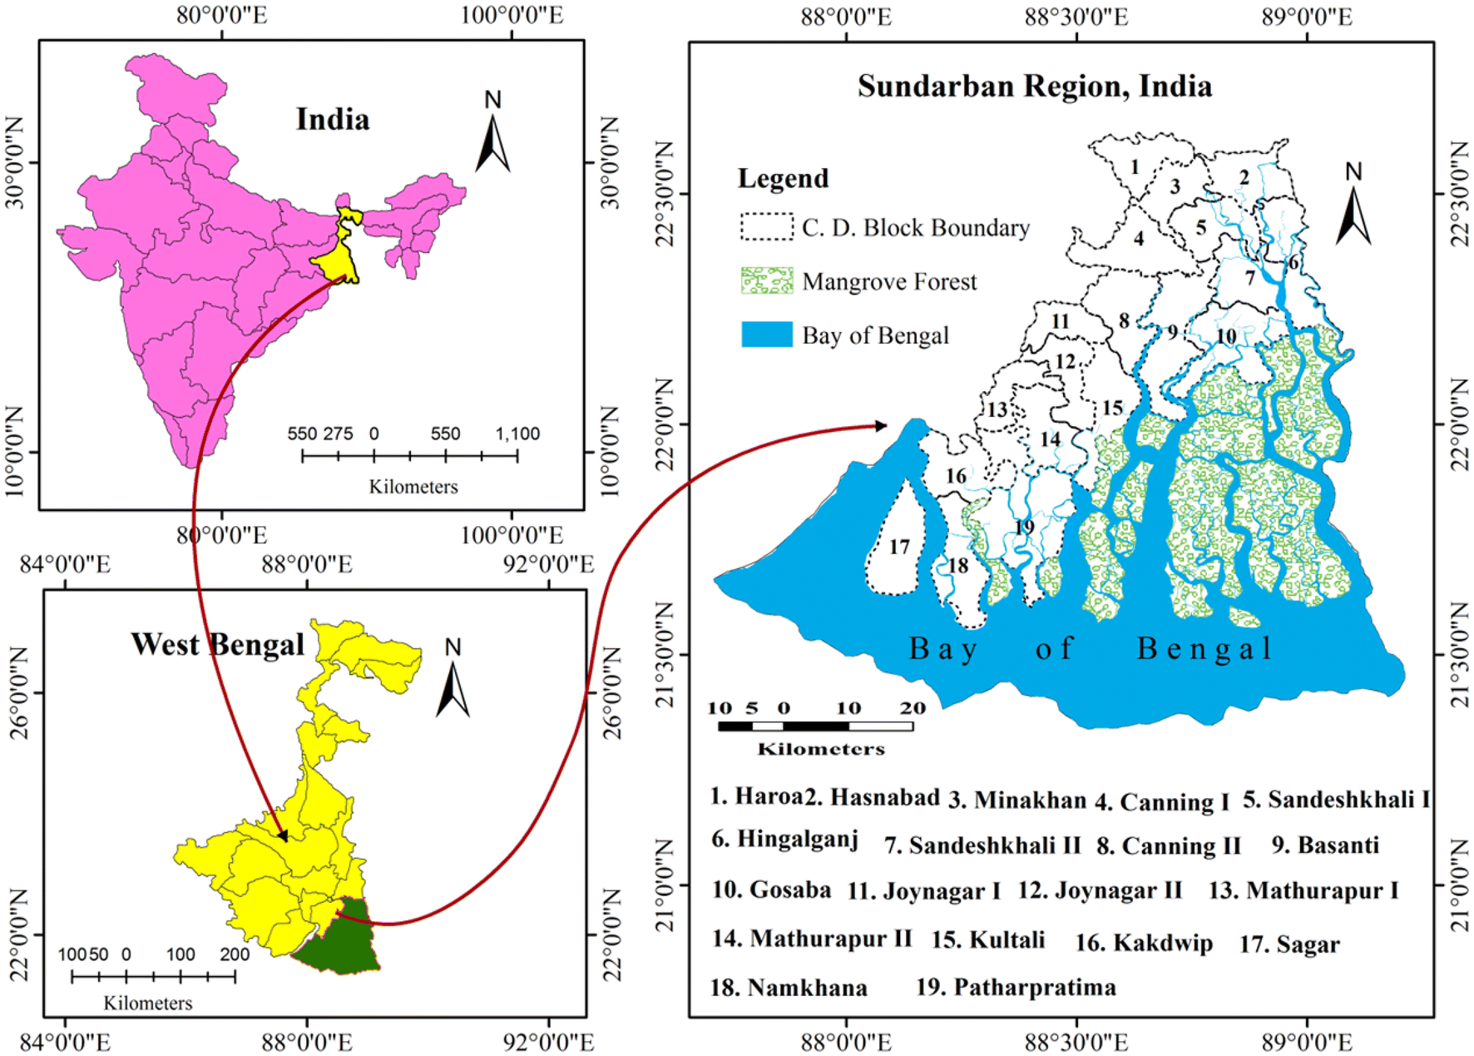
Sundarbans, formerly Sunderbunds, vast tract of forest and saltwater swamp forming the lower part of the Padma - Ganga - Brahmaputra River delta in south-eastern West Bengal state and southern Bangladesh. The tract extends approximately 160 miles (260 km) west-east along the Bay of Bengal from the Hugli River estuary in India to the western segment of the Meghna River estuary in Bangladesh and reaches inland for about 50 miles (80 km) at its broadest point. Lying between latitude 21°27´30´´ and 22°30´00´´North and longitude 89°02´00´´ and 90°00´00´´ East and total area of 10,000 km². The land area, including exposed sandbars, occupies 414,259 ha (70%) with water bodies covering 187,413 ha (30%) (Fig.1).
Indian Sundarban is bound on the west by river Muriganga and on the east by rivers Harinbhahga and Raimangal. Sundarban is spread over 16 Police Stations and 19 Blocks of South & North 24-Parganas districts. They are Haroa, Hasnabad, Hingalganj, Minakhan, Sandeshkhali-I and Sandeshkhali-II in North 24-Parganas district and Basanti, Canning-I, Canning-II, Gosaba, Joynagar-I, Joynagar-II, Kakdwip, Kultali, Mathurapur-I, Mathurapur-II, Namkhana, Patharpratima and Sagar in South 24-Parganas District. The land area measures about 9629 sq. km., of which, 4493 sq. km. is inhabited by people and the rest is Reserve Forest. The total number of mouzas under the region is 1093.
Fig1: Location map of Sundarbans

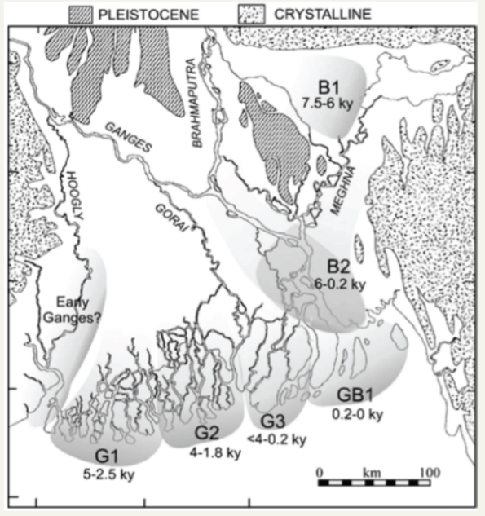
Geology and Soil Formation
The geological history of the area began probably
from the early Pleistocene, and this delta formation started from the tertiary period. The Sundarbans landforms have developed due to the continual deposition of the weathered materials carried by the part of the deltaic plains of three mightily river the Ganges, Brahmaputra, and Meghna (Fig:2).
Two distinct processes of soil development have been explained by Bandyopadhyay et.al., (2003) that, the alluvium was directly carried and deposited by the river Hugli, and silt- clay loads indirectly deposited in the deltaic region through backwater. The clay fractions went partial transformation through high salt concentration of sea water which, return back through the rivers and had been deposited in the land. Because of post harvesting water stress, deep cracks in such heavy soil (clay) are very common in the land.
Fig2: Holocene deposition in the lower delta
plain of Ganga, Brahmaputra and Meghna

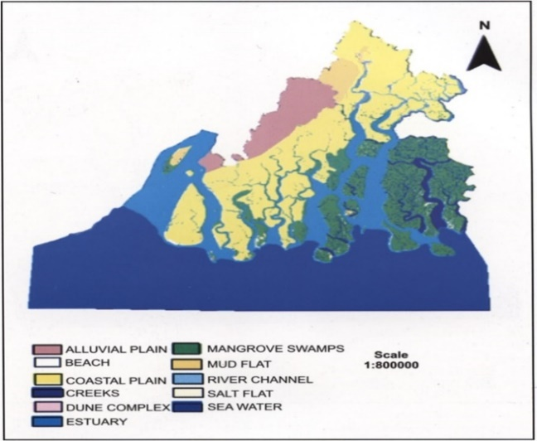
Soil
The soil reaction is strongly acidic to neutral in nature. Moderate to strongly acidic soil reaction (pH5-6) is concentrated in nearly half of the agricultural land, mostly in the north eastern portion. On the contrary, large proportion (more than 86%) of the agricultural land is characterized by very slight salinity (1.63±1.63 dS/m) while, a negligible proportion (1.4%) of agricultural land have moderate (4-8 dS/m) toxicity, on an average, the entire area may be divided into low salinity up to 8PPT - northern part, and high salinity from 8PPT to 20PPT-southern part of Sundarbans (Fig:3). More than 80 percent of the agricultural land is moderately enriched with soil organic carbon (SOC).
Fig3: Soil structure of Sundarbans

Climate
Climate Since the forest is located on the south of the Tropic of Cancer and bounded by the northern limits of the Bay of Bengal, it is classified as tropical moist forest. The average annual maximum and minimum temperatures vary between 30° and 21°C. High temperatures occur from mid-March to mid-June and low in December and January. The mean maximum temperature for the hottest months has been recorded as 32.4°C at Patuakhali, in the east of the Sundarbans.
Fig4: Distribution of Rainfall

Distribution of Rainfall
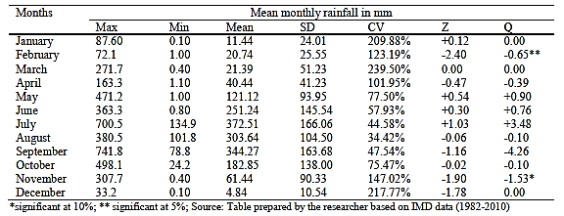
Sundarbans receives an average amount of 1700 mm rainfall annually, though inter annual variability in rainfall occurrences is remarkably wide (1200mm to 2500 mm). More than 70% of the annual rainfall occurs during the monsoon season which generally lasts for four months (June to September). July moth receives the highest rainfall which contributes nearly 370mm rainfall to the season followed by September (344mm) (Fig:4). The lowest rainfall occurs in the month of December (4mm) followed by January (11mm). The occasional incidences of heavy shower in association with Norwesters (Kalboishakhi) in pre-monsoon months (March-May) also contribute considerable amount to the island hydrological cycle (Table1).
Table1: Descriptive Statistics of Maximum, Minimum and Mean Monthly Rainfall in the Sagar
Fig5: variation in Atmospheric temperature

Atmospheric Temperature
Sundarban experiences about 27°C average ambient temperature. Temperature gradually rises after the winter season (20°C to 23°C) which turns into unbearable hot during summer seasons (27°C to 30°C). After the onset of monsoon, it slightly decreases and remains within the range of 28°C to 29°C during four monsoon months which gradually rises with the recession of monsoon (Fig.5). May is the hottest (30°C) month followed by April (29°C) and January is the coldest (20°C) month followed by December (21.5°C) as observed in the land (Mandal et al., 2013). The mean monthly range of temperature is about 7°C while, the highest range of monthly temperature recorded in the month of December (10°C) and, it was the minimum in the month of July (4.5°C). The maximum temperature rises up to 32.5°C in July whereas, the minimum temperature declines 15.5°C in the month of January (Table2).

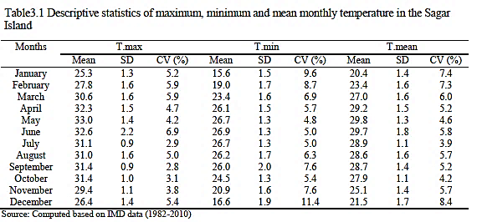
Table2: Descriptive Statistics of Maximum, Minimum and Mean Monthly Temperature in the

Relative Humidity
The average relative humidity (RHmean) in the Sundarban is observed as 79%, the highest of which is recorded in the month of August (85.2%) and the lowest in December (72%). The observed maximum relative humidity (RHmax) is recorded as 80.4% in the annual scale which was found in between the highest value of 86% in August and the lowest value of 75% in December. Similarly, the average value of minimum relative humidity (RHmin) was observed as 77.6% for the land.

Hydrology and Irrigation
Sundarban is criss-crossed by numerous tidal creeks of saline water having no potential for irrigation and household uses. It is clear that the Sundarbans possess 1% irrigated, 19% partially irrigated and 80% rain-fed/un-irrigated land. If this 20% irrigated or partially irrigated land could belong to the category of medium and upland area, then possibly cropping intensity in Sundarbans would have increase substantially. But the fact remains that 100% of this irrigated and partially irrigated land has also a separate distribution pattern. 10% falls under lowland, 30% in the category of medium land and 60% in upland (Table.3).

a) Rainfed farming:
This farming is the practice of crop production entirely with rain water. More than 80% of the total cultivable lands (4,34,237 ha) of this island situations of the Sundarbans falls under rainfed farming with a single crop of long duration traditional Aman rice during mid-June to mid-December. After harvesting of Aman rice most of the lands remain fallow for next 6 to 7 months owing to soil salinity and lack of irrigation facilities.

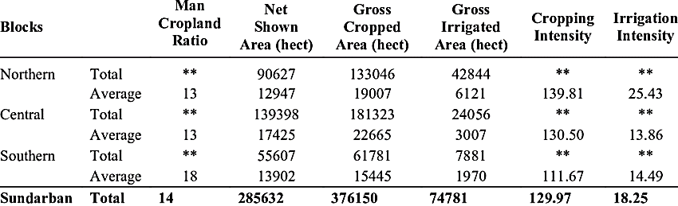
Table3: Distribution of Irrigated Land
Source: Sustainable water resource management (2010-2011)
a) Rainfed farming:

b) Partially irrigated
It is also predominantly one kind of dry farming practice but where one or two lifesaving irrigation or pitcher irrigation is available to the crop during its critical stage of growth.

c) Irrigated farming situation:
Only 1% of the total cultivable lands of Sundarbans are irrigated. These are double cropped area occupied with high value winter vegetables and other cash crops.
As a consequence, hectares of land in the island remain uncultivated during the lean period due to lack of irrigation facilities. While drinking water is the prime concern, people depend on tube wells for it. The number of tube wells is also inadequate, as reflected by the tube well dependency ratio (1 tube well per 100 households or more than 500 populations).
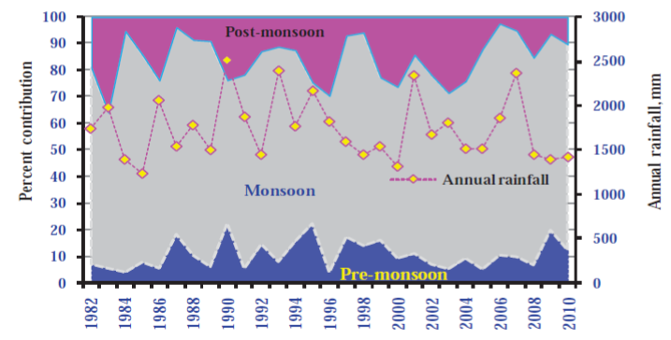
Climate change impact over the Environment:
The study area was affected by different environmental hazards and other climatic hazards which make the environment unsustainable and also affect over the livelihood of the villagers in the study area. The impacts are following below

A. Increasing temperatures
Between 1980 and 2007, it has been observed that the temperature of the waters in the Sundarbans has increased at an accelerated rate of 0.5°C per decade compared to the observed global sea surface temperature warming at the rate of 0.06°C per decade (Fig6). This change greatly impacts the Sundarbans area as it is an estuarine delta. Further, it detrimentally affects the health of the mangrove ecosystem.
Fig6: Categorization of long monsoon rainfall

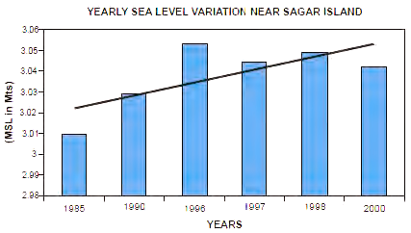
B. Rising sea-levels
The sea level rise is also affecting the availability of sediment, directly impeding the establishment of new groves. In 2010 it was observed that, with the sea levels rising ominously, the New Moore Island/ South Talpatti Island disappeared. Scientists have predicted that the other low-lying islands could also vanish as sea levels continue to rise (Fig.7).

C. Cyclones
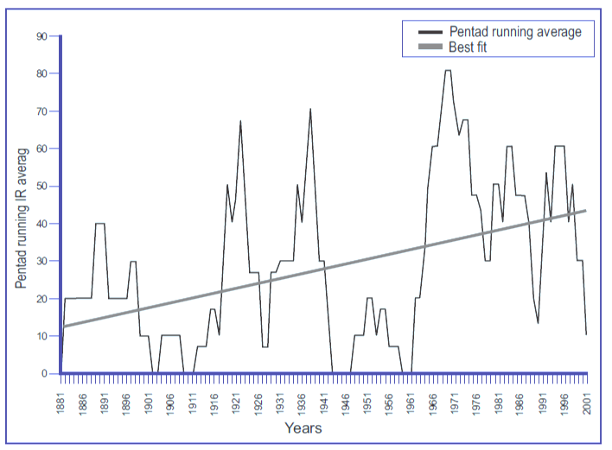
It has been observed that there has been an increase in the intensity of cyclonic storms hitting the Sundarbans between 1951 and 2010 (Fig.8).
Fig7: Variation in Sea level
During the occurrence of Cyclone Aila in 2009, a 400 km stretch of embankment was breached and the waves crossed over the height of the embankment and entered the flood plains. Over just the past three years, the Sundarbans, which is home to close to five million people, has been battered by four tropical cyclones – Fani (May 2019), Bulbul (November 2019), Amphan (May 2020) and Yass (May2021).
Fig8: Rise of frequency of severe cyclonic storms
over Bay of Bengal during the past 120 years

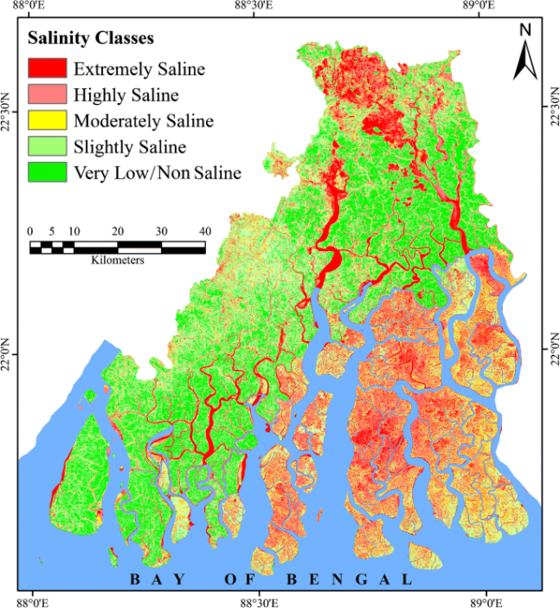
D. Rise in Salinity; Impact on Agriculture
Studies suggest that in the last two decades, the run off in the eastern rivers of Sundarbans has decreased resulting in ever increasing salinity and sea water-sulphate concentrations. The decrease in fresh water runoff has affected mangrove growth. Further, agriculture is being affected because of the high levels of salinity of the soils due to high tides, cyclones and storm surges, and problems of water stagnation, sometimes even beyond monsoon seasons (Fig.9).
Fig9: Salinity Classes in Sundarbans

E. Change in agricultural patterns
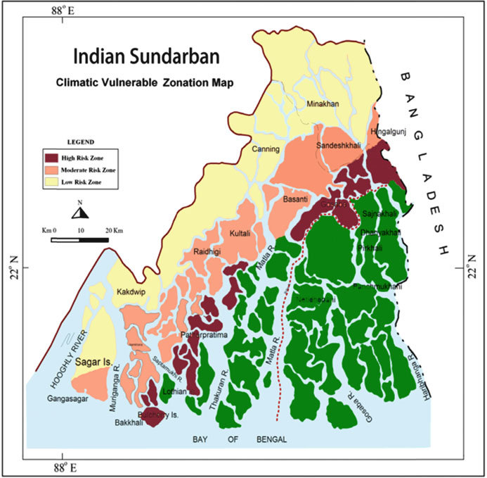
According to the West Bengal Government, in 2009, the agricultural area had shrunk between 2002 and 2009 from 2,149.615 square kilometres to 1,691.246 square kilometres. The area suffers from a low intensity of cropping because mono cropping of rice is practiced seasonally, and horticultural crops are rarely grown. Further, only 12% of the cropped area in the Sundarbans is irrigated through rainfed ponds, tanks and canals; majority of the agricultural land is rainfed. It has been observed that rainfall has become erratic and its intensity has increased causing further damage to the agricultural yield (Fig.10).
Fig10: Climatic vulnerable zones in Sundarbans

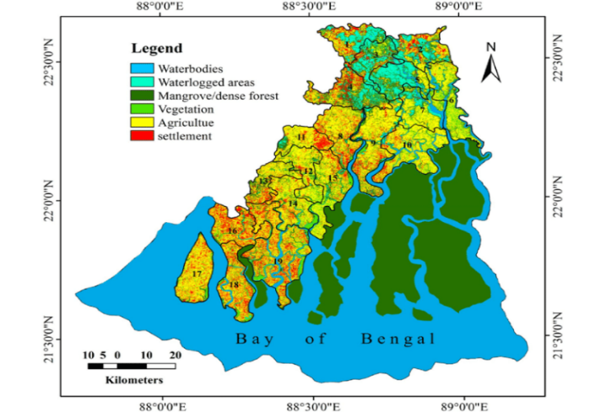
F. Deforestation
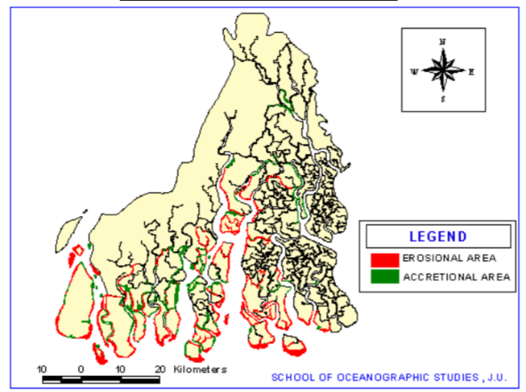
Between 1777 and 1971, continuous deforestation and land reclamation activities have been carried out in the Sundarbans region. It has been observed that 5% of forest cover was lost between 1989 and 2009. This deforestation has increased man-animal conflict, local extirpation of several species and added to the biological loss of the region. Further, clearing of forests have not facilitated self-sustaining agriculture on the flood plain, as it tends to be submerged under saline water during high tides (Fig.11).
Fig11: Degradation of Forestation

G. River Bank Erosion
River bank erosion is majorly affected at the time of September and October due to rain almost every year (Table.4) the calamity affects the villagers of Ketarchak, also in the months of June and July there lives a moderate threat
Fig12: River bank erosion
of river bank erosion in the village which leads to huge loss of agriculture and the livelihood of the villagers (Fig.12).
Table4: Impact of Erosion in Sundarbans
Source: Multiple website
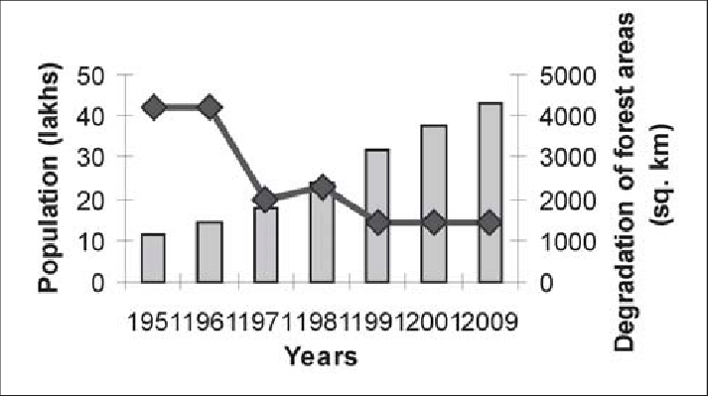
Agriculture
The statistics of cultivable land in Sundarbans is still have different figures. According to some sources it is 4.71lakh hactre, whereas other says 3.15lakh ha. Only 65,000 ha out of this is cultivated with a double crop. Sundarbans lands can be categorized into three types. Upland (water stagnation up to150mm) - out of the total cultivable area only 12% is high lands. These high lands are cultivated with irrigated winter vegetables or high value crops. Medium upload (water stagnation 151-300mm) - out of the total cultivable area only 27% area is under medium land situation. Low land and deep low land (water stagnation 301-600mm and above) - 61% of the total cultivated lands of Sundarbans fall under low land category. Majority of these low lands remain fallow after aman paddy harvested due to salinity of the soil and non-availability of good quality irrigation water (Fig.13).
Fig13: Distribution of Agricultural land
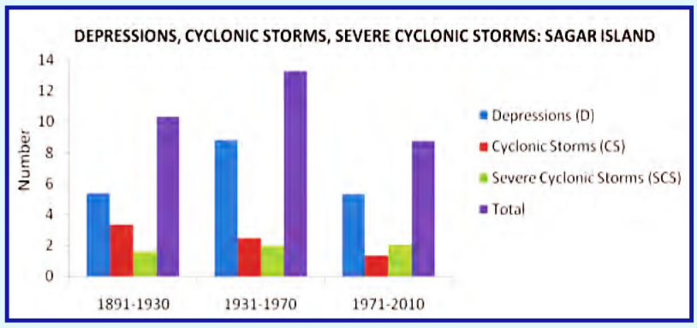
As this article discusses on changing in agriculture pattern of the Sundarbans, we would consider the existing cropping pattern in all these three types of lands are. During Kharif season paddy is the main crop in all the land situation but the harvesting time varies. In upland paddy is harvested in the middle of October, in medium upland it is in end of October or early November, whereas the lowland is released from paddy at the end of December. For a second crop all these three types of lands require irrigation. Sundarbans being a rain-fed area, irrigation potentially during rabi-summer season is very poor.
Kharif Crops
More than 68% (195,610ha) of the island’s populations solely depend on Kharif rice cultivation for their livelihood. However, the productivity of this system fluctuates with the variation of monsoon rainfall. Long duration (140-160 days) traditional cultivars i.e., Bhuri, Dangapatnai, Dharitri, Dudheswar, Langalmura, Malabati, Marichsal, Pankaj, Patnai-23, Sadamota etc are the well-known rice varieties in the island. During the last decade the average production and productivity of Kharif rice was nearly 223,010 metric tons and 1.14 metric tons per hectare respectively.
Fig14: Hazards in Sundarbans

Rabi Crops
In the last decade some winter crops have been successfully cultivated in the island e.g., irrigated rice (Boro), grass pea, potato, green gram, sunflower, mustard, green chilli, zinger, turmeric etc. Inadequate irrigation facility along with high economic inputs (in the form of more pesticides, chemical fertilizers and high labour costs etc.) are major constraints for boro rice cultivation. So, it occupies only 37% of the agricultural land, while kharif rice occupies more than 63% of the agricultural land. Wheat was never been a profitable crop in the island; still farmers grow this crop from their personal interest in spite of the unfavourable soil and climatic conditions. As a result, the return is very low (1.7 tons ha-1) and in the past decade, the crop area drastically declined from 50 ha in 2001 to 9 ha in 2011.
Other Crops
Water melon is a famous zaid crop that is being cultivated (63,100ha) from long back in the area. But now the water melon area was decreased drastically from 52 ha to only 6 ha during 2001 to 2011. Zinger and turmeric that have increased from 24 ha to 37 ha and 27 ha to 43 ha (2001-2011) with an average productivity of 5.06 tons ha-1 and 1.5 tons ha-1 respectively. At present the most popular and highly profitable cash crop in the area is betel leaves production. It is generally cultivated in betel vines made of bamboo, wood and straw. Both the area and production of betel leaves have sharply increased from 210 ha to 305 ha and 104500 motes to 207400 motes during 2001-2011.

Change in Agricultural Pattern Impact Over the Sustainable Livelihood:
Unavailability of fodder: The villages are of mono-crop type and due to high level of soil salinity there is very less amount of grass grows in the fields which leads to scarcity of fodder. The scarcity is most in the months of September and October. In the months of summer, the scarcity is moderate.
Scarcity of water for Cultivation: There is no scarcity of water but the available water is highly saline which cannot be used for cultivation. In the month of March, the scarcity of water for cultivation starts and becomes more severe at the month of April and May.
Crisis of Food: The villages are a mono-cropped area hence scarcity of food is present in the village. Scarcity of the food majorly affects the village in the month of October also the scarcity food is there at time of November.
Unavailability of Work: The only time in which there is availability of work is at the Aman Paddy Cultivating season which is June-July. The time when there is unavailability of work present in the village the male working group villagers migrate to various parts of India like Kerala, Andhra Pradesh, Rajasthan also to Kolkata and Burdwan.
Changing pattern of livelihood and migration: A changing pattern of livelihood has been identified among the villagers. More than 95% of the villagers used to migrate.

Major Findings
- Aila, Yass, Fani have huge adverse effect on the life and livelihood of the villager.
- The agricultural pattern is mono-crop and only Aman paddy is cultivated.
- Saline water stagnation leads to increased salinity of soil.
- The villagers use HYV seeds for cultivation and they feel more the fertilizer and pesticides are used more production will take place.
- Agricultural production cost has increased due to Cyclones.

Recommendations
- Establishment of area wise weather information centres as there is no weather station except Sagar.
- Strengthening of river bank and height pond barriers should be increased to avoid saline water contamination.
- Saline tolerant vegetable and crop seeds can be used to increase agricultural production.
- Mangrove plantation in the river embankments of the village.
- Land shaping can be done and organic farming with integrated techniques of farming can be initiated in the village to enhance productivity.
- Rain water harvesting will lead to better future for agriculture and fish-culture.
Conclusion
It has been discussed that the conditions of the villages in terms of the major indicators of climate change. The study shows that the village have faced huge adverse effects due to the climate change. The soil salinity and rising sea level causing riverbank erosion is one of the major threats to the village. Rising sea-levels destroy not only homes but livelihoods as well because salt water contamination with the inhabitants of rice paddies they become unusable for three years. The study also reveals the changes of livelihood pattern due to Aila and other natural calamities occurred in the villages. Migration has been a real issue in the village. Only 6 months of work is present in the village. The villagers are still practicing the dangerous techniques led from the Green revolution which is HYV seeds and chemical fertiliser based farming technique; which is not a sustainable approach for agriculture. Climate change is a global issue where the villagers of Sundarbans are one of the biggest sufferers. The only thing that the villagers can do at the moment is adapt with the changing paradigm of the world due climate change. The world is leading toward a wrong destination due to climate change. It can be easily said that climate change is the ultimate weapon for mass destruction and the poorer people are the major sufferers of the changing situation.
REFERENCES
Abdi, H. and Williams, L. J. (2010). Principal component analysis. Wiley Interdisciplinary Reviews: Computational Statistics 2:433-459. doi: 10.1002/wics.101
Abson, D. J., Dougill, A. J. and Stringer, L. C. (2012). Using Principal Component Analysis for information- rich socio-ecological vulnerability mapping in Southern Africa. Appl Geog 35(1-2):515-524. doi: 10.1016/j.apgeog.2012.08.004
Acreman, M. G. (1990). A simple stochastic model of hourly rainfall for Farnborough, England. J de Sci Hydrol 35(2): 119-148
Adger, W. and Kelly, P. (1999). Social vulnerability to climate change and the architecture of entitlements. Mitigation and Adaptation Strategies for Global Change 4: 253–266
Bandopadhyay, S. (2000). Sagardwip: Some Environmental Problems and Men, in: Bomkesh Maity (ed) Bish Sataker Sagardwip (20th Century Sagar Island), Quarterly April-June.
Bandyopadhyay, S. (1997). Natural environmental hazards and their management: a case study of Sagar Island, India. Singapore J Trop Geogr 18(1):20–45. doi: 10.1111/1467-9493.00003
Bandyopadhyay, B. K., Maji, B., Sen, H. S. and Tyagi, N. K. (2003). Coastal Soils of West Bengal Their Nature, Distribution and Characteristics, Bulletin No. 1/2003. Central Soil Salinity Research Institute, Regional Research Station, Canning Town, West Bengal, India. p. 62.
Barman, D., Saha, A. R., Kundu, D. K. and Mohapatra, B. S. (2012). Rainfall Characteristics Analysis for Jute based Cropping System at Barrackpore, West Bengal, India. J Agr Phys 12(1):23 28
Carey, W. H. (1882). The Good Old Days of Honorable John Company etc., 1906-reprint.
Department of Sundarbans Affairs, Government of West Bengal. June 10,2012. http://www.sadepartmentwb.org
Environmental Information System. Department of Environment, Government of West Bengal, Government of India. June 10, 2012. http://www.enviswb.gov.in/ .
Government of West Bengal, Government of India, “West Bengal State Action Plan on Climate Change”.
Majumdar, R. K. and Das, D. (2011). Hydrological characterization and estimation of aquifer
properties from electrical sounding data in Sagar Island Region, South 24 Parganas, West
Bengal, India. Asian J Earth Sci 4(2):60–74. doi: 10.3923/ajes.2011.60.74
Planning Commission, Government of India, “Faster, Sustainable and More Inclusive Growth: An Approach to the Twelfth Five Year Plan (2012-2017),” October, 2011.
Wild Bengal. Directorate of Forests, Government of West Bengal, Government of India. June 10, 2012. http://www.wildbengal.com/.
West Bengal Forest Department. June 10, 2012. http://westbengalforest.gov.in/.
W.M.O. (1992). International meteorological vocabulary, 2nd edition. Publication No. 182.
W.W.F.-India, (2010). Sundarbans Future imperfect, climate adaptation report. pp 1-29

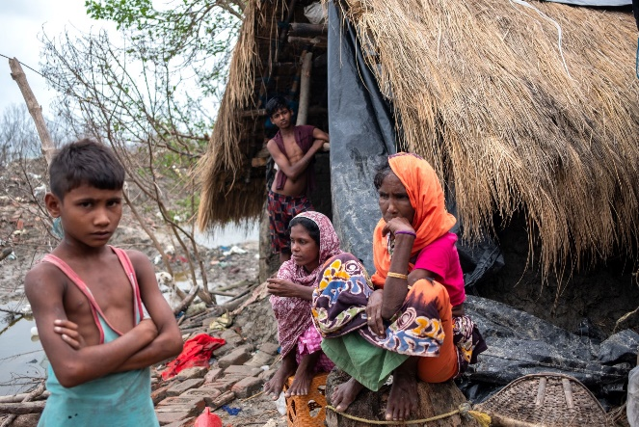
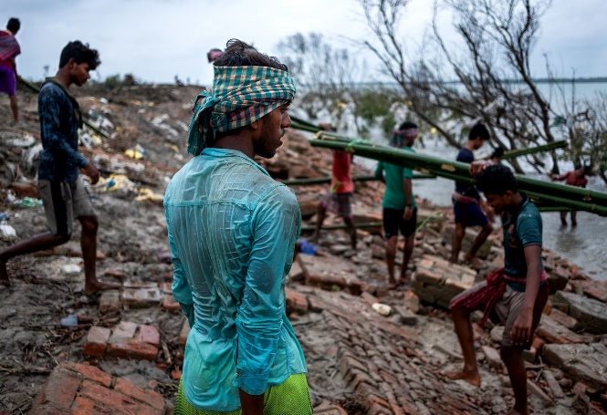
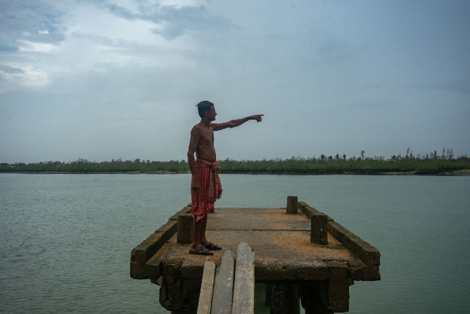
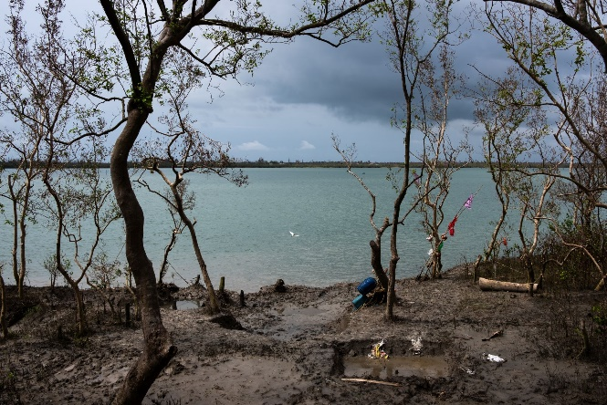
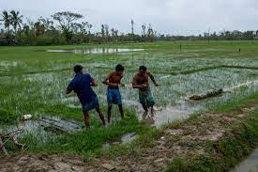
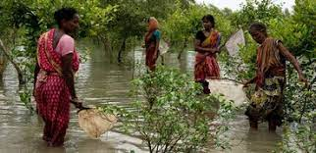
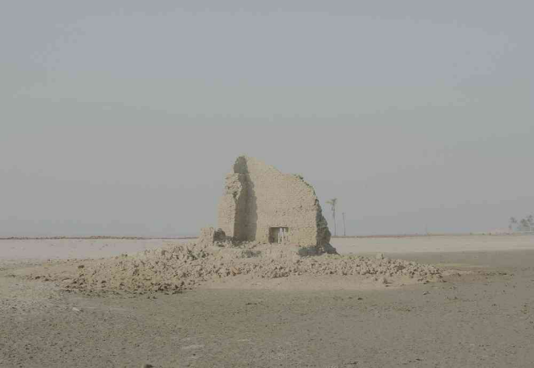
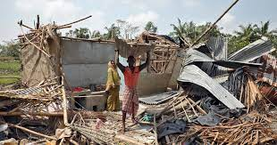
Image taken by Subharajit Sen
Home destroyed by Amphan
Locals are trying to reconstruct some infrastructures
Mangrove deforestation has aggravated the destruction caused by cyclones
A man points at the Chaltamuniya Khal which has now turned into a river due to the rise in seawater
Brackish water has entered farms and destroyed standing crops and rendered lands barren
Cropland eroded by river
Post Amphan scenario at Sagar Island
House eroded by sea in Mousuni Island
Photo sheet: Devastations for the Climate change

