“Things” and Communication Trends in IoT
Manjuanath R¹  Professor, CSE Department  R R Institute of Technology, Bengaluru,  Karnataka, India, drmanjunath.raj@gmail.com | Sowmya Naik P²  Professor, CSE Department  City Engineering College, Bengaluru  Karnataka, India, sowmya.vturesearch@gmail.com
Shivashankar³  Professor, ECE Department  R R Institute of Technology, Bengaluru,  Karnataka, India, drmanjunath.raj@gmail.com | Sumanth V⁴  Assistant Professor, Manipal Institute of Technology, Manipal Academy of Higher Education, Bengaluru,  Karnataka, India, ssumanth6@gmail.com
ABSTRACT
As of now, there is an overabundance of IoT correspondence conventions, the advances used to interface IoT gadgets to the web, utilized across the world. The broad assortment of correspondence conventions can prompt issues with interoperability between and inside IoT biological systems. There is as of now no worldwide IoT correspondence guidelines, making enormous scope IoT appropriation more complicated than it wants to be. A consolidated "Things" and Correspondence Patterns in IoT principles are fundamental to understand the involved capability of IoT. The primary focal point of IoT innovation is endpoint security, for example alludes to the security of related figuring gadgets. The focal reason of IoT is the expression "network Sensors and Actuators". The IoT gadgets are related to Web over a wide variety of correspondence innovation. This book section depicts the few advances elaborate in IoT correspondence. The variety in correspondence builds the enquiry to choose for the future and proposed application. The fundamental target of the application prerequisites to characterize obviously. The elements applications, for example, range, recurrence groups, power utilization, geography, obliged gadgets, compelled hub and organizations impact the decision of picking at least one IoT correspondence innovation.

- INTRODUCTION
The Internet of Thing (IoT) portrays the organization of actual articles "things" are implanted with sensors, actuators, programming, and different innovations for the goal of associating and exchanging data with other conveying gadgets and frameworks through the web. These IoT conveying gadgets range from common homegrown items to complex modern instruments.
IoT is the systems administration of actual things that contain hardware embedded inside their structure to impart and detect associations between one another or with adoration to the fringe climate. In the approaching years, IoT-based innovation will offer high level degrees of administrations and essentially have an impact on the manner in which individuals carry on with their everyday existences. Headways in medication, power, quality treatments, farming, savvy urban communities, and shrewd homes are only a not very many of the downright models where IoT is emphatically settled.
Explicit sensors will likewise be prepared inside existing spaces to screen the wellbeing and all inclusive prosperity of senior residents, while additionally defending that reasonable treatment is being guided and helping public individuals to recuperate lost adaptability through treatment too. These sensors structure an organization of clever sensors which can gather, cycle, move and study esteemed information in various circumstances, for example, interfacing in-home checking gadgets to medical clinic based frameworks. Other client gadgets to rouse solid living which are associated scales or wearable heart screens, are likewise a chance with the IoT. The utilizations of Correspondence Patterns in IoT are start to finish wellbeing checking utilizing IoT stages likewise accessible for pre-birth and durable patients, assisting them with overseeing wellbeing vitals and repeating medicine necessities.

- SENSORS IN INTERNET OF THINGS
A sensor does precisely as its name demonstrates: It detects. All the more explicitly, A sensor estimates some actual amount and converts that estimation adding something extra to a computerized portrayal. That computerized portrayal is normally passed to one more gadget for change into helpful information that can be consumed by savvy gadgets or people. Sensors can be promptly implanted in any actual articles that are effortlessly associated with the Web by wired or remote organizations. Since these associated have actual items with complex detecting abilities speak with one another and outside frameworks, they can decipher their current circumstance and pursue shrewd choices.

- Applications For Sensors
Sensors have been around since the beginning of power and have been being used in an exceptionally extensive variety of utilizations. We use sensors in gadgets projects, mechanical technology, industry, and significantly more. Table 1 is a brief list of typical applications of sensors.
Table 1: List of Sensor Applications
Automation  Robotics  Embedded Systems  Computers  Smart Cars  Avionics  Satellites | Smart Homes  Smartphones  Smart Watches  Energy plants  Remote Sensing  Communications  Medical domain
- Sensors Classifications
Dynamic or latent: Sensors can be sorted in light of whether they produce an energy yield and commonly require an outside power supply (dynamic) or whether they essentially get energy and regularly require no outer power supply (aloof).
Obtrusive or harmless: Sensors can be classified in light of whether a sensor is essential for the climate it is estimating (obtrusive) or outer to it (painless).
Contact or no-contact: Sensors can be sorted in view of whether they require actual contact with what they are estimating (contact) or not (no contact). Outright or relative: Sensors can be sorted in light of whether they measure on a flat out scale (outright) or in view of a distinction with a fixed or variable reference esteem (relative).
Area of utilization: Sensors can be sorted in light of the particular business or vertical where they are being utilized.
How sensors measure: Sensors can be arranged in light of the actual system used to gauge tangible info. What sensors measure: Sensors can be arranged in light of their applications or what actual factors they measure.

- Sensor Types
The most helpful order plot for the even minded use of sensors in an IoT organization, is to just group in view of what actual peculiarity a sensor is estimating. This sort of arrangement is shown in Table 2.

Table 2: Different Types of Sensors
Temperature Sensor |  | One of the most widely recognized and most well known sensors is the Temperature Sensor. A Temperature Sensor, as the name proposes, faculties the temperature i.e., it estimates the progressions in the temperature.
Proximity Sensors |  | Proximity Sensor is a non-contact type sensor that identifies the presence of an item. Closeness Sensors can be carried out utilizing various methods like Optical (like Infrared or Laser), Sound (Ultrasonic), Attractive (Lobby Impact), Capacitive, and so on.
Infrared Sensor (IR Sensor) |  | IR Sensors or Infrared Sensor are light based sensor that are utilized in different applications like Nearness and Article Discovery. IR Sensors are utilized as closeness sensors in practically all cell phones.
Ultrasonic Sensor |  | A Ultrasonic Sensor is a non-contact type gadget that can be utilized to gauge distance as well as speed of an item. A Ultrasonic Sensor works in light of the properties of the sound waves with recurrence more noteworthy than that of the human perceptible reach.
Light Sensor |  | A straightforward Light Sensor accessible today is the Light Reliant Resistor or LDR. The property of LDR is that its obstruction is contrarily relative to the power of the surrounding light i.e., when the force of light expands, its opposition diminishes and tight clamp versa.
Smoke and Gas Sensors |  | One of the extremely helpful sensors in wellbeing related applications are Smoke and Gas Sensors. Practically all workplaces and enterprises are furnished with a few smoke alarms, which distinguish any smoke (because of fire) and sound a caution.
Alcohol Sensor |  | As the name recommends, a Liquor Sensor identifies liquor. Typically, liquor sensors are utilized in breathalyzer gadgets, which decide if an individual is tanked or not. Policing utilizes breathalyzers to get intoxicated and-drive guilty parties.
Touch Sensor |  | We don't give a lot of significance to contact sensors yet they turned into a necessary piece of our life. Regardless of whether you know, all touch screen gadgets (Cell Phones, Tablets, PCs, and so forth) have contact sensors in them. One more typical use of touch sensor is trackpads in our laptop.
Color Sensor |  | A color Sensor is a helpful gadget in building variety detecting applications in the field of picture handling, variety ID, modern item following and so forth. The TCS3200 is a basic Variety Sensor, which can identify any tone and result a square wave relative to the frequency of the distinguished variety.
Humidity Sensor |  | On the off chance that we can see Weather conditions Checking Frameworks, they frequently give temperature as well as moistness information. Along these lines, estimating moistness is a significant assignment in numerous applications and Mugginess Sensors help us in accomplishing this.
Tilt Sensor |  | Frequently used to identify tendency or direction, Slant Sensors are one of the most straightforward and cheap sensors out there. Beforehand, slant sensors are comprised of Mercury (and subsequently they are at times called as Mercury Switches) however most current slant sensors contain a roller ball.
Radiation Sensor |  | A radiation sensor is a gadgets instrument that faculties and measures the radiation particles like alpha, beta, gamma, neutrons, X-beams.
Level Sensor |  | The main role of the level sensor is to measure the level or height of different materials like solid, liquid, and gaseous.
Vibration Sensor |  | The vibration sensor identifies and records any development or exercises. Furthermore, it gives information or signs to associated machines or frameworks.
Image Sensor | The image sensor is an electronic gadget that is utilized to identify the picture pixels and give data to the presentation gadgets.
Flame Sensor | The flame sensor effectively identifies fire or fire of neighboring materials. These identified signs are passed to the associated control gadgets.
Leak Sensor | A leak sensor is utilized in a shut vessel or vacuum for recognizing water spillage, liquid spillage, air spillage, and so on.
Mark Sensor | Mark sensor gauges and recognizes for all intents and purposes any cycle liquid. Mark sensor works as a photoelectric type of sensor.
Flow Sensor or Float Sensor | It is used to sense colour marks in the presence of objects. This recognized information will be given to the regulator framework. It is utilized in modern regions, power creating instruments, power plants, and so forth.

- How To Choose The Right Sensor?
There are many elements to consider while picking a sensor for any venture. Yet, all beginnings by choosing the actual boundary we will quantify. Then, at that point, it's an ideal opportunity to consider a few different elements to get the best sensors for best outcomes and inside the given limitations like spending plan, precision, and so on. Down beneath are probably the main variables to consider.
Range of Operation: The main variable to consider in a sensor is the working reach.
Accuracy (Resolution): Settle on the necessary goal (exactness) of the sensor your applications need before picking a sensor.
Total Cost: Electronic sensors range broadly in cost. You can without much of a stretch conjecture that high precision sensors are in every case far more costly than low exactness ones. The working wide powerful fury likewise assumes a part in deciding the cost of the sensor, and so forth.
Interfacing Method: As we've expressed prior, a few sensors are simple and others are computerized. Thus, there are various approaches to communicate and peruse these sensors utilizing simple information pins of a MCU.
Information Rate (For Computerized Sensors): Advanced sensors can send you readings (information) at a rate we call the testing rate. Ordinarily sensors' rate is characterized by ksp/s (kilo tests each second) which is 1,000 example focuses (readings) in a moment. A few sensors can supply up to a couple of Msp/s. More often than not, it's a programmable element in sensor modules. Documentation: Great documentation is key regardless of whether to pick a sensor
Example: Advanced mobile phones.
In excess of a billion PDAs are sold every year, and every one has above and beyond twelve sensors inside it (displayed in Figure 1), and that number keeps on developing every year. Envision the outstanding impact of stretching out sensors to for all intents and purposes each innovation, industry, and vertical.

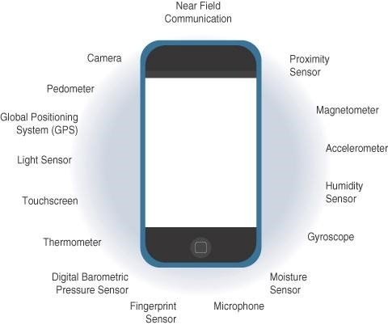

Figure 1: Sensors in a Smart Phone

- ACTUATORS IN INTERNET OF THINGS
Actuators are normal supplements to sensors. Sensors are intended to detect and quantify basically any quantifiable variable in the actual world. They convert their estimations (regularly simple) into electric signs or computerized portrayals that can be consumed by a keen specialist (a gadget or a human). Actuators get some sort of control signal (normally an electric sign or computerized order) that sets off an actual impact, generally a movement, power of some sort, etc. Figure 2 shows the evenness and reciprocal nature of these two sorts of gadgets.

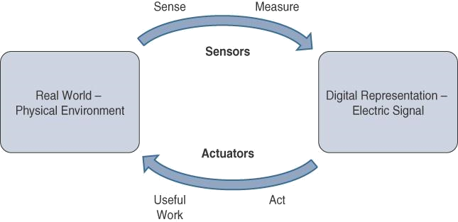

Figure 2 : How Sensors and Actuators Interact with the Physical World.

Figure 3 presents examination of Sensor and Actuator Usefulness with People. People utilize their five faculties to detect and quantify their current circumstance. The tactile organs convert this tangible data into electrical motivations that the sensory system ships off the mind for handling. Likewise, IoT sensors are gadgets that sense and measure the actual world and (commonly) signal their estimations as electric signs shipped off a chip of some sort or another or microcontroller for extra handling. A processor can convey an electric message to an actuator that makes an interpretation of the sign into a development of some sort or another (direct, rotational, etc) or valuable work that changes or quantifiably affects the actual world.
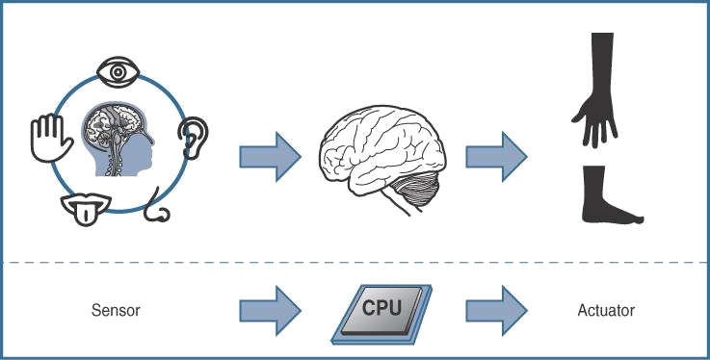

Figure 3: Comparison of Sensor and Actuator Functionality with Human

- Classification of Actuators
Similar as sensors, actuators likewise change extraordinarily in capability, size, plan, etc. A few familiar ways that they can be grouped incorporate the accompanying:
Type of motion: Actuators can be characterized in view of the sort of movement they produce (for instance, straight, rotational, one/two/three-tomahawks).
Power: Actuators can be grouped in view of their power yield (for instance, high power, low power, miniature power).
Binary or continuous: Actuators can be characterized in light of the quantity of stable-state yields.
Area of application: Actuators can be characterized in light of the particular business or vertical where they are utilized.
Type of energy:: Actuators can be grouped in view of their energy type.

- Types of Actuators
The different types of actuators are shown in below Table 3.

Table 3: Types of Actuators
Types of Motion and functions
Linear Actuators | Linear actuators, as their name recommends, are gadgets that move in an orderly fashion. They are commonly tracked down in water powered and pneumatic gear and can be mechanical or electrical.
Rotary Actuators | Rotating actuators, as opposed to straight sorts of actuators, produce a round movement. Most machines, as the expression "revolving" infers, use pivoting components to achieve a turning development. In the event that a machine needs to push ahead, in reverse, up, or down, they are much of the time used regarding a straight actuator.
Types of Energy
Hydraulic Actuators | Hydraulic actuators utilize a liquid filled chamber with a cylinder situated in the center to work. Hydraulic actuators ordinarily make direct developments, with a spring connected to one end for bring movement back. These actuators can be found in an assortment of gym equipment, including steppers and vehicle transport transporters
Pneumatic Actuators | Pneumatic actuators are one of the most reliable machine movement choices. To make mechanical development, they utilize compacted gases. Numerous organizations incline toward pneumatic actuators since they can perform very exact activities, especially while beginning and halting machines.
Electric Actuators | Electrical actuators, as you could expect, depend on power to work. Electric vehicles, fabricating stuff, and advanced mechanics hardware are notable models. They produce exact movement similarly that pneumatic actuators do in light of the fact that the progression of electrical power is steady.

- Applications for Different Types of Actuators
In designing, actuators are habitually used to present movement. They can, nonetheless, be clasped to a choice to stop movement. Actuators are utilized in different applications which are shown in Table 4.
Table 4: Types of Actuators
Hydraulic piston  Comb drive  Relay  Electric motor  Digital micromirror device | Thermal bimorph  Electroactive polymer  Piezoelectric actuator  Servomechanism

- SMART OBJECTS IN INTERNET OF THINGS
Smart objects are the structure blocks of IoT. They change regular items into an organization of wise articles that can gain from and collaborate with their current circumstance in a significant manner. The capacity to impart over an organization makes a multiplicative difference and considers exceptionally refined relationship and cooperation between divergent shrewd items.

- Smart Objects: A Definition
Smart objects is frequently utilized conversely with terms like brilliant sensor, shrewd gadget, IoT gadget, insightful gadget, thing, brilliant thing, clever hub, keen thing, universal thing, and wise item. A savvy object, as depicted all through this book, is a gadget that has, at the very least, the accompanying four main qualities (introduced in figure 4).
The fundamental parts of "Things" and Communication Trends in IoT are Handling unit, specialized gadgets, Sensor(s) or potentially actuator(s) and power sources.
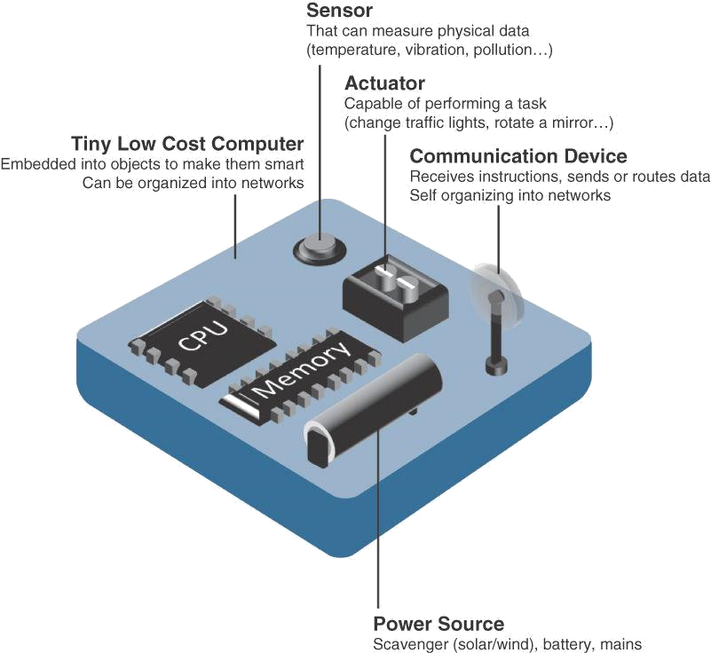

Figure 4 : Characteristics of a Smart Objects
- Trends in Smart Objects
Size is decreasing:: A few savvy objects are so little they are not even noticeable to the unaided eye. This diminished size makes shrewd articles more straightforward to implant in regular items.
Power consumption is decreasing: The different equipment parts of a savvy object ceaselessly consume less power.
Processing power is increasing: Processors are ceaselessly getting all the more remarkable and more modest to Handle power. This is a vital progression for brilliant items, as they become progressively complicated and associated.
Communication capabilities are improving: IoT is driving the improvement of increasingly more particular correspondence conventions covering a more noteworthy variety of purpose cases and conditions.
Communication is being increasingly standardized: There is major areas of strength for an in the business to foster open guidelines for IoT correspondence conventions.

- COMMUNICATION CRITERIA
Interfacing "things," countless wired and remote access advancements are accessible or a work in progress. Prior to exploring a portion of these entrance advances, it means quite a bit to discuss the standards to use in assessing them for different use cases and framework arrangements. Measures' are utilized in assessing access advancements of different use cases and framework arrangements.
Range: How far does the sign should be engendered? What will be the area of inclusion for a chose remote innovation? Ought to indoor versus outside arrangements be separated? All the time, these are the primary inquiries posed while examining wired and remote access innovations. The easiest way to deal with responding to these sorts of inquiries is to arrange these advancements in to short, medium and long reach. Short reach: The old style wired model is a sequential link. Remote short reach innovations are in many cases considered as an option in contrast to a sequential link, supporting several meters of greatest distance between two gadgets. Medium reach: This reach is the primary classification of IoT access advances. In the scope of tens to many meters, numerous particulars and executions are accessible. The most extreme distance is by and large under 1 mile between two gadgets, despite the fact that RF advances don't have genuine greatest distances characterized, as long as the radio transmission is communicated and gotten in the extent of the pertinent detail. Long reach: Distances more noteworthy than 1 mile between two gadgets require long-range innovations. Remote models are cell (2G, 3G, 4G) and a few utilizations of open air IEEE 802.11 Wi-Fi and Low-Power Wide Region (LPWA) innovations. LPWA correspondences can convey over a huge region without consuming a lot of force. These advances are hence great for battery-controlled IoT sensors.

Frequency Bands: Radio range is managed by nations and additionally associations, like the Worldwide Telecom Association (ITU) and the Government Correspondences Commission (FCC). These gatherings characterize the guidelines and transmission prerequisites for different recurrence groups. For instance, bits of the range are distributed to kinds of media communications like radio, TV, military, etc. Authorized range is by and large pertinent to IoT long-range access innovations and apportioned to interchanges foundations sent by administrations suppliers, public administrations, telecasters, and utilities. Unlicensed Range : The ITU has additionally characterized unlicensed range for the modern, logical, and clinical (ISM) parts of the radio groups. These frequencies are utilized in numerous correspondences advancements for short-range gadgets (SRDs). Unlicensed implies that no certifications or assurances are presented in the ISM groups for gadget correspondences.

Power Consumption: While the meaning of IoT gadget is exceptionally expansive, there is a reasonable outline between Fueled hubs and Battery-controlled hubs. A fueled hub has an immediate association with a power source, and correspondences are generally not restricted by power utilization standards. Notwithstanding, simplicity of organization of fueled hubs is restricted by the accessibility of a power source, which makes portability more complicated. Battery-controlled hubs carry substantially more adaptability to IoT gadgets. These hubs are much of the time characterized by the necessary lifetimes of their batteries. For gadgets under customary support, a battery duration of 2 to 3 years is a choice.

Topology: For interfacing IoT gadgets, three fundamental geography plans are prevailing: star, cross section, and shared. For long-reach and short-range innovations, a star geography is predominant, as seen with cell, LPWA, and Bluetooth organizations. Star geographies use a solitary focal base station or regulator to permit correspondences with endpoints. For medium-range innovations, a star, shared, or network geography is normal. Distributed geographies permit any gadget to speak with some other gadget for however long they are in scope of one another.

Constrained Devices: obliged gadget as a rule has exceptionally restricted power, memory, and handling cycles. The IoT is to a great extent comprised of obliged gadgets, like brilliant sensors and implanted gadgets. They are intended for use in an extremely unpleasant climate. To decrease potential assaults to a base, they have only a couple of correspondence interfaces. They are situated in an exceptionally gotten climate.

Constrained-Node Networks: Compelled hub networks are frequently alluded to as low-power and lossy organizations (LLNs). Low-power with regards to LLNs alludes to the way that hubs should adapt to the necessities from controlled and battery-fueled compelled hubs. Lossy organizations demonstrates that network execution might experience the ill effects of obstruction and inconstancy because of cruel radio conditions. Layer 1 and Layer 2 conventions that can be utilized for obliged hub networks should be assessed with regards to the accompanying qualities for use-case pertinence: Information rate and throughput, Idleness and determinism, and above and payload.

- CONCLUSION
This chapters gives prologue to correspondence of IoTs, sensors, sensor applications, sensor characterizations and types. Then we have examined about actuators, actuators applications, actuator groupings and types. It likewise introduced the shrewd articles and patterns in brilliant articles. In this section, we have bantered about the ongoing correspondence patterns, for example, range, recurrence groups, power utilizations, geography, obliged gadgets, and compelled hub network advances which are famously utilized in assessing access advances of different use cases and framework arrangements. IoT correspondence and advancements alludes to the arrangement of interconnected processing gadgets which can impart and move of information with no prerequisite of clear humanoid or PC associations. "Things" and Correspondence Patterns in IoT patterns has projected the world elements and standpoint with regards to both exploration development and business world. With various kinds of sensors, gadgets, and applications, IoT pattern enables more straightforward existing, yet in addition extra efficient and genuine one. For instance, a voice partner will assist the costumer with turning on or switch off lights and fans, yet additionally "sense" when there isn't being used and change off the machines to save power. IoT-drove applications to appreciate clients' traditions and ingesting designs utilizing complex projects or calculations and afterward apply them to tweak the application yields.

Reference:

- Rajesh Kumar Kaushal, Rajat Bhardwaj, Naveen Kumar, Abeer A. Aljohani, Shashi Kant Gupta, Prabhdeep Singh and Nitin Purohit,
“Using Mobile Computing to Provide a Smart and Secure Internet of Things (IoT) Framework for Medical Applications”, Wireless Communications and Mobile Computing-Hindawi, Volume 2022 | Article ID 8741357 | https://doi.org/10.1155/2022/8741357, 2023.
- Rajesh Kumar Kaushal, Rajat Bhardwaj, Naveen Kumar, Abeer A. Aljohani , Shashi Kant Gupta, Prabhdeep Singh and Nitin Purohit, “Using Mobile Computing to Provide a Smart and Secure Internet of Things (IoT) Framework for Medical Applications”, Hindawi- Wireless Communications and Mobile Computing Volume 2022, Article ID 8741357, pp.13-22, https://doi.org/10.1155/2022/8741357, 2022.
- Ebenezer Esenogho, Karim Djouani and Anish M. Kurien , “Integrating Artificial Intelligence Internet of Things and 5G for Next-Generation Smartgrid: A Survey of Trends Challenges and Prospect”, IEEE Access, DoI 10.1109/ACCESS.2022.3140595, Volume- 10, 2022.
- K. Shafique, B. A. Khawaja, F. Sabir, S. Qazi, and M. Mustaqim, ‘‘Internet of Things (IoT) for next-generation smart systems: A review of current challenges, future trends and prospects for emerging 5G-IoT scenarios,’’ IEEE Access, vol. 8, pp. 23022–23040, 2020.
- Accessed: Jul. 10, 2021. [Online]. Available: https://siliconsemi conductor.net/article/106227/AI_In_Sensors_For_IoT
- P. P. Raya and N. Kumar, ‘‘SDN/NFV architectures for edge-cloud oriented IoT: A systematic review,’’ Comput. Commun., vol. 169, pp. 129–153, Jan. 2021.
- K. Shafique, B. A. Khawaja, F. Sabir, S. Qazi, and M. Mustaqim, ‘‘Internet of Things (IoT) for next-generation smart systems: A review of current challenges, future trends and prospects for emerging 5G-IoT scenarios,’’ IEEE Access, vol. 8, pp. 23022–23040, 2020.
- P. P. Raya and N. Kumar, ‘‘SDN/NFV architectures for edge-cloud oriented IoT: A systematic review,’’ Comput. Commun., vol. 169, pp. 129–153, Jan. 2021.
- Z. Wang, Y. Liu, Z. Ma, X. Liu, and J. Ma, ‘‘LiPSG: Lightweight privacypreserving Q-learning-based energy management for the IoT-enabled smart grid,’’ IEEE Internet Things J., vol. 7, no. 5, pp. 3935–3947, Jan. 2020.
- Z. Wang, Y. Liu, Z. Ma, X. Liu, and J. Ma, ‘‘LiPSG: Lightweight privacypreserving Q-learning-based energy management for the IoT-enabled smart grid,’’ IEEE Internet Things J., vol. 7, no. 5, pp. 3935–3947, Jan. 2020.
- Akshi Kumar, Danda B. Rawat, Neeli Rashmi Prasad and Sumarga Kumar Sah Tyagi, “AI-Integrated Wireless Communications and Computing Trends for Next-Generation IoT”, Wireless Communications and Mobile Computing-Hindawi, 2023.

