RARE CASE REPORT ON PEDIATRIC PRES SECONDARY TO AGN
Mohammed Rashid¹, Jiby Remola², Jimmy Alexander³
1 Assistant Professor, The Tamilnadu DR MGR Medical University, Tamilnadu, India
2 Research Scholar, The Tamilnadu DR MGR Medical University, Tamilnadu, India
3 Associate Professor, The Tamilnadu DR MGR Medical University, Tamilnadu, India
Corresponding Author: Mohammed Rashid, Assistant Professor, the Tamilnadu DR MGR Medical University, Tamilnadu, India
Mail id; rashirash4481@gmail.com

ABSTRACT
Posterior reversible encephalopathy syndrome (PRES) is a rare but distinctive clinic radiological entity with heterogeneous etiologies such as renal failure, hypertensive emergencies, cytotoxic drugs, autoimmune disorders. More likely pediatric PRES may develop in patients suffering from nephrologic pathology, neurological complications, hemodynamic instability and undergoing dialysis therapy.We present a case of 11year old girl, who has developed constellation of symptoms such as seizure headache , acute glomerular nephritis (no hematuria , positive antistreptolysin O titer) , hypertensive emergency with seizure and later developed PRES, which confirmed upon suspicious through brain imaging. Management include antihypertensive and anticonvulsants which helped for the resolution of the condition.This case illustrate a rare occurance of PRES secondary to acute glomerular nephritis in children. This may add to the thriving literatures of pediatric PRES.
KEYWORDS: Posterior reversible encephalopathy syndrome (PRES), Acute glomerular nephritis (AGN), Pediatric.
INTRODUCTION
Nephrotic syndrome is a minimal change disease especially in children younger than 10 years. Occassionaly NS is induced by renal diseases such as acute glomerular nephritis.Acute Glomerular Nephritis is characterised by hematuria, proteinuria, edema followed by hypertension and mild renal injury. In the absence of these characteristic findings, chances of misdiagnosis is relatively high. AGN patients are at high right of developing acute neurological complications due to electrolyte imbalance, hemodynamic instability and dialysis therapies. Among many medical complications of AGN, Post Reversible Encephalopathy Syndrome is potentially serious if not recognized. We present a rare case of PRES secondary to AGN without haematuria.

CASE REPORT
11 year old female child referred from a private hospital as a case of acute central nervous system infection (CNS) admitted in Tiruppur medical college hosptal on 18/07/2022. On elaborating the history the child had complaints of fever, headache and vomiting for four days followed by cough and cold with breathing difficulty. Child had one episode of generalised tonic clonic seizure which lasted for two minutes with upward gaze and frothing followed by altered sensorium. The child didnot regain the sensorium since then.Two years back the child was diagnosed with hypothyroidism, and she was taking medication Tab.Eltroxin 100mcg once daily and the drug compliance was good. She had family history of seizure present in grandmother. On receiving, the child was in altered sensorium,febrile,tachypenic, obese with reduced tone in all four limbs. The heart rate was 120 beats per minute(bpm) respiratory rate, 22 bpm peripheral pulses were equally felt The child was treated with anti convulsants, anti pyretics and child was treated with nasal oxygen via non breather mask ,intravenous antibiotics. After four hours of admission the child again developed multiple episodes of seizures,the child was treated with intravenous benzodiazepines,levetiracetam,phenytoin and the seizure was controlled. Blood pressure was recorded with appropriate sized cuff and found to be more than ninty fifth centile +12mm/Hg. Fig : 1
On the history there was no altered color,urine output or reduced urine output. On meticulous examination there was minimal petting pedal edema so the etiology is suspected to be of renal origin. Investigations revealed mild microcytic hypochromic anemia on complete hemogram Fig : 2, increased antistreptolysin –o titre in detailed blood report, reduced complement levels, normal lipid profile and radiological examination showed pulmonary edema on chest roentgenograph. features of posterior reversible encephalopathy syndrome due to hypertensive encephalopathy on computer tomography of brain Fig : 4. Bedside echocardiogram reveals left ventricular failure. Bilateral renal artery doppler was normal. The patient was diagnosed as acute glomerular nephritis with hypertensive encephalopathy with left ventricular failure with pulmonary edema. The child was treated with intravenous furosemide,nitroglycerin infusion , anticonvulsants and antihypertevnsie drugs. The symptoms resolveds and child become normotensive after one week of treatment.

Sl.NO. | DATE | BP VALUE (mmHg)
1 | 19/7 | 140/100
2 | 20/7 | 130/80
3 | 21/7 | 100/70
4 | 22/7 | 140/100
5 | 23/7 | 130/100
6 | 24/7 | 130/80
7 | 25/7 | 120/80
S.NO. | LAB VALUE | UNIT | 18/7/22 | 19/7/22
1 | WBC | ×10³/µL | 9.5 | 14.4
2 | RBC | ×10⁶/µL | 2.75 | 4.07
3 | HB | g/dl | 6.9 | 9.6
4 | HCT | % | 21.5 | 32.0
5 | MCV | fl | 78.2 | 78.6
6 | MCH | pg | 25.1 | 23.6
7 | MCHC | g/dl | 32.1 | 30.0
8 | PLT | ×10³/µL | 512 | 584

Fig 1 Fig 2

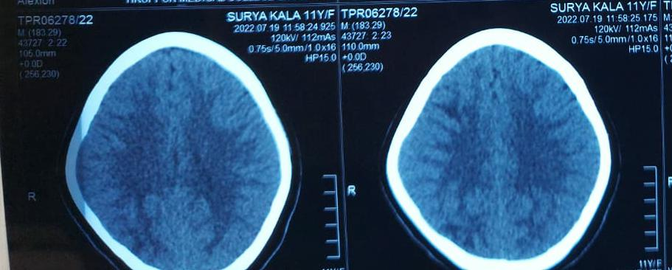
Fig 3 : CT Scan
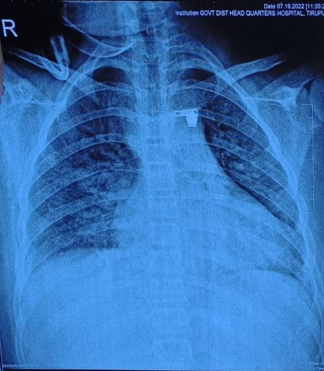
Fig 4 : Chest Xray

DISCUSSION
The possible diagnosis of PRES following hypertensive encephalopathy secondary to AGN without haematuria was determine based on clinical presentation, laboratory and imaging data’s. Acute glomerular nephritis is characterized by sudden onset of edema with gross haematuria and hypertension are common which is correlated with fluid retension.however in this case the patient exhibited no haematuria which is a rare occurrence in nephritic syndrom.the paediatric patients suffering from nephrologic problems are at high risk of developing acute neurological complications. Among the many medical complications PRES is potentially serious one PRES was first described by Him chey et al in 1996 and known as Reversible Posterior Leukoencephalopathy Syndrome (RPLS) PRES is clinical radiographic syndrome of heterogeneous etiologies such as renal disease, hypertensive encephalopathy, haemolytic and uremic syndrome. Hypertension is one of the common presentation pattern in pediatricPRES which is the most common identifiable triggers. CT scan and MRI are helpful to confirm the diagnosis of PRES. There are three different theory that explain the mechanism behind PRES Fig: 3. They are hypertension/hyperperfusion theory autoregulation theory, endothelial theory Chemotherapeutic and immunosuppressive drugs are trigger factors for PRES.Chronic kidney disease and acute kidney injury are common factors in PRES.AGN which leads to hypertensive en ephalopathy may also result in PRES.AGN is the major disease among glomerular nephritis which patient exhibits abrupt onset of edema, hematuria, hyperension etc. Bu our patient exhibited no signs of haematuria which is a rare occurrence. On further examination, it was found to be PRES secondary to AGN without headache by clotting renal biopsies and MRI imaging. Without detailed studies or examination, patients condition may misdiagnosed and treatment want to be helpful. PRES due to AGN in children is a rare incidence but AGN without haematuria is more.
CONCLUSION
Paediatric PRES is a well-recognized neuron-radiological syndrome which is mostly underreported in developing countries. These case reports about PRES due to AGN which does not shows up symptoms of haematuria. We are hoping that this case report will stimulate scholarly dialog and research among health professionals on PRES and AGN even in the absence of haematuria.
Author Contributions
1 Mohammed Rashid: Carryout the needed medical test data collection and write up part of introduction and abstract
2 Jiby Remola: Clearly arranged the collected data and all other necessary documents .also did the write up part of case report and discussion
3. Jimmy Alexander: Carryout the overall arrangement of collected data and carryout the result part.Collecte the supporting data for the publication.

REFERENCE
1 Welch T. An Approach to the Child with Acute Glomerulonephritis. International Journal of
Pediatrics. 2012;2012:1-3.
2 Chauvet S, Berthaud R, Devriese M, Mignotet M, Vieira Martins P, Robe-Rybkine T et al.
Anti-Factor B Antibodies and Acute Postinfectious GN in Children. Journal of the American
Society of Nephrology. 2020;31(4):829-840.
3 Marshall C, Currie B, Towers R, Markey P, Krause V, Scott L et al. Acute Post-
Streptococcal Glomerulonephritis in the Northern Territory of Australia: A Review of 16
Years Data and Comparison with the Literature. The American Journal of Tropical Medicine
and Hygiene. 2011;85(4):703-7108.
4 Clinic Proceedings. 2013;88(11):1284-1293.Sethi S, Rajkumar S. Monoclonal
Gammopathy–Associated Proliferative Glomerulonephritis. Mayo
5 Liu P. Dissociative Identity Disorder: Understanding of DID, Symptoms and Causes.
International Journal of Pharma Medicine and Biological Sciences. 2022;11(1):26-29.
6 Boyer O, Moulder J, Somers M. Focal and segmental glomerulosclerosis in children: a
longitudinal assessment. Pediatric Nephrology. 2007;22(8):1159-1166.
7 Iwafuchi Y, Morita T, Kamimura A, Kunisada K, Miyazaki S. Human parvovirus B19
infection associated with hemolytic uremic syndrome. Clinical and Experimental
Nephrology. 2000;4(2):156-159.

