The Blockchain Technology: An Extensive Survey

Nagarajan.B ¹, Ananth.C², Mohananthini.N^{3*}
^{1, 2,}Division of Computer and Information Science, Annamalai University,Chidambaram, India, 608002.
³ Associate Professor, Muthayammal Engineering College, Rasipuram, India, 637408.

E-mail addresses
(Nagarajan.B) thilaknaga@gmail.com
(Ananth.C) ananth.prog@gmail.com
(Mohananthini.N) mohananthini@yahoo.co.in

Abstract
In the modern computer world, Blockchain applications are involved in securing data transmission. The main advantages of Blockchain applications are transparency, increases hope, security, traceability of data shared across a network, delivers cost savings with new Efficiencies, Decentralization, Pertinacity, and Audit ability. Nowadays Internet of Things, Energy Trading, Healthcare, Education, e-Voting, Smart city, Shooting, Live Stream, Marine, Business, and many more services are using Blockchain Technology. Only a few such services are carried out with Blockchain and it is considered to be dependent only on financial services. Despite the name of modern technology progress is very limited; it is commonly used and assumed that there are practical difficulties in accepting it in some services. Some countries are generally afraid to use Blockchain in their services due to their lack of understanding its advantages. The present study entitled on also discusses the Blockchain and its Blockchain Technology: An Extensive Survey perspectives on drawbacks and issues, and challenges to be faced in it.
Keywords: Applications, Blockchain, Bitcoin, Crypto Currency, Distributed Ledger, Decentralized Network, Hash Algorithm

INTRODUCTION
The backbone of Blockchain technology is the Decentralized Network in which all records are transmitted over a Decentralized Network in Hash method. Blockchain was first used as a Digital Currency Transaction, the first use of digital currency (Bitcoin), from one end to the other i.e peer-to-peer network (Nakamoto, n.d.). Every transaction made through a Data on a Decentralized network is verified by 51% of nodes in the Decentralized Network. The specific Hash for transactions is created in sync with the data, which distinguishes one data from another and creates a unique identity for the transaction. This gives each record a (PoW) Proof of Work for its work so that the data shared over the Decentralized Network is more secure (Karame, 2016). They are administered according to different Blockchain applications according to the Hash algorithm. Secured Hash Algorithm is more powerful and safer than any other algorithm used by the Blockchain. This double Hash is more efficient than any other algorithm as all the data about the Hash is exchanged with the unique Hash code (M. Wang et al., 2018). Every transaction is monitored and processed in Hash method. The specific Hash value for a generic transaction is generated arbitrarily and all transactions are generated into a block at a given time and a unique Hash is assigned to it. This option saves a transaction to other computers connected to it via a Decentralized Network, thus rendering it ineffective if we attempt to modify or delete the transaction within it. It Works much more efficiently than other algorithms. This SHA algorithm has 3 generations but currently, we are only using the 2nd and 3rd generation SHA algorithm (F. Wang et al., 2020). The Blockchain is generally considered to be applicable only to postgraduate applications but beyond that its use is applicable to all services. The Blockchain can also be used in financial services such as banking, in digital assets and online transactions by allowing to provide financial services safely and efficiently without intermediaries (Zheng et al., 2018). The present article also discusses and explores in detail how the Blockchain Technology works and its concepts and the problems it may face in the future, and the benefits that future social technological changes will bring about them. We have categorized the rest of this article as follows.

Taxonomy of the Blockchain
The Blockchain Technology is a type of database that is a collection of information stored electronically on a computer that is commonly used to easily identify data through this database. The Blockchain has a Decentralized Network, so every piece of information in it is stored in clones in all computer databases. Blockchain transmissions are usually sent in separate blocks, so having clones at each end of the network is not easy to intercept because the Hash value is like a fingerprint. The datum are bundled in separate blocks, every 10 minutes one block is created. The information is exchanged in Hash method so that even if we intercept it, we can only see the hexadecimal of that individual block. It is not possible to access because all the blocks of that information are interconnected.
The Figure 1 below illustrates how a transaction can be successfully executed on the Blockchain Technology. For example, suppose a person is transacting from one node, the transaction work begins after first checking whether the node belongs to the network. The transactions carried out together become a block at 10 minute intervals and then the block is sent to 51% of the nodes in that network. All nodes check the received transaction. If it is accepted that block is allowed, the mathematical algorithms for the block give a specific reward to the nodes that reach the solution. By connecting the block to a Decentralized Network the clone of the block is accepted as the new block at all nodes and the transaction reaches the recipient.
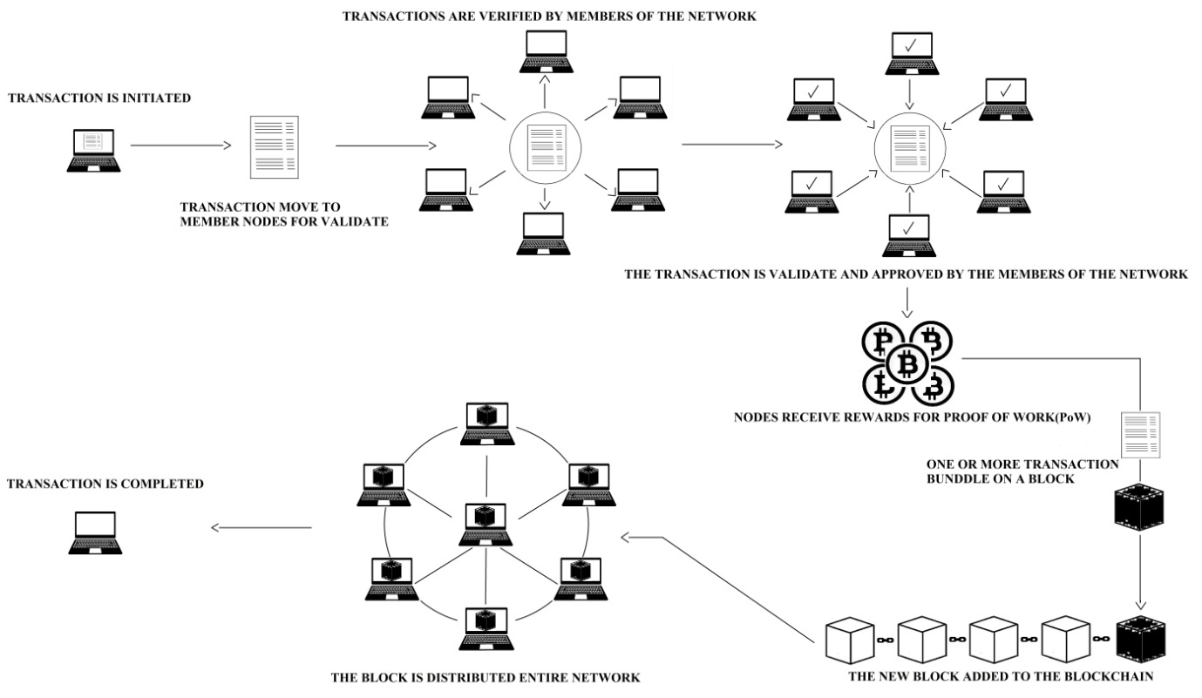
Figure 1. The Blockchain Technology Working Model

Secured Hash Algorithem (SHA – 256) in Depth of Merkle Root.
A Hash like a finger print so can’t be changed its value. The Hash has a fixed length, which makes it almost impossible to guess the Hash code if the hacker tries to break the Blockchain. A Hash is created based on the information in the block title that is the backbone of the Blockchain technology. Here a Block communicates information securely through Hash. The information in a block is multilayered and the information is transmitted securely from one end to another through a Hash. There is no such thing as a server in the Blockchain technology. In Decentralized Network saves all datum to each node so if someone interrupts a particular block the Secured Hash algorithm (SHA – 256) protects the data from Corruption. Even if the data is changed, the modified data at the nodes in the network is subjected to testing. The Hash of the modified data is discarded if it differs from the Hash of the other nodes.
All the blocks are connected / communicate to each other by the Hash, making it impossible to intercept the information of a block. A block can contain multiple transactions. Digital signatures are generated through completed transactions. This allows the user to decide whether or not to transact in a particular Block. Hashes are calculated in pairs as long as there is only one Hash left. A Hash, at the end, forms the Hash of that block. Merkel trees are formed through this procedure.
The Figure 2. below shows how one block interacts with other block. A Hash is generated for each of the transactions 1,2,3 and 4 carried out in a block, which varies according to the data in each Hash transaction. Here the transaction has 1 Hash value as A and transactions 2,3 and 4 have the Hash value of B, C, and D respectively. In the second stage, the Hash values ​​of the first two transactions are converted to the new Hash value, and the Hash values ​​of the third and fourth transactions are converted to the new Hash value, respectively. In the third stage, the transactions combine the Hash values ​​generated by AB and CD to form a root Hash. As each block is created, a nonce value is created with it.The Merkel root Hash differs by adding nonce value even if the same data is in different blocks.
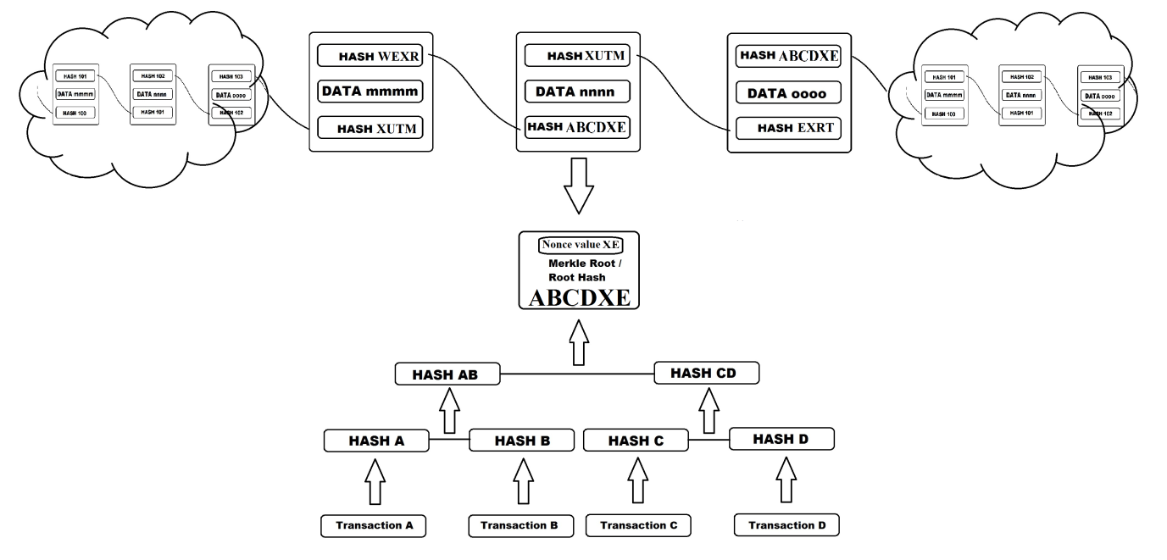
Figure 2. HASH Work Together and Depth of Merkle Root

The Blockchain Features.
The Blockchain technology main Characteristics at the application level a) Immutability, b) Transparency, c)Identity d) Distribution e) Transactions f) Historical record g) Ecosystem and h) Inefficiency (Sukheja et al., 2019). Other than this main feature Increased Capacity, Better Security, Faster Settlement, Decentralized System, Minting (6 Major Features Of Blockchain | Why Blockchain Is Popular? - DataFlair, n.d.).

Increased Capacity.
Its efficiency and storage are multiplied as it is not a personal server-dependent. A separate server contains all the datum but in the Blockchain technology there is no separate server for it and instead, all the nodes have every data here.

Better Security.
The Blockchain Technology has the best protection in itself so that the data can be handled very well. Usually, even financial system enterprise computer systems are sometimes hacked but not a single block has ever been hacked. If we explore why there are innumerable nodes in it without being dependent on a server-like data centralized network. So all the datum is stored on all the nodes so that the data is confirmed every time.

Faster Settlement.
The reason why the bank service is so slow is that all its operations depend on a single service center. In this case, the transaction is impossible without human interference. Thus, the transaction is much delayed. Each transaction is verified directly. This forces customers to wait a very long time. Due to this, it has to improve its service capacity for providing quick and secure service.

Decentralized System.
Power is evenly distributed to all nodes in the decentralized network, and no individual oversees this structure. Each of these nodes is directly connected to the Blockchain. Store anything like Cryptocurrencies, important documents, contracts or other valuable Digital assets. Blockchain gives an individual right to own property using a private key, thereby ensuring the individual's financial resources and return of ownership of the property.
Minting.
Minting is defined as the process of verifying data information, converting verified data into blocks, and linking blocks to the Blockchain. The Blockchain stimulates a block, the Blockchain works on the basis that there are only specific records on a page in the Blockchain where specific transactions are created as a block and stored inside the Blockchain. Usually, a block is created every 10 minutes and at the other end the data is verified and also the verified information is created into a block.

The Blockchain Ideological System.
Distributed Ledger.
The Distributed Ledger is also known as Distributed Ledger Technology (DLT) or shared ledger. DLT is spread across many platforms and there is no definition for it. It refers to a consensus for shared information. DLT is not managed by anyone, but the central network has an administrator, DLT datum are stored on all DLT nodes. Usually, the DLT block is the structure of the organized information. Like this and many more blocks are created and merged with the previous block after exploring its authenticity. The time it is created on the block i.e. (timestamp) and its Hash are generated automatically.

RJT, or Replicated Journal Technology, is another name for distributed ledger. This is because the information in a block is collected not only at one node but at all its nodes so that all the information about a particular post in a block is shared at all nodes. It is also called RJT because all the information in a record is copied and pasted on all nodes ("Distributed Ledger," 2021).
Consensus Algorithms.
The Blockchain is a Decentralized, peer-to-peer system. All of these decisions are made by an organization on the blockchain, it should be a government or a private organization. It is very difficult to design policy decisions that are acceptable to everyone in the organization. This is because one cannot force one’s opinion or the opinion of a group to be accepted by others, but in a centralized system, its administrator or team usually makes decisions much more easily. They must follow its "consensus measures" to reach a conclusion. Consensus can be defined as a professionally acceptable resolution that can be supported even if it is not to everyone likes. Consensus decision-making is the process by which team members form and agree to support a decision for the overall benefit. A method of consensus decision-making is called a "consensus method".
The feature of the Blockchain scheme is that the nodes do not trust each other, and some claim that they can operate in Byzantine ways. The contract conference must withstand the Byzantine disappointments. The study inscription of the reported contract is huge, there are many variations recently proposed Traditions are being created for the Blockchain (Dinh et al., 2018).

Cryptography.
To ensure the reliability of the records, the Blockchain systems make extensive use of cryptographic techniques. Cryptography (concealed or secret) is the ancient Greek word for Cryptos and Graphene. The word cryptos means hidden and Graphene means writing. The terms cryptography of encryption and decryption are in circulation. Encryption is a simple text (plain text) process for cipher text (random sequence of bits). Decryption is the reverse process of encryption, converting cipher text to plain text. There are advantages to the asymmetric encryption method unique public and private keys, which can be passed through insecure channels.

- It has the disadvantages of low processing speed and low encryption strength (Zhai et al., 2019).
- It is necessary to ensure the security of the asymmetric encryption algorithm based on mathematical problems (Zhai et al., 2019).

This technology is used for several purposes to protect the various transactions that take place on the Blockchain Network, and to verify digital assets and block transactions. The safety of the Blockchain shows off that the availability of public-key cryptography is anticipated.

Smart Contracts.
The Smart Contracts is an indication that a transaction has taken place between two beneficiaries in order to make a cash transaction or a property transaction. For example, money or property contains information that has been transferred. The business rules enforced by the contract are embedded in the Blockchain and implemented within the transaction. For example, the integrated smart contract verifies transaction entries in Cryptocurrencies by verifying their signatures. Next, it demonstrates that the output address corresponds to the balanced input balance. It is useful in many cases to change human intervention (e.g. in the case of a lessee, to automatically send the key once the contract is signed and the rent is paid).

The below Figure 3. Shows how a smart contract is formed. The agreement reached by the nodes is the cryptography algorithm, which takes the form of programs here. The cryptography algorithm also agrees with the accompanying volumes. Through this, the new algorithm is implemented by the nodes to be adopted. Sub-nodes in the same network automatically accept this. This will create a secure, non-intermediary and non-arbitrary; can also create a loss-less station.

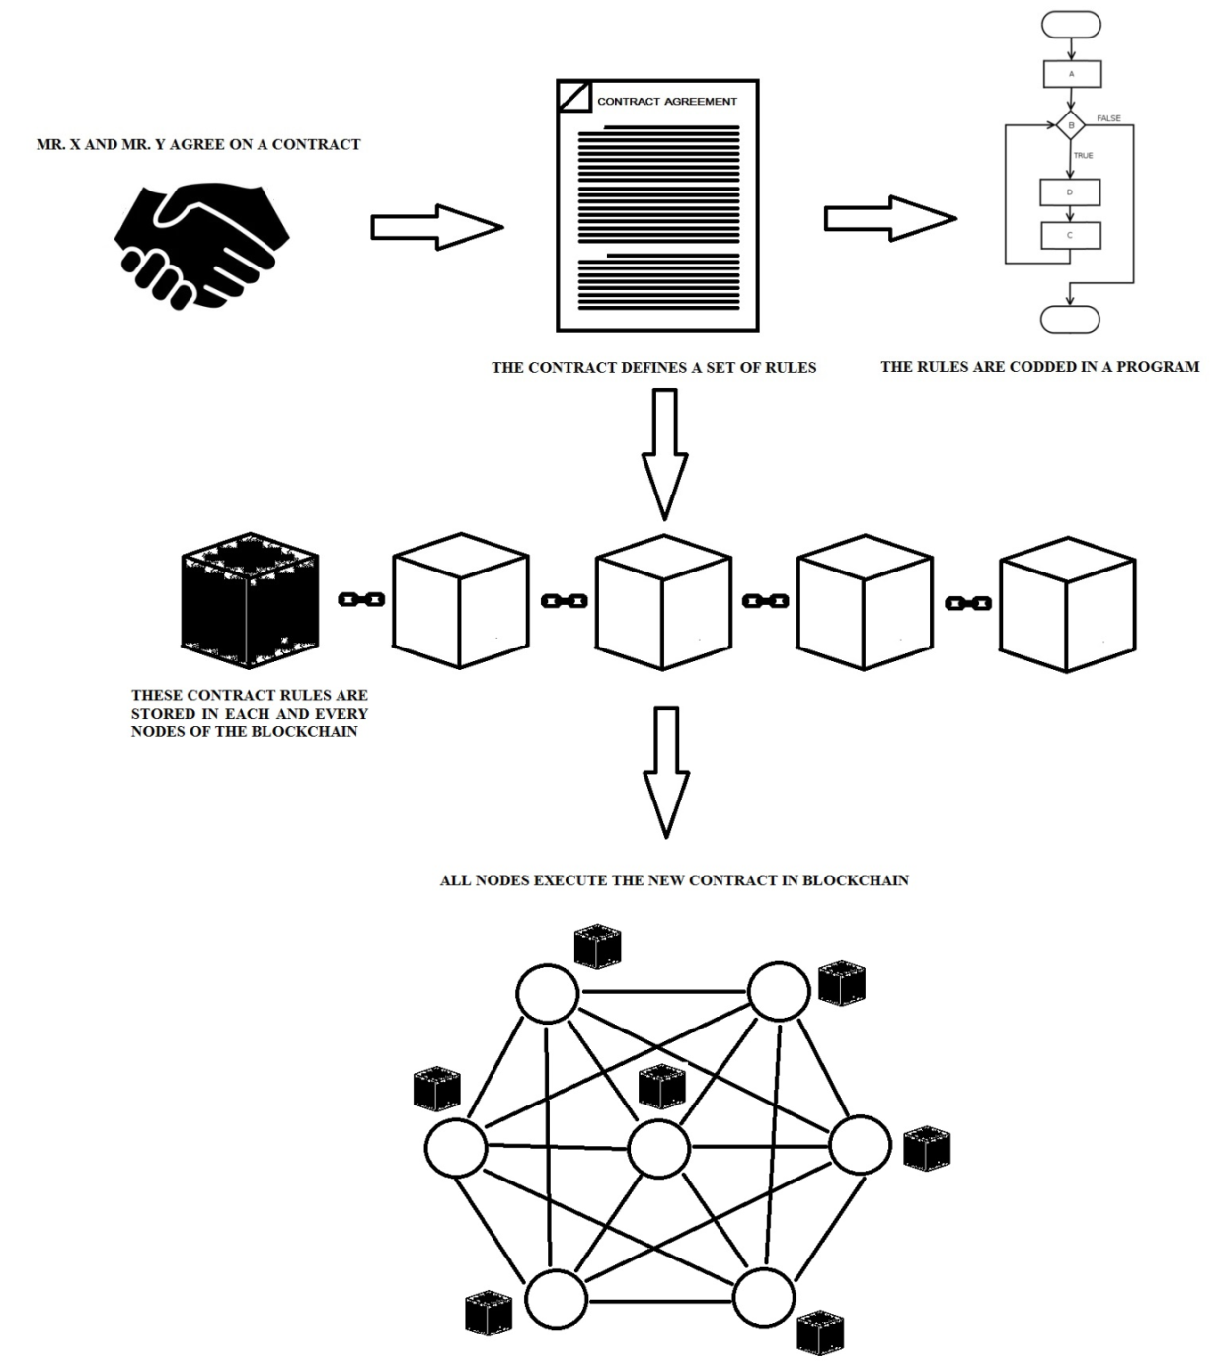
Figure 3. Smart Contract can Automate Execution of Transactions

The Blockchain Technology – Advantages.

High reliability.

Data from the Decentralized Network of advanced Blockchain Technology is retrieved and verified from hundreds of nodes. Only an administration with hundreds of nodes can maintain such data and open up distributed documents (Sukheja et al., 2019). Especially in a Decentralised Network, the data is copied and stored at all nodes so that a node loss or man-made error does not affect the Decentralised Network at all. The Blockchain Technology compares data loss because the data is copied to hundreds of nodes on the peer-to-peer network. Generally, agreeable data at all nodes is allowed here. Blockchain Technology assures that applications are developed in a way that is not intended to deceive an individual, a company, or a Government.

Trust.
The Blockchain trust is founded on the mutual trust of two or more users, participants, or companies who are unfamiliar with one another. Its main purpose is to control the course of transactions in which transactions made by two unknown persons, participants, or companies are genuine and ineffective. Its authenticity is further enhanced by the fact that the transactions that take place are recorded at all nodes, and the resulting processes (Golosova & Romanovs, 2018).

Enhanced security.

For security, the Blockchain Hash works with the function, and the algorithm has a one-way function, which makes it not possible to recover the record once activated. It protects the value of data by a Hash. Its value can only be obtained by that particular user, and no information can be obtained through it even if it is intercepted. This is because it has the ability to take a numeric long input string and convert it into a standard long binary array.

Efficiency.
The Blockchain Technology is structured in such a way that all transactions take place through this system, which is used to mark labour costs while at the same time reducing transaction time for the transaction, thereby increasing its efficiency. Transactions take place in more detail by minimizing intermediaries. Blockchain technology speeds up the settlement of certain economic transactions by streamlining the process quickly and step by step. (Sukheja et al., 2019).

CONSENSUS MECHANISMS
In blockchain, there are numerous consensus Mechanisms that allow us to choose suitable colleagues to sign the next block on a network. All nodes must work in unison to maintain the blockchain. Consensus is a set of rules that all nodes must follow. Consensus is used here to connect new data to the network. Its purpose is to reach an agreement between the nodes. A lot of information is distributed on the network through the Blockchain. In this, connection all the functions of the data performed on one node are stored as clones on all other nodes in the distributed network. These work in unison to form a block and follow a consensus. There is a lot of transaction information in a particular block. For example, it's like a company managing the pages in its budget ledger. This includes some records that the company makes every day. Here we take pages as blocks (Blockchain Consensus Algorithm, n.d.).

The Blockchain works on a consensus basis. Because, all the nodes in the Decentralized Network follow the same concept or rule in unison. Transactions and data are immediately verified and linked to other modules in the Blockchain. When the new module is attached to a chain-link it must have sufficient block. All the nodes to connect a block to the Blockchain are trying to solve Cryptographic mysteries.

Let's explore some of the important consensus mechanisms.

Proof-of-Work (PoW)
Synchronization for transactions transmitted over the network, Transactions on the Blockchain are usually based on the basic premise of proof of work. PoW stands for the completion of a transaction and the acceptance of it by other parties. This is common to all nodes in the Blockchain. If the solution is set to accept all nodes, the new block will be accepted by the nodes in the link and integrated into the Blockchain Network. The solution to this difficult cryptographic mystery is what we call the PoW (Proof-of-Work). If a transaction is accepted in the Blockchain, it must have the corresponding PoW (Raikwar et al., 2019).
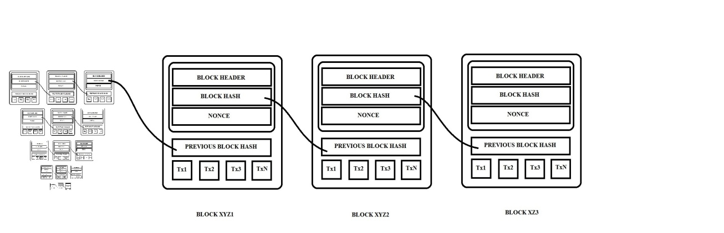
Figure 4. Proof of Work
A Proof of Work (PoW) is a proof of work done by the consensus mechanism on the blockchain. The above Figure 4. illustrates how transactions that are shared on a particular network are analysed by the nodes in it using a Cryptography Algorithm. The completed transactions are converted into blocks and connected to the network. Minorities compete to complete transactions, also known as "mines." The miner will also be rewarded for completing the settlement for that particular block.

Proof-of-Stake (PoS)
Proof-of-Stake (PoS) is a popular consensus method on the Blockchain Network. It can also be used as a PoW alternative as it acts like a PoW. But its processes are slightly different from PoW. Usually, in this method, a node with a large number of resources, such as Cryptocurrency, is selected to create the next block in the blockchain. PoS also solve mathematical problems and create new blocks. There is no reward for creating a block; instead, the node is rewarded for completing a transaction (What Is Consensus Algorithm In Blockchain & Different Types Of Consensus Models | by BangBit Technologies | Medium, n.d.)(Overview of 9 Blockchain Consensus Algorithms, n.d.).

Figure 5. Below illustrates, depending on the number of coins a miner can hold, a block can be created or mined, or verified. PoS is a PoW alternative its attack capacity is lower than PoW thus creating losses that make attacks less favourable to miners. This allows it to work for transactions rather than a block.
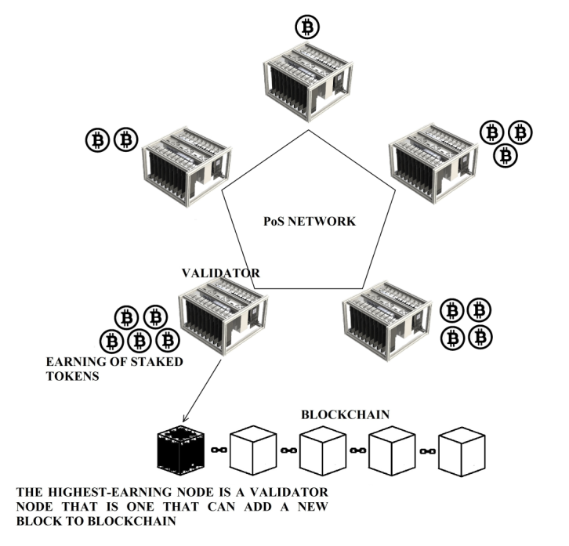
Figure 5. Proof of Stake
Delegated Proof-of-Stake (DPoS)
DPoS (Delegated Proof of Stake) works similarly to PoS (Proof of Stake), but one difference is that delegates dominate here. In particular, 20-100 delegates will take part in it. Delegates will participate in the referendum by connecting a block to the network. First, any participant who solves of a particular volume will be considered a witness (winning nodes) thus get more transactions for them (What Is Consensus Algorithm In Blockchain & Different Types Of Consensus Models | by BangBit Technologies | Medium, n.d.)(Overview of 9 Blockchain Consensus Algorithms, n.d.)(Yadav, 2020).

Bellow Figure 6, the nodes that get the most votes are the witnesses and more and more transactions can be checked and they can be rewarded. Users can vote on who can be the representative. Representative may affect future updates to the Blockchain. Representatives who do not succeed in this process will be considered to lose in this process. The winner is the witness, and then the block is added to the Blockchain.
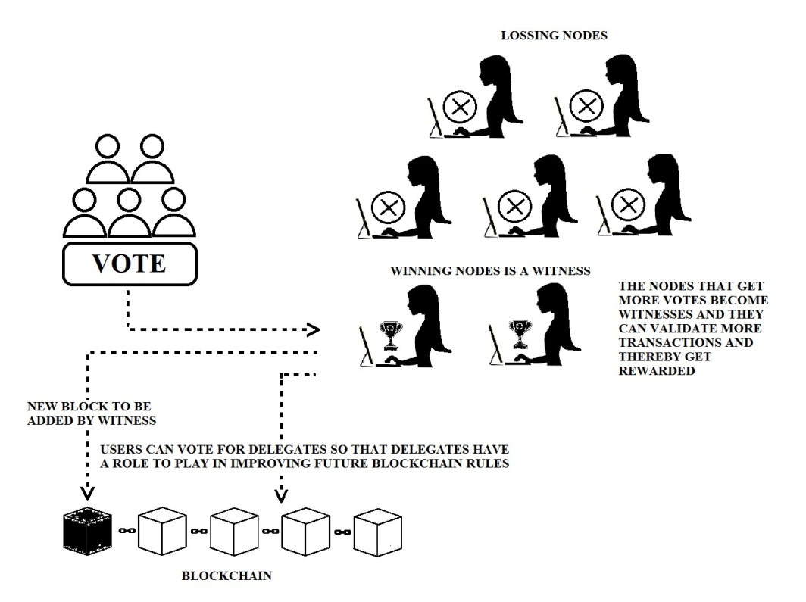
Figure 6. Delegated Proof of Stake.

Proof-of-Weight
Proof-of-Weight is a broad classification of consensus mechanisms which is surrounding the algorithm consensus model. The PoS gives the probability of "finding" the next batch of tokens owned by the network, while the other value of relative weight is used. Filecoin’s Proof-of-Space Time weighs in on how much IPFS data is stored (What Is Consensus Algorithm In Blockchain & Different Types Of Consensus Models | by BangBit Technologies | Medium, n.d.).
Proof-of-Burn (PoB)
Proof-of-Burn (PoB) is a one-time or distributed consensus. It is an alternative to the certificate of proof-work-work and stock. It can be used to bootstrap one Cryptocurrency from another. All sources of native Cryptocurrency function by providing evidence of extracted Cryptocurrencies. Hence the ultimate source of scarcity — work-proof of cut fuel. No one has access to a wallet for a specific portion of the currencies in circulation. This removes these coins from being costly. Although they will always be part of the coins that need to be created (Proof of Burn - Bitcoin Wiki, n.d.).
Proof-of-Activity (PoA)
PoA is a strong link between both PoW and PoS. The purpose of the PoA discovery is to serve as an alternative incentive framework for miners in post-coin Miners follow the PoA process to solve complex Cryptographic math puzzles. If no transaction takes place in the extracted volume, the system converts it to PoS. Eligible committees are appointed to sign a new constituency based on the title. Anyone who has received too much Bitcoin is more likely to be selected. If this group fails to complete one block, another panel will be selected. This process continues until a block has been successfully created and integrated into the binding. Rewards are divided between the miner and the validator. The only currency that uses the verification-function for verification is the "decred"(What Is Consensus Algorithm In Blockchain & Different Types Of Consensus Models | by BangBit Technologies | Medium, n.d.). The purpose of the PoA protocol is to have a Decentralised Cryptocurrency Network; its security work is based on a combination of Proof of Work and Proof of Stake. In general, job-based protocols give decision-making power to companies performing computational tasks; evidence of stock-based ethics will give the decision power to companies holding shares in the system (Bentov et al., n.d.).

Proof-of-Capacity (PoC)
Proof-of-capacity (POC) is the Blockchain consensus algorithm. Proof-of-Capacity is also known as Proof-of-Space. PoC, Proof-of-Capacity, Consensus Algorithm is very different from the others. The Blockchain Network allows miners to use their own hard drive to assert their rights, such as proof-of-work algorithm or proof-of-stake algorithm. Evidence of efficiency has emerged as one of the many alternative solutions to the problem of high energy consumption proof (PoW) of work, which is inherently the problem that promotes Cryptocurrencies instead of spending to prove hardening stocks. Demonstrating capability allows mining devices (nodes) in the Blockchain Network to use the free space on their hard disk to mine available Cryptocurrency.

Table 1.

Cons and Pros of some of Important consensus algorithms

Consensus Algorithm | Digital currencies  used | Pros | Cons
PoW -  Type: Competitive | Bitcoin, Litecoin,  Namecoin, Dogecoin,  Primecoin, Auroracoin, Mazacoin,  Monero, Titcoin, Verge, Vertcoin, Ethereum, Ethereum Classic, Tether, Zcash  Bitcoin Cash | - Still the day we can use it | - Using a lot of Power  - Slow Process
PoS  Type: Competitive | Ethereum, Peercoin, Nxt, EOS.IO, Cardano | - Less Energy  - Expensive to attack | - No- Risk Occur
PoS -  Type:  Collaborative | Gridcoin, BitShares, Steemit, EOS, Lisk, Ark | - Energy Consumption. | - Participants with higher stakes may vote for themselves to become a checker.  - A small volume of centralized
PoW -  Type: Competitive | Algorand | - Energy- efficient.  - Highly customizable and scalable. | - Motivation can be hard.
PoB -  Type: Competitive | Slimcoin, TGCoin | - POB is often called a POW system without energy waste  - Miners are encouraged to work together for a long time  - rewarded with more mining power. | - Attempt to advance projects in a way that benefits users.  - Bitcoin generally operates on its network, making it impossible for network losses to recover bitcoin
PoA -  Type:  Collaborative | Decred | - Combines the best features in PoW and PoS systems | - New blocks only contain a block header and the miner’s reward address
PoC -  Type:  Collaborative | Burstcoin, Chia, SpaceMint | - Similar to PoW but uses space instead of calculation.  - can be to prevent an anti-spam and service attack | - Encouraging miners can be difficult

THE BLOCKCHAIN TECHNOLOGY APPLICATIONS
There is a general misconception that the Blockchain is based on a particular financial trade. That is, there is a misconception that Cryptocurrency and Bitcoin are the only ones that really go beyond this. This Bitcoin Technology was developed in 2008 by Satoshi Nakamoto (Nakamoto, n.d.). People look beyond Bitcoin as a controversial currency for bad black market activity and the endless possibilities it offers. The Blockchain stores data in Distributed Ledger Technology (DLT) method at other nodes in its connection. It contains a complex mathematical algorithm in each module. Thus only nodes that agree with this mathematical algorithm concept will participate. Thus making the data more secure.

The Blockchain technology key features are (Shalini et al., 2018).
1. Lower transfer and limited interaction fees.
2. High degree of security and trust.
3. High degree of frankness, transparency, and dependability.
4. Amalgamate the digital and physical world.

Its primary purpose was to transmit digital currency as extensively and securely as it could be used to transmit digital currency from one transaction to another, but in the long run due to its transparency and speed, and its high accuracy, the Technology saves companies the time and money required to carry out transactions. The Blockchain technology explores everything from how a company executes contracts to how it effectively enables a government to operate. Let see some of other Applications in the Blockchain.

Education System
Education revolution 4.0.
This article is about the great benefit of students with the Blockchain and how to store their data securely. Students who do not have enough knowledge about its benefit because a lot of the information produced by this field is continuous from childhood education to undergraduate. Implementing the principles in advance will increase its effectiveness. Students will have no difficulty in managing the data with this. It is a highly secure and reliable machine which is available to a high level of student information gathering. A few people are exploring this with old solutions so it seems to be full of problems and thus the programs are vague. But the authors of the article say that this can be done better if the data is grouped and followed the rules (Rizky, Silen, et al., 2021).

Information System Security on Education.
The present study argue that the information and data entered into by the Blockchain enhancement in the field of education cannot be forged, lost, or easily damaged. Data can be easily stored and manipulated without third-party intervention, but its use in education is minimal. Researchers are trying to evaluate the security of information systems in education using fingerprints by enforcing cryptographic Hash security. They also pointed to the use of the Blockchain technology in the implementation of information system security in Indonesian educational institutions (Rizky, Kurniawan, et al., 2021).

Online Education.
In this chapter, he says that online education has developed a new teaching method with the contribution of Technology the online education system certainly faces many problems in terms of credibility, credits, certification, the privacy of students and course sharing. Through literary study and case analysis, this article discusses the basic technical principles and application aspects and also provides solutions to the problems of online education. The authors claim that the integration only will enhance the growth of online education. (Sun et al., 2018).

Government
This study discusses the innovation of the Blockchain Technology and its impact on the government process. In it, they discuss the exaggeration in the literature about black chain Technology. It addresses the need to adapt the application to Government processes and their benefits. The potential benefits of the Blockchain applications in e-government role of the Blockchain structures management of applications in line with social needs and public values ​​are discussed the problems caused by doing. They also discuss services in public sector companies and money transactions. They also explore the Blockchain characteristics, flexibility, and conflicting built-in mechanisms that require strong administration. It is said that a small amount of research can be done before making a big move to avoid large losses (Ølnes et al., 2017).

Energy Trading
Secure Energy Trading (IIOT).
The energy trade in the Industrial Internet of Things (IIoT) Decentralized Network takes place in a wide variety of scenarios everywhere. Thus there are common security and privacy challenges posed by unreliable and transparent energy markets. And about a secure energy trading system called the Blockchain to tackle the challenges. They also discuss the possibility of advancing a limit-based credit-based payment plan due to delays in supporting fast trading. Debates over energy-currency loans are being used to advance the economic benefits of credit banks using the Stackelberg game to advance optimal pricing strategies. IIoT nodes with better or worse credit ratings discuss project development and similar issues (Li et al., 2017).

Energy Trading System.
The study claims that all scientists have been inspired by the research carried out with the Blockchain technology on transactions in safe and low-cost neighbouring countries in the energy economy distributed (through Brooklyn microgrid network). it says the service and security issues which currently faces is high. Its explores the importance of Blockchain Technology in the energy sector and analyze the issues and claim attack efficiency. As for the future, as for the future, they say need one program to prevent various attacks (Rahmadika et al., 2018).

Lightweight Hash (IIoT).
This study examines the distributed binding with Hash (QUARK, PHOTON, and SPONGENT) in three ways, and found that Microchips commonly used in IoT, such as MSP and ARM processors, provide a Cryptographic Hash. It is said to be 5000 GE lower than the common Hash. The process of controlling each cell is referred to as reducing the load and delay by this method. They revealed that the results will be processed according to the context within a specified time. They claim that using too much lightweight Hash can be used for too many different IIoT applications. They argue that using this will only cause a delay of less than a second. They also worry that transaction delays are common. They plan to conduct a simulation using a real-world simulator similar to NS-3 to demonstrate the effectiveness of the framework and use it in real achievements and use it against attack on the Blockchain (Seok et al., 2019).

Securing Smart City
Future works will aim to design a computer-level model to explore the dynamics and scalability of different sites used in the smart city (Biswas & Muthukkumarasamy, 2016). The study explains how to bring the Blockchain Technology to the structure of a smart city and improve its security. The Blockchain describes the security issues that arise when connecting to a smart city and claims that a common ground can be managed by integrating the achievements of the smart city. This allows them to securely access the devices on the Decentralized Network.

E-Voting
Secure Digital Voting System.
The voting system in this article can be advanced through a network decentralized through the Blockchain to store data more securely. They argue that the e-voting system can be improved by improving regulatory processes. They argue that in-depth assessment is needed to meet basic needs and the improved studies are needed to implement this (Khan et al., 2018).
Voting System Requirements.
In this article, the Blockchain claims that the voting system meets the essential basic requirements. Votes are linked via Cryptography algorithm blocks and all ballots are digitally signed and time-stamped and linked to the Blockchain as blocks. They also say that encryption will not be done because voting is common. Its Cryptography suggests that ECC is a public key that can be attacked by quantum computers. The Blockchain is said to be under attack by quantum computers and will soon be studied in quantum computers (Yi, 2019).

Stock Exchange Platform
This article addresses the issues and inefficiencies in data management by facilitating and updating its also deals about maintaining the limited visibility data access time of the ledger shared on the Stock Exchange platform with the Blockchain. Also, delays in financial transactions can be minimized. Network sizes from multiple tests to 10 validators and up to 350 tx/sec Rate increase and vulnerability due to large workload or limited calculations (Al-Shaibani et al., 2020).

Stream Video Transmissions and Telecommunications
The present study focuses the Technology of the Blockchain to enhance changes in its methodology in the field of live streaming and telecommunications to ensure consistent secure packets of information or data packets are encrypted and shared in the network. Furthermore, the use of an improved performance algorithm means that the improved process sends packets faster and more securely in live streaming than the method used in the common Hash system. Moreover, it is said to perform better than other live streaming and Telecommunications Technologies. Its effectiveness has been tested with the Testing and Simulation on OS2 software and the results obtained are satisfactory (Khalaf et al., 2020).

Marine Data Security
This study discusses the fast-growing maritime data for storage and safe transmission. Concerns have been raised that the security of maritime data is questionable in existing Technology. Maritime data can be more securely transmitted and stored over a Decentralized Network by using the Blockchain Technology and streamlined method. Through this, the context of a new environmental data resource is also proposed and discussed by the authors (Yang et al., 2018).

Business
Business Cybersecurity and Accounting.
In this study, the authors have made some suggestions on the basis of which they describe the possibilities in streamlining the business Technology-based data in the Blockchain to streamline cybersecurity and accounting processes. They also argue that more research on business technology is needed in the Blockchain technology. Thus the Blockchain technology has ample applications to make data secure and transparent in a Decentralized Network and as part of an accounting system. To improve this they are proposing to make it part of the company's financial system and demand that companies focus on cybersecurity investment strategies and their applications in accounting (Demirkan et al., 2020).

Fraud Detections for Online Businesses.
The study argues that the value of an item that customers buy is determined by its ratings, but that a few companies can tarnish the reputation of an item with false ratings. Online Item ratings are the only way to bring the quality of a product and its goodwill to the people in online sales. Furthermore, the effectiveness of the Blockchain technology in objective fraud and its scope of subjective fraud in assessment fraud. The authors claim that some companies carry out attacks in a variety of ways to tarnish the reputation of a popular product in order to gain a reputation online, but that these attacks can be controlled with the Blockchain Technology. The study points out, that however its effectiveness is high in preventing bad noise and whitewash attacks, but they are limited to detecting the ballot in Sibilant attacks, Static attacks, and Camouflage attacks (Cai & Zhu, 2016).

Electronic Health Care Records
The study discusses how the Blockchain Technology can securely store electronic health records and share data in the healthcare industry. Despite adequate inventions, they found that there were some technical issues. Ensuring that electronic information is secure through the protocols improved by the Blockchain. In addition, the IPS proposes that the system load the storage problems using the off-chain storage system in the Interplanetary File System. They also say that they can use this to address electronic health record issues and will be involved in furthering their research into the payroll(Shahnaz et al., 2019).

SECURITY ISSUES AND CHALLENGES
Blockchain has so far attracted the attention of a wide range of Industries. The Blockchain has many problems and challenges it faces. For example, practical problems and security measures and the measurement problems that the Blockchain has to face are widespread. The main and lofty purpose of the Blockchain is to transmit data in a decentralised network very securely and quickly between previously unfamiliar nodes.

Proof of a job can be obtained through a transaction or a completed batch. The mining node that completes the mathematical solution very quickly gets the reward for it, and that particular node gets the power to link that block to the blockchain. Because of this, people tend to connect more blocks. This is where the power of the computer comes in, so he can take control of the Blockchain as soon as 51% of the computing power arrives. A security issue will arise as he takes full control. It is easier to find solutions than others nodes, and that particular mining node has completly control over which modules are allowed. Thus, changing transaction data, which can lead to a double-cost attack and stop the transaction verification module and any available block in the minefield. The majority attack is most likely to occur in the past when most transactions were significantly higher than the volume reward and the network Hash rate was very low and likely. Restoration with the advent of new mining technologies (Courtois & Bahack, 2014) (Eyal & Sirer, 2013) (“Best Delegated Proof of Stake Coins (Best DPoS Coins),” 2018) (Rosenfeld, 2014) (Gervais et al., 2015).

Fork Problems
Forks refer to splits caused by policy variances in the order of the blocks in the blockchain. The Blockchain-enabled software is commonly available on the Internet as open-source, and its code can be downloaded for free on the Internet. This means that anyone can propose a theory and a code. These are fed into experiments with open source software for easy Cryptocurrency Transactions. This is open-source software that is a great help to the Blockchain for changes and updates. It is caused by the malware, selfishness, and carelessness of the miners at the fork nodes in the blockchain. It is up to the miners to decide which software to use next. If the result is two, then it will have two different effects (Lin & Liao, 2017). Only Cryptography used by Bitcoin after 2009, created by Satoshi Nakamoto, was in circulation. Litecoin, created in October 2011 as a split between the two opinions, was later accepted by the public for its credibility (“Cryptocurrency,” 2021). The fork is formed here by two different opinions. When opinions break down, a new Cryptocurrency is created here.

Hard Fork.
A Hard Fork is like creating other currency from Bitcoin (Dhuddu & Mahankali, 2021). This is usually a change in the upgrade of new rules in nodes caused by two different concepts. The new currency is created here only because the new rules are superior. The new rules must be acceptable to all nodes here otherwise only the nodes that accept it can make the transaction for this new currency application. The hard fork is completely different from the old agreement because the nodes that accept the new agreement are not able to transact with the nodes in the old network. If the new version is not unanimously approved, it will cause two the Blockchain to use the same software variant.
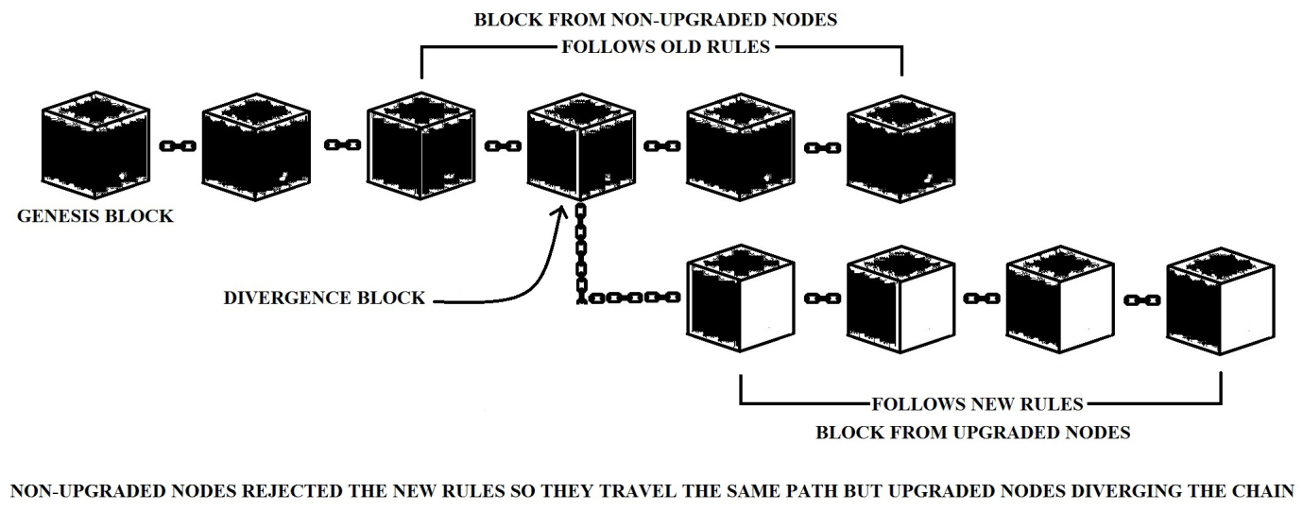
Figure 7. Hard Fork

The above Figure 7. illustrates this, a hard fork in the Blockchain technology is an upgrade to the latest change. Hard forks are different from the old protocols. The hard fork is an upgrade to the latest impact on all nodes. Nodes that do not accept the upgrade are still in the old protocol, the nodes that supported the upgrade will function in the new Blockchain as new modules in the new protocol. this is good example of Bitcoin and Ethereum. Two different Blockchain series are formed here by different protocols which do not overlap.

Soft Fork.
The soft fork is backward compatible (Lin & Liao, 2017). The system used in the Blockchain on a network will accept the innovative rules and it will not accept the terminal blocks running with its old rule and the old the Blockchain will support the new block. It will be a one-way trip. Excess nozzles must follow the new rule to operate a soft fork. Unlike hard fork, it also leads to gradual improvement. Checking for the Blockchain transactions running with the new rule. For example, soft forks have been used in both Bitcoin and Ethereum the Blockchain. The new and old nodes in the Soft fork travel in a straight line.
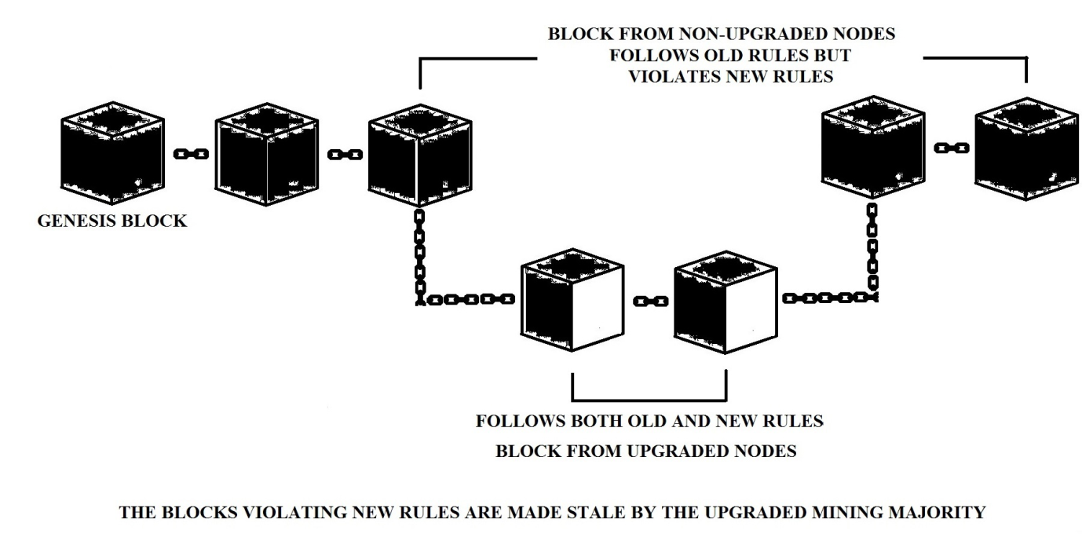
Figure 8. Soft Fork

Soft Fork is created by performing a new change in software protocol on the Blockchain Network. The Blockchain is Soft Fork which is compatible with the new protocol and the old protocol. The new fork will follow the new protocol as well as follow the old protocol. Implementing protocols with the support of all the nodes in that link for advanced new protocols as an alternative to hard fork. Adequate miners are needed to adopt the new regulations. The above Figure 8 illustrates how soft fork works.

The Blockchain Challenges

Regulation.
In India, the rupee is recognised by the government and is printed and put into circulation. It is handled daily by people. It is printed to suit the cash requirement. It is governed by the laws of India and the Central Bank. Value is determined by the market and the law. But adherence to discipline in a non-digital and digital currency is more challenging because technology is evolving faster than the rules. Currency evolution saw a shift from rupee currency to e-money, and from Virtual currency to Cryptocurrencies (Al-Saqaf & Seidler, 2017).

Complex to understand.
The complexity of Blockchain Technology makes it difficult for a layperson to comprehend and understand its benefits. Before diving into this ground-breaking application, one must first read it and grasp the concepts of encryption and distributed ledger. Another factor that makes blockchain difficult to implement is that, in comparison to the costs associated with blockchain, financial institutions are capable of providing secure payment gateways and other services at reasonable pricing.

Delay Performance.
It faces many challenges when there is too much energy thus reducing its usefulness. Defence refers to immutability and the way to escape from the attack. Low performance, low internet speeds, delays, etc. affect Blockchain performance (V, 2019).

Privacy and Security.
The Blockchain has a 51% probability of attack; one of these nodes can exert its absolute dominance in that web by successfully manipulating major mathematical solutions. Thus adequate safety research is needed to meet this challenge which has the potential to change the course of the Blockchain (Ghosh et al., 2020).

Lack of Demand.
The demand for the Blockchain is increasing day by day and also the demand for specialists. At the same time, the Blockchain Technology is seen as challenging even for the talented. As of 2019, the Blockchain Engineer demand is 517%. The Blockchain development is slowing down due to a shortage of Technicians capable of troubleshooting the problem (Sharma, 2020).

Scalability.
The blockchain industry is still grappling with how to manage a big number of users at once. To conduct a single transaction, blockchain technology uses numerous sophisticated algorithms. The overall number of coinbase users was estimated to be 11.7 million as of October 2017. The typical transaction has increased considerably as more individuals have become accustomed to it. It had a significant impact on transaction processing speed because a larger number of individuals means more computers writing and accessing the network, resulting in a more cumbersome system overall.

Cost.
Blockchain is typically used to eliminate costs associated with third parties and middlemen involved in the value transfer process. Though Blockchain Technology has many advantages, it is still in its early phases of development, making it difficult to integrate into existing systems. It makes it an expensive affair in general, preventing it from being adopted by both the government and commercial businesses.

DISCUSSION
Usually, there are a few misunderstandings about the blockchain that are caused by human error or lack of proper involvement. I did not mention that the Blockchain Network was decentralised and only needed to upload well-researched information because all the information in it is valid. But all the information is uploaded without prejudice. To prove the concept, someone stored the misinformation ("the earth is flat") in the Blockchain. We must independently verify this information, which does not change in the blockchain, but that does not mean that the information is accurate (Tang, 2019).
Although there are a majority of talented developers in India, the Blockchain is only nominal. Because there is not enough progress or construction for this. Its old history is not so relevant because in the early days extremist organizations used it to exchange money so that the afterlife did not gain a reputation. Later, many countries became aware of its use and used it legally for industry and money transfer.
The government of India is also interested in making transactions through the Blockchain. Blockchain has become a buzzword in India. The Blockchain is ideal for storing data and sending it easily to the user because breaking the security chain and stealing information is not possible. There is a misconception among people that this is only for cash transactions. In India, the Staff Selection Board is still facing unspeakable challenges and fraud in publishing its results, making it difficult to publish them. Thus many pending cases are still talk of the town. It can also use the Blockchain Network to securely communicate data on its personal network, such as Medical, Military, and Agricultural data, Satellite records, and Financial transactions. Lack of adequate regulation and adequate regulation of financial transactions also delays the adoption of delays, configuration, and the Blockchain to make changes to existing legislation on financial transactions. Transactions in the data carried out with appropriate verification in the Blockchain take place through the Cryptography algorithm of the Blockchain. Thus, the potential for interruption is very low.

CONCLUSION
The Blockchain operates over a Decentralized Network, every transaction is carefully verified and stored with the most sophisticated Cryptography Algorithm. So the potential for interruption is very low. Its service is not dependent on a centralized system so its performance is high and accurate and the service is very fast due to the absence of intermediaries. Transactions made with the Blockchain Network can save time and money. The present study explores the concepts of the Blockchain Technology; including the impact that the Blockchain has had on some areas, the basic definitions, characteristics, some key concepts, advantages, limitations, consensus, security and challenges, and Discussion about Misunderstanding. Future issues can be readily handled by promoting modern works like Blockchain and providing the appropriate regulations, Techniques, and process guidance. Advancing among students and providing opportunities for them would propel India forward in the future, enhancing our country's economy and enhancing our country's greatness. Thus the result says that, it is critical for people to embrace new technology such as Blockchain-based Decentralized Networks.

REFERENCES
6 Major Features Of Blockchain | Why Blockchain is Popular? - DataFlair. (n.d.). Retrieved July 30, 2021, from https://data-flair.training/blogs/features-of-blockchain/
Al-Saqaf, W., & Seidler, N. (2017). Blockchain technology for social impact: Opportunities and challenges ahead. Journal of Cyber Policy, 2(3), 338–354. https://doi.org/10.1080/23738871.2017.1400084
Al-Shaibani, H., Lasla, N., & Abdallah, M. (2020). Consortium Blockchain-Based Decentralized Stock Exchange Platform. IEEE Access, 8, 123711–123725. https://doi.org/10.1109/ACCESS.2020.3005663
Bentov, I., Lee, C., & Mizrahi, A. (n.d.). Proof of Activity: Extending Bitcoin’s Proof of Work via Proof of Stake. 4.
Best Delegated Proof of Stake Coins (Best DPoS Coins). (2018, November 6). Free Startup Kits. https://freestartupkits.com/articles/technology/cryptocurrency-news-and-tips/best-delegated-proof-of-stake-coins-best-dpos-coins/
Biswas, K., & Muthukkumarasamy, V. (2016). Securing Smart Cities Using Blockchain Technology. 2016 IEEE 18th International Conference on High Performance Computing and Communications; IEEE 14th International Conference on Smart City; IEEE 2nd International Conference on Data Science and Systems (HPCC/SmartCity/DSS), 1392–1393. https://doi.org/10.1109/HPCC-SmartCity-DSS.2016.0198
Blockchain Consensus Algorithm: Proof Of Work (POW). (n.d.). Retrieved July 31, 2021, from https://www.cisin.com/coffee-break/technology/blockchain-consensus-algorithm-proof-of-work-pow.html
Cai, Y., & Zhu, D. (2016). Fraud detections for online businesses: A perspective from blockchain technology. Financial Innovation, 2(1), 20. https://doi.org/10.1186/s40854-016-0039-4
Courtois, N. T., & Bahack, L. (2014). On Subversive Miner Strategies and Block Withholding Attack in Bitcoin Digital Currency. ArXiv:1402.1718 [Cs]. http://arxiv.org/abs/1402.1718
Cryptocurrency. (2021). In Wikipedia. https://en.wikipedia.org/w/index.php?title=Cryptocurrency&oldid=1031829886
Demirkan, S., Demirkan, I., & McKee, A. (2020). Blockchain technology in the future of business cyber security and accounting. Journal of Management Analytics, 7(2), 189–208. https://doi.org/10.1080/23270012.2020.1731721
Dhuddu, R., & Mahankali, S. (2021). Blockchain A to Z Explained: Become a Blockchain Pro with 400+ Terms (English Edition). BPB Publications.
Dinh, T. T. A., Liu, R., Zhang, M., Chen, G., Ooi, B. C., & Wang, J. (2018). Untangling Blockchain: A Data Processing View of Blockchain Systems. IEEE Transactions on Knowledge and Data Engineering, 30(7), 1366–1385. https://doi.org/10.1109/TKDE.2017.2781227
Distributed ledger. (2021). In Wikipedia. https://en.wikipedia.org/w/index.php?title=Distributed_ledger&oldid=1025658594
Eyal, I., & Sirer, E. G. (2013). Majority is not Enough: Bitcoin Mining is Vulnerable. ArXiv:1311.0243 [Cs]. http://arxiv.org/abs/1311.0243
Gervais, A., Ritzdorf, H., Karame, G. O., & Capkun, S. (2015). Tampering with the Delivery of Blocks and Transactions in Bitcoin. Proceedings of the 22nd ACM SIGSAC Conference on Computer and Communications Security, 692–705. https://doi.org/10.1145/2810103.2813655
Ghosh, A., Gupta, S., Dua, A., & Kumar, N. (2020). Security of Cryptocurrencies in blockchain technology: State-of-art, challenges and future prospects. Journal of Network and Computer Applications, 163, 102635. https://doi.org/10.1016/j.jnca.2020.102635
Golosova, J., & Romanovs, A. (2018). The Advantages and Disadvantages of the Blockchain Technology. 2018 IEEE 6th Workshop on Advances in Information, Electronic and Electrical Engineering (AIEEE), 1–6. https://doi.org/10.1109/AIEEE.2018.8592253
Karame, G. (2016). On the Security and Scalability of Bitcoin’s Blockchain. Proceedings of the 2016 ACM SIGSAC Conference on Computer and Communications Security, 1861–1862. https://doi.org/10.1145/2976749.2976756
Khalaf, O. I., Abdulsahib, G. M., Kasmaei, H. D., & Ogudo, K. A. (2020). A New Algorithm on Application of Blockchain Technology in Live Stream Video Transmissions and Telecommunications: International Journal of E-Collaboration, 16(1), 16–32. https://doi.org/10.4018/IJeC.2020010102
Khan, K. M., Arshad, J., & Khan, M. M. (2018). Secure Digital Voting System Based on Blockchain Technology: International Journal of Electronic Government Research, 14(1), 53–62. https://doi.org/10.4018/IJEGR.2018010103
Li, Z., Kang, J., Yu, R., Ye, D., Deng, Q., & Zhang, Y. (2017). Consortium Blockchain for Secure Energy Trading in Industrial Internet of Things. IEEE Transactions on Industrial Informatics, 1–1. https://doi.org/10.1109/TII.2017.2786307
Lin, I., & Liao, T.-C. (2017). A Survey of Blockchain Security Issues and Challenges. Int. J. Netw. Secur. https://doi.org/10.6633/IJNS.201709.19(5).01
Nakamoto, S. (n.d.). Bitcoin: A Peer-to-Peer Electronic Cash System. 9.
Ølnes, S., Ubacht, J., & Janssen, M. (2017). Blockchain in government: Benefits and implications of distributed ledger technology for information sharing. Government Information Quarterly, 34(3), 355–364. https://doi.org/10.1016/j.giq.2017.09.007
Overview of 9 blockchain consensus algorithms. (n.d.). Retrieved July 31, 2021, from https://digiforest.io/en/blog/blockchain-consensus-algorithms
Proof of burn—Bitcoin Wiki. (n.d.). Retrieved July 31, 2021, from https://en.bitcoin.it/wiki/Proof_of_burn
Rahmadika, S., Ramdania, D. R., & Harika, M. (2018). Security Analysis on the Decentralized Energy Trading System Using Blockchain Technology. Jurnal Online Informatika, 3(1), 44–47. https://doi.org/10.15575/join.v3i1.207
Raikwar, M., Gligoroski, D., & Kralevska, K. (2019). SoK of Used Cryptography in Blockchain. IEEE Access, 7, 148550–148575. https://doi.org/10.1109/ACCESS.2019.2946983
Rizky, A., Kurniawan, S., Gumelar, R. D., Andriyan, V., & Prakoso, M. B. (2021). Use of Blockchain Technology in Implementing Information System Security On Education. BEST Journal (Biology Education, Sains and Technology), 4(1), 62–70. https://doi.org/10.30743/best.v4i1.3640
Rizky, A., Silen, S., & Putra, D. A. (2021). THE ROLE OF BLOCKCHAIN TECHNOLOGY IN FACING REVOLUTION EDUCATION 4.0. BEST Journal (Biology Education, Sains and Technology), 4(1), 77–85. https://doi.org/10.30743/best.v4i1.3704
Rosenfeld, M. (2014). Analysis of Hashrate-Based Double Spending. ArXiv:1402.2009 [Cs]. http://arxiv.org/abs/1402.2009
Seok, B., Park, J., & Park, J. H. (2019). A Lightweight Hash-Based Blockchain Architecture for Industrial IoT. Applied Sciences, 9(18), 3740. https://doi.org/10.3390/app9183740
Shahnaz, A., Qamar, U., & Khalid, A. (2019). Using Blockchain for Electronic Health Records. IEEE Access, 7, 147782–147795. https://doi.org/10.1109/ACCESS.2019.2946373
Shalini, M., Com, M., Ed, B., & Phil, M. (2018). A Conceptual Framework on Block Chain. 5(3), 5.
Sharma, T. K. (2020, March 26). 5 Key Challenges For Blockchain Adoption In 2020. https://www.blockchain-council.org/blockchain/5-key-challenges-for-blockchain-adoption-in-2020/
Sukheja, D., Indira, L., Sharma, P., & Chirgaiya, S. (2019). Blockchain Technology: A Comprehensive Survey. Journal of Advanced Research in Dynamical and Control Systems, 11, 1187–1203. https://doi.org/10.5373/JARDCS/V11/20192690
Sun, H., Wang, X., & Wang, X. (2018). Application of Blockchain Technology in Online Education. International Journal of Emerging Technologies in Learning (IJET), 13(10), 252–259.
Tang, D. (2019, April 30). 8 most common misunderstandings in blockchain discussion. Kepler Blockchain Lab. https://medium.com/kepler-blockchain-lab/8-most-common-misunderstandings-in-blockchain-discussion-54c61fd701c6
V, S. (2019). SECURITY AND PRIVACY MECHANISM USING BLOCKCHAIN. Journal of Ubiquitous Computing and Communication Technologies, 01(01), 45–54. https://doi.org/10.36548/jucct.2019.1.005
Wang, F., Chen, Y., Wang, R., Francis, A. O., Emmanuel, B., Zheng, W., & Chen, J. (2020). An Experimental Investigation Into the Hash Functions Used in Blockchains. IEEE Transactions on Engineering Management, 67(4), 1404–1424. https://doi.org/10.1109/TEM.2019.2932202
Wang, M., Duan, M., & Zhu, J. (2018). Research on the Security Criteria of Hash Functions in the Blockchain. Proceedings of the 2nd ACM Workshop on Blockchains, Cryptocurrencies, and Contracts - BCC ’18, 47–55. https://doi.org/10.1145/3205230.3205238
What is Consensus Algorithm In Blockchain & Different Types Of Consensus Models | by BangBit Technologies | Medium. (n.d.). Retrieved July 31, 2021, from https://medium.com/@BangBitTech/what-is-consensus-algorithm-in-blockchain-different-types-of-consensus-models-12cce443fc77
Yadav, R. (2020, January 20). What Are The Top Blockchain Consensus Algorithms? Analytics India Magazine. https://analyticsindiamag.com/blockchain-consensus-algorithms/
Yang, Z., Xie, W., Huang, L., & Wei, Z. (2018). Marine data security based on blockchain technology. IOP Conference Series: Materials Science and Engineering, 322, 052028. https://doi.org/10.1088/1757-899X/322/5/052028
Yi, H. (2019). Securing e-voting based on blockchain in P2P network. EURASIP Journal on Wireless Communications and Networking, 2019(1), 137. https://doi.org/10.1186/s13638-019-1473-6
Zhai, S., Yang, Y., Li, J., Qiu, C., & Zhao, J. (2019). Research on the Application of Cryptography on the Blockchain. Journal of Physics: Conference Series, 1168, 032077. https://doi.org/10.1088/1742-6596/1168/3/032077
Zheng, Z., Xie, S., Dai, H.-N., Chen, X., & Wang, H. (2018). Blockchain challenges and opportunities: A survey. International Journal of Web and Grid Services, 14, 352. https://doi.org/10.1504/IJWGS.2018.095647

