Chapter – 3

Futuristic Trends in Nursing Related to Management in Health Care

“If we are together nothing Is impossible.
If we are divided,all will fail”.
-Winston Churchill

Author

Mrs. Sonam Chauhan

Assistant professor, Radha Govind Institute Of Nursing Science, Meerut, Uttar Pradesh,

India

Chapter – 3

Futuristic Trends in Nursing Related to Management In Health Care

Mrs. Sonam Chauhan

Introduction

Good career prospects exist in nursing, and these chances change and reflect the society in which nurses reside . Patricia Benner projected that nurses would perform more tasks in the community or in hospitals in the new millennium, but they would also continue to play a bigger role in the delivery of intensive care. A chance exists for nursing to advance and refine its practice and educational mission.

It is time for nursing to reconsider its place in the system, define its function within it, and take action to create the future that the nursing profession aspires to and deliver better healthcare.

Meaning- The introduction of a new method, idea, or product is what futuristic meant by (Innovative/ Revolutionary).

Definition-

- Futuristic nursing is the art of promoting quality of life as defined by patients and families throughout their life experiences, from conception to the end of life, employing the most recent scientific and technological advancements.
- It is time for nursing to reflect on and redefine its place in the system, as well as take action to create the future that the nursing profession aspires to.

Model for futuristic nursing

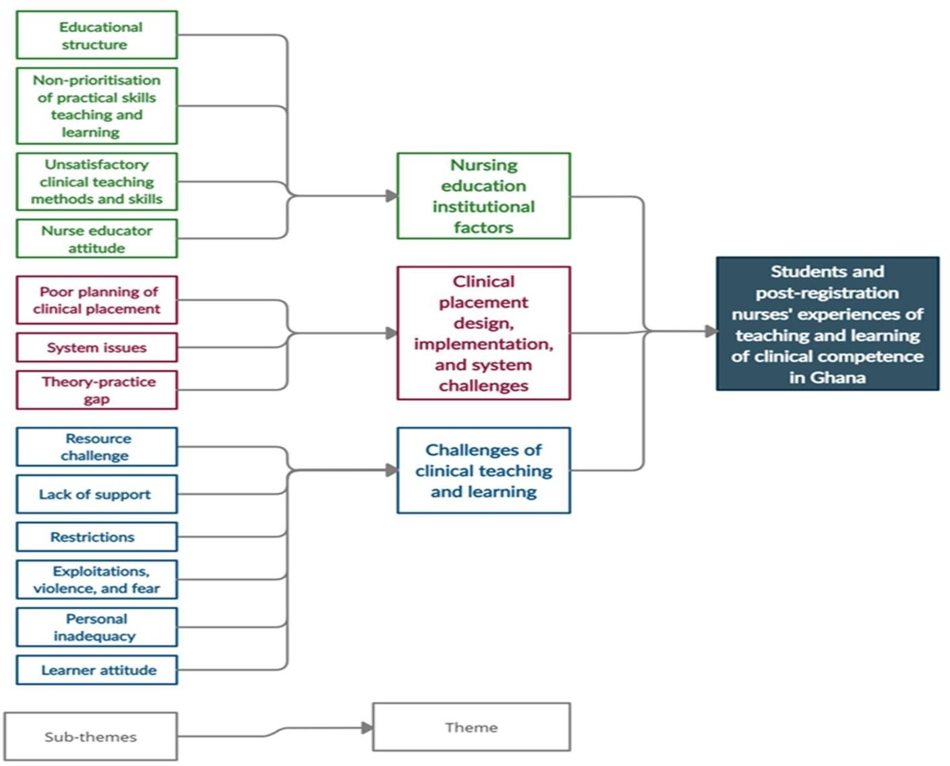

Top "four" trends that will shape nursing's role in health care management in the future.

- There is a high demand for nursing professionals everywhere.

- The nursing industry is now a worldwide one.

- Nursing professionals place more value on technical skills.

- The need of a nursing higher education.

Administration of Healthcare -

Scaling up the number and quality of healthcare services and enhancing population health are both dependent on competent administration..

Goals of health management in futuristic nursing-

- Increasing public health.

- Increasing the quantity and quality of healthcare services in accordance with patient and community demand.Health.

Health-

"Health is a state of complete physical, mental, and social well-being and not merely the absence of disease or infirmity,"

Health care-
The term "health care service" refers to all assistance, instruction, research, nursing services, etc. used to assess, diagnose, treat, and monitor patients with the purpose of maintaining necessary health, avoiding disease, or "HOSPITAL".

Health care in India

70% of India population live in rural area but 80% of doctors, and 60% of hospitals are in urban area.

Health Care Challenges India's health system

Although 60% of hospitals and 80% of doctors are located in metropolitan areas, 70% of Indians reside in rural areas.

Health Care Issues

- Highly complicated environment
- Task scope and complexity
- Economic and social inequality
- Increasing health care costs
- Technological development
- Demographic change

Scope of management of health

 | Running and improving health services | Introduce new health service
Mapping community | (PHC units, hospital, clinic) | protocol etc.
Health Profile and policy

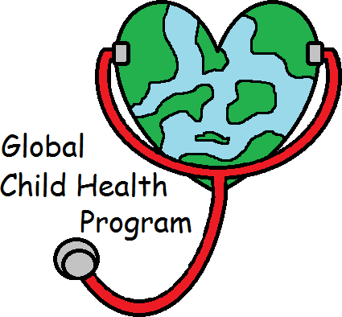

Running a health programme or a project Conducting a research thesis, survey etc.

Cycle of management
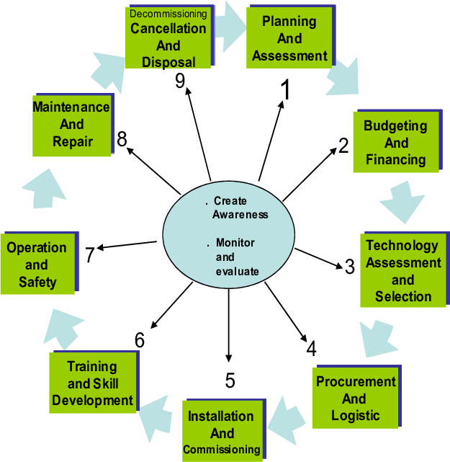

Future trends in nursing related to management in health care

Trend #1 - The rise of telemedicine
Trend #2 – Consumer grade patient experience Trend #3 – Essential Need for Self-Care in Nursing Trend #4. Nursing Advocacy and Action
Trend #5. Evolution of the Workplace Trend #6. Expanding Distance Education Trend #7. Interprofessional Partnerships Trend #8. Increased Specialization

Trend #1.
The rise of telemedicine
The Greek term "Tele" means "Distance," while the Latin word "Madera" means "to heal." When people are separated by distance, telemedicine uses electronic information to communicate technology to offer or support healthcare. By expanding access to healthcare and medical information, it enhances client results.
Medical imaging, video consultations, tele-diagnosis, tele-treatment, and medical management are a few examples.
During the pandemic's tragedy, telehealth offered a link to care. Today, it offers a chance to reconsider virtual and hybrid virtual/in-person care models in order to improve healthcare outcomes, accessibility, and affordability.
From the pre-COVID-19 baseline, the number of telehealth programmes has multiplied 38 times.

The future of health care is telemedicine.
- Increased customer desire to use telehealth is one of the primary elements driving this boom in telemedicine adoption.
- A rise in the usage of telehealth by providers.
- Regulatory adjustments that facilitate excellent access and reimbursement.
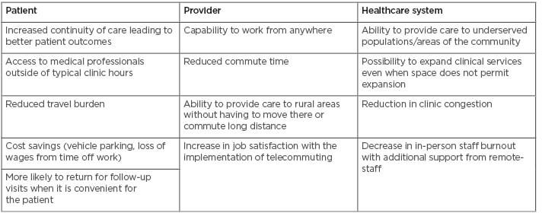

Types of telehealth
- There are four broad categories that telehealth falls under.
Interactivity. From the patient's home or a specified medical facility, doctors and patients communicate in real time. They are able to communicate by phone or with the aid of health insurance-compliant video conferencing software.
Remote patient observation. Patients can check their symptoms or condition with telemonitoring while at home. They employ programmes that gather information about body temperature, blood sugar levels, blood pressure, and other vital signs as well as mobile health equipment, such as wearable technologies.
Mobile. The term "mobile telehealth" refers to the use of mobile devices in healthcare. This could include patient-doctor communication via mobile patient portals and remote healthcare services like consultations.
Forward and store. This method, often referred to as asynchronous telehealth, enables the sharing of patient data, such as lab results, between healthcare professionals.

Trend #2: Patient experience rated by consumers

Consumers are taking control of their own medical decisions, and the healthcare system is matching its investments in digital health to its overall health plan. Hospitals and the healthcare system must have a strong awareness of patient expectations if they are to effectively manage the changing health care environment.

Trend #3. Essential Need for Self-Care in Nursing

Stress and trauma are commonplace experiences for nurses, and they can have a negative impact on their general quality of life, mental health, and job satisfaction. In the nursing profession, educating nurses about self-care and increasing awareness of it has become crucial. Stress management skills improve a person's ability to assist patients.
“According to numerous studies, nurses are motivated to stay in the field for reasons other than pay, adds Fuller. "In the fight against nurse burnout and fatigue, employers who promote self-care and a healthy work environment are also on the rise."
Fuller says there is a correlation between a healthy work environment and nurses being able to provide optimal care that leads to positive patient outcomes.
According to a 2021 study by the National Academies of Sciences, Engineering and Medicine (NASEM), more institutions are recognizing the importance of health equity for everyone, including healthcare workers

Trend #4. Nursing Advocacy and Action

According to this NASEM study, nurses, who make up the biggest group of health care workers in the country, have a significant opportunity to influence the direction of healthcare and the health of our country.

The study emphasizes how important it is for nurses to continue to advocate for social determinants of health and health justice. The U.S. Department of Health and Human Services defines social determinants of health as circumstances and events that can have an array of effects on people's lives..

Trend #5. Evolution of the Workplace

Career options for nurses are always changing, even if the pandemic has elevated the importance of nurses' employment in acute care settings. Nurses can pursue a variety of occupations outside of hospitals.
Travel nursing is growing in popularity. It allows nurses to move between regions with the greatest need for medical care and gain financial benefits in the process. As a travel nurse, entry-level nurses can explore nursing opportunities and experienced nurses can lend their expertise in crisis situations. School nurses are also in high demand.

Trend #6. Expanding Distance Education

The epidemic made the use of online education necessary while highlighting its benefits and usefulness for education. Students who attend college remotely and live in rural areas have particularly profited from online learning.
Michele McMahon, DNP, stated in an interview for a piece on the potential uses of virtual reality in nursing education, "Purdue Global has moved to implement immersive learning experiences throughout the nursing school and has been using [virtual reality] in our nursing programs since before the pandemic."

Trend #7. Interprofessional Partnerships

Over the past 20 years, interprofessional collaboration has been a trend in nursing. Now, interprofessional partnerships are emerging. In response to client demand, established professional boundaries are shifting and the public is expecting more convenient service.
According to a research that was published in the Journal of Professional Nursing in October 2021, interprofessional education increased the self-awareness, situational awareness, and teamwork values of nursing and medical students.
With a focus on collaboration, professionals exchange knowledge and expertise. One illustration of this is how pharmacies have developed into community care providers by offering easy access to diagnosis and treatment.

Trend #8. Increased Specialization

According to Fuller, there is a growing need for nurses with specific medical specializations, such as psychiatry, obstetrics, gerontology, and others. By specializing, a nurse can become an authority in the field in which she delivers care. Opportunities for career progression may also become available as a result.

Role of nurse in management of health care

- Helping patients with long-term illnesses modify their behavior and changing their prescription regimens in accordance with guidelines provided by practitioners.

2) Managing teams to lower expenses and enhance care for patients with high needs.

- Organizing the care of individuals with chronic illnesses between the neighborhood's healthcare facilities and the main care facility.

- 3) Encouraging population health, which includes assisting localities in developing healthier places for people to live, work, learn, and have fun..

- Providing high quality patient care

- Educating patients and their families/carers

- Promoting a safe environment

- Evolving professionally

Conclusion

Future of nursing is of great scope for management of health care. Nurse researcher are harnessing the knowledge they acquire to perform evidence based practice. They are at the fore front carrying out research work and play a key role for improving quality of life for patient.

In the future nurses will be in the spotlight research innovation related to health care.

Reference

  - Roussel, Linda management and leadership for nurse administrators. Edition (2010), jonnes and Bartlett India private limited, new Delhi.
  - Cohen, J. D.(2006). The aging nursing work force. How to retain experienced nurses. Journal of health care Management, 51,233-245.
  - Seethe Lakshmi, futuristic nursing, nightingale nursing times, volume 5, may 2009, page no 17 -18.
  - Margaret M.Moloney, professionalization of nursing, published by J.B Lippincott company page no 309 – 320
  - John Manju ,Essential of leadership and management in nursing, Edition 2nd (2017), Kumar Publishing House.105-107
  - Dash Bijayalaskhmi, nursing administration and management, edition1st (2021), Kumar Publishing house page no-213-215.
  - Basheer.S.Yasmeen khan advanced nursing practice 2nd edition 2017.page no 59 – 63.
  - Navdeep Kaur Brar. H C Rawat Advanced nursing practice 1st Edition .page no – 945, 984, 961, 1010, 1026.
  - Clement I, professional trends and adjustment in nursing, 1st edition (2016)
  - Potter and Perry, fundamental of Nursing , 6th edition, Mosby publishers, page no - 22-23.

Website
- https;// online nursing.duq.edu.>
- https;//online.marymount.edu>blog>10 – nursing- trends
- https;//www.ncbi.nim.nih.gov>articles>PMC 903532
- https;//www.emjreviews.com>blog
- https;//www.nishithdeshai.com>pdf
- https;//www.spec-india.com.blog
- http;//www.slideshare.net>healthcare management. Dalia El –Shafei
- www.healthguidance . org.

