ROOTSTOCKS FOR TROPICAL AND SUB- TROPICAL FRUIT CROPS
Shivaji N. Kolekar Ph.D. Scholar Dr.PDKV Akola ABSTRACT
When it comes to fruit crops, rootstocks are crucial in determining how productive orchards are. separate growth results can be obtained by budding or grafting two separate plants together that have complementary traits. This variance is apparent when taking into account the relative importance of rootstocks with respect to precocity, yield, and tree size control; additionally, variations in crop load, annual phenological cycles, fruit respiration patterns, and canopy management approaches are all taken into account. However, the impact of these factors on physiological, biochemical, and molecular aspects is still not fully comprehended. Rootstocks exert their influence on scion growth, vigor, and structure, as well as the precocity of the scion, flowering abundance, the likelihood of successful fruit set, and yield efficiency.
The utilization of rootstocks in various fruit crops significantly impacts fruit crop production by influencing factors such as canopy structure, nutrient absorption, flowering, yield, and fruit quality (Rom et al., 1987). Moreover, rootstocks can also mitigate both biotic and abiotic stressors, including challenges related to soil pathogens, temperature extremes, salinity, and nutritional imbalances (Reddy et al., 2003). Rootstocks play a central role in determining the overall efficiency of orchards, encompassing responsibilities for water and mineral uptake and providing tree stability. They can provide some degree of tolerance to soils that may be overly moist or dry, and they are essential in regulating the size of trees. Studies and research on the selection and use of appropriate rootstocks in crops such as citrus, mango, and grapes have previously been carried out in a number of nations, with an emphasis on controlling growth vigor, nutrient absorption, soil salinity, moisture stress, and yield efficiency.
India has yet to fully exploit the significant potential of rootstocks for many commercial fruit crops, and there is a need to identify rootstocks with optimal attributes that align with the specific environmental conditions in which the trees will be cultivated. This implies that a rootstock deemed most suitable for a particular variety and set of environmental conditions may not be the ideal choice for a different variety in a distinct environmental context (Nimbolkar et al., 2016). As such, comprehensive research on rootstocks for tropical and sub-tropical fruit crops becomes imperative.

INTRODUCTION:
When it comes to fruit crops, rootstocks are crucial in determining the total productivity of orchards. Different growth outcomes can be obtained by grafting or budding two separate plants together to combine their ideal traits. When evaluating the relative importance of rootstocks with respect to precocity, yield, and tree size regulation, as well as when comparing yearly phenological cycles, fruit respiration patterns, crop load, and canopy management strategies, these distinctions become apparent. Still, little is known about how rootstocks affect physiological, biochemical, and molecular characteristics. Rootstocks affect a variety of scion characteristics, including growth, vigor, and growth habits; they also affect scion precocity, blooming abundance, fruit development propensity, and overall production efficiency.
What is mean by Rootstock?
- The lower portion of the graft, known as the rootstock, is what eventually grows into the grafted plant's root system.
- Rootstock options encompass seedlings, rooted cuttings, or layered plants.
- iii. It also describes a plant that has been grafted with a cutting or bud from another plant onto an established, healthy root system.
- The plant component grafted onto the rootstock is typically referred to as the scion.
- Rootstocks have played a crucial role in plant propagation for over two millennia.
- The rootstock may belong to the same or a different species compared to the scion.
- The utilization of rootstocks is most commonly associated with fruit crops.
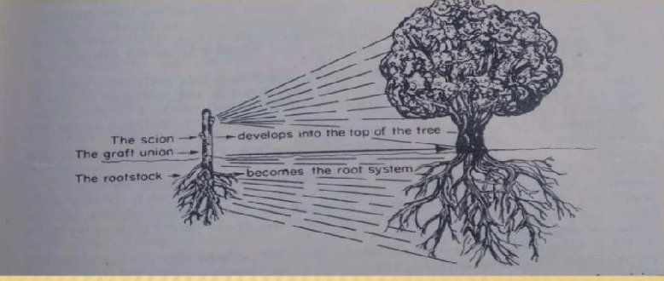

History of Rootstock
- i. Although grafting has been done for many hundreds of years, the majority of the rootstocks used in orchards today were created in the 20th century.
ii. Citrus budding, or grafting, became common when Phytopthora foot rot first surfaced in the Azores in 1842.
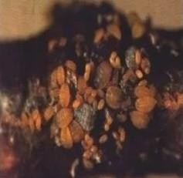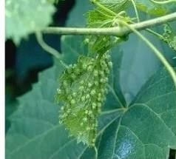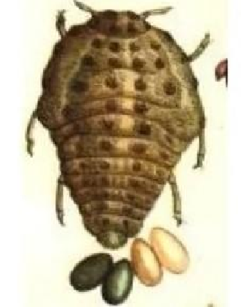

Abilities of Rootstock
- Nursery ability:
  - Ready availability of seed
  - High percentage of polyembrony
  - Good germination and seedling growth
  - Free from pest’s attacks and easy budding
- Soil adaptability:
Growth vigor varies depending on the soil's pH, salinity, structure, texture, moisture content, and nutrient availability.
- Climatic adaptability:
  - Hardiness
  - Resistant to cold
- Biotic adaptability:
  - Free from or resistant to various soil borne diseases.
  - None of these rootstocks is shown to be noticeably superior in every regard; some are found to be better in one or more of these categories but poorer in others.
  - Under certain environmental conditions, certain rootstocks may be better for a certain scion variety while being inferior for a different type.
Importance of rootstock in fruit crops:
i.Impart resistance to biotic and abiotic stresses of scion cultivar ii.Resistant to adverse soil and climatic conditions
- Cold hardiness
- Providing strong root system
- Regulate uptake of moisture and nutrients
- Regulate tree vigour and size vii.Dwarfing effect
viii.Affect flowering, fruit set, fruit drop, fruit size ix.Affect fruit quality and yield
x.Trees propagated on rootstocks are true to type, comes to bear earlier, precocious.
Types of Rootstock
There are two types of rootstocks used in fruit crops.
- Seedling rootstocks
- Clonal rootstocks
  - Seedling rootstocks:
- i. They are grown from seeds.
- Rootstocks derived from seeds are known for their simplicity and cost-effectiveness in production.
- Root systems that originate from seedlings often exhibit greater depth.
- Their primary application is in tropical and sub-tropical fruit crops.
- One advantage of seedling rootstocks is their ability to avoid retaining viruses present in their parent plants
- However, a drawback of using seedling rootstocks is the potential for genetic variation, which can result in varying scion performance..
  - Clonal rootstocks
- Rootstocks propagated vegetatively are known as clonal rootstocks.
- These also include those propagated through a zygotic seed (parthenogenetic, polyembryonic and apomictic seeds.) iii.Each clonal individual plant is genetically same and have identical growth characteristics in a given environment
(Hartman et al,2002).
- Major disadvantage of clonal rootstocks is that; they retain the viruses occurring in the parent plants.
- They will not produce deeper roots.
- These are available in majority for temperate fruits.
Characteristics of an Ideal Rootstock
i. Compatibility with scion cultivars and ensuring the longest possible productive lifespan of the trees are essential considerations.
ii. Adaptation to the agro-climatic conditions specific to the area, including factors such as frost, cold, and heat, is crucial.
iii. Resistance to diseases and pests that are common in the region is a key requirement. iv. Tolerance to adverse soil conditions, such as salt, alkalinity, acidity, and drought, is also vital..

It should contribute positively to the fruiting and quality of the scion variety.
ii. It should have strong germination capabilities, a high level of polyembryony, the capacity to reach a suitable grafting size quickly, and minimal branching.
iii. It must demonstrate a beneficial and constructive impact on the scion variety's performance, fruiting, and quality.

Stock-Scion Relationships.
The portion of a plant that is grafted onto a rootstock—typically an underground portion—allows for the production of new aboveground growth. This new growth is referred to as a scion. The scion should have every desired quality. When the stock and scion are completely compatible, a grafted or budded plant is an excellent union to create a composite plant. A grafted or budded plant may occasionally exhibit odd growth patterns that differ from what would have happened if each component of the graftage had been grown separately. The term "stock-scion relationship" refers to how a scion cultivar's performance is influenced by a rootstock's unique characteristics or vice versa. They are as follows:
  - Effect of stocks on scion cultivars
  - Effect of scion on rootstock
  - Influence on inter-stock
- Effect of stocks on scion cultivars
  - On size and growth:
  - A scion will develop less strongly if it is grafted on dwarf stocks; but, if it is grafted on very vigorous stocks or rootstocks, it will grow very furiously.Trifoliate oranges are thought to be dwarfing stocks for sweet oranges and grapes. Grafting certain mango rootstocks on scion cultivars such as Kalapade, Olour, etc. results in dwarfism. A dwarf guava cultivar would result from grafting on Psidium pumilum. Pusa Srijan guava stock is a commercial variety of guava that also causes dwarfism in Allahabad Safeda.
  - Precocity in flowering and fruiting:
- Precocity, or the amount of time from planting to fruiting, is influenced by rootstocks. Precocity often refers to slowness to fruiting with robust stocks and dwarfing stocks or rootstocks. Mandarin citrus fruit requires fewer days to fruit when grafted on Citrus jambhiri rootstock than when grafted on acid lime.
- Fruit set and yield
- Compared to acid limes budded on troyer citrange, Rangpur lime, or their own stock, acid limes will yield 70% more when budded on rough lemon.
- Fruit quality
- Grafted Sathugudi sweet oranges on Gajanimma rootstocks provide huge, low-quality fruits, while on their own stocks, they produce many, high-quality fruits with a high juice content.If sweet orange is grafted on Cleopatra mandarin seedlings, the physiological disturbance known as "granulation" is very minimal; in contrast, rough lemon seedling stocks generate considerable granulation.
- Nutrient status of scion
- Rootstocks have an impact on scion's nutritional behavior as well. Compared to their own rootstock or Cleopatra Mandarin rootstocks, Sathugudi orange trees provide a higher nutritional status for all nutrients in the leaves when they budded on C. volkarimariana root stock.
- Disease resistance
- In citrus, there is a suitable variance in the rootstocks' susceptibility to worms and illnesses. Rough lemon stock, for instance, is susceptible to nematodes and gummosis but tolerant of tristeza, xyloporosis, and exocortis. Troyer Citrange, on the other hand, is susceptible to gummosis but causes exocortis virus illness.
- Winter hardiness
- Young grapefruit plants grafted into Rangpur limes fare better in winter damage than do rough lemon or sour orange trees. Colder and more resilient were sweet oranges and mandarins grown on trifoliate stocks.
- Capability to stand out the soil opposing status
- When it comes to citrus rootstocks, foliate oranges are weak, whereas Rangpur limes, sweet oranges, and sour orange stocks are mediumly able to withstand higher salt levels in the soil.
- Effect of scion on rootstock
- Vigor of the stock
Effect of scion cultivar on the form, size, and characteristics of the stock. Grafting a strong scion on weak or dwarf stocks will also cause the stocks to grow; however, grafting a weak or dwarf scion on vigorous stocks will cause the stocks to grow less. The roots of a robust scion always become more resilient to moist, inadequately aerated soils.
- Cold hardiness of the rootstock
- Citrus root cold hardiness is impacted by scion. When sour orange seedlings are budded on Eureka rootstock, they suffer from winter injury substantially more than unbudded seedlings.
- Precocity in flowering
A six month or one-year-old mango rootstock seedlings exhibited flowering when its branches were inarched from the tree.
Influence on inter-stock
It is common practice to employ specific dwarfing rootstocks as a vigorous to produce early-bearing, non-vigorous trees. Anupam mango variety is suggested as inter-stock for Amrapali, grafted on Mallika stock to promote dwarfism, precocity, and development of fruit quality. Conversely, inter-stock may occasionally have little effect on desired traits.
Rootstocks for Citrus
Citrus rootstocks are widely recognized for their ability to withstand both biotic and abiotic stressors while simultaneously boosting yield and quality. There exists a vast array of rootstocks, all possessing favorable characteristics.
The practice of using rootstocks in citrus cultivation has been in existence for over a century, highlighting the necessity for a comprehensive understanding of rootstocks, including their characteristics, utility, and availability. Among the numerous factors influencing the performance of grafted citrus trees, the choice of rootstock plays a pivotal role. The portion of the plant in charge of the shoot system is called the "scion," and the portion in charge of the root system is called the "rootstock." It is commonly known that different citrus species and types require different rootstock and scion combinations that are suited to their unique agroclimatic conditions. As such, rootstocks play a crucial role in the intensive cultivation of citrus. Citrus rootstocks play a major role on scion vigor, fruit size, yield, quality, and juice content. They also affect the trees' resistance to cold, drought, salinity, alkalinity, and nutrient content. Additionally, the compatibility of rootstocks for various soil types, root distribution patterns, and mycorrhizal connections vary.
Just a few rootstocks were studied in the early days of rootstock research, mostly rough lemon, sour orange, trifoliate orange, sweet orange, and perhaps grapefruit or Cleopatra mandarin. Citrus tree budding or grafting became popular when Phytophthora foot rot first appeared in the Azores in 1842. This marked a pivotal transition in citriculture, shifting from seedling trees to budded trees. Over time, Phytophthora foot rot was observed in various Mediterranean countries, becoming a widespread concern by approximately 1935. As a result, seedlings gradually gave way to budding on rootstock seedlings, which is now the predominant method for propagating citrus trees.
The choice of rootstocks is a crucial factor that determines whether the rootstock and scion combination will be successful. When choosing a rootstock, factors including vigor, yield, quality, compatibility, and the tree's estimated productive life should all be taken into account.
Table no. 1 Variability in Citrus Rootstocks
Species | Variability
Rough lemon(C. jambhiri) | Mithi, lambhiri Kotagiri, Renuka lemon, Florida Rough, Jatti Khatta, Jatti  Khatti, Pathancot, lambhiri Nagpur, Khatta, Jallandar Khatti.
Rangpur lime(C. limonia) | Brazil orange, Brazilian Rangpur, Florida Rangpur-8748, Khasi lime, L-2  Rangpur lime, Marmalade orange, Pink Fleshed Lime.
Small fruited Mandarin (C. resin) | Kodakithuli, Citrus China, Cleopatra mandarin, Soh - seim, Karpura Tenga.
Sour orange (C.aurantium) | Karun jamir, Molepuli, Seville orange, Willow leaf sour orange,
Sweet orange(C. limettoides) | Sweet orange Aabbu, Mithanembu, Sweet lime, Mitha.
Trifoliate orange (Poncirus trifoliata) | Christensen, English Dwarf, English Large, Flying Dragon, Trifoliate  Argentina, Trifoliate Florida, Trifoliate William.
Trifoliate hybrids | Citrangequat, Citrange Morton, Citrumello, Swingle Citrumello, Savage, Troyer Citrange, Carrizo citrange, Rusk citrange.
Kharna Khatta (C. Karna) | Karna Khatta, Karna, Soh-sarkar, Karna Nimboo.
Qualities of a good rootstock:
An essential component of a grafted plant is the rootstock. It is impossible to switch the rootstock once the trees have been planted in the orchard and budded on it without suffering significant losses. The following characteristics are essential for a good rootstock:
- The rootstock should demonstrate a strong compatibility with the scion variety and contribute to the tree's extended economic life.
- It must possess adaptability to the specific agro-climatic conditions of the intended region.
- Resistance to prevalent diseases and pests in the area is essential.
- It should positively impact the performance, yield, and fruit quality of the scion.
- Desirable characteristics including cold endurance, drought resistance, and salt tolerance should also be present in the rootstock. These characteristics can be especially significant in certain climates.
Commonly used rootstocks:
  - Rough lemon (C. jambhiri Lush)
Of probable hybrid origin, standard lemon varieties are known for their high polyembryonic nature. This rootstock is widely utilized in regions such as India, South Africa, Florida, and Brazil. It results in the development of large trees with high yields and large fruit; however, it exhibits poor cold hardiness and is susceptible to foot rot and blight, especially in conditions of excess soil moisture. While it demonstrates tristeza tolerance, it is susceptible to drought, which can lead to a thickened texture of the fruit, increased coarseness, and lower sugar and acid content in the fruit juice. It thrives on deep sandy soils but can adapt to various soil types. The rough lemon rootstock is notable for its ability to be used as a replant in old citrus soil.
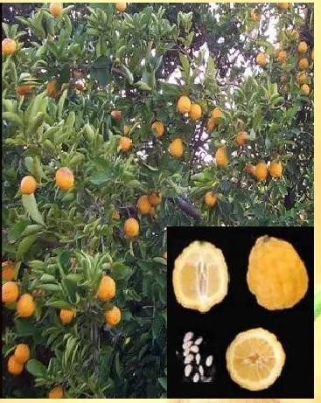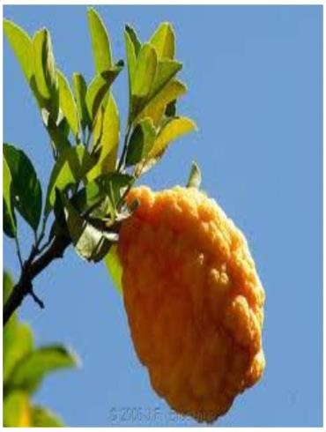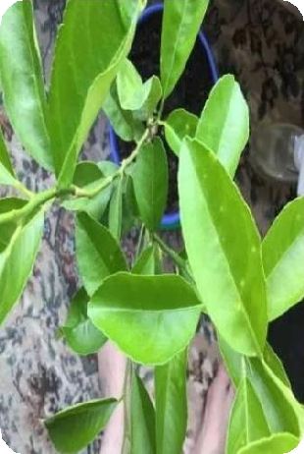
Rough lemon

3. Sour Orange (C. aurantium)
Sour Orange stands out as a leading citrus rootstock, widely adopted worldwide where tristeza is not a limiting factor. It is highly regarded as a rootstock. Trees grafted onto Sour Orange rootstock exhibit moderate vigor and yield good crops with high Total Soluble Solids (TSS) and acid content. Sour Orange rootstock can thrive in a range of soil types, from sandy to loamy or clayey soils. It adapts well to heavy, sometimes waterlogged soils, in part due to its moderate resistance to Phytophthora foot rot. Trees on Sour Orange rootstock are essentially immune to exocortis or xyloporosis.

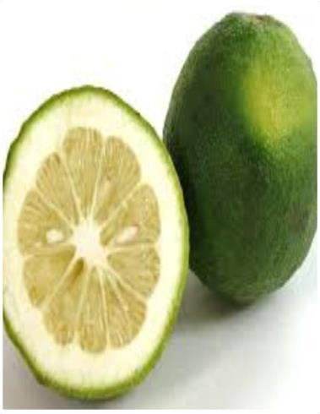
Sour Orange
- Rangpur lime (C. limonia Osb.)
Rangpur lime, likely a mandarin hybrid rather than a true acid lime like C. aurantifolia (Christm) Swingle, which is commonly used as scions, is associated with vigorous tree growth and high productivity, especially in the early stages. These trees produce medium to large-sized fruits with juice of low to moderate quality. Rangpur lime thrives in loam and clay loam soils and offers a valuable alternative in regions where the life span of rough lemon is limited, thanks to its robustness and tolerance to salt and lime. These large and vigorous trees are sensitive to exocortis, but they exhibit tristeza tolerance. They produce high yields with medium fruit quality and are also resistant to foot rot. Notably, the fruit quality of Rangpur lime surpasses that of rough lemon. This rootstock is well-suited for a wide range of soil types, making it a promising option for grafting oranges, grapefruit, and mandarins.
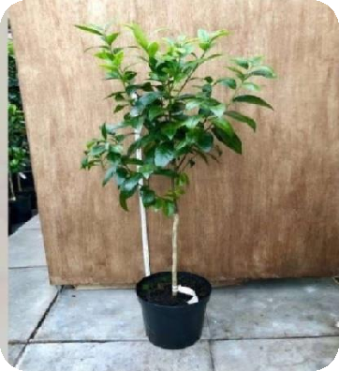
Rangpur lime
- Troyer citrange
Being a cross between a sweet orange and a trifoliate orange, it has absorbed the positive traits from both of its parents. It quickly declines and is very resistant to gummosis. The trees produce huge, high-quality fruit in large, early crops. Compared to trees on sour or sweet orange, trees budded on Troyer citrus are more resilient to cold weather.
Disadvantages:
  - Adversely affected by high pH
  - Sensitive to soil salinity and water logging.
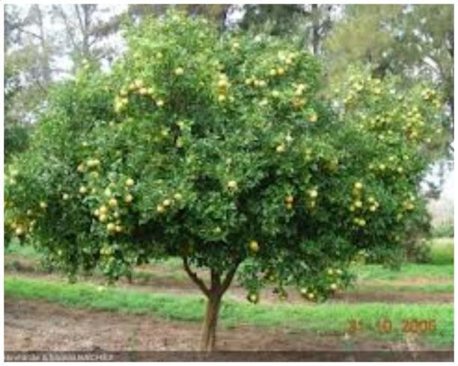
Troyer citrange

- Cleopatra mandarin (C. reshni)
One of the most studied and popular rootstocks, Cleopatra Mandarin is renowned for its exceptional qualities. It exhibits resistance to calcareous soils, salt, xyloporosis, tristeza, and exocortis. Many rootstock attempts have included Cleopatra, particularly in those areas where tristeza eventually displaced sour orange. Because of its deep-rooted nature and profusion of lateral root growth, Cleopatra is especially well-suited to sandy soils. On heavier soils or those with a clay layer close to the soil surface, nevertheless, it performs best. These trees are usually huge, bearing little yet excellent-quality fruits. They grow slowly in the nursery, but they are resistant to tristeza, salt, and cold, and they are not easily affected by blight, burrowing worms, or foot rot. Cleopatra mandarin is a preferred rootstock for mandarins, pineapples, Hamlin, tangelos, oranges, and grapefruits since it can tolerate a variety of soil types.
Disadvantages:
Susceptible to foot rot, burrowing nematode and blight is very low.
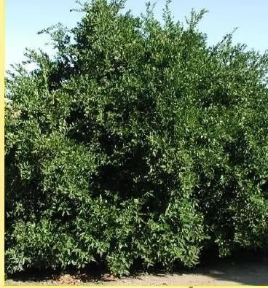
Cleopatra mandarin
- Alemow (C. macrophylla Wester)
Alemow is a hybrid species, possibly originating from citrus celebica and C. grandis, and is native to the Philippines. When used as a rootstock and budded with lemon cultivars, it yields large, vigorous trees that thrive in various soil types, including sandy and high-pH, calcareous soils. These high-yielding trees are characterized by C. macrophylla's deep and dense root system, which imparts drought tolerance to the grafted scion. Alemow serves as an excellent rootstock for mandarins, lemons, and limes. It is particularly well-suited to cooler, drier climates and exhibits greater tolerance to foot rot compared to true lemons. Alemow is a prime example of a rootstock that possesses outstanding traits, while still having some drawbacks. It showcases remarkable tolerance to high levels of soil boron, chloride, and calcium, typically featuring high leaf mineral content. Additionally, Alemow is considered resistant to Phytophthora.
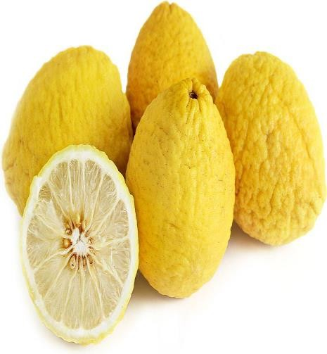
Alemow
- Trifoliate orange (Poncirus trifoliata (L) Raf)
The lone deciduous species in the genus Poncirus, Poncirus trifoliata, has been extremely important in supplying rootstock cultivars. These plants are noted for their great productivity and excellent fruit quality, despite being smaller than typical citrus trees. They exhibit excellent cold hardiness and resistance to foot rot, tristeza, Phytophthora, and nematodes. However, they have lower tolerance to salt and are typically used for grafting oranges and grapefruit. Trifoliate orange rootstocks are characterized by relatively small root systems and perform less effectively in infertile sandy soils, especially in areas with salinity issues. They have resistance to rot, tristeza, and citrus nematodes. Their root systems are shallow with weak lateral root development but abundant fibrous roots.
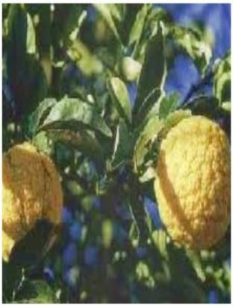

- Carrizo citrange:
i.Hybrid of Washington navel orange X Ponicirus trifoldiata. ii.Advantages:
iii.Cold tolerant iv.Tolerant to tristeza
v.Tolerant to phytopthora and nematode vi.Disadvantage:
vii.Adversely affected by high pH. Uses:
i. Fully compatible with navel and Valencia orange varieties.
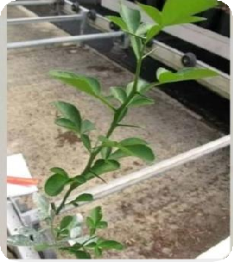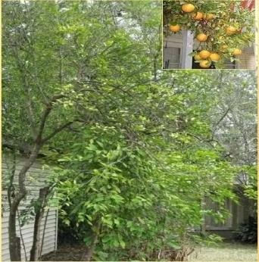
Carrizo Citrange
- Flying Dragon:
Potential ultra dwarfing rootstock. Resistant to tristeza virus.Tolerant to xyloporosis, exocortis and gummosis.
- Karna Khatta:
Suitable semi- vigorous rootstock for Kinnow in India.
- Soh Sarkar:
Suitable vigorous rootstock for Kinnow in India.
- Rough lemon, Lemon and Cleopatra mandarin: Suitable rootstock for sweet orange in India.
- C. Macrophylla:Resistant to tristeza virus.
- C. Unshiu:Freeze tolerant.
- Citron, Kumquat:Highly resistant to citrus canker.
- Volkmer lemon (C. volkameriana) F & A: Suitable for navel orange, Valencia orange and grape fruit.
Table:2 Characteristics of some selected citrus rootstocks

Rootstocks | Horticultural performance
 | Yield | Quality | Plant vigour
Rangpur lime | G | M | G
Marmalade orange | G | M | G
Rough lemon | G | L | G
Cleopatra mandarin | M | M | M
Sour orange | G | G | M
Sweet lime | M | M | G
Trifoliate orange | L | M | L
Troyer citrange | M | G | M
Carrizo citrange | M | G | M
Sweet orange | G | G | M
Karna Khatta | G | M | M
Nasnaran | M | G | M
G = Good, M = Moderate, L = Poor or low

Table: 3 Characteristics of some selected citrus rootstocks:

Rootstock | Reaction to
 | Yield | Root rot | Citrus nematode | Tristeza | Exocortis | Salt | Drought | Root system
Rangpur lime | G | MT | S | R | S | R | R | D
Marmalade orange | G | MT | MT | R | S | R | R | D
Rough lemon | G | S | S | R | R | T | T | D
Cleopatra mandarin | M | T | S | R | R | MT | S | M
Sour orange | G | R | T | HS | T | T | MT | D
Sweet lime | M | S | MT | S | S | S | S | M
Trifoliate orange | L | R | R | R | H | HS | HS | SH
Troyer citrange | M | MT | T | MT | S | HS | HS | SH
Carrizo citrange | M | MT | T | MT | S | HS | HS | SH
Sweet orange | G | HS | HS | MT | R | S | S | M
Karna Khatta | G | S | MT | - | T | T | S | D
Nasnaran | M | S | MT | T | R | HT | S | M

G = Good, M = Moderate, L = Poor or low, R = Resistant, T = Tolerant, MT = Moderately tolerant, S =Susceptible, HS = Highly susceptible, D = Deep, M = Medium, SH = Shallow, - = No information

Rootstocks of Mango
- In India, the primary method for multiplying rootstocks is through seed propagation.
- Both monoembryonic and polyembryonic rootstocks are utilized in mango propagation.
- Two highly desirable traits for a mango rootstock are dwarfism and salinity tolerance.
- The use of nondescript mango stones for rootstock propagation has resulted in significant variations in the performance of mango clones within orchards.

Classification of Mango rootstocks are as follows:
- Polyembronoic
- Monoembroyonic
- Polyembronoic rootstocks:
Goa, Olour , Bappakai, Bellary , Kurukan, Mylepalium.
- Monoembroyonic
Langara, Dashehari, Bombay green, Totapuri red small.

Effect of different mango rootstocks on scion cultivars:
  - Dwarfing effect: -
  - Kalapady, Olour, Kerela dwarf, Manjeera, Crepping, Amrapali, and Vellaikulamban are among the Indian rootstocks that have a dwarfing effect. Rootstock Vellaikulaban causes Dashehari and Alphonso to become dwarfed, whereas Olour causes Langra and Himsagar cultivars to become dwarfed (Kulkarni, 1991).
  - Ability to absorb nutrients: -
  - Mango rootstock 13-1 is known to lower the frequency of internal fruit breakdown because it can withstand the absorption and translocation of Na and Cl, as well as make it easier for calcium to be absorbed. There is greater Cl leaf content in Amrapali grafted on Kurukkan rootstock than any other rootstock (Dayal et al, 2014).
  - Tolerance to salt: -
  - Indian mango rootstocks have a limited tolerance to salt. Higher salinity levels were tolerated by Bappakai, Olour, and Kurukkan, three polyembryonic rootstocks. The mango cultivar 13-1 has been chosen as a polyembryonic rootstock for irrigation with saline water or calcareous soils.
  - Fruit quality and yield:
Numerous Indian trials have documented the impact of rootstock on fruit output and quality. Grafting the Neelum cultivar on the polyembryonic rootstock Bappakai results in a higher yield and total soluble content than on other polyembryonic and numerous other monoembryonic rootstocks. Compared to other rootstocks, Mylepalium and Vellaikulamban rootstocks raised the TSS of the Dashehari cultivar. The maximum quantity of fruits per plant is recorded by Langra grafted on Bappakai rootstock, followed by Vellaikulamban.
Rootstocks of Mango:
The poly-embryonic races of mango, which are characterized by their homogeneity and rapid growth, present a great deal of potential for usage as rootstocks in order to reduce variability.
Table: 4 Rootstocks of Mango
Sr. No. | Rootstocks | Special features
1 | Kurrukan | Salt resistant polyembryonic
2 | Olour | Vigorous rootstock
3 | Vellaikolamban | Dwarfing and allopolyploid
4 | Olour, Villai collumban and  Rumani | Dwarfing
5 | Moovandan and Nekkare | Salt tolerant
6 | Gomera l | Most adaptable in saline conditions where low water quality
7 | Species Mangifera minor | Resistant to anthracnose
8 | Mangifera zeylanica | Salinity resistance
9 | Bappakai and Olour | Salt tolerant for high survival, germination and growth  percentage under salt stress condition (Varu and Barad, 2010)
10 | Dashehari and Chousa | Salt resistant

Rootstocks of Grape
Table: 5 Recommended grape rootstocks for different situation.

Situation /problem | Rootstock
Water shortage | 1103P, 140RU,110R,420A,SO4,99R
Soil EC >2mmhos/cm and water EC>1mmhos/cm | Ramsay, Dogridge B, 140RU, 99R,110R
Soil ESP> 15% and or water SAR >8% | 140RU,1613, Ramsay, Dogridge
Free Ca content of soil is >12% | Fercal, 140RU, 420A,SO4
Chloride content of water is >4 meq/lit | Ramsay, Dogridge B,140RU,teleki-5-C
Poor vigor of the variety without any soil/water problem | Ramsay, Dogridge B,140 RU
For increased Nitrogen and Phosphorus uptake | Dogridge B, St. George, 34 EM, Ramsay
For Increased bud break | 1613

Table:6 Recommended grape rootstocks
Sr. No. | Rootstocks | Special Features
1 | Riparia Gloire, St. George (Rupestris du lot), S04 (Selection Oppenheim), 5BB (Kober),  5C (Teleki), 420A (Millardet et de Grasset), 99R (Richter). | Phylloxera resistance
2 | Salt creek and Dogridge | Salt and nematode resistant
3 | Temple | Multiple resistant/pierce's disease
4 | V. berlandieri | Resistant to Phylloxera, and high lime content in the  soils but difficult to propagate vegetatively.
5 | V. labrusca | Cold hardy, resistant to many pests and diseases.
6 | V. amurensis | Resistant to cold and frost.
7 | V. aestivali | Resistant to many fungal diseases but susceptible to  Phylloxera, best for hot climatic condition.
Rootstocks of Guava
Table: 7 Suitablerootstocks of guava for different purpose
Rootstocks | Specific features
Pusa Srijan (aneuploidy tetrasomic, 2n+2) | Potential for dwarfing, resistant to wilt.
P. friendrichsthalianum | Dwarfing, resistant to wilt and nematode
P. molle | Resistant to guava wilt
P. Pumilium , P. cujavilis | Highly dwarf high sugar content.
Crioula | New guava rootstock, it is tolerant to pests and diseases, especially guava rust (Puccinia psidii),  tolerant to salinity.
Psidium cattleianum | Tolerant for low temp.
Rootstocks of Sapota
Table: 8 Suitable rootstocks for sapota
Rootstocks | Specific features
Ryan or Khirni / Pala (Manilkara hexandra) | Commercial rootstock in India.
Chrysophyllum lanceolatum | Wider soil adaptability.

Species like have been reported as rootstocks for sapota.(Bose,1985).
1.Mimusops kauki (Adams apple) 2.Madhuka lattifolia (Mahua) 3.Bassia longifolia (Mee tree) 4.Chrysophyllum cainito (star apple)
- Sideroxylon dulicifolium (Miracular fruit)

Rootstocks of Avocado
Table: 9 Suitable rootstocks for avocado
Rootstocks | Specific features
Duke -7, Zentmyer, Uzi and Steddom | Tolerant to phytophthora root rot
Nachlat | Tolerant to lime
Pollock | Tolerant to salinity

Dwarfing Rootstocks suitable for fruit crops
The vigor, precocity, and fruit quality of trees, as well as the productivity and longevity of varieties grafted on them, are all known to be significantly impacted by the root stocks. The scion, the rootstock, or both may be to blame for dwarfing.

Table: 10 Dwarfing Rootstocks for fruit crops
Crop | Dwarfing Rootstock
Mango | Vellaikolumban (Alphonso), Olour (Himsagar and Langra)
Guava | Pusa srijan, Psidium friedrichsthalianum.
Citrus | Trifoliate orange, Sour orange, Flying Dragon

Table: 12 Worldwide Resistant / tolerant rootstocks in fruit crops
Crop | Rootstocks | Resistance/Tolerance traits
Mango | Carabao | Resistant to wilt
 | Gomera-1,13/3,Kurukan,Olour, Bappakkai and 13-1 | Tolerant to salinity
Guava | P.friedrichsthalianum,  P.cattleianumvar.lucidum,P. guineense | Resistance to root-knot nematode
 | Crioula | Tolerant to salinity
Grapes | Ramsey, Dog Ridge, Harmony and Freedom | Resistance to root-knot nematodes
 | UCD GRN1 and VR O39-16 | Resistance to the root lesion nematode
 | Ramsey,Riparia Glorie, 5C | screened for salt tolerant
 | Ramsey and 1103 Paulsen | Tolerance of phylloxera and nematodes
 | 140Ru | Tolerance to water deficit condition
 | Beta and 3309C | Cold hardiness
 | A15 and A17 | Tolerance to alkalinity
 | Hybrids of V. berlandieri x V. riparia | Tolerance to drought
 | 196-17, CH-1, CH-2 | Tolerance to salinity
Avocado | G755C13-1 | Salinity tolerance
 | Duke 7 and G6 | Resistance to P. cinnamomi
Citrus | C. Macrophylla, Mandarin Clemenules trees grafted on Carrizo performed well | Resistance to salinity
 | Pearl, Mosambi x Kinnow & Mosambi x Nagpur, Star ruby and ruby red | Resistant against citrus pyslla
 | A 418 (Troyer citrange X Cleopatra mandarin) | Dwarfing rootstock
 | US 852 Hybrid Selection | Phytophthora resistance

Challenges in rootstocks utilization in fruit production
    - i. Regular updates on rootstock research are essential to meet the changing needs of growers and the environment.
    - ii. While low-vigor rootstocks are common in various fruit species' breeding projects, it's important to also consider semi-dwarf and moderately vigorous rootstocks for sustainable systems, especially in areas where maintaining year-round grass cover and managing weed competition is crucial.
    - iii. Expanding fruit cultivation into new regions demands a different approach to rootstock research.
    - iv. The importance of rootstock adaptation to temperature swings, cold resistance, winter hardiness, drought tolerance, water-logging, effective water use, and the capacity to flourish in less-than-ideal soil conditions is highlighted by climate change.
Future thrust
    - There is urge to develop new rootstocks which will imparts those qualities in scion cultivar which will provide dwarfing effect, required canopy and ultimately quality fruit yield.
    - vi. To start looking into the best rootstock to choose for fruit crops based on the current soil and climate.
vii. In order to grow various tropical and subtropical fruit, rootstocks that are resistant to biotic and abiotic stressors must evolve.crops.

Conclusion
i. The development of rootstocks is a continuously evolving process with no predetermined endpoint.
ii. Current advancements in rootstock management significantly impact orchard efficiency and the sustainability of fruit crops.

- Precocity/juvenility, yield, tree size control, disease resistance or tolerance, fruit respiration behavior, crop load, and canopy management strategies can all be impacted by rootstocks.
iv. Employing dwarf rootstocks in high-density planting can enhance yield per unit area.

References
Bhullar, 1.S. and lP. Nauriyal (1975). Effect of different rootstocks on vigour, yield andfruit quality of Blood Red Orange. Indian 1. Hort., 32: 45-49.
Bose, TK, Mitra, SK Sadhu, MK Das, P Sanyal, D and Parthasarathy, VA. 2005.Propagation of tropical and subtropical horticultural crops vol1 (3rd revised edition), NayaUdyog Publication, Kolkata, pp;101 -104.
Chadha K L, Singh H P. Citriculture scenario of India. in Citriculture in North- western India: Proceedings of Citrus Show-cum-Seminar. Prospects and Problems of Kinnow Cultivation (K.S. Gill, J.S. Kanwar and R. Singh, eds.). Punjab Agricultural University, Ludhiana, 1990, 21-64.
Chadha, K.L. and H.P. Singh (1996). Description, Classification and Cataloguing ofgenetic resChandan, P. M., Kadam, J. H. and Ambad, S. N. Effect of different polyembryonic and monoembryonic rootstocks on performance of Dashehari mango. Inst. J. Agril. Sci., 2006,2(2):pp. 594-595.ources of citrus in India. Consultancy Report, IPGRI-APO, Singapore.
De, T.C., K.M. Bujarbaruah, D.S. Yadav, Y.P. Sharma, RK. Patel, R.K.Yadav and A.N.Shylesha (2006). Citrus Rejuvenation Packages in North East India. Research BulletinNo.22, ICAR Research Complex for NEH Region, Umiam, Meghalaya, Pp.24.\
Gunjate RT. Advances in mango culture in India. Acta Hort. 820:69-78 Litz, R.E. 2009. Mango. Wiley Publishers, 2009, 530.
Hartmann, HT, Kester, DE, Davies Jr., FT and Geneve, RL. 2002. Plant Propagation Principle and Practices (6thedn.). Prentice Hall of India Pvt. Ltd. New Delhi.
Lal N, Singh A, Gupta AK, Marboh ES, Kumar A and Nath V. 2019. Precocious Flowering and Dwarf NRCL-29-A New Genetic Stock of Litchi (Litchi chinensis Sonn.). Chemical Science Reviews & Letters, 8 (32): 206-210.
Nimbolkar P. K., Awachare C, N Reddy Y.T., Chander S. and Hussain, F.2016.Journal of Agricultural Engineering and Food Technology Volume 3, Issue 3; July-September, 2016 pp. 183-188.
Rajput, CB S and Haribabu, RS. 1995. Citriculture. Kalyani Publisher, New Delhi. pp.147.
Reddy, Y. T. N., Reju, M., Kurian, P. R., Ramachander, Gorakh Singh and Kohli, R. R. Long term effects of rootstocks on growth, fruit yielding patterns of Alphonso mango (M. indica) Scientia Hort., 2003, 97(2): pp. 95-108.
Singh, H.P. and K.L. Chadha (1993). Genetic resources of citrus. Pp. 95-122. In:Advances in Horticulture-Fruit Crops (K.L. Chadha and O.P. Pareeks eds.), Vol 2,Malhotra Publishing House, New Delhi.
Ribeiro IJA, Rossetto CJ, Donadio LC, Sabino JC, Martins AIM, Gallo PB et al. Mango Wilt. XIV Selection of mango (Mangifera indica L.) rootstocks resistant to the mango wilt Fungus Ceratocystis fimbriata Ell & Halst. In International Symposium on Tropical Fruits, 370, 1993, 159-166.
Rossetto CJ, Ribeiro IJA, Gallo PB, Soares NB, Sabino JC, Martins ALM et al. Mango breeding for resistance to diseases and pests. In Vth International Mango Symposium. 1996; 455:299-304.
Rom, R. C., Carlson, R. F. Rootstocks for fruit crops. New York, Wiley and Sons. 1987, pp. 494.

