Cell Fusion: Mechanisms and Biological Implications

Dr. Kumara Wodeyar D.S¹ Dr. Ananth Krishna.L.R ², Dr.Ramesh.D^{3*}, Dr.Yathish.H.M⁴, Dr. Anil Gattani⁵

1. Assistant Professor, Department of Veterinary Physiology and Biochemistry, Veterinary College Gadag, KVAFSU, Karnataka, India

2. Associate Professor and Head Department of Veterinary Physiology and Biochemistry, Veterinary College Gadag, KVAFSU, Karnataka, India.

3. Assistant Professor Department of Veterinary Physiology and Biochemistry, Veterinary College Hassan, KVAFSU, Karnataka-573202, India.

4. Assistant Professor Department of Animal Genetics and Breeding, Veterinary College Bengaluru, KVAFSU, Karnataka, India

5. Associate Professor Department of Veterinary Biochemistry, College of veterinary Science and Animal Husbandry, Jabalpur India.

*Corresponding Author

Assistant Professor Department of Veterinary Physiology and Biochemistry, Veterinary College Hassan, KVAFSU, Karnataka-573202, India. Email-drrameshd@gmail.com Mobile-8277522429.
Abbreviations used | Expansion
cAKA | Cyclic Adenosine-Dependent Protein Kinase-A
MAPK | Mitogen-Activated Protein Kinase
BMDCs | Bone Marrow-Derived Cells
HAP2/ GCS1 | Hapless 2/Generative Cell-Speciﬁc Protein 1
T-SNARE | Target-Soluble N-Ethylmaleimide-Sensitive Factor Attachment Protein Receptor
V-SNARE | vesicular-SNARE
HERV | Human Endogenous Retrovirus
SU | Surface Subunit
TM | Transmembrane Subunit
Asct-2 | Sodium-Dependent Type 2 Neutral Amino Acid Transporter
GCM1 | Glial Cell Missing 1
β-HCG | β-Human Chorionic Gonadotropin
GRP78 | Glucose-Regulatory Protein 78 kDa
Ig | Immunoglobulin
DC-STAMP | Dendritic Cell- Speciﬁc Transmembrane Protein
OC-STAMP | Osteoclast- Stimulating Transmembrane Protein
HA | Hemagglutinin
cAMP/PKA | Cyclic Adenosine-dependent Protein Kinase A
ZO-1 | zona occludens-1
Wnt | wingless/integrase-1
PEG | Polyethylene Glycol
JNK | c-Jun N-Terminal Kinase
NIR | Near Infrared Laser
The cell fusion process involves the merging a number of uninucleate cells results in the formation of a multinucleate cell called syncytium. The cell fusion includes membranes fusion, cytoplasmic mixing and fusion of nuclei. It is a fundamental step for maturation of cells as well as the maintenance of their specific functions during growth. Also cell fusion occurs in various pathological and physiological processes like embryogenesis, morphogenesis and tissue repair, immunological response and also in cancer development. It is controlled by diverse proteins and signaling pathways like syncytin-1, syncytin-2, galectin-1,glial cell missing-1and additional proteins like annexins, myomaker, myomerger etc.
I. Introduction
Cell fusion entails both pathological and physiological processes. Based on the cell types involved cell fusion can be homogeneous or heterogeneous. Also based on the contents cells mingle cell fusion can be complete fusion or hemifusion. The process involves the membrane fusion followed by cytoplasmic mixing and nuclear fusion which can leads to development of heterokaryon (multinuclear cells) or synkaryons (mononuclear cells).Daughter cells in synkaryons have all the chromosomes of the closely related cells and are created via recombination, nuclear membrane separation, and cell division. The hybrid cell transforms into a polyploidy with more than two sets of chromosomes in its genome and adopts on a new phenotype. In numerous physiological or pathological stages, including those associated with growth, development, aging, stress, cancer, and other diseases, polyploidy cells can be seen. The heteromorphic cell fusion has a crucial effect on growth of tissues and disease progression.
II. Types of Cell Fusion
Cell union can be of the homotypic or heterotypic type. Homotypic cell fusion happens when cells of the similar kind come together. The osteoclasts or myofibers fusion involves homotypic fusion. Heterotypic cell fusion take places among cells of dissimilar types for example fusion of bone marrow-derived cells (BMDCs) with the parenchymatous organs.
III. The Progression of Cell Fusion
The fusion of membranes begins when separate membrane vesicles or compartments are brought close to together. Initiation requires overcoming two main forces: an attractive hydrophobic force between the hydrocarbon interiors of the bilayers and a repulsive hydration force brought on by water that is tightly linked to the hydrophilic lipid head groups, cell fusion includes both an integration of the internal components of the cells and also a morphological restoration of the cell membrane.
Under specific circumstances, proteins from fused cells are released, allowing them to communicate with their surroundings and the fusion target. It has been discovered that the group of proteins known as "fusogens" which are necessary to trigger cell fusion via several different methods. Sometimes cell fusions are regulated by a specific fusogen, whereas other fusions rely on an array of proteins that work together to complete the fusion or work together to manage the fusion process. For example the myomaker and myomerger act as lone fusogens in myoblast fusion, the hapless 2/generative cell-speciﬁc protein 1(HAP2/ GCS1) are active in later stages of gamete fusion and in Caenorhabditis elegans, EFF-1 and AFF-1 act independently to induce auto-fusion.
The entire fusion process involves in three phases. The initial step starts with preparation of cells for fusion by cell-cell recognition followed by membrane approach mediated by fusogens and in final stage new cells formed by lipidic rearrangements (Fig:1).
For the early stage of cell fusion, primarily depends on the reception of extracellular signals meant for cell differentiation, cell-cell recognition and interaction are necessary. When cells are fewer than 10 nm apart from one another, they begin to tightly adhere to one another, and then fusogens work in the last approach between membranes. The cell fusogens mediates in morphological changes includes dehydration, hemifusion, pore opening and spreading out cell membranes with the intention of the union of experiences. The last stage involves the fusion of the cell membranes into a new, single ring that shares all of the cytoplasm and genetic material. But occasionally, the process abruptly ends before pore opening and extension occur, leaving the cell in the hemifusion stage, where its cellular components cannot be in contact with one another and exchanged.
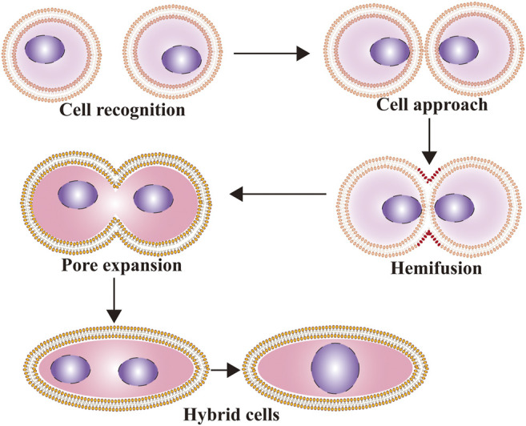
FIGURE 1: Cell fusionprogessioncan be divided into 3 steps 1.preparation for fusion, 2. membrane approach under the accomplishment of fusogens, and 3. Constitution of new cells by means of lipidic rearrangements. (Source:Hao Zhang et al., 2021)

IV. Cell Fusion Associated Proteins
Fusogenic proteins and actin-propelled membrane protrusions are essential for the earliest stage of cell-cell fusion. For example syncytin-1 and syncytin-2 required in helix fusion process, T-SNARE (Target-soluble N-ethylmaleimide-sensitive factor attachment protein receptor) and V-SNARE (Vesicular-SNARE) are the components of the helical fusion mechanism that facilitate intracellular membrane fusion by forming -helical bundles that result in membrane fusion.
The membrane glycoprotein, syncytin-1 encoded by the ENV gene of HERV (human endogenous retrovirus) W family was the ﬁrst fusion-promoting protein found to be involved in syncytiotrophoblast cell formation. Syncytin-1 expressed in placenta which is has surface subunit (SU) and transmembrane subunit (TM) components. The SU of syncytin-1 coalesces with type D retrovirus receptor named as sodium-dependent type 2 neutral amino acid transporter (ASCT-2). The conformational change in the TM causes the two trophoblast cells phospholipid bilayer configurations to become closely bound. The main purpose of syncytin-1 is to support the fusion of mononuclear trophoblast cells into multinuclear syncytiotrophoblast cells. Also Syncytin-1 is involved in myoblast fusion and osteoclast formation.
Syncytin-2, a endogenous retrovirus gene product and a fusion protein plays a role in arrangement of placental syncytiotrophoblast cells andplacenta formation, is involved osteoclast and macrophage fusion.
GCM1 is a zinc finger-containing transcription factor that is exclusive to the embryo and is highly expressed in placental trophoblast cells. Its primary function is to control syncytin-1 expression and mediate the differentiation of mononuclear cell trophoblasts into multinuclear syncytiotrophoblasts.
Galectin-1, a soluble lectin involved in cell fusion linked to the expression of syncytin-2 and in addition implicated to trophoblast cell fusion.
Oocyte tetrosomal proteins CD9 and CD81 are essential for the fusion that occurs during fertilization. Glucose-regulatory protein 78 kDa (GRP78), an endoplasmic reticulum protein expressed on the surface of trophoblast cells and helps to enhance cell fusion. The immunoglobulin like cell adhesion particles essential for cell-cell fusion and recognition in myoblasts. The proteins like CD47, CD200, DC-STAMP (dendritic cell- speciﬁc transmembrane protein) and OC-STAMP (osteoclast- stimulating transmembrane protein) are important for macrophage fusion in osteoclasts. The muscle-speciﬁc protein called myomaker (Tmem8c) found on the plasma membrane is involved in myoblast fusion. Annexins are molecule with multiple Ca²⁺-binding sites and mediate the fusion reaction or induce a conformational change in a fusogenic protein.
V. Cell Fusion Related Signaling Pathways
Syncytin-1 expression is regulated by a number of signaling pathways throughout embryonic development, including the wingless/integrase-1 (Wnt), cyclic Adenosine-dependent Protein Kinase A (cAMP/PKA), Mitogen-Activated Protein Kinase (MAPK), and c-Jun N-terminal kinase (JNK) signaling pathways. Syncytin-1 is increased as a result of the cAMP pathway being activated. TGF-β1 and TGF-β3 are major negative regulators of cell fusion.
VI. Cell Fusion during Embryonic Development
The growth of syncytiotrophoblasts in the placenta and the occurrence of sperm/egg fertilization during sexual reproduction occur as cell fusion proceeds. The IZUMO proteins in sperm play a role in fertilization via changeable cell fusion and their failure of expression results in sterility due to failure of sperm-egg fusion. Placental formation occurs by cell fusion and is separated into two phases (Figure 2). In the ﬁrst phase, cytotrophoblast cells unite to develop into polynuclear syncytiotrophoblast cells, which move and infiltrate the mother's uterus and serve as an exchange route for oxygen, nutrients and metabolic wastes between the embryo and the mother. In the second stage, cytotrophoblasts and syncytiotrophoblasts combine for tissue restoration.

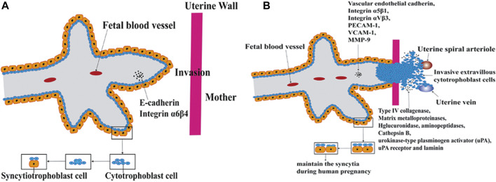

2. Fig 2: The arrangement of the placenta is accompanied by cell fusion and is separated into two phases according to the diverse functions in the fusion process. A. In the ﬁrst phase, cytotrophoblasts and syncytiotrophoblasts fuse for tissue regeneration (B) In the second phase cytotrophoblasts and syncytiotrophoblastscombine for tissue regeneration.(Source:Hao Zhang et al., 2021)

VII. Cell Fusion Techniques
The various cell fusion procedures offer an effective tool for new discoveries in the realm of genetic and epigenetic studies of the genome.
Electrical cell fusion involves dielectrophoresis, in which two cells are brought into contact by means of high frequency alternating current. A pulsed voltage is applied once the cells are joined. The pulse voltage causes the cell membrane to permeate, as a result the membranes combine and the cells fuse. Following this, an alternate voltage is provided for a brief amount of time to stabilize the process, leading to the complete fusing of the cell membrane and mixing of the cytoplasm.
Polyethylene Glycol (PEG) is the simplest, but most toxic way to fuse cells. In this PEG acts as a dehydrating agent cause in fusion of plasma membranes and intracellular membranes. As the PEG encourages cell agglutination with cell-to-cell contact. Unwantedly, PEG can cause uncontrollable cell fusions that culminate in the formation of large polykaryons. This type of cell fusion is frequently employed for the creation of somatic cell hybrids and for nuclear transfer in mammalian cloning.
Sendai virus induced cell fusion occurs in four different phases. first stage occurs within 10 minutes in which adsorption of virus occurs the adsorbed virus can be repressed by viral antibodies. the next 20 minutes pH reliant phase where adding viral antiserum can still reduce ultimate fusion. The viral envelope components remain detectable on the outside of cells in the antibody-refractory stage. At fourth stage cell fusion becomes apparent with fusion features to begin disappear.
Thermoplasmonics induced cell fusion technique is based on near infrared laser (NIR) and a plasmonic nanoparticle. The nanoscopic plasmonic particle is heated to extremely high temperatures in a small area using a laser, which typically functions as an optical entrap. Such optical trapping at the interface between two membrane vesicles or two cells leads to immediate fusion verified by both content and lipid mixing. Here, there are benefits to having a variety of cells to fuse with, and fusion can occur in any buffer environment.
VIII. Applications of Cell Fusion
Biologists have started thinking about the possibility of therapeutic make use of cell fusion due to the lack of organs and tissue available for transplantation. Cell fusion can be used to examine how cells divide and how genes are expressed, to study malignant transformations, to obtain viral replication, to map genes and chromosomes, to make monoclonal antibodies by creating hybridomas, to make induced stem cells, and to measure protein shuttling in an assay known as a heterokaryon fusion.
IX. Conclusion
cell fusion serves as a bridge between the proteins and pathways discussed. There are still many challenges to be solved if cell fusion is to be used as a therapeutic method. These difficulties include choosing which cells to use for the reparative fusion and how to properly introduce the chosen cells into the desired tissue, figuring out ways to increase the incidence of cell fusion, and ensuring that the fusion products that result will work as intended. Cell fusion may be therapeutic if these difficulties can be addressed.

References:
1. Hao Zhang, Hong Ma, Xiaohui Yang, Linlin Fan, Shifeng Tian, Rui Niu, Man Yan, Minying Zheng, and Shiwu Zhang.(2021). Cell Fusion-Related Proteins and Signaling Pathways,and Their Roles in the Development and Progression of Cancer. Front Cell Dev Biol., 9: 809668. (doi: 10.3389/fcell.2021.809668)
2. William Wickner and Randy Schekman (2008). Membrane fusion. Nat Struct Mol Biol. 15(7): 658–664.
3. Chernomordik LV, Kozlov MM. (2008). Mechanics of membrane fusion. Nat Struct Mol Biol.15:675–683.
4. Chen YA, Scheller RH. (2001). SNARE-mediated membrane fusion. Nat Rev Mol Cell Biol. 2:98–106.
5. https://en.wikipedia.org/wiki/Cell_fusion

