PRINTOVATION: - from virtual to reality

Priya sharan
Department of Computer Application (BCA),
Patna Women’s College, Patna, India
Priyasharan24april@gmail.com

Priya Vandana
Department of Computer Application (BCA),
Patna Women’s College, Patna, India
vandanapriya528@gmail.com

- Introduction
The Internet of Things (IoT) is made up of networked sensors and gadgets that exchange and collect data. On the other hand, 3D printing makes it possible to produce three-dimensional objects from computer designs. When these technologies are combined, 3D printing in the Internet of Things (IoT) emerges as a revolutionary strategy that uses linked devices and sensors to materialize digital conceptions.

The manufacturing landscape is changing as a result of the convergence of 3D printing and the Internet of Things (IoT). Manufacturers may create networked systems that easily communicate and share data by incorporating 3D printers into IoT networks. Numerous benefits come with this potent fusion, such as improved precision, higher manufacturing efficiency, and capabilities for remote monitoring and control.
The IoT application of 3D printing has the potential to completely transform the manufacturing sector, even if it is still in its infancy(Boubiche et al., 2018). Notably, 3D printing satisfies the requirement for distinctive solutions in the IoT space by enabling highly customized parts and products.

In addition to opening up new customization options, the combination of 3D printing and IoT also streamlines the manufacturing process, increasing responsiveness and efficiency. As this union develops, we may anticipate notable advancements and a wide range of revolutionary uses that will influence manufacturing in the future.

- Unleashing Synergy: The Symbiotic Integration of 3D Printing and IoT

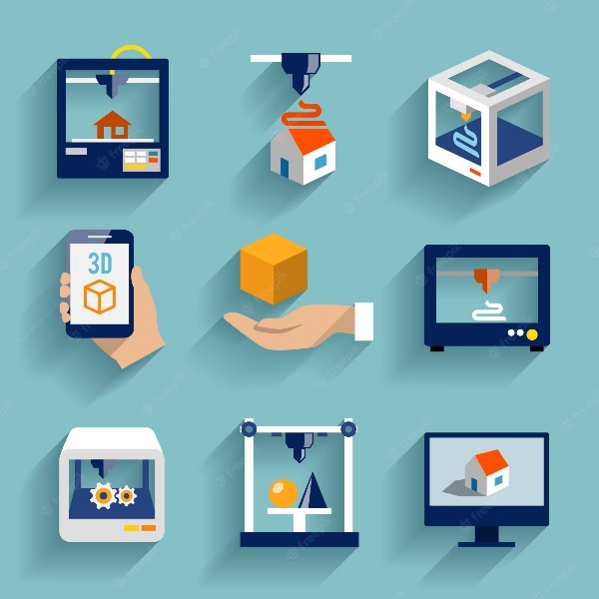
The Internet of Things (IoT) and 3D printing work together dynamically to power a revolutionary manufacturing strategy. Fundamentally, IoT 3D printing uses sensors and linked devices to gather and process data. This information is then used to create a precise digital file that serves as the design for 3D printing.
Figure 1: Collaboration of 3D Printing with IOT.

The magic happens after the digital file is sent to a 3D printer. The printer carefully crafts the required thing layer by layer using additive manufacturing processes. Real-time monitoring and control solutions may optimize the printing process, ensuring quality, accuracy, and efficiency, through seamless interaction with IoT networks(Vashi et al., 2017).

IoT integration enables a number of 3D printing breakthroughs. In order to streamline production and create individualized
designs, automation and customization take the stage. Utilizing the enormous potential of this collaboration, industries can achieve breakthroughs in efficiency, cost-cutting, and innovation(Chowdury et al., 2019).

The limits of what is possible will be pushed further as the connection between 3D printing and IoT continues to grow. This unprecedented synergy is poised to revolutionize sectors across the board and present a variety of exciting options for innovative manufacturing solutions that are effective, affordable, and efficient.
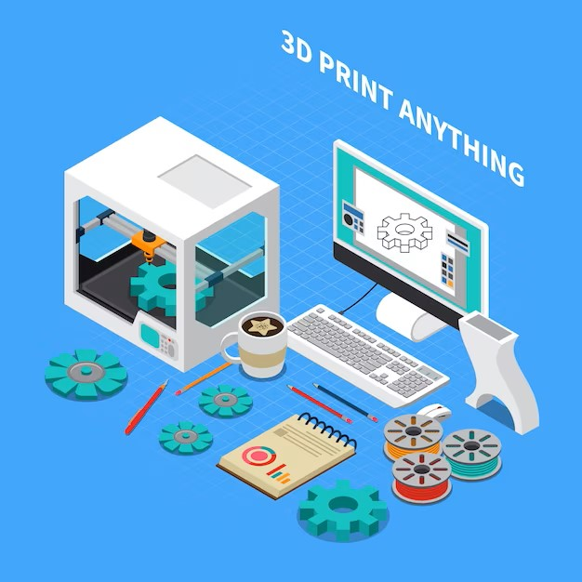
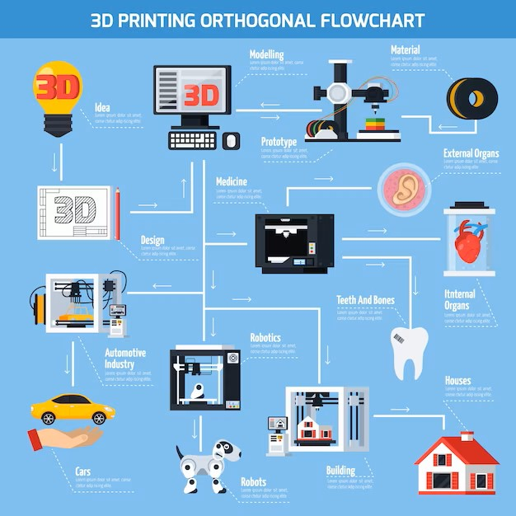
Figure 3: 3D Print the Unexpectable.
Figure 2: Flowchart for 3D Printing Process

- Unlocking Social Impact: How 3D Printing in IoT Empowers Positive Change

The potential applications of 3D printing technology are vast, and the Internet of Things (IoT) is one field that stands to gain significantly from this development. The integration of IoT devices with 3D printing opens up new opportunities for making a positive impact on society as these devices proliferate in homes and workplaces(Tawalbeh et al., 2020).

Numerous potentials exist to use technology for social benefit as a result of the combination of 3D printing and IoT. Making personalized prosthetic limbs gives those who have lost limbs due to disease or injury hope and a better quality of life(Gowri, 2019). This is one significant use. The creation of specialized medical implants like pacemakers and artificial hearts is also made possible by this technology, offering personalized, life-saving treatments(Khot, 2020).

Additionally, IoT-based 3D printing can alleviate the housing issues that people in underdeveloped nations experience since they lack access to traditional building materials. Making use of 3D printing technology makes it possible to build economical and environmentally friendly homes, reducing poverty and improving living conditions for millions of people globally. Virtually anything can be done with 3D printing to have a beneficial effect on the world(Domb, 2018).

The ability of 3D printing technology to effect positive change will increase as it develops further. The combination of 3D printing and IoT holds enormous promise for improving lives and ushering in a better future with further innovation(Suciu et al., 2019).

- Exploring Diverse Materials in 3D Printing

The world of 3D printing encompasses a wide range of materials with unique properties and applications. Here are some notable examples:

1. Wood Filament: Utilizes a mixture of wood fibers and a polymer binder, resulting in prints that resemble wood with texture and appearance.

2. Carbon Fiber: Infused with tiny carbon fibers, it produces lightweight and strong prints, popular in aerospace and automotive industries.

3. Flexible Filament: TPU and similar materials enable the creation of elastic and bendable objects, widely used in wearable items and prosthetics.

4. Conductive Filament: Contains conductive particles, allowing for the printing of objects with electrical conductivity, suitable for circuits, sensors, and electronic components.

5. Ceramic: Ceramic printing involves using a paste made of ceramic powders and binders, useful for architectural models, custom parts, and pottery.

6. Bioinks: Designed for 3D bioprinting, bioinks combine living cells and biocompatible gels, advancing research in tissue engineering and regenerative medicine.

7. Concrete: Mixture of cement, sand, and additives enables large-scale 3D printing for construction purposes, such as building components and houses.

8. Wax: Used for investment casting, wax models are printed and transformed into molds for metal casting, widely employed in jewelry and manufacturing industries.

These examples showcase the breadth of materials available in 3D printing, with ongoing research and development leading to the emergence of even more innovative options for diverse applications(Rahmani et al., 2018).
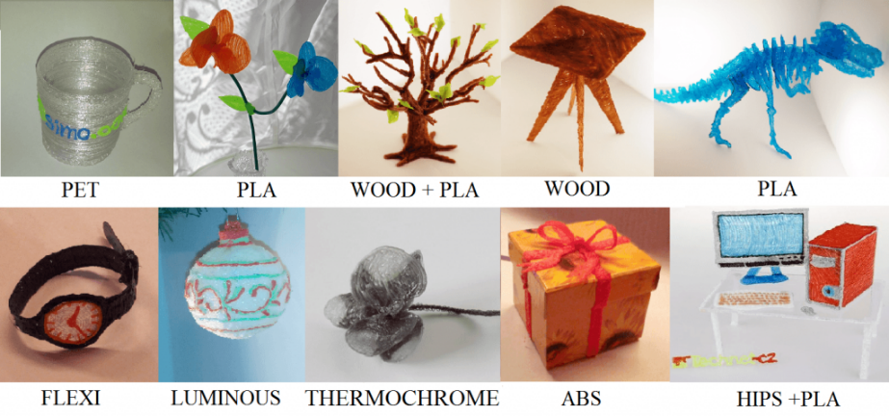
Figure 4: Materials Used in 3D Printing.

- A Transformational Path Ahead: 3D Printing and IoT Shaping the Future

Because of the rising possibilities and technological breakthroughs, the future of 3D printing with IoT offers enormous promise. A widening selection of materials makes it possible to create complicated designs while 3D printing is becoming more accessible, inexpensive, and capable of producing high-quality prints. It has the ability to transform conventional manufacturing procedures, cut waste, and open the door to the development of sustainable and individualized products.

Beyond manufacturing, 3D printing has a wide range of effects. It has the potential to transform industry on a worldwide scale, offer affordable homes and shelters for disaster relief efforts, and advance healthcare through the production of organs, tissues, prosthetics, and implants. The fusion of IoT and 3D printing opens up fresh possibilities for social good and revolutionary developments(Baker et al., 2017).
Amazing applications and industry transformations in the future are expected to have a significant impact on our world. A spectacular future in which numerous industries undergo positive change is predicted by the convergence of 3D printing and IoT.

- Unlocking the Potential: Additive Manufacturing Empowering IoT

The Internet of Things (IoT) holds enormous potential for 3D printing and is already changing the landscape of manufacturing and design. The ability to create elaborate and complicated products with 3D printing makes it perfect for prototyping, small-batch manufacturing, and customization. Due to its quickness and effectiveness, businesses are able to experiment with novel designs while spending little time and money.

IoT Worlds and other businesses are using 3D printing to produce connected home devices and unique drone parts. As technology develops, 3D printing will completely change how IoT devices are made, allowing for quick prototype, customization, and low-cost production. IoT and additive manufacturing working together will spur new developments and ground-breaking uses in this revolutionary area(Boubiche et al., 2018).

- Revolutionizing IoT with Customization: The Role of 3D Printing

A higher level of customization and flexibility in the production process brought about by the incorporation of 3D printing technology is changing the market for IoT devices. With the help of manufacturers, performance, aesthetics, and user experience may all be enhanced through the development of specialized components, design optimization, and the production of custom enclosures. The production process is being revolutionized by this revolutionary impact, which is also encouraging the development of cutting-edge, customized IoT devices. The IoT sector will continue to expand and flourish as a result of the increasing role that 3D printing will play in it(Mohd Aman et al., 2021).

- Unleashing Innovation: How 3D Printing Fuels IoT Advancements

By enabling manufacturers to push the frontiers of product design and customization, 3D printing has emerged as a catalyst for new possibilities in IoT. Beyond the constraints of conventional manufacturing techniques, it enables the production of items with complex geometry. This adaptability enables businesses to create distinctive gadgets that are suited to particular uses.
Another benefit of 3D printing in the IoT is its speed in producing prototypes and small batches of goods. Businesses can test several ideas and make iterative adjustments early in the design process which saves time and lowers the possibility of costly changes being made during mass production(L’Heureux et al., 2017).
An organization using 3D printing to open up new IoT possibilities is IoT Worlds. Leading businesses across industries may efficiently prototype and produce customized products thanks to their services. They can quickly create and iterate thanks to this technology, from sensor nodes to wearable(Nayyar & Puri, 2017).
The fusion of IoT and 3D printing gives manufacturers a competitive edge and propels innovation in the sector. It accelerates innovation and opens up ground-breaking opportunities in the developing IoT landscape by encouraging the development of highly customized devices while streamlining the design and development process.

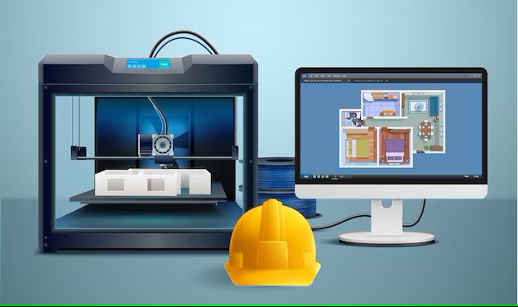
Figure 5: Good Scope of 3D printing with IOT.

- Empowering 3D Printing through IoT Integration
The manufacturing scene is transformed by the Internet of Things (IoT) and 3D printing technology integration, which improves process efficiency, automation, remote accessibility, collaboration, and quality control. IoT makes it possible for 3D printers to be monitored and controlled in real-time, as well as for 3D printed objects to be traceable and authenticated. It also streamlines material management and provides real-time quality control feedback. These technologies' revolutionary potential and avenues for innovation will grow as they develop.

- Exploring the Diverse Applications of 3D Printing
The adaptability of 3D printing, also known as additive manufacturing, has opened the door for outstanding developments in a variety of industries. Let's examine the various ways that 3D printing is used in different sectors of the economy:
- Manufacturing and prototyping: By swiftly producing physical models for testing and iteration, 3D printing enables rapid prototyping, optimizing the product development process and cutting time and cost.
- Healthcare & Medicine: The manufacturing of patient-specific implants, prosthetics, and anatomical models is an advantage of 3D printing for the healthcare sector. With possible uses in the future for tissue and organ regeneration through bioprinting, customization improves patient outcomes and surgical procedures.
- Aerospace and Defense: By generating complicated components with less weight, better performance, and quicker production, 3D printing revolutionizes aerospace and defense manufacturing. It permits complex geometries and combined components, which improves fuel economy and lowers costs.
- Automotive Industry: Automakers use 3D printing for low-volume production, tooling, and quick prototypes. Customized and lightweight components increase design flexibility, save lead times, and improve the overall performance of the vehicle.
- Construction and architecture: 3D printing has the potential to revolutionize the building sector. Building components can be produced by large-scale 3D printers utilizing materials like concrete, leading to quicker construction, less waste, and the realization of complicated and unique structures.
- Education and Research: Students can build physical models, prototypes, and scientific models using 3D printers in educational settings which promotes hands-on learning. Researchers in a variety of scientific fields also use 3D printing to create prototypes and carry out studies.
- Fashion and design: 3D printing has made a name for itself in the fashion and design sector, allowing designers to produce elaborate and unique apparel, accessories, and footwear. It offers chances for original designs, customization, and experimenting with unusual materials.
- Art & sculpture: By employing 3D printing to realize their ideas, artists and sculptors are able to produce elaborate and detailed artworks, sculptures, and installations that would have been difficult to make with more conventional techniques.
- Food business: 3D printers present opportunities for the food business by enabling the production of complex and aesthetically pleasing food products with unique shapes and textures. It opens up opportunities for distinctive dining encounters and the study of individualized nutrition.
- These various uses highlight 3D printing's transformational potential by revolutionizing production processes, enabling customization, and stimulating innovation across various industries.
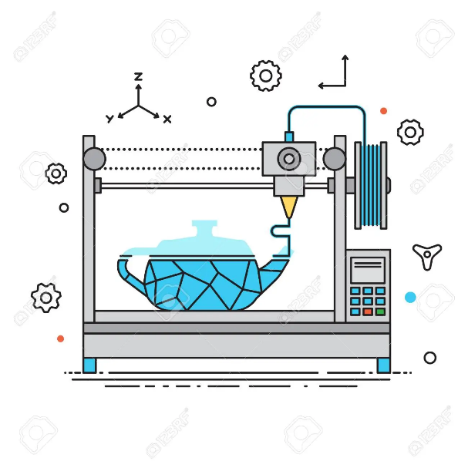
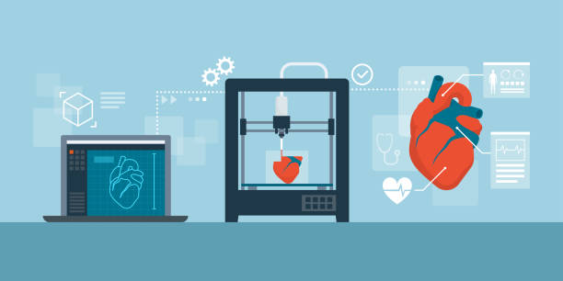
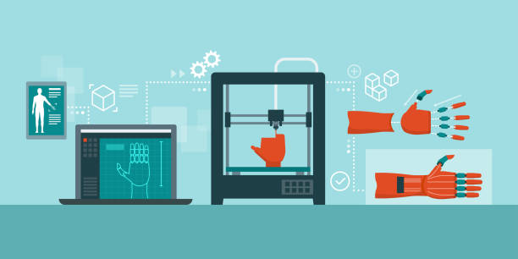

- Revolutionizing Everyday Applications: The Fusion of IoT and 3D Printing
Through useful applications including customized products, effective replacement parts, faster prototyping, empowering DIY projects, improved education and learning, artistic expression, and enriching hobbyist hobbies, the integration of IoT and 3D printing improves our daily life. These illustrations show how the combination of IoT with 3D printing opens up new possibilities for customization, practicality, effectiveness, creativity, and educational opportunities in numerous spheres of our lives. As these technologies develop, we can anticipate further integration and creative applications that will keep improving our daily lives.

a) What are the challenges of 3D printing in IoT?

The enormous long-term benefits that 3D printing in IoT offers are one of its main features. Initial obstacles might include the need for high-quality digital data, the cost of 3D printers and skilled employees, but these are one-time expenses that could pay off handsomely. Once the infrastructure is in place, the uses for the technology are nearly limitless and the possibilities are unlimited. The IoT holds great promise for the development of spectacular and affordable solutions thanks to ongoing improvements and refinements in 3D printing.

- Conclusion
As a result, the Internet of Things (IoT) and 3D printing are revolutionizing many industries and creating new opportunities for innovation and personalization. With the help of this potent combination, 3D printing procedures may be remotely monitored, customized, quickly prototyped, and run more efficiently (Tawalbeh et al., 2020).
We have already seen amazing progress in the creation of individualized medical implants, prosthetic limbs, and even cost-effective housing options. Complex geometries and specialized items, which were previously difficult to manufacture using conventional manufacturing techniques, are now possible.
Despite difficulties like the necessity for high-quality digital data and the price of 3D printers, ongoing technological developments and expanding accessibility will probably resolve these obstacles. This will increase the range of IoT applications for 3D printing.
The combination of 3D printing and IoT holds enormous promise for businesses ranging from manufacturing and healthcare to construction and education by promoting individualization, efficiency, and innovation. We can expect even more revolutionary discoveries in the future as we continue to push these technologies to their limits(Farooq et al., 2019).

In the end, the applications for 3D printing in the Internet of Things are only limited by our imagination. We may anticipate significant changes in the way we create, manufacture, and interact with the environment around us as a result of continual inquiry and innovation.

Reference
Baker, S. B., Xiang, W., & Atkinson, I. (2017). Internet of Things for Smart Healthcare: Technologies, Challenges, and Opportunities. In IEEE Access. https://doi.org/10.1109/ACCESS.2017.2775180
Boubiche, S., Boubiche, D. E., Bilami, A., & Toral-Cruz, H. (2018). Big Data Challenges and Data Aggregation Strategies in Wireless Sensor Networks. IEEE Access, 6, 20558–20571. https://doi.org/10.1109/ACCESS.2018.2821445
Chowdury, M. S. U., Emran, T. Bin, Ghosh, S., Pathak, A., Alam, M. M., Absar, N., Andersson, K., & Hossain, M. S. (2019). IoT based real-time river water quality monitoring system. Procedia Computer Science, 155(March 2020), 161–168. https://doi.org/10.1016/j.procs.2019.08.025
Domb, M. (2018). An Adaptive Lightweight Security Framework Suited for IoT. Internet of Things - Technology, Applications and Standardization. https://doi.org/10.5772/INTECHOPEN.73712
Farooq, U., Ul Hasan, N., Baig, I., & Shehzad, N. (2019). Efficient adaptive framework for securing the Internet of Things devices. EURASIP Journal on Wireless Communications and Networking 2019 2019:1, 2019(1), 1–13. https://doi.org/10.1186/S13638-019-1531-0
Gowri, K. R. (2019). Greenhouse Monitoring and Scheming based IoT Technology. EPRA IJRD, 4(4), 316–321.
Khot, I. M. (2020). IoT Assisted Drinkable Water Quality Analysis System using Machine Learning Techniques. International Journal for Research in Applied Science and Engineering Technology, 8(9), 228–236. https://doi.org/10.22214/ijraset.2020.31221
L’Heureux, A., Grolinger, K., Elyamany, H. F., & Capretz, M. A. M. (2017). Machine Learning with Big Data: Challenges and Approaches. IEEE Access, 5, 7776–7797. https://doi.org/10.1109/ACCESS.2017.2696365
Mohd Aman, A. H., Hassan, W. H., Sameen, S., Attarbashi, Z. S., Alizadeh, M., & Latiff, L. A. (2021). IoMT amid COVID-19 pandemic: Application, architecture, technology, and security. Journal of Network and Computer Applications, 174(October 2020), 102886. https://doi.org/10.1016/j.jnca.2020.102886
Nayyar, A., & Puri, V. (2017). Smart farming: Iot based smart sensors agriculture stick for live temperature and moisture monitoring using arduino, cloud computing & solar technology. Communication and Computing Systems - Proceedings of the International Conference on Communication and Computing Systems, ICCCS 2016, October, 673–680. https://doi.org/10.1201/9781315364094-121
Rahmani, A. M., Gia, T. N., Negash, B., Anzanpour, A., Azimi, I., Jiang, M., & Liljeberg, P. (2018). Exploiting smart e-Health gateways at the edge of healthcare Internet-of-Things: A fog computing approach. Future Generation Computer Systems. https://doi.org/10.1016/j.future.2017.02.014
Suciu, G., Istrate, C. I., & Ditu, M. C. (2019). Secure smart agriculture monitoring technique through isolation. Global IoT Summit, GIoTS 2019 - Proceedings. https://doi.org/10.1109/GIOTS.2019.8766433
Tawalbeh, L., Muheidat, F., Tawalbeh, M., & Quwaider, M. (2020). applied sciences IoT Privacy and Security : Challenges and Solutions. Mdpi, 1–17.
Vashi, S., Ram, J., Modi, J., Verma, S., & Prakash, C. (2017). Internet of Things (IoT): A vision, architectural elements, and security issues. Proceedings of the International Conference on IoT in Social, Mobile, Analytics and Cloud, I-SMAC 2017, February 2017, 492–496. https://doi.org/10.1109/I-SMAC.2017.8058399

