ADVANCES IN MICROENCAPSULATION: FROM TECHNIQUES TO APPLICATIONS
SUBASRI.G, RAM KUMAR.S, H.GAYATHRI
*SRM College of Pharmacy, SRMIST, Kattankulathur campus, Tamil Nadu, India.
Abstract:
Microencapsulation is a versatile and innovative technology with applications spanning various fields, including pharmaceuticals, food, cosmetics, agriculture, and more. This process involves encapsulating tiny particles or droplets within a protective shell, resulting in improved stability, controlled release, and enhanced functionality of the encapsulated materials. The encapsulation techniques can be classified into different categories such as spray drying, coacervation, emulsion-based methods, and layer-by-layer assembly. This abstract provides an overview of microencapsulation principles, methods, and their widespread applications. It highlights the significance of microencapsulation in extending product shelf-life, protecting sensitive ingredients, controlling release kinetics, and enabling targeted delivery. The choice of encapsulation material, core material, and encapsulation method greatly influences the final properties and performance of microcapsules. As research in microencapsulation continues to advance, the potential for designing novel formulations and optimizing encapsulation processes becomes increasingly promising. This abstract underlines the importance of microencapsulation as a tool for innovation in various industries and its role in shaping the future of functional materials and product design.
INTRODUCTION:
Microencapsulation is defined as a technique in which droplets or small particles of active substances or drug materials are embedded in a homogeneous or heterogeneous matrix or surrounded by a coating material of polymer, which gives small capsules of controlled control drug delivery[1]. A physical barrier is introduced between the core ingredient and the additional product elements that can be created by microencapsulation. Microencapsulation is a method for trapping liquid droplets, solid particles, or gas molecules in thin films of a microencapsulating polymer. One or more substances may make up the core, and the wall may have one or two layers. These cores' chemical functionality, solubility, polarity, and volatility all influence how long they can be retained[2] There are six reasons why microencapsulation is used in the pharmaceutical industry: to make handling easier, to control the rate of release at the targeted site, to avoid environmental reaction with the core material, to mask the taste of the core material, and to dilute the core material when it needed incredibly in small amounts[3].
Micro-encapsulation is a process that can provide tiny capsules by enclosing the minute particles or droplets of the core material or the active substance in an encapsulated covering. A microcapsule is a relatively simple kind of little spherical enclosed by an even wall. The refers to the substance contained within the microcapsule the wall, while the core, internal phase, or fill is occasionally referred to as a shell, covering membrane[4]. Typically, microcapsules have diameters. Within a range of a few micrometers and a few millimeters.

Morphology Microcapsules
Microcapsules are subcategorized into monocored, polycored, and matrix microcapsules. There is only one hollow chamber in a monocored microcapsule. The polycore microcapsules' shells contain chambers of various sizes. The active components of the matrix-type microparticle are incorporated into the shell material of polymer matrix. The materials chosen for the shell and the microencapsulation techniques used, however, have a significant impact on the morphology of a microparticle's internal structure[2]. The composition of the core and the method used to deposit the shell determine the form of microcapsules.
1. The shell material surrounds the mononuclear (core-shell) core.[3].
2. Multiple polynuclear cores are encased within the shell[3].
3. Homogeneous distribution of the core components within the matrix encapsulation's shell material[3]
RELEASE MECHANISM:
Different release mechanisms of encapsulated materials are available to allow controlled, sustained, or targeted release of core material. The core material that is enclosed in the capsule is released primarily through three separate ways.
• Mechanical separation of the capsule
• Wall disintegration or melting
• Wall diffusion
MICROENCAPSULATION METHODS | COATING MATERIAL | STEPS | APPLICATION | REFERENCE
CHEMICAL PROCESS  Coacervation or phase separation | Protein, polysaccharides, ethyl cellulose, gelatin, (drugs) | a. Formation of a three-immiscible chemical  phases  b. Deposition of the coating  c. Solidification of  the coating | Drug delivery | [5]
Supercritical fluid expansion | Paraffin wax, polyethylene glycol | a.The coating material is maintained at high temperature and the supercritical fluid contains core material.  b. then released through the nozzle, sudden reduction in pressure results in desolvation of the shell causing the shell to deposit on the core. | Used in encapsulation of pesticides, vitamins, flavours, and dyes. | [11]
Polymer-polymer incompatibility |  | a. Involves two polymers which have a common solvent  b. Forms separate phases, one is to form the wall, and another polymer is to induce the separation of polymer. | Drug delivery | [14]
Interfacial polymeriazation | Isocyanate, acid chlorides, polyamine, vinyl monomers. | a.multifuctional monomer is dissolved in liquid core material  b. coreactant monomer is added , results in rapid condensation polymeriazation reaction at the interface and generates polymeric capsule shell | Drug delivery | [15]
MECHANICAL PROCESS  Spray drying | Polymers ( food ingredient) | a. Preparation of the dispersion  b. Homogenization of the dispersion  c. Atomization of the infeed dispersion.  Dehydration of the atomized particles | Food technology | [13]
Spray congeling | Waxes, fatty acids, alcohol and polymer which are meltable at room temperature. | a. Spray drying equipment can used  b. core material is dispersed in the coating material.  c. Introduce the hot spray mixture into the cool stream | Drug delivery | [16]
Fluidized-bed coating | Gelatin, carbohydrates, lipids | a. Making the coating solution.  b. Core particle fluidization.  c. Core particle coating | Food technology | [20]
Table 1: Microencapsulation methods

Fig 1 Microencapsulation technique classification
Coacervation:
The first recorded microencapsulation technique that has been applied to the commercial production of microparticles is coacervation. Carbonless copy paper was the first large commercial product to use coacervation[5]. A homogeneous polymer solution is partially desolvated during coacervation to form a polymer-rich phase (coacervate) and a polymer-poor, diluted liquid phase (coacervation medium). Simple and complex coacervation have been identified as the two forms of coacervation. With the difference of how phase separation is accomplished, the mechanisms of microparticle production for these two processes are comparable. Simple coacervation necessitates either a change in the polymer solution's temperature or the addition of a desolvation agent, typically a water-miscible non-solvent like ethanol, acetone, dioxane, isopropanol, or propanol[6]. On the other hand, complicated coacervation entails causing polymer-polymer interaction between two oppositely charged polymers, resulting in phase separation as a result of electrostatic interaction between the two polymers. The development of immiscible phases is typically followed by polymer deposition on the core material(s) for both simple and complex coacervation[7]. By cross-linking, desolvation, or temperature change, the deposited polymer can be stabilized.
Several process variables are necessary for the effective coacervation of medicines. The viscosity and kinds of coacervates used have a substantial impact on a coacervating agent's ability to disperse and absorb dispersed medications. Complex coacervation is influenced by electrostatic interactions, hence the pH of the medium must be carefully controlled to maintain control of the polymeric species charges[8]. For instance, the pH should be adjusted in a gelatin-gum Arabic combination to be below the isoelectric point of the gelatin so that the positively charged gelatin is drawn to the negatively charged gum Arabic. The same study demonstrated that the microparticle size distribution is influenced by the medium's rate of acidification. The concentration of surfactants employed in the process is another consideration. Several studies have shown how different surfactant concentrations affect drug loading, coacervation yield, and particle size distribution[9].
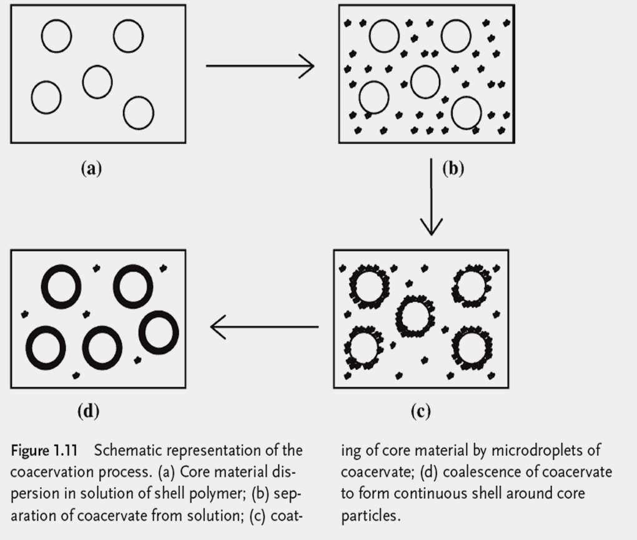
Fig 2: Microencapsulation by coacervation phase separation
Supercritical fluid expansion:
A greater range of options is available when using supercritical fluids as solubilizing agents for core and/or shell materials. The two crucial factors in this specific microencapsulation method, temperature, and pressure, can change how well supercritical fluids can dissolve the materials in the core and shell[10]. The use of supercritical fluids as extractants in addition to solvating the active ingredients is well established. As a result, if the initial solution is properly prepared, the final microencapsulated product can be produced in a single step that involves two main processe[11]. the precipitation of compounds by supercritical fluid in the supercritical anti-solvent process and the solvation of active principles by supercritical fluid in the rapid expansion of supercritical solutions (RESS) process[12].
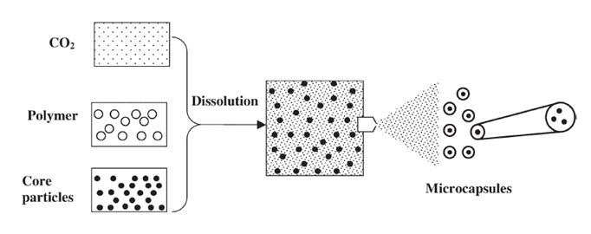
Fig 3: Microencapsulation by supercritical fluid expansion

Sprayed Drying
A commercially effective, relatively inexpensive method of microencapsulation is spray drying. Spray drying is being used in a variety of commercial settings, including the food industry's encapsulation of flavors and scents and the production of paint pigments in the production of microencapsulation[13]. The method involves the core material being emulsified or mixed initially with a strong solution of the shell's composition. After that, the mixture is turned into a solvent is heated in a gas carrier chamber. To create dry microparticles, the liquid is quickly removed. One significant benefit of spray drying is the capacity to mass Microparticle production is reasonably simple and inexpensive. However, a significant restriction is the limited use of many owing to concerns with flammability, chemicals besides water[14]. Spray drying is being used in a variety of commercial settings, including the food industry's encapsulation of flavors and scents and for the production of paint pigments in the production of Dual forms of soluble shell materials or at the very least water-dispersible. At the moment, other solvent alternatives as a cosolvent system with ethanol and water and methylene chloride are being investigated. The limited control over the drying process using spray drying is another drawback. geometries of the generated microparticles and their propensity to agglomerate. The primary emulsion's viscosity and particle size distribution significantly affect the morphology. and the subsequent spray drying process's size distribution. For instance, if the viscosity is excessively high, lengthy and Large droplets can develop. The amount of wall-forming components in the solution directly affects the Core material effectiveness for microencapsulation[15]. Various processing criteria must be met during spray drying can be enhanced to generate high-quality microparticles. Feed temperature and air inlet are a few of these variables and outlet temperatures , the rate at which the emulsion mixture is provided to the atomizer, and the rate at which air is introduced flow . enhancing these and numerous more elements that effect spray drying microencapsulation are mostly tested through a trial-and-error process.
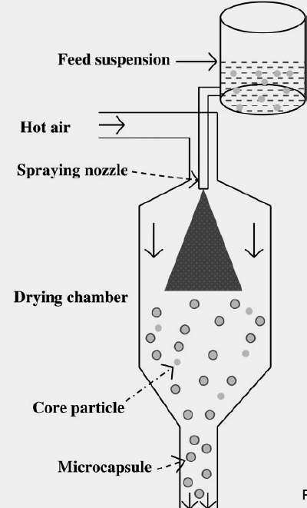
Fig 4 : Microencapsulation by spray drying method

Spray Congealing:
Spray coating is frequently used to enclose porous or solid particles. In spray coating procedures, coating is done rotating the particles and it is moved in a predetermined pattern to enable an even application of a liquid coating mixture to their surfaces. By cooling or allowing the solvent to evaporate, the coating formulation is allowed to dry. The coating procedure can often be repeated until the appropriate capsule thickness is reached[15]. Spray coating can be roughly categorized as either pan coating or fluidized bed coating , depending on how the particles are rotated and combined. While the latter has a greater tendency to coat the surface of tablets, the former is routinely used in microencapsulation. Only fluidized bed coating will be covered in this talk. The solid microparticles are suspended by flowing in the gas stream, fluidized bed coaters carry out their duty. There are three different types of fluidized bed coaters: top spray, tangential spray, and bottom spray. For different compositions of the liquid the nozzle position of the spray varies accordingly. A top spray coater sprays the coating solution onto the fluidized bed dryer from the top of the apparatus[16]. If the coating solution contains a volatile solvent, the amount of solids in the coating formulation droplet will increase over the period of time it spends before coming into contact with the microparticle, which will hinder the droplet's ability to spread on the particle surface. As a result, this method frequently produces microparticles with porous coverings and a limited amount of interior empty space. More continuous coatings can be produced by units that use tangential and bottom spray (also known as Wurster spray). In these two types of fluidized bed coaters, the sprayed droplets move in the same direction as the gas stream transporting the microparticles. The coating formulation makes contact with the microparticles' surface before actually doing so,by minimizing the evaporation of the solvent travels short distance
The coated items are then transported by the gas stream into the spray coating unit's upper section, where the coating can harden by solvent evaporation or cooling. Once the microparticles have settled, a new cycle can start. Up until the appropriate coating thickness is reached, this procedure is repeated. Currently, process analytical technologies (PAT) like near-infrared (NIR) spectroscopy are used to monitor the drying process. Compared to the other encapsulation techniques, spray coating methods' quality of encapsulation may be more dependent on physical factors. The quality of the coating is affected by a number of variables within the same type of spray coating system, including the rate of gas flow, the distance from the nozzle to the bed, the quantity of nozzles being used, and the rate of spraying, for example Premature solvent evaporation could happen if the distance between the nozzle and the bed is too great, leaving parts of the microparticles' surfaces unevenly coated. In addition to physical characteristics, physicochemical elements like the density of the core material and the viscosity of the coating formulation also have an impact on spray coating quality.
Centrifugal Extrusion:
Two immiscible liquids must be pushed into a rotating two-fluid nozzle as part of the centrifugal extrusion process. While the shell liquid is delivered into the peripheral fluid channel, the core fluid is fed into the center fluid channel. The two-liquid column spontaneously fragments into a stream of tiny droplets as it leaves the nozzle. Liquid-filled shells encircle droplets with liquid centres. Rapid cooling can cause shell material to harden as the droplets form. Alternatively, the droplets may fall away from the nozzle. may plunge into a bath of gelling, which transforms the aqueous shell into a gel-like capsule. The technique used to solidify depending on the shell's polymer's characteristics material[17].
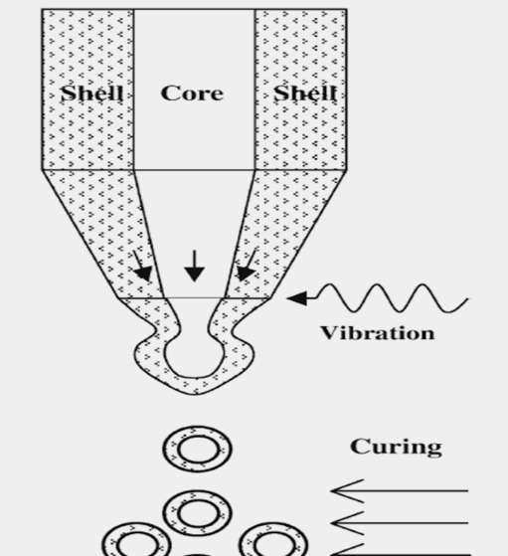
Fig 5 : Microencapsualtion by centrifugal extrusion

Fluidized bed coating:
It is especially efficient to use fluidized bed technology by applying a homogeneous layer of the coating material to the core material, the coating solution contains a volatile solvent[18]. It's noteworthy that fluidized bed technology is one of the few state-of-the-art methods that may coat particles with any kind of external substance, including polysaccharides, proteins, emulsifiers, lipids, complex formulations, enteric coating, powder coatings, yeast cell extract, etc[19]. Therefore, the fluidized bed technology offers much better flexibility for controlled release alternatives than other techniques. Aqueous solutions of hydrocolloids such as proteins and gums, ethanolic solutions of synthetic polymers, and melted fats and waxes have all been employed as coating formulations in fluidized bed microencapsulation techniques[20]. Spray-dried microcapsules may eventually be coated to improve their stability and protected with a fat layer by fluidized bed-drying
In this method, the coating material is atomized by high velocity air were the coating material is suspended on the solid material by temperature controlled chamber and humidity controlled chamber. Between 50 and 500 microns of particle size yield the best outcomes[21]. The distribution of particle sizes should also be restricted. Depending on how long the particles are in the chamber, different amounts of material will coat them. This method works with solvent-based coatings like starches, gums, and maltodextrin as well as hot-melt coatings like stearines, fatty acids, emulsifiers, and waxes[22].

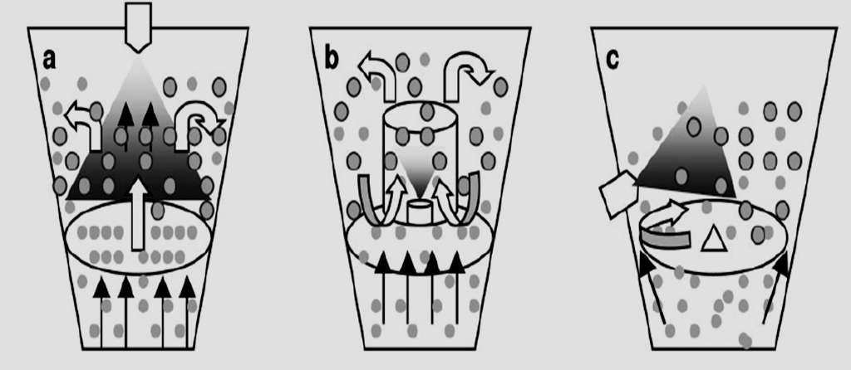
Fig 6: Microencapsulation by fluidized bed drying
APPLICATION:
PHARMACEUTICALS:
- Pharmaceutical and biomedical industries are one of the main industries where encapsulation method is used for controlled/sustained drug delivery[22].
- This drug delivery system may be used to substitute therapeutic medicines (such as insulin, which is not currently taken orally) for gene therapy, and to administer vaccinations for the treatment of AIDS tumors,cancer, and diabetes[23].
- Drugs that are proteins like insulin, growth hormone, and erythropoietin (used to treat anemia) are examples of those that would profit from this novel oral delivery method[24].
- A number of hereditary illnesses, including cystic fibrosis and hemophilia, may be treatable by the transfer of corrected gene sequences in the form of plasmid DNA[25].
FOOD INDUSTRY:
- By offering effective texture mixing, enticing scent release, and taste, odor, and color masking, microencapsulation is employed to address all of these difficulties.
- Food producers may now add essential oils, flavors, vitamins, and minerals thanks to technology[26].
- Microencapsulation can also reduce production costs by permitting batch processing with inexpensive powder handling equipment, simplifying the food manufacturing process by turning liquids into solid powder[27].
DEFENCE:
- Self-healing polymers and composites are one of the key defense applications for microencapsulation technology.
- They have the potential to provide highly durable structural materials due to the presence of microencapsulated healing agents contained within the matrix[2].

References:
- N. Venkata Naga Jyothi, P. Muthu Prasanna, Suhas Narayan Sakarkar, K. Surya Prabha, P. Seetha Ramaiah & G. Y Srawan (2010) Microencapsulation techniques, factors influencing encapsulation efficiency, Journal of Microencapsulation, 27:3, 187-197, DOI: 10.3109/02652040903131301
- Deasy PB. Microencapsulation and related drug processes. Drugs and the pharmaceutical sciences. 1984;20.
- Jyothi NV, Prasanna PM, Sakarkar SN, Prabha KS, Ramaiah PS, Srawan GY. Microencapsulation techniques, factors influencing encapsulation efficiency. Journal of microencapsulation. 2010 May 1;27(3):187-97.
- Poshadri A, Aparna K. Microencapsulation technology: a review. Journal of Research ANGRAU. 2010;38(1):86-102.
- Kas HS, Oner L. Microencapsulation using coacervation/phase separation: An overview of the technique and applications. Marcel Dekker, Inc.: New York, NY, USA; 2000 Aug 24.
- Arshady R. Microspheres and microcapsules, a survey of manufacturing techniques Part II: Coacervation. Polymer Engineering & Science. 1990 Aug;30(15):905-14.
- Timilsena YP, Akanbi TO, Khalid N, Adhikari B, Barrow CJ. Complex coacervation: Principles, mechanisms and applications in microencapsulation. International journal of biological macromolecules. 2019 Jan 1;121:1276-86.
- Aloys H, Korma SA, Alice TM, Chantal N, Ali AH, Abed SM, Ildephonse H. Microencapsulation by complex coacervation: Methods, techniques, benefits, and applications-A review. American Journal of Food Science and Nutrition Research. 2016;3(6):188-92.
- Gharanjig H, Farzi G. Microencapsulation: Coacervation phase separation. InPrinciples of Biomaterials Encapsulation: Volume One 2023 Jan 1 (pp. 323-376). Woodhead Publishing
- Fages J, Lochard H, Letourneau JJ, Sauceau M, Rodier E. Particle generation for pharmaceutical applications using supercritical fluid technology. Powder Technology. 2004 Mar 30;141(3):219-26.
- Perrut M, Clavier JY. Supercritical fluid formulation: process choice and scale-up. Industrial & engineering chemistry research. 2003 Dec 10;42(25):6375-83.
- Kröber H, Teipel U. Microencapsulation of particles using supercritical carbon dioxide. Chemical Engineering and Processing: Process Intensification. 2005 Feb 1;44(2):215-9.
- I Ré M. Microencapsulation by spray drying. Drying technology. 1998 Jan 1;16(6):1195-236.
- Janiszewska-Turak E. Carotenoids microencapsulation by spray drying method and supercritical micronization. Food research international. 2017 Sep 1;99:891-901.
- Soottitantawat A, Yoshii H, Furuta T, Ohkawara M, Linko P. Microencapsulation by spray drying: influence of emulsion size on the retention of volatile compounds. Journal of food science. 2003 Sep;68(7):2256-62.
- Gharsallaoui A, Roudaut G, Chambin O, Voilley A, Saurel R. Applications of spray-drying in microencapsulation of food ingredients: An overview. Food research international. 2007 Nov 1;40(9):1107-21.
- Badalan M, Ghigliotti G, Achard JL, Bottausci F, Balarac G. Physical analysis of the centrifugal microencapsulation process. Industrial & Engineering Chemistry Research. 2022 Jul 25;61(30):10891-914.
- Semyonov D, Ramon O, Kovacs A, Friedlander L, Shimoni E. Air-suspension fluidized-bed microencapsulation of probiotics. Drying Technology. 2012 Dec 15;30(16):1918-30.
- Frey C. Fluid bed coating-based microencapsulation. InMicroencapsulation in the Food Industry 2023 Jan 1 (pp. 83-115). Academic Press.
- Gouin S. Fluidized bed microencapsulation: Thermodynamics of aqueous and ethanolic coating processes. Journal of microencapsulation. 2005 Jan 1;22(8):829-39.
- Frey C. Fluid bed coating-based microencapsulation. InMicroencapsulation in the Food Industry 2023 Jan 1 (pp. 83-115). Academic Press.
- Semyonov D, Ramon O, Kovacs A, Friedlander L, Shimoni E. Air-suspension fluidized-bed microencapsulation of probiotics. Drying Technology. 2012 Dec 15;30(16):1918-30.
- Richardson JJ, Teng D, Björnmalm M, Gunawan ST, Guo J, Cui J, Franks GV, Caruso F. Fluidized bed layer-by-layer microcapsule formation. Langmuir. 2014 Aug 26;30(33):10028-34.
- Pasha A, Utekar S, Ghosh R. Recent advances in Microencapsulation Technology and their Applications. The Bombay Technologist. 2021 Oct 6;68(1).
- Gouin S. Fluidized bed microencapsulation: Thermodynamics of aqueous and ethanolic coating processes. Journal of microencapsulation. 2005 Jan 1;22(8):829-39.
- Arshady R. Microcapsules for food. Journal of Microencapsulation. 1993 Jan 1;10(4):413-35.
- Jackson LS, Lee K. Microencapsulation and the food industry. Lebensm. Wiss. Technol. 1991 Jan 1;24(4):289-97.

