Computerized Tomography and Radiological Diagnosis of Two Cases of Eagle Syndrome

INTRODUCTION

Elongated styloid process related to an ossifying process of the stylohyoid ligament was first described by Pietro
Marchetti in 1652.

Watt Weems Eagle, a Rhinolarygologist, later defined Eagle syndrome in 1937. Eagle considered any styloid process longer than 25 mm in an adult to be abnormal.¹ About 4% of the population has long styloid process more than 3 cm; Watt Weems Eagle, a Rhinolarygologist, later defined Eagle syndrome in 1937. Eagle considered any styloid process longer than 25 mm in an adult to be abnormal.¹ About 4% of the population has long styloid process more than 3 cm;

Eagle syndrome is a rare and unusual cause of head and neck pain. It can be confused with propharyngeal and maxillofacial disorders and particularly with cranial neuralgias but with appropriate clinical history and radiography, Eagle syndrome can easily be identified and treated.³
Although exact etiology is not known, dystrophic and degenerative changes in the hyoid complex of the styloid process is the cause of Eagle syndrome. Purulent facial and cervical inflammation, tumors, tonsillectomies and trauma play a major role.⁴

CASE REPORT 1:
A female patient aged about 32 years had a complaint of pain in her neck since 5 years. The pain was radiating to side of the face and jaws. The patient consulted a orthopedician and was diagnosed as spondylosis and was given treatment accordingly.

No investigations were done at that time. The pain was persistent even after the treatment and the patient consulted a dental surgeon with a complaint of pain in temporomandibular joint. The dental surgeon provisionally diagnosed as impacted 3rd molar and referred the patient for orthopantomography (OPG).

Her past medical history was insignificant and she had undergone professional cleaning from dentist. She had undergone root canal treatment of few teeth and did not have any problem with the same. The length of the calicified stylohoid ligament was 35 mm and she also experienced stiffness of the neck. Her left third molar was surgically extracted and had an uneventful healing but the pain in the neck was still persistent. Though OPG revealed horizontal impaction of lower left 3rd molar, calcification of stylohyoid ligament was also noticed (Image-1). The
patient was then finally diagnosed as Eagle syndrome and advised to undergo further investigations and surgical treatment.
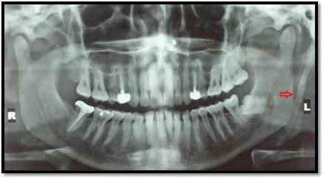

CASE REPORT 2
A female patient aged 24 years reported with pain in right lower posterior region for the past 4-5 days. Patient reported about medical history of polycystic ovarian disorder which was being treated by the gynaecologist. Past dental history was insignificant. On examination it was found patient was suffering from Pericoronitis and the patient had been advised to take antibiotics for the same (Amoxycillin+Clavulanic acid) and analgesic for 7 days. The patient wasn’t convinced for the treatment.
offered for both impacted third molar and the elongated styloid process. The patiencame back and reported with heaviness behind the both right and left ear lobes and she was advised for OPG (digital X- ray) and CBCT after suspecting elongated stylohyoid process and to see the impacted teeth. OPG (Image & 2.2) and CBCT (Image 2.3 & 2.4) revealed elongated styloid process on both sides and was diagnosed as Eagle syndrome. Patient was explained about the syndrome and the treatment options.

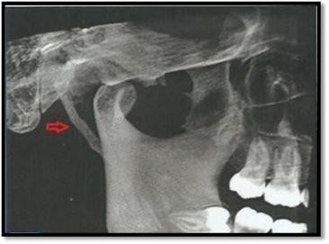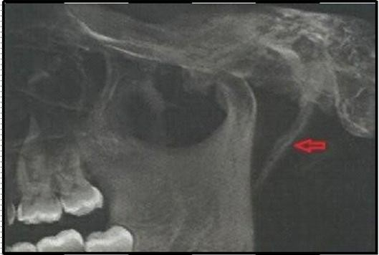

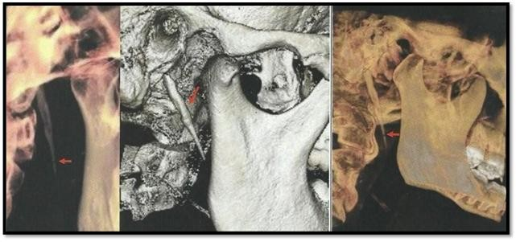

Discussion

Orofacial pain secondary to calcification of stylohyoid ligament or elongated styloid process has been known as Eagle syndrome. Eagle defined the normal length of stylohyoid process as 2.5 to 3cm. Coorel et al. (1979) defined the normal length as ˂2.5cm. According to Lindemann normal length of styloid process is ˂3cm. On an average ˃2.5 to 3cm is considered significant. 4 % of the general population are affected by this and out of this 4% are symptomatic. Male: female ratio is 1:3. Bilateral pain is quite common, but most commonly unilateral involvement. Eagle syndrome manifests as dull aching persisted pharyngeal pain, radiating to the ipsilateral ear, or foreign body sensation in the throat, dysphagia, pain on twisting the neck. There are three theories of aetiology regarding the development of Eagle syndrome. The persistence of the cartilaginuous precursor leads to congenital elongation of the styloid process was his first theory, the second theory explains that by a mysterious process calcification of the stylohoid ligament occurs, and the third theory is regarding the growth of osseous tissue at the insertion of the stylohyoid ligament.6.Three mechanisms can cause ossification of stylohyoid ligament (Steinmann et al.,) 7: Reactive hyperplasia, when trauma activates the remnants of the original connective and fibro cartilaginous cells. Reactive metaplasia, or an abnormal healing following a trauma that initiates ossification of the stylohyoid ligament; and Anatomic variance, which occurs without any distinctive trauma
Etiology is highly complex. Trauma or embryonic origin, osseous metaplasia of Reichert’s cartilage residue from which styloid process develops.5 Syndrome was divided into two forms by Eagle, Classic type and carotid type. The classic type develops after tonsillectomy, when scar tissue under the tonsillar fossa compresses and stretches cranial nerves 5th, 7th, 9th and 10th.1 In carotid artery type compression of external and internal carotid artery due to medially deviated elongated styloid process produces tinnitus, dysphagia, headache and orofacial pain.5
Diagnosis is based on clinical signs, digital palpation of styloid process in the tonsillar fossa, radiological finding and lidocaine infiltration test. 3D CT is considered to be the gold standard for the diagnosis of Eagle syndrome, also OPG or a cranial radiograph using a lateral projection are of great importance. Differential diagnosis of Eagle syndrome should include trigeminal neuralgia, migraine headache, TMJ disorders, temporal rachitis, pterygomandibular space infections due to third molar impaction and faulty dental prostheses.8

Cone Beam Computed Tomography (CBCT) is an advanced medical imaging technique. It generates three dimensional images with a lower absorbed dose when compared with Computed Tomography scan (CT) and at the lower cost. Imaging is accomplished by using a rotating gantry to which cone shaped x-ray source and detector are fixed. The cone shaped x-ray beam on a two dimensional detector performs a single rotation around the object, producing
a series of two dimensional images. These images are then reconstructed in three dimensional using a modification of original Cone Beam algorithm (Feldkamp et al 1984). CBCT images of craniofacial region are often collected with a higher resolution than those collected with conventional CT. 9 Pharmacological treatment included analgesics, anticonvulsants, antidepressants. Surgical excision can be done by intraoral or extraoral approaches. In the intraoral approach, the styloid process is found with palpation of the tonsillar fossa. The overlying mucosa and superior constrictor muscle are incised vertically, and the styloid process are dissected out and resected using a rongeur forceps. The intraoral approach is good for aesthetic consideration as external scarring is avoided and for shorter operative times. The intraoral approach also has the disadvantages of poor access, as in cases of trismus, and risk of intraoperative injury. An extraoral approach involves making a cervical incision from the proximal portion of the sternocleidomastoid muscle to the hyoid bone, and then dissecting and removing the styloid process. The external approach has the advantage of good anatomic exposure of the styloid process. However, it requires more intervention and results in a visible scar. The common complications are neck space infection and facial nerve involvement. Careful dissection and good antibiotic coverage pre and post operatively can avoid these complications.10

CONCLUSION:
Though with specific signs and symptoms Eagle syndrome cannot be diagnosed without proper investigations. The role of dental surgeon, otolaryngologist and surgeons are very important for the proper diagnosis and treatment of Eagle syndrome. In any case of pain in the head and neck region differential diagnosis should be made of Eagle syndrome and should be ruled out with proper investigations

REFERENCES:
    - Chang-Sig Moon et al., Eagle’s syndrome: a case report. J Korean Assoc Oral Maxillofac Surg 2014; 40:43-47.
    - Hadi Sasani, Ozgur Ceyhan, Serre Sencer, Mehdi Sasani. 3D reconstruction computerized tomography findings of an asymptomatic Eagle’s syndrome patient: a case report. International Journal of Anatomical Variations (2013) 6:176-178.
    - Iram Fatma Uludag, levent Ocek, Yasar Zorlu, Burhanettin Uludag. Eagle syndrome: case report. AGRI 2013;25(2):87-89.
    - Navbir Pasricha, Alka Nagar, R S Bedi, Antima Gupta and Karan Punn. Anatomical Perspective of Eagle’s syndrome: Review and a Case report. Asian Journal of Oral Health & Allied Sciences 2012, Volume 2, Issue 1, 35- 39.
    - R Shyamala. Stylalgia – Eagle’s syndrome – Case report. Chettinad Health City Medical Journal, 65-66.
    - Moon CS, Lee BS, Kwon YD, Choi BJ, Lee JW, Lee HW, Yun SU, Ohe JY. Eagle's syndrome: a case report. J Korean Assoc Oral Maxillofac Surg. 2014 Feb;40(1):43-7
    - Ranjan V, Rai S, Misra D, Panjwani S. Eagle's syndrome veiling as pain of odontogenic origin: Report of two cases with cone beam computed tomography illustration. Natl J Maxillofac Surg. 2015 Jul-Dec;6(2):219-2
    - Thoenissen P, Bittermann G, Schmelzeisen R, Oshima T, Fretwurst T. Eagle's syndrome-A non-perceived differential diagnosis of temporomandibular disorder. Int J Surg Case Rep. 2015;15:123-6
    - Venkatesh E, Elluru SV. Cone beam computed tomography: basics and applications in dentistry. J Istanb Univ Fac Dent. 2017 Dec 2;51(3 Suppl 1):S102-S121.
    - Saccomanno S, Greco F, DE Corso E, Lucidi D, Deli R, D'Addona A, Paludetti G. Eagle's Syndrome, from clinical presentation to diagnosis and surgical treatment: a case report. Acta Otorhinolaryngol Ital. 2018 Apr;38(2):166-169

