"Revolutionizing Safety:

Automatic Seatbelt Integration for Enhanced Protection"

Prof. Bhushan Subhashrao Deshmukh
Professor, Dept. of Mechanical Engineering, MVPSs Rajarshi Shahu Maharaj Poly., Nashik, Maharashtra, India
---------------------------------------------------------------------***-------------------------------------------------------------------
-

ABSTRACT
It observed that the people who drive the vehicle other than metro cities like. Village area generally not uses seatbelt compulsory. It is breaking the traffic rules also will have safety problem of driver of car as well as passenger. To overcome this problem & to compulsory use of seatbelt we will make this system for driver safety. The statement of project is “design & development of automatic seatbelt integrated safety parking brake system” for used in safety of automobile. The main purpose of this project is to ensure drivers safety through a modified handbrake in car.
Key words: Handbrake, pneumatics, automation, safety.[3]

- INTRODUCTION

The number one reason of this undertaking is to ensure drivers protection through a changed handbrake in car. A handbrake is a further braking mechanism installed on all industrial automobiles that’s completely end up unbiased from foot pedal -operated in motors the parking brake, moreover called hand brake, emergency brake, or brake, is a latching brake, usually used to preserve the car table bound. Most usually used to prevent the automobile from rolling even as it's far parked. Car hand brakes embody a cable right away associated with the brake mechanism on one quit and to a lever on the driving pressure's feature. The usage of your handbrake to prevent a transferring automobile can harm the brake tool. Pneumatics is a section of generation that offers with the study and application of pressurized gasoline to provide mechanical motion. Pneumatic structures which can be used extensively in organization and factories are usually plumbed with compressed air or compressed inert gases. This is because a centrally placed and electrically powered compressor,
that powers cylinders and different pneumatic devices through solenoid valves, can often offer purpose power in a less expensive, greater relaxed, extra flexible and further reliable manner than a big type of electric powered motors and actuators. Pneumatics also has packages in dentistry, creation, mining, and different regions. Welding, superior insulating functions and design versatility. Simplicity of layout and manage - Machines are without problems designed the usage of fashionable cylinders and other components, and function thru easy on-off manage. Reliability- Pneumatic systems commonly have long going for walks lives and require little renovation.[1]

  - Problem Statement

It observed that the people who drive the vehicle other than metro cities like. Village area generally not uses seatbelt compulsory. It is breaking the traffic rules also will have safety problem of driver of car as well as passenger. To overcome this problem & to compulsory use of seatbelt we will make this system for driver safety. The statement of project is “design & development of automatic seatbelt integrated safety parking brake system” for used in safety of automobile.

  - Objective

To reduce the greater efforts during operation of handbrake elimination on the time of starting of vehicle braking gadget.
To hold the accuracy in hand brake operation in case of hand brake isn't absolutely do away with or lock in case of emergency braking system operation.

LITRATURE REVIEW

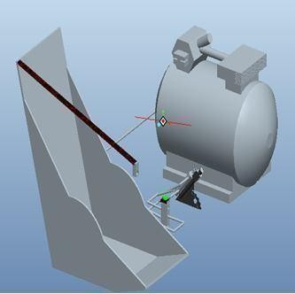
So as to get the idea approximately the area of research it's far critical to discuss the some of the previous study undertaken in this subject. Review of the literature shows that one of a kind researchers and professionals within the fields of situation monitoring of machines have mentioned various components of the monitoring of machines. This examine is an attempt to address the troubles related to machines fitness condition and the issues associated with respective causes.

GAP ON LITERATURE REVIEW

From papers which studied for literature evaluate, it’s observed that there is no examine did to locate the answer of layout & development of computerized Seatbelt incorporated safety Parking Brake gadget . So there is nonetheless scope for the research to develop computerized Seatbelt included protection Parking Brake machine , it reasons the rack to move linearly inflicting the engagement of handbrake. On turning the ignition on and tasty the equipment lever a spring connected to handbrake robotically disengages the handbrake.[4]

WORKING

The inlet port of the five/2 pneumatic Solenoid valve is been related to the compressor, The five/2 valve is been integrated within the seat belt locket in the sort of manner that the seat belt give up turns on the frenzy button, Double acting cylinder is been clamped along the frame of the hand brake. The end of the piston rod is bolted with the clamp connecting with the hand brake A Solenoid valve type pneumatic valve is being incorporated inside a seat belt locket. Whilst the seat belt is been locked it activates the Solenoid valve. With the aid of this pneumatic cylinder is been activated. The pneumatic cylinder is been welded with the clamp related with the hand brake lever. At some stage in the forward stroke of the piston the lever of hand brake is been pushed down and the brake is launched. On return stroke the lever is delivered to its preliminary role.[1]

Fig3.2. Assembled view of the safety parking brake setup.

CONTRUCTION

  - Double acting cylinders:
Cylinders are linear actuators which convert fluid energy into mechanical electricity. They are also known as JACKS or RAMS. Hydraulic cylinders are used at excessive temperature and produce massive forces and unique movement. Because of this, they're built of strong substances which include metallic and designed to resist huge forces. Because fuel is an steeply-priced substance, it's far risky to use pneumatic cylinders at excessive pressures so they're confined to approximately 10 bar pressures. Therefore, they're comprised of lighter materials which include aluminum and brass. Due to the fact fuel is a compressible substance, the motion of a pneumatic cylinder is difficult to govern exactly.[2]

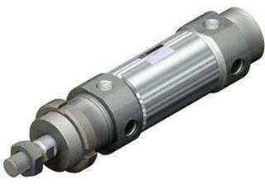

Fig4.1. Double acting cylinder

Pneumatic pipe fittings:
Pneumatic tubing is likewise available in some of different materials each with and without reinforcement for use in trendy packages. SMC fittings comprise a tremendous tube seal whilst the precise is below strain which lets in polyurethane tubing to be used. This may be used for connection of pneumatic gadget with assemble.
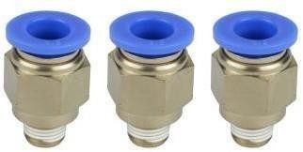
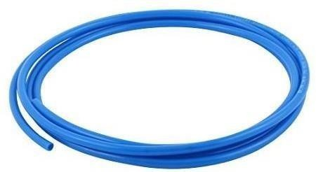

Fig.4.2. Pneumatic hoses and fittings.

Hand brake set:
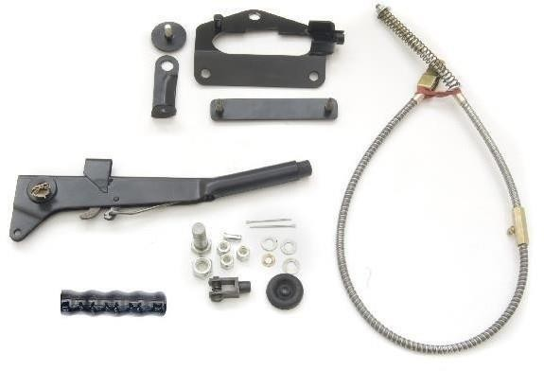

Fig.4.3. Hand brake set.

Seat belt:

4.5 Seat belt and lock clamp:
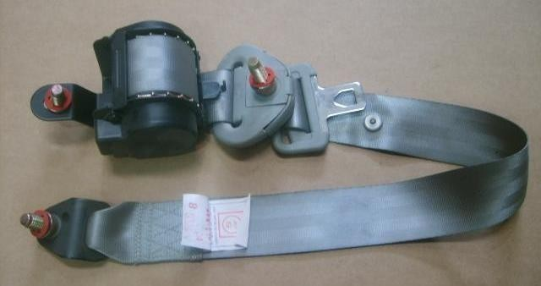
Fig4.4. Seat & belt lock.

CONCLUSION
Even as concluding this record, we experience quite satisfy in having completed the assignment mission well on time, we had substantial sensible enjoy on fulfillment of the manufacturing schedules of the working assignment model. We're therefore, glad to state that the in calculation of mechanical flair proved to be a very useful purpose.
Although the design criterions imposed difficult troubles which, but have been overcome via us due to availability of accurate reference books. The selection of preference uncooked substances helped us in machining of the various components to very close tolerance and thereby minimizing the level of balancing trouble. Pointless to emphasis right here that we had elevate no stone unturned in our ability efforts at some stage in machining, fabrication and assembly work of the assignment version to our complete pride.[2]

- REFERENCES

- Naveen Kumar.B, Lokesh Raj.K, Ramerow Jacob.R, Santhosh.B, & Ravi
Prasad.P.S, Design of Seatbelt Activated Handbrake System In Cars, International
Journal of Mechanical And Production Engineering, ISSN: 2320-2092, Volume- 2, Issue-10, Oct.2014, pp.53-55.

- S. Ekinovic A, E. Saric B, Optimisation of the composing part of hand brake mechanism, Journal of Achievements in Materials and Manufacturing Engineering, VOLUME 24 ,ISSUE 1 September 2007,pp.208-211.

- William K. Lennon and Kevin M. Passino, Intelligent Control for Brake Systems ,
IEEE Transactions On Control Systems Technology, Vol. 7, No. 2, March 1,pp.188- 202.
Sanjay B S, Sunil M K, Akhilesh P, Nataraj G & Sunil Kumar B., Design and
Fabrication of Automatic Hand Braking System, IJSRD - International Journal for
Scientific Research & Development| Vol. 5, Issue 04, 2017 | ISSN (online): 2321- 0613, PP.729-731.

[4] Rohan E. Dalvi, Ramesh G. Sutar, Prashant H. Karke & Jitendra B. Satpute,
Design and Development of Hand Brake Release System, GRD Journals- Global
Research and Development Journal for Engineering | Volume 2 | Issue 6 | May 2017, ISSN: 2455- 5703, PP.280-284.

[5] Aditya Kapadnis, Ajinkya Khairnar, Aniket Kumbhar, Mr. Y. S. Khadke
Automatic Seat Belt Integrated Parking in a Car
International Journal of Advanced Research in Science, Communication and Technology (IJARSCT) Volume 7, Issue 2, July 2021

