DESALINATION AND ADVANCED WATER TREATMENT

RADHIKA JAMWAL^{1*}, MONIKA PANCHANI², SANJAY NARANG³, MANOJ THAKUR⁴
^{1,2,3}Department of Zoology, Vallabh Govt. College, Mandi, Himachal Pradesh, India
⁴Department of Enviornment Sciences, Vallabh Govt. College, Mandi, Himachal Pradesh, India
^{1*}radhika.jamwal09@gmail.com, 9418080991

Abstract: Water covers about 71%the Earth's surface, oceans hold 97.5% percent and the remaining 2.5% is fresh water is locked up in the atmosphere, ground, glaciers and ice caps. Only 1% this fresh water is drinkable. Out of that, only ∼0.014% is directly accessible for human beings and other forms of life. Therefore, there is constant need for fresh water, required for drinking or agriculture purposes. Thus, water treatment methods becomes utmost importance, especially the most desired one developed is desalination of seawater using desalination plants. The conventional wastewater treatment methods are used to reduce the amount of suspended or floatable materials and treatment of biodegradable organic matters present in it. But advanced wastewater treatment methods are mainly used to eliminate all nutrients, suspended solids, dissolved solids and toxic substances present in it. Hence, in this chapter we will discuss the most important methods used in desalination and water treatment.

Introduction: According to the United Nations Environment Programme (UNEP), one-third of the world's population resides in countries with insufficient freshwater supplies to sustain the population. As a result, good drinking water is becoming increasingly difficult to find.As oceans are the greatest reservoirs in the world, therefore, desalination technology has proved to be an important tool enabling the use of sea water as an alternative water resource especially in many arid areas. Apart from seawater, brackish water is also important source of desalination technology. Desalination is implemented in more than 100 countries around the world, including the India, China, Japan, Spain, Italy, Greece, Australia, some Middle East countries, the Mediterranean, and the Caribbean. Worldwide, the desalination plant produces over 3.5 billion gallons per day of potable water.
The desalination plant intends to purify sea water as well as brackish water. Salinity in brackish water is halfway between that of fresh and seawater. Total dissolved solids (TDS) in seawater are about 35,000 mg/L in pure form, but TDS in brackish water ranges from 1,000 to 15,000 mg/L. Brackish water may result from the mixing of sea and fresh water, eg. as in rivers, lakes, estuaries, and underground.
Water treatment and purification refers to the processes used to remove microorganisms, natural contaminants, suspended and dissolved solids, organic materials, unfavorable chemicals or toxic substances, and other dissolved inorganic or environmental tenacious pharmaceutical contaminants from water. Water treatment not only intends to make water fit for consumption but also other applications including agricultural purposes, medical, pharmacological, or other industrial applications.
Water treatment technologies
The selection of the technique depends on the properties of the water to be treated, the treatment system capital cost, and the requirements predicted of the treated water. The methods discussed below are some of the regularly used methods in water treatment and distillation plants. A few or more may additionally now are not employed according to the treatment plant scale and the characteristics of (feed/source) water.
This method includes the physical methods such as sedimentation, filtration distillation and biological methods e.g. slow sand filters or biologically activated carbon; chemical methods such as coagulation, flocculation, and chlorination in addition to the use of electromagnetic methods such as ultraviolet light.

I. Pretreatment methods

i. Pumping
To avoid mixing of nearby unintended water contaminants, the piping system or storage tanks must be properly installed with high-quality materials to prevent water contamination. The treated water is extracted from its source and directed into the piping system or storage tanks using pumps.
ii. Screening
It is the preliminary treatment employed when a water source contain big particles, sticks, dirt, leaves, coarse debris such as gravel, sand, and grit and other enormous specks that needs to be screened out that may damage the subsequent purification/treatment procedures.
iii. pH adjustment
Natural water has a pH close to 7, while the moderately alkaline range of seawater's pH values ranges from 7.5 to 8.4. Based on the geology of the water aquifer or basin and their effects on pollutants, water can have pH levels that vary greatly. Sodium hydroxide, lime, or soda ash can be used to elevate the pH at some stage throughout the water treatment processes if the water is acidic (has a pH value lower than 7). The calcium ion concentration rises as a result of the lime addition, increasing the water's level of hardness. Moreover, "Compelled draught degasifiers" may be a useful tool to raise the pH level in acidic waters by removing "dissolved carbon dioxide" from the water.
Alkaline water ( with higher pH) helps "coagulation and flocculation" processes and also lowers the chance that "lead" may dissolve from pipes or from solder used in pipe fittings. Additionally, adequate alkalinity reduces water-borne corrosion of iron pipes. Alkaline water may occasionally also be mixed with acid to lower pH, such as sulfuric, hydrochloric, or carbonic acid. Above pH 7.0, alkaline water no longer necessarily means that lead or copper won't scatter from the plumbing device into the pumped water. Due to water's propensity to precipitate "calcium," the likelihood of hazardous elements like lead dissolving in water is significantly reduced to protect surfaces of metal pipes.

iv. Presedimentation
Presedimentation is generally used to remove up to 60% of settleable material. Silt is filtered away in order to prevent it from impeding the coagulation and sedimentation processes, as well as gravel and sand, which can jam machinery and wear out pump impellers.
v. Microstaining
In order to minimise the suspended solids in water to be treated that have high levels of algae, other aquatic organisms, and microscopic debris that might clog filters. Typically, a drum is wrapped in a fine fabric or screen. Water flows from the inside of the drum to the outside as it rotates in a circle while being submerged. As the water flows through the drum, the thin fabric catches the particles. However, bacteria are not removed by this process.
vi. Coagulation and flocculation
Coagulation and flocculation are used to remove colloidal particles (biological and inorganic) which cause turbidity and color. It is one of the most important step in conventional water treatment methods is the addition of specific chemicals to remove the suspended components. These suspended components may come from biological and inorganic sources that include algae, bacteria, viruses and other naturally occurring organic matter, as well as like clay and silt respectively.
The objective of coagulation and flocculation is to turn small, stable particles into larger flocs that can be settled or filtered out of solution in subsequent processes. Most of the colloidal particles in natural waters have a negative surface charge. When a coagulant having positive charge is added, causes destabilized particles to collide and stick together, forming larger particles called as"floc." . This is referred as "flocculation process."
Metal salts such as aluminum and iron salts can be used as coagulants. For example, inorganic coagulants like aluminium sulphate (or alum) and iron salts such as iron chloride are used to swiftly and efficiently neutralise the particles. In addition, as a result of chemical and physical reactions iron and aluminium ion-containing metal hydroxide precipitates also begin to form, which further aggregate into larger particles. Then suspended particles can easily be removed using processes like filtration and sedimentation.
vii.Clarification
Clarification aims to lower turbidity of water below 10 NTU. It involves a solid-liquid separation technique used to lower the solids (both inorganic and organic particles) in water. Additionally, it is crucial process for getting rid of pathogens like Giardia and Cryptosporidium. There are the two most frequently utilised alternatives in a conventional treatment process viz. sedimentation and dissolved-air flotation.
- Sedimentation
Sedimentation rate of flocculent particles depends upon the volume/area of the tank, the flow rate through the tank, settling velocity of the suspended particles and theproperties of the particles. The overflow rate for design sedimentation tanks is computed between 1.25 and 2.5 metres per hour, or 0.5 to 1.0 gallons per minute per square foot. Retention duration or tank depth often has no effect on the effectiveness of a sedimentation tank. The tank should, however, be sufficient to prevent agitation of the sludge that the water currents have created. The particle concentrations in the settled water increase as you get closer to the sludge level at the bottom of the tank, and due to the buildup of suspended particles, settling velocities can make a significant effect. Ordinary sedimentation retention time varies from 1.5 to 4 hours and tank depth varies from 10 to 15 ft. (3–4.5 m)
b. Dissolved air flotation (DAF)
DAF can be used as an alternative to sedimentation. When suspended particles do not easily settle down in the water through sedimentation, dissolved air flotation technique is frequently used to purify the water. Diffusers of air on the DAF system tank’s base are created to produce bubbles of air that attach to floc particles resulting in suspended floating mass of the floc to rise. The floating bubble-floc blanket is removed with a scraper and clear water is drawn from the base of the tank.
The advantage of DAF systems is that they have ability to eliminate tiny, low-density particles like algae that are hard to settle through conventional sedimentation. In addition to this DAF can lower coagulant dose and shorten flocculation time than those required for typical sedimentation.
viii. Filtration
Filteration removes microorganisms, pathogens and suspended particles that do not settle. It is advantageous technique capable of fixing influent turbidities in the range of 10-20 NTU. There are two sub categories of filtration technology: gravity and pressure filtration systems. Typically, rapid rate gravity filtration is the most commonly used technology employed in conventional water treatment.
The most popular gravity filter types are rapid sand filters. The "anthracite coal" or "activated carbon" layered sand bed are used for vertical flow of water through it. Natural components are removed by the top layer, which affects flavour and odour. Simple filtration is insufficient because the space between sand particles is typically larger than the smallest particle suspended in water and pass through the layers. Some, meanwhile, get stuck in the cracks or stick to the sand particles. The size of the sand filter affects how well it filters. The contaminated water may be disposed of with the sludge created in the sedimentation tank, or it may be recycled.Apart from sand filters, pressure filters are alsofrequently used in water treatment plants. It operates on the same principle as rapid gravity filter. The filter medium is housed inside a vessel where water is forced through the filter medium under pressure.

ix. Storage
Water can be stored in the tanks on the rear for periods of time ranging from a few days to several months, allowing a biological cleaning process to take place naturally. This is especially important if the treatment is carried out using slow sand filters.
x.Disinfection
Disinfection is mainly used to inactivate pathogens, lessen the growth of microorganisms and making them incapable of reproducing and transmitting diseases. Commonly used disinfectants include Chlorine, Chloramine,Chlorine dioxide and Ozone etc.

xi. Other treatment methods
• Ion exchange: In these systems, zeolite-packed columns or ion exchange resin is employed to remove undesired ions. For softening water, Ca2+ and Mg2+ ions with are exchanged with Na+ or K+ ions. Ion exchange resins are also used to prevent the absorption of heavy metals like mercury, lead, and arsenic.
• Microfilteration: This technique can purge the water of contaminants and microorganisms. Microfilters can filter out big colloids and pathogens including bacteria, algae, and protozoa but not viruses since their pore diameters range from 0.1 to 10 microns. It is also frequently employed to eliminate of pathogens that are resistant to chlorine, like Giardia cysts and Cryptosporidium oocysts.
• Ultrafiltration membranes: Both microfilteration and ultrafiltration eliminate contaminants from the water through straining, or size exclusion. But in ultrafiltration membranes have smaller pore sizes ranging from 0.001 to 0.1 μm. The polymeric or ceramic membranes with microscopic pores is employed to eliminate most water turbidity including bacteria, viruses, toxins and pathogens.

II. Desalination technologies

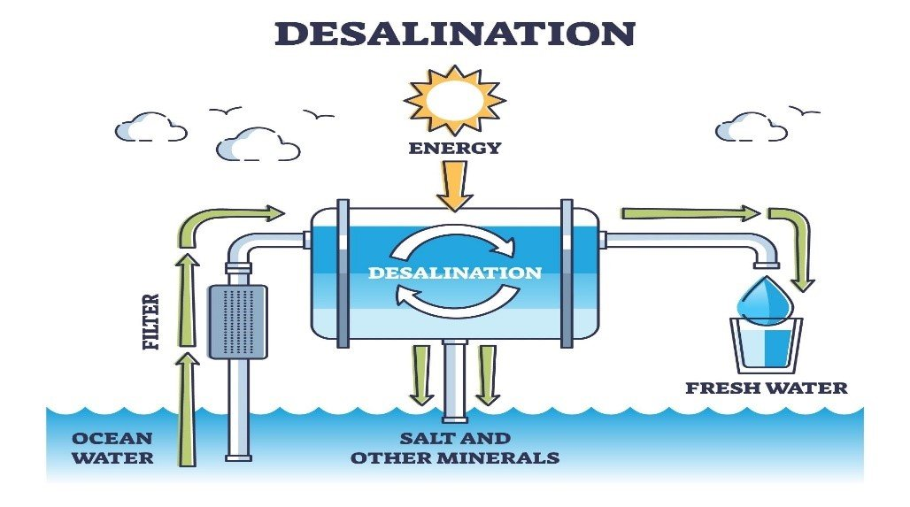

Fig. 1: Desalination process

Image Source:https://www.safewater.org/fact-sheets-1/2017/1/5/desalination

Desalination is the technique to extract salts and minerals from saline water to produce desalinated water suitable for human consumption or irrigation. The by-product of the desalination process is brineor concentrate (Fig. 1). It was earliest invented by Thomas Jefferson in the year 1791. Typically, sea water and brackish water both are purified using desalination. NaSO4, NaCl, MgCl2, LiCl, and MgSO4 are among the salts that are eliminated during the desalination process.

Broadly, desalination methods can be divided into thermal-based (e.g., multistage flash distillation)and membrane-based (e.g., reverse osmosis). Desalination techniques that have been in use for a very long period have been established using three traditional criteria: thermal, electrical, and pressure.

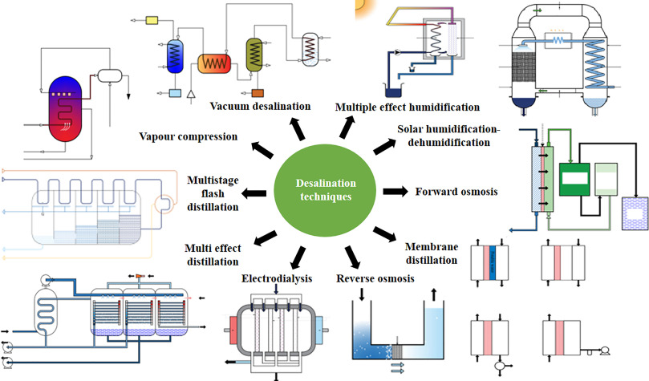

Fig. 2: Different types desalination techniques

Image source: Bhoj, et al. 2021: Recent advancements in practices related to desalination by means of nanotechnology,Chemical Physics Impact, 2, 100025, https://doi.org/10.1016/j.chphi.2021.100025

There are numerous desalination methods (Fig.2). The classic method is relied solely on large-scale thermal evaporation or distillation, which involves heating and then re-condensing seawater to remove saltsand contaminants. Prior to the development of membrane technology, this strategy was primarily employed.The following one involves using electric current to remove salt. This strategy was primarily employed before the introduction of membrane technology, utilizing electric current to remove salt.A selectively permeable membrane is traversed by the ions as a result of the electric current, releasing salts along the way.Numerous natural pollutants and bacteria can be removed using different membrane technologies. Additionally, compared to thermal systems, membrane systems frequently have reduced capital expenses and energy requirements. However, thermal desalination systems stand out because they produce water with a lower salt content than membrane systems (typically much less than 25 mg/l (ppm) total dissolved solids (TDS) as opposed to 500 ppm in water from membrane systems).

Another advanced technique is reverse osmosis, in which pressure and salt water are both transmitted transversely through a membrane. The pressure helps the water whip across the membrane, separating the salt in the process. The fundamental thermal, electrical, and pressure-placed processes outlined above have inspired a wide range of other processes. Each has advantages and disadvantages but all are useful. Some of these techniquesinclude:
- Solar Distillation
Solar desalination is a renewable energy-driven method that works on two scientific principles: evaporation of a saline water followed by condensation of the generated vapor. In conventional solar desalination units, solar irradiation penetrates the still through a transparent inclined condensing plate positioned over a feedwater basin filled with saline/brackish water.
Most solar stills are simple black bottomed vessels that house the distillation equipment.Radiation that strikes the basin is primarily absorbed by it. The transparent cover traps infrared electromagnetic waves that are emitted from the heated surface, raising the temperature inside the system. Saline/brackish water in feedwater basinevaporates, the water vapor is condensed onto a cool surface(Fig.3). Most pollutants do not evaporate, so they are left behind.
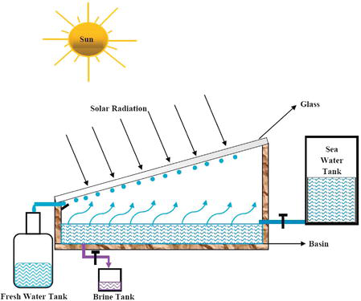
Fig. 3: Solar Distillation
(Image source:https://www.intechopen.com/chapters/61215)
2. Vacuum distillation
Distillation operated under reduced pressure or pressure below atmospheric pressure is known as Vacuum distillation. The vacuum desalination process causes the majority of the volatile liquid to evaporate by lowering the pressure above the liquid mixture to below its vapour pressure(Fig.4).
It is based on the principle that as pressure decrease, the boiling point of the compound also decrease or boiling occurs when vapor pressure of liquid exceeds ambient pressure. Vacuum desalinationis used with or without heating the liquid mixture. This is performed by lowering the pressures in the column or the reactor.

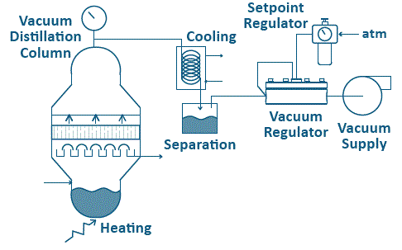
Fig.4: Vacuum distillation
Image source: https://www.equilibar.com/application/vacuum-distillation/

3.1 Multistage flash distillation (MSF)
3.Multistage flash distillation
It is the most frequent thermal desalination technology based on flashing process, producing distilled water from sea water. The water to be desalinated is heated at low pressure, which causes sudden, irreversible evaporation. This process is repeated in subsequent stages where the pressure decreases in accordance different conditions. In this process, preheated sea water is heated upto 90⁰- 120⁰ in brine heater under low pressure steam. Then, sucessively flashed in multiple stages comprising of countercurrent heat exchangersat decreasing pressure levels. The vaporsproduced ateach step each are condensed outside preheated condenser and collected as pure water (Fig. 5).
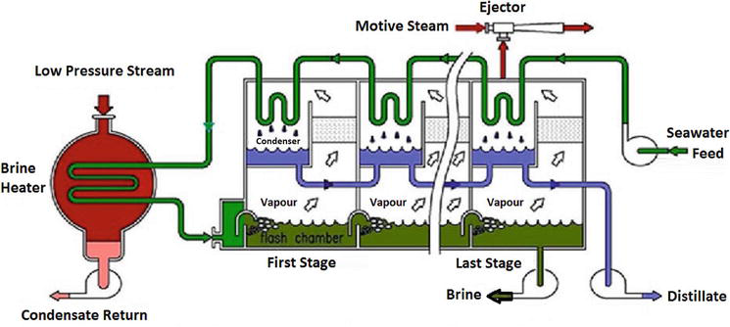

Fig. 5.Multistage flash distillation

(Image source: https://www.barc.gov.in/div/57_237_t403_406.pdf)

It is appropriate for waters with high salinities, higher temperatures and more pollutants. The high energy consumption of MSF plants is a key drawback.

4. Multiple-effect distillation (MED)
In multiple-effect distillation the treated water is passed sequentially through a number of evaporators (varies from 8 to 16 stages) in series. It works on the same principle (i.e., evaporation and condensation at reduced pressure) same as thatof MSF. Each step effectively recycles the energy from the one before it, with progressively lower temperatures and pressures. However, the design of the plant is different and it is thermodynamically more efficient method compared to MSF. (Fig.6)

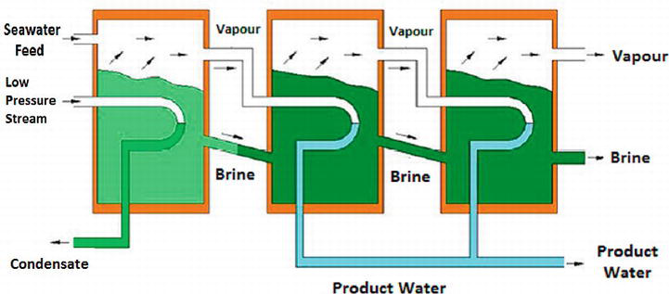
Fig. 6: Multiple-effect distillation
(Image source: https://www.intechopen.com/chapters/71348)

5. Vapor-compression (VCD)
Vapor-compression distillation technology is frequently utilised for seawater desalting plants within small to medium scale. By reducing the pressure, as with MSF and MED, it lowers the boiling point of saline water. The method is applied either alone or in conjunction with MED (Fig. 7). There are two methods of VC: mechanical vapor-compression (MVC), which is usually electrically driven, or a thermal vapor-compression (TVC).
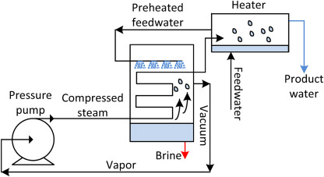
Fig. 7: Vapor-compression distillation (VCD)
(Image source: https://www.sciencedirect.com/topics/engineering/vapor-compression)

6. Electrodialysis and electrodialysis reversal (EDR)
Electrodialysis desalinationis electrically driven membraneprocess based on the principle of electrodialysis and works similarly to “ion exchange” treatment process.This technique employes both cation and anion selective membranes to separate charged ions (Fig.8).
In electrodialysis, suspended particulates with positive or negative electrical charges are deposited on the membrane surface, which significantly increases the membrane's resistance. However, this can be circumvented by switching the polarity of the applied electrical potential at predetermined intervals, which removes charged particles that have collected on the membranes. This technique is referred to as electrodialysis reversal (EDR

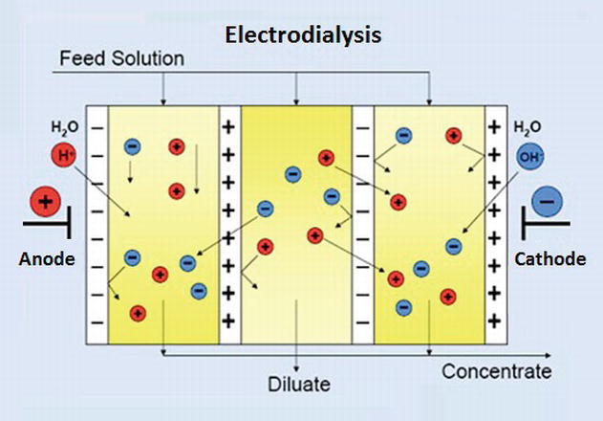

Fig.4:Electrodialysis and electrodialysis reversal
(Image source: https://www.intechopen.com/chapters/71348)

7. Reverse osmosis
The key technology in the desalination process is Reverse Osmosis. Reverse osmosis desalination employs the principle of osmosis and requires a membrane barrier to separate salts, small particles and dissolved organic matter from seawater. Reverse osmosis membrane is a pressure-driven semipermeable membrane allowing fluid to be purified to permit through the membrane and rejecting contaminants. Osmosis is used to separate two solvents, from region of low solute concentration to the high solute concentration. However, in the reverse osmosis desalination process, external pressure greater than the osmotic pressure applied to the saline water will cause fresh water to flow through the membrane while holding back the solutes (salts). By applying an external pressure on the higher concentration side, the flow could be stopped or reversed, the phenomenon is called “reverse osmosis.”(Fig.9) Firstly, organic impurities such as oil, seaweed, rubbish etc. were removed from seawater. Once free of organic substances, the saltwater can be subjected to reverse osmosis. Following filtering, two streams are obtained: one is brine and the other is freshwater. Before being reintroduced to the ocean, the brine solution is diluted to reduce salt concentrations that might be harmful to the ecology. The freshwater passes through a remineralization and chlorination process, after which it is stored in tanks and then sent to the distribution network for consumption.Reverse osmosis is able to filter proteins, carbohydrates, salts, dyes, bacteria, and other contaminants with a molecular weight greater than the 150–250 daltons.
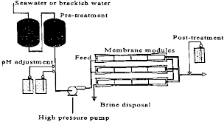
Fig. 9: Reverse Osmosis (Image source:https://www.oas.org/DSD/publications/Unit/oea59e/ch20.htm)

8. Nanofiltration (NF)
Nanofiltration ismembrane filtration-based method accomplished using a membrane with a nanometer sized poresranging from 0.5 and 2 nm and operating pressures between 5 and 40 bars. NF allows particles smaller than 10 nanometers pass through the membrane. It is frequently is used to treat solutions that contain organic molecules, sugars, and multivalent salts. Typically, polymers such as polyethylene terephthalate, poly-ether-sulfones, aromatic poly(acrylonitrile), polyamides, and poly(phenylene oxide), metals such as aluminumas well as other modifications of these, are used to create the membranes.There are two types of membranes,Charged nanofiltration membrane and Non-charged nanofiltration membrane. Charged nanofiltration membrane discards negative charged ions, such as phosphate or sulfate according to membrane charge and membrane fouling mechanism. On the other hand, non-charged nanofiltration membrane discards dissolved matter and uncharged ions based on the shape and size of the molecule (Fig. 10).NF membranes supports the porous layer, attributing to the properties of separation. These membranes have distinct nanometer-sized pores.

. 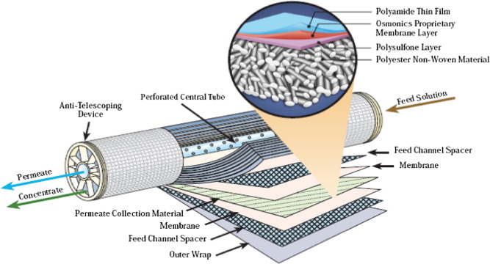
Fig. 10: Nanofilteration
Image Source Mona A. Abdel-Fatah. 2018Nanofiltration systems and applications in wastewater treatment: Review article, Ain Shams Engineering Journal, 9(4): 3077-3092,https://doi.org/10.1016/j.asej.2018.08.001)

9. Membrane distillation
Membrane distillation is a thermally driven separation process using water desalination membrane presently in constrained commercial use. This technology is based on the principle in which separation is driven by phase change. Membrane distillation is a combination of distillation and RO that uses a synthetic hydrophobic membrane ( acting as a barrier for the liquid phase) to allow water vapour to diffuse over the membrane pores and prevent the solution from passing through.With the help of membrane distillation, water from a brine solution is turned into vapour, which is then condensed into clear condensate on the cooled side of the membrane (Fig. 11).The process is driven by a partial vapour pressure difference, which is frequently brought on by a temperature difference.
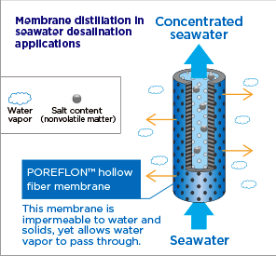
Fig. 11:Membrane distillation (Image Source: https://sumitomoelectric.com/id/topics/2021/09/002)
10. Forward osmosis(FO)
Forward osmosis is a relatively new industrial technique. It is anenergy-efficient technology and extremely effective purification process that removes salt from seawater by driving a salt concentration gradient (osmotic pressure) through a semipermeable membrane.In other words FO employs the natural energy of osmotic pressure to transport water through the membrane while retaining all the dissolved solutes on the other side. Due to the transport of water across membrane concentrated effluent is created, the draw solution becomes diluted, and the feed solution is concentrated(Fig. 12).
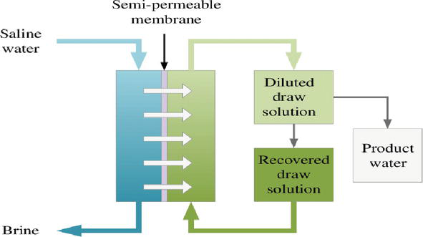
Fig. 12.Forward osmosis.
(Image Source: Jiaoet al. 2015. Osmosis and Its Applications. 10.1007/978-1-4614-5491-5_1741)

11. Adsorption desalination (AD)
Adsorption is advanced desalination method that may eventually replace of the existing thermally activated and membrane-based desalination systems. Beacause to its comparatively low cost, low energy requirements, excellent salt removal efficiency, and minimal environmental impact, adsorption is a promising desalination technique.
To assist and reject latent heat of evaporation, a silica gel adsorbent (desiccant) is utilised as a medium between an evaporator and a condenser ((Fig.13)). The silica gel is packed into beds and stacked around tubes where it can be cooled for adsorption or heated for desorption by water. The process temperature is within a range of 20°C and 85°C for the beds and condenser, respectively. To keep the feedwater temperature constant, the evaporator needs a heat source.

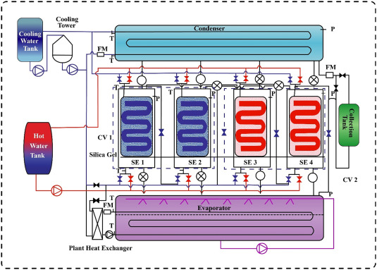
Fig.13: Adsorption desalination
(Image Source: https://www.sciencedirect.com/science/article/abs/pii/S0735193321004875)

12. Membrane Pervaporation
Membrane pervaporationis one of the effective membrane based separation process used to segregate two or more components (volatile compounds out of solutions) across a selective membrane employing differential rates of diffusion. An energy-efficient combination of permeation and evaporation is the foundation of this process. A vacuum is provided to the downstream side of the membrane while the upstream side of the membrane is in contact with the feed liquid during the membrane the separation process. Between the upstream and downstream sides of the membrane, the liquid permeant vaporises and is obtained as vapour. Pervaporation can also be used to dehydrate organic solutions and remove organic impurities from aqueous solutions by utilising selective membranes(Fig. 14).
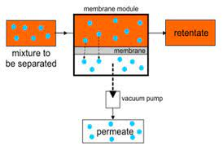
Fig.14: Membrane Pervaporation
(Image Source: Manshad et al. 2016. Membranes with Favorable Chemical Materials for Pervaporation Process: A Review Soheila Manshad et al. J. of membrane science and technology,6:4)
Summary
The World Health Organisation (WHO) recommendations state that the maximum amount of salt that can be present in drinking water is 500 parts per million (ppm), with a special exception of 1000 ppm. Most of the water on Earth has a salinity of up to 10,000 ppm, while seawater typically has a salinity of between 35,000 and 45,000 ppm of total dissolved salts. With increasing population, drinking water of acceptable quality has become a scarce commodity. Therefore, desalination of seawater emerges as one of the most significant commercial processes for providing fresh water for numerous communities and industrial sectors that are essential to socio-economic development in a number of developing nations, which suffer from a scarcity of fresh water.
However, the desalination plants run on fossil fuels, they are becoming incredibly expensive to operate, and the environmental pollution they generate is becoming more and more detrimental to the planet. Furthermore, even close to a coast where there is an abundance of seawater, such plants are not commercially feasible. In many of these places, there is frequently a lack of fossil fuels as well as insufficient power supply. But in remote areas, typical basin solar stills with a relatively large footprint is viable and simple technology of producing fresh water from saline water.

