State-of-the-art technologies in Hydrodynamic Cavitation(HC)

Dr.Venkatesh T. Lamani
Dept. of Mechanical Engineering
B.M.S. College of engineering
Bengaluru, India
E-mail:venkateshtl.mech@gmail.com

Mr. Hari Babu D
M/s HIT- Haritham Innovative
Technologies
Sarada Colony Guntur,
Andhra Pradesh, India
E-mail: hitharibabu@gmail.com

Dr.Sudarshan B
Dept. of Mechanical Engineering
B.M.S. College of engineering
Bengaluru, India
E-mail: bsudarshan.mech@bmsce.ac.in

Dr. Ramesha D K
Dept. of Mechanical Engineering
UVCE, K.R. Circle
Bengaluru, India
E-mail: rameshdkuvce@gmail.com

ABSTRACT
Cavitation is a phenomenon in which the static pressure of a liquid to below the liquid’s vapor pressure leads to the formation of small vapor- filled cavities in the liquid. Hydrodynamic Cavitation is a process in which high energy is released in a flowing liquid upon bubble implosion due to decrease in local pressure. HC is considered to be a promising technology for process intensification, due to its high energy efficiency, cost-effective operation, ability to induce chemical reactions, and scale-up possibilities. The Rotational HC Reactor (RHCR) is mainly composed of a rotor and a stator. The flow pattern in similar in reactor and RHCR, fluid rotates with the rotor due to this bubbles are formed which leads to the effect of cavitation in the reactor. This research predominantly delivers deliberations on several phenomena connecting to the start and growth of cavitation in liquid flows, exclusively on the base of the experimental data acquired by various researchers. Most of the work is based on references [1] and [4].

Keywords - Hydrodynamic Reactor, Cavitation, Multiphase, Fluid mechanics

INTRODUCTION

Cavitation is a phenomenon in which the static pressure of a liquid reduces to below the liquid’s vapor pressure leading to the formation of small vapor- filled cavities in the liquid [1]. Cavitation is defined as the process of evolving and collapsing vapor bubbles in a liquid, frequently due to vicissitudes in pressure. This can ensue in a variety of circumstances, such as when a liquid is flowing through a pump, when a propeller is spinning in water, or when an object is moving through a liquid. The process of cavitation can be originated by a decline in pressure, which roots the liquid to boil and form vapor bubbles. When the pressure yields to normal, the vapor bubbles collapse, causing in a release of energy in the form of shock waves and high-speed jets. The causes of cavitation can vary depending on the context in which it occurs. For example, in a pump, cavitation can be caused by a reduction in pressure due to the pump's design, a lack of proper fluid flow, or a clogged suction line. In a propeller, cavitation can be caused by the speed of the propeller and the shape of the blades. In general, cavitation can be initiated by changes in pressure that cause the liquid to boil and form vapor bubbles.
The effects of cavitation can be both negative and positive, depending on the context in which it occurs. On the negative side, cavitation can lead to reduced efficiency in hydraulic systems, noise, and damage to mechanical components. The high-speed jets and shock waves produced by the collapse of the vapor bubbles can cause erosion and wear on surfaces, leading to reduced performance and potential failure of equipment.
On the positive side, cavitation can also be harnessed for beneficial applications. For example, ultrasonic cleaning uses cavitation to generate high-frequency sound waves that agitate the liquid and remove dirt and contaminants from surfaces. Sonochemistry uses cavitation to generate high-intensity shock waves and high-speed jets that can be used for a variety of purposes, such as the production of nanomaterials, the degradation of pollutants, and the synthesis of new materials.
In conclusion, cavitation is a complex and multifaceted process that is both a challenge and an opportunity in various engineering and scientific fields. While it can lead to negative effects, such as reduced efficiency and damage to mechanical components, it can also be harnessed for beneficial applications, such as ultrasonic cleaning and sonochemistry. Understanding the definition, causes, and effects of cavitation is essential for optimizing its use and minimizing its potential negative impacts. It is conventional to categorize the cavitating flows based on the cavitation number. The cavitation number represents the same ratio as the Euler number where in both numbers the ratio of the free stream pressure head to the inertial forces are computed. However, in the cavitation number the pressure head is the difference between the reference pressure and the saturation pressure. Therefore, the cavitation number reflects how close the liquid pressure is to the saturation pressure. It should be noted that cavitating flows are affected by the boundary layer (e.g laminar flow or transient flow), thus the Reynolds number also becomes important as presented in equation 1 [2].
$Re=\frac{ρUD}{μ}$ ……………………………….1

HYDRODYNAMIC CAVITATION

Basic Conceptss of Hydrodynamic cavitation
HC is a phenomenon that occurs in bore type geometry surfaces, such as pipes or channels, in which low-pressure regions form in a flowing liquid due to the action of a pump or a high-velocity fluid. When these low-pressure regions reach the vapor pressure of the liquid, bubbles of vapor are formed and grow rapidly. When these bubbles reach a certain size, they collapse suddenly, releasing a high amount of energy in the form of shock waves and high-velocity fluid jets, which can cause significant damage to the bore surface [1]. In bore type geometry, the fluid velocity is high and uniform, creating ideal conditions for HC. The collapse of the vapor bubbles produces high levels of pressure, temperature, and velocity, which can cause pitting, erosion, and fatigue of the material, leading to reductions in service life and reliability. Additionally, the cavitation can also cause changes in the flow characteristics, leading to increased turbulence and reduced efficiency. [1]
HC is a fascinating phenomenon that occurs in flowing liquids and involves the formation, growth, and implosion of vapor-filled cavities or bubbles. It is driven by pressure fluctuations induced by flow conditions or external influences, leading to the creation of intense physical and chemical effects. The study and application of HC have gained significant attention in recent years due to its potential to revolutionize various industries, including wastewater treatment, food processing, chemical reactions, and more. In HC, the flow conditions in a liquid medium cause a decrease in static pressure, leading to the formation of cavitation bubbles. These bubbles grow as the pressure continues to drop and eventually collapse due to the recovery of pressure or interaction with nearby surfaces. The collapse of cavitation bubbles generates a variety of dynamic phenomena, such as shock waves, micro-jets, and high-velocity liquid streams, resulting in intense mixing, mass transfer, and heat transfer in the surrounding liquid [1]. One of the key advantages of HC is its ability to decompose complex compounds that are typically resistant to conventional treatment methods. During bubble collapse, the release of energy and the formation of micro-jets induce physicochemical changes in the liquid. The intense shear forces and high temperatures generated during collapse can break molecular bonds, thermally decompose pollutants, and destroy microorganisms. Additionally, HC enhances gas-liquid mass transfer, improving the removal of mass transfer resistances in the system. This makes it particularly effective in treating refractory substances, such as dyes, antibiotics, and pesticides [1]. Energy efficiency is another significant advantage of HC. Unlike other forms of cavitation, such as acoustic or ultrasonic cavitation, which require additional energy input, HC utilizes the energy of the flowing liquid itself. This makes it a more sustainable and cost-effective option for various applications. [1]
HC can be generated using different devices and geometries, depending on the specific requirements and desired outcomes. Venturi tubes, nozzles, orifice plates, vortex-based systems, and rotating-type devices are commonly used to induce HC. The choice of cavitation device depends on factors such as flow rate and pressure.
While HC offers numerous advantages, there are also challenges that need to be addressed for its widespread implementation. One such challenge is the potential damage to equipment surfaces due to the intense forces and erosion associated with cavitation. Controlling flow velocity and pressure is crucial to prevent water hammer and cavitation onset, which can be damaging to the system. Additionally, the development of high-temperature and high-pressure resistant materials is necessary to withstand the extreme conditions generated during the cavitation process. The field of HC is constantly evolving, with ongoing research and development efforts aimed at optimizing reactor designs, exploring new catalysts, investigating hybrid techniques with other advanced oxidation processes, and focusing on energy-efficient and cost-effective approaches. Advancements in monitoring and control systems will further facilitate the practical application of HC in wastewater treatment and other industries. [1]
HC is a promising technology that offers a sustainable and efficient approach for various applications. Its ability to decompose complex compounds, improve mass transfer, and enhance energy efficiency make it an attractive option for wastewater treatment, food processing, and chemical reactions. Continued research and innovation in HC will lead to further advancements, enabling its wider adoption and contributing to the development of more sustainable and environmentally friendly industrial processes.

Cavitation number
The cavitation number, σ, is presented in Equation 2 where in this equation U∞ and p∞ are respectively the reference velocity and pressure, ρ_{l} is the density of liquid, and p_{sat} is the saturation pressure
$=\frac{p_{∞}-p_{sat}}{0.5ρ_{l}U_{∞}^{2}}$ …………………………………………………………………..2
Phase Diagram (PD) for Water
PD for water presented in figure 1. Water is an exceptional element in numerous ways. Unique of these distinct properties is the fact that ice is less dense than liquid water just beyond the freezing point. The PD for water is shown in Figure below. The PD for water is special because the solid-liquid phase line has a negative slope
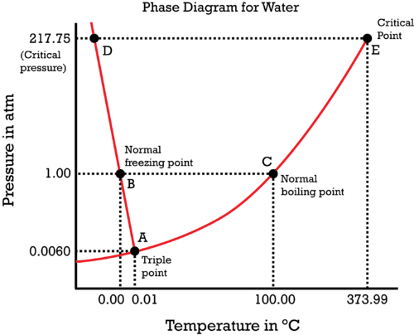
Figure 1: Phase diagram for water. [3]
Notice one key difference between the general PD and the PD for water. In water’s diagram, the slope of the line between the solid and liquid states is -ve rather than +tive. The purpose is that water is rare material in its solid state is less dense than the liquid state. Hence, a pressure change has the reverse effect on those two phases. If ice is relatively near its melting point, it can be changed into liquid water by the application of pressure. The water molecules are actually closer together in the liquid phase than they are in the solid phase.
Refer again to water’s phase diagram (Figure). Notice point E, labeled the critical point. What does that mean? At 373.99°C, particles of water in the gas phase are moving very, very rapidly. At any temperature higher than that, the gas phase cannot be made to liquefy, no matter how much pressure is applied to the gas. The critical pressure (Pc) is the pressure that must be applied to the gas at the critical temperature in order to turn it into a liquid. For water, the critical pressure is very high, 217.75 atm. The critical point is the intersection point of the critical temperature and the critical pressure.

MECHANISMS OF HYDRODYNAMIC CAVITATION

HC involves complex mechanisms that occur during the formation, growth, and collapse of cavitation bubbles. These mechanisms include bubble nucleation, bubble dynamics, bubble collapse, and the generation of various physical and chemical effects. The collapse of cavitation bubbles generates shock waves, micro-jets, and hotspots, resulting in intense pressure and temperature fluctuations within the liquid [4]. HC involves three key mechanisms they are nucleation, bubble growth, and bubble implosion. These mechanisms occur as a fluid flow passes through irregular geometries or narrow orifices, causing a decrease in static pressure and the formation of cavities within the fluid [4]. The pictorial representation of HC Mechanism is depicted in figure2 and 3.
Nucleation: Nucleation is the initial stage of HC. It occurs when the fluid flow experiences a rapid increase in velocity, causing a decrease in static pressure. When the local pressure falls below the saturated vapor pressure of the fluid, small vapor-filled cavities, known as nuclei, are formed. These nuclei act as the starting points for cavitation bubble formation [4].
Bubble Growth: Once nucleation occurs, the vapor-filled cavities begin to grow. As the fluid continues to flow and the pressure decreases further, the cavities expand in size due to the reduced pressure on their surfaces. The growth of the cavitation bubbles is influenced by various factors, including the flow velocity, geometry of the system, and fluid properties [4].
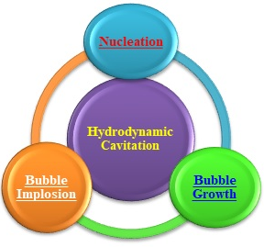
Figure 2: Pictorial representation of HC Mechanism
Bubble Implosion: The final stage of HC is bubble implosion. As the flow conditions change or the pressure increases, the cavitation bubbles collapse or implode. The collapse of the bubbles generates intense shock waves, micro-jets, and hotspots within the surrounding fluid. These phenomena create localized regions of high pressure and temperature, resulting in physical and chemical effects such as micro-mixing, scale-free heating, and enhanced friction between the rotor and the liquid [4].
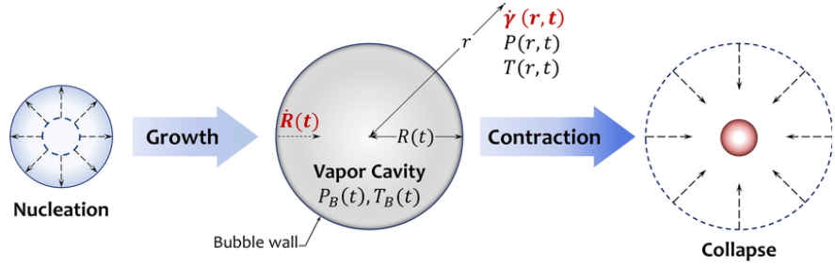

Figure 3: Nucleation, growth and growth of bubbles during cavitation [5]
The implosion of cavitation bubbles releases a significant amount of energy into the surrounding fluid, leading to various effects. Micro-mixing refers to the intense mixing of fluid streams caused by the rapid collapse of cavitation bubbles, facilitating the dispersion of substances and enhancing chemical reactions. Scale-free heating occurs due to the conversion of the kinetic energy of collapsing bubbles into heat, leading to localized increases in temperature. The controllable friction between the rotor and the liquid can be leveraged for specific applications that require mechanical energy transfer or agitation [4].
HC is a phenomenon that occurs when vapor-filled cavities are formed, grow, and eventually collapse within a flowing fluid. This process gives rise to a series of effects, including shock waves, micro-jets, and thermal changes, which contribute to the distinctive characteristics and potential applications of HC. These features make it an exciting technology with numerous possibilities in various fields such as water treatment, food processing, and chemical reactions [4].
One of the key aspects of HC is the formation and growth of vapor-filled cavities within a fluid flow. As the fluid flows through a constriction or an area of low pressure, the pressure drops, causing dissolved gases or vapor pockets to form. These cavities then grow in size as the fluid continues to flow, leading to a reduction in pressure and an increase in velocity. This growth phase is crucial for generating the desired effects of HC. The subsequent implosion of these vapor-filled cavities is what sets HC apart. As the cavities collapse, they release a tremendous amount of energy in the form of shock waves. These shock waves propagate through the surrounding fluid, creating intense localized pressures and high-speed micro-jets. These effects can induce turbulent mixing, enhance heat transfer rates, and promote mass transfer, making HC an attractive technology for various applications.
The shock waves generated during cavitation implosion can lead to enhanced mixing in a fluid system. The high pressures and velocities associated with the collapse of cavities create turbulence and promote the mixing of different components within the fluid. This improved mixing capability can be advantageous in applications such as water treatment, where the thorough dispersion of chemicals or the efficient blending of additives is essential. Additionally, HC can be employed for heating purposes. The collapse of cavities generates localized high temperatures due to the compression of the fluid during implosion. These thermal effects can be utilized for processes that require rapid and uniform heating, such as in food processing or sterilization applications.
The intense micro-jets resulting from cavitation implosion also contribute to the efficient transfer of heat across surfaces, further enhancing the heating capabilities of HC. Furthermore, the physical forces generated by cavitation implosion, including shock waves and micro-jets, can induce mechanical and chemical effects. The high pressures and velocities can lead to the generation of shear forces and turbulence, promoting chemical reactions and facilitating the breakdown of complex molecules.
In summary, HC involves the formation, growth, and implosion of vapor-filled cavities within a fluid flow. The resulting shock waves, micro-jets, and thermal effects offer unique characteristics and potential applications in fields such as water treatment, food processing, and chemical reactions. The enhanced mixing, heating, and friction associated with HC make it a promising technology with broad-ranging possibilities for improving industrial processes and achieving more efficient and sustainable outcomes [4].

APPLICATIONS OF HYDRODYNAMIC CAVITATION
HC has a wide range of applications across various industries due to its unique ability to generate intense fluid dynamics and physical effects. Some of the notable applications of HC include:
Nanomaterial Synthesis: Figure 4 denotes Rotor- stator type HC reactor used for synthesis of nano materials. HC is used as a tool for the synthesis of nanomaterials. The controlled collapse of cavitation bubbles creates localized high temperatures and pressures, enabling the formation of nanoparticles with specific properties and characteristics. This application finds use in industries such as electronics, materials science, and biomedical engineering.
Chemical and Physical Processes: HC is employed in chemical and physical processes such as polymerization and depolymerization reactions. The intense mixing and localized heating generated by cavitation enhance reaction rates and improve product quality. It is also utilized for microbial cell disruption and fatty acid hydrolysis.
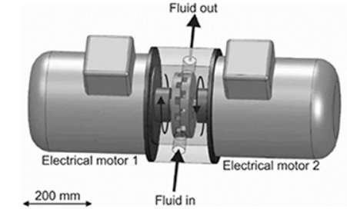
Figure 4: Rotor- stator type HC reactor used for synthesis of nano materials [7].
Water Decontamination: Figure 5 portrays typical waste water decontamination unit. HC is an effective method for water decontamination. The collapse of cavitation bubbles produces shock waves and micro-jets that disrupt and destroy microorganisms, pollutants, and organic compounds in water. This application is particularly useful in wastewater treatment, water disinfection, and remediation of contaminated water sources [6].
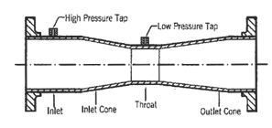
Figure 5: A typical waste water decontamination [6].
Biodiesel Synthesis: HC is utilized in the production of biodiesel from various feedstocks. The high shear and localized heating generated during cavitation help in the efficient transesterification of triglycerides into biodiesel, improving the reaction kinetics and reducing the processing time.
Desulfurization of Fuels: Figure 6 represents desulfurization HC, can be used for desulfurization of fuels, particularly in the petroleum industry. The localized high temperatures and pressures generated during cavitation can break down sulfur compounds, reducing the sulfur content in fuels and meeting regulatory requirements.
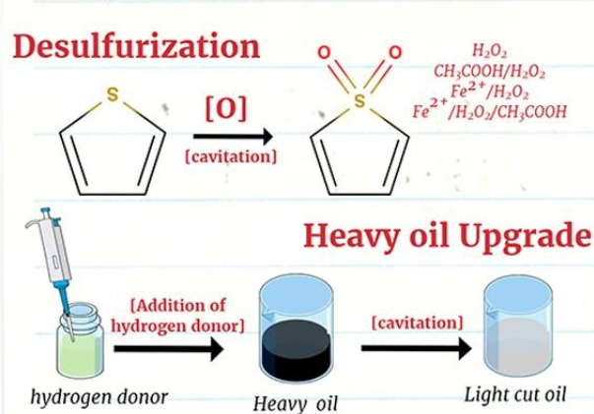
Figure 6: Desulfurization methodology by HC [8]
Food and Beverage Industry: Figure 7 depicts the dairy products processing setup. HC finds applications in the food and beverage industry for various processes, including extraction, emulsification, and preservation. It can enhance the mixing, dispersion, and homogenization of ingredients, improving the quality and stability of food products.
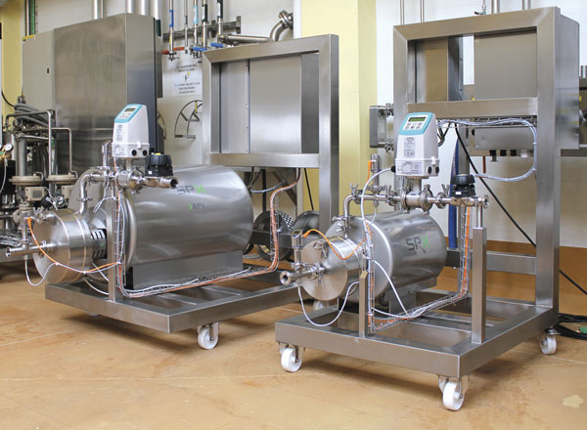
Figure 7: Dairy products processing setup [9]

CONCLUSIONS

With the improvement of cavitation investigation, HC know-how has been smeared in numerous arenas.
- Exclusively in the meadow of water treatment, it has been confirmed to have abundant prospective of improvement.
- Contemporary, the examination on HC water treatment essentially emphases on the cavitation principle, aspects affecting HC water treatment, conjunctive use of HC and other water treatment methods, optimization of HC reactor and so on.
- The contemporaneous study assessments the improvement of HC technology for water treatment. HC could incapacitate bacteria, microalgae and organic materials based on thermal effect, mechanical effect and chemical effect.
- HC disinfection cannot totally incapacitate organic constituents, so it can be combined with chemical or physical systems to accomplish a greater treating effect.
- In the past two decades, several new HC reactors were proposed and researched, which improved HC efficiency and application effect.
- In summary, HC is an efficient technology for water treatment and more efforts are required to effectively promote the industrialization of this technology.

REFERENCES

- W.Zhang, C. Xie, H. Fan, and B.Liu, “Influence of hole geometry on performance of a rotational hydrodynamic cavitation reactor,” Frontiers in Energy Research, vol.10, pp.881811, 2022.
- Asnaghi, “Developing computational methods for detailed assessment of cavitation on marine propellers,” Chalmers Tekniska Hogskola (Sweden), 2015.
- M. Helleve, “Study of Near and Far Field Measurements for Underwater Ship Noise” (Master's thesis, The University of Bergen),2023.
- J. Zhu, “Recent developments in hydrodynamic cavitation reactors: Cavitation mechanism, reactor design, and applications,” Engineering, 2022.
- J. Eshraghi, J.C. Veilleux, G. Shi, D. Collins, A.M. Ardekani, and P.P. Vlachos, “Assessment of cavitation intensity in accelerating syringes of spring-driven autoinjectors,” Pharmaceutical Research, 39(9), pp.2247-2261, 2022.
- E. Dindar, “An overview of the application of hydrodinamic cavitation for the intensification of wastewater treatment applications: a review,” Innovative Energy & Research, 5(137), pp.1-7, 2016.
- X.Sun, S.Chen, J.Liu, S. Zhao, and J.Y. Yoon, “Hydrodynamic cavitation: a promising technology for industrial-scale synthesis of nanomaterials,” Frontiers in Chemistry, 8, p.259, 2020.
- E.Cako, Z. Wang, R. Castro-Munoz, M.P. Rayaroth, and G. Boczkaj, “Cavitation based cleaner technologies for biodiesel production and processing of hydrocarbon streams: A perspective on key fundamentals, missing process data and economic feasibility–A review,,”. Ultrasonics sonochemistry, 88, p.106081, 2022.
- M.Ashokkumar, R. Rink, and S.Shestakov, Hydrodynamic cavitation-an alternative to ultrasonic food processing. Technical Acoustics/Tekhnicheskaya Akustika, (9), 2011.

