Knowledge, Perception and Awareness of Renewable Energy (the future trend of energy)
Dr. Hitika Dhingra
University School of Financial Studies, Guru Nanak Dev University, Amritsar.

Sirjan Singh
Student
Department of Computer Science and Engineering,
Thapar Institute of Engineering and Technology, Patiala.

Abstract
Mankind's encounter with environment is as old as the Man himself. Scientists tell us that Man is three million years old. For these three million years Man has survived his profligacy. Though his actions long affected his local environment it is only with the advent of the industrial revolution that the scope of this influence expanded to a global scale.
In our era, humanity's pursuit of mastery over the entire biosphere poses a serious threat to our intended goals, as it risks damaging and potentially extinguishing life, including human life.
Given the escalating demand for energy and concerns about the depletion of traditional fuel resources, there is an urgent imperative to raise awareness about the utilization of clean, sustainable energy sources. This paper places a significant emphasis on evaluating the awareness and opinions of respondents regarding critical topics such as the ecosystem, global warming, environmental pollution, climate change, and the advantages of renewable energy.
The study's sample encompasses a diverse group of two hundred and twenty respondents of varying ages and genders from Patiala city. The research methodology involves descriptive research using interview schedules and data collection via a questionnaire. Analysis of the findings incorporates the use of percentages, graphs, and diagrams.
The study reveals that there is currently inadequate environmental awareness and insufficient social acceptance of renewable energy. Preventing environmental degradation and facilitating the adoption of renewable energy is contingent on enlightening and educating the public, emphasizing that these resources belong to them and that it is their responsibility to safeguard them. Importantly, the research underscores that a lack of awareness can significantly delay the acceptance of proposed initiatives by decision-makers and the majority of the public.

Introduction
Mankind's encounter with environment is as old as the Man himself. Scientists tell us that Man is three million years old. For these three million years Man has survived his profligacy. Though his actions long affected his local environment it is only with the advent of the industrial revolution that the scope of this influence expanded to a global scale. In our generation, Man's competition of his mastery over the whole of the biosphere is threatening to defeat Man's intentions by wrecking the biosphere and extinguishing life, including human life itself.
The primary objective of development should extend beyond economic, social, and political objectives. It must prioritize the holistic advancement of all facets of human life and the well-being of other living organisms. Currently, we are depleting our environmental resources at a rate that surpasses our capacity to replenish them. Energy consumption is a significant contributor to this issue. Environmental advocates have long urged the exploration of alternative energy sources to reduce our dependence on traditional ones and to allow nature the time and space to regenerate. Governments, both at country and state level, should lead by example in adopting safe environmental practices and inspire others to do the same. The current efforts of the government are inadequate. Some steps have been taken by the Punjab government in harnessing renewable energy sources but more significant action needs to be done.
Objectives
• The primary objective of this research is to assess the awareness level of Patiala's residents concerning renewable energy.
• This study primarily focuses on understanding the awareness and viewpoints of the respondents regarding ecosystem, global warming, climate change, and factors contributing to environmental degradation.
• Additionally, the study investigates the extent to which individuals are willing to pay more for 24-hour power supply, especially if it is derived from renewable sources, and it examines people's preferences regarding whether they prefer personal or district-level generation of power from renewable sources.

Research Methodology
Sampling Plan: The following are included in the sampling plan for the purpose of present study:
a) Universe of sample:
The sample has been taken from the universe of Patiala city.
b) Sampling unit: The sampling unit consists of different individual respondents of different gender and age from the city of Patiala.
c) Sample size:
The sample size of the study is two hundred and fifty-seven respondents.
d) Sampling procedure and Method:
The survey employed a convenience sampling technique, and the study relied on gathering primary data through the administration of interview schedules.
e) Collecting the Information:
Data collection is not only the costliest aspect but also the one most susceptible to errors. Out of the 239 interview schedules distributed, 220 responses were deemed suitable for the study's objectives.
f) Tools of analyses:
Percentages, bar graphs and pie charts have been used for analysis of the study. The tools automatically provide visual representations for a clear understanding of the analyses of the collected data.

Review of Literature
Lovins and the Rocky Mountain Institute (2011) has conducted an analysis of the potential for the United States to transition towards almost exclusive reliance on renewable energy sources, such as solar and wind power. He argues that renewable energy is already more cost-effective than fossil fuels, and his analysis predicts further cost reductions for renewables.
Lovins envisions a future without the fears associated with conventional energy sources: no climate change, no oil spills, no harm to coal miners, no pollution of the air, no devastation of lands, and no loss of wildlife. In this vision, there would be no energy poverty, no conflicts driven by oil dependency, no tyrannies or terrorist funding, nothing finite to deplete, nothing vulnerable to disruption, and nothing to be anxious about. Instead, he envisions a world with abundant, environmentally-friendly, and affordable energy accessible to everyone, indefinitely.
Lovins' discussion encompasses a wide range of topics, including the redesign of heavy trucks for greater fuel efficiency and the modification of industrial processes to conserve energy. His book outlines a roadmap for the United States to achieve the following goals by 2050: complete reliance on hydrogen fuel cells, electricity, and biofuels for cars; 84% of trucks and airplanes powered by biomass fuels; 80% of the nation's electricity generated from renewable sources; savings of $5 trillion; and an economy that has expanded by 158%.

Mishra S. (October, 2016) in his paper “Renewable energy awareness in India” has aimed to address the issue of energy proliferation. He emphasized the significance of awareness in advancing the adoption of renewable energy. While many people in India understand the importance of energy for national growth, there is a noticeable lack of education and awareness regarding energy, particularly in the context of renewable resources. Among the Indian population, there is limited awareness of renewable energy, with most people associating energy with traditional sources. Although government agencies in India have launched various educational initiatives over the past decade at school, city, and village block levels, these efforts often lack synchronization and suffer from overly aggressive advertising campaigns, leaving the audience with incomplete information. The paper suggests a systematic approach to educate and prepare the target audience before providing them with comprehensive knowledge on the subject.
Fatma Agpak F. and Ozcicek O. (December, 2017) in their paper, “The Role of Education on Renewable Energy Use: Evidence from Poisson Pseudo Maximum Likelihood Estimations” have emphasized the influence of education levels on the utilization of non-hydro renewable energy and has assessed this in relation to two distinct metrics. According to her, a society's education level plays a pivotal role in shaping the demand and supply of renewable energy within that economy. In highly educated societies, there is an expected increase in environmental awareness and social acceptance of renewable energy, leading to a higher demand for it. On the supply side, greater scientific knowledge and expertise have been shown to promote the innovation and diffusion of renewable energy technologies.
In their study, these theoretical arguments are put to the test using data from 62 countries spanning the years 1990 to 2014. To address potential statistical issues, they have employed the pseudo-Poisson maximum likelihood technique. The results indicate a positive correlation between education level and involvement in renewable energy at a significance level of 1%. Furthermore, the impact of higher education levels is found to be more pronounced than that of lower education levels.
Nandy J. (2022) in the article, “climate crisis linked to India’s spring heatwave” in Hindustan Times has warned of a severe heatwave in major parts of India over the next few days, stretching from east to west and north west. Dry warm winds have been blowing in north India pretty sooner than usual and therefore raising summer temperatures before time. According to Friederike Otto, leader of World Weather Attribution group and senior lecturer in Climate Science at the Grantham Institute, Imperial College London, the present heatwave in India has been intensified due to climate change which in turn is the outcome of activities by human. Otto has further warned that the heat waves in India will further become more dangerous and hotter if the net greenhouse gas emissions aren’t eliminated. The conditions in India have been in the follow-up of abnormal weather conditions in rest of the world. It has been reported that both the polar regions of Earth encountered heat waves simultaneously, resulting in the average temperature to be 4.8°C higher than the average.

Results and Discussion
The first and second questions were designed to introduce participants to the concepts of the eco-system, climate change, global warming, and renewable and green energy. These questions aimed to raise awareness about the importance of using renewable energy technology for a better environment.
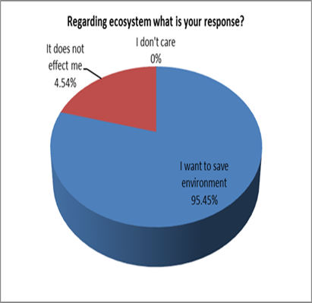
Figure 1
Majority of the respondents (95%) want to save environment, whereas only 4.54% of respondents are of the view that it does not affect them personally. However, no negative response such as ‘I do not care’ was received (Figure 1).
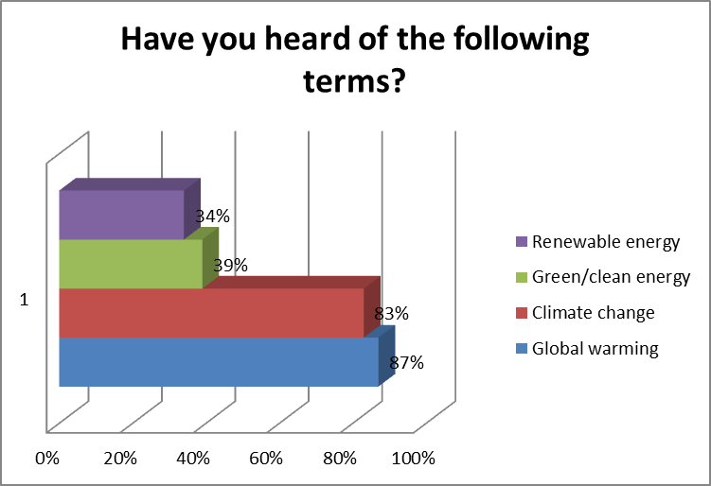
Figure 2
A significant percentage of respondents were aware of terms like "global warming" (87%) and "climate change" (83%), indicating some awareness of environmental issues. However, there was a substantial lack of education and awareness regarding "Renewable Energy," with only 44% having heard of this term (Figure 2).
The findings emphasize the need for more education and awareness-building efforts in the area of renewable and clean energy sources.
The third question in the survey aimed to educate respondents about various sources of renewable energy. The options provided included solar power (78% awareness), hydro power (77% awareness), wind power (57% awareness), biomass (45% awareness), and waste-to-energy (low awareness) (Figure 3).
A varying degree of awareness was found among respondents regarding different renewable energy sources, with solar and hydro power being the most recognized, while waste-to-energy had the lowest awareness.

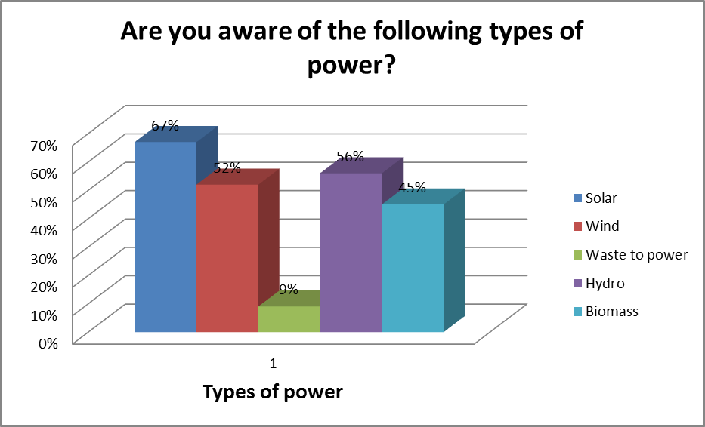
Figure 3

Figure 4
Majority of the respondents identified renewable energy mainly with ‘good for environment’, around 76% agreeing with it. Surprisingly 11% did not even know what are the benefits of renewable energy. 68% of respondents said ‘no power cuts’, 20% said ‘good for businesses as benefits of renewable energy and 16% said ‘less dependence utility’. (Figure 4).
Lack of knowledge and education regarding benefits of renewable energy was predominant. It is important for the government as well as renewable energy agencies to communicate and educate the benefits of renewable to the people as well as adopt intensive marketing to have an advantage of better acceptance of products developed using renewable energy.

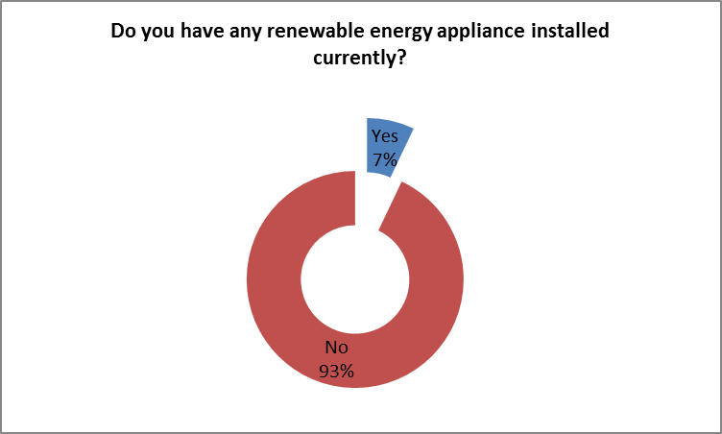
Figure 5

Around 16% of all the respondents had renewable energy appliance installed (Figure 5). Out of these 24 respondents, 9 respondents had solar heaters, 6 had solar panels, 7 had solar lights, and 2 had biomass systems installed. However, the majority, comprising 84% of the respondents, did not have any form of renewable energy installed in their homes or properties.

(Figure 5.1).

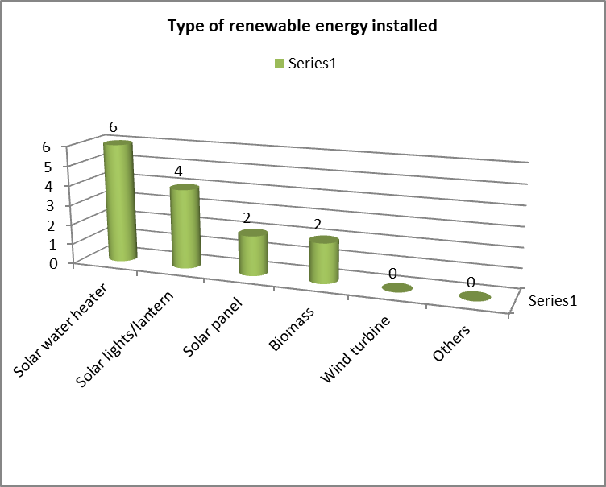
Figure 5.1

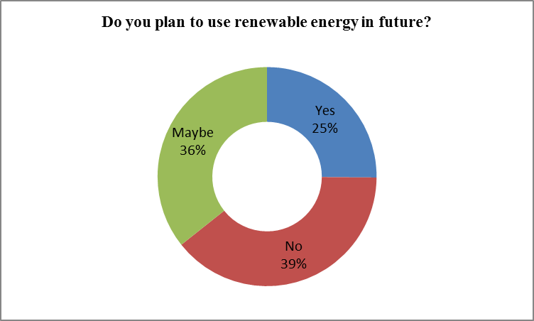
Figure 6
Approximately 36% of the respondents expressed that they are considering the possibility of installing renewable energy systems in the future. About 25% of the respondents stated that they are definite about installing renewable energy in the future. The remaining 39% indicated that they have no intentions of installing any form of renewable energy in the future.
A majority of 97.98% respondents favoured having electricity round the clock (Figure 7).
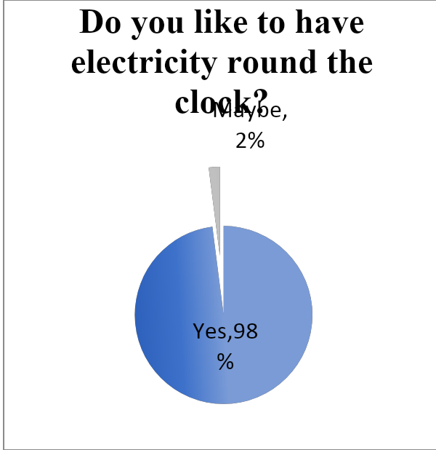
Figure 7

The findings reveal an interesting irony: while a significant portion of respondents are open to paying a slightly higher cost for electricity from renewable sources (55% are willing, 29% are uncertain), a notable 16% outright refuse to do so. Many of these individuals have backup generators.
To potentially shift those who are uncertain ('maybe') towards a positive stance ('yes'), it's crucial to engage in education and communication efforts to highlight the benefits of renewable energy. Additionally, there's an opportunity for the government to reduce the cost of renewable energy generation through investments in research and development.

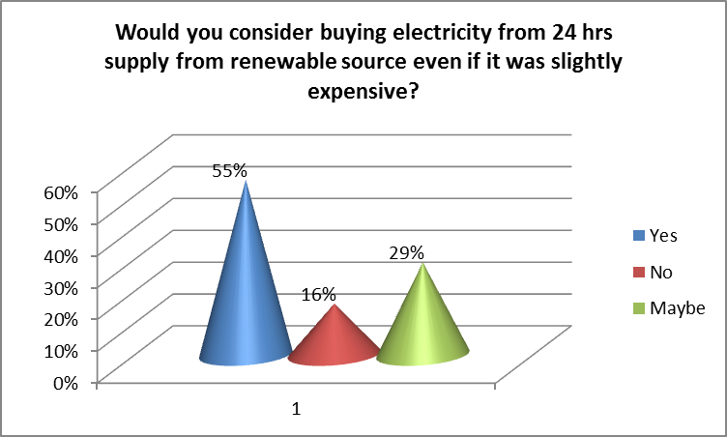
Figure 8
The overwhelming majority of respondents, 96.46%, prefer the generation and distribution of renewable energy at the district level. This preference is attributed to concerns about the visual impact and space occupation of solar panels on rooftops. People are also hesitant because such panels are uncommon in their neighbourhoods. To build confidence among the public, the suggestion is for the government to construct at least one passive house in each region and actively advertise it as a demonstration of renewable energy benefits.

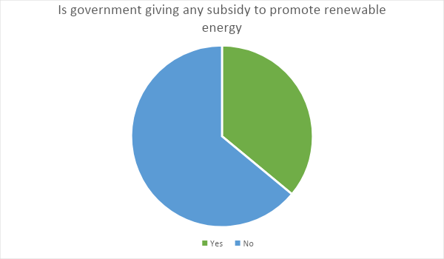
Figure 9

About 64% of respondents had not heard of any subsidy by government for renewable energy. Awareness is quite low among the people. To speed up the installation of renewable energy, education, increasing communication and intensive marketing should be done.

Conclusion

Overall, it was found that there was a lack of awareness among people about renewable energy and its benefits. The respondents surveyed were more aware of solar than other renewable sources. It was basically due to awareness of solar water heaters, solar panels and solar lights.
Government has responsibility to educate and communicate about subsidy programs and policies.
It becomes much easier to develop a renewable energy project on a land close to population if they are already communicated and educated about the benefits.
Majority of the people are not willing to pay more even if they get electricity for 24 hours.
There is also need for the government and renewable energy agencies to take the lead and focus investment in Research and Development (R&D) for making cost effective equipments for providing energy from renewable sources at par with conventional sources of energy.
In democratic societies, decision-making should take into account both knowledge of experts and the thoughts and feelings of the public. The lack of awareness and effective marketing strategies can lead to a major delay between when decision-makers express interest in an initiative and when it gains acceptance from the majority of the public. In other words, public awareness and effective communication are critical for aligning public opinion with decision-makers' initiatives in a timely manner.

SUGGESTIONS
In India, every year there is an increase of 8-10 percent in energy requirement in the commercial sector and 20-30 percent increase in residential sector. This is leading to a situation where there are energy deficits. Green Energy is the only answer to overcome this deficit.
Cost reduction, grid management, community acceptance, landscape issues and lack of adequate marketing are the main bottlenecks to awareness and commitment to Green Energy.
India needs to take the lead and develop efficient, hi-tech and cost effective equipments based on Green Energy, not only for industrial and domestic purpose, but also for agricultural and irrigation needs. There is an imperative need for extensive focus and investments in Research and Development (R&D) for making cost effective equipments as well as marketing them to bring about the much-needed GREEN ENERGY REVOLUTION in India.
To advocate the development and acceptance of renewable energy technology, it is crucial to bridge the gap between the general public's perspective and that of energy technologists. This entails educating the public about the importance of prevailing renewable energy technology and fostering greater awareness of its advantages. Essentially, augmenting public knowledge and understanding of renewable energy technology is crucial for its wider adoption and utilization.

References
Bagga, N. (2014, November 16). Solar energy largely untapped. Amritsar Tribune , p. 1.
Bebbington, J. and Thy, C. (1999). Compulsory Environment Reporting in Denmark: An Evaluation. Social and Environmental Accountability Journal, Vol. 19 (2).
Bhalla,G.S. and Khanna, H., (2007). Environment Education. New Delhi: Deep and Deep Publication.
Bhattacharjee, J.B., (1996). Our Environment. Silchar. AU.
Blackstone, W.T., (1974) “Philosophy and Environment Crisis”, University of Georgia Press, Athens.
Dasgupta, P. (2001), "Human Well-Being and the Natural Environment", Oxford University Press, Oxford.
Dhingra, H., & Bhalla, D. G. (2018). need to increase awareness about environment pollution to augment its prevention. Journal of Emerging Technologies and Innovative Research.
India Renewable Energy Awareness Survey (2010), Mercom Capital Group. Retrieved on 24th April, 2014 from www.mercomcapital.com
Jha, P.K. 1998.
Khalid, Fazlam and Joanne O’Brien (eds.), (1992) “Man and Ecology”, Cassell, New York.
Marilyn, A. B. and Sovacool, B.K. (2011), “Climate Change and Global Energy Security: Technology and Policy Options”, MIT Press, Cambridge, USA.
Mark Diesendorf, (2007) “Greenhouse Solutions with Sustainable Energy”, University of New South Wales Press, Sydney.
Moula, E., Johana Maula, Mohamed Hamdy et.al (2013), “Researching social acceptability of renewable energy technologies in Finland”, International Journal of Sustainable Built Environment, UNESCO Commission, Finland, pp. 89-98
Ozcicek, O. and Agpak, F. (2017). The Role of Education on Renewable Energy Use: Evidence From Poisson Pseudo Maximum Likelihood Estimations. Journal of Business & Economic Policy Vol. 4 No.4
Viegas , P. and Menon, G.(1989) "The impact of environmental degradation on people", Indian Social Institute, New Delhi.
10.1007/s40518-016-0055-z

Dear Respondents,
I am pursuing B.Tech. from Thapar Institute. I request you to kindly spare your valuable time to give appropriate responses to the issues addressed in this questionnaire. I shall be highly thankful for your kind cooperation in this regard.

1. Regarding environment what is your response to the following?
(a) I want to save environment
(b) It does not affect me
(c) Don’t care

2. Have you heard of the following terms? (You can tick multiple options)
(a) Global Warming (b) Climate Change
(c) Renewable Energy (d) Green Energy/Clean Energy

3. Have you heard of the following types of power? (You can tick multiple options)
(a) Solar power (d) Hydro power
(b) Wind power (e) Biomass
(c) Waste to power

4. Can you point out the benefits of renewable energy? (You can tick multiple options)
(a) Good for environment (b) Less dependence
(c) Good for business/industry (d) Government subsidy
(e) No power cuts (f) No benefit
(g) Don’t know

5. Do you currently have any renewable energy appliance installed?
(a) Yes (b) No

If yes, which type of renewable energy have you installed? (You can tick multiple options)
(a) Solar water heater (b) Solar panel
(c) Biomass (d) Wind turbine
(e) Any other, please specify_________________________

6. Do you have plans to use renewable energy in near future?
(a) Yes (b) No (c) Maybe

7. Do you like to have electricity round the clock?
(a) Yes (b) No (c) Maybe

8. Would you consider buying electricity for 24 hours supply from a renewable source even if it was slightly
expensive?
(a) Yes (b) No (c) Maybe

9. What will you prefer, renewable energy source generated and distributed at
(a) District level (b) Personal level

10. Are you aware of any government subsidies for renewable energy?
(a) Yes (b) No

