ECONOMIC EXPLOITATION OF NON-EDIBLE SEED OIL FROM JATROPHA CURCAS- A PROMISING APPROACH TOWARDS THE PRODUCTION OF II GENERATION BIOFUEL

Author information:
SUBIKSHA G R
Mail Id: subiksharamkumar650@gmail.com
School Of Life Sciences
Bharathidasan University
Tiruchirapalli-620 024.

Abstract:
Towards the alarming rate of environmentally hazardous greenhouse gas emissions, this chapter features the potential exploitation of seeds of Jatropha curcas L. as a raw material for biodiesel production. Biodiesels are chemically defined as mono-alkyl esters of vegetable and animal oils, which serve as a sustainable liquid biofuel feedstock. As biodiesels have evolved to meet the growing energy demands and dwindling fossil fuel reserves, the exploration of oil from J. curcas seeds proves to be economically viable, environmentally safe, and technically feasible. The seeds of J. curcas possess good fuel properties with an enormous quantity of oil extracted per hectare, accounting for 40% per seed by weight; it contributes to developmental strategies involved in marketing low-cost biodiesel on a large scale. Further, biodiesels have no traces of sulfur, aromatic hydrocarbons, or crude oil leftovers, leading to a firm possibility to overcome the release of harmful pollutants (CO₂, SO₂, methane, etc.) The extraction of seed oil from Jatropha spp. has also led to outweigh the growing critical concerns and impact of ‘food’ over ‘fuel’ in highly populated countries such as India and China; the production of second-generation biofuels from non-edible sources (J. curcas L.) deduces the chance of usage of edible oil sources (Soybean oil, for instance) as biodiesel feedstock. With the physicochemical properties evaluated to be in an acceptable range for use in diesel engines, the delimiting exploitation of biofuels from Jatropha sp. finds promising economic value in semi-arid regions and encourages the betterment of rural life. This chapter aims to disclose the replacement of fossil fuels by an alternative renewable energy source and describe the methods of oil extraction, biodiesel production, and improvement strategies in crop yield and crude oil properties of J. curcas L. seeds.
- INTRODUCTION
Over the last two decades, one can witness the growing popularity of Jatropha cultivation across the globe, especially in developing countries, owing to the production of liquid biodiesels which serve as a renewable source of energy in the future. The critical concerns associated with growing energy demands and the socioeconomic status of under-developed countries have been addressed via two prospects. The emerging exploration of low-cost harvesting of non-edible seeds especially, Jatropha curcas L. has provided a promising approach towards mitigation of negative influences of combustion of fossil fuels in the environment and the emergence of sustainable second-generation biofuels across the globe. Despite a profoundly high biodiesel production rate and simple oil extraction methods, the first-generation biodiesel feedstock from readily accessible edible seeds has simply impeded the global concerns over food, owing to 75% of the entire cost of biodiesel production (Soyabean, linseed, and sunflower, for instance).
To overcome the ‘food vs fuel’ economic crisis, novel research directions look forward to the cultivation of non-edible seeds for biodiesel feedstock on an industrial scale. The genus Jatropha particularly, J. curcas L. has provided a promising yield to drive the production of second-generation biodiesels. Jatropha curcas L. is tropical deciduous plant that grows in wild or semi-cultivated environments (Kumar and Sharma, 2008). It belongs to the Euphorbiaceae family’s Jatropheae tribe with around 170 species discovered at present (Carels, 2009). The name “Jatropha” comes from the Greek words “Jatros”, which means “doctor”, and “trophy”, which means “food”, and refers to the plant’s medicinal and therapeutic uses (Kumar and Sharma, 2008). It has been traditionally used as a medicinal plant possessing anti-microbial, anti-inflammatory, healing, homeostatic, anti-cholinesterase, anti-diarrheal, anti-hypertensive and anti-cancer properties, which finds applications in pharmaceutical industries (M. Moniruzzaman and M. Shahinuzzaman et al.)
Jatropha curcas L. is a drought-resistant wild variety of regions that span South and Central America and shows effective growth in the tropics with an annual rainfall of 250 to 3,000 mm (Foidl et al., 1996). It has a worldwide distribution of more than 1,000,000 ha, owing the majority of its provenances to Asian countries (85%) i.e., India, China, and Myanmar; the remaining 12% in Africa and 2% in Latin America (Brazil and Mexico) (M. Moniruzzaman and M. Shahinuzzaman et al.). the preferable growth conditions for Jatropha cultivation include temperatures ranging between 20-26°C, well-aerated soil, proper drainage, and pH values between 5.0 and 6.5 (Katwal and Soni, 2003). As it can thrive in low-nutrient, marginal soils, the plant has now acquired its pantropical distribution with distinct varieties (Kumar and Sharma, 2011; Moser, 2011). It has been reported that the plantation area of 2m×2m, 2.5m×2.5m, and 3m×3m, is adequate for proper growth of the plant (Heller, 19196). The current scenario focuses on the seed properties, challenges of the total seed output, oil extraction methods, setbacks of seed oil, biodiesel production, improvement in crop yield, and agronomic practices.
- JATROPHA- A POTENTIAL ENRGY SOURCE
The potential of biomass as a source of renewable energy to meet the demand for fossil fuels is attracted by a number of factors, including its ease of production, long-term viability, and environmental friendliness (Valipour, 2014).
Jatropha has a 40–60% oil content and can grow on a variety of wastelands without any agricultural input such as fertilizers and irrigation (Koh, M.Y. and T.I.M. Ghazi, 2011, Mofijur, M., et al., 2012). Jatropha is a promising crop for biofuel because of its simple propagation, quick growth, drought tolerance, pest resistance, higher oil content than other oil crops, adaptation to a wide range of environmental conditions, short gestation period, and ideal plant size and architecture facilitating the see collection (Singh, B., et al., 2013, Atabani, A., et al., 2013, Abhilash, P., et al., 2011). Jatropha yields in the field have been reported as 0.5-1.4 mg/ha/yr, 0.5 mg/ha/yr, 0.35 mg/ha/yr, and 2 mg/ha/yr in India, Belgium, South Africa, and Tanzania, respectively (Kant, P. and S. Wu, 2011).
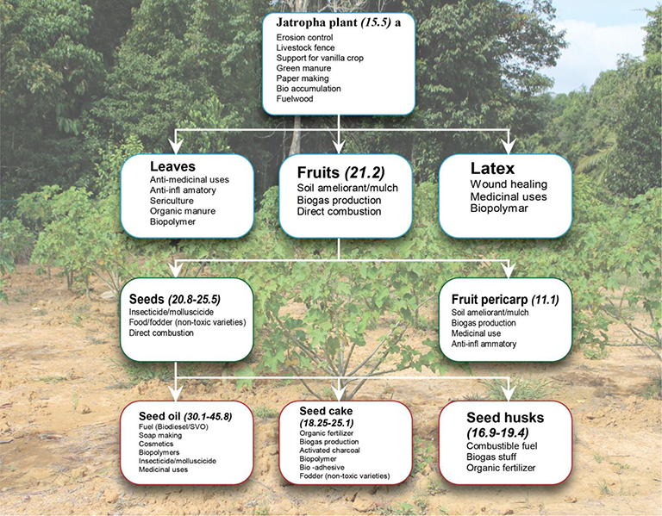

Figure 1: Potential uses of Jatropha plant (Jatropha Biofuel Industry: The Challenges, http://dx.doi.org/10.5772/64979
Wood, fruit shells, seed husks, and kernels from the Jatropha plant are used to generate energy. In rural places, its wood, leaves, and fruits have been used as firewood. Jatropha was used in prehistoric times to manage soil erosion and as a hedge (M. Moniruzzaman & M. Shahinuzzaman et.al.,).
The primary resource derived from Jatropha is raw oil. Decorticated seeds contain 40-60% oil, depending on the variety/cultivar. Because the properties of Jatropha seed oil mirror those of diesel, it is referred to as a biodiesel plant (Liberalino, A.A.A., et al., 1988, Gandhi, V., K. Cherian, and M. Mulky, 1995, Sharma, G., S. Gupta, and M. Khabiruddin, 1997, Wink, M., et al., 1997, Makkar, H. and K. Becker, 1997, Openshaw, K., 2000).

- Physical and Chemical properties of Jatropha seed oil:
The seeds of Jatropha Curcas are 212 cm long and readily split to obtain the oil (Raju and Ezradanam, 2002; Kumar and Sharma, 2011). Jatropha seed contains 37.5% fruit shell and 62.5% seed (42% skin seeds or husk and 58% kernel), as well as 64.4% oil or fat (triglycerol 88.2% and linoleic acid 47.3%). The oil content of Jatropha varies depending on where it is planted and the treatments used, such as water and fertilizer (Gudeta TB, 2016. Different chemical compositions, varietals, genetics, age, and environment may account for the variance in dry weight in a similar number of seeds (Achten WMJ, et.al., 2008).
Toxins such as phorbol esters, curcin, trypsin inhibitors, lectins, and phytates are present in such high concentrations in most provenance's blackish seeds that the seeds, oil, and seed cake should not be consumed without detoxification (Raju and Ezradanam, 2002; Kumar and Sharma, 2011).
Jatropha oil contains around 24.60% crude protein, 47.25% crude fat, and 5.54% moisture, respectively (Akintayo, E., 2004). Jatropha seed oil has a higher energy value (39MJ kg-1) than anthracite coal and is comparable to crude oil (Sotolongo, J.A., et al., 2007).
Properties | Units | Diesel | Jatropha biodiesel (JME) | Palm biodiesel (PME) | Calophyllum inophyllum (COME) | Rapeseed oil
Viscosity | cSt | 3.6 @35°C | 3.57 @ 35°C | 4.5 @ 40°C | 4.72 @ 40°C | 42.1 @ 40°C
Specific density | Kg/L | 0.841 @35°C | 0.8809 @ 35°C | 0.855 @40°C | 0.8768 @ 40°C | 0.917 @ 15°C
Cetane value | - | 47.8 | 58.4 | 65 | 51.9 | 36-55
Flash point | °C | 52 | 174 | 174 | 151 | 100
Carbon residue | Wt% | 5 | 2.4 | 2 | - | 78.0
Sulfur | %m/m | <1.0 | - | 0.04 | 1.6 | 0.005
Calorific value | J/Kg | 45,457 | 39,340 | 41,300 | 39,880 | 36,992
Density, viscosity, cetane number, and flash point are the most important fuel parameters to consider while using biodiesel in diesel engines (Patel, C., Chandra, K., et al., 2019).
Table 1: Comparative study of the physicochemical properties of biodiesels feedstocks and fossil-derived diesel Abbreviations: JME- Jatropha oil methyl ester, PME- Palm oil methyl ester, COME- Calophyllum oil methyl ester
References: https://www.researchgate.net/profile/Robinson-Ejilah/publication/290825132/figure/tbl2/AS:669400281673745@1536608872951/Physical-and-chemical-properties-of-Jatropha-curcas-oil-and-diesel.png
https://www.researchgate.net/profile/Robinson-Ejilah/publication/290825132/figure/tbl2/AS:669400281673745@1536608872951/Physical-and-chemical-properties-of-Jatropha-curcas-oil-and-diesel.png

In diesel engines, the Cetane number is the primary measure of fuel quality, particularly ignition and combustion. A high Cetane number typically indicates a shorter ignition delay time—that is, the time interval between fuel injection and ignition activation in the combustion chamber. The parameter typically provides good fuel combustion, cold start, and engine performance, as well as reduced white smoke generation and emissions (Ramos, M.J.; Fernández, C.M.; 2009). The cetane number of Jatropha is said to be comparable to that of diesel. As a result, any biodiesel that is to be efficiently replaced for diesel should have a higher cetane number.
In practice, any vegetable-based biodiesel blended with petroleum diesel must meet the two most commonly referred biodiesel standards, namely the American Standard Specifications for Biodiesel Fuel (B100) Blend Stock for Distillate Fuels (ASTM 6751) and the European Standard for Biodiesel (EN 14214). Both requirements require biodiesel to have a minimum flash point, which is more than 120 °C. The flashpoint of a fuel is the temperature at which it begins to burn after coming into contact with fire. Typically, any fuel with a high flash point can cause carbon deposition in the combustion compartment.
According to Table 1, Jatropha oil has a middle viscosity between diesel and other fatty acid methyl esters (FAME), making it suitable for biodiesel use. Most vegetable oils have a higher viscosity than petroleum fuel because of their high fatty acid content. The higher the viscosity, the better the lubrication of the gasoline, which decreases wear on the engine's moving mechanical elements. Finally, reduced wear minimizes leakage and decreases concerns linked to power losses and engine durability. Viscosity affects the atomization effectiveness of fuel injection inside the combustion chamber, the size distribution of fuel droplets, and the homogeneity of the mixture. High viscosity can cause pump breakage, filter clogging, poor combustion, and increased emissions. A higher viscosity additionally generates more surface tension and impacts the disintegration of a liquid jet into smaller fuel droplets, which has an adverse effect on the spray characteristic of a diesel engine's fuel spray injector. As a result, instead of a spray of tiny droplets, larger-sized fuel droplets are injected from an injector nozzle, resulting in inadequate air-fuel mixing (Ejim, C.E.; Fleck, B.A.; 2007; Abedin, M.J.; Masjuki, H.H.; 2014).
- Second-generation biofuels:
The main biofuel components of various agricultural biomasses produced by various biochemical processes are bioethanol, biodiesel, and biogas.
The shell of a Jatropha seed includes 34% cellulose, 10% hemicelluloses, and 12% lignin (Singh, R., et al., 2008). One (1) kilogram of Jatropha seed shell delivers approximately 11.1 MJ of energy (Sotolongo, J.A., et al., 2007). The seed husk contains ash (4%), volatile matter (71%), and fixed carbon (25%). One (1) kilogram seed husk yields approximately 16 MJ of energy, which is comparable to wood (Vyas, D. and R. Singh, 2007).
Figure 2: Processing of Jatropha curcas seeds (Evangelista and Cermak, 2007; Rao and Rao, 2013; Rao and Rao, 2013)
Jatropha curcas plant with fruits | Jatropha curcas seed | Jatropha curcas seeds with shells
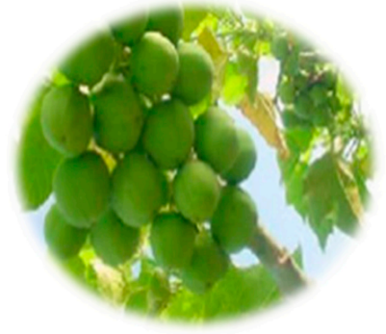 | 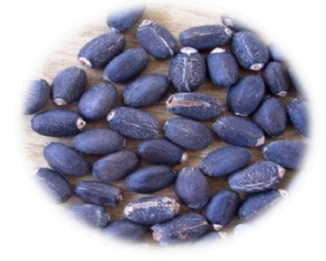 | 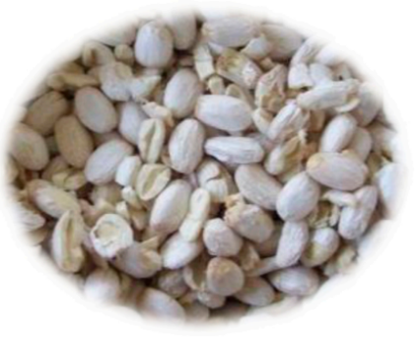

Lignocellulose biohydrogen can be generated via the fermentation of de-oiled Jatropha solid waste (DJSW) and lignocellulose-containing Jatropha seed cake (Kumar, G., et al., 2015; Lopes, S.L., et al., 2015). Under ideal circumstances, Kumar and colleagues reported the greatest attainable cumulative hydrogen production (CHP) of 296 mL H2 from the fermentation of de-oiled Jatropha waste. The claimed optimal conditions are 211 g/L substrate concentration, pH 6.5, and 55.4°C temperature. It is significant in terms of energy conservation (Kumar, G., et al., 2015).
Additional possible biofuel products from Jatropha Curcas growth include methane synthesis from the de-oiled cake, fuel briquette production from the husk, and pyrolysis of Jatropha Curcas biomass to bio-oil with physicochemical properties similar to crude petroleum (Meher et al., 2013).
- Industrial uses:
The thick oil extracted from Jatropha seed is commonly used to make soap (Openshaw, K., 2000). Because of the high palmitic acid concentration and hydrophobic character of Jatropha oil, it is simple to make soft and lasting soap (Pratt, J., et al., 2002).
Jatropha soap is commonly used in West Africa, Zambia, Tanzania, and Zimbabwe. Given the presence of glycerine in Jatropha oil soap, the white soap is gentle on the skin. It also has excellent foaming characteristics (Henning, R., 2000). Because of its therapeutic characteristics, jatropha soap can be used to treat a variety of skin problems (Messemaker, L., 2008). Jatropha seed oil comprises 32.8% linoleic acid (C18:2), which is beneficial to skin care (Pratt, J., et al., 2002; Benge, M., 2006). The oil is also used in hair conditioners (Brittaine, R. and N. Lutaladio, 2010).

Fatty acid (%) | Jatropha curcas oil | Palm oil
Oleic | 44.7 | 39.2
Linoleic | 32.8 | 10.1
Palmitic | 14.2 | 44.0
Stearic | 7.0 | 4.5
Table3: Fatty acid profile of Jatropha curcas oil and palm oil (Sinha P., Islam M.A., Negi M.S., Tripathi S.B., 2015; Aransiola E.F., Daramola M.O., et al., 2012)
Jatropha contains a variety of phytochemical components. This plant contains alkaloids, coumarins, flavonoids, lignoids, phenols, saponins, steroids, tannins, and terpenoids in various portions (Zhang, X.P., et al., 2009). These components have anti-cancer (Shahwar, D., et al., 2010; Kharat, A., A. Dolui, and S. Das, 2011), anti-microbial (Ravindranath, N., et al., 2003), anti-inflammatory (Bhagat, R., et al. 2011; Apu, A.S., et al., 2012; Reena, P., 2011), healing, homeostatic (Oduola, T., et al., 2005), anti-cholinesterase (Singh, D. and A. Singh, 2005; Feitosa, C., et al., 2011), anti-diarrheal (Apu, A.S., et al., 2012; Silva, S.d.N., et al., 2011 Félix-Silva, J., et al., 2014), and anti-hypersensitive properties (Abreu, I.C., et al., 2003). It is vital to investigate the toxicity of these phytochemicals. The toxic effects may reduce its medical usefulness.
D. Ecological uses:
Jatropha has been utilized for hedges since prehistoric times. The advantage is that it is not eaten by animals. Seed-germinating plants have taproots in addition to surface roots; Jatropha is a seed-germinating plant that protects the soil from erosion. It also serves as a nutrition pump since the roots can absorb leached-down minerals and return them as leaf fall, fruit debris, and other organic remnants.
After detoxification, Jatropha seed cake has a greater protein content (58.1% by weight) than soy meal (48%), making it an excellent animal feed protein supplement. Jatropha seed cake is regarded as an excellent source of minerals because it contains the majority of them: nitrogen, potassium, calcium, magnesium, sulfur, iron, phosphorus, zinc, copper, and manganese. Hence, it has been established as an excellent source of organic fertilizer (Achten, W., et al., 2008; Ghosh, Arup, J. S. Patolia et al., 2007).
- OIL EXTRACTION METHODS
The oil from Jatropha Curcas is retained in the fruit as triacylglycerol (TAG); in order to release these lipids, the cell wall must be damaged or broken. A variety of lipid extraction procedures can be used to recover lipids from various organic sources. The oil amount and kind of lipid components vary. Many methods are being used to improve the process of extracting the most oil from the Jatropha Curcas seed at the lowest possible cost (Mariana et al.).
Techniques commonly used for Jatropha oil extraction are as follows:
- Mechanical extraction
- Soxhlet extraction
Owing to technological improvements in recent years, some new methods have been established. These oil extraction procedures are designed to produce high extraction yields and high-value meals by getting high-quality oil with minimal undesirable components. They include supercritical fluid extraction, ultrasound-assisted extraction, and microwave-assisted extraction.
- Mechanical extraction:
Mechanical pressing is a common method of recovering oil. In the mechanical pressing technique, a helical body (spring) that spins in a tight area generates the pressing force, which can be operated by hydraulic presses or screw presses (press chamber). Continuous screw presses were used instead of hydraulic presses since they required a smaller workforce. To apply pressure to the oilseeds, a vertical feeder and a horizontal screw with increasing body diameter advance along the length of the press. The screw barrel has slots running the length of it, allowing increasing internal pressure to first release air and subsequently drain the oil through the barrel. The de-oiled cake is ejected at the end of the screw, and the Jatropha curcas oil is collected in a container (Romanić, 2020).
Oilseed materials are exposed to various pre-treatments such as washing, conditioning, heating, flaking, and dehulling prior to pressing in order to maximize the volume and quality of oil recovered from the raw material (Riayatsyah et al., 2022).
Significant efforts were made in the past to improve the oil extraction efficiency of screw presses. As a result, most studies focused on enhancing pressing process variables such as applied pressure, pressing temperature, and moisture conditioning of the given sample (Ofori-Boateng et al., 2012; Subroto et al., 2015).
Merits of mechanical extraction:
• Screw presses are typically preferred by small enterprises because they are less expensive, safer, and require less maintenance than solvent extraction.
• The fundamental feature of screw presses is that they can handle vast amounts of Jatropha curcas seed with little effort, and continuous oil extraction is possible.
Demerits of mechanical extraction:
• Because 8-14% of the oil remains in the cake and residual material, mechanical screw presses are suited for higher oil yield feedstocks. This method is not suitable for low oil yield feedstock; instead, solvent extraction would be preferable.

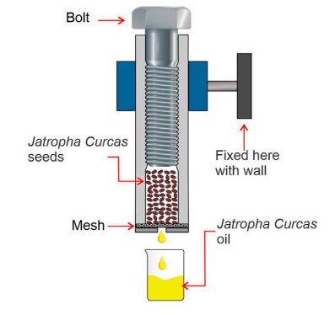

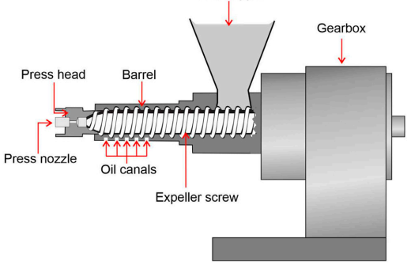
- B. Soxhlet extraction method:
Figure 3: The screw press design obtains oil by pressing seeds and nuts through a high friction and pressure chamber. The procedure does not include any additional heat, but the seeds are crushed using friction, which generates heat between 60 and 100° C. After the seeds have been crushed, the oil will be extracted. The seeds will remain in the press and harden into a "brick" that can be used as animal feed. (Riayatsyah et al., January 2022)
Figure 4: The cold-pressed method involves pressing the seed with an oilseed press to produce cold-pressed oil with less heat used or generated throughout the process. This technique is performed at a much lower temperature (50°C). (Riayatsyah et al., January 2022)

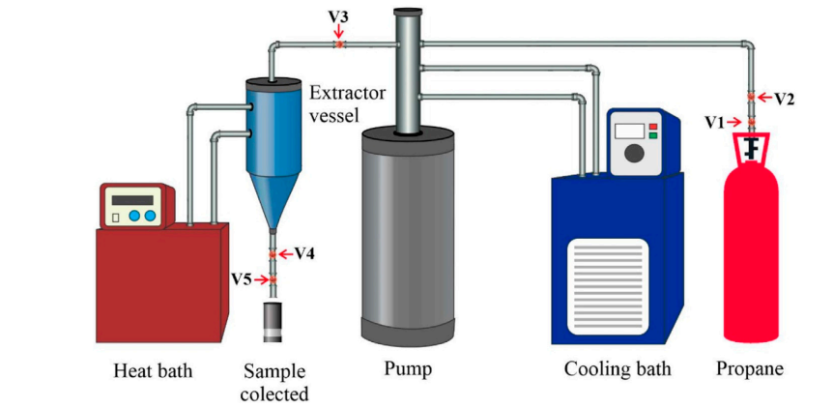

Figure 5: Soxhlet extraction using propane as the leaching solvent. V1 and V2 denote the ball valves; V3 and V5 the needle valves; V4 the blockage valve. (Riayatsyah et al., January 2022)
The soluble fraction (solute or leachate) from Jatropha Curcas seeds is extracted into a liquid solvent using the leaching or solvent-based extraction process (Bhuiya et al., 2020). Because of the high percentage of oil output and the expectation of generating high-quality oil, chemical extraction has gained popularity in the oil extraction industry. Because of their polarity, different solvents may generate varying oil yields when employing the solvent extraction procedure. Hexane, propane, ethane, tetrahydrofuran (THF), ethanol, dichloromethane, methanol, and the methanol-water binary system were all often used as oil extraction solvents (Haile et al., 2019; Zhang et al., 2019; Alrashidi et al., 2020). Even if there is high oil production and purity by using solvent, energy is still wasted throughout the lengthy extraction process.
Table 4: Comparative study of optimization analysis of crude oil yield in different plant species
Plant species | Calophyllum inophyllum | Nigella sativa L. | Prosopis julifera | Moringa stenopeta
Solvent | n-hexane | Ethanol | Polar and non-polar | Hexane
Seed-to-solvent ratio | 3:1, 5:1, 7:1 |  | 1:9
Reaction temperature | 60°C - 70°C |  | 60°C
Duration | (4,5,6) h |  | 9h
Yield | 86.4% | 40.2% | 37% | 34.8% - 42.3%
Reference | (Jose et al., 2011; Bhuiya et al., 2020). | (Alrashidi et al., 2020) | (Rajeshwaran et al., 2020) | (Haile et al., 2019)
The Response surface methodology used a set of parameters under consideration for the optimization analysis of crude oil. The solvent-to-seed ratio, reaction temperature, and extraction duration were the analytical parameters (Riayatsyah et al., 2022).
Because it involves dissolving oil by contacting oilseeds with a liquid solvent, solvent extraction is a substantially more successful method of obtaining oil from oilseeds than mechanical extraction.
Demerits of the Soxhlet extraction method:
- The separation of the oil and solvent mixture is difficult with this method, making it more suitable for a small-scale manufacturing plant.

- Supercritical fluid extraction:
Principle:
- As an alternative to standard oil and oilseed processing, the supercritical fluid extraction (SCFE) technology was proposed. This process is most commonly used in the essential oil industry (Xiong and Chen, 2020).
- Ethanol, isopropyl alcohol, acetone, iso-hexane, n-hexane, propane, and other supercritical fluids similar to those used in the Soxhlet extraction technique are among the solvents used.
- Supercritical carbon dioxide extraction (SC-CO2) is a process that employs carbon dioxide as a solvent above its critical pressure and temperature.
- The pressure in the system will be released after the oil has been extracted, the CO2 will return to the gas phase, and the oil will be precipitated from the CO2-Jatropha curcas oil combination.
Advantages:
- Unlike other solvents (n-hexane, ethanol, propane), CO₂ can be readily removed from the Jatropha curcas oil
- Minimal processing time of (25-30) min is achieved (De Lara Lopes et al., 2020; Fetzer et al., 2021).

- Other methods of Jatropha oil extraction:
Ultrasound-assisted extraction (UAE) and Microwave assisted extraction (MAE) are newly employed techniques to extract Jatropha curcas seed oil in recent times. These techniques might possibly ease the extraction process with minimal timeframe, high reproducibility, and low consumption of solvents and other materials required for the extraction process. The principle behind the UAE and MAE is the generation of turbulence between the matrix solutes and solvents namely, ethanol, n-hexane and propanol, etc. This process is facilitated by the poking or cavitation of plant cell walls by creating ultrasound-assisted microbubbles thereby, facilitating rapid diffusion of solvents into the internal area of the plant cells (Suganya et al., 2014). Recent studies highlight the optimizing role of UAE and MAE in the extraction of oils from microalgae and other plant species including Jatropha curcas.
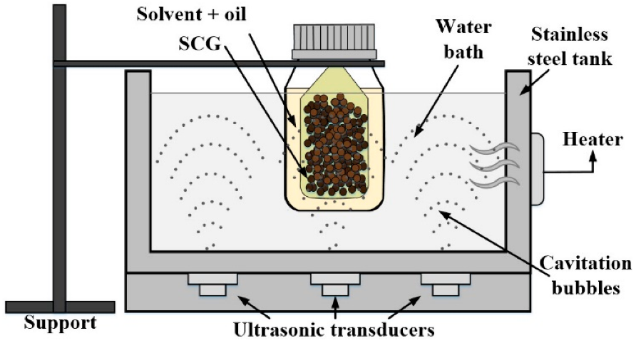

Figure 6: Studies showing the mechanism of ultrasound-assisted oil extraction using spent coffee grounds (SCP) (Malek Miladi et al., Nov 2021)
- BIODIESEL PREPARATION- TRANSESTERIFICATION:
Transesterification is described as the chemical process of converting triglycerides with alcohol into alkyl esters using a catalyst. Because of their low cost and ease of availability, methanol, and ethanol are commonly employed alcohols in this procedure. Transesterification is an environmentally favourable procedure that takes place in mild settings. This method can manufacture biodiesel from a range of feedstocks. Triglycerides derived from vegetable or animal oils are made up of three fatty acids connected to one glycerol molecule. Through three sequential reactions, triglycerides are reacted with an alcohol to create esters and glycerol.
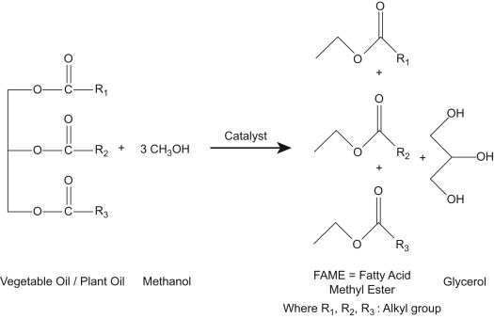

Figure 7: Transesterification reaction (Nikul K. Patel, Shailesh N. Shah, in Food, Energy, and Water, 2015)

Transesterification of biodiesel is usually carried out using a homogenous alkaline catalyst such as NaOH or KOH.
Although ethanol can be used to produce biodiesel, the use of methanol in biodiesel production is more prevalent and preferred due to its lower cost and huge available feedstock (L S Keong, D S Patle, S R Shukor, Z Ahmad)
- Challenges of biodiesel processing and purification:
Following the extraction of the oil, it is purified and trans esterified in order to produce crude biodiesel. However, due to limitations such as industry standard biodiesel standards, the crude biodiesel cannot be used directly as a transportation fuel. As a result, before being used in diesel engines, crude biodiesel is normally blended in particular quantities with pure diesel. The crude biodiesel is filtered before mixing to remove undesirable moisture and chemical waste created during the transesterification process. Water washing is the most popular method of purification since it is inexpensive and simple, albeit this time-consuming procedure must be repeated numerous times until no more glycerol is created (Ali, R.M.; Farag, H.A.; Amin, N.A.; Farag, I.H., 2015).
The fatty acid composition has a considerable impact on the fuel qualities of biodiesel (Saraf, S.; Thomas, B., 2007). Inedible oils, such as Jatropha, typically contain significant levels of harmful free fatty acids (FFA) (>1% w/w), lowering biodiesel production. Similarly, the large amount of fatty acid inhibits direct conversion of the oil into biodiesel because the high FFAs increase soap production, which might impede product separation during or after transesterification. Jatropha oil has over 14% FFA, greatly exceeding the regulatory limit of 1% FFA. As a result, the pretreatment stage is required to reduce the feedstock FFAs for increased biodiesel yield (Atadashi, I.M.; Aroua, M.K.; Aziz, A.A., 2010). When NaOH catalyst is used, the typical undesirable saponification reaction produces soap and water.

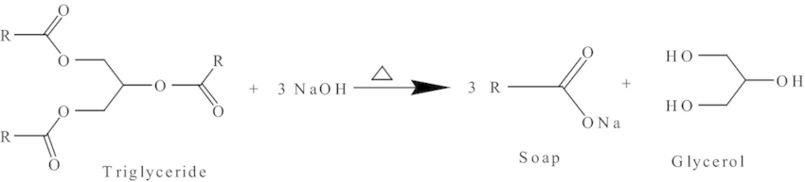
Figure 8: Saponification (Jatropha Biofuel Industry: The Challenges, http://dx.doi.org/10.5772/64979)

- Jatropha plant cultivation
2. Fruit harvesting
7. Transesterification
3. Pretreatment
4. Seeds/kernel storage
5. Oil extraction
6. Crude oil purification
8. Biodiesel purification

Figure 9: Biodiesel processing and challenges (https://doi.org/10.3390/pr8070786)
- Measures undertaken during trans esterification:
The two-step transesterification process is an efficient method for processing crude oil containing considerable FFAs from Jatropha curcas. Furthermore, the acid-base catalyst is used in the pretreatment or esterification process to lower the FFA level of Jatropha curcas oil. As a result, transesterification yields an ideal yield of 90% methyl ester after two hours (Berchmans, H.J.; Hirata, S., 2008). Furthermore, the acid catalyst decreases the FFA concentration to 1% through esterification, which converts the FFA into esters. The triglycerides in J. curcas oil are trans esterified into biodiesel in the presence of an alkaline catalyst in the second stage. The unsaturation of fatty acids in oil is a significant aspect in determining the quality of biodiesel.
- Pyrolysis/thermal cracking:
Pyrolysis is described as the thermal conversion of vegetable oils into alkanes, alkenes, aromatics, carboxylic acids, and trace amounts of gaseous products in the absence of air (Madras, G., C. Kolluru, and R. Kumar, 2004). Catalytic pyrolysis increases product yield by breaking big molecules and improves product quality (biofuel).
Vegetable oil catalytic cracking is a three-step process. The first is the elimination of oxygen via C=O bond hydrogenation, followed by C-O bond rupture, and finally C-C bond breaking via a catalyst. The cracking reaction can take several forms, including hydrodeoxygenation, decarboxylation, and decarbonylation. With the elimination of water, CO, CO2, and other contaminants, each pathway yields shorter and straighter chain hydrocarbons (M. Moniruzzaman, M. Shahinuzzaman et al.).
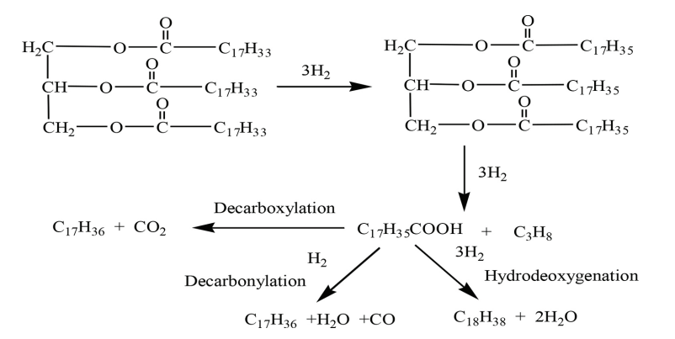
Figure 9: Thermal cracking of triglyceride ((Jatropha Biofuel Industry: The Challenges, http://dx.doi.org/10.5772/64979).

The hydrocracking process requires more energy and temperature (280-300°C) than transesterification of Jatropha vegetable oil for biofuel production, but the pyrolyzed products have a higher cetane number and oxidation stability (Liu, J., et al., 2012).
Because of its reusability, low cost, and good selectivity (Ramachandran, K., et al., 2013), the homogeneous solid base catalyst outperforms the other catalytic systems for hydro processing Jatropha oil. However, the base catalyst generates soap with FFA and requires high quality Jatropha oil, which is the main impediment (Borges, M. and L. Díaz, 2012). The freezing point and low production of Jatropha bio-jet fuel are the main issues. The freezing point of catalytically cracked Jatropha hydrocarbon is greater than zero degrees Celsius, whereas the freezing point of traditional jet fuel is less than 40 degrees Celsius (Liu, Q., et al., 2013; Morgan, P. and P. Roets. 2011; Bishop, G.J.). To address this issue, a novel catalyst system for hydroprocessing Jatropha oil must be developed.
Because of the flexible properties of zeolite, there are numerous advantages to employing metal supported on microporous zeolite catalysts for hydrocracking Jatropha oil (Hancsók, J., et al., 2007). Zeolite catalysts have great porosity, a large surface area, and a concurrent-base nature for ion exchange (Saifuddin, N., A. Samiuddin, and P. Kumaran, 2015). Because of its unique structure, it can overcome the diffusion limitation and boost manufacturing yield. High temperatures (280-300°C) and pressure are required for cracking reactions, which raises the production cost. As a result, it is critical to select and optimize the nonsulphided metal supported zeolite catalyst, as well as the optimal conditions (temperature, pressure, and reaction time) for hydrocracking Jatropha oil to create diesel and jet-fuel range hydrocarbons.
V. LIMITATIONS OF JATROPHA AS A BIOFUEL CROP
- There is still a need for a viable commercial cultivar with increased yield and disease resistance.
- Significant variation in yield among trees.
– Fruiting requires correct irrigation and nutrients, yet it can live with insufficient irrigation and nutrition.
– Long gestation period: it takes 3-5 years to become commercially productive. Its usage as a feed and therapeutic agent is limited due to the presence of hazardous components.
– According to a recent study, Jatropha is prone to pests and illnesses.
– Frost and water logging are problems for Jatropha.
– Some diseases (cassava diseases) may be found in Jatropha.
– Jatropha seed oil's high viscosity limits its application in cool climates.
– Jatropha can become a weed in some conditions.
(M. Moniruzzaman, Zahira Yaakob, M. Shahinuzzaman, Rahima Khatun and A.K.M. Aminul Islam)
VI. MAJOR SETBACKS OF JATROPHA CULTIVATION:
- Poor crop yield:
According to experts, a Jatropha seed yield of 4-5 Mg/ha/yr is required for the industry's commercial viability. Jatropha would compete with soybeans (USA 0.38 Mg oil/ha) and rapeseed (Europe 1.0 Mg oil/ha) if the normal seed yield of 3.75 Mg/ha with 30-35% oil content or 1.2 Mg/ha oil yield was used (Gopinathan, M.C. and R. Sudhakaran, 2011). However, the unit seed yield and seed oil content of Jatropha are highly flocculated. According to several writers, one of the most significant barriers to the economic sustainability of the Jatropha biodiesel business is the poor seed yield and seed oil content (Singh, K., et al., 2014; Weyerhaeuser, H., et al., 2007; Zhang, G.-w., Y. Peng, and M. Huang, 2009; YU, B., et al., 2007; Fei, S., X. Chen, and Y. He, 2006).
After 5 years of plantation in India, a various site trial at diverse agro-climatic areas was undertaken, and the average seed yield was recorded as 0.5-1.4 Mg/ha/yr (Sabandar, C.W., et al., 2013). A similar result was obtained from the sodic soil plantation of 24 elite accessions (Singh, B., et al., 2013) with good plant architecture (height and branching pattern).
According to a recent evaluation, the global average seed productivity of Jatropha is 1.6 Mg/ha, which is equivalent to 0.475 Mg/ha/yr biodiesel production, which is insufficient for the business to be commercially viable.
One of the most effective remedies is the development of a higher yielding and more oil-containing cultivar. A good commercial variation, on the other hand, is still lacking (Moniruzzaman, M., Z. Yaakob, and R. Khatun, 2016). According to recent research, one of the most significant barriers to Jatropha planting is variety breeding (Zhang, G.-w., Y. Peng, and M. Huang, 2009). Actually, the current Jatropha breeding program is confined to conventional breeding and a survey of wild Jatropha plant germplasm resources (Zhang, G.-w., Y. Peng, and M. Huang, 2009). However, research on the use of current biotechnology to Jatropha improvement is restricted (Moniruzzaman, M., Z. Yaakob, and R. Khatun, 2016). Cloning, expression, and biological function annotation investigations for Jatropha genes, which are responsible for economic features, are particularly lacking.
Furthermore, there are no/only a few extensive studies on field observations of seed yield under various growth strategies. Data on tree density for Jatropha cultivation, canopy pruning intensity and frequency, pesticide action, and fertilization and irrigation efficiency, for example, are mostly lacking in the literature.
- Low input crop:
Because of its capacity to grow on barren soil, J. curcas is thought to be a low input crop. However, in order to thrive as a profitable crop, it requires appropriate nutrients in the form of fertilizer as well as rainfall or irrigation. Excess fertilizer and irrigation, on the other hand, may promote vegetative growth (biomass production) at the expense of fruit yield. Moisture and minerals have a greater impact on seed production and oil productivity from marginal lands plantations. J. curcas plant growth and seed yield were much higher under irrigated conditions than under non-irrigated ones (Tikkoo, A., S. Yadav, and N. Kaushik, 2013; Singh, B., et al., 2013).
Nitrogen and phosphorus applications boosted J. curcas growth, seed output, and oil yield (Patolia, J. S., Arup Ghosh, Jitendra Chikara, D. R. et al., 2007). Furthermore, another analysis by the BAIF Development Research Foundation revealed a seed production of approximately 500 kg/ha under rainfed circumstances in the fifth year of planted. However, after consistent irrigation of the same planting, the seed output increased to around 1200 kg/ha the following year (Daniel, J., 2008). Despite support for large-scale plantation of J. curcas, systematic studies for yield improvement, agronomy (particularly irrigation and nutritional requirements) under varied agroclimatic situations have not been fully addressed (Mohapatra, S. and P.K. Panda, 2011).
- Disease susceptibility:
According to recent research, the plants were vulnerable to viral infection (Cucumber mosaic virus), insect attack, rodents, powdery mildew, leaf spots, insect defoliation, and fungal soil infections (Singh, B., et al., 2013; Everson, C.S., M.G. Mengistu, and M.B. Gush, 2013).
VII. CONCLUSION:
Research studies have ensured the economic exploitation of Jatropha seed oil as a potential renewable energy source. The physicochemical properties of Jatropha curcas oil were evaluated and scientifically proven to be in an acceptable range for use as a biofuel crop. Comparative analysis of different fatty acid methyl esters (FAME) was performed and Jatropha biodiesel outweighed as an excellent source of biofuel, owing to its non-sulfur content. The presence of sulfur in biodiesels could lead to the emission of H₂S, which merely contributes to global warming and greenhouse gas emissions (GHG). Furthermore, Jatropha seeds cannot be used for human consumption due to the presence of toxins such as ‘curcin’ which makes it non-edible. These plants can be easily propagated on marginal farms or wastelands, providing a promising approach towards the socioeconomic growth of underdeveloped nations. The biofuel industries have lately employed numerous outbreaking oil extraction techniques for the extraction of Jatropha oil on a large scale, ensuring a proper quality oil yield and higher percentage of lipids present in the oil. However, it has got its own drawbacks in the biodiesel processing of Jatropha oil. The solvents used for oil extraction are hazardous and not cost-effective, and the use of solvents is limited to small throughput industries. In addition to this, the conventional use of mechanical pressing using screw presses finds to be poor-yielding in terms of both quality and quantity. The exploration of novel efficient oil extraction techniques is carried out across the scientific grounds. And, the newly evolved methodologies include Ultrasound assisted extraction (UAE) and Microwave assisted extraction (MAE). Thus far, research studies based on optimization analysis of seed-to-solvent ratio, extraction duration and other processing parameters (Temperature, pressure, etc.) were performed. The results have exquisitely shown to reduce the oil extraction duration (30 mins vs 16 h).
Conversion of crude oil to biodiesel (JME) is another challenge. Transesterification/alcoholysis and thermal cracking/pyrolysis are two commonly used biodiesel preparation techniques. The presence of excessive (14%) free fatty acids (FFA) in crude oil hampers the conversion process and leads to saponification in the presence of base-catalyst therefore, a two-step transesterification is established to reduce the FFA content with the initial step involving an acid catalyst. This establishment has contributed to increased yield and quality, and eases the separation process eventually. Further, appropriate techniques should be developed for efficient recovery of glycerine from the end-products of biodiesel preparation for its extended use in soap and cosmetic industries. On the other hand, thermal cracking involves provision of high temperatures which is quite expensive. However, the introduction of zeolite catalyst has ascertained its own advantages.
Above all, researchers have brought into light the existing knowledge gap in terms of poor crop yield, low input crop, pest and disease susceptibility. Focus on agronomic studies and crop improvement must be enlightened to seal the gap. Diverse breeding programmes must be established for the development of a variety of germplasm to enhance the crop improvement strategies. Applied biotechnological techniques such as marker-assisted selection shall render benefits in the determination of genes associated with high oil yield. Various aspects of Jatropha cultivation and germplasm improvement shall be focused to meet out the demands of fossil fuel-driven vehicles in future, culminating to a sustainable replacement of fuels.
References:
Valipour, A. (2014). A Review on Combustion, Performance and Emission Characteristics of Liquid Alternative Fuels for Diesel Engine. Oxford: Oxford University Press.
Kumar, A., and Sharma, S. (2008). An Evaluation of Multipurpose Oil Seed Crop for Industrial Uses (Jatropha Curcas L.): A Review. Ind. Crops Prod. 28, 1–10. doi: 10.1016/j.indcrop.2008.01.001
Wang, X.-R., and Ding, G.-J. (20122012). Reproductive Biology Characteristic of Jatropha Curcas (Euphorbiaceae). Rev. Biol. Trop. 60 (4), 1525–1533. doi:10.15517/rbt.v60i4.2070
Silitonga, A. S., Mahlia, T. M. I., Kusumo, F., Dharma, S., Sebayang, A. H., Sembiring, R. W., et al. (2019). Intensification of Reutealis Trisperma Biodiesel Production Using Infrared Radiation: Simulation, Optimisation and Validationfication of Reutealis Trisperma Biodiesel Production Using Infrared Radiation: Simulation, Optimisation and Validation. Renew. Energ. 133, 520–527. doi: 10.1016/j.renene.2018.10.023
Ambat, I., Srivastava, V., Iftekhar, S., Haapaniemi, E., and Sillanpää, M. (2020). Effect of Different Co-solvents on Biodiesel Production from Various Low-Cost Feedstocks Using Sr-Al Double Oxides. Renew. Energ. 146, 2158–2169. doi: 10.1016/j.renene.2019.08.061
Ong, H. C., Tiong, Y. W., Goh, B. H. H., Gan, Y. Y., Mofijur, M., Fattah, I. M. R., et al. (2021). Recent Advances in Biodiesel Production from Agricultural Products and Microalgae Using Ionic Liquids: Opportunities and Challenges. Energ. Convers. Management 228, 113647. doi:10.1016/ j. enconman.2020.113647
Meher, L. C., Churamani, C. P., Arif, M., Ahmed, Z., and Naik, S. N. (2013). Jatropha Curcas as a Renewable Source for Bio-Fuels-A Review. Renew. Sustainable Energ. Rev. 26, 397–407. doi: 10.1016/j.rser.2013.05.065
Foidl, N., Foidl, G., Sanchez, M., Mittelbach, M., and Hackel, S. (1996). Jatropha Curcas L. As a Source for the Production of Biofuel in Nicaragua. Bioresour. Technology 58, 77–82. doi:10.1016/s0960-8524(96)00111-3
Carels, N. (2009). Chapter 2 Jatropha Curcas. Adv. Bot. Res. 50, 39–86. doi:10.1016/ s0065-2296(08)00802-1
Garnayak, D. K., Pradhan, R. C., Naik, S. N., and Bhatnagar, N. (2008). Moisturedependent Physical Properties of Jatropha Seed (Jatropha Curcas L). Ind. Crops Prod. 27, 123–129. doi:10.1016/j.indcrop.2007.09.001
Kumar, A., and Sharma, S. (2011). Potential Non-edible Oil Resources as Biodiesel Feedstock: An Indian Perspective. Renew. Sustainable Energ. Rev. 15, 1791–1800. doi:10.1016/j.rser.2010.11.020
Moser, B. R. (2011).“Biodiesel Production, Properties, and Feedstocks,”in Biofuels. Editors D. Tomes, P. Lakshmanan, and D. Songstad (New York: Springer), 285–347. doi:10.1007/978-1-4419-7145-6_15
Divakara, B. N., Upadhyaya, H. D., Wani, S. P., and Gowda, C. L. L. (2010). Biology and Genetic Improvement of Jatropha Curcas L.: A Review. Appl. Energ. 87, 732–742. doi:10.1016/j.apenergy.2009.07.013
Raju, A. S., and Ezradanam, V. (2002). Pollination Ecology and Fruiting Behaviour in a Monoecious Species Jatropha Curcas L.(Euphorbiaceae). CURRENT SCIENCE-BANGALORE- 83, 1395–1397.
Mariana, I., Nicoleta, U., Sorin-Ştefan, B., Gheorghe, V., and Mirela, D. (2013). ACTUAL METHODS FOR OBTAINING VEGETABLE OIL FROM OILSEEDS.
Romanić, R. (2020). “Chapter 17 - Cold Pressed sunflower (Helianthus Annuus L) Oil,” in Cold Pressed Oils: Green Technology, Bioactive Compounds, Functionality, and Applications. Editor M. F. Ramadan (Academic Press), 197–218
Ofori-Boateng, C., Keat Teong, L., and Jitkang, L. (2012). Comparative Exergy Analyses of Jatropha Curcas Oil Extraction Methods: Solvent and Mechanical Extraction Processes. Energ. Convers. Management 55, 164–171. doi:10.1016/ j.enconman.2011.11.005
Subroto, E., Manurung, R., Heeres, H. J., and Broekhuis, A. A. (2015). Optimization of Mechanical Oil Extraction from Jatropha Curcas L. Kernel Using Response Surface Method. Ind. Crops Prod. 63, 294–302. doi:10.1016/ j.indcrop.2014.08.050
Chapuis, A., Blin, J., Carré, P., and Lecomte, D. (2014). Separation Efficiency and Energy Consumption of Oil Expression Using a Screw-Press: The Case of Jatropha Curcas L. Seeds. Ind. Crops Prod. 52, 752–761. doi:10.1016/ j.indcrop.2013.11.046
Yate, A. V., Narváez, P. C., Orjuela, A., Hernández, A., and Acevedo, H. (2020). A Systematic Evaluation of the Mechanical Extraction of Jatropha Curcas L. Oil for Biofuels Production. Food Bioproducts Process. 122, 72–81. doi:10.1016/ j.fbp.2020.04.001
Bhuiya, M. M. K., Rasul, M., Khan, M., Ashwath, N., and Mofijur, M. (2020). Comparison of Oil Extraction between Screw Press and Solvent (N-hexane) Extraction Technique from beauty Leaf (Calophyllum inophyllum L.) Feedstock. Ind. Crops Prod. 144, 112024. doi:10.1016/ j.indcrop.2019.112024
Haile, M., Duguma, H. T., Chameno, G., and Kuyu, C. G. (2019). Effects of Location and Extraction Solvent on Physico Chemical Properties of Moringa Stenopetala Seed Oil. Heliyon 5, e02781. doi:10.1016/j.heliyon.2019.e02781
Zhang, Y., Chang, C., Tan, B., Xu, D., Wang, Y., and Qi, T. (2019). Application of a Sustainable Bioderived Solvent (Biodiesel) for Phenol Extraction. Acs Omega 4, 10431–10437. doi:10.1021/acsomega.9b00977
Alrashidi, M., Derawi, D., Salimon, J., and Yusoff, M. F. (2020). An Investigation of Physicochemical Properties of Nigella Sativa L. Seed Oil from Al-Qassim by Different Extraction Methods. J. King Saud University-Science 32, 3337–3342. doi:10.1016/j.jksus.2020.09.019
Xiong, K., and Chen, Y. (2020). Supercritical Carbon Dioxide Extraction of Essential Oil from Tangerine Peel: Experimental Optimization and Kinetics Modelling. Chem. Eng. Res. Des. 164, 412–423. doi:10.1016/ j.cherd.2020.09.032
De Lara Lopes, N., De Almeida-Couto, J. M. F., Da Silva, C., Pereira, M. B., Pimentel, T. C., Barão, C. E., et al. (2020). Evaluation of the Effects of Pressurized Solvents and Extraction Process Parameters on Seed Oil Extraction in Pachira Aquatica. J. Supercrit. Fluids 161, 104823. doi:10.1016/ j.supflu.2020.104823
Fetzer, D. L., Hamerski, F., Errico, M., and Corazza, M. L. (2021). Extraction of Cumaru Seed Oil Using Compressed Propane as Solvent. J. Supercrit. Fluids 169, 105123. doi:10.1016/j.supflu.2020.105123
Suganya, T., Kasirajan, R., and Renganathan, S. (2014). Ultrasound-enhanced Rapid In Situ Transesterification of marine Macroalgae Enteromorpha Compressa for Biodiesel Production. Bioresour. Technol. 156, 283–290. doi:10.1016/j.biortech.2014.01.050
Koh, M.Y. and T.I.M. Ghazi, A review of biodiesel production from Jatropha curcas L. oil. Renewable and Sustainable Energy Reviews, 2011. 15(5): pp. 2240–2251.
Mofijur, M., et al., Prospects of biodiesel from Jatropha in Malaysia. Renewable and Sustainable Energy Reviews, 2012. 16(7): pp. 5007–5020.
Singh, B., et al., Agro-technology of Jatropha curcas for diverse environmental conditions in India. Biomass and bioenergy, 2013. 48: pp. 191
Atabani, A., et al., Investigation of physical and chemical properties of potential edible and non-edible feedstocks for biodiesel production, a comparative analysis. Renewable and Sustainable Energy Reviews, 2013. 21: pp. 749–755.
Abhilash, P., et al., Revisited Jatropha curcas as an oil plant of multiple benefits: critical research needs and prospects for the future. Environmental Science and Pollution Research, 2011. 18(1): pp. 127–131
Kant, P. and S. Wu, The extraordinary collapse of Jatropha as a global biofuel. Environmental Science & Technology, 2011. 45(17): pp. 7114–7115.
Liberalino, A.A.A., et al., Jatropha curcas L. seeds: chemical analysis and toxicity. Arquivos de Biologia e Tecnologia, 1988. 31(4): pp. 539–550.
Gandhi, V., K. Cherian, and M. Mulky, Toxicological studies on ratanjyot oil. Food and Chemical Toxicology, 1995. 33(1): pp. 39–42.
Sharma, G., S. Gupta, and M. Khabiruddin. Cultivation of Jatropha curcas as a future source of hydrocarbon and other industrial products. In Biofuels and industrial products from Jatropha curcas-Proceedings from the Symposium Jatropha. 1997
Wink, M., et al., 4.1 Phorbol Esters of J. curcas-Biological Activities and Potential Applications. 1997.
Makkar, H. and K. Becker, Potential of Jatropha curcas seed meal as a protein supplement to livestock feed, constraints to its utilization and possible strategies to overcome constraints. Proceeding Jatropha, 1997. 97: p. 37-40.
Openshaw, K., A review ofJatropha curcas: an oil plant of unfulfilled promise. Biomass and Bioenergy, 2000. 19(1): pp. 1–15.
Akintayo, E., Characteristics and composition of Parkia biglobbossa and Jatropha curcas oils and cakes. Bioresource Technology, 2004. 92(3): pp. 307–310.
Sotolongo, J.A., et al., Jatropha curcas L. as a source for the production of biodiesel: A Cuban experience. in 15th European biomass conference and exhibition, Berlin, Germany. 2007.
Singh, R., et al., SPRERI experience on holistic approach to utilize all parts ofJatropha curcasfruit for energy. Renewable Energy, 2008. 33(8): p. 1868-1873.
Kumar, G., et al., Lignocellulose biohydrogen: practical challenges and recent progress. Renewable and Sustainable Energy Reviews, 2015. 44: pp. 728–737.
Kumar, G., et al., Modeling and optimization of biohydrogen production from de-oiled Jatropha using the response surface method. Arabian Journal for Science and Engineering, 2015. 40(1): pp. 15–22.
Kumar, G., et al., Comparative evaluation of hydrogen fermentation of de-oiled Jatropha waste hydrolyzates. International Journal of Hydrogen Energy, 2015. 40(34): pp. 10766–10774
Lopes, S.L., et al., Bioconversion of Jatropha curcas seed cake to hydrogen by a strain of Enterobacter aerogenes. Fuel, 2015. 139(0): pp. 715–719.
Pratt, J., et al., Malawi Agroforestry Extension Project Marketing & Enterprise Program, Main Report. Malawi Agroforestry, 2002: p. 139.
Henning, R., The Jatropha Manual. A guide to the integrated exploitation of the Jatropha plant in Zambia. Germany: Deutsche Gesellschaft für Technische Zusammenarbeit GTZ, 2000.
Messemaker, L., Assessment of the Jatropha value chain and its potential for pro poor biofuel development in Northern Tanzania. 2008, MSc thesis International development studies at the Faculty of Geosciences, Utrecht University, 2008.
Benge, M., Assessment of the potential of Jatropha curcas,(biodiesel tree,) for energy production and other uses in developing countries. USAID Report, 2006.
Brittaine, R. and N. Lutaladio, Jatropha: a smallholder bioenergy crop: the potential for pro-poor development. Vol. 8. 2010: Food and Agriculture Organization of the United Nations (FAO).
Zhang, X.P., et al., Chemical constituents of the plants from genus Jatropha. Chemistry & Biodiversity, 2009. 6(12): pp. 2166–2183.
Ravindranath, N., et al., Jatrophenone, a novel macrocyclic bioactive diterpene from Jatropha gossypifolia. Chemical and Pharmaceutical Bulletin, 2003. 51(7): pp. 870–871.
Bhagat, R., et al., Anti-inflammatory activity of Jatropha gossypifolia L. leaves in albino mice and Wistar rat. Journal of Scientific and Industrial Research, 2011. 70(4): pp. 289–292
Apu, A.S., et al., Study of pharmacological activities of methanol extract of Jatropha gossypifolia fruits. Journal of Basic and Clinical Pharmacy, 2012. 4(1): p. 20.
Reena, P., Evaluation of antimicrobial and anti-inflammatory activities of bark of Jatropha gossypifolia. World Journal of Science and Technology, 2011. 1(10).
Oduola, T., et al., Mechanism of action of Jatropha gossypifolia stem latex as a haemostatic agent. European Journal of General Medicine, 2005. 2(4): pp. 140–14
Singh, D. and A. Singh, The toxicity of four native Indian plants: effect on AChE and acid/alkaline phosphatase level in fishChanna marulius . Chemosphere, 2005. 60(1): pp. 135–140.
Feitosa, C., et al., Acetylcholinesterase inhibition by somes promising Brazilian medicinal plants. Brazilian Journal of Biology, 2011. 71(3): pp. 783–789.
Apu, A.S., et al., Anti-diarrheal Potential of Jatropha gossypifolia (Linn.). Journal of Medical Sciences, 2012. 12(8): pp. 274–279.
Silva, S.d.N., et al., Antispasmodic effect of Jatropha gossypiifolia is mediated through dual blockade of muscarinic receptors and Ca2+ channels. Revista Brasileira de Farmacognosia, 2011. 21(4): pp. 715–720.
Félix-Silva, J., et al., Jatropha gossypiifolia L.(Euphorbiaceae): a review of traditional uses, phytochemistry, pharmacology, and toxicology of this medicinal plant. EvidenceBased Complementary and Alternative Medicine, 2014. 2014 1–32
Abreu, I.C., et al., Hypotensive and vasorelaxant effects of ethanolic extract from Jatropha gossypiifolia L. in rats. Fitoterapia, 2003. 74(7): pp. 650–657.
Shahwar, D., et al., Antioxidant activities of the selected plants from the family Euphorbiaceae, Lauraceae, Malvaceae and Balsaminaceae. African Journal of Biotechnology, 2010. 9(7): pp. 1086–
Kharat, A., A. Dolui, and S. Das, Free radical scavenging potential of Jatropha gossypifolia. Asian Journal of Chemistry, 2011. 23(2): pp. 799–801.
Achten, W., et al.,Jatropha bio-diesel production and use. Biomass and Bioenergy, 2008. 32(12): pp. 1063–1084
Ghosh, Arup, J. S. Patolia, D. R. Chaudhary, Jitendra Chikara, S. N. Rao, Dheerendra Kumar, G. N. Boricha, and A. Zala. “Response of Jatropha curcas under different spacing to Jatropha de-oiled cake.” In Expert seminar on Jatropha curcas L. Agronomy and genetics, pp. 26–28. 2007.
Gopinathan, M.C. and R. Sudhakaran, Biofuels: opportunities and challenges in India, in Biofuels. 2011, Springer, New York, pp. 173–209.
Weyerhaeuser, H., et al., Biofuels in China: an analysis of the opportunities and challenges of Jatropha curcas in Southwest China. World Agroforestry Centre, ICRAF Working Paper, 2007. 53.
Zhang, G.-w., Y. Peng, and M. Huang, Existing Problems and Countermeasures for Jatropha curcas Industrialization in China [J]. Journal of Anhui Agricultural Sciences, 2009. 8.
YU, B., et al., The Current Situation and Countermeasures of Jatropha curcas L. in Sichuan Province. Sichuan Forestry Exploration and Design, 2007. 3: p. 005.
Fei, S., X. Chen, and Y. He, Prospects of studies on Jatropha curcas biodiesel in Sichuan. Biomass Chemical Engineering, 2006. 40(12): pp. 193–139.
Singh, B., et al., The field performance of some accessions of Jatropha curcas L.(Biodiesel Plant) on degraded sodic land in North India. International journal of green energy, 2013. 10(10): pp. 1026–040.
Moniruzzaman, M., Z. Yaakob, and R. Khatun, Biotechnology for Jatropha improvement: a worthy exploration. Renewable and Sustainable Energy Reviews, 2016. 54: pp. 1262–1277.
Patolia, J. S., Arup Ghosh, Jitendra Chikara, D. R. Chaudhary, D. R. Parmar, and H. M. Bhuva. “Response of Jatropha curcas grown on wasteland to N and P fertilization.” In Expert seminar on Jatropha curcas L. Agronomy and genetics, pp. 26–28. 2007.
Daniel, J., Jatropha Oilseed Production: a realistic approach. BAIF Development Research Foundation.(Available Online: http://www. baif. org. in/aspx_pages/pdf/ Agroforesty/MEDA. pdf), 2008.
Mohapatra, S. and P.K. Panda, Effects of fertilizer application on growth and yield of Jatropha curcas L. in an aeric tropaquept of eastern India. Notulae Scientia Biologicae, 2011. 3(1): p. 95.
Madras, G., C. Kolluru, and R. Kumar, Synthesis of biodiesel in supercritical fluids. Fuel, 2004. 83(14): pp. 2029–2033.
Liu, J., et al., Hydroprocessing of Jatropha oil over NiMoCe/Al2O3 catalyst. International Journal of Hydrogen Energy, 2012. 37(23): pp. 17731–17737.
Ramachandran, K., et al., Recent developments for biodiesel production by ultrasonic assist transesterification using different heterogeneous catalyst: a review. Renewable and Sustainable Energy Reviews, 2013. 22: pp. 410–418.
Borges, M. and L. Díaz, Recent developments on heterogeneous catalysts for biodiesel production by oil esterification and transesterification reactions: a review. Renewable and Sustainable Energy Reviews, 2012. 16(5): pp. 2839–2849.
Liu, Q., et al., One-step hydrodeoxygenation of palm oil to isomerized hydrocarbon fuels over Ni supported on nano-sized SAPO-11 catalysts. Applied Catalysis A: General, 2013. 468: pp. 68–74.
Morgan, P. and P. Roets. The Synthetic Jet Fuel Journey. in 20th World Petroleum Congress. 2011. World Petroleum Congress, 4–8 December, Doha, Qatar.
Bishop, G.J., Aviation Turbine Fuels. Ullmann's Encyclopedia of Industrial Chemistry.
Hancsók, J., et al., Investigation of the production of high cetane number bio gas oil from pre-hydrogenated vegetable oils over Pt/HZSM-22/Al2O3 . Microporous and Mesoporous Materials, 2007. 101(1): pp. 148–152.
Saifuddin, N., A. Samiuddin, and P. Kumaran, A review on processing technology for biodiesel production. Trends in Applied Sciences Research, 2015. 10(1): p. 1.
Tikkoo, A., S. Yadav, and N. Kaushik, Effect of irrigation, nitrogen and potassium on seed yield and oil content of Jatropha curcas in coarse textured soils of northwest India. Soil and Tillage Research, 2013. 134: pp. 142–146.
Everson, C.S., M.G. Mengistu, and M.B. Gush, A field assessment of the agronomic performance and water use of Jatropha curcas in South Africa. Biomass and Bioenergy, 2013. 59(0): pp. 59–69.
Gudeta TB. Chemical composition, bio-diesel potential and uses of Jatropha curcas L. (Euphorbiaceae). Am J Agric Forest 2016;4(2):35–48. http://dx.doi.org/10.11648/j.ajaf.20160402.15.
Achten WMJ, Verchot L, Franken YJ, Mathijs E, Singh VP, Aerts R, et al. Jatropha biodiesel production and use. Biomass Bioenergy 2008;32:1063–84. http://dx.doi.org/10.1016/j.biombioe.2008.03.003
Ramos, M.J.; Fernández, C.M.; Casas, A.; Rodríguez, L.; Pérez, Á. Influence of fatty acid composition of raw materials on biodiesel properties. Bioresour. Technol. 2009, 100, 261–268. [Google Scholar] [CrossRef] [PubMed]

Saraf, S.; Thomas, B. Influence of feedstock and process chemistry on biodiesel quality. Process. Saf. Environ. Prot. 2007, 85, 360–364. [Google Scholar] [CrossRef]

Ejim, C.E.; Fleck, B.A.; Amirfazli, A. Analytical study for atomization of biodiesels and their blends in a typical injector: Surface tension and viscosity effects. Fuel 2007, 86, 1534–1544. [Google Scholar] [CrossRef]

Abedin, M.J.; Masjuki, H.H.; Kalam, M.A.; Sanjid, A.; Rahman, S.M.A.; Fattah, I.M.R. Performance, emissions, and heat losses of palm and jatropha biodiesel blends in a diesel engine. Ind. Crops Prod. 2014, 59, 96–104. [Google Scholar] [CrossRef]

Lim, S.; Teong, L.K. Recent trends, opportunities and challenges of biodiesel in Malaysia: An overview. Renew. Sustain. Energy Rev. 2010, 14, 938–954. [Google Scholar] [CrossRef]

Koh, M.Y.; Idaty, T.; Ghazi, M. A review of biodiesel production from Jatropha curcas L. oil. Renew. Sustain. Energy Rev. 2011, 15, 2240–2251. [Google Scholar] [CrossRef]

Jongh, J.A.; van der Putten, E. Contributors. In The Jatropha Handbook. From Cultivation to Application; FACT Foundation: Omaha, NE, USA, 2010; ISBN1 9081521918. ISBN2 9789081521918. [Google Scholar]

Kalam, M.A.; Ahamed, J.U.; Masjuki, H.H. Land availability of Jatropha production in Malaysia. Renew. Sustain. Energy Rev. 2012, 16, 3999–4007. [Google Scholar] [CrossRef]

Mehla, S.K. Biodiesel Production Technologies; Joshi, D.C., Sutar, R.F., Parmar, M.R., Singh, S.N., Eds.; Pointer Publishers: Jaipur, India, 2007; Chapter 11; ISBN1 10: 8171325173. ISBN2 13: 9788171325177. [Google Scholar]

Vairavan, K.; Thukkaiyannan, P.; Paramathma, M.; Venkatachalam, P.; Sampathrajan, A. Biofuel Crops Cultivation and Management: Jatropha, Sweet Sorghum and Sugarbeet; Agrobios: Jodhpur, India, 2007; ISBN1 8177543164. ISBN2 9788177543162. [Google Scholar]

Ali, R.M.; Farag, H.A.; Amin, N.A.; Farag, I.H. Abu-Tartour phosphate rock catalyst for biodiesel production from waste frying oil. JOKULL 2015, 65, 233–244. [Google Scholar]

Berchmans, H.J.; Hirata, S. Biodiesel production from crude Jatropha curcas L. seed oil with a high content of free fatty acids. Bioresour. Technol. 2008, 99, 1716–1721. [Google Scholar] [CrossRef]

Augustus, G.D.P.S.; Jayabalan, M.; Seiler, G.J. Evaluation and bioinduction of energy components of Jatropha curcas. Biomass Bioenergy 2002, 23, 161–164. [Google Scholar] [CrossRef]

Emil, A.; Yaakob, Z.; Kumar, M.N.S.; Jahim, J.M.; Salimon, J. Comparative evaluation of physicochemical properties of jatropha seed oil from Malaysia, Indonesia and Thailand. JAOCS J. Am. Oil Chem. Soc. 2010, 87, 689–695. [Google Scholar] [CrossRef]

Sinha P., Islam M.A., Negi M.S., Tripathi S.B. Changes in oil content and fatty acid composition in Jatropha curcas during seed development. Ind. Crop. Prod. 2015;77:508–510. doi: 10.1016/j.indcrop.2015.09.025. [CrossRef] [Google Scholar]
Aransiola E.F., Daramola M.O., Ojumu T.V., Aremu M.O., Layokun S.K., Solomon B.O. Nigerian Jatropha curcas oil seeds: Prospect for biodiesel production in Nigeria. Int. J. Renew. Energy Res. IJRER. 2012;2:317–325. [Google Scholar]

