Title:TRIKONASANA FOR SHOULDER PAIN IN DIABITIC PATIENT.

A Research Project
For the Degree of Bachelor of Science in Yoga
Yogic Art and Science

By
Mr. Subhankar Rauth

Guided by
Dr. Amaravathi Eraballi, Ph.D., MPT, CYEP, ERYT

Co-guide
Mr. Rupesh Kumar M.A

Department of Yogic Art & Science
Vinaya Bhavana
Visva-Bharati
(A Central University of National Importance)
Santiniketan -731235, West Bengal,
India

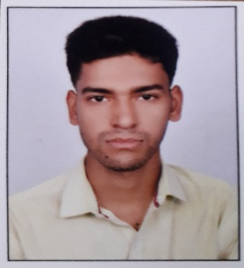
VITAE

NAME OF THE AUTHOR :Subhankar Rauth
DATE OF BIRTH : 02/02/1999
ADDRESS : Rabindrapally bypass, Bolpur
P.O-Bolpur, PIN- 731204, DIST- Birbhum
STATE- West Bengal.
MOBILE NO : 9083619777 / 7098759945
E. mail :subhankarrauth4@gmail.com
EDUCATIONAL INSTITUTIONS ATTENDED:
- Radha Charan Memorial Institute (ENG MED) [WBBSE]
- Raipur Sithi Kantha Memorial High School (WBCHSE)
- Dept of Yogic Art& Science (VISVA BHARATI)
ACADEMIC ACHIEVEMENTS
- Madhyamik Examination: 2014
- Higher Secondary Examination: 2016
- Graduation(B.Sc):Appearing
OTHER ACHIEVEMENTS
- 5th Year in Guitar Course ( Chandigarh Kala Kendra Vidyalaya)
- I.T.I (Diesel)

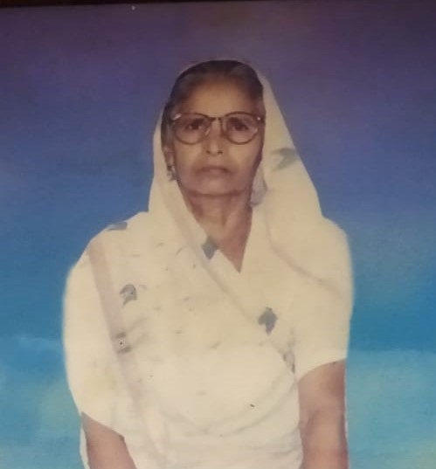

I WOULD LIKE TO DEDICATE MY RESEARCH PROJECT TO MY BELOVED GRANDMOTHER

ACKNOWLEDGEMENT

First and foremost, I would like to thank the Almighty God for blessing, helping and guiding me throughout my study.

I convey my deep sense of gratitude to Dr. Amaravathi Eravalli qualification of PhD (yoga and Life Sciences), MPT (Cardio-Respiratory conditions) CYEP (USA) for the able guidance in acquainting clinical experience and completion of the project.

I am greatly indebted to my teacher, instructor and co-guide Mr. Rupesh Kumar qualificationof M.A for the help rendered in the completion of the study.

I express my thanks to all the other staff Members of Yogic Art and Science for providing me timely guidance for the project.

I would like to thank all the Subjects who participated in the study without whom I would not have been able to accomplish my project goals in this lockdown situation.

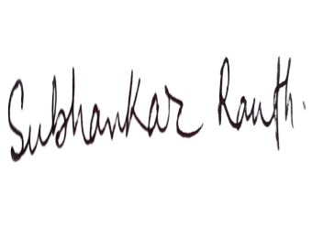
I would like to thank all my Colleagues at Yogic Art and Science for their insightful comments, support and encouragement
(Subhankar Rauth)

CERTIFICATE

This is to certify that the project of “TRIKONASANA FOR SHOULDERPAIN IN DIABITIC PATIENT.” has been carried out by the candidate under my direct supervision and the findings have been checked thoroughly.

I am satisfied with the work of (Subhankar Rauth) BSc in Yogic Art and Science and Reg No: VB-0613 of 2018-19is submitted toVisva Bharati, Santiniketan, West bengal, INDIA.
It is further certified that (Subhankar Rauth) has undergone the prescribed course of studies leading to Bachelor of Science Degree Examinations in accordance with the university regulations.

Date: 02/08/2021
Dr. Samiran Mondal
Professor and HOD
Yogic Art and Science
- Guide: Dr. Amaravathi Eraballi

- Co-Guide: Mr. Rupesh Kumar

 | CONTENTS
S.N.O. | TITLE | PAGE NO.
 | TITLE PAGE | 1
 | ABSTRACT | 2
 | INTRODUCTION  3.1. Frozen Shoulder:  3.1.1. Peri-arthritis  3.1.2. Anatomy:  3.1.3. Pathophysiology:  3.1.4. Frozen shoulder  3.1.5. Causes  3.1.6. Clinical features  3.1.7. Diagnosis  3.1.8. General Intervention  3.2. DIABETES  3.2.1. Introduction to diabetes  3.2.3. Yoga Interventions  3.2.3.1. Mechanism of Yoga practice  3.2.3.2. Application and Recommendation of Yoga for future  3.2.4. According to H.Y.P  3.2.4.1. Vaman Dhauti  3.2.4.2. Kapalbhati  3.2.4.3. Shankhaprakshalana:  3.2.4.4. Agnisar kriya  3.2.5. Surya namaskar (sun salutation)  3.2.6. Bandha (lock)  3.2.6.1. Uddiyan bandha  3.2.7. Aum/Om chanting  3.2.8. Sudarshan kriya  3.2.9. Dhyan (meditation)  3.2.10. Yogic relaxation technique  3.2.11. Mudras  3.2.12. Duration And Frequency of Yoga Practice  3.2.13. Precautions and contraindications | 3  3  3  5  7  8  9  9  10  11  12  12  13  13  15  16  16  16  16  16  17  17  17  17  18  18  18  18  19  19
 | NEED OF THE STUDY | 21
 | REVIEW OF ANCIENT LITERATURE  5.1. LANGUAGES USED:  5.1.1. Sanskrit With Transliteration  5.1.2. English Alphabet  5.1.3. Bengali Barnamala  5.1.4. Hindi/ Devanagari Barnamala  5.2. SCRIPTURES  5.2.1. Bhagawad Gita: Diet, mitahara  5.2.2. Hatha yoga Pradipika Text:  5.2.2.1. Kriya:  5.2.2.2. According to Gheranda samhita  5.3. Asana: Trikonasana or Triangle pose  5.4. Pranayama: Bhramari  5.5. Patanjali Yoga sutra: Concepts of asana, pranayama,  - Asana  - Pranayama (yogic breathing)  - Ayurveda  - Etiopathogenesis  - Etiology (Nidana):  - Aharaja:  - Viharaja:  - Plavana:  - Bharavahana:  - Balawat Vigraha:  - Dukkha Shayya  - Samprapti:  - Marma abhighata:  - Chikitsa:  - Modern description  - Treatment schedule  - Criteria for assessment of the study | 22  22  23  24  25  26  26  26  26  26  27  27  27  27  27  28  28  29  29  29  29  30  30  31  31  32  33  33
 | REVIEW OF MODERN LITERATURE | 36
 | METHODOLOGY  7.1.1. Research Design:  7.1.2. Population:  7.1.3. Place of the study:  7.1.4. SELECTION CRITERIA  - Inclusion criteria  - Exclusion criteria  - . Sample size: 2  7.1.6. Data extraction or study design:  - PARAMETERS  - Specific parameters  - Empty can test:  - Rage of motion (ROM):  - Visual Analogue Scale (VAS):  - Trikonasana  - Intervention or Treatment or Independent Variable  - Trikonasana with Mechanism  - Parivritta Trikonasan:  - Ayurvedic sthula sharir assessment: Questionnaire  7.4.1. SCORING  7.5. INTERVENTION  7.6. Statistical analysis | 37  37  37  37  37  37  38  38  38  38  38  40  41  42  43  44  44  44  44  45  45  45-47  47  47
 | RESULTS | 47
 | DISCUSSION  9.1 Improvements of Frozen shoulder with yoga practices  9.2 Neutral changes of Frozen shoulder with yoga practices  9.3 Adverse changes of Frozen shoulder with yoga practices  9.4. Possible mechanisms from modern research | 50  50  51  51  51
 | CONCLUSION | 53
 | LIMITATIONS | 54
 | STRENGTHS AND FURTHER RESEARCH | 54
 | REFERENCES | 55
 | ANNEXURES  Annexure:1  Annexure:2  Annexure:3  Annexure:4  Annexure:5  Annexure:6  Annexure:7  Annexure:8 | 57  57  58  59  59  60  60  61  62

1. Title: TRIKONASANA FOR SHOULDER PAIN IN DIABETIC PATIENT.

2. Abstract
Frozen shoulder, also known as adhesive capsulitis, is a condition characterized by stiffness and pain in shoulder joint. Diabetes as a metabolic disorder can easily affect the glucose levels deep inside the joints especially the most movable joint and is least blood supply like shoulder can easily affected. In this study we collected the sample from population of shoulder pain and divided into wo groups with criteria and implied the intervention with physiotherapy and Yoga practices under supervision of experts at yogic arts and Science department, Visva Bharati,Bolpur, West Bengal. The parameters are qualitative measurements like range of motion (ROM), Repetition maximum and duration of posture and qualitative measurements are VAS scale for pain sthoola sarira. Intervention includes, ultra sound therapy for pain relief. Passive stretching or manipulations for releasing the stiffness or adhesions if any. Trikona asana where active arm stretches or eccentric contraction happens to rotator cuff muscles. Sun salutation as general mobilization and weight bearing practice. Yogic diet to enhance the heat for the healing processes of whole body like turmeric in milk and cinnamon tea for few days of treatment. Advise to avoid ‘vaat’ prakriti ahara. Results were compared within groups and between groups.

Keywords: Trikonasna, Diabetes, Frozen shoulder, Apabahuka.
- INTRODUCTION

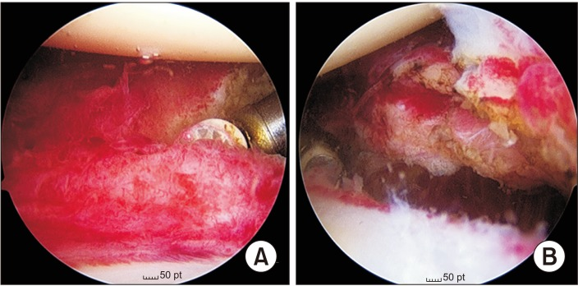
Fig:1
3.1 Frozen Shoulder: Frozen shoulder, affects 2-5% of the general population and is characterized by pain and progressive loss of shoulder range of motion.
3.1.1 Peri-arthritis or frozen shoulder or adhesive capsulitis: This is a descriptive term used to indicate a clinical syndrome wherein the patient has a restricted range of active and passive glenohumeral motion. The Simmonds have reported on the tight inelastic tissues around the shoulder joint. They believed that the pathological changes in frozen shoulder were due to degeneration and focal necrosis of the supra-spinous tendon. With revascularization, the tendon pathology could resolve. With inadequate vascular response, the tendons would continue to degenerate, developing tears of varying size, or a secondary biceps tendinitis could develop. In this condition, pain and stiffness of the shoulder joint are the cardinal symptoms leading to inability or loss of function of the affected upper limb. This may be achieved in three phases.
- Painful phase
- Stiffening phase
- Thawn / Resolving phase
The patient gives a history of having noticed a slight painful catch in the region of the shoulder and upper arm for several months, gradually becoming aware of the inability to perform certain tasks, because of stiffness of the arm. Night pain, often awakening him after he has fallen asleep, is a common complaint. Frequently it radiates down the arm to the hand without being localized to any nerve distribution. Stiffness of the shoulder increases until all movements are lost.
Frozen shoulder onset can follow trauma to the shoulder, such as a fracture, surgery, or period of immobilization. Adhesive capsulitis can also have an insidious onset, with no prior trauma or injury to the shoulder. There are many established risk factors for the onset of insidious adhesive capsulitis. Of those, diabetics have been identified as having a significantly higher risk of development, severity, and recurrence of insidious onset adhesive capsulitis. Many irreversible organic and systemic changes occur in Diabetes. Soft tissue, bony and cartilaginous damage are some of the common rheumatologic manifestations that are more common in type1 Diabetes. Conditions like neuroarthropathy, joint stiffness and hyperostosis are often associated with diabetic mellitus. capsulitis, Dupuytren’s disease and tenosynovitis of flexor tendons are four times more frequent in diabetics than non-diabetics. The literature, which shows greater level of pain and disability in frozen shoulder patients with diabetes mellitus, suggests that treatment strategy might also vary between these groups. For instance, patients with diabetes and adhesive capsulitis showed less improvement of pain and function following arthroscopic rotator cuff repair than their non-diabetic counterparts.7 Another work showed that shoulder pain in diabetes was often more resistant to conventional treatment.3 Hence, quantification of disability level independently in frozen shoulder patients with diabetes is crucial. Increasing intensity of pain scores was associated with poor glycaemic control in diabetic frozen shoulder patients shown by higher HbA1c level.8 This information raises the possibility and importance of prevention of ‘greater’ disability due to frozen shoulder in diabetic population by strict control of glycaemic state. Conversely, a review article revealed that people with diabetes and frozen shoulder have significantly less pain compared with patients who do not have diabetes.3 Again, the Australian study also did not show significant difference in disability (p ¼ 0.16) between diabetic and non-diabetic group.4 This represents the dissimilarities among articles regarding the level of pain and disability. A literature search found that only few studies discussed the disability level in frozen shoulder patients and very few looked into the pain and disability level among diabetic group.
Yoga is based on the principle that the mind and body are intimately related. It improves flexibility, muscle strength, blood circulation, and oxygen uptake. Yoga exhibits many health benefits, such as improving physical fitness, relaxation, and awareness of self. Various lifestyle disorders, including diabetes, can be effectively addressed by the practice of yoga, given acceptably high levels of adherence. Yoga practice improves an individual's discipline regarding food and exercise, thereby helping to modify patient-related reluctance that results in the underutilization of exercise as a treatment modality.
3.1.2. Anatomy:
Shoulder is made up of three bones that form a ball-and-socket joint. They are our upper arm (humerus), shoulder blade (scapula), and collarbone (clavicle). There’s also tissues surrounding the shoulder joint that holds everything together like arachnoid ligament, collateral ligaments, and importantly adhesive capsule that deepens the glenoid fossa of scapula (socket). With frozen shoulder, the capsule becomes so thick and tight that it’s hard to move with chronic or old injury of shoulder. Bands of scar tissue form and there’s less synovial fluid to keep the joint lubricated. Hence there is formation of lymphatic nodules around the joint like bursa and muscles. Slowly pain itself stops the movement and restriction becomes common at joint level called adhesion or frozen of muscles around the shoulder joint. These muscles are called rotator cuff muscles above the ligaments holding the joint from all directions. These events limit motion even more and progress to inflammation called adhesive capsulitis.
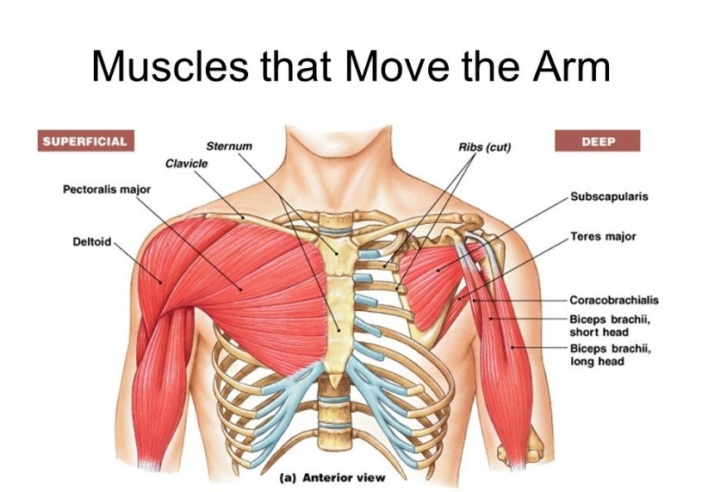
Fig:2
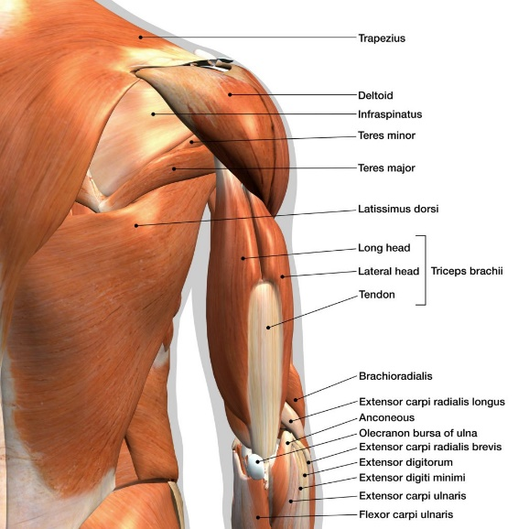
Fig:3

The primary muscle group that supports the shoulder joint is the rotator cuff muscles. The four rotator cuff muscles are supraspinatus, infraspinatus, teres minor, and subscapularis. Together the rotator cuff muscles form a musculotendinous cuff as they insert on the proximal humerus. The rotator cuff muscles attach to the proximal humerus anteriorly at the greater tuberosity. The rotator cuff muscles provide considerable structural support to the glenohumeral joint and keep the humeral head in a firm position by articulating with the scapula within the glenoid cavity. The muscles of the chest also provide structural support to the shoulder joint.
3.1.3 Pathophysiology:
The musculoskeletal system can be affected by diabetes in a number of ways. The shoulder is one of the frequently affected sites. One of the rheumatic conditions caused by diabetes is frozen shoulder (adhesive capsulitis), which is characterized by pain and severe limited active and passive range of motion of the glenohumeral joint, particularly external rotation.
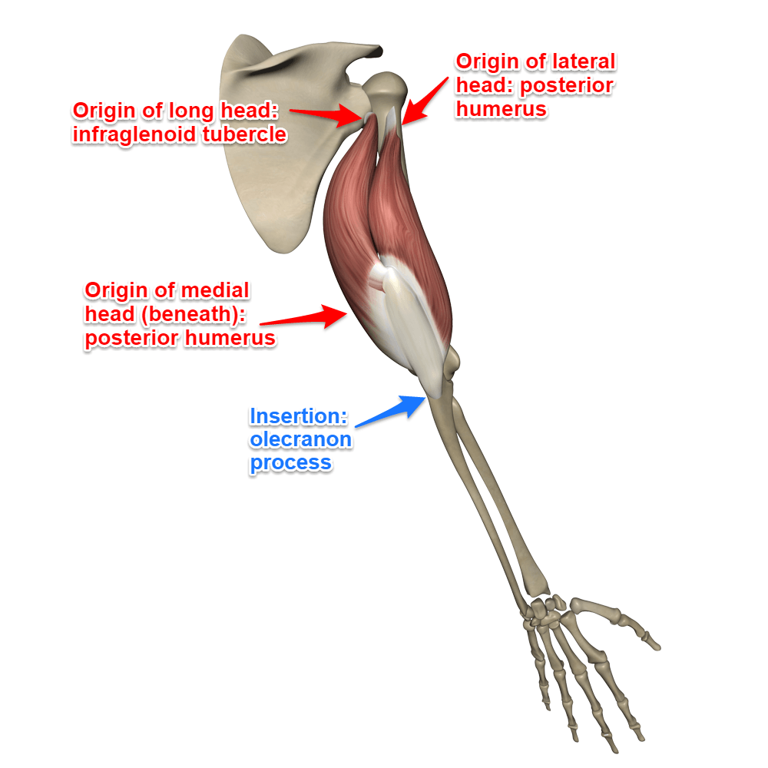
3.1.4. Frozen shoulder
Fig:4
The shoulder complex involves 3 physiological joints and one floating joint:
- Glenohumeral (GH) joint,
- Acromioclavicular (AC) joint
- Sternoclavicular (SC) joint
- Scapulothoracic (ST) joint - known as a "functional joint". is not a true joint
You can also consider the contributions of the sternocostal, vertebrocostal, and sternomanubrium joints when thinking about movement involving the shoulder complex.
3.1.5. Causes
It is not fully understood why frozen shoulder occurs. As one person’s symptoms can be different to another’s, it can be hard to categorically say what causes the condition.
There are a number of causes that are believed to increase the risk of developing frozen shoulder, including:
- Other health conditions – such as diabetes, heart disease, stroke, overactive and underactive thyroid
- Recent surgery or injury – frozen shoulder can develop after a shoulder or arm injury or surgery – this may be partly due to keeping your shoulder still for prolonged periods during your recovery
- Age and gender – frozen shoulder most affects people aged between 40 and 60, while women are more likely to develop the condition than men
- Altered arm mobility – not moving your shoulder for long periods, such as during a stay in hospital, or participating in an activity that involves arm rotation, overweight weight lifting and sudden stress via injury can cause frozen shoulder
- Other shoulder conditions – such as calcific tendonitis and rotator cuff tear

3.1.6. Clinical features: Shoulder pain are two types i) Acute shoulder pain, ii) Chronic Shoulder pain, Acute shoulder pain by injury is temporary but if not treated it becomes chronic, the joints space reduces and it is called Frozen shoulder which grow faster in diabetic patients.
Pain and stiffness are the two main symptoms of frozen shoulder, which can vary from being mild to severe enough that you may not be able to move your shoulder.
Symptoms typically affect patients across three different stages:
- Stage one: Freezing (lasts between six weeks to nine months) – your shoulder will become very painful and can result in range of motion being lost
- Stage two: Frozen (lasts between four to 12 months) – your pain may ease, but your shoulder could become increasingly stiff
- Stage three: Thawing (lasts between six months to many years) – ability to move your shoulder will improve and you may be able to resume doing more everyday tasks
Individuals can experience great differences in symptoms, but early diagnosis and treatment can reduce their severity. In a minority of cases, symptoms can last for a number of years.
3.1.7. Diagnosis: Early diagnosis of frozen shoulder can help prevent long-term symptoms and get you on treatment for stiffness and pain as soon as possible.
  - if any persistent pain in shoulder, especially if this is limiting the shoulder movement then imaging tests such as X-rays, ultrasound scan and an MRI (magnetic resonance imaging) scan may be conducted to rule out physical problems with your shoulder.
  - A physical examination will be conducted to evaluate the pain and range of motion.
  - You will be asked to perform tasks such as raising your hands up, touching your opposite shoulder and scratching your back.
  - You will also be asked about your symptoms, including their severity, when they started and if you have any other health conditions. A blood test may be conducted to rule out other possible health conditions.
- General parameters are shown in the table-1. Specific parameters are shown in the table-2.
- Specific parameters: introduction, describe, Implementation, reliability, validity
3.1.8. General Intervention
Medication for frozen shoulder focuses on controlling the pain and helping restore some movement. This can vary across levels of severity.
The doctor or physiotherapist will run through this with you, as well as the prospect of deep massage of the affected tendons and trigger points.
Anti-inflammatory painkillers may be advised to ease the pain, as well as ordinary painkillers such as codeine.
A steroid injection to reduce inflammation can provide relief from symptoms, while surgery may be considered when all other treatments are not helping.

3.2. DIABETES
3.2.1. Introduction to diabetes
Diabetes is a chronic metabolic disease that adversely affects quality of life. Psychological stress and negative mood have a bidirectional effect in the control of diabetes. Stress increases the risk and severity of diabetes by stimulating the hypothalamic-pituitary-adrenal (HPA) and sympathetic axes and parasympathetic withdrawal, resulting in increases in the levels of cortisol, epinephrine, norepinephrine, growth hormone, glucagon, catecholamines, prolactin, leptin, and neuropeptide Y. Chronic activation of the HPA axis is associated with poor control of diabetes and complications such as diabetic neuropathy. An increased level of inflammatory cytokines results in insulin resistance in patients with type 2 diabetes. Chronic psychological stress can result in insulin resistance, hypertension, and an increased risk of cardiovascular events. Yoga effectively reduces stress, thereby helping diabetes control. Yoga practice in healthy volunteers was found to result in increases in wellness; reductions in stress, depression, and anxiety; improvements in the physical, psychological, and social domains and total quality of life; a feeling of balance; and a new outlook on life. Yoga practice results in significant improvements in the scores of various psychological assessments, including satisfaction impact and worry. Yoga also results in improvements in physical exercise, behavioural changes, and dietary practices, in addition to its effects on relaxation and stress management.
Abdominal stretching during yoga exercises is believed to result in the regeneration of pancreatic cells. The various postures during yoga practice help to improve the sensitivity of β-cells to glucose, thereby improving insulin secretion, and increase the blood supply to the muscle and muscle relaxation, thereby improving glucose uptake. Improvements in hormonal homeostasis also improve glycaemic control in people with diabetes mellitus. Yoga therapy also results in immunomodulation by reducing proinflammatory responses and improving immune function.
3.2.2. Yoga Interventions
Yoga practice is thought to have “beyond the drug action,” which refers to the potential to induce stem cell trafficking from the bone marrow to the peripheral blood, which may lead to tissue regeneration by replacement and recruitment of cells differentiated from the stem cells. However, this mechanism needs to be further explored.
Yoga asana also modulate gene expression and increase muscle activity, strength, endurance, flexibility, and balance, resulting in favourable effects on body weight, adiposity, dyslipidaemia, and insulin resistance.
    - Mechanism of Yoga practice
The various health benefits of yoga therapy are related to changes in the level of various hormones and neurotransmitters: joy and euphoria during yoga therapy are due to an increase in β-endorphin, serotonin, and dopamine levels; improvements in arousal are due to increased arginine-vasopressin levels, which reduce the gamma-aminobutyric acid (GABA)-ergic inhibition of the supraoptic area of the hypothalamus; its calming effect is due to melatonin; the ecstatic and blissful feelings that arise during yoga are due to lateral hypothalamic stimulation; and the decrease in spatial orientation and out-of-body experiences during meditation are due to decreased levels of GABA and increased levels of N-acetylaspartylglutamate and 5-methoxydimethyl tryptamine (from pineal enzymes).
Yoga reduces oxidative stress, as demonstrated by reductions in serum malondialdehyde, interleukin 6, and leptin levels, and improvements in adiponectin levels. Yoga therapy increases the number of insulin receptors and increases the proportion of receptor binding in patients with diabetes. It improves insulin kinetics by reducing fasting insulin levels, shifting the peak insulin level to the left, and by normalising the insulin-to-glucose ratio. It also reduces levels of free fatty acids, indirectly indicating improved insulin sensitivity or reduced insulin resistance. Yoga and various breathing exercises were found to lead to improvements on lung function tests. Yoga improves cell-mediated immunity, as demonstrated by improvements in the lymphocyte migration test in people with type 2 diabetes.
Yoga also prevents the development of diabetes in high-risk individuals. It was found to improve symptom scores in people with diabetes. It also results in reduction of fasting blood sugar, postprandial blood sugar, haemoglobin A1c, and anti-diabetic drug requirements, suggesting improved glycaemic control. Yoga therapy results in a reduction in body weight, body mass index, the waist-to-hip ratio, body fat percentage, body fat mass, and skin fold thickness, thereby increasing lean body weight

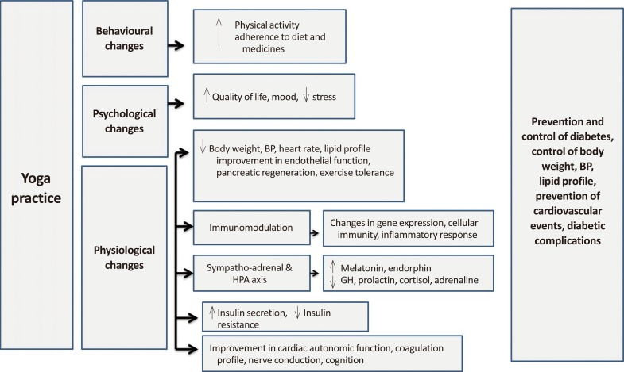
Flow chart :1
Yoga reduces levels of triglycerides, low density lipoprotein cholesterol, and free fatty acids, and improves high density lipoprotein cholesterol levels. It induces discipline regarding food and exercise. The regular practice of yoga improves exercise tolerance, and it has been shown that yoga improved performance on the treadmill test from eight metabolic equivalents (METS) to 12 METS and resulted in the postponement of the anaerobic threshold. Some studies have shown that there were reductions in both systolic and diastolic blood pressure in persons practicing yoga.
    - Application and Recommendation of Yoga for future
The regular practice of yoga reduces the risk of diabetes-related complications. Cardiac autonomic dysfunction is believed to be a cause of sudden death in patients with diabetes mellitus. Clinical studies have shown that regular yoga practice improved cardiac autonomic function independently of glycaemic control and reduced the risk of cardiovascular events. Yoga therapy also stabilizes the coagulation profile, thereby improving nerve conduction and cognitive function in patients with diabetes.
In patients with type 2 diabetes, improvements in glycaemic control with up-titration of the insulin regimen or anti-diabetic medicines, without diet control or exercise, result in weight gain. In contrast, yoga improves glycaemic control without increasing body weight, and some studies have found it to reduce body weight.
The ease of use, safety, and multiple psychological benefits of yoga have led it to be more widely accepted in society, and it can now be considered a low-cost intervention to control various lifestyle disorders, including diabetes.
Pranayama is controlled or regulated yogic breathing practice. The slow breathing technique in pranayama causes comprehensive changes in body physiology by controllingthe autonomic nervous system; it regularizes the rate and pattern of breathing and regulates the heart rate and its variability.
Slow pranayamas, such as anulom vilom (alternate nostril breathing), chandranadi (left nostril breathing), sitkari (cooling breaths), and bhramari (humming bee breath) augment cerebral blood flow and oxygenation, thereby improving the neuronal activities of the brain centres, including those present in the limbic areas, hypothalamus, and medulla, as well as improving sympathovagal outflow. Anulom vilom pranayama (alternate nostril breathing) has been shown to yield significant improvements in components of health-related fitness (i.e., cardiorespiratory endurance, flexibility, and percentage of body fat). The vibrations created in bhramari prayanama (humming bee breath) have a soothing and calming effect on the mind and could play a vital role in improving mental and physical health. Right nostril breathing is believed to have a sympathetic stimulating effect and may be recommended in people with diabetes. Bhastrika pranayama (bellow-breathing) is a powerful and energetic pranayama referred to as “the breath of fire.” It helps in the regulation of the pineal, pituitary, and adrenal glands, which play an important role in the regulation of metabolism.
    - According to H.Y.P
      - Vaman Dhauti: A study showed that vaman dhauti practice (emetic therapy) caused a marked reduction in fasting and postprandial blood sugar levels. It is believed to increase glucose uptake, minimize insulin resistance, and promote the function of insulin by reducing levels of circulating free fatty acids in the body.
      - Kapalbhati:The abdominal pressure created during exhalation in kapalbhati improves the efficiency of β-cells of the pancreas.
      - Shankhaprakshalana: Shankhaprakshalana is the process of cleansing the intestinal tract by practicing a set of yoga postures and drinking lukewarm water with salt in between. This sequence is repeated till only water is evacuated. The level of blood glucose falls significantly with this intestinal cleansing process. It has been claimed that this practice increases insulin production and helps in the control of diabetes.
      - Agnisar kriya:Agnisar kriya (stimulation of the digestive fire) involves pulling the abdomen in (uddiyan bandha) and snapping it backwards and forwards while holding the breath. The ‘vacuum’ effect of this action massages the internal organs and increase blood flow to the area. It boosts metabolism and facilitates the proper functioning of the abdominal organs. This practice is recommended for the management of diabetes.
    - Surya namaskar (sun salutation)
Surya Namaskar Mantra
|hiranmayena patrena satyasyapihitam mukham |
|tat tvam pusannapavrnu satyadharmaya drstaye|
Surya namaskar involves a series of dynamic yoga postures performed in a specific sequence. A brisk surya namaskar performed in an energetic way increases cellular requirements for oxygen and glucose. To meet these requirements, insulin production is stimulated through brain signalling.
In a study, a yoga intervention consisting of 25 minutes of surya namaskar along with other yoga postures and a deep relaxation technique in perimenopausal women resulted in a significant decrease in diastolic blood pressure and hip circumference, and beneficial effects on glycaemic outcomes.

    - Bandha (lock)
Bandha refers to a hold, tightening, or lock. It constricts a certain part of the body and re-directs the flow of blood and lymph to other parts. Asanas or pranayama may be combined with bandhas.
      - Uddiyan bandha (abdominal lock), which involves creating negative pressure in the abdomen and contracting the abdominal area, may have a therapeutic effect in the management of diabetes. It is believed that the negative pressure created in the abdominal cavity may improve pancreatic function.
    - Aum/Om chanting
Scientific analyses have shown that chanting “Aum” is based on the physics of sound, vibrations, and resonance, and has a positive influence on health. Chanting the “Aum” mantra results in stabilization of the brain, removal of negative thoughts, and increase of energy, and mental improvements and relaxation of the body take place within minutes of practice. Pranava pranayama (chanting “Aum”) in the supine posture produces an integrated relaxation response, which may have clinical significance in the management of hypertension and diabetes.
Evaluation of the immediate effects of the mind-sound resonance technique in people with type 2 diabetes showed its potential role in enhancing cognitive function.
    - Sudarshan kriya
Sudarshan kriya is a specific breathing sequence involving “Aum” chanting, ujjayi pranayama, and bhastrika pranayama with rhythmic, cyclical breathing at slow, medium, and fast paces. In a study, significant improvements in physical, psychological, and social domains and total quality of life in diabetes patients were observed after the practice of sudarshan kriya yoga and pranayama in comparison to a group following standard treatment alone.
    - Dhyan (meditation)
Meditation has been shown to cause physiological changes in the brain. Meditators experience beneficial psychological effects, such as faster reactions to stimuli, and are less prone to various forms of stress. The mental stability attained through the practice of meditation helps diabetes patients. A 6-week meditation and sahaja yoga meditation treatment showed improvements in quality of life, anxiety reduction, and blood pressure control. Visualization and concentration on the pancreas during meditation has positive effects on sugar levels and is recommended in the management of diabetes. Mindfulness practice is advocated for better sleep, greater relaxation, and more accepting approaches to illness and the illness experience in people with diabetes and coronary heart disease.

    - Yogic relaxation technique, yoga nidra (yogic sleep)
Yoga nidra (conscious, dynamic, psychic sleep) is a comprehensive, profound relaxation technique for removing physical, mental, and emotional tensions. Yoga nidra practice in middle-age diabetes patients on oral medications led to improved symptom scores and reductions of fasting blood glucose and postprandial blood glucose levels.
    - Mudras (gestures)
Mudras are a combination of subtle physical movements that alter mood, attitude and perception, and deepen awareness and concentration .Some hasta mudras (hand gestures), such as linga mudra, surya mudra, and prana mudra, are believed to be helpful for diabetes. Regular practice of these mudras boosts metabolic rates, promotes weight loss, and reduces sugar levels. Certain other mudras, such as apan mudra and gyan mudra, are recommended for diabetes patients for deep relaxation and eliminating stress. However, their individual effects have not been evaluated in scientific studies.
    - Duration And Frequency of Yoga Practice
The recommended type, duration, and frequency of yoga practice have not been clearly defined, and studies have analysed various frequencies and durations of yoga practice. Durations of yoga practice ranging from 10 minutes, 25 to 35 minutes, and 60 minutes daily, 45- to 60-minute sessions 6 days a week, and three sessions of 75 minutes each per week, to 90-minute sessions twice weekly have shown beneficial results. Many studies have reported beneficial effects after 3 months of the intervention , while in a few studies, interventions of 15 days ,40 days, and 6 months were evaluated. Adherence to yoga practice was shown to have an impact on its beneficial effects .
    - Precautions and contraindications
Yoga should be learned under the guidance of a qualified yoga professional. There are many different styles of yoga, and while many are safe, some can be strenuous and may not be appropriate for everyone. Fast-paced yoga practice and vigorous exercises in extreme temperature conditions, as in hot or Bikram yoga, are not recommended for individuals with diabetes, cardiovascular disease, or who are at risk of complications. A relatively safe yoga style suitable for an individual's requirements should be practised. Beginners should avoid extreme practices. Patients taking medication to control diabetes should carefully monitor their bodies' reactions to any new fitness activity. Overlooking the warning signals of pain and discomfort while performing yoga practice may result in serious injury. Yoga practitioners should never push themselves beyond their physical capacity. Yoga practices are generally recommended on an empty stomach, but those taking treatments for diabetes may take light snacks to prevent hypoglycaemia. Inverted poses such as sarvangasan and sheershasan cause blood to rush or pool into the head and upper body,which may lead to a risk of retinal detachment or bleeding; such poses should be avoided in patients with diabetes or practiced with utmost care, only after an ophthalmic evaluation.
Balancing poses should be practiced carefully to avoid traumatic injuries. Yoga poses must be practiced slowly, without any sudden jerky movements and without pushing beyond one's limits. Complications of diabetes, such as autonomic neuropathy, may cause dizziness when sitting or standing abruptly because of a sudden drop in blood pressure. Individuals with diabetes are advised to enter and come out of poses slowly, pausing for a breath or two if required while practicing the pose.

4. Need of the study
Frozen shoulder is frequently associated with other systemic conditions, most commonly diabetes mellitus. The condition has been reported in 10-36% of diabetics, who are approximately 2-4 times more likely to develop a frozen shoulder than members of the general population. Insulin-dependent diabetics are at the highest risk, and the condition is often particularly severe in these cases after that it is lead to dialysis and it’s makes a huge risk for life, but in yogic therapy these situations are not built. It’s also improves our body by mentally and physically. By this experimental study we understand how affected it is on the Frozen shoulder patients.
- REVIEW OF ANCIENT LITERATURE
  - LANGUAGES USED:

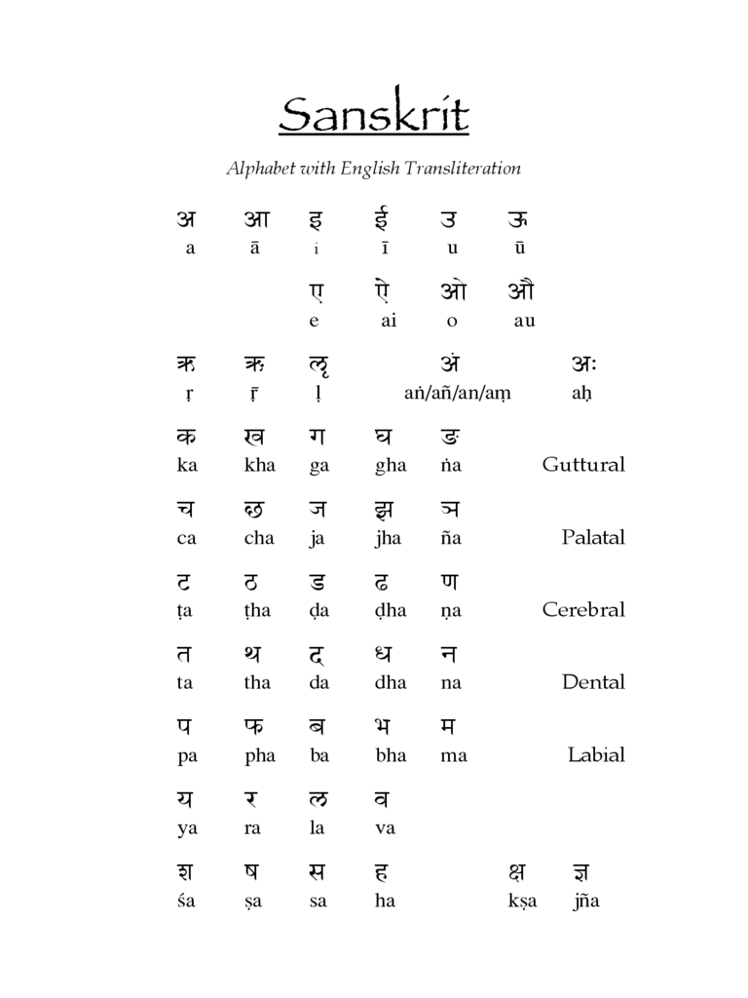
    - Sanskrit With Transliteration

    - English Alphabet
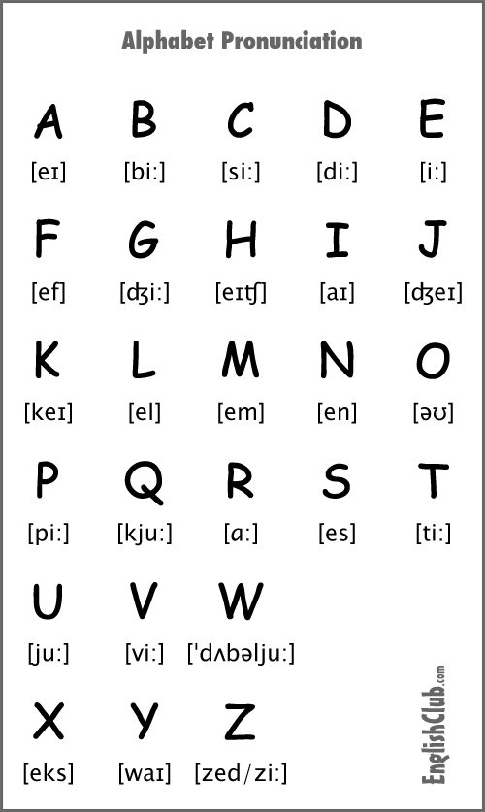

5.1.3 Bengali Barnamala
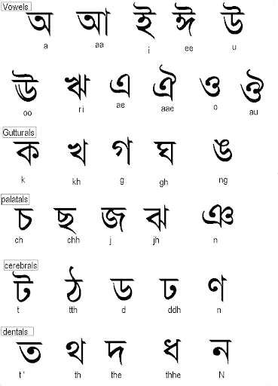

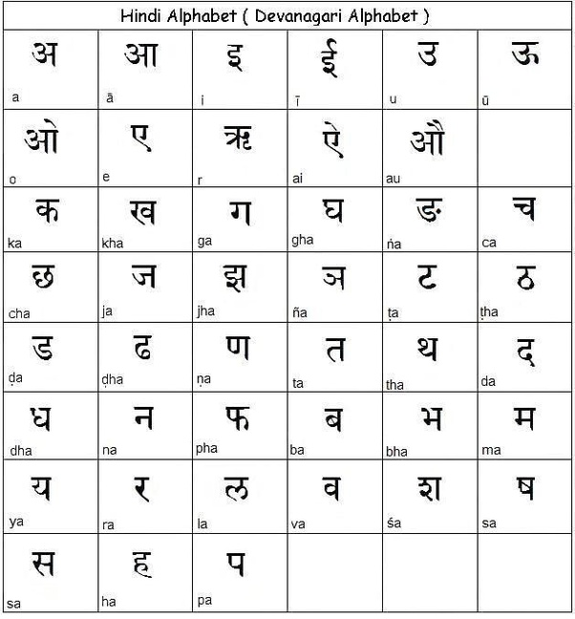
5.1.4 Hindi/ Devanagari Barnamala

5.2. SCRIPTURES
5.2.1 Bhagawad Gita: Diet, mitahara
“Yuktaahaarviharasya yuktachestasya karmasu
Yuktaswapnavbodhasya yogo bhavatidukhah”
(Srimad Bhagvad Gita- 6/17)

He whose food and enjoyment are balanced, whose movements in actions are balanced, whose sleeping and waking is balanced, his yoga becomes eliminator of sorrows.

    - Hatha yoga Pradipika Text:
      - Kriya: In the present study we implemented laghu shankha prakshalana at the beginning of protocol. It is one of the Shta Kriya.
धौतिर्बस्तिस्तथानेतिस्त्राटकंनौलिकंतथा |
कपाल-भातिश्छैतानिषहट-कर्माणिपरछक्ष्हते || २२ ||
dhautirbastistathā netistrāṭakaṃ naulikaṃ tathā |
kapāla-bhātiśchaitāni ṣhaṭ-karmāṇi prachakṣhate || 22 ||
The six kinds of duties are: Dhauti, Basti, Neti, Trâtaka, Nauti and Kapâla Bhâti.
      - According to Gheranda samhita
षट्कर्मणाशोधनञ्चआसनेनभवेद्दृढम्।
मुद्रयास्थिरताचैवप्रत्याहारेणधीरता।। 1/10 ।।
प्राणायामाल्लाघवञ्चध्यानात्प्रत्यक्षमात्मनि।
समाधिनाचनिर्लिप्तंमुक्तिरेवंनसंशय: ।। 1/11 ।।
The classical ancient texts Hatha Yoga Pradipika and Gheranda Samhita describe purification/cleansing practices known as shatkarmas. Of these, the practices of vaman dhauti (stomach cleansing with induced vomiting), kapalbhati (frontal brain purification, which is a breathing technique with forceful exhalations and automatic inhalations), and shankhaprakshalana (intestinal cleansing) help to increase the production of insulin and to control blood glucose levels. Regular internal cleansing enhances the functional capacity of the organs.
  - Asana: Trikonasana or Triangle pose
Stand erect with the feet about a metre apart. Turn the right foot to the right side. Stretch the arms sideways and raise them to shoulder level so that they are in one straight line. Bend to the right, taking care not to bring the body forward. Simultaneously bend the right knee slightly. Place the right hand on the right foot, keeping the two 152 arms in line with each other. Turn the left palm forward. Look up at the left hand in the final position. Return to the upright position with the arms in a straight line. Repeat on the opposite side, bending the left knee slightly.
  - Pranayama: Bhramari
अथ भरामरी
वेगाद्घोष्हं पूरकं भॄङ्ग-नादं
भॄङ्गी-नादं रेछकं मन्द-मन्दम |
योगीन्द्राणमेवमभ्यास-योगाछ
छित्ते जाता काछिदानन्द-लीला || ६८ ||
atha bhrāmarī
veghādghoṣhaṃ pūrakaṃ bhṝnggha-nādaṃ
bhṝngghī-nādaṃ rechakaṃ manda-mandam |
yoghīndrāṇamevamabhyāsa-yoghāch
chitte jātā kāchidānanda-līlā || 68 ||
Breathe in quickly, making a reverberating sound like the male black bee, and exhale slowly while softly making the sound of the female black bee. By this yogic practice one becomes lord of the yogis and mind is absorbed in bliss.

  - Patanjali Yoga sutra: Concepts of asana, pranayama,
    - Asana
स्थिरसुखमासनम्॥४६॥
sthira sukham asanam॥46॥
Asanas emphasize the relationship of body, mind, and awareness, focusing on the synchronization of breathing and movement. They involve stretching/twisting movements and relaxation. The key to performing a yoga posture is that it should be performed with stability and comfort. Seated postures such as ardhamatsyendrasan, yoga mudra, and mandukasan improve pancreatic function. Asanas with forward bends massage and pressurize the pancreas and stimulate the secretion of insulin. Twisting poses, such as vakrasan and ardhamatsyendrasan (seated spinal twist) squeeze the intestines and massage them to prevent the stagnation of colonic contents. For therapeutic benefits, the poses need to be maintained for approximately 30 seconds to 1 minute, depending on individual capacity, and the duration may be gradually increased.
    - Pranayama (yogic breathing)
//Tasmin satisvasa prasvasayoh gativicchedah pranayamah// (P.Y.S)
Tasmin - on this
sati – being accomplished
svasa – inbreath, inhalation
prasvasayoh – outbreath, exhalation
gati – movement, motion, path
vicchedah – cessation, stop
pagepranayamah – regulation.
Pranayama is the regulation of the incoming and outgoing flow of breath with retention. It is to be practiced only after perfection in asana is achieved.

    - Ayurveda
Vata is considered as a chief factor for the physiological maintenance of the body. Factors provoking Vata result in the instantaneous manifestation of diseases, which can even prove to be fatal. Therefore, the Vataja nanatmaja vyadhis are of utmost importance, rather than the vyadhis produced by the other two doshas. Contradictory approaches to pacify this vitiated state have to be restored to, to maintain the equilibrium.
In the modern point of view, the diseases involving the neurological, musculoskeletal, psychosomatic, and gastrointestinal system disorders have more similarity with the Vata vyadhi. It indicates the wide-ranging involvement of Vata in various systems of the body.
The economy of the country relies on its work force. Apabahuka is one such disease that hampers the day-to-day activity of an individual. The fact that Vata vyadhi is one among the Ashta maha gada, is itself explanatory, with regard to the consequences caused by Apabahuka. Even though a definite factor responsible for the manifestation of this disease is not mentioned, a set of etiological factors can be interpreted. On analyzing the etiopathology, it may be interpreted that the disease Apabahuka manifests due to the depletion of tissue elements (dhatu kshaya) as well as Samsrushta dosha.
Apabahuka is considered to be a disease that usually affects the shoulder joint (amsa sandhi) and is produced by the Vata dosha. Even though the term Apabahuka is not mentioned in the nanatmaja Vata vyadhi, Acharya Sushruta and others have considered Apabahuka as a Vata vyadhi. Amsa shosha can be considered as the preliminary stage of the disease where loss or dryness of the Shleshaka Kapha from the shoulder joint occurs. The next stage, that is, Apabahuka, occurs due to the loss of Shleshaka Kapha and symptoms like shoola during movement, restricted movement, and so on, are manifested. Even as this is commented on in the Madhukosha teeka, it is mentioned that Amsa shosha is produced by dhatukshaya, that is, shuddha Vata janya, and Apabahuka is Vata Kapha janya.

5.6. Etiopathogenesis
a) Etiology (Nidana): The causes (hetu) of Apabahuka may be classified into two groups. (i) Bahya hetu — Causing injury to the vital parts of the body (marma) or the region surrounding the amsa sandhi, which is also known as bahya abhigataja that manifests the vyadhi or disease first; (ii) Abhyantara hetu — Indulging in the etiological factors that aggravate Vata leading to the vitiation of vata in that region and is also known as dosha prokopajanya (Samshraya), which in turn leads to karmahani of bahu. The descriptions of Nidana are given below:
b) Aharaja: Katu, Tikta, kashaya rasas, laghu sukshma, and sheeta guna cause vitiation of the Vata.
c) Viharaja: The exercises directly or indirectly influencing the shoulder or amsa desha should be considered here:
d) Plavana: Results in Vata kopa due to overexertion in the joint.
e) Bharavahana: Carrying heavy loads over the shoulders will cause Vata prakopa and deformity in the joint capsule. This leads to disease formation.
f) Balawat Vigraha: Wrestling with a person who is more powerful will cause agahata to the amsapradesha and Vataparkopa takes place. This manifests the disease.
g) Dukkha Shayya: Improper posture that creates a great amount of more pressure on the amsasandhi will disturb the muscular integrity, and provokes vata. This manifests the disease. Other viharaja nidanas as reported in the Vatavyadhi context may influence the condition by provocating Vatadosha. Even though a specific bahya hetu (external cause) has not been mentioned for Apabahuka, the general factors reported for Vata prakopa have to be analysed and elicited.
To summarize, the above-mentioned nidanas, under vihara, especially involving the amsa sandhi and marmabhighata to amsa, lead to the development of Apabahuka.
h) Samprapti: In case of Apabahuka, two ways of vitiation of the vata can be considered. The etiological factors like ruksha, laghu and so on, and atibharavahana and the like cause vitiation of the vata directly. In another way, Kapha prakopaka nidanas like taking of atisnigdha, atiguru dravya, and so on cause an increase in the vikruta Kapha, which produces the Kaphavrita-vata condition. In both ways, the vikruta vata dosha gets accumulated in the bio channels (srotas) and manifests symptoms like the stabdha poorna kosthata. In the prakopa avasta, the Vata produces symptoms like koshtha toda and sancharana and prasara avastha symptoms like atopa may also be produced. However, Ashukaritva being one among the symptoms of Vata, the symptoms produced by it are very quick in onset, and hence, the dosha kriyakalas of the vyadhi are ill-defined and cannot be observed properly.
Sthana samsraya avastha of the vyadhi occurs with the localization of the aggravated Vata in the specific dhatu, that is, dosha dushya sammurachana, which occurs in the specific organ of the body where kha vaigunya has previously taken place by the specific part of the nidanas, simultaneously with the dosha vikruti. Shiro marma is considered as the uttamanga and is mentioned as the seat or moola of all indriyas. Shiro marma performs all types of cheshta in the presence of the normal vata because, among the three doshas, only the Vata is responssible for all types of cheshta. The Charaka samhita has mentioned that when shiro marma gets affected, it produces symptoms like chestahani. In this case, the sthana samshraya of the dosha can be taken, as in siro pradesha. Usually in the sthana samshraya avasta, the poorvaroopa of the vyadhi are manifested.
As Apabahuka is considered as a vata vyadhi, and Vata has the ashukari guna, the poorvaroopas like bahupraspandita hara and shoola may manifest mildly or are totally absent. However, the above-mentioned symptoms are clearly manifested in the vyaktha avastha or in the roopa avastha of the vyadhis in the vyakta sthana, that is, in the amsa pradesha. In this stage the amsa pradesha gets affected by the aggravated Vata, on account of which Amsashosha occurs in the initial stage by the decrease of the Shleshaka Kapha, which further leads to the manifestation of Apabahuka, with symptoms like bahupraspandita hara and shoola. Therefore, in the Madhukosha commentary of Madhava nidana it is mentioned that amsa shosha and Apabahuka are the two stages of the vyadhi.
5.7. Marma abhighata: Morbid vyana Vata in another way may cause abhyantara marmabhighata or any external trauma to amsapradesha may also cause bahya marmbhighata to the amsa marma present in amsadesha. As amsa marma is a snayu and vaikalyakara marma, afflicting snayu will manifest bahupraspanditahara.
Even in modern medical science, the partial loss of blood supply in the area of insertion of tendons or some idiopathic cause can produce localized degeneration of the collagen. This induces an autoimmune response and cause a tear or distortion of the tendinous sheaths and ligaments. This obliterates the integral stability of the joint and results in restricted movement with painful and stiffened joints.
5.8. Chikitsa: The general line of treatment mentioned for Vatavyadhi in Ayurvedic classics include Snehana (both internal and external), Swedana, Mrudusamshodhana, Basti, sirobasti Nasya, and so on. Charaka further states that, depending on the location and dushya (tissue element vitiated by Vata) each patient should be given specific therapies. Vagbhata has mentioned Nasyakarma in the jatroordhva Vatavikaras. Three major approaches are followed in the management of Vatavyadhi.
- Treatment of Kevala Vata
- Treatment of Samsrusta Vata
- Treatment of Avruta Vata
    - Ayurvedic classics explain the chikitsa of Apabahuka as follows.
- Nasya and uttarabhaktika Snehapana are useful in the management of Apabahuka.
- Astanga Sangraha mentions Navana Nasya and sneha pana for Apabahuka.
- Sushrutacharya advises Vatavyadhi chikitsa for Apabahuka, except siravyadha.
- Chikitsa sara sangraha advises Nasya, Uttara bhaktika Snehapana, and Sweda for the treatment of Apabahuka.
- Brumhana nasya is indicated in Apabahuka by Vagbhata.
    - By considering the above references, the following can be stated as the line of treatment of Apabahuka.
- Nidana parivarjana
- Abhyanga
- Swedana
- Uttarabhaktika snehapana
- Nasyakarma
- Shamanoushadhi
  - Modern description
There are some clinical conditions of modern science, which may be compared with that of Apabahuka. These may be categorized as follows:
- Periarthritis, frozen shoulder or adhesive capsulitis
- Subacromial or subdeltoid bursitis
- Subcoracoid bursitis
- Painful shoulder
- Bicipital tendinitis
- Osteoarthritis of shoulder joint
- Brachial plexes neuropathies
However, in this study, the clinical condition, namely, periarthritis or frozen shoulder or adhesive capsulitis has been taken to correlate with Apabahuka.
In Ayurveda, therapies like abhyanga, swedana, snehapana nasya karma, vasti karma, and shamana Aushadhi are mentioned to combat the Vata vyadhi. In the present study nasyakarma with Laghumasha taila, in the form of Marsha nasya have been advised for patients suffering from Apabahuka. Laghumasha taila contains drugs like Kapikacchu, Bala, Shatavari, Sita, Punarnava, Saindhava, Jingini, Sarshapa taila, and Masha.
  - Treatment schedule
After diagnosis, the randomly selected patients were treated with Marsha nasya with Laghumasha taila in doses of 6, 8, or 10 drops, as required by the patients, for seven days. Out of the 9 selected patients, seven patients were dropped from the study and the remaining 2 patients completed the course of the study.

  - Criteria for assessment of the study
The improvements in the patients were assessed on the basis of relief in the signs and symptoms of the disease. To analyze the efficacy of the drug, scores were given for each symptom. According to the severity of the symptoms, the grading was given, as mentioned herewith:

The improvement is documented through statistical significance. The subjective and objective parameters are assessed by means of interrogation and by ascertaining the signs and symptoms before and after the treatment. The response of the drug is assessed weekly through interrogation, signs, and symptoms.
A) Observations
The observations made of the 09 patients with Apabahuka were as follows:
Maximum number of patients were obtained in the age group of 40 – 65 years. Most of the patients were male (60%). Most of the patients, that is, 100%, were from the Hindu community, followed by 0% from the Muslim community, and 0% from the Christian community. Most of the patients (0%) were laborers, followed by housewives (25%); the maximum number of patients (40%) were from the lower socioeconomic status group; maximum number of patients (58%) were nonvegetarian, followed by 42% who were vegetarian.
Table 1
Effect of the therapy on main symptoms in 1patient with Apabahuka
Main symptoms | Pre-Data | Post Data | % Of relief
Bahupraspandita | 2 | 1 | 50
Shoola | 2 | 1 | 50
Table 2
Effect of the therapy on associated symptoms of Apabahuka in 1 patient

Associated symptoms | Pre- Data | Post-Data | % Of relief
Stambha | 3 | 1 | 66.333
Atopa | 2 | 2 | 0
Amsha Shosha (Wasting of mussle) | 2 | 1 | 50

  - Result
Overall effect of the therapy, there is no complete relief yet. But here we seeing that Moderate Change or Moderate Improvement
  - Discussion
The present drug formulation Laghumasha taila contains drugs like Kapikacchu, Bala, Shatavari, Sita, Punarnava, Saindhava, Jingini, Sarshapa taila, and Masha.

- REVIEW OF MODERN LITERATURE
Electronic database from PubMed, Science Direct, Google scholar, etc., were done prior to the study. The lacking of specific intervention for shoulder pain in Diabetics was not yet researched. The present clinical study will give an idea of how the practices can be beneficial and how far in reality. Hence it is an evidence based practice.
PubMed- Data base | No. of studies
Triangle pose for DM | 1
Bhramari for DM | 15
Kriya for DM | 8
Meditation for DM | 86
Bandha for DM | 0
Table:3
- METHODOLOGY
7.1.1 Research Design: This is a prospective comparative study or Experimental research. It was done on the outpatients of the department of yogic art and science. Patients who came with shoulder pain were the target population of the study. During the data collection period held on women’s day, 09 patients were registered as having shoulder pain. Participants were selected from the registered patients by simple random sampling.
a) Type of research: Experimental
b) Sampling method: Simple random sampling
c) Study design: Cross sectional studies
d) Clinical Presentation
7.1.2 Population: Data were collected from a camp held on Women’s Day; the total population are 56 but we were registered only 09 patients is the sample sizehaving diabetes with frozen shoulder among them 2 are completed the criteria as per
    - Place of the study: Vinaya bhavana, Visva Bharati

7.1.4. SELECTION CRITERIA
- Inclusion criteria
Age: 30-50 years
Gender: Male
health status: Diabetes since 3 years
social distancing: willing to have online session after consultation
physical examination: Empty can test positive
sthoola sarira assessment score: (ayurvedic view?)
Range of motion: <90 degrees
Visual analogue scale (VAS): Severe
- Exclusion criteria
Age: > 50 (suspecting Arthiritis)
Gender: female (suspecting irregular household activities)
health status: any other associated diseases (hypertension, Obesity)
not interested, some are taking modern medical treatment,
physical examination: Empty can test -ve
sthoola sarira assessment score: (ayurvedic view?)
Range of motion: >120 degrees
Visual analogue scale (VAS): Mild
    - Sample size: 2
    - Data extraction or study design: Sample were divided inti two groups. The 2 sample after selection criteria are the experimental group and the others with home advices are in control group. The pre data collection happened on 08/04/2021 for both the groups. Post data collection on 07/07/2021.

  - PARAMETERS
    - General parameters are shown in the table-5.
The study procedure is summarized by a case reporting format. Patients with shoulder pain attending the outpatient clinics of department of Yogic art and science were examined by us and with our professor. Relevant history was taken and a physical examination was done. The patients with frozen shoulder were diagnosed clinically and referred to our experts. Frozen shoulder patients who met the inclusion and exclusion criteria were given a plain ultrasound therapy on the affected shoulder. Patients with known diabetes were subjected to 2h postprandial blood glucose (after meal). Patients with no known history of diabetes were subjected to a 2- sample oral glucose tolerance test. Diabetes was diagnosed according to WHO criteria. Patients were assessed for pain and disability level. Data was collected in a semi-structured questionnaire. The questionnaire consisted of 10 questions.
Table-4: List of parameters:
PARAMETERS | NORMAL RANGE
Height, | NIL
Weight, | NIL
BMI, | 18.5-25
Pulse rate, | 72 beats/ min.
Respiratory rate, | 12-16
Blood pressure | 120/80
Oxygen Saturation rate, | 95-100
Body temperature | 97-99
blood glucose level. | 70-99 (Fasting), <140(1-2hr after meal)
.

 | Pre- Data | Post-Data
Date(dd/mm/yy) | 06/04/21 | 25/07/21
Height(cm) | 155.5 | 155.5
Weight(kg) | 61 | 61
Body mass index(kg/m²) | 25.2 | 25.2
Pulse rate(bpm) | 81 | 86
Respiratory rate(cpm) | 22 | 20
Blood pressure(mmHg) | 130/80 | 118/80
Oxygen saturation rate (%) | 99 | 98
Body temperature
Blood glucose level (mg/dl)
Patient no.2

    - Specific parameters
As shown in the table-2, Empty can test, ROM, VAS, RM of Trikonasana, Upper arm stretch by Ayurveda assessment.
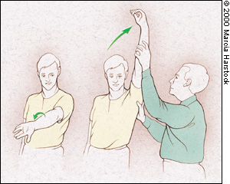
- Empty can test: It is a physiotherapy physical examination widely used for frozen shoulder.
Fig-5 : Empty Can Test from previous studies
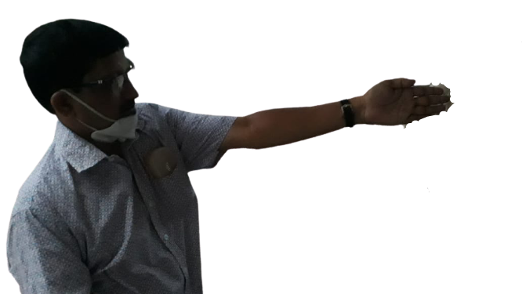 | 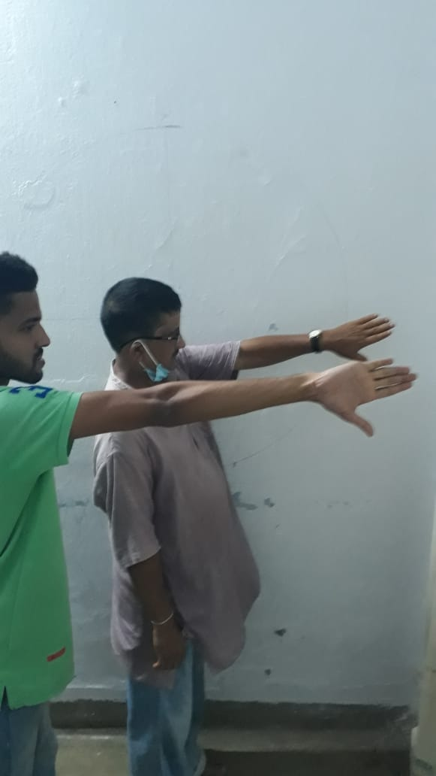

Fig- 6: Before treatment Fig-7: After Treatment

- Rage of motion (ROM): It is a physiotherapy physical examination widely used for frozen shoulder.
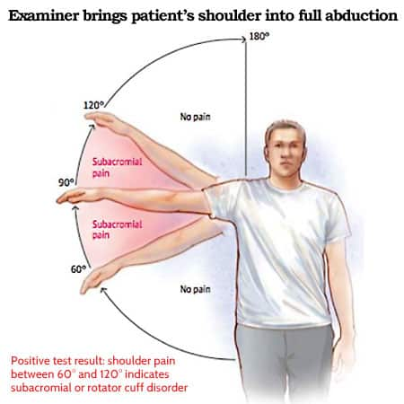
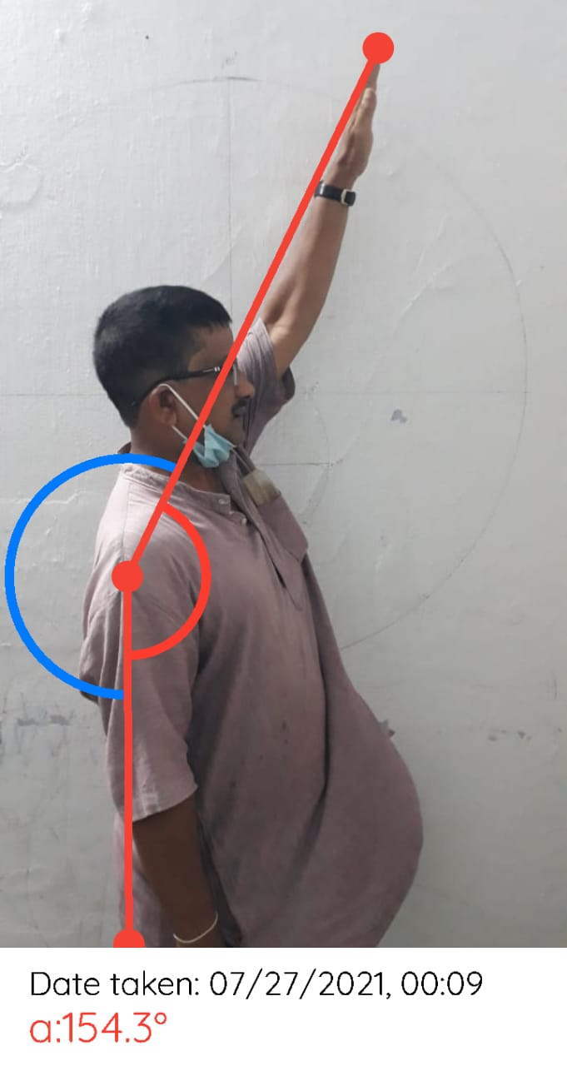 | 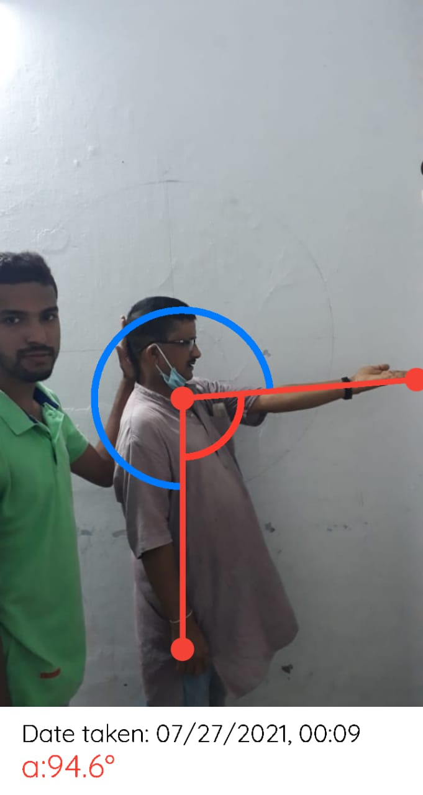
Fig:8
Fig-9: ROM from previous studies
Fig-6: ROM of flexion with Lateral rotation
Fig-5: ROM of flexion with Medial Rotation

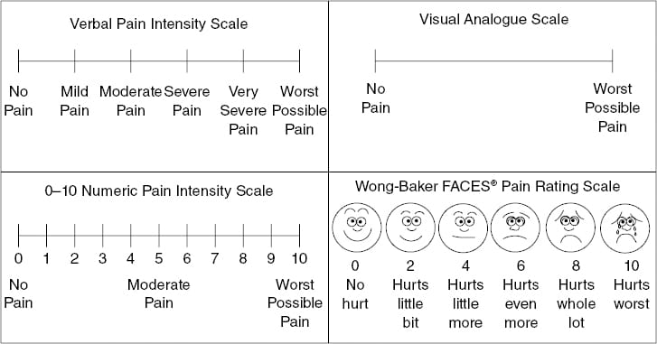
- Visual Analogue Scale (VAS):It is a physiotherapy physical examination widely used for frozen shoulder.[https://www.pinterest.com/rahimiaminali/]

Fig:10
- Trikonasana
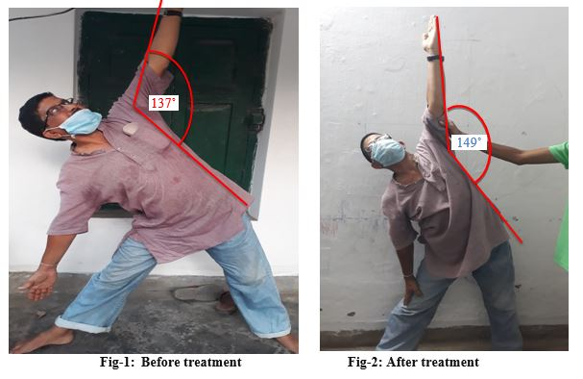
Fig:11: Before treatment Fig:12: After treatment
  - Intervention or Treatment or Independent Variable
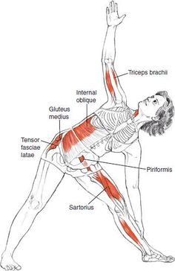
- Trikonasana with Mechanism: In trikonasana, more of a lateral line stretch would result from a wide spacing of the feet, and an intention to initiate the movement primarily from the pelvis while maintaining the spine in neutral extension. This also turns the pose into more of a hip-opener. Lateral flexion of the spine could be emphasized by a closer spacing of the feet, which allows for more stabilization of the relationship between the pelvis and thighs, which would require the movement to come from the lateral bending of the spine.
Fig:13

- Parivritta Trikonasan:
Revolved Triangle Pose par-ee-vrit-tah trik-cone-AHS-anna parivrtta = to turn around, revolve tri = three kona = angle

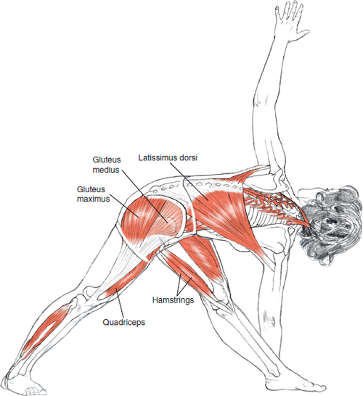
Fig:14
Mechanism: Neutral extension, axial rotation. Upper limbs:
Abduction, external rotation, elbow extension. Front leg: Hip flexion, adduction, external rotation; knee extension; ankle slight plantarflexion. Back leg: Hip mild flexion, internal rotation; knee extension; ankle dorsiflexion; foot supinated heel, pronated at forefoot. Transverso-spinalis group (especially multifidi), erector spinae group, internal and external obliques—to maintain neutral extension in the spine against the pull of gravity and the muscular efforts of the leg and pelvis.

  - Ayurvedic sthula sharir assessment: Questionnaire
    - SCORING

Main symptoms
Table 5: Pre-Post changes with only Ayurveda treatment
Bahupraspandita hara | Pre Score | Post Score
Can do work without being affected | 0 | 0
Can do strenuous work with difficulty | 1 | 1 *
Can do daily routine work with great difficulty | 2 * | 2
Cannot do any work | 3 | 3
Shoolas
No pain at all | 0 | 0
Mild pain,can do strenuous work with difficulty | 1 | 1 *
Moderate pain, can do normal work with support | 2 * | 2
Severe pain, unable to lift | 3 | 3
Associated complaints
stambha
No stiffness | 0 | 0
Mild, has difficulty in the joints without support | 1 | 1*
Moderate, has difficulty in moving, can lift only with support | 2 | 2
Severe, unable to lift | 3 * | 3
Atopa
No atopa | 0 | 0
Palpable atopa | 1 | 1
Audible from a little distance | 2 * | 2 *
Amsha shosha (Wasting of muscles)
No wasting | 0 | 0
Mild wasting, can do work | 1 | 1 *
Moderate wasting, works with difficulty | 2 * | 2
Severe wasting, cannot move | 3 | 3
Sroto dushti
No symptom | 0 | 0
Presence of only one symptom | 1 | 1
Presence of two symptoms | 2 * | 2 *
Presence of more than two symptoms | 3 | 3

  - INTERVENTION
Medication: Painkillers rarly
Physiotherapy: Shoulder exercises and stretching is commonly advised to keep the shoulder from further stiffening. Utra Sound (US)
Yoga: Tiangle pose (Trikonasana), Parivritta Trikonasan, Yoga nidra,
Diet: Green Leaves, less amount of Rice, Increase the quantity of chapati
Yogic counselling
  - Statistical analysis

We didn’t have sufficient data, so we are given the raw data in table form

- Result:
Since the sample size is less no statistical tests were done. But the raw data comparisons were considered to bring out the conclusions. This kind of comparisions were done as authenticative process in the previous non-pharmacological and natural studies like Ayurveda. For assessing the improvement of symptomatic relief and to analyze it statistically, the observations were recorded before and after the treatment. The Pre and post data, percentage, were calculated from the observations recorded.
Range of of motion improve within 12 weeks. There is loss of of pain during the short lever practice. 50% change in wasting of muscle according to sthoola sarira questionnaire whereas near about 66.33% in stambha which is the highest change among all of the items in questionnaire
Table-6 : Pre-post data of General Parameters

Date (dd/mm/yy) | 08/04/21 | 12/04/21 | 17/07/’21
Height (cm) | 155.4 | 155.4 | 155.4
Weight (kg) | 57 |  | 57
Body mass index (kg/m²) | 23.6 |  | 23.6
Pulse rate (bpm) | 83 | 86 | 76
Respiratory rate (cpm) | 20 | 20 | 27
Bhramari Time (Sec)
Inhale Breath Holding Time (Sec)
Exhale Breath Holding Time (Sec)
Blood pressure (mmHg) | 132/86 | 136/82 | 138/86
Oxygen saturation rate (%) | 97 | Nil | 99
Body temperature | Nil | Nil
Blood glucose level (mg/dl)

Table-7: Pre-post data of Specific Parameters

Date (dd/mm/yy) | 08/04/21 | 17/07/’21
ECT | Positive | Negative
ROM | 90⁰ | 150⁰
VAS | 10 | 3
RM | 3 | 5
Ayurveda- Stretch | 5 sec | 20 sec
Ayurveda- Pain | Severe | Moderate

- DISCUSSION
9.1 Improvements of Frozen shoulder with yoga practices
Empty can test shown positive results after 3 months of Trikonasana or triangle pose and Parivritta Trikonasana or revolved triangle pose. General range of motion or Vyayama are the best mobilizing practices for rotation of ball and socket joints like shoulder. This was previous studies with general vyayama (Roy, Chatterjee, & Mondal, 2018)
There is loss of pain during the short lever practice like stretches that were given to catch the opposite elbow over the lower back or waist. This benefit was observed in post-operative patients in the previous studies by Eraballi. A et al, 2018. (Eraballi, Raghuram, Ramarao, Pradhan, & Rao, 2018)
Pranayama like high frequency and low frequency are popular for many diseases ranging from respiratory to metabolic. High frequency breathing practices can increase the metabolic rate initially as shown in previous studies by Mondal J, 2015 (Mondal, Balakrishnan, & Krishnamurthy, 2015). Low frequency pranayama can improve the oxygenation as shown in Chatterjee S, 2014 (Chatterjee, 2014)
Range of motion improve within 12 weeks from 90⁰ to 150⁰. Trikonasana was proved as a good stretching practice compared to exercise (Gothe & McAuley, 2016)
Ayurveda treatment alone has proven in a clinical trial as; https://www.ncbi.nlm.nih.gov/pmc/articles/PMC3202264/
- Complete relief: One hundred percent relief in the complaints of patients, along with elevation of shoulder joint up to 180° and flexion and abduction of the joint up to 90°.
- Marked improvement: More than 75% relief in the complaints as well as significant improvement in the elevation of joint up to 135°, and flexion and abduction up to 60°.
- Moderate improvement: More than 50% relief in the complaints along with improvements in elevation of joint up to 90° and flexion and abduction of joints up to 30°.
- Improvement: Twenty-five to fifty percent relief in the complaints.

9.2 Neutral changes of Frozen shoulder with yoga practices
Unchanged ROM was observed with Ayurveda treatment asper previous clinical trial “patients with less than 25% relief in their complaints were regarded as unchanged”.(Das.B, Danesh R.M, Mishra P.K)

9.3 Adverse changes of Frozen shoulder with yoga practices
Pain still existing with long lever practice mimicking empty can test. The ability of lifting the body weight against gravity is a minor challenge still existing in this case. It may be because of very low healing processes of diabetes. Hence Trikonasana is long lever practice where the challenge is more. (Hegde et al., 2011)

9.4. Possible mechanisms from modern research
A study showed that yoga postures had a positive effect on glucose utilization and fat redistribution in individuals with type 2 diabetes. In patients with diabetes, pancreatic cells may be rejuvenated and pancreatic β-cell sensitivity may be increased by the alternating abdominal contractions and relaxations involved in yoga practice. Improved blood supply to muscles may enhance insulin receptor expression in the muscles, causing increased glucose uptake.
In a study, it was observed that optimum control of diabetes was achieved by practicing dhanurasana and ardhamatsayendrasana. Halasana, vajrasana, bhujangasana, and naukasana were also found to be effective. However, yoga mudra and shalabasana worsened participants' diabetic status, for reasons that are not clearly understood.
A study evaluated the effects of four specific sets of asanas, dhanurasana+matsyendrasana, halasana+vajrasana, naukasana+bhujangasana, and setubandhasana+pavanamuktasana, on releasing insulin from the pancreas. Increased sensitivity of the β-cells of the pancreas to the glucose signal was observed, which appeared to be a sustained change resulting from a progressive long-term effect of the asanas.
It was suggested that as little as 10 minutes of the yoga intervention combined with standard medical care could improve metabolic health significantly.

- CONCLUSION:
Trikonasana or triangle poses are best yoga practices in reducing shoulder pain of Diabetics. Range of motion, repetition maximum or muscle performance improves with Trikonasana or triangle poses by reducing the gap between the joint within 3 months of lockdown life.

- LIMITATIONS
- Small sample size
- Lack of interaction with patient due to covid-19 online treatment
- Online sessions were suggested were selected from the protocol of International Day of Yoga by Indian govt.

- STRENGTHS AND FURTHER RESEARCH
- The patients have shown great cooperation towards the yoga asana, pranayama technique and general walking.
- The examination or special test were taught to the patient on contact session and asked to repeat for the long-term by the patient to show in online session.
- In future it is very efficient and beneficial for all at large.
- We recommend for frequent blood sugar level and quality of life during employment comparing to present lockdown situation.

- REFERENCES
- (Das, Ganesh, Mishra, & Bhuyan, 2010)Chatterjee, S. (2014). Vitamin D, Optimal Health and Athletic Performance: A Review Study. International Journal of Nutrition and Food Sciences, 3(6), 526. https://doi.org/10.11648/j.ijnfs.20140306.16
- Das, B., Ganesh, R. M., Mishra, P. K., & Bhuyan, G. (2010). A study on Apabahuka (frozen shoulder) and its management by Laghumasha taila nasya. Ayu, 31(4), 488. https://doi.org/10.4103/0974-8520.82048
- Eraballi, A., Raghuram, N., Ramarao, N. H., Pradhan, B., & Rao, P. V. (2018). Yoga based lifestyle program in improving quality of life after coronary artery bypass graft surgery: A randomised controlled trial. Journal of Clinical and Diagnostic Research, 12(3), YC05–YC09. https://doi.org/10.7860/JCDR/2017/30296.11303
- Gothe, N. P., & McAuley, E. (2016). Yoga Is as Good as Stretching-Strengthening Exercises in Improving Functional Fitness Outcomes: Results From a Randomized Controlled Trial. Journals of Gerontology - Series A Biological Sciences and Medical Sciences, 71(3), 406–411. https://doi.org/10.1093/gerona/glv127
- Hegde, S. V., Adhikari, P., Kotian, S., Pinto, V. J., D’Souza, S., & D’Souza, V. (2011). Effect of 3-month yoga on oxidative stress in type 2 diabetes with or without complications: A controlled clinical trial. Diabetes Care, 34(10), 2208–2210. https://doi.org/10.2337/dc10-2430
- Mondal, J., Balakrishnan, R., & Krishnamurthy, M. N. (2015). Regulation of autonomic functions following two high frequency yogic breathing techniques. TANG [HUMANITAS MEDICINE], 5(1), 4.1-4.4. https://doi.org/10.5667/tang.2014.0015
- Roy, B., Chatterjee, S., & Mondal, S. (2018). Yoga and Vyayama: Traditional mind-body technique of ancient india. International Journal of Yoga, Physiotherapy and Physical Education, 3(2), 208–211. Vivekananda, S. (n.d.). Patanjali Yoga Sutras.
- Das B, Ganesh RM, Mishra PK, Bhuyan G. A study on Apabahuka (frozen shoulder) and its management by Laghumasha taila nasya. Ayu [Internet]. 2010 [cited 2021 Aug 22];31(4):488. Available from: /pmc/articles/PMC3202264/
- Swami Satyananda Saraswati ISBN: 978-81-86336-14-4 Publisher and distributor: Yoga Publications Trust, Ganga Darshan Munger, Bihar, India.
- Printed & Published by : Gita Press, Gorakhpur-273005 (INDIA) (a unit of Gobind Bhavan-Karyalaya, Kolkata) 1584 Gita Roman_Section
- M.M.Gore MEDICINE & ANATOMY AND PHYSIOLOGY OF YOGIC PRACTICES ISBN: 978-81-7822-390-2 (Series) ISBN: 978-81-7822-391-9

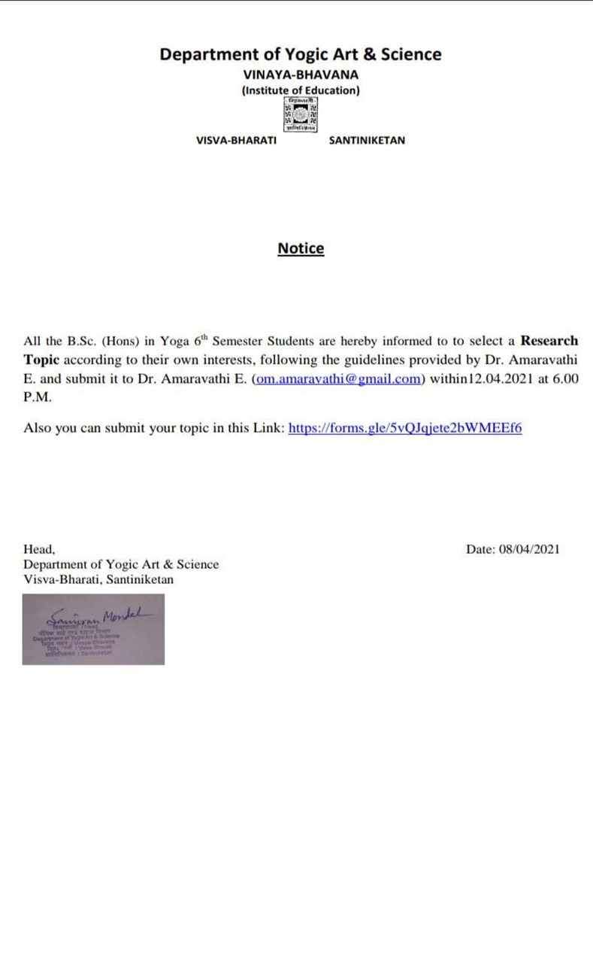
14. Annexures
Annexure:1

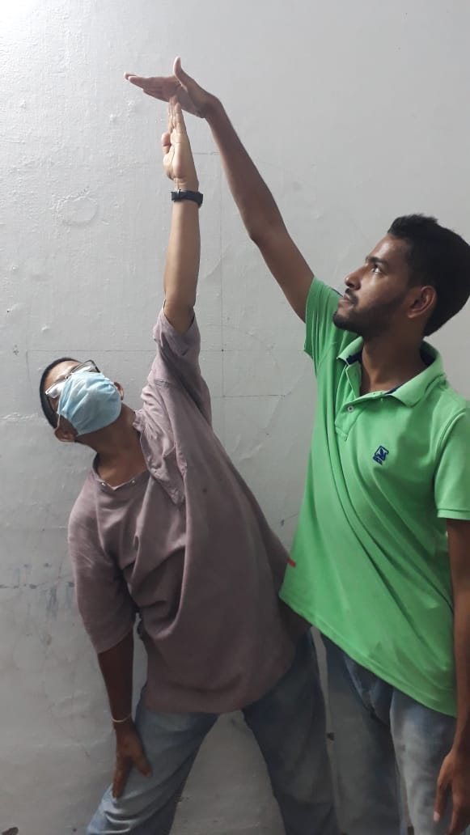
Annexure:2
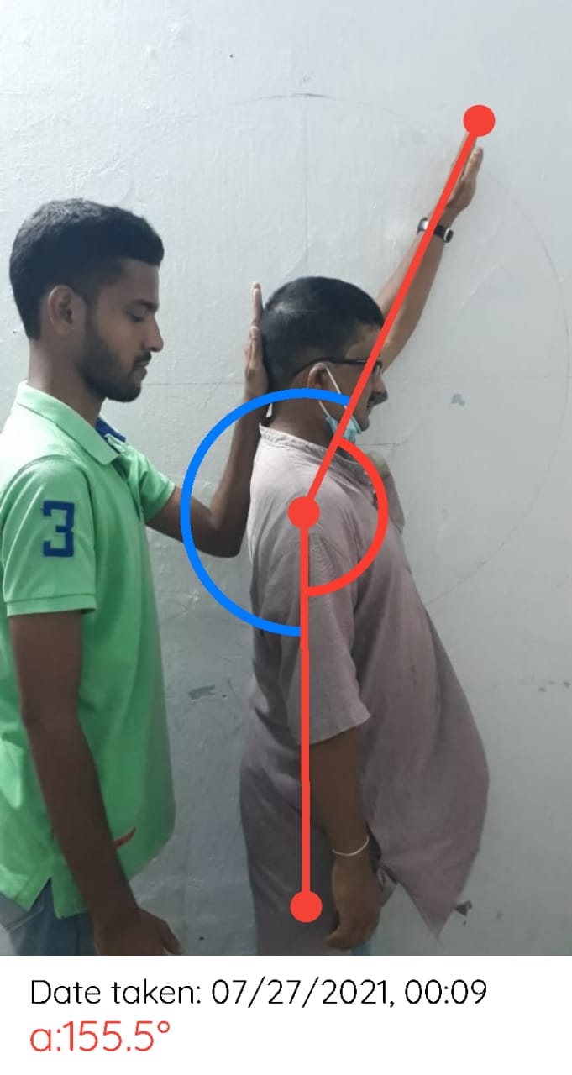
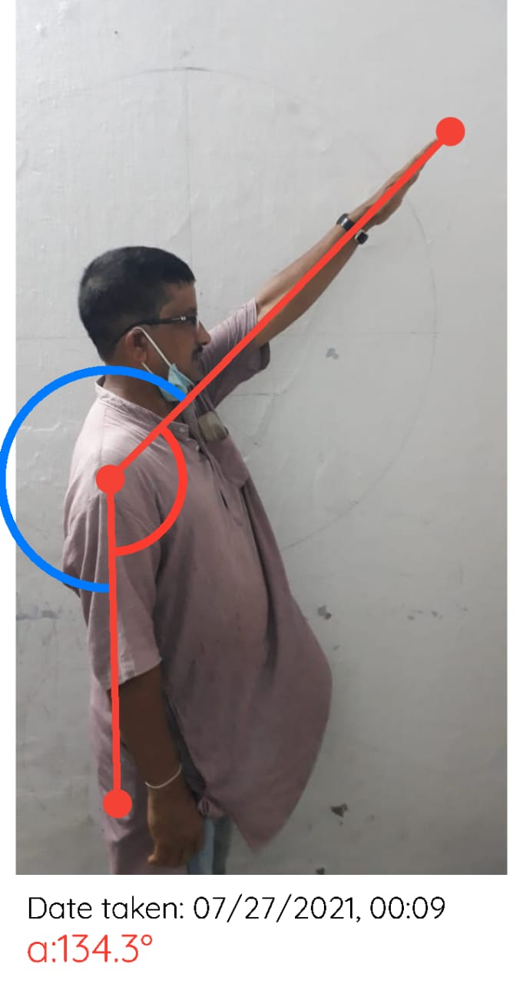
Annexure:3
Annexure:4
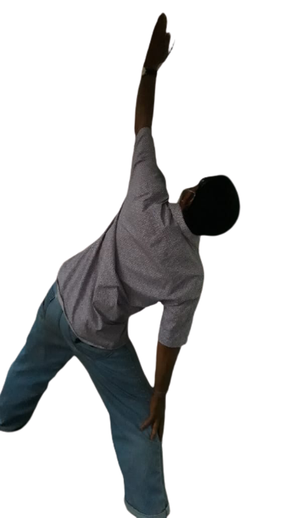
Annexure:5
Annexure:6
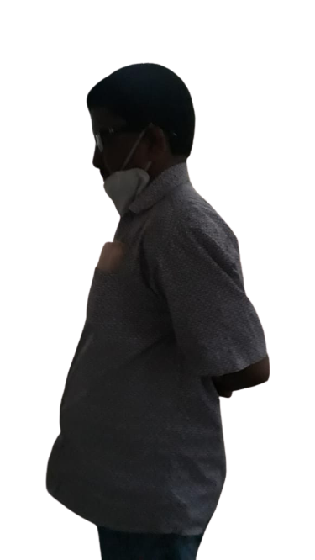
Annexure:7
Annexure:8
