Aromatherapy

Jasmeen Syan
Assistant Professor
College of Pharmacy, Shivalik Campus
Dehradun, Uttarakhand
Email- jasmeen.syan@copdoon.org
Mobile No.- 6395577900

Abstract: In complementary and alternative medicine, aromatherapy is frequently used to treat medical issues. In this sort of treatment, essential oils are frequently used since they contain unpleasant components. One of the most rapidly expanding alternative medical practices is aromatherapy, which merges massage with counselling and pleasant aromas while using essential oils and aromatic chemical compounds from plants. Scientific research demonstrates that aromatherapy, which involves breathing in or absorbing fragrant plant extracts, may also help calm your body and reduce discomfort. Essential oils have been found in studies to affect brainwaves and modify behavior. Aromatherapy, when practiced safely and effectively, has a lot to offer as a complement to traditional medicine or as an alternative therapy. Aromatherapy examines various forms of practices for the discipline as well as the problems with quality and safety that come up when applying essential oils in healthcare.
Key Words: Essential oil, Therapy, Distillation, Aroma, Medicines, Traditional
Introduction
Aromatherapy derived its name from the word aroma, which means fragrance or smell and therapy which means treatment. This therapy is a natural way of healing a person's mind, body and soul [1]. The use of aromatherapy in the treatment of a wide range of problems and illnesses has grown increasingly popular. A review of the literature indicates that this therapy acquired a lot of interest in the 20th and 21st centuries as well, and as a result of its value, appeal, and widespread application, it has become recognized as aroma medical therapy [2].
Aromatherapy is an alternative holistic treatment that applies essential oils to balance and improve our emotional and physical well-being. Aromatherapy and essential oils' aromatic sensations have an enormous effect on the mind and body. The regulated utilisation of essential oils to support and maintain an individual's physical, psychological, and spiritual wellness is known as aromatherapy. The art and science of utilising naturally derived fragrant essences from plants to balance, harmonise, and advance the health of body, mind, and spirit is known as aromatherapy, also known as essential oil therapy. It aims to integrate psychological, spiritual, and physiological processes to strengthen a person's intrinsic healing process [3,4,5]. The use of essential oils for medicinal, cosmetic, aromatic, fragrant, and spiritual purposes has grown in importance [6,7]. Essential oils, which are believed to be highly concentrated chemicals derived from flowers, leaves, stalks, fruits, and roots as well as distilled from resins, are used as the primary therapeutic agents in aromatherapy [8]. Saturated and unsaturated hydrocarbons, alcohol, aldehydes, esters, ketones, oxides, phenols, and terpenes are all components of essential oils, which can result in peculiar aromas [9].
Within a brief period of time, the application of aromatherapy in holistic health has advanced significantly [10]. Reviewing the research on this therapy reveals that many studies have been done to examine how it affects the human brain and its emotions. Recent scientific debate has focused heavily on its function in mood, attentiveness, and mental stress in healthy persons. Through the use of electroencephalogram patterns and functional imaging investigations, several researchers attempted to look into the impacts on work ability, response speed, and certain spontaneous behaviours on the brain [11]. When compared to artificial odours, this treatment was shown to be better. In general, synthetic perfumes contain irritants such propellants and solvents that might irritate individuals [12,13]. Aromatherapy is a separate science and practise from herbal medicine, although the study and use of essential oils in herbal medicine is not. Herbalists often work with entire plants compared to plant constituents like essential oils. A conventional or clinical herbalist, however, might create or employ a medicinal-grade essential oil in the context of their work. The herbalist who uses essential oils refers to themselves as herbalists rather than aromatherapists. In their practices, aroma therapists and mind-body practitioners commonly work together to create therapeutic spaces that show how plants may improve their customers' emotions [14].
Classification of Aromatherapy
- Cosmetic aromatherapy: Certain essential oils are used in this therapy to make cosmetic items for the skin, body, face, and hair. These products are used for their varying cleaning, moisturising, drying, and toning actions. Essential oils can be used in face products to promote healthy skin. On a personal level, using foot or full-body aromatherapy during a bath will be a quick and efficient approach to enjoy an experience. Similar to this, a few drops of the right oil provide a revitalising and reviving effect [15].
- Massage aromatherapy: It has been demonstrated that grape seed, almond, or jojoba oil to pure vegetable oil before massaging someone produces great results. This is often referred to as massage treatment with a therapeutic touch [16].
- Medical aromatherapy: Rene-Maurice Gattefosse, the father of contemporary aromatherapy, has applied the medical aromatherapy understanding of the impact of essential oils on promoting and treating clinically identified medical illnesses to massage patients during surgery [17].
- Olfactory aromatherapy: Olfactory aromatherapy, which is a result of the inhalation of essential oils, has been shown to improve mental wellbeing, peacefulness, relaxation, or physical renewal in humans. Pleasurable fragrances that trigger odour memories are incorporated together with the relaxation of stress [18].
- Psycho-aromatherapy: Aromatic oils provide the pleasure of relaxation, energization, or a pleasant memory can be used in psycho-aromatherapy to achieve specific mood and emotional states. In this therapy, the oils are directly inhaled by the patient as they are being infused. Aromacology and psycho-aromatherapy both focus on the analysis and results of aroma, whether it be synthetic or natural [19].
Plants used in Aromatherapy
1. Jasmine
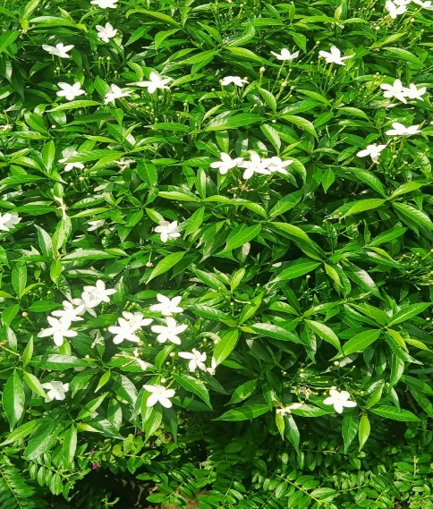
Figure 1: Jasmine Plant Species
Biological source: It consist of fresh flowers of Jasminum officinale, belonging to family Oleaceae.
Commonly known as Jasminum sambac, Mogra, Chameli
Description: Jasmine has small white flowers, although some species have bright yellow, with long shoots that climb. Typically, each flower will have about four to nine petals, two locules, and one to four ovules, with two stamens and very short filaments.
Distribution: In India, Jasmines are cultivated throughout the country but the commercial cultivation is confined to Coimbatore, Madurai, and Dindigul (Tamil Nadu); Bangalore and Maharashtra.
Therapeutic indications: Antidepressant, Antiseptic Antispasmodic, Expectorant, Sedative and Antibacterial etc.
Chemical Constituent: It contain volatile oil jasminol, Essence also contain of benzyl acetate, linalool, Ethereal extract from the leaves yield an alkaloid and jasminine.
Uses: Skin disease and wound healing, Used for the treatment of arthritis and gout.
In Aromatherapy: Relieves Depression, Stimulates Sexual, Fades Scar Marks, Treats Insomnia, Emmenagogue, Facilitates Lactation [20].
2. Lemon
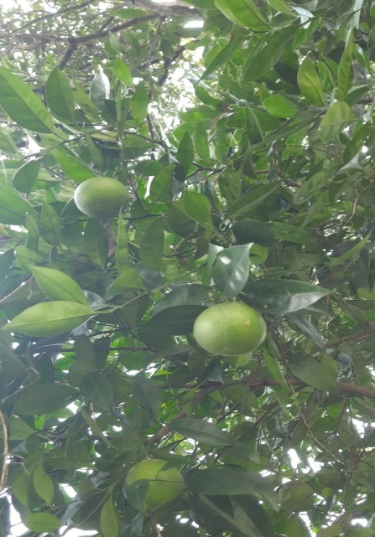
Figure 2: Lemon Plant Species
Biological Source: Lemon peel is the outer part of pericarp of the ripe fruit or nearly ripe of Citrus limonis belonging to the family Rutaceae.
Common names: Lemon, Nimbu.
Description: The true lemon tree reaches 10 to 20 ft (3-6 m) in height and usually has sharp thorns on the twigs. The alternate leaves, reddish when young, become dark-green above, light-green below. The mildly fragrant flowers may be solitary or there may be 2 or more clustered in the leaf axils. Buds are reddish; the opened flowers have 4 or 5 petals 3/4 in (2 cm) long, white on the upper surface (inside), purplish beneath (outside), and 20-40 more or less united stamens with yellow anthers. The fruit is oval with a nipple-like protuberance at the apex.
Distribution: In india lemon is cultivated in Andhra Pradesh, Maharashtra, tamil nadu, gujrat, rajasthan, and bihar.
Therapeutic indication: Treats Indigestion, Fever, cholera, Dental Care, Hair Care, skin care, Cures Burns, Internal Bleeding
Chemical constituent: It contains Volatile oil 2 to 4 percent, Limonine, citral, Other constiuent of the peels are Hespiridin, pectin, Calcium oxalate and bitter substance, romatic substances are gernyl acetate.
Uses: Carminative and stimulant, Oil is used as perfuming and flavouring agent.
In Aromatherapy: Skin irritation, Immunity booster, Mood enhancer [21].
3. Mentha
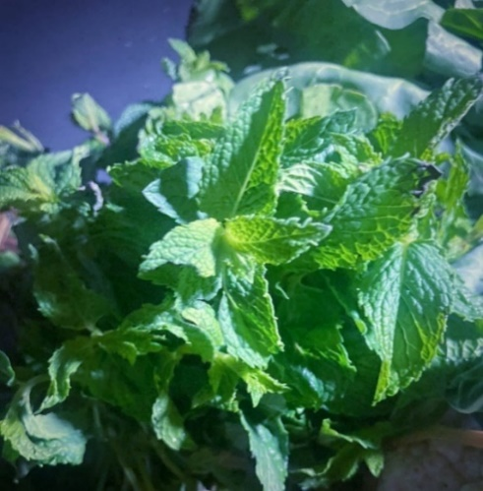
Figure 3: Mentha Plant Species
Biological Source: It is the oil obtained by the distillation of Mentha piperita, belonging to family Lamiaceae.
Common names: Pudina, Corn Mint
Description: Peppermint thrives best in a fairly warm, preferably moist climate, with well-drained, deep soils rich in humus. Peppermint will grow successfully, if once started into growth and carefully cultivated. The usual method of cultivation is to dig runners in the early spring and lay them in shallow trenches, 3 feet apart in well-prepared soil.
Distribution: It is widely distributed in India, Japan, Thailand, Korea, Taiwan. In India, it is chiefly grown in northern states of Jammu and Kashmir, Punjab, Haryana
Chemical Constituents: The mint main chemical compounds consist of limonene, cineole, menthone, menthofuran, isomenthone, menthyl acetate, isoeugenol, menthol, pulegone and carvone.
Uses: It is stimulant, stomachic, carminative, in flatulence, and colic; in some dyspepsia, sudden pains, for cramp in the abdomen and also in cholera and diarrhoea. Oil of peppermint allays sickness and nausea, as infants’ cordial. Peppermint is good to aid in raising internal heat and inducing perspiration. It is also used in cases of hysteria and nervous disorders [22].
Pharmacological actions
1. Heart Rate: In Yale University research (1988) the sedative effects of scents were measured using changes in blood pressure and heart rate. The scent of spiced apples has strong vasodepressant and stress-relieving properties. Yamaguchi (1990) also measured the impact of lemon and rose smells using variations in heart rate. When compared to rose scent, lemon aroma increased heart rate while rose aroma decreased it. This research suggests that although rose scent has a calming impact (a drop-in heart rate), lemon aroma has a stimulating effect (an increase in heart rate) [23].
2. Blood Pressure: One of the physiological variables that is most commonly monitored is blood pressure. The use of an essential oil-based scent to lower stress in people as determined by the drop in blood pressure and self-ratings was patented by Warren et al. in 1987. According to this study, essential oil lowers systolic blood pressure by 9 mmHg. Additionally, individuals report feeling happier and more at peace with themselves, as well as less anxious, angry, and embarrassed. Two components of nutmeg oil, myristicin and elemicin, might be responsible for these effects [24].
3. Anti-Tumour Activity: Human melanoma M14 WT and M14 adriamicin-resistant cells were able to grow more slowly when treated with tea tree oil and terpinen-4-ol, respectively. In melanoma cells, a caspase-dependent pathway connected this activity to apoptosis. If geraniol, a component of plant essential oils, sensitises human colon cancer cells, 5-fluorouracil therapy is increased. The relationship between essential oils and their anti-tumor action is now being investigated [25,26].
4. Anti-oxidant Activity: In vitro, essential oil is a strong antioxidant with significant hydroxyl radical scavenging action. Manuka (Leptospermum scoparium), Kanuka (Kunzea ericoides) have strong antibacterial and antioxidant capabilities. The essential oils has significant antioxidant potential; it modifies superoxide dismutase parameters and raises vitamin E and vitamin C concentrations [27].
5. Anti-Inflammatory Activity: In humans, tea tree oil decreased the histamine reactivity of flare and weal. After 10 minutes, 100% tea tree oil used topically can lessen the irritation brought on by histamine diphosphate [28].

Conclusion:
The facts and research mentioned above lead us to the conclusion that aromatherapy is a safe, all-natural gift from nature to humanity. The application of aroma helps to boost every organ as well as eliminate illness symptoms. The physiological, spiritual, and psychological upliftment for the next stage of life is regulated by aromatherapy. Essential oils can be a useful addition to cancer treatment, helping to control side symptoms including sleeplessness and nausea. This treatment can be utilised in both the acute and chronic stages of illness, in addition to being preventative. The pharmaceutical industry is attempting to develop disease-related to pathogens and metabolism, alternative, natural, and environmentally friendly medicines. By using these essential oils, it may be possible to increase the bioavailability and response time of medications. It is anticipated that research and development in this area will continue and remain committed to evaluating the psychological impacts of aromas. Further cutting-edge investigation into the endocrine, immunological, and pharmacological impacts of aromas has already started and is expected to produce significant results presently.
Bibliography
- Worwood VA. Aromatherapy for the Healthy Child: More Than 300 Natural, Nontoxic, and Fragrant Essential Oil Blends. New World Library; 2000.
- Esposito ER, Bystrek MV, Klein JS. An elective course in aromatherapy science. American Journal of Pharmaceutical Education. 2014 May 15;78(4).
- Hedaoo SA, Chandurkar PA. A review on aromatherapy. World Journal of Pharmaceutical Research. 2019 Mar 28;8(7):635-51.
- Gabriel Mojay. What is Aromatherapy? National Association for Holistic Aromatherapy. https://naha.org/explore-aromatherapy/about-aromatherapy/what-is-aromatherapy/.
- Querequincia JM, Faller EM. A Review on the different studies on aromatherapy conducted in the Philippines. GSC Biological and Pharmaceutical Sciences. 2021 Aug 30;16(2):028-31.
- Evans WC. Trease and Evans' pharmacognosy. Elsevier Health Sciences; 2009 May 27.
- Svoboda KP, Deans SG. Biological activities of essential oils from selected aromatic plants. InInternat. Symposium on Medicinal and Aromatic Plants 390 1994 Aug 21 (pp. 203-209).
- Dunning T. Aromatherapy: overview, safety and quality issues. OA Altern Med. 2013;1(1):6.
- Schiller C, Schiller D. 500 formulas for aromatherapy: mixing essential oils for every use. Sterling Publishing Company, Inc.; 1994.
- Buchbauer G, Jirovetz L, Jager W, Plank C, Dietrich H. Fragrance compounds and essential oils with sedative effects upon inhalation. Journal of pharmaceutical sciences. 1993 Jun;82(6):660-4.
- Vethanayagam D, Vliagoftis H, Mah D, Beach J, Smith L, Moqbel R. Fragrance materials in asthma: a pilot study using a surrogate aerosol product. Journal of Asthma. 2013 Nov 1;50(9):975-82.
- Silva-Néto RP, Peres MF, Valença MM. Odorant substances that trigger headaches in migraine patients. Cephalalgia. 2014 Jan;34(1):14-21.
- Cooke B, Ernst E. Aromatherapy: a systematic review. British journal of general practice. 2000; 50(455):493-6.
- Buckle J. Aromatherapy. Nursing Times. 1993; 89(20):32-5.
- ZIOSI P, Manfredini S, Vertuani S, Ruscetta V, Radice M, Sacchetti G. Evaluating essential oils in cosmetics: antioxidant capacity and functionality. Cosmetics and toiletries. 2010;125(6).
- Chang SY. Effects of aroma hand massage on pain, state anxiety and depression in hospice patients with terminal cancer. Journal of Korean Academy of Nursing. 2008 Aug 1;38(4):493-502.
- Maeda K, Ito T, Shioda S. Medical aromatherapy practice in Japan. Essence. 2012;10(4):14-6.
- Price S. Aromatherapy for Common Ailments: How to use essential oils--such as Rosemary, Chamomile, and Lavender--to prevent and treat more than 40 common ailments. Simon and Schuster; 2003 Dec 23.
- Perry N, Perry E. Aromatherapy in the management of psychiatric disorders: clinical and neuropharmacological perspectives. CNS drugs. 2006 Apr;20:257-80.
- Dr. Josh Axe. Jasmine Oil- Mood Booster and Stress Buster. Dr. Axe Food is Medicine; July 23, 2018. https://draxe.com.
- . Cathy Wong. Lemon Essential Oil Benefits and Uses; March 31, 2019. https://www.verywellhealth.com.
- Alankar S (2009) A review on peppermint oil. Asian J Pharm Clin Res 2: 27-33.
- Schwartz et al., 1988. Psychology, 15: 281; cited according reference of Manley, C. H. 1993. Psychological effect of odor. Crit. Rev. Food Sci. Nutr., 33(1): 57-62.
- Warren, C.B., Munteanu, M.A., Schwartz, G.E., Benaim, C., Walter, H.G., Leight, R.S., Withycombe, D.A., Mookerjee, B.D., and Trenkle, R.W. 1987. Method of causing the reduction of physiological and/or subjective reactivity to stress in humans being subjected to stress conditions.
- Carnesecchi S, Langley K, Exinger F, Gosse F, Raul F. Geraniol, a component of plant essential oils, sensitizes human colonic cancer cells to 5-fluorouracil treatment. Journal of Pharmacology and Experimental Therapeutics. 2002 May 1;301(2):625-30.
- Carnesecchi S, Langley K, Exinger F, Gosse F, Raul F. Geraniol, a component of plant essential oils, sensitizes human colonic cancer cells to 5-fluorouracil treatment. Journal of Pharmacology and Experimental Therapeutics. 2002 May 1;301(2):625-30.
- Baratta MT, Dorman HD, Deans SG, Biondi DM, Ruberto G. Chemical composition, antimicrobial and antioxidative activity of laurel, sage, rosemary, oregano and coriander essential oils. Journal of Essential Oil Research. 1998 Nov 1;10(6):618-27.
- Koh KJ, Pearce AL, Marshman G, Finlay‐Jones JJ, Hart PH. Tea tree oil reduces histamine‐induced skin inflammation. British Journal of Dermatology. 2002 Dec 1;147(6):1212-7.

