Smoke Detector Sensor

1st Shreyas Manoj Baviskar
Dept. of Electrical Engineering
G H Raisoni Institute of Engineering & Business Management Jalgaon, India
shreyasbaviskar66@gmail.com

4th Priyanka D Gajare
Dept. of Electrical Engineering
G H Raisoni Institute of Engineering & Business Management Jalgaon, India
priyanka.gajare@raisoni.net

2nd Deepak Parag Patil
Dept. of Electrical Engineering
G H Raisoni Institute of Engineering & Business Management Jalgaon, India
deepakpatil830820@gmail.com

5th Pratik Chrmade
Dept. of Electrical Engineering
G H Raisoni Institute of Engineering & Business Management Jalgaon, India
pratik.chirmade@raisoni.net

3rd Prathamesh Sambhaji Shinde
Dept. of Electrical Engineering
G H Raisoni Institute of Engineering & Business Management Jalgaon,
India
prathmesh050803@gmail.com

6th Bipasa Bimalendu Patra
Dept. of Electrical Engineering
G H Raisoni Institute of Engineering
& Business Management Jalgaon, India
akasvora@gmail.com

Abstract--This research paper delves into an in-depth analysis of various smoke detector sensor technologies and their practical applications. Smoke detection plays a crucial role in fire safety systems, and the effectiveness of these detectors is heavily reliant on the underlying sensor technology. The paper explores the operational principles, advantages, limitations, and real-world use cases of these sensors. The proposed system described in the paper operates by having a smoke detector sense smoke, trigger its alarm, and send a low voltage signal to nearby smoke detectors. These receiving detectors then activate their individual relays, emitting an audible tone to alert residents of the smoke presence. What's noteworthy is that this system eliminates the need for a central base unit, and each smoke detector is self-contained, battery-operated, and easy to install. The design objectives of the system are cost efficiency, compactness, expandability, ease of installation, and replaceable components. The paper discusses testing the system indoors and outdoors under various conditions, including different distances and noise levels. Furthermore, the paper touches upon the standards for the safety of smoke alarms, particularly ANSI/UL 217-2015, which sets performance requirements for smoke alarms. The research involved testing 45 distinct smoke alarm models and concluded that none of the current models were likely to meet the new performance standards outlined in the standard. In summary, the paper provides valuable insights into smoke detector technology and its real-world applications, showcasing a novel system design with several desirable features. The use of keywords like "smoke detector alarm," "Fire detector," "Arduino," and "MQ2 Smoke sensor" indicates the paper's focus on these critical elements in the field of fire safety and detection.

- INTRODUCTION
A smoke detector is a device that senses the presence of smoke, often indicating a fire. In commercial settings, these devices send signals to a fire alarm control panel as part of a larger fire alarm system. On the other hand, in homes, they are commonly known as smoke alarms and typically produce a loud sound or flashing light from the detector itself, or multiple detectors can be interconnected to sound alarms throughout the house in case of smoke detection. Smoke detectors are typically housed in plastic enclosures and come in various shapes and sizes, but they are commonly around 150 millimeters in diameter and 25 millimeters thick. Smoke detectors play a crucial role in the fire detection strategy of modern commercial and residential buildings. In the 1970s, there was a notable increase in their usage, backed by significant research projects that highlighted their effectiveness in life safety protection. To better understand how these detectors operate, researchers have conducted various studies. Predicting the performance of smoke detectors accurately is crucial, as the response of these detectors can impact the safety of occupants and the notification of fire services. Fire Dynamic Simulator software is one tool used for predicting smoke detector responses. It's worth noting that fire loss data demonstrates the effectiveness of automatic sprinkler systems in controlling and extinguishing fires in buildings. Therefore, the integration of fire detection systems with automatic sprinklers is crucial for fire protection in commercial buildings. However, there are concerns related to the reliability of automatic smoke detection systems, including issues with false alarms and the choice of sensor combinations. Researchers have been conducting studies on fires in different settings, such as residential areas and commercial buildings. In summary, a smoke detector is a device that senses smoke, often as an indicator of a fire. It plays a vital role in both commercial and residential settings, contributing to fire safety and early detection.

II. LITERATURE SURVEY
A smoke detector is a device that helps detect the presence of smoke, typically as a sign of a fire or in areas designated as non-smoking zones. It plays a crucial role in ensuring human safety and protecting property from the dangers of fire in both homes and businesses. Various methods have been developed to achieve smoke detection, each with its own unique design. However, these designs are primarily based on two fundamental types of smoke detectors:
- Photoelectric Smoke Detector: This type of smoke detector employs an optical beam to search for smoke in its vicinity. When smoke particles obstruct the beam, a photoelectric cell within the detector notices a reduction in light intensity, and this triggers an alarm. Photoelectric smoke detectors are especially responsive to smoldering fires that produce a relatively significant amount of smoke.
- Ionization Chamber Smoke Detector (ICSD): On the other hand, the ionization chamber smoke detector is more sensitive to detecting flaming fires that tend to produce less smoke. This detector relies on a radioactive material to ionize the air inside a sensing chamber. The presence of smoke affects the flow of ions between two electrodes in the chamber, which then sets off the alarm. In a typical setup, the radioactive material emits alpha particles that remove electrons from air molecules, creating positively charged oxygen and nitrogen ions. These electrons attach themselves to other air molecules, forming negatively charged oxygen and nitrogen ions. Two oppositely charged electrodes inside the sensing chamber attract these ions, creating a small current flow in the air space between them. However, when smoke particles enter the chamber, they draw in some of these ions, disrupting the current flow and triggering the alarm.
In summary, smoke detectors are essential safety devices that come in different designs, with photoelectric detectors being quicker to respond to smoldering fires with significant smoke production, while ionization chamber detectors are more sensitive to flaming fires with less smoke. Both types play a crucial role in keeping people and property safe from the dangers of fire.

- PROBLEM STATEMENT
It's clear that you recognize the importance of fire safety in residential and commercial buildings and are interested in designing a microcontroller-based smoke alarm system. Such systems are indeed crucial for early detection and alerting, which can significantly reduce the risk to life and property in the event of a fire. Here are some key points and considerations based on the information you've provided:
Placement of Smoke Detectors: Your understanding that smoke detectors should be placed in every bedroom and hallway, as well as on every floor, is correct. Proper placement ensures comprehensive coverage and early detection of smoke or fire in various areas of the building.
Use of Smoke Detectors: Smoke detectors are widely used in both residential and industrial settings due to their effectiveness in detecting smoke, which is often an early sign of a fire. The fact that they respond quickly to smoldering fires, which can be more dangerous in some cases, makes them a valuable safety tool.
Microcontroller-Based System: Using a microcontroller-based system to interface with smoke detectors is a smart approach. It allows for the integration of multiple sensors and alarms in different locations, providing a centralized monitoring and alerting system.
Sensor Types: You've mentioned the difference between ionization and photoelectric smoke detectors. It's important to choose the right type of sensor for your specific application. Photoelectric detectors are often preferred for their ability to detect smoke particles from both smoldering and flaming fires, making them more versatile.
Power Supply: Having a power supply that can be directly connected to the mains is convenient and ensures the system operates reliably. However, it's crucial to implement safety measures and backup power solutions in case of power outages.
Cost Considerations: Your acknowledgment of the relatively low cost of implementing such a system is accurate. Cost-effectiveness is an essential factor when designing safety systems, as it encourages widespread adoption.
Additional Applications: Mentioning the potential use of the system for detecting and deterring smokers in prohibited areas demonstrates versatility in its application. However, it's important to ensure that the system respects privacy and complies with relevant regulations when used for such purposes
Education and Maintenance: In addition to the system's design, consider the importance of educating occupants or users about its operation and conducting regular maintenance to ensure its ongoing reliability.
Regulations and Standards: Be sure to comply with local building codes, fire safety regulations, and industry standards when designing and installing smoke alarm systems. These standards often specify the type, placement, and maintenance requirements for smoke detectors.

BLOCK DIAGRAM OF SMOKE DETECTOR ALARM:

- Block Diagram

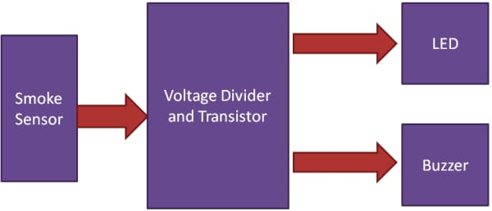

- HARDWARE DESIGN AND COMPOUNDS:

- Schematic diagram

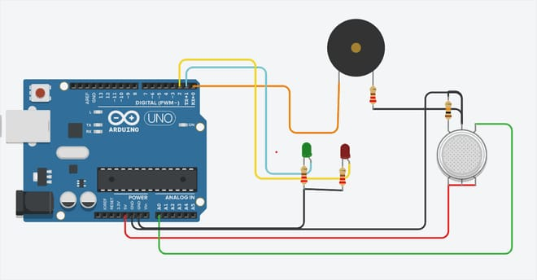

Type of components:

The Basic Components of the smoke detector alarm
a) Arduino uno
b) PCB design
c) MQ2 sensor
d) LED light
e) Buzzer
f) power supply (9v battery)
g) Resistor
h) Male to Female Jumper Wires

- Arduino Uno:

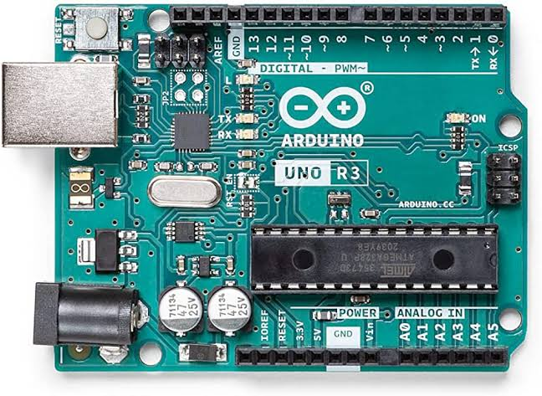
Arduino Uno

The Arduino Uno is a small computer board that uses a microcontroller called the ATmega328. This board is equipped with 14 pins that can either take in or send out electrical signals (digital input/output pins). Out of these, 6 pins can be used to generate pulse-width modulation (PWM) signals, which are useful for controlling things like the brightness of an LED. Additionally, there are 6 analog input pins, which can be used to read varying voltage levels, like those from sensors.
The Arduino Uno also includes a 16 MHz ceramic resonator, which is like a tiny clock that helps the microcontroller keep track of time. It has a USB connection, allowing you to connect it to a computer with a USB cable. You can also power it using an AC-to-DC adapter or a battery. To get started with the Arduino Uno, you simply need to connect it to a power source.

- PCB:

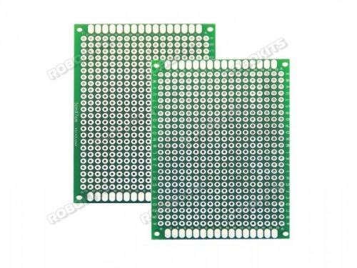
PCB

A printed circuit board, often referred to as a PCB, serves as both a mechanical support and an electrical connection system for various electronic or electrical components. It achieves this by having conductive pathways, pads, and other features created by etching one or more layers of copper onto, or in between, layers of a non-conductive substrate material.
Electronic components are typically attached to the PCB through soldering, which accomplishes two critical tasks: it establishes an electrical connection and secures the components firmly in place. PCBs are an essential component in nearly all electronic devices, ranging from basic gadgets to complex systems. They also find application in certain electrical products, such as passive switch boxes.
PCBs come in different configurations: single-sided, double-sided, and multi-layer. Single-sided PCBs consist of one layer of copper, while double-sided PCBs have copper layers on both sides of a single substrate layer. Multi-layer PCBs are more intricate, with multiple layers of copper and substrate stacked alternately. Multi-layer PCBs offer advantages like higher component density because they allow inner layers to carry circuit traces, freeing up surface space for components.
The popularity of multi-layer PCBs, especially those with more than four copper layers, coincided with the adoption of surface mount technology. However, it's worth noting that multi-layer PCBs make tasks like repairing, analyzing, or modifying circuits in the field much more challenging and often unfeasible.

- MQ2 Sensor:

The MQ2 sensor module was chosen for the task of detecting smoke for several compelling reasons:
Wide Detection Range: The MQ2 sensor is capable of detecting a broad range of substances, including smoke and various flammable gases.
Swift Response and High Sensitivity: It exhibits a rapid response time and is highly sensitive to changes in the presence of smoke or combustible gases.
Sturdy and Long-lasting: This sensor offers stability and a long operational life, ensuring it can function reliably over an extended period.
Simple Drive Circuit: The MQ2 sensor is straightforward to interface with, making it easy to incorporate into electronic circuits.

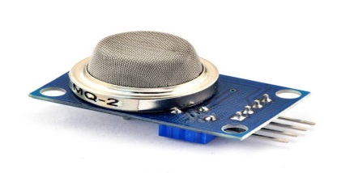

MQ2 SENSOR DETAILS

The MQ-2 smoke sensor possesses the ability to detect smoke within a range of 300 to 10,000 parts per million (ppm) and provides an analog output voltage that varies between 0 volts and 5 volts. The voltage output is contingent on the amount of smoke detected. The sensor utilizes a sensitive material called SnO2, which exhibits lower conductivity in clean air. However, as the concentration of combustible gases increases, the conductivity of SnO2 rises accordingly, resulting in an analog voltage output that corresponds to the gas concentration.
Furthermore, the MQ2 sensor includes an integrated potentiometer that allows users to adjust the sensor's sensitivity to achieve the desired level of accuracy in gas detection. This feature enables fine-tuning of the sensor's responsiveness to varying levels of smoke and flammable gases, making it adaptable for different applications.

- Led Light:

An LED, or light-emitting diode, is a special type of electronic component with just two wires. It's like a tiny light bulb made from semiconductor material. When you give it the right amount of electrical power, it starts to shine. This happens because electrons inside the LED join up with "holes" in the material, and when they do, they release light. This magical light-making process is called electroluminescence. The color of the light depends on how much energy the electrons give off, which is decided by the material's energy gap. So, LEDs can produce different colors by using different types of semiconductors.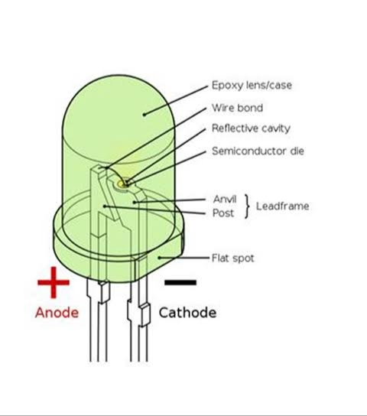

Parts of an LED

- Buzzer:

A buzzer is a sound-making device that is commonly used to create audible alerts in various applications such as alarms, timers, and notifications. Buzzers can come in different types, including mechanical, electromechanical, or piezoelectric varieties

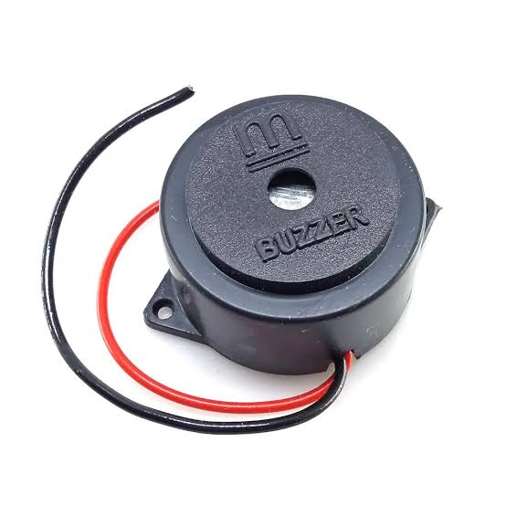
Buzzer

Electromechanical buzzers function by using a relay to disrupt their own electrical current, resulting in the contacts vibrating and producing a buzzing sound. Mechanical buzzers, on the other hand, are entirely mechanical in nature and require external drivers to produce sound. Piezoelectric buzzers rely on piezoelectric elements, which respond to electrical signals, and are driven by an oscillating electronic circuit or another audio signal source, often amplified by a piezoelectric audio amplifier.
For the specific project at hand, we are using a compact electromagnetic buzzer with pin terminals, which generates an audio output at a frequency of 2048 Hz. This buzzer is designed with pin-type terminals for easy installation directly onto printed circuit boards.

IV. WORKING OF SMOKE DECTECTOR ALARM:
The sensor's voltage output varies in response to the levels of smoke or gas present in the air. It means that as the amount of smoke or gas in the atmosphere increases, the sensor will produce a higher voltage signal. Conversely, if there is less smoke or gas in the air, the sensor will generate a lower voltage signal. In simpler terms, the sensor's voltage output reflects the amount of smoke or gas it detects, with higher concentrations resulting in higher voltage readings, and lower concentrations leading to lower voltage readings

- INSTALLATION AND PLACEMENT
The rules and guidelines for installing smoke detectors in existing homes are generally consistent across developed countries, although there may be some variations depending on the local regulations. For instance, both Canada and Australia mandate that every level of a building should have a functioning smoke detector. In the United States, the NFPA code, mentioned earlier, stipulates that smoke detectors should be installed on every habitable level and in proximity to all bedrooms. This includes attics that are tall enough to access. Many other countries have similar requirements.
In new construction, the minimum standards for smoke detectors are usually more stringent. All smoke detectors must be directly connected to the electrical wiring, interlinked with each other, and equipped with a battery backup. Additionally, depending on local building codes, smoke detectors may be required inside or outside every bedroom. Having detectors on the outside can detect fires more quickly, assuming the fire doesn't start in the bedroom, but it might result in a lower alarm sound that might not wake some individuals. In certain regions, there's also a requirement for smoke detectors in stairways, main hallways, and garages.

To improve safety further, a dozen or more smoke detectors can be interconnected either through wiring or wirelessly. This means that if one detector senses smoke, all the detectors in the network will sound the alarm. This enhances the chances of alerting occupants, even if smoke is detected far from where they are. Wired interconnections are more feasible in new construction projects compared to retrofitting existing buildings.

V. CONCLUSION
When it comes to fire safety, it's a good idea to have a smoke detector in every bedroom and hallway, as well as on every floor of our home. By having multiple smoke detectors, we can feel confident that our home is well-protected from the possibility of a fire. Smoke detectors are one of the simplest and most cost-effective ways to ensure our safety. They are widely used in various industries because they quickly and effectively detect the presence of smoke.
This system can be incredibly valuable in both homes and industrial settings to detect smoke and warn people about a potential fire. Smoke is usually an early sign of a fire, so relying on smoke detectors is more proactive than waiting for heat or temperature sensors to trigger an alarm once a fire has already begun. This system can greatly contribute to saving lives. Additionally, it can be used to identify and discourage smoking in areas where smoking is not allowed.
The cost of setting up this system is relatively low since the components needed are affordable and readily available in the market. A single microcontroller can be used to connect multiple sensors to alarms placed in different locations, as long as there are enough pins available for multiple inputs and outputs. This system also includes a power supply that can be directly connected to the electrical mains (240V AC) to provide the necessary operating voltage.
By implementing this project, we can significantly reduce the risk of fire accidents in various places, such as homes, forests, colleges, industries, trains, and other public spaces. Fire accidents often result in the loss of many lives, but with this technology, we can easily save those lives. Additionally, it can help identify and deter chain smokers, who pose a health hazard to themselves and others.

VI. REFERENCES
[1] "Smoke Alarms in U.S. Home Fires". nfpa.org. September 2015. Archived from the original on 2017-07-29. Retrieved 2017-07-28.
[2] "Smoke Alarm Myths Explained". The World Fire Safety Foundation. Archived from the original on 2014-10-06. Retrieved 2014-09-03
[3] Residential Smoke Alarm Performance, Thomas Cleary, Building and Fire Research Laboratory, National Institute of Standards and Technology, UL Smoke and Fire Dynamics Seminar. November, 2007. [4] "SMOKE ALARM SAFETY TIPS". Safety Information. National Fire Protection Association. Archived from the original on 2009-08-21. Retrieved 2009-05-17.
[5] "Smoke Alarms". Hansard - Mr Christopher Gulaptis MP, Private Member's Statements, New South Wales Parliamentary Debates, Legislative Assembly, New South Wales, Australia 20 June 2013, pp.22218. Archived from the original on 29 October 2013. Retrieved 2013-06-26 .

[6] Guruprasad P. Sali, Mohini J. Deshmukh, Mrunalini S. Wankhede, Bipasa B. Patra, "Smart IOT Automation for Advanced Home Security”, International Journal of Engineering Research in Electrical and Electronic Engineering (IJEREEE), Vol 6, Issue 4, IFERP, April 2020, ISSN (Online) - 2395-2717, pp.1-6, doi: 01.1617/vol7/iss4/pid4582
[7]Patra, Bipasa Bimalendu. "Necessity for Future Smarter Nation with a Sustainable Trend-Smart Grid." BUSINESS AND TECHNOLOGY (IJSSBT), Volume 6, No. 2, September 2018 ISSN (Print) 2277-7261: 35.

