The world is moving fastly
towards automation. People have less time
to handle any work so automation is simple
way to handle any device or machine will
work to our desire. This paper aim is to
develop and design a Home automation
using Arduino with Bluetooth module.
Home automation system gives a simple and
reliable technology with Android
application. Home appliances like fan, Bulb,
AC, automatic door lock are controlled by
Home automation system using Arduino
Uno with Bluetooth module. The paper
mainly focuses on the monitor and control of
smart home by Andorid phone and provide a
security based smart home, when the people
does not present at home. This paper motive
is controlled home appliances in smart home
with user friendly, design at low cost, simple
installation
The world is moving fastly
towards automation. People have less time
to handle any work so automation is simple
way to handle any device or machine will
work to our desire. This paper aim is to
develop and design a Home automation
using Arduino with Bluetooth module.
Home automation system gives a simple and
reliable technology with Android
application. Home appliances like fan, Bulb,
AC, automatic door lock are controlled by
Home automation system using Arduino
Uno with Bluetooth module. The paper
mainly focuses on the monitor and control of
smart home by Andorid phone and provide a
security based smart home, when the people
does not present at home. This paper motive
is controlled home appliances in smart home
with user friendly, design at low cost, simple
installation
BLUETOOTH BASED HOME AUTOMATION USING ARDUINO
¹Dr J Rethna Virgil Jeny , ²Divya Sai Leela Amrutha
¹Professor, ²UG Scholar
^{1,2}Department of CSE(AI&ML)
¹jeny.navagar18@gmail.com, ²divya.sai.leela.amrutha.26@gmail.com
Vignan Institute of Technology and Science

ABSTRACT
A growing number of processes are being automated. Since it takes less time for people to complete jobs, automation is a rapid way to get any equipment or gadget to do what we want it to. In this article, an Arduino and a Bluetooth module will be used to design and build a home automation system. A home automation system with an Android app offers a straightforward and reliable technology. An Arduino Uno with a Bluetooth module is used by the home automation system to control devices like fans, lamps, air conditioners, and automated door locks. The post largely focuses on providing a secure smart house when no one is home, as well as monitoring and managing smart homes using Android phones. This is a controllable smart home gadget with a user-friendly, budget-friendly design.
Keywords: Arduino, Bluetooth, Automation
1.INTRODUCTION
Use of automatic technology with the goal of reducing labour is what is meant by a home automation system. Due to the rapid advancement of technology, cell phones are required to remotely manage household equipment. An automated gadget has the ability to perform adaptably and with little error. Systems for home automation are created to make it easier for users to operate frequently used products using wired or wireless communication. Automation systems reduce the need for human labour while also saving time and resources. Home automation systems were first solely employed in labour-saving machinery, but today their major goal is to give old, disabled, and persons with physical disabilities the ability to turn on or off any electrical device. A wireless home automation system powered by Bluetooth and smartphones can be easily installed in an existing home for a minimal cost. Depending on the type of Bluetooth device being used, Bluetooth-based technology has the potential to send data over distances ranging from 10 metres to 100 metres. This paper describes the core building blocks include an Arduino UNO board, an HC-05 Bluetooth module, a smartphone app, and the free software tool known as Arduino IDE. A Bluetooth module named HC-05 is interfaced with the Arduino board, and home appliances are connected to it via a relay[1].
Building home automation involves automating a residence, also referred to as a sensible home or smart home. You can control gadgets like lights, fans, TVs, and other appliances in the IoT home automation ecosystem. A home automation system can keep an eye on and/or control features including lighting, climate control, entertainment systems, and appliances. Controlling your home's appliances is highly useful. Additionally, it will feature home security measures like access control and alarm systems. Domestic appliances are a crucial component of the Internet of Things once they are connected to the internet[2]. Controlled gadgets are typically linked to a central hub or gateway via a domestic automation system. A smartphone application, tablet computer, desktop computer, wall-mounted terminals, or even an internet interface that can be accessed from off-site over the Internet are all used by the programme to operate the system.
The implementation of a smart home automation system within the home environment is defined as helping the client by offering comfort, convenience, and energy efficiency. The services it offers create a more comfortable environment. Additionally, the response time has increased. Because it enables intelligent communication between people, systems, and objects, it completely transforms the home environment. The advantage of having smart devices connected to the internet enables a simple method for devices to monitor and regulate their state [3]. Real-time device control is made possible by smart home automation. The smartphones that we all carry about in our pockets or in our hands are incredibly strong instruments that help us stay connected to the entire world and simplify our lives.
The term "smart home automation" refers to the use of technology to automate and regulate various house operations like lighting, heating, cooling, and security. Home automation systems can be managed and watched remotely via a network connection in the context of IoT (Internet of Things) and M2M (Machine-to-Machine) communications. The ability to operate and monitor a variety of equipment and systems from a single, centralised location, such as a smartphone or tablet, is one of the main advantages of IoT-enabled home automation. This can encompass everything from climate control and lighting to alarm systems and security cameras. The ability to remotely monitor and manage equipment while away from home is another benefit of IoT-enabled home automation. This can be helpful for reducing energy use and guaranteeing the home's security and safety[4].
Smart gadgets, such thermostats, lightbulbs, and security cameras, are frequently used in IoT-enabled home automation systems. These devices can be managed and controlled via a centralised hub or mobile app. Wireless protocols like Zigbee, Z-Wave, and Bluetooth can be used to connect these smart devices to the central hub and to each other. In order to offer more functionality and convenience, IoT-enabled home automation systems can interact with other smart home technologies, such as voice assistants like Alexa and Google Home. In general, IoT-enabled home automation can provide homeowners a number of advantages, such as improved convenience, energy efficiency, and security[5]. The security of these systems must be ensured, though, as they may be susceptible to hacking and other online threats.
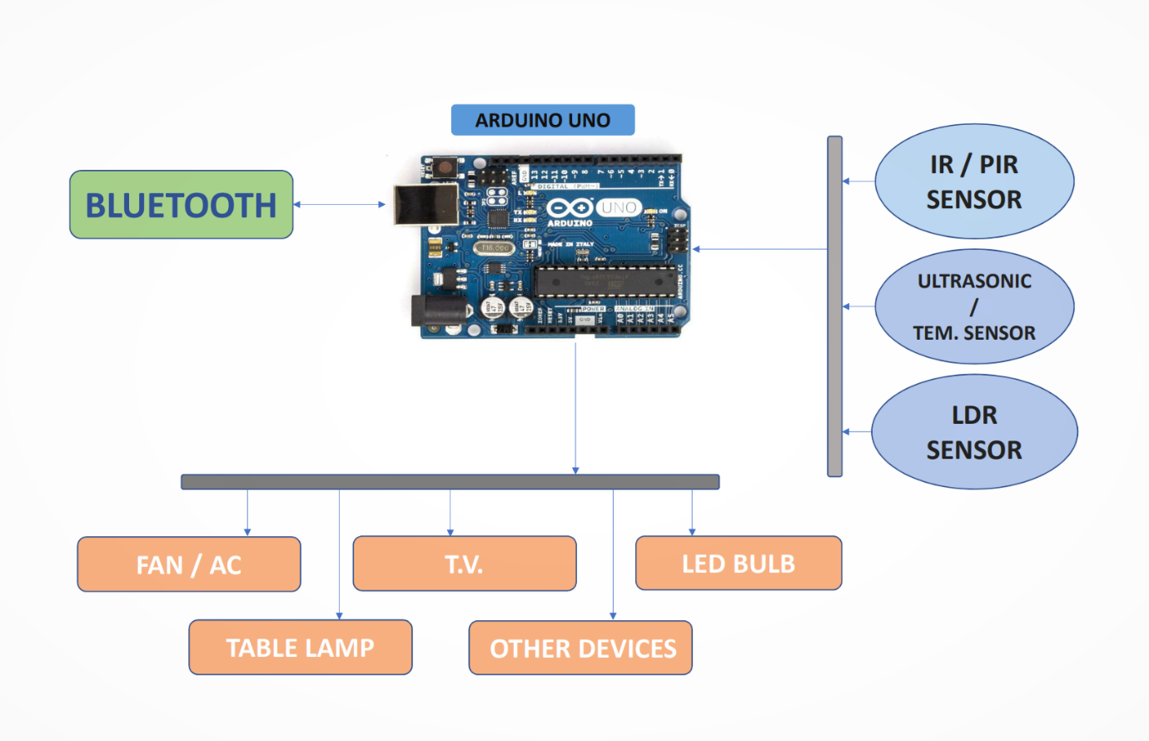
Figure 1:Architecture of Smart Home
The IOT architecture is made up of software programmes that communicate with hardware boards connected to home appliances over the internet. Every relay module acts as a switch for the devices in the home by being attached to one input output pin of the hardware board. The hardware board has a static IP address that we may use to access it or use a software programme to run any stored scripts. The sensors play the largest part in supplying the energy efficiency in IOT systems [6] as they are utilised to process or generate the relevant environmental data in real time needed for the systems. The hardware board can also be connected to sensors such as temperature and motion sensors for cameras, among others. Different hardware boards typically have separate input output pins, but some boards support the same input output pins that are utilised by smart home devices. Systems that can be implemented without the usage of sensors won't offer complete assistance. As a result of the data shared through a sensor network, the application of sensor technologies enables the measurement and evaluation of environmental indicators [7].
In this paper, Arduino acts as the brain, interpreting data from sensors and directing actuators to take specific actions in response to user or programmed conditions. Your preferences can be taken into account when integrating various components, which will increase the responsiveness of your home to your demands and improve your quality of life.
Important elements frequently used in Arduino-based home automation projects include:
1. Sensors: These collect data from the outside world, including temperature, humidity, motion, light levels, and more. The information required for making decisions throughout the automation process is provided by sensors.
2. Actuators: Actuators are machines that respond to commands from users or sensor input to perform actions. Examples include relays for managing appliances, motors for opening doors, and servos for manipulating drapes or blinds.
3. Communication Modules: You can incorporate communication modules like Wi-Fi, Bluetooth, Zigbee, or even GSM/3G/4G modules to provide remote control and monitoring. These enable remote control access to your home automation system via cellphones or other devices.
4. Microcontrollers (like Arduino): These devices process data from sensors, carry out preprogrammed logic, and manage actuators. Arduino is a well-liked option for creating home automation systems because to its simplicity of use and large community support.
5. User Interface: Creating a user interface allows people to engage with the home automation system, whether it be through a smartphone app, a web app, or a physical control panel. This interface enables you to remotely activate activities, change settings, and check the condition of devices.
6. Software: In order to define the characteristics of the home automation system, programming is necessary. Writing code to receive sensor data, make judgements, and control actuators is made simpler by the programming environment of Arduino, libraries, and frameworks.
The use of Arduino for home automation opens up a world of opportunities for designing a smarter, more effective, and more comfortable home. You may develop and deploy a personalised system that fits your lifestyle and tastes if you have the necessary technical skills and imagination.
2.METHODOLOGY
Planning, choosing hardware, programming, and testing are all steps in the process of building an Arduino-based home automation system.Home automation refers to a network of controllable devices that operate in concert to make your house more secure, comfortable, and efficient. The Arduino, Bluetooth module, Relay drivers, Android application, and stepdown transformer are the five essential components of this gadget. First, we power the step-down transformer, which reduces the input voltage and then supplies the Arduino with power via the VIN pin. The Arduino is also attached to the Rx and Tx pins of the Bluetooth module, which feeds information to the microcontroller. The information is read by the microcontroller and sent to the relay drivers, which serve as switches. We upload the programme to the Arduino according to the specifications, and it then executes various logical and mathematical operations to control the home appliances.

3.HARDWARE COMPONENTS

Arduino requires a variety of components to build a home automation system with a range of functionalities.

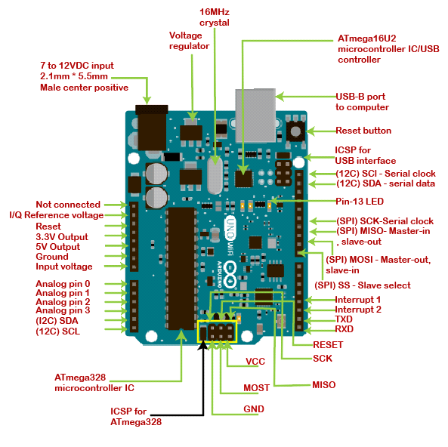
Figure 2: Hardware Components of Arduino
3.1 Sensors
- Temperature and Humidity Sensor (DHT11 or DHT22)
- Passive Infrared (PIR) Motion Sensor
- Light Sensor (LDR)
- Gas Sensor (MQ series for detecting gas leaks)
- Door/Window Contact Sensor (reed switch)
3.2 Actuators
- Relay Modules (for controlling appliances, lights, etc.)
- Servo Motors (for opening curtains, blinds, etc.)
- DC Motors (for controlling door locks, motorized windows, etc.)

3.3 Communication Modules
- Wi-Fi Module (ESP8266) for internet connectivity.
- Bluetooth Module (HC-05) for local communication.

3.4 User Interface
• Mobile App for managing and controlling your home automation system;
• Smartphone or computer for accessing a web-based interface
Power supply: You could need a reliable power source depending on the power needs of your components. You might utilise a mix of batteries, adapters, and power banks.
Relay Boards: To properly control higher-voltage appliances or devices, relay boards are used to connect low-voltage Arduino signals to them.
Breadboard and Jumper Wires:These are used for prototyping your circuit before moving on to a more permanent setup.
Cables and Connectors:Necessary for connecting components and modules together.
4. SOFTWARE REQUIREMENTS
4.1 Arduino Integrated Development Environment (IDE)
A condensed version of the C and C++ programming languages are the main languages used by the Arduino IDE. It offers functions and a syntax that are user-friendly for dealing with physical elements. Numerous operating systems, including Windows, macOS, and Linux, are supported by the Arduino IDE, making it usable by a variety of users. The Arduino board can interpret and execute the machine-readable instructions created by the IDE from the written code. You may test and debug your projects in real-time by using the IDE to upload your compiled code to the Arduino board over USB.
5. IMPLEMENTATION
Thanks to an Arduino-based Bluetooth home automation project, the user may control any electronic device using the gadget operate software on their Android smartphone. The Android app sends commands to the Arduino controller through Bluetooth wireless technology. Relays are capable of being connected to numerous electronic devices. According to the block diagram, Device 1 is a buzzer, Device 2 is a fan, and Device 3 is a pair of lights. When the user clicks the 'On' button on the device 1 app, the Buzzer is activated. To turn off the buzzer, push the same button one again. The user touches the 'On' button on the app for the device 2 to switch on the fan in a similar way. The fan can be stopped by pressing the same button one more. This home automation project uses an Arduino and Bluetooth to control any AC or DC item. The demonstration made use of a DC fan and a DC bulb. This DC fan and light is powered by a 9V battery that is fastened to it.
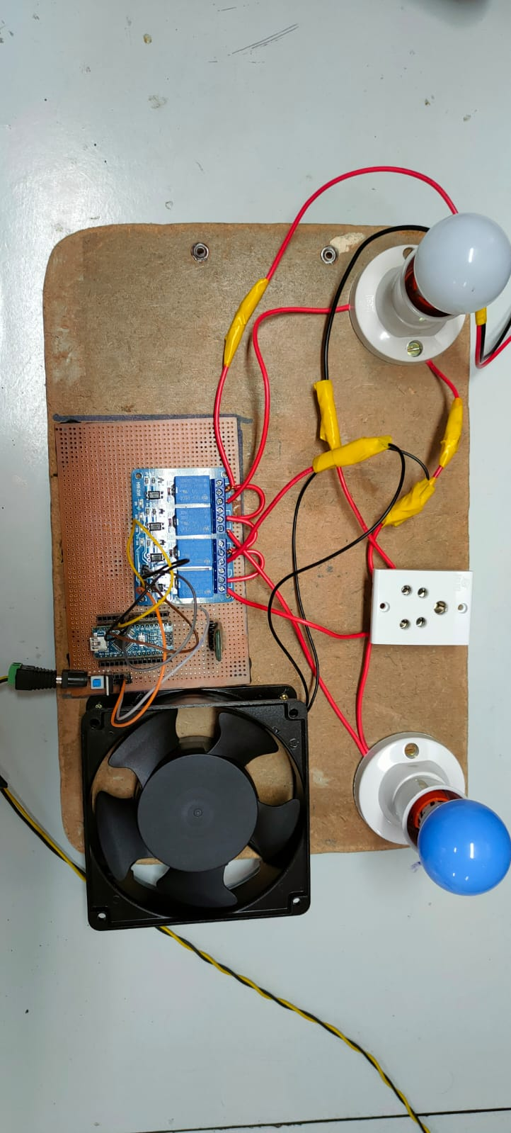
Figure 3: Design of Home Automation
ADVANTAGES: Home automation has a number of benefits that can improve your home's comfort, convenience, security, and energy efficiency. The following are some major benefits of home automation:
Convenience: Home automation makes it possible for you to remotely control a variety of appliances and systems in your house, frequently using a smartphone app. This eliminates the need to manually operate each item by allowing you to control your lighting, thermostat, security cameras, and more from anywhere.
Energy Efficiency: You may successfully manage your energy consumption with the help of many home automation technologies. Your heating, cooling, and lighting systems may all be scheduled and controlled to operate only when necessary. Over time, this may result in energy savings and lower electricity costs.
Security: By incorporating security cameras, motion detectors, doorbell cameras, and smart locks, home automation can improve the security of your house. Real-time property monitoring, alerts regarding possible security breaches, and even remote door locking and unlocking for guests are all possible.
Safety: By including features like smoke detectors, carbon monoxide detectors, and water leak sensors, home automation systems can also improve safety. You will receive an immediate alert if any potentially dangerous circumstances are found, enabling you to take appropriate action.
Remote Monitoring: You can watch over your house while you're gone thanks to home automation. You may view security camera feeds, keep an eye on the weather, and get notifications if anything out of the ordinary happens.
Time Savings: Automating repetitive tasks like controlling household appliances, lighting, and thermostats can save you time and lessen the mental strain that comes with doing these things by hand.
Reduced Wastage: By ensuring that devices are turned off when not in use, automation can assist decrease wastage. This is applicable to electrical appliances, lighting, and other energy-guzzling equipment.
6. CONCLUSION
The explanation above suggests that home automation is a unique category of technology that regulates household appliances. And in this article, we showed how home automation is developed, talked about how new technology may be used to lessen human labour, and created a specific kind of gadget that is small in size, inexpensive, has a high capacity, lasts a long time, and can receive signals from farther away. The technology that improves human lifestyle and conserves electricity. Home automation systems based on Arduino provide a flexible and affordable way to handle a variety of features, including lighting, temperature, security, and more.
7. FUTURE SCOPE
Due to the fact that hardware costs are not rising significantly, IOT-based solutions are actually thought to be low budget. This is the main reason it is currently being used in various industries because it gives consumers the option of automating any task. Smart home automation solutions improve people's quality of life and create a relaxing environment where they can unwind without worrying about accidents.
• The expansion of mobile platforms to IOS (iPhone operating System), as the majority of systems do not allow android applications because they do not receive complete platform support from hardware boards.
• A speech-to-text module can be integrated so that the user can engage verbally and fully comprehend the module.
• The addition of voice recognition technology is a potential new feature.
• Since security is the most important component of any module, a low-cost camera with facial recognition functionality can be included for that purpose. This will increase security.
• This system may benefit greatly by the addition of a sensor like a heartbeat sensor, which could be used to check the patient's heartbeat in an emergency.
• Machine learning algorithms that monitor a person's activity and sleep patterns can be used to advise ways for that user to improve their lifestyle.
• Future IOT sensors will need to be more secure in order to fend off cyberattacks. This can be done by incorporating security features into the hardware and software stack of IOT sensors as well as by adding additional layers of security, such as private keys and random number generators, to deter hackers from breaking into the network.
• Additional features can include temperature control and appliance power monitoring.
• Adding a GUI interface could increase interest in the project.

REFERENCES

- BN, D. L., & Ashwini, N. (2023). Smart Home Automation Using IoT. Journal of Scholastic Engineering Science and Management, 2(3), 78-87.
- Sirsath, N. S., Dhole, P. S., Mohire, N. P., Naik, S. C., & Ratnaparkhi, N. S. Department of Computer Engineering, 44. Vidyanagari, Parvati, Pune-411009, India University of Pune,“Home Automation using Cloud Network and Mobile Devices.
- Vikram, N., Harish, K. S., Nihaal, M. S., Umesh, R., & Kumar, S. A. A. (2017, January). A low cost home automation system using Wi-Fi based wireless sensor network incorporating Internet of Things (IoT). In 2017 IEEE 7th International Advance Computing Conference (IACC) (pp. 174-178). IEEE.
- Puri, V., & Nayyar, A. (2016, March). Real time smart home automation based on PIC microcontroller, Bluetooth and Android technology. In 2016 3rd International Conference on Computing for Sustainable Global Development (INDIACom) (pp. 1478-1484). IEEE.
- Kodali, R. K., Jain, V., Bose, S., & Boppana, L. (2016, April). IoT based smart security and home automation system. In 2016 international conference on computing, communication and automation (ICCCA) (pp. 1286-1289). IEEE.
- Bedi, G., Venayagamoorthy, G. K., & Singh, R. (2016, December). Internet of Things (IoT) sensors for smart home electric energy usage management. In 2016 IEEE International Conference on Information and Automation for Sustainability (ICIAfS) (pp. 1-6). IEEE.
- Tseng, S. P., Li, B. R., Pan, J. L., & Lin, C. J. (2014, September). An application of Internet of things with motion sensing on smart house. In 2014 International Conference on Orange Technologies (pp. 65-68). IEEE.

