Assessment of Judicial Interventions on Legal Issues Pertaining to
Mental Health in India after 2017
Dr. Sarvesh shahi Ms. Anantyoya Chatterjee
Assistant professor Student, BA LLB, 4th year
School of Law, KIIT, Bhubaneswar, Odisha School of Law, KIIT, Bhubaneswar, Odisha
E-mail: sarvesh.shahi@kls.ac.in E-mail: anantyoya.456@gmail.com

ABSTRACT
The present paper primarily describes the nature of mental illnesses prevailing in society and investigates the reason for it. The purpose is to inquire about the problems faced by mentally ill people in approaching the right forum and how the working legislations have pointed out the plights of them. It further investigates the factors responsible for the sufferings and how the matter has been placed before higher courts after the making of special legislation termed as Mental Healthcare Act, 2017 and disposed of by the Indian judiciary. The authors have scrutinized the observations of court and tried to bring out valuable suggestions on the legal solutions for the sufferers.

- Introduction:
Mental Health Care is the current need of the hour, no matter in which state, country or origin we reside in. Shri Ram Nath Kovind, the 14th and former President of India, issued an advisory in December 2017 about a looming psychological health catastrophe in the country. Research, surveys, and analysis are necessary to examine the implementation and impact of the Mental Health Care Act, 2017, which was developed and revised to raise awareness about mental health. However, despite its existence on paper, it appears that this awareness has not yet translated into meaningful action among the general public. The Mental Healthcare Act of 1987 was superseded by the MHA of 2017, which prioritized institutionalization of mentally ill people over the rights of those who were suffering from the condition. Psychiatrists had to get licenses under the 1987 Act, which imposed onerous standards. As in relation to physical health, social welfare, mental health differs from it in the most distinct way as possible. With the under-staffed psychologists and psychiatrists in India, lack of research and awareness in rural areas and working sector, various taboos associated with it, mental health poses significant risk to the lives of people whose opinions and concerns remain bottled up. It is necessary to address the ratios of this developing dementia in the minds of society and apply more research and awareness for the development of the overall well-being of the person as a whole.
- Objective Of The Paper:
The paper highlights the lack of awareness among people regarding mental health issues and the general taboos associated with being mentally ill. These issues can hinder the effective implementation of the Mental Health Care Act, 2017, making it difficult for mental health patients to get the proper care and support they need. The paper discusses the concerning mental health statistics in India, specifically in relation to the COVID-19 pandemic. It provides an overview of the current issues and constraints of the Mental Health Care Act of 2017, and includes relevant court rulings to aid in better comprehension of the legal framework. Overall, the paper raises important concerns about the need for greater awareness and understanding of mental health issues in society, and the importance of implementing policies and programs that can support mental health patients.
- Literature Review:
Globally, the allocation of health and medical treatment is rife with injustice. The World Health Organization said in January 2017 that the "right to health" is realized in "certain ways" by legislation. According to Cambridge University Press, depression is the primary determinant of disability globally and accounts for around 800,000 suicide deaths annually. Despite these statistics, many low-income nations report that 75% of those suffering by mental illness do not have access to therapy.
Section 20 of the 2017 Mental Health Care Act describes various rights that individuals with mental disorders have. Among these rights is the right to protection from cruel and degrading treatment in mental health facilities. In other words, mental health facilities should ensure that they treat individuals with mental disorders humanely and respectfully, and do not subject them to any form of mistreatment or abuse. In these facilities, torture-related deaths have also been documented. At least two additional pieces of law provide the government the authority to take action to control such centre by issuing notifications of regulations and enforcing them. These laws include the Clinical Establishment Act (CEA), 2010, and the Narcotic Drugs and Psychotropic Substances (NDPS) Act, which was passed in 1985. However, the Act's existing system leaves room for interpretation as to which types of SUD would be covered by the 2017 MHCA. Until individuals with SUD may extract value from the legislation and prevent any difficulties that can arise, the Act has to be appropriately changed, or guidelines need to be developed resolve the background knowledge. It is already a tiny win that the IPS and MHCA contributed to the historic decision that invalidated section 377 of the IPC. The IPS conceptualized, tested, and wrote the MHA in 1987. However, IPS was not considered while the new MHCA 2017 was being written. The IPS was not given any meaningful responsibility in the creation of the new legislation, although being requested to participate in the deliberation at several points. The Mental Healthcare Act 2017 in India is designed to bring significant changes to how psychological health issues are treated, as the country has a large population and is rapidly growing. The current punitive model will be replaced by a caregiver model, which will focus on health promotion, readmission, and therapy. However, to ensure the success of the new model, it is crucial to revisit and improve these areas. The effectiveness of the Act can only be evaluated after it has been implemented. Therefore, we should wait and observe the execution of the new model before forming a definitive opinion. Because individuals with psychological illnesses might not always be able to live independently, mental illness differs greatly from physical well being. According to the study on the international impact of illness, decades spent with impairment associated with depression are the main source of psychological disorders, accounting for 13% of all victims living wasted years. With the introduction of COVID, this has grown dramatically over time.
A little over 40% of nations are devoid of any support systems, and 64% are devoid of any psychiatric laws or have laws that are more than ten years old. Even where there are psycho-social regulations and legislation, many of them prioritize locking up persons with mental disorders in mental hospitals while failing to adequately protect their civil dignity. Rawl's concept has great involvement here. The core of Rawls' explicit articulation of his interpretation of a social compact is this resort to interaction justice. Second, Rawls emphasizes the significance of public opinion as a limitation on conceptions of justice. The court's fundamental precepts and the reasons behind them must be openly recognized. The requirements that constitute responsibility for fairness revolve upon this restriction. Last but not least, Rawls advances the idea that "rationality" must restrict the substance of public discussions and choices regarding fundamental issues of justice, eliminating specific considerations that could be components of peoples' all-encompassing moral philosophies (Rawls 1993). Judgment are pushed to provide justifications that everyone can agree are pertinent to the objectives of collaborative primary healthcare schemes by the responsibility for rationality. In this manner, the democratic discourse that Rawls also supports is promoted by oversight for fairness. Despite having lower per capita GDPs than the United States, wealthy nations with more equitable cash dividends like Sweden and Japan enjoy longer average life expectancy than the US. Likewise, nations like Costa Rica that possess a low GDP but a remarkable long life expectancy tend to exhibit a more fair wealth inequality.
- Awareness Of Mental Health In India:
The COVID-19 pandemic has caused a notable effect on mental well-being globally, and India is no exception. There have been some recent advancements in the field of mental health in India since 2020.
- Mental Health Helplines: India has set up various helplines to offer mental health assistance to those affected by the pandemic. One such helpline is the national toll-free helpline (080-4611 0007) launched by the Ministry of Health and Family Welfare in April 2020. It provides psychological counselling and support to individuals impacted by the pandemic. In addition, guidelines were issued by the Ministry of Health and Family Welfare in April 2020 for telemedicine services in India, which also included guidelines for tele-consultation for mental health services. This has made it convenient for people to access mental health services remotely.
- Focus on Mental Health of Frontline Workers: The pandemic has highlighted the mental health challenges faced by frontline workers, including healthcare workers and essential service providers. As a result, there has been increased attention on providing mental health support to these workers, including through dedicated helplines and counselling services.
- Online Mental Health Services: There has been a significant increase in the availability of online mental health services in India after 2020. Many mental health professionals and organizations have started offering online counselling and therapy services to help people cope with the pandemic-related stress and anxiety.
To prioritize mental health, the Insurance Regulatory and Development Authority (IRDAI) has instructed insurance firms to include coverage for mental illness. This is particularly important during the ongoing Covid-19 pandemic. Insurance companies must adhere to the guidelines of the Mental Healthcare Act, 2017 and make sure to provide coverage for mental illnesses without any deviation by October 31, 2022. This means that from November 2022 onwards, all health insurance policies should cover mental illness. The NHRC has issued notices to the heads of 46 government mental healthcare institutions across India for the unacceptable conditions and handling of mentally ill patients, which the commission believes is a violation of their human rights NHRC members and special rapporteurs visited hospitals to assess the execution of the Mental Healthcare Act of 2017.The NHRC found that cured patients were being illegally detained in hospitals and that there was a lack of medical professionals and staff. The Union health and family welfare secretary and directors of the mental health institutions have been given six weeks to submit action taken reports, including an explanation as to why cured patients were being detained illegally in mental hospitals. The Mental Healthcare Act of 2017 aims to protect and improve the rights of individuals who are experiencing mental illness. This action by the NHRC highlights the need for the proper implementation of the act and improvements to mental healthcare services across India.
The COVID-19 pandemic has caused mental health to become a prominent issue in India, resulting in a greater focus on and allocation of resources towards mental health services.
- Current Evaluations:
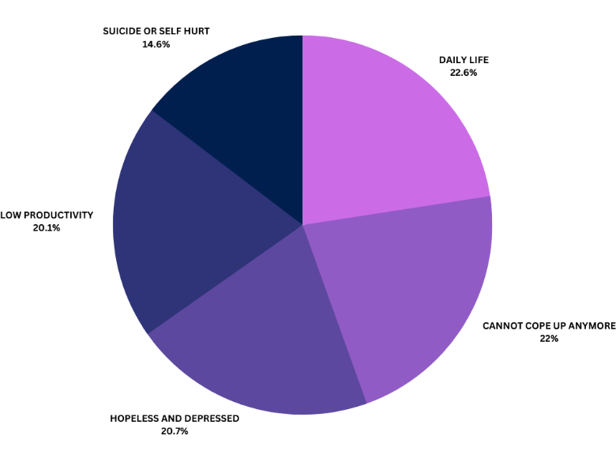
Image 1: Mental Health Care Implications On A Normal Person’s Life
According to a poll by HR solutions supplier Genius Consultants, 77% of employees feel that stress at work has a negative impact on their mental health, causing tension, anxiety, and despair. stated 82% of the participants agreed that stress at work is a direct cause of health problems such as gastrointestinal illnesses, musculoskeletal disorders, and immune system disorders. The research is based on a poll of 1,380 workers from various industries conducted from September 5 through October 15, 2022. The COVID-19 pandemic and the resulting economic downturn have adversely affected the mental health of many individuals, especially those already struggling with mental illness and substance abuse. In India, there is a significant burden of illness, with an estimated 2443 per 100,000 people, and the suicide rate, adjusted for age, is 21.1 per 100,000 people, according to WHO's assessments. To rephrase it, the WHO's evaluations indicate that India has a high prevalence of disease, with 2443 out of 100,000 individuals affected, and a suicide rate of 21.1 per 100,000 people, adjusted for age, reflecting the negative impact of COVID-19 on mental health in the country. One in seven Indian youths aged 15 to 24 report experiencing frequent depression or low levels of interest in activities. UNICEF suggests that the COVID-19 pandemic could have enduring impacts on the mental health and overall well-being of children and young individuals. With the disruptions in their daily lives, educational pursuits, and recreational activities, many young people are experiencing fear, anger, and anxiety regarding the physical health and financial security of their families.
According to the World Happiness Report of 2021, mental health has been heavily impacted by the pandemic and subsequent lockdown measures. The most severely impacted groups are women, young people, and the impoverished, which exacerbates already-existing disparities in mental health. Given their lower socio - economic status than males, a greater weight of everyday duties, and a stronger involvement in maintaining food availability, women are more likely to have mental health issues, as well as heightened stress and worry. During the epidemic in India, 66% of women and 34% of males reported feeling stressed or anxious.
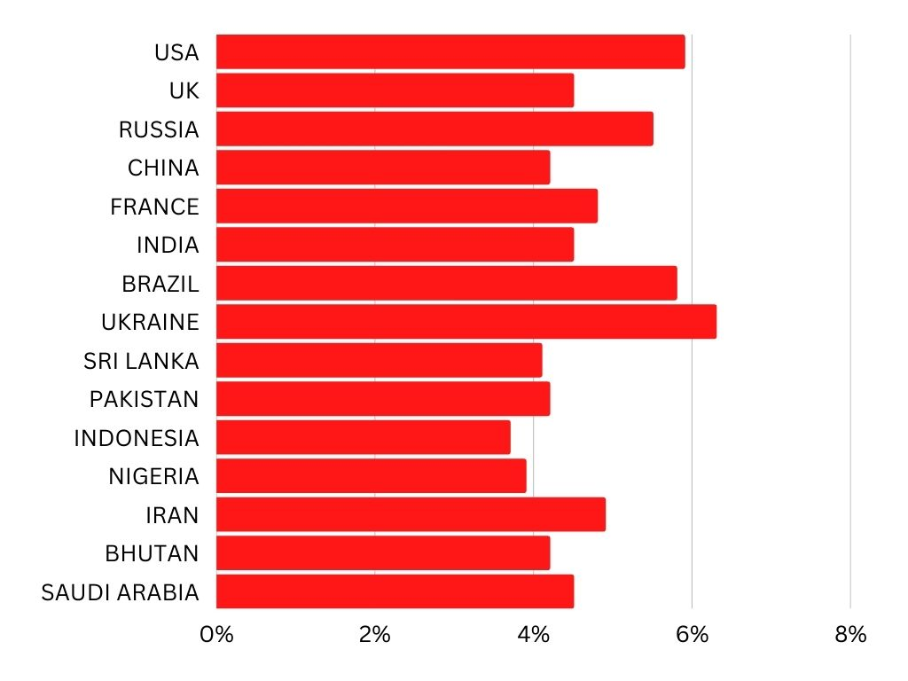
Image 2: Country-wise classification of “Depression” in %
Pregnant women and new moms are undoubtedly more apprehensive during the COVID-19 crisis because of possible barriers to services and societal care as well as fear of infection. This detrimental effect may prolong the current epidemic and further intensify the mental health crisis. The Mental HealthCare Act of 2017 ensures that government-managed or sponsored programs provide mental healthcare and therapy to all individuals who require it. This guarantees that everyone who needs mental healthcare has access to it. The Indian government has made significant changes to the application of Section 309 IPC, limiting punishment for attempted suicide to certain circumstances. In 2020, the Ministry of Social Justice and Empowerment established a toll-free helpline called "Kiran" to provide support for individuals dealing with mental health issues such as anxiety, stress, depression, and suicidal thoughts. The Ministry of Education's Manodarpan Initiative is a program designed to offer psychological assistance to students, families, and teachers affected by the Covid-19 pandemic. To promote mental health among all age groups, the Indian government launched the MANAS Mobile App in 2021, which was approved as a national initiative by the Prime Minister's Science, Technology, and Innovation Advisory Council (PM-STIAC).
In a May 2022 study in India, Rakuten Insight found that 58% of respondents in the 35 to 44-year-old age range reported that they were purposefully trying to improve their mental wellness. In the same study, 32% of those who were 55 years of age and older reported that they were hardly perusing mental well-being. According to the WHO, the psychological health sector in India is inadequate, with a significant deficit of psychiatric doctors and psychologists in the nation in comparison to the number of individuals living with mental health concerns. The World Health Organization (WHO) reports that in India, there are very few mental health professionals available, with only 0.3 psychiatrists, 0.12 nurses, 0.07 psychologists, and 0.07 social workers per 100,000 people. Ideally, there should be at least 3 psychiatrists and psychologists per 100,000 people. Unfortunately, in India, there are 56 million people who experience depression, and another 38 million who suffer from anxiety, highlighting the significant shortage of mental health professionals in the country. Infants and toddlers should not be taken from their mothers unless there is a danger towards the kid, according to a fresh rule developed by MHCA. It can be difficult to keep a mother and a small kid together in a hospital setting, notably in mental care settings. The young patient can be at danger from other troubled individuals. Mother-baby units in mental inpatient hospitals are not recommended by the MHCA in this respect. Meeting the Sustainable Development Goals [SDGs] requires multidisciplinary and trans-disciplinary approaches since psychological health is so important. The WHO advised nations to include specific funding for psychological therapies in their national recovery and response strategies plans in order to maintain their mental health support during the epidemic. The WHO has initiated a program called Special Initiative for Mental Health with the aim to provide better mental healthcare to everyone as part of universal health coverage, and to ensure that no one is excluded from accessing these services.
- History And Summary Of The Mental Health Care Act, 2017:
The Mental Healthcare Act 2017, which was passed by the Lok Sabha on March 27, 2017, after being approved by the Rajya Sabha in August 2016 and the President of India in April 2017, defines "mental illness" as a significant disturbance in thinking, mood, perception, orientation, or memory that severely affects judgment or ability to cope with daily life. This new law replaces the Mental Healthcare Legislation of 1987, which was criticized for failing to recognize the rights of mentally ill individuals and allowing for their isolation. Section 309 of the Indian Penal Code, which criminalizes self-harm by individuals with mental illness, is also repealed by this act.
Another notable aspect of this law is the protection of the rights of those who suffer from mental illness, easing their access to care and allowing them to express their preferences for therapy beforehand. The act legalizes attempted suicide by a person who is mentally ill. Additionally, it places a responsibility on the government to assist in the rehabilitation of that individual to prevent future suicide attempts. Despite the administration of pain medication and anaesthetic, electro - convulsive treatment (ECT) treatment is not permitted for those who have mental illnesses. Additionally, children will not receive ECT treatment. The Mental Healthcare Act of 2017 aims to provide mental healthcare services to individuals with mental illnesses and safeguard their rights to lead a dignified life by shielding them from any form of mistreatment and prejudice. According to a report by the World Health Organization, the economic cost resulting from mental health issues in India from 2012 to 2030 is estimated to be 1.03 trillion dollars in 2010 currency. According to the World Health Organization, the funding for the National Mental Health Programme has decreased from Rs 50 crore in the previous year to Rs 40 crore for 2019-20, despite having an overall healthcare budget of Rs 61,398 crore. Section 2(s) of The Mental Health Act does not cover developmental delays, but it does include symptoms linked to alcohol and drug abuse. The Act acknowledges that mental illness is a medical condition that requires medical treatment and professional assistance. However, it fails to address the essential aspect of promoting mental well-being awareness and prevention. In accordance with the proposed "advance medical directive," people can specify how they "want to be" and "desire not to be treated" and can choose a close relative to act for them in the event that they lack their cognitive capacity. However, it is not able to offer a detailed preparation method.
- Judicial Pronouncements:
In Sairabanu Mohammed Rafi v. State of T.N., the Madras High Court designated the wife as the partner's guardianship in order to manage his real estate and bank accounts. The spouse was unconscious. The Court noted that in this scenario, there is no legal mechanism for the appointment of a guardian. The petition might have used a legal system remedy to contact the court of law, the judge further said. By the way, the Supreme Court took into account the advanced MHA laws when it rendered its historic decision in Navtej Singh Johar v. Union of India (2018) to decriminalize homosexuality in India. Justice Indu Malhotra's decision affirms that under Sections 18(1) and (2) along with 21(1)(a) of the Mental Healthcare Act, 2017, individuals have the right to receive psychiatric care and equivalent treatment for their illnesses without any discrimination, including on the basis of "gender identity". This means that all individuals should have access to mental healthcare services regardless of their gender identity, and they should receive equivalent treatment without any bias or unequal treatment. Justice D.Y. Chandrachud, in his ruling, acknowledged the mental health challenges faced by the LGBTQIA+ community and emphasized that bias, shame, and discrimination continue to have a detrimental impact on the psychological well-being of individuals affected by Section 377 of the Indian Penal Code.The Supreme Court took into account international psychiatric scholarship that demonstrated a direct link between societal and political contexts and a patient's mental wellbeing and that regulations that target LGBTQIA+ people for persecution increase rates of depression, anxiety, self-harm, as well as suicide. In addition, Justice Malhotra pointed out that LGBT people face significant disadvantages and discrimination while trying to obtain medical facilities. Individuals in this category have major health problems as a result, include depression and suicidal thoughts.
Similar to this, in Ravinder Kumar Dhariwal v. The Union of India (2021), the Supreme Court addressed the great significance of eradicating the burden of mental wellbeing. Several grassroots organizations point the way, including the Blue Dawn organization founded by journalist Divya Kundukuri, which promotes and supports accessible mental healthcare treatments for underserved populations. The Hon'ble Court determined in the case of Devidas Loka Rathod v. State of Maharastra that culturally abnormal conduct and disputes which mainly involves the person and community really aren't mental diseases unless they are caused by a breakdown in the subject. the International Classification of Diseases (ICD), which is recognized under Section 3 of the Mental Health Care Act of 2017, as "severe mental illness." There don't seem to be any predetermined diseases or impairments for assessing "severe mental illness," but a "test of severity" may serve as a key criterion for identifying those psychological disorders which qualifies for an exclusion.
Subhash Chandra Bose and Others are defendants in the case C.E.S.C Limited v. Indian- Supreme Court held that countries all across the world are looking for workable solutions to the problem of how to provide health care for their population. The World Health Organization (WHO) defines health as more than just the absence of disease or physical weakness. It encompasses a holistic state of well-being that includes mental, spiritual, social, and physical aspects. Access to a healthy environment and well-being is considered a fundamental right and a vital necessity. Sections 5 and 23 of the Mental Health Care Act, 2017, to be interpreted with such a ruling made by the Hon'ble Supreme Court in Justice K.S. The Mental Health Care Act, 2017 should be understood in conjunction with a ruling by the Supreme Court in the case of Justice K.S. Puttaswamy (Retd.) vs. Union of India & Ors. Furthermore, it has been argued that only doctors at IHBAS should have access to information regarding the child's treatment and illness.
‘X’ v. State of Maharashtra– Indian Supreme Court ruled that now the defendant must have "knowledge" of the offense he or she perpetrated as well as having "communicated" the reason for the capital punishment under Article 20(1) of the Indian Constitution. Consequently, the reason of the sentence is compromised if it is discovered that an individual really does have a psychiatric illness guilty that hinders people from understanding the reason for his death. According to the Judge, no inmate who already has received a sentencing to death has to undergo the same if his mental ability fails to reason with him on the reason of him receiving such sentence. The fundamental purpose of imposing the sentence in the initial situation is defeated by such incompetence. The Supreme Court emphasized that establishing fear is among the most crucial aspects of imposing a capital punishment. Following an accused person's conviction in Bachan Singh v. State of Punjab, his punishment will be determined by putting into account all relevant severe and extenuating circumstances. When the court has already taken into account the exacerbating and contributing factors, it makes no sense to include post-conviction mental disorder as a contributory circumstance because it only becomes apparent after the sentence has been given. It is more accurate to classify post-conviction mental illness as an admissible "commuting factor" ahead of the execution. The Judge noted that if a mental examination of such plaintiff is conducted well before the last entries have become progressed, it will aid the Court. This opinion was made in the context of the recent judgment in Manoj v. State of M.P., wherein the Court enforced that the Trial Courts obtain psychiatric and psychological assessment document of the suspect before appointing the capital punishment.
- Conclusion:
The Mental Health Care Act, 2017 has indeed developed significantly over the years and had great implications in Indian Judiciary and also Law and Order of the society. Even though Mental health as a subject itself has a long way to actually get effectively implemented and put forth, Indian cases and The Mental Health Care Act, 2017 have aided to a large extent possible in order to achieve the goal and there is still a long way to go. The minute details in judgements viewing and aiding the efficiency of mental health services all over India is a huge appraisal in concern with the nation which holds one of the largest population all over the world. Furthermost, the responsibility of the legislature in the amendment of the Act and succeeding to it, the development it has led in the society is yet an issue to be addressed because of the large gap in the black and white letters of law and the actual implementation and awareness of the Act and the importance of “Mental Health” itself. The legislature and the judiciary seem to run together but the society lacks far behind which remains a grave concern. Most cases are such that there along with being lack of doctors, even the patients are unaware that they are victims of certain mental health issues and choose to deny it because of general taboos of being called “mentally-ill” or “mentally-retarded”. Hence, further decreasing the effective implementation of The Mental Health Care Act, 2017. The general taboos going around is talking to friend or parents and the least no. of mental health patients are concerned with the visiting a psychiatrist or a psychologist or doing any kind of physical well-being activity to actually help improve their mental state, further being a menace to the proper utilization of the aforementioned act.

Lynn Chan, Mental Health in Asia: The Numbers, OUR BETTER WORLD, (Accessed on April 5, 2023)
Richard M. Duffy and Brendan D. Kelly, The Right to Mental Healthcare: India Moves Forward, 214(2) THE BRITISH JOURNAL OF PSYCHIATRY, 59–60 (2019).
Galhotra, Abhiruchi, and Abhisek Mishra, Mental Healthcare Act 2017: Need to Wait and Watch., 8(2) INTERNATIONAL JOURNAL OF APPLIED AND BASIC MEDICAL RESEARCH, 67 (2018).
V. Patel & Kleinman A, Poverty and common mental disorders in developing countries, BULL WORLD HEALTH ORGAN 609‐615 (2003).
Global, regional, and national incidence, prevalence, and years lived with disability for 301 acute and chronic diseases and injuries in 188 countries, 1990‐2013: A systematic analysis for the global burden of disease study 2013, 386(9995) GLOBAL BURDEN OF DISEASE STUDY 2013 COLLABORATORS, 743‐800 (2015) .
Pooja Sharma, Ankita Singh & Dipanjan Bhattacharjee, Human rights of people with mental illness: Provisions made in mental healthcare act 2017,INDIAN JOURNAL OF PSYCHIATRY SOCIAL WORK, (2020).
Norman Daniels,Justice, Health, and Healthcare, HEIN ONLINE, (Accessed on April 5, 2023)
77 pc employees think work-related stress can induce anxiety, depression: Report, THE ECONOMIC TIMES. (Accessed on April 5, 2023)
The Implications of COVID-19 for Mental Health and Substance Use, KFF. (Accessed on April 5, 2023)
Mental health and the COVID-19 pandemic, THE WORLD HAPPINESS REPORT, (Accessed on April 5, 2023
Depression Rates by Country 2022, WORLD POPULATION REVIEW, (Accessed on April 5, 2023)
#HealthyAtHome - Mental health, WORLD HEALTH ORGANISATION, (Accessed on April 5, 2023)
Mental Healthcare, DRISHTI IAS, www.drishtiias.com/to-the-points/Paper2/mental-healthcare.
World Mental Health Day 2020: In Numbers, The Burden of Mental Disorders in India,SWACHH INDIA:NDTV (Accessed on April 5, 2023)
Eesha Sharma & John Vijay Sagar Kommu, Mental Healthcare Act 2017, India: Child and Adolescent, 61(4) INDIAN JOURNAL OF PSYCHIATRY, 756-S762, (2019) x
Galhotra, Abhiruchi, and Abhisek Mishra, Mental Healthcare Act 2017: Need to Wait and Watch, 8(2) INTERNATIONAL JOURNAL OF APPLIED AND BASIC MEDICAL RESEARCH, 67 (2018).
Rajeev Satav, The Gaps In Mental Healthcare Act, LIVE MINT, (Accessed on April 5, 2023)
Navtej Singh Johar v. Union of India (2018) 10 scc 1
Ravinder Kumar Dhariwal v. The Union of India 2021 SCC OnLine SC 1293
Devidas Loka Rathod v. State of Maharastra AIR 2018 SC 3093
C.E.S.C Limited v. Indian (1992) 1 SCC 441
Justice K.S. Puttaswamy (Retd.) vs. Union of India & Ors (2017) 10 SCC 1
‘X’ v. State of Maharashtra (2019) 7 SCC 1
Bachan Singh v. State of Punjab AIR 1980 SC 89
Manoj v. State of M.P. 2022 SCC OnLine SC 677

