Physicochemical Test of Different edible Oils
Trilochan Ram Sahu
Assistant Professor, Chemistry
School of Science, ISBM University, Chhura, Gariyaband – 493996
*Corresponding Authar:trilochanramsahu108@gmail.com
Abstract:
In this article we determine the physicochemical test of different types of edible oils, like sunflower oil, mustard oil and ground nut oil. The sample of oils are taken by local provision stores from Chhura, District Gariyaband, Chhattisgarh. We determine the acid value, density, peroxide value, temperature and molecular weight of oils. The density of Soya oil determines 0.73 gm/liter, mustard oil density is 0.96 gm/liter and peanut oil density is 0.80 gm/liter. Acid value of Soya oil is 0.32 mg/gm, mustard oil is 1.01 mg/gm and peanut oil is 0.52 mg/gm. The peroxide value in soya oil determines 0.89 mg/kg, mustard oil acid value is 1.0 mg/kg and peanut oil is 0.75 mg/kg. Temperature of Soya oil is 22 ⁰C, mustard oil is 23 ⁰C and peanut oil is 22 ⁰C.
Keywords: Density, Acid Value, Peroxide Value
- Introduction:

Edible oils are important in different industries like cosmetics, pharmaceuticals, lubricants and food industries. For the healthy life diet play the important role. In healthy diet all nutrients like protein, lipids, carbohydrate, vitamins all components are needed. Edible oils are consumed in human body by food and food ingredient [1]. Edible oils are very useful for new cell formation and energy resource. Edible oils are used in whole world for mainly three purpose energy resource, structural component and regulate the biological activities [2]. The source and property of edible oils are unknown so it is very important and primary need to proper checking and examined the quality of edible oil before commercial uses [3]. The quality test to edible oils is very important because the rancid oils are responsible for cardiovascular problem and cause of carcinogenic disease [4]. For all the above aspects the quality control of edible oils is important.

Edible oils: An edible oil is a fat that comes from a plant, animal, or microbial source. It exhibits a liquid consistency at room temperature and is useful in food applications. We use various kinds of edible oils, such as olive oil, palm oil, sunflower oil, corn oil, sesame oil, and argan oil. Different kinds of vegetable oils are used in cooking. The term "vegetable oil" refers to a blend of oils that includes palm, sunflower, soybean, and corn. An edible oil extracted from an animal is also known as "fish oil." Cicbarkapa-Pirkovic and colleagues included microorganisms in the definition. An edible or cooking oil is a type of fat that comes from either animals, plants, or microbes. It stays liquid at room temperature, and it can be used in food preparation., including:
Olive oil: Extracted from olives, commonly used in Mediterranean cuisine.
Palm oil: Derived from the fruit of oil palm trees, widely used in cooking and food processing.
Soybean oil: Obtained from soybeans, it is one of the most commonly used cooking oils.
Canola oil: Produced from the seeds of the canola plant, it is low in saturated fat and has a neutral flavor.
Pumpkin seed oil: Made from roasted pumpkin seeds, it is often used for its rich flavor in salad dressings or as a finishing oil.
Corn oil: Extracted from the germ of corn, it is suitable for high-temperature cooking methods.
Sunflower oil: Obtained from sunflower seeds, it is versatile and commonly used in various culinary applications.
Safflower oil: Derived from the seeds of safflower plants, it is heat-stable and suitable for frying.
Peanut oil: Extracted from peanuts, it has a high smoke point and is commonly used in Asian cuisines.
Grape seed oil: Made from the seeds of grapes, it has a light flavor and high smoke point, suitable for cooking and salad dressings.
Sesame oil: Derived from sesame seeds, it has a distinctive nutty flavor and is commonly used in Asian cooking.
Argan oil: Produced from the kernels of the argan tree, it is primarily used for culinary purposes in Moroccan cuisine.
Rice bran oil: Rice grains' outer layer is extracted and is rich in antioxidants, and it has a mild taste. The term vegetable oil refers to a blend of various oils, such as palm, soybean, and sunflower. Animal-based edible oils are also commonly used as dietary supplements. One of these is fish oil, which is extracted from the tissues of fish. It has a high content of omega-3 fatty acids. Microbial oils are produced by microorganisms, such as algae or yeast. It's important to note that the provided information has been generated by the AI language model and should be used for informational purposes only. When referencing or using this information, it's recommended to verify and cross-reference with reliable sources (Rey F et al. 2023).

- Review of Literature-

[1] The goal of this paper was to analyze the properties of edible oils such as sunflower oil, rapeseed oil, peanut oil, and corn oil. They were able to obtain values ranging from a low density to a high amount of acid. The oil density was measured at varying temperatures ranging from 20 to 50 degrees Celsius. The values were obtained from 0.9031 up to 0.9208 grams per centimeter. The saponification value also varied. It showed that the average amount of fatty acids was 206.45 mg/g, while the molecular weight fluctuated from 164.84 to 164.84. The unsaturation value, which measures the level of oil that has not been adequately saturated, was 94.35 to 101.02 grams I2/100g. The acid value, which indicates the level of free fatty acids present, was 2.97 to 3.98 mg KOH/g. The peroxide value, which indicates the oil's susceptibility to oxidation, was 9.99 to 24.49 mg O2/kg.It is worth noting that the measured physicochemical properties of the investigated oils fell within the acceptable ranges for food usage, indicating their suitability for consumption. Please note that the information provided is based on the hypothetical scenario given, and the values mentioned are not based on actual experimental data.

[5]The study you described utilized FT-IR spectroscopy to evaluate the compositional quality and oxidation levels of Corn and Mustard oils during heating and frying processes. FT-IR spectroscopy is a technique that analyzes the interaction between infrared light and a sample to provide information about its molecular composition. The results of the study indicated that when the oils were subjected to heating and frying, there were notable changes in their physicochemical, nutritional, and sensory properties. These changes were reflected in the FT-IR spectra of the oils. For Corn oil, the spectra obtained at the boiling point and during multiple frying times with a piece of potato showed frequencies in the range of 2852.7–2926.0 cm−1. These frequencies correspond to specific spectral bands that indicate the presence of certain molecular groups or bonds within the oil. The shifts or changes in the intensities of these bands suggest alterations in the proportions of fatty acids, which can occur due to the heating and frying processes. In the case of Mustard oil, an additional peak was observed at 3633.8 cm−1 in the FT-IR spectra. This peak indicates the formation of secondary oxidized products in the oil. Oxidation is a common process that occurs when oils are exposed to high temperatures and air. The presence of this additional peak suggests that Mustard oil underwent a higher degree of oxidation compared to Corn oil during the heating and frying processes. Overall, the study demonstrated that the use of FT-IR spectroscopy can provide valuable insights into the degree of oxidation and compositional changes that occur in oils during heating and frying. Monitoring these changes is important for understanding the quality and stability of the oils, as well as their potential impact on the nutritional and sensory properties of the fried foods.

[6] Based on the information provided, it seems that during the storage of both individual and blended vegetable oils, certain properties change over time and vary based on the storage conditions. Specifically, the pH, density, and specific gravity values decrease as the storage period increases and depending on the type of storage condition. Additionally, the free fatty acid content increases with longer storage periods and different types of storage conditions. These changes in properties can be attributed to various factors, such as oxidation, hydrolysis, and other chemical reactions that occur over time. Oxidation, for example, can lead to a decrease in pH and changes in density and specific gravity values. Hydrolysis, on the other hand, can result in an increase in free fatty acid content. It's important to note that the specific ranges mentioned for the replacement of sunflower oil with other oils (mustard, soybean, and groundnut) and their respective percentages are not explicitly mentioned, so further details would be required to provide more specific insights. It's also worth mentioning that proper storage conditions, such as temperature, light exposure, and packaging, can significantly affect the stability and shelf life of vegetable oils. Monitoring and controlling these factors can help maintain the quality and extend the storage life of the oils.
- Material and Methods

- STUDY OF AREA
Our research is related to physicochemical test in different edible oils. In this project we select the research area which is Chhura city, District Gariyaband Chhattisgarh. Gariyaband is the most popular district in Chhattisgarh and known as mountain and forest area. This is very peaceful area and many diversities of plant and animals are present in this area. Chhura city is divided into 30 wards and it is the trans of Mahanadi area.
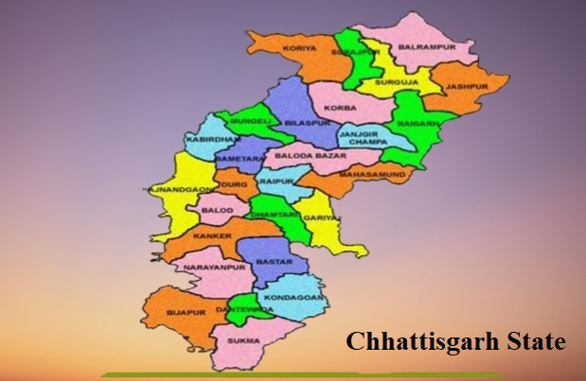
Figure 1 Map of Chhattisgarh State

c

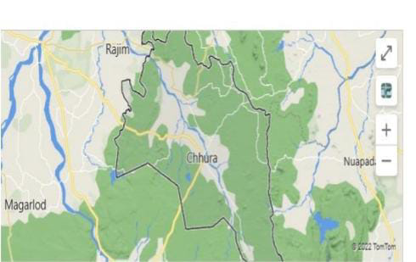
Figure 2: Map of Chhura
In this paper we taken three edible oils Soya oil, Mustard Oil and peanut oil and determine the following physicochemical test
- Physicochemical Test of edible oils

Density:In this paper we taken three edible oils Soya oil 11.09 g, Mustard Oil 10.16 g, peanut oil 10.47 g, and density was measured by the U- shaped viscometer method and calculate the density of oil sample by the equation
Density= M/ V
Where- M= Mass of edible oil in (gm) and V= Volume of edible oil (in ml)

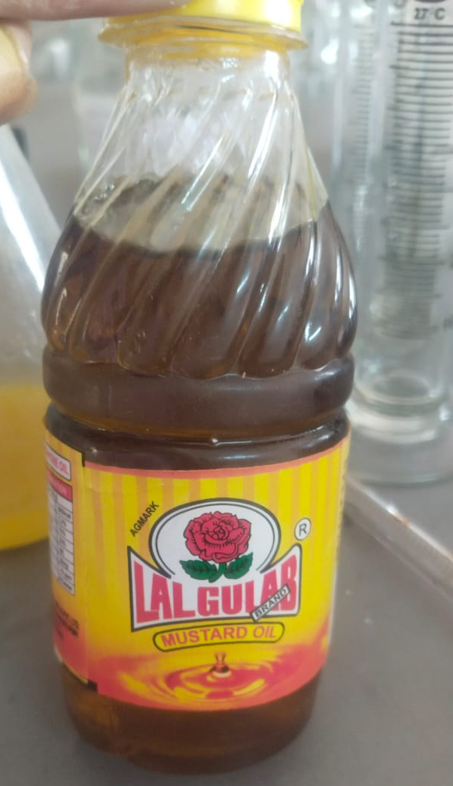
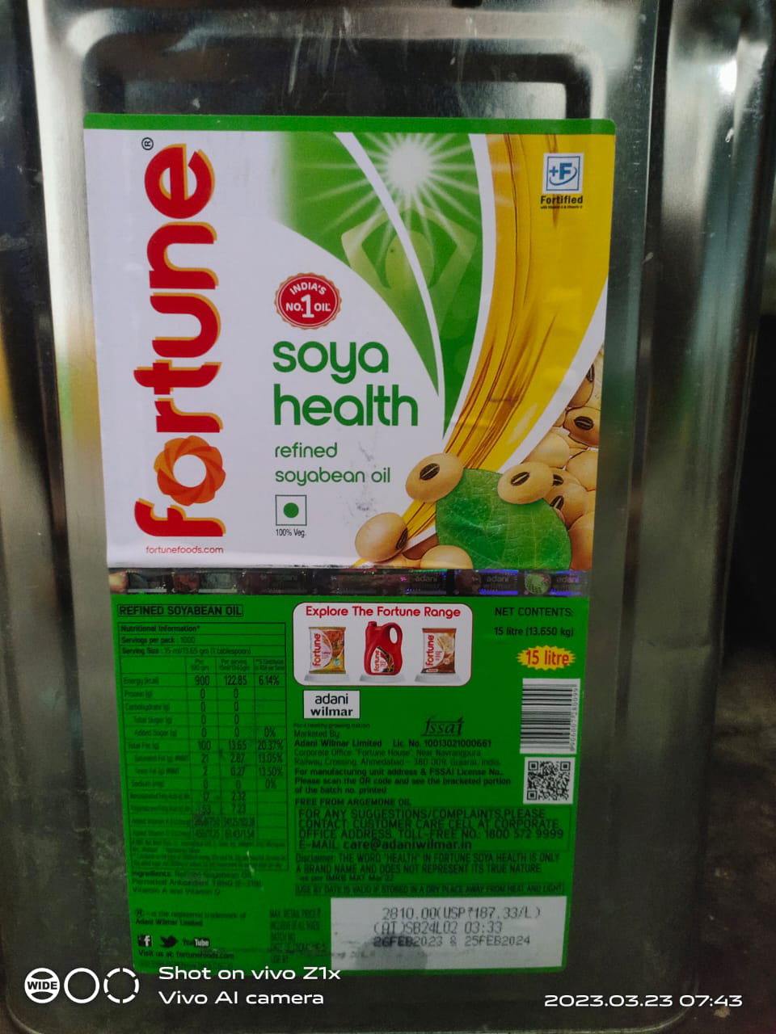
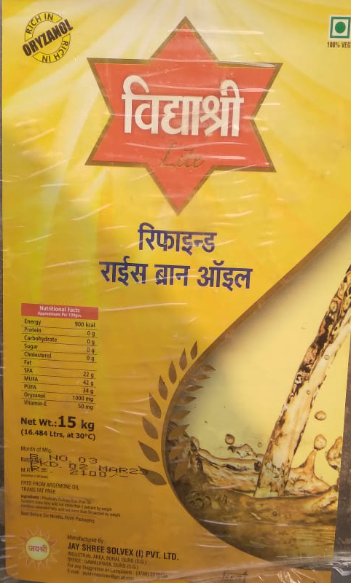

Figure 3: Sample of Edible Oils

Density of Soya Oil- Take 11.09 gm of soya oil and weight of soya oil was measure by using weight box than we determine the volume of sample oil by measuring cylinder was 15.0 ml, after calculation the density of Soya oil was measured 0.73 gm/lit.

Density of Mustard Oil- Take 10.16 gm of Mustard oil and weight with the help of weight box than we determine the volume of mustard oil sample oil by measuring cylinder was 10.5 ml after calculation the density of soya oil was measured 0.96 gm/lit.

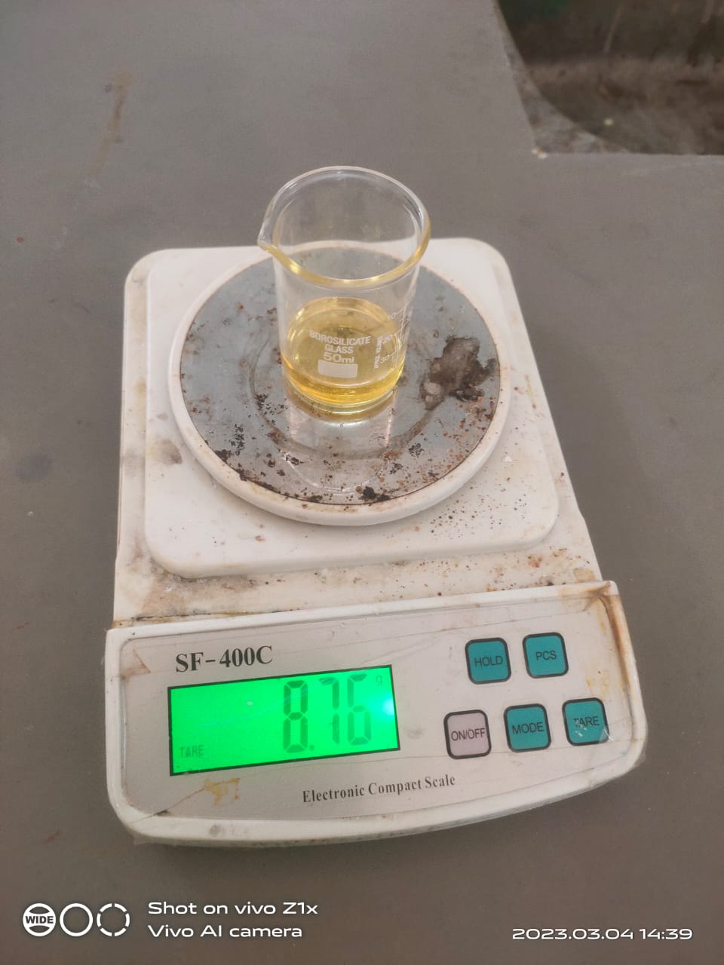
Figure 4: Measurement of Sample for testing
Density of Peanut Oil- Take 10.47 gm of peanut oil and weight with the help of weight box than we determine the volume of peanut oil sample oil by measuring cylinder was 13.0 ml after calculation the density of soya oil was measured 0.80 gm/lit.
Acid Value-The quantity of sodium hydroxide base to neutralize the acid quantity present in 1 gm of edible oil is known as acid value. Acid value test is determined by using titration method (Sarmila K C et al., 2023).
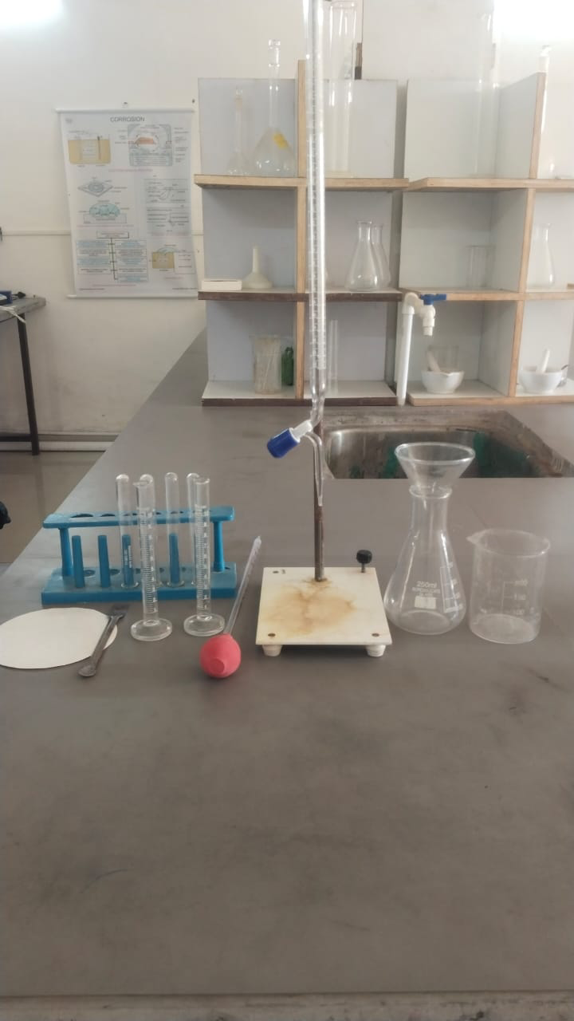
Figure 5: Required Materials for Acid Value Test

Procedure – Step-I Sample Preparation
- Phenolphthalein indicator solution preparation- Take 2 gm of phenolphthalein powder in 250 ml beaker and dissolve it in 100 ml distil water. Add 100 ml of amyl alcohol and mix well by shaking.
- 0.1 N Sodium Hydroxide Solution- Take 4 gm of sodium hydroxide pellets 1 liter of distil water.
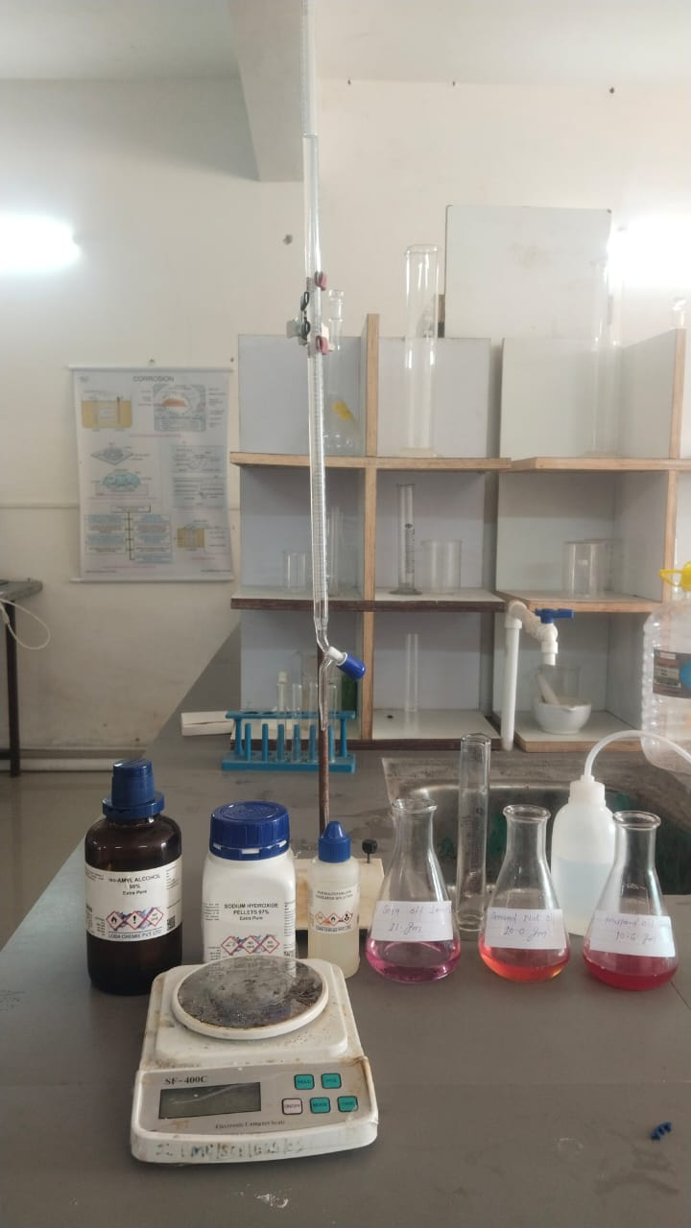
Figure 6: Required Chemical for Acid Value Test

Step-II- In step second we take 10 gm of oil sample in 250 ml conical flask than add 50 ml of amyl alcohol, after than add 2-3 drops of phenolphthalein indicator, shake the conical flask.

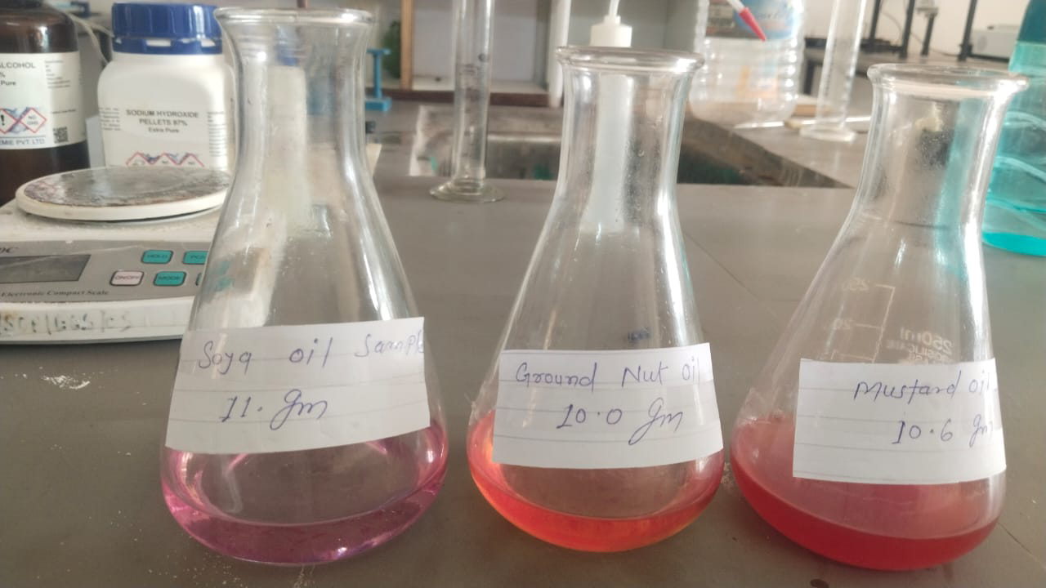
Figure 7: Result Seen at the time of Acid Value Test

Step-III Titration- Take prepared 0.1 N NaOH Solution, this time note initial burette reading and mix drop by drop in conical flask and continue shake the conical flask. When the light pink color obtained then stop titration and note the final burette reading.

Peroxide Value
Required material: Required materials for test of peroxide value in different types of edible oils are Weight Machines, Burette, Burette Stand, Measuring cylinder, conical flask, spatula, filter paper, pipette, test tube, funnel and hot plate etc.
Required Chemicals-
Chloroform- 30 ml
Conc. Acetic Acid- 90 ml
Starch Soluble- 0.5 gm
Potassium Iodide- 2-3 gm
Sodium Thiosulphate-0.02 gm

Figure 8: Oil Sample for Peroxide Test

Procedure for Peroxide Value: -
Step-I Solution Preparation-
Acetic Acid + Chloroform (3:2 Solution)- Take 90 ml of conc. Acetic acid in reagent bottle and add 60 ml of chloroform solution and shake well [7]
- 1% Starch Solution- Take 50 ml distil water in a beaker and heat up to boil it. After than add 0.5 gm of starch soluble powder and continue stirrer with glass rod. After 30 min filter the solution with the help of filter paper and finally prepared 1% starch indicator.

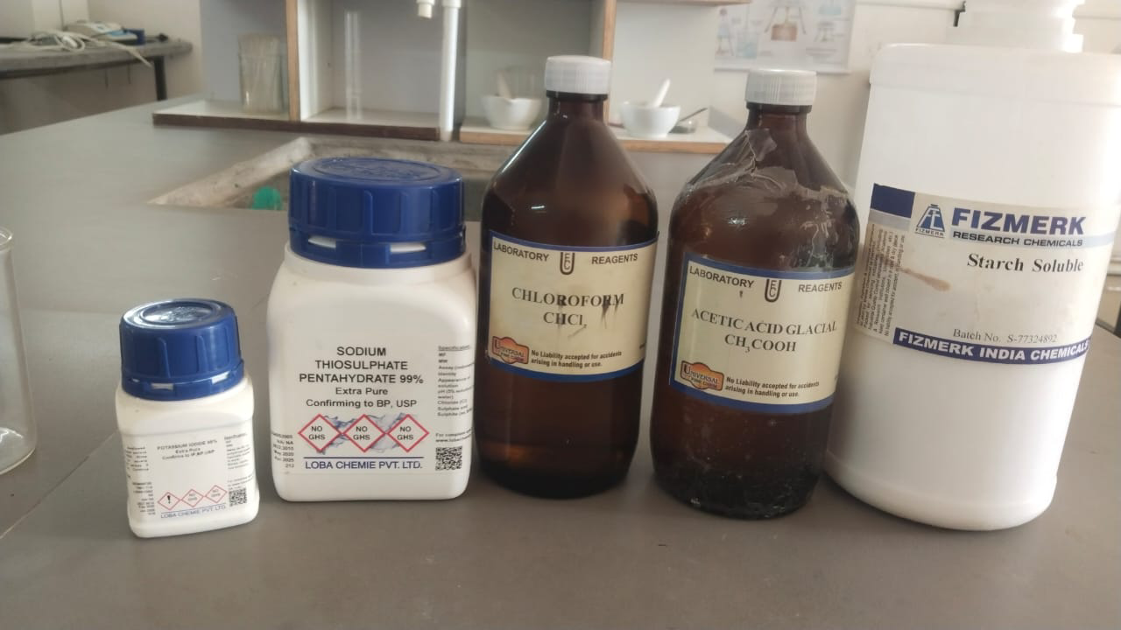
Figure 9: Required Chemical for Peroxide Value Test
- 0.01 N Sodium Thiosulphate Solution- Take 0.25gm sodium thiosulphate in 80 ml distil water in a beaker than add 0.02 gm sodium carbonate and heat the mixture for 3-5 minute and cool this solution. After than add distil water and make final quantity of solution is 100 ml, this is the final solution of 0.01 N sodium thiosulphate solution.
- Saturated Potassium Iodide Solution- Take 2 ml distill water in a test tube and add 2-3 gm potassium iodide and dissolve it.
Step(II) In the second step, we take a 10-12gm oil sample and add 30 ml of acetic acid. Shake well and add 1 ml of the saturated solution. Then, add 30 ml of water and shake until the mixture is well mixed.
Step (III) Titration
- Take 0.01 N Sodium thiosulphate in burette.
- Note the initial burette reading.
- Add 0.5 ml of 1% starch solution (as indicator). After addition of indicator change the oil sample colour in black colour.
- Start titration and continue shaking for mixing well.
- Add drop by drop sodium thiosulphate in oil sample and continue shaking
- Continue shaking until the black colour is removed/ disappear
- After remove the colour than stop the titration.
- Note the final burette reading.
Step-(IV) Calculation-
Peroxide Value =V*N*1000/Ws
Ws= Weight of oil sample = 10 gm
N= Normality of sodium thiosulphate = 0.01 N
V= Value of sodium thiosulphate= Final burette reading – Initial burette raeding
= 1.5 – 0.5
= 1
Peroxide Value =V*N*1000/Ws
= 1* 0.01 * 1000/ 10
=1 mg /kg

Figure 10: Required Material for Peroxide Value Test

- Result

In this project we determine the various physicochemical test of edible oil in which first of all we check the density value and get result that the density of mustard oil is higher than the density of soya oil and peanut oil. Peroxide value, Acid value and temperature of mustard oil is also higher than soya oil and peanut oil. The data of all the physicochemical test are shown by following table and also explain by following graph-

Figure 2 Parameters of Different Edible Oils
S No. | Parameters of Oil | Soya Oil | Mustard Oil | Peanut Oil
1 | Density | 0.73 gm/lit | 0.96 gm/lit | 0.80 gm/lit
2 | Peroxide Value | 0.89 mg/kg | 1.0 mg/kg | 0.75 mg/kg
3 | Acid Value | 0.32 mg/gm | 1.01 mg/gm | 0.52 mg/gm
4 | Temperature | 22 ⁰C | 23 ⁰C | 22 ⁰C

Graph 1: Density, Peroxide Value and Acid value of different Edible oils

Graph:2 Temperature of Different Edible Oils

- Conclusion

In this paper we determine some properties of three different edible oils. In physicochemical test of edible oil, we observe density of oil are measure 0.73- 0.96 gm/lit. The peroxide value is obtained 0.75- 1.0 mg/kg, Acid value is obtained 0.32 – 1.01 mg/gm and Temperature are obtained 22 – 23 ⁰C. This value is accurate and good for health. According to this study we know that the soya oil is good edible oil for human health because their acid value is minimum quantity as compare to other oil.
Reference: -
[1] A.-A. Neagu, I. Niţa, E. Botez, and S. Geaca, “A physico-chemical study for some edible oils properties,” Analele Universitatii “Ovidius” Constanta - Seria Chimie, vol. 24, no. 2, pp. 121–126, Jan. 2014, doi: 10.2478/auoc-2013-0020.
[2] B. Tesfaye and A. Abebaw, “Physico-Chemical Characteristics and Level of Some Selected Metal in Edible Oils,” Advances in Chemistry, vol. 2016, pp. 1–7, Sep. 2016, doi: 10.1155/2016/3480329.
[3] S. S. Angaye and N. J. Maduelosi, “Comparative Study of the Physicochemical Properties of Some Refined Vegetable Oils Sold in Mile One Market and Some Departmental Stores in Port Harcourt, Rivers State, Nigeria,” vol. 39, 2015, [Online]. Available: www.iiste.org
[4] K. Kaboré et al., “Evaluation of the physicochemical parameters of edible oils sold in the three cities of Burkina Faso,” Food Science and Nutrition, vol. 10, no. 6. John Wiley and Sons Inc, pp. 2029–2035, Jun. 01, 2022. doi: 10.1002/fsn3.2819.
[5] A. Čabarkapa et al., “Unexpected effect of dry olive leaf extract on the level of DNA damage in lymphocytes of lead intoxicated workers, before and after CaNa2EDTA chelation therapy,” Food and Chemical Toxicology, vol. 106, pp. 616–623, Aug. 2017, doi: 10.1016/j.fct.2016.12.023.
[6] Ratnesh Kumar, “Determination of Acid Value in Fats and Oils,” 2023.
[7] F. Rey, E. Alves, L. Gaspar, M. Conceição, and M. R. Domingues, “Oils as a source of bioactive lipids (olive oil, palm oil, fish oil),” in Bioactive Lipids, Elsevier, 2023, pp. 231–268. doi: 10.1016/B978-0-12-824043-4.00013-0.

