Synthesis, spectral characterization, Insilco molecular docking and in-vitro antimicrobial studies of 5-(4-substituted phenyl)-3-(thiophen-2-yl)-4, 5-dihydropyrazole-1-carbothoamide derivatives
¹A. A. Jafeena , ^{1*}M.R.Ezhilarasi and ²M.Suganthi
1. PG Student, Dr.N.G.P.Arts and Science College, Coimbatore -641 048, Tamil Nadu, India
1* & 2. Assistant Professor, Dr.N.G.P.Arts and Science College, Coimbatore -641 048, Tamil Nadu, India
Email id: mrezhilarasi@gmail.com & skaamindan@gmail.com

Abstract:
Using the melting point, FT-IR, one-dimensional ¹H and ¹³C NMR spectroscopic data, A new series of pyrimidines were harmonized and characterized. In vitro antibacterial and antifungal activities of all the harmonized compounds are tested. Also the same compound is tested by zone of inhibition against set of bacterial and fungal strains, by this the compound 2a tested against S.Aureus, S.Pyogenes, E.Coli, 4b against P.Aeruginosa, and this shows an excellent antibacterial activity. Similarly the compound 2c can show inhibition against C.albicans. And also all the compounds were undergone in-silico molecular docking predictions. The docking studies were inspect by proteins like Bacterial protein 1UAG.They shows good docking score than the standard drug.
Keywords: Substituted acetophenone, thiphene-2-carbaldehyde, antimicrobial activity, molecular docking, 1UAG.
1. INTRODUCTION:
In current days an extensive variety of microorganisms like bacteria, viruses, protozoa and fungi are becoming rebellious to drugs that are used to cure infections. This resistance is a major hurdle to treatment of infectious diseases worldwide [1]. Microbial infections are a rising problem in contemporary medicine and the use of antibiotics is habitual across the world. Accordingly, there is an urgent need to widen antimicrobial agents, which have a broad spectrum of activity against the repellent microorganism [2]. Therefore, it is obligatory to have microbial agents with upgrade potency. The area of organic chemistry developing referring to harmonize of bioactive compounds. one of nitrogen containing heterocyclic compounds; pyrimidines evidently acquired significant importance mature to their varied biological properties and therapeutically importance.the most rudimentary nucleus present in the nucleic acid is named as pyrimidine, which is correlated with a large number of biological activities. The marketed drugs likes anti-atheroscletic aronixil, anti-histaminic thonzylamine, antianxielytic buspirone, antihypertensive minoxidil and prazosin, anti-psoriatic enazadrem,and other medically pertinent compounds which contains the familiar substituted aminopyrimidine. A bit of remarkable biological activity of Pyrimidine derivatives includes adenosine receptor antagonists [3], kinase inhibitors [4], analgesic [5], anti-inflammatory [5], inhibitors of cyclin-dependent kinase 1 and 2[6], calcium channel antagonist [7], anti-histaminic [8] and antitubercular [9] activities. Different N-functionalized morpholines are showing assuring various pharmacological activities. They were reported to exert a number of important physiological activities such asantidiabetic[10], antiemetic[11],platelet aggregation inhibitors, anti-hypeelipoproteinemics[10] bronchodilators, growth stimulants [12] and antidepressants’[13]. These were also used for inflammatory diseases, pain, migraine and asthma [14]. Tridemorph, morpholine derivatives was also used as an antifungal agent [15].4-Phenyl morpholine derivatives were outline to possess anti-inflammatory [16] and central nervous system [17] activities. some of pyrimidine’s moiety containing clinically beneficial compounds reveal strong tuberculosis(A) and anti-microbial activity(B) from scheme 1. Besides, few of the clinically essential drugs carry morpholine moiety in addition to N-heterocycles which are isolated from one or more carbon atoms. Drugs obtained from morpholine assimilated compounds include dextromoramide, (C) a narcotic analgesic and doxapram HCl, (D) a respiratory stimulant. Doxapram used in the treatment of respiratory depression following anaesthesia[18]. Minoxidil[E] was a very good antihypertensive vasorelaxation (reduce blood pressure) and also used for medication of hair growth for men and women and was marketed under the trade name of Rogaine.

Scheme- 1: Some of the synthetic compounds having the core pyrimidine and morpholine nuclei with therapeutic activities
Structure based drug designing (SBDD) and Ligand based drug designing (LBDD) techniques are employed as important drug discovery tools in rational drug designing process [19]. Molecular docking is the advanced computational used techniques in SBDD to obtain optimized conformation of Ligand-receptor interaction and to study their relative orientation through the minimized energy free system [20]. Computer aided drug designing (CADD) is fast, economical modernized technique that gives valuable, accurate and deep understandings of experimental findings and new suggestions for molecular structures to be synthesized [21]. In continuation of our interest in synthesizing structurally diverse biologically active heterocycles [22-27], we report now the synthesis of pyrimidine derivatives and the biological and insilico studies.
2. EXPERIMENTAL METHOD
2.1. MATERIALS AND METHODS:
All chemical were bought from sigma Aldrich INDIA. Using open capillary method, the determination of melting point will be done. TLC has been checked for formation of compounds regularly and spots were seen by iodine. For neat liquid compounds FT-IR spectra was taken and for KBr pellets for solids on a Shimadzu spectrum RXI FT-IR.
2.2. MAKING OF TLC PLATES& COLUMN CHROMATOGRAPHY:
Using silica gel pre camouflaged glass plates the Analytical TLC was carry out (Merck, Germany). Silica gel was prepared with 30g was in 100ml of water. Then the mixture of solution was coated on the glass plates and dry in air for 3 hours and kept in an oven for another one hour before using the plate. Using silica gel (60-120 mesh. Merck, India) the Column chromatography was carry out
2.3. EQUIPMENTS AND ANALYTICAL INSTRUMENTS:
The open capillary tubes are used for the determination of Melting points. FT-IR-8400 instrument is using for IR spectra. The uncorrected IR was recorded on a Shimadzu and Perkin Elmer transform spectrometer. Bruker Avance 400 NMR instrument was using for ¹H NMR spectra and Bruker Avance 400 NMR instrument using for ¹³C NMR spectra.
2.4. PERCENTAGE OF THE PRODUCT:
Using recrystallization procedures purification of All the harmonized compounds will be done. Using TLC method, the cleanness of the compound was examined. The percentage of the compound calculated using the equation.
2.5. COMMON PROCEDURE FOR THE PREPARATION OF CHALCONE DERIVATIVES: (1a-1c)
Take a beaker and add One mole of thiophen-2-carbaldehyde and one mole of various substituted acetophenone followed by the addition of 30ml of ethanol containing 2g of NaOH pellets. Using magnetic stirrer, the mixture was stirred well for 30 minutes in a cold-water immersion, after it was poured into the crushed ice containing 500ml beaker and this reaction mixture was kept overnight at room temperature. The chalcones were precipitated out as solid. Then it was filtered, dried and recrystallized from ethanol. Using CHCl₃ as a solvent the goodness of the compound was checked by TLC method
2.6. COMMON PROCEDURE FOR THE PREPARATION OF 5-(4-SUBSTITUTED PHENYL)-3-(THIOPHEN-2-YL)-4, 5-DIHYDROPYRAZOLE-1-CARBOTHIOAMIDE DERIVATIVES: (2a-2c)
Thiosemicarbazide (0.001 mmol) and 2 ml of 2% sodium hydroxide solution was added in to a different mixture of chalcone (0.001mol) in ethanol (40 ml). Then the mixture was warmed up and refluxed for 16 hours. Then the reaction gets completed, that mixture was streamed into squashed ice and hold on to overnight at normal temperature. After this reaction it was filtered by using filter paper and dried. After that it gets recrystallized by using ethanol. Using TLC method, the purity of the resulted compound was checked, in this reaction utilized solvent is CHCl_{3.}
2.7. ANTIMICROBIAL ACTIVITY ASSAY
There is a discrete evaluation of harmonized compounds done against a panel of Gram twins (Gram-positive and Gram-negative (GNB)) bacteria pathogen, and fungi. Antimicrobial tests were conducted using the agar well-diffusion method [28-30].After the media had cooled and solidified, well (6 mm in diameter) were made in the solidified agar, before microbial inoculums was uniformly spread using a sterile cotton swab on a sterile Petri dish containing agar nutrient (NA) medium, or Sabouraud dextrose agar (SDA) media for bacteria and fungi, respectively.The 1 mg of the compound dissolved in 1 mL of dimethylsulfoxide (DMSO) to obtain quantity of 100μL of the evaluated compound solution. The hatching of immunized plates was done for 24h at 37˚C for bacteria and yeast, and 48h at 28˚C for fungi. The tested compounds were dissolved with the help of DMSO for the preparation of negative controls. The utilized standards of bacteria and fungi is named as Ciprofloxacin (1mg/mL), Clotrimazole(1mg/mL) respectively. After the procedure of incubation, the calculation of the zone of inhibition against the tested microorganisms is help to evaluate the antimicrobial activity. Using the inhibition diameter zones in millimeters (mm) the antimicrobial activity was conveyed. By adopting the literature precedent, the antimicrobial activity procedure was followed [31].
Computational study
Molecular Docking Study
using bacterial protein by Auto dock version 4.2.5.1 docking software, the 4-(furan-2-yl)-6-(4-morpholinophenyl) pyrimidine-2-amine derivatives 2a-2c done their Molecular docking studies. The reference method was followed for the docking study [32].
3. RESULT AND DISCUSSION
3.1. Chemistry:
Due to the in-depth scientific studies, the formation of the chemistry of chalcones is occur throughout the world. the main focused area of interest is synthesis and biodynamic activity of chalcones. In chalcones, aliphatic three carbon chain connected with two aromatic rings. Chalcone carries a good python so that diversity of novel heterocyclic with good pharmaceutical profile can be outlined. Harmonization of Thiophen chalcone from different substituted acetophenone reacted with thiophen-2-carbaldehyde in the presence of ethanol containing NaOH solution. The thiophen chalcone were then condensed with hydroxylamine hydrochloride to give carbothioamide derivatives. To generate specific compound like trans E-isomer, the Claisen-Schmidt condensation method is used.
Scheme - 2: Synthetic route for the target compounds
From the IR spectrum information gathered for (1a-1c) compound are; the carbonyl compounds has shown the stretching at 1690-1750 Cm⁻¹, the Aromatic C-H compounds stretches at 3000-3100 Cm⁻¹ and Aliphatic C-H bond stretching is found at 2900-3000 Cm⁻¹. The(2a-2c) compound shows IR spectra at different stretching frequency including C=N Stretching about 1600-1650 Cm⁻¹, the N-H bond Stretches about 3350-3500 Cm⁻¹. The Aromatic C-H bond stretches about 3000-3100 Cm⁻¹, the C=C Stretches about 1450-1600 Cm⁻¹, Aromatic ring stretches at 600-800 Cm⁻¹. The ¹H NMR spectrum of the 1a compound exhibit that the proton H-5 in the pyrimidine moiety gives a singlet peak at 6.16 ppm. The NH₂ proton of pyrimidine ring gives broad singlet peak at 5.13 ppm. The protons H-3, H-4 &H-5 gives peaks at 6.85 ppm and 6.96 ppm. The protons present in the aromatic ring gives peaks within the range of 7.08-8.02 ppm. On taking the ¹³C NMR of 1a compound exhibit the peaks at 165.30 and 163.22 ppm, these are the peaks for C=N in the pyrimidine moiety. The peaks at the down field region at 152.90 ppm is the representation of C-N in pyrimidine moiety. The resonance at 100.60 ppm is of C-5 carbon of pyrimidine. The peak 156.61 ppm in the down field region is the resonance of C-2 carbon in the furan ring. The C-3, C-4 and C-5 carbon of furan ring is found to give signals at 108.69, 112.80 and 144.44 ppm. The Aromatic carbon in the compound gave the resonance in the range of 113.32-130.87 ppm. From the above discussed characteristics of the compound assigned from FT-IR, ¹H NMR, ¹³C NMR, the skeletal structure of the particular compound is confirmed. The spectral results of the compounds are discussed in the tables below.
Table 1: IR Frequency (E)1-(4-substituted phenyl)-3-(thiophen-2-yl)prop-2- en-1-one derivatives (1a-1c)
Compounds | C=O  Stretching | Ar-CH  Stretching | Aliphatic-CH  Stretching | Ar ring  Stretching | Ar C=C  Stretching
1a | 1653.07 | 3030.30  3058.23 | 2932.89  2963.75 | 691.51,736.84  767.70 | 1449.57
2a | 1655.96 | 3066.85  3180.40 | 2925.17  2962.79 | 687.65,734.91  768.67 | 1410.02
1c | 1676.21 | 3068.27 | 2924.21 | 692.47,758.06  814.21 | 1400.38

Table 2:IR Frequency 5-(4-substituted phenyl)-3-(thiophen-2-yl)-4, 5-dihydropyrazole-1-carbothoamide derivatives(2a-2c)
Compounds | N-H  Stretching | C=N  Stretching | Ar-CH  Stretching | Ar ring  Stretching
2a | 3349.53,3473.95 | 1572.05 | 3048.62 | 694.40,760.79  833.28
2b | 3404.51 | 1588.45,1681.04 | 3029.34  3054.41 | 765.77, 819.78  838.11
2c | 3408.36  3553.03 | 1587.48, 1680.07 | 3030.30, 3058.34  3076.54 | 695.37,765.77  841.96

Table 3: Physical characterizations of the synthesized compounds 2a-2c
Compound | Molecular  Formula | Mol.Wt | Yield  % | Color | Melting  Point⁰C
1a | C₁₄H₁₂O₂S | 244.31 | 83 | Yellow | 112
1b | C₁₃H₉NO₃S | 259.28 | 78 | Brown | 104
1c | C₁₄H₁₂OS | 228.31 | 80 | Yellow | 101
2a | C₁₅H₁₅N₃OS₂ | 317.43 | 75 | Yellow | 179
2b | C₁₄H₁₂N₄O₂S₂ | 332.40 | 68 | Brown | 184
2c | C₁₅H₁₅N₃S₂ | 301.43 | 72 | Yellow | 195

MOLECULAR DOCKING STUDIES:
In silico Activity: The mechanism of cell wall synthesis is done by the help of IUAG protein. a good docking score and good interaction is displayed by the recently prepared compounds. mainly (compound 2b) exhibiting a good docking score (-6.7 kcal/mol) related to another 2 compounds. another compound docking scores are specified by reducing order -6.3, -6.0 kcal/mol of 2c,2a. There is an interaction will be occurred between compound 2b and IUAG by forming conventional hydrogen bonding at ARG A: 302, LYS A: 319 and LYS A: 115. the conventional hydrogen bond at VAL A: 335, GLY A: 337 will be also formed by compound 2c. Compounds 2a forms conventional hydrogen bonding at ASN A: 421. The interaction of ALA A: 414 and the alkyl,pi-alkyl will gives the compound 2b. Compound 2c forms alkyl,pi-alkyl relation at LEU A: 333, LEU A: 330, LEU A: 339, VAL A: 364.Binding score value of the prepared compounds are listed in the Table-4.The2d and 3D images of the harmonized compounds are given in Table-5.
TABLE-4: Docking Binding Score values of the synthesized compounds 2a-2c
S.No | Compounds structure | Compounds | Binding affinity value  (kcal/mol) | Conventional hydrogen bond interaction | Alkyl and  pi - Alkyl bond interaction | Other bond  interactions
1. |  | 2a | -6.0 | ASN A: 421 | - | SER A: 415,  GLU A: 423
2. |  | 2b | -6.7 | ARG A: 302, LYS A: 319,  LYS A: 115 | ALA A: 414 | SER A : 415
3. |  | 2c | -6.3 | VAL A: 335  GLY A: 337 | LEU A: 333, LEU A: 330, LEU A: 339, VAL A: 364 | ASN A: 363
(‘ - ’) which is indicates that there is no bond interaction
Table-5: The 2d and 3D images of the synthesized compounds 2a-2c
Compounds | 2D Image | 3D Image
2a | 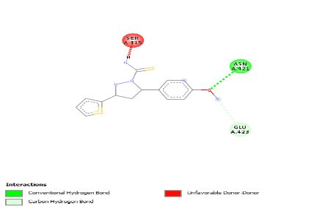 | 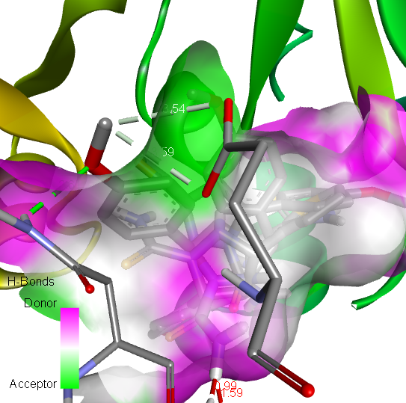
2b | 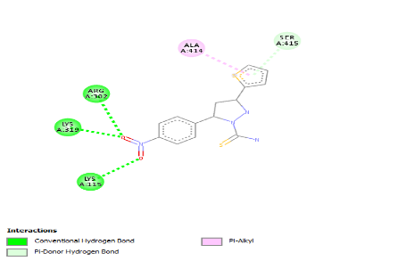 | 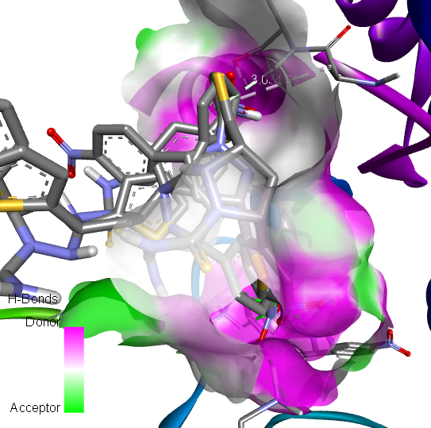
2c | 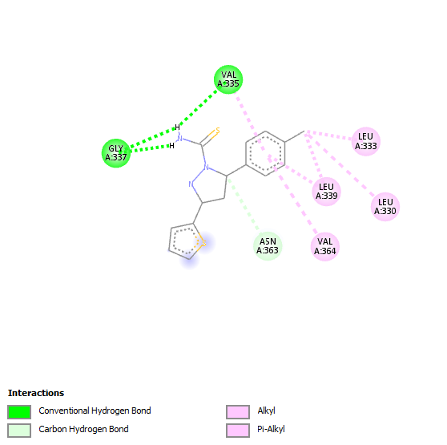 | 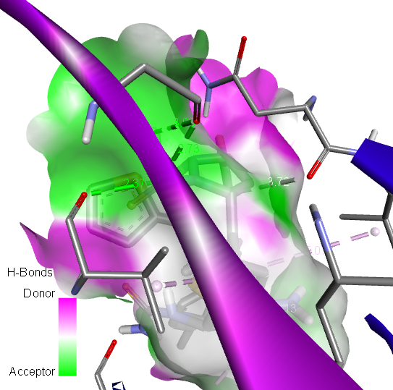

Biology
Antimicrobial study
Using disc diffusion method, the novel pyrimidine derivatives 2a-2c were tested for their antibacterial activity against tested bacterial and fungal strains and the results are exhibited in Table-6. The property of zone of inhibition against S.Pyogens showed by compound 4a very excellent manner. As well as the E.Coli also shows good zone of inhibition against S.Aureus and P.Aeruginosa. the another excellent zone of inhibition showed by compound 4b against E.Coli and P.Aeruginosa and also good zone of inhibition against S.Aureus and S.Pyogenes. The compound 2c showing good zone of inhibition opposed to S.Aureus, S.Pyogenes E.Coli and P.Aeruginosa. when corelate with the standard drug ciprofloxacin some of the harmonized compound 2a-2c the 2a presenting best zone of inhibition. according to antifungal studies the excellent zone of inhibition showed by 2c against C.albican and also when corelate with the standard drug Clotrimazole the compound 2a and 2b displays good zone of inhibition.
Table-6 Antimicrobial activity screening of the compounds (2a-2c) at 10mg/ml
Entry | Bacterial Strain |  |  |  | Fungal Strain
 | S.Aureus | S .Pyogenes | E.Coli | P.aeruginosa | C.albicans
4a | 23 | 21 | 22 | 19 | 15
4b | 18 | 17 | 19 | 24 | 17
4c | 19 | 15 | 13 | 16 | 21
Ciprofloxin/ Clotrimazole | 26 | 19 | 17 | 22 | 24

Figure- 1 in vitro antimicrobial microbial activity of 2a-2c by disc diffusion method
Conclusion:

In summary, new and most relevant synthetic way of a few amino pyrimidine derivatives were attained. based on elemental analysis, spectral data and alternative methods The construction of the recently developed compounds was entrenched. The recently synthesized compounds were assessed for their antimicrobial activity against Gram-twins’ bacteria as well as fungal stain. The conclusion shows that the synthesized compounds 4a-4c displayed a sufficient restrictive growth of Gram-twins’ bacteria. mainly, there is a magnificent zone of inhibition (23mm in diameter) of Compound 2a will be occur against S.Aureus. and also this compound 2a shows magnificent zone of inhibition (21 mm in diameter) against S.Pyogenes as well as the compound shows outstanding zone of inhibition against E.Coli (22 mm in diameter) when compared with the standard drug Ciprofloxacin. There is a better antibacterial activity occur by compound 2a against all the compounds. According to fungal study declare that the compound 4c shows good zone of inhibition (21 mm in diameter) against the fungal stain C.albican, because of the thiophene ring contains a methyl group in their fifth position. The molecular docking studies were take place by bacterial protein and Breast cancer protein. All the compounds exhibiting best binding activity scores.
References
1. Desai N C, Rapara.K.M, Joshi .V.V, Vaghani H V,Sadodiya H M. Synthesis, characterizationand antimicrobial screening of hybrid molecules containing quinoline, pyrimidine and morpholine analogues. 2013, J.Chem.sci., Vol.125,No.2,321-333.
2. Humaira Parveen, Raedah Aiyed Suliman Alatawi, nadia Hussein El Sayed, Sadaf Hasan, Sayeed Mukhtar,Asad U Khan. Synthesis,characterization and biological evaluation of some novel nitrogen and sulphur containing organometalic heterocycles.2015, Arabian Journal ofChemistry, http://dx.doi.org/10.1016/j.arabjc.2015.05.002
3.Van veldhoven J p D, Chang l C W, Von Frijtag drabbe Kunzel J K, mulder-krieger t, Struensee-Link R, Beukers M W, Brussee J and Ijermen A P 2008 Bioorg.Med.Chem.16 ,274.
4. Hughes T V, Emanuel S L, Beck A K, Wetter S K, Connolly P J, Karnachi P, Reuman M, Seraj J, Fuentes-Pesquera A R, Gruninger R H, Middleton s A, Lin R, Davis J M and Moddat D F C 2007, Bioorg.Med.Chem.Lett. 17 3266
5. Chhabria M T, bhatt h G, Raval H G and Oza P M 2007 Bioorg.Med.Chem. Lett 17 1022
6. sayle K L, Bentley j, Boyle F T, Calvert A H, Cheng Y, Curtin N J, Endicott J A, Golding B T, Hardcastle I R, Jewsbury P, Mesguiche V, Newell D R, Noble M E M, Parsons R J, Pratt D J, Wang L Z and Griffin R J 2003 Bioorg.Med.Chem. Lett. 13 3079
7. Pastor A, Alajarin R, Vaquero J J, Alvarez- Builla J, Fau de Casa-Juana M, Sunkel C, Priego J G, Fonseca I and Sanz-Aparicio J 1984 Tetrahedron 50 8085
8. Youssuf m S, Kaiser P, Singh G D, Singh S, Bani S, Gupta V K, Satti N K and Suri K A 2008 Int. Immunopharmacol 8 1049
9. Gasse c, Douguet D, Huteau V, Marchal g, munier-Lehmann H and pochet S 2008 Bioorg.Med.Chem. 16 6075
10. Manfred R, Michael m, Robert S, Wolfgang G , Eur. Pat. Appl.Ep 1989 334146:28,Chem.Abstr,112:178999
11. Hale J J, Mills S G, Mac cross M, Dorn C P, Fink P E, Budhu R J, etal , 2000 J. med. Chem, 43 1234-1237
12. Fisher m H, Wyvratt m J, US Patent 1991 5077290:10. Chem.Abstr.116:214513
13. Avramova P, Danchev N, Buyukliev R, Bogoslovova T, 1998 Arch.Pharm, 331, 342-346
14. Dorn C P, Hale J J, MacCross M, Mills S G, US patent 1997 5691336:82. Chem.Abstr.128:48231
15. Parks L W, C R C Crit.Rev.Microbiol,6 1978 301-341
16. Misra v S, Singh, Agarwal R, Chaudhry K C, J.Chem.Soc.Pak. 3 1981 209-211
17. Agarwal R, Chaudhry K C, Misra M S, J.Chem.Soc.Pak 6 (1984)308-310.
18. Kanagaran V, Thanusu J, Gopalakrishnan M. Synthesis and in vitro microbial evaluation of an array of biolabile 2-morpholino-N-(4,6-diarylpyrimidin-2-yl)acetamides. Eur.J.Med.Chem. 2010. 45, 1583-1589 doi:10.1016/j.ejmech.2009.12.068
19. Ferraria L G.;Santos RND.; Oliva G.;Andricopulo. Molecular docking and structure based drug design stratergies. Molecules 2015, 20, 13384-13421.https://doi.org/10.3390/molecules200713384
20. Muchtaridi M.; Dermawan D.;Yusuf M. Molecular docking 3d structure-based pharmacophore modelling and ADME prediction of alpha mangostin and its derivatives against estrogen receptor alpha. J Young Pharm 2018, 10(3), 252-259.https:// DOI: 10.5530/jyp.2018.10.58
21. Liao C.; Sitzmann M.; Pugliese A.; Nicklaus MC.Sofware and resources for computational medicinal chemistry. Future Med Chem 2011, 3(8), 1057-1085. https:// DOI: 10.4155/fmc.11.63
22. Kanagarajan K, Ezhilarasi M R, Gopalakrishnan M.Synthesis and in vitro microbiological evaluation of diethyl 6,6’-(1,4-phenylene)bis(4-aryl-2-oxo-cyclohex-3-enecarboxylates). Journal of Enzyme Inhibition and Medicinal Chemistry ,2011, 26(4),498-505.
23. Senthieel Khumar A B, Ezhilarasi M.R, Prabha B, Raja C. Molecular docking study of the new series of ethyl 6-(furan-2-yl)4-(4-morpholino phenyl)-2-oxo cyclohex-3-ene carboxylates and their bacterial activity.Re.J.Chem Environ.2019, Vol:23(4),70-77.
24. Manju Mathew, Raja Chinamanayakar,Ezhilarasi Muthuvel Ramanathan. Synthesis, invitro antimicrobial evaluation and insilico Molecular docking and ADMEprediction of 4-chlorophenyl furfuran derivatives bearing pyrazole moieties. Asian Journal of Chemistry, 2020, Vol.32.No.6,1482-1490.
25. Senthieel Khumar A B, Naveen Kumar K, Raja C, Ezhilarasi m R. In vitro anticancer activity, antimicrobial and in silico studies of naphthyl pyrazole analogues. Rasayan Journal of Chemistry, 2020, Vol.13,No.2, 1199-1214.
26. Raja Chinnamanayakar.; Ezhilarasi M.R.; Prabha B.; Kulandhaivel M. Synthesis and characterization of cyclohexane-1,3-dione derivatives, and their in-silico and in-vitro studies on antimicrobial and breast cancer activity. Asian J. Pharm and Clinical Research 2019, 12 (3), 311-320. http //dx.doi.org/ 10. 22159/ajpcr. 2019. V12i3. 30481.
27. Rathinamanivannan S.; Megha K,Raja Chinnamanayakar.; Ashok kumar.;Ezhilarasi M R. Synthesis characterization of 2-pyrazoline derivatives and their insilico and invitro studies on microbial and anticancer activity. Asian J Chem 2019, vol-31 No-10, 2191-2196. http://doi.org/10.14233/ajchem.1029.22082.
28.Sharma R, Sharma K, Dixit S . Synthesis characterization, and biological activities of some new arylpyrazoles. Int.J.Chem Tech.Res, 2010, 2, 800-806
29. Studennikova L .Hydrazones of acetaceric ester. Sb Nauch Ref Zh Kim, 1969, 1(7173):46
30. Amir M, Agarwal R. Synthesis and antibacterial activity of 1-thio-carbamoyl-3-methyl-4-(arylhydrazono)-2-pyrazolin-5-one. Indian Chem Soc, 1997, 74(2), 154-155
31.Yasser H Zaki, Marwas S Al Gendey, Abdou O Abdelhamid. A facile synthesis, and antimicrobial and anticancer activities of some pyridines, thioamides, thiazole,urea, quinazolone, β-naphthyl carbamate, and pyrano[2,3-d] thiazole derivatives. Chemistry Central Journal, 2018,12:70 https://doi.org/10.1186/s 13065-018-0439-9
32. Zhuang C, Wen Zhang, Sheng C, Zhang W, Xing C, Miao. Chem Rev, 2017, 117, 7762
https://doi.org/10.1021/acs.chemistry.7b00020

