Author: Parveen Shaieka, Research Scholar, Department of History and Archaeology, Central University of Karnataka, Kadaganchi.Gulbarga, Karnataka.585367, Email: parveenshaieka@gmail.com.

Co-Author: Dr. Remya V. P, Asst. Professor, Department of History and Archaeology, Central University of Karnataka, Gulbarga, Karnataka.585367

The contribution of white women during the national Movement in Bihar from a feminist perspective, 1917-1947.

Abstract
The paper focuses on white women contributions in India, explicitly referencing Bihar's during the national movement between 1917 and 1947. Various uprisings and revolts occurred, and men and women groups launched popular campaigns against colonial rule which highlighted gender dichotomy in India. White women oppose gender discrimination and the orthodox social system of India. White women's role may be traced to when Mrs. Annie Wood Besant, Margaret Cousin, and Dorothy Jinarajadasa participated in the first mass movement of the Home Rule League in Patna alongside other local women. Mrs. Forster who was wearing a Home Rule Badge delivered lecture on theosophy supporting women pleaders at Patna at Home Rule meeting. The local women in village called them the so-called memsahibs or gori aurat. (Amrendra,1998). Annie Besant and Dorothy Jinarajadasa, an English theosophist became the first president and secretary of Women's Indian Association in 1917. (Gupta, 2016) Similarly, Gandhiji also visited Bihar on the Champaran issue. It began as a peasant movement and eventually evolved into the first instance of civil disobedience in India. It also fostered a sense of Indian nationalism, particularly after Gandhiji entered the political sphere. The main population in the national movements came from all over India; some were upper-caste women from wealthy families, while others were impoverished, marginalized women who worked as farmers, laborers, widows, untouchables, and prostitutes during the freedom movement. The paper's first half examines how European women arrived in the Indian subcontinent under Crown rule. They were mainly the wives of British officers or daughters and families. Later, for various reasons, they became directly or indirectly involved in the national movement during the early 19th and 20th centuries. The Indian National Archive has preserved the evidence of white women's role and their permanent settlement in India. The local women's economic stability was aided by white women's efforts to educate and train them in vocational fields. White women's work as midwife (Dais) nurses has also improved the quality of life for Bihari women. White women's influence and involvement in the national movement are examined.

Keywords: National Movement, White women, Bihar, feminism, gender history
Introduction:
Due to the long-lasting dominance of the vast Mauryan empire, the Mughal invasion, and the Mughals' establishment in Bihar, Bengal, and Orissa after receiving the Diwani gift, Pataliputra (now Patna in Bihar) has a rich historical background. British influence resulted in numerous changes to the Indian social, political, and economic system. British missionaries effectively spread Christianity and Western education in India starting in 1833. Additionally, they abolished many orthodox social rituals and customs. They introduced gender-neutral laws, which resulted in a significant shift in the sociocultural outlook of the area as well as the status of women throughout India. However, in the modern period, Society had many shortcomings, like discrimination based on caste, gender, and economic equality. Bihar is a state where Purdah system is extremely prevalent saw several instances of discrimination against women, in the 19th and 20th centuries. Due to the British government's exploitative economic policies, the revolt of 1857 happened in different states of India in general and undivided Bihar, Bengal Presidency in particular. Women who were involved in this revolt of 1857, Begum Hazrat Mahal, Rani Laxmi Bai, Avantibai Lodhi, Rani Durgavati, and Kittur Chennamma were among the brave women who fought for their rights against the British Raj (academi.edu. pp.06).
On the other hand, many European white women like Helena Blavatsky, Annie Besant, Madeleine Slade, Margaret Noble, Richard, Agnes Smedley, Katherine Mayo, and others arrived in Indian. According to the sources, British women's handwritten letters detailing the 1857 uprising in Bihar are in archival records. An English woman named E. Grifter wrote a secret letter she sent describing the situation of the Danapur (Bihar) uprising in a letter to her husband. (Pashupati Singh, p.26). Many women pursuing apathy, atrocities, and moral basis migrated to India through World War I and II. Those women were nurses, missionaries, scholars (anthropologists), teachers, journalists, feminists, relatives, and wives of administrative officials, and they also joined the Indian National Congress. Humanity everywhere was subject to the ordeals of the volcanic cataclysm of both Wars. Their identities as English, Welsh, Scottish, or Irish women who lived in India are revealed in a number of narratives, diaries, and recorded interviews, some by coercion and some by choice (Bhattacharjee, 2007). India experienced many societal problems during its struggle for independence, including poverty, the plague, illnesses, social and economic inequalities, and the devastation brought on by international conflicts. (2008, Chandra). Women like Sarojini Naidu, Vijaya Laxmi Pandit, Sucheta Kripalani, Aruna Asaf Ali, and others have significantly contributed to contemporary History. Gandhiji's concept of truth, nonviolence and passive resistance, adopted in India and abroad, significantly impacted many European and Indian women. First of all, Sister Nivedita (Margaret Nobel) is another renowned lady who immigrated to India. Madeleine Slade (Mira Behn) and Annie Besant, a well-known woman, constantly helped and supported Gandhiji in passive resistance. They promoted Gandhiji's Ashram constructive work such as spinning and khadi charkha. These Western women embraced the socialist, nationalist, and feminist methods to distract all of the attention of Indian leaders by introducing Home Rule at the national level. (1998, Amrendra Kumar).
Historiography: The white women's Other Burden by Kumari Jayawardena throws significant light on white women who are associated with the social reform movement in India. These white women supported local women, awakened, gave them first feminist perspective on gender discrimination. Women reformist, socialists, nationalist has come forward to ameliorate miserable condition of society during British rule. Through their discourses, feminist theory seeks to understand the first- wave of feminism, like women’s suffrage right irrespective of caste, colour, and gender during colonial rule. Also, how white women's contributions were not recognized. These white women criticize British autocratic rule and empathetic to Indian people. The white women struggled to provide education to liberate women outside from British colonialism and inside from domestic violence. (Kumari, 2016). Vina Mazumdar, a pioneer of women's studies and feminist research on gender women linked History as independent branch studies, wrote on women's studies and the women's movement in India in 1994. Many historical works on women's History have been published in the later decades of the 19th and 20th centuries. Judith Butler presented the contemporary feminist theory in her 1990 book Gender Trouble: Feminism Subversive of Identity, which emphasizes performativity and social, economic, and political equality for women. Butler sees gender as what we do rather than who we are as individuals. One of the first attempts to tackle human History from a feminist perspective was De Beauvoir's 1949 book The Second Sex. She talked about how women are treated in today's Society and throughout History's facts, legends, and actual experiences. In 1979, Gerda Lerner discussed the significance of including all women's experiences when creating a new women's History. Kumkum Roy discusses sex workers and the courtesan tradition of the early period in her book Representing the Courtesan Tradition: An Exploration of Early Historical Texts. investigating women's pasts from lower social classes (Roy, 2010). One of the earliest collections of female poetry is undoubtedly Uma Chakravarti's Therighatha Verse of Song of Bhikkhuni. After reading the ancient treaties Mahabharata and Ramayana, modern historians like R.C. Majumdar believed that the situation of women in ancient Indian History had been exalted (Majumdar, 1956). Bina Agarwal has concentrated on how law shapes gender relations by denying women access to productive resources in the form of land, which provides an understanding of the political economy of the vulnerability of women. Durba Ghosh has written about prostitutes serving British and Indian soldiers to satisfy their heterodox sexual impulses, and she also describes the influx of white women from Europe during the 1857 revolt (Ghosh, 2004). (Agarwal,2000). In her well-known feminist work, which may be seen as a feminist book here, Nivedita Menon examined several forms of feminism, including liberal, socialist, and radical feminism. A tonne of historical documents are available that describe the perspectives of British women in the 20th century. The nationalist ideas that influenced, in particular, the first wave of independence movements and postcolonial works of literature from 1947 are now generally acknowledged by feminist and postcolonial critics to have cast a gendered mold. (Boehmer, 2005, p. 22). White women in India and their Activities: Since the topic of the article is white women, many of them came to India throughout the 19th and 20th centuries or the World Wars, such as Madame Blavatsky, Lady Harrison, Princess Sophie Duleep Singh, Dorothy Jinarjadas, and Margaret Cousins. (2007, Bhattacharjee). However, several white women, without notice, died in India during the colonial period; historical records show evidence of white women in India dating back to the 1857 insurrection in a letter written by a British woman to her husband. Archive from Patna. On the other side, Mahatma Gandhi also arrived in India after a protracted voyage through South Africa, helped pave the way for the freedom of women, and persuaded many white women to travel to India and participate in satyagraha while residing in the Asrama. (2008, Chandra). Foreign women who served as Christian missionaries contributed to the liberation struggle, according to nationalist historians. Nearly all of them were motivated by Mr. Gandhi. (1998, Amrendra). Still, other historians believe that the inspiration to aid the Indians in their fight for independence came from within. It was due to his profound sympathy for all people, not just Indians. Mahatma Gandhi's influence was so great that foreign ladies began to feel more remorse and inadvertently became connected to India's freedom. (Kumar, 1994). Anyone may become a fervent humanist because of the environment, education, and culture these foreign women were exposed to. The most pressing issue in England at the time was the issue of India's independence. As a result, the leader of India actively backed British ladies. (Kumar,1994). We followed the emergence of foreign women in India from the beginning of the 19th century, says Helena Petrovna Blavatsky. One of them, Miss Mary Carpenter, traveled to Calcutta in 1866 and promoted female education. She also named Annette Akroyd to establish regular school hours for the Hindu Mahila Vidyalaya in Calcutta. (Forbes,2008). Madame Blavatsky was the first woman to visit India, however. On November 17, 1875, she established the Theosophical Society in New York to foster interreligious harmony devoid of prejudice and disseminate ancient spiritual wisdom. On February 17, 1879, she arrived at Bombay Port to launch this Society in India. She has stayed here ever since. Madam Blavatsky has been linked to the Indian freedom struggle, either directly or indirectly. One such foreign woman goes by the name of Emily Luton; in actuality, Lady Emily Luton has likewise endured great hardships to promote India's interests. In London, the British Women's Association also staged events to support India's independence and foster an understanding of India's concerns in England. The names Lady Harrison and Lady Vethick Lawrence are noteworthy for this service. In terms of the contributions made by foreign women, Annie Wood Besant reserved the first place in Indian History. She was born to middle-class parents in London on October 1, 1847. She had two children with the clergyman. She married Frank Besant. However, Woods' anti-religious position prompted a formal divorce in 1873. Besant visited India for the first time twenty years after her divorce. She was one of the renowned political activists, freedom fighter, and champion of women's rights. She embraced Blavatsky's belief, which seemed to ignite a religious awakening within her. Being socialist and having spiritual solace led her to join the Theosophical Society in 1889, and she came to India in 1893. By then, she worked with Charles Bradlaugh on the national reformer, became a critic of British colonialism, and joined the Theosophical Society. Before moving to India, she was actively involved in social and political reforms in England. She participated in the Fabian Society. Besant promoted birth control, women's rights, workers' rights, and improved working conditions for women in factories. Madam Blavatsky established the Theosophical Society in 1875, based on Hindu notions of Karma and rebirth. She supported the Sanatan Dharma movement, advocating for Hindu children to learn simplicity and spirituality in Sanskrit. However, despite this revivalist strain, she translated many religious Indian texts into English in 1895 after having started to learn Sanskrit in 1893. She believed in the equal rights of men and women on the equal but complementary basis. Initially, she felt that Indians needed to educate themselves before she was capable of self-government. It was the propagation of theosophy that brought Besant to India, but nationalist propaganda caught her imagination. After collaborating with the moderates, she became vocal about her involvement with the Indian National Congress and went to arrange meetings with the national movement, where she greeted with the cries of Bande Mataram, which meant Mother, I bow to thee. Besant was one of its members and became the Theosophical Society president, and it was his duty to promote theosophical concepts worldwide, especially in India. For the remainder of her life, Besant resided in India Adyar in Madras. She focused all of her efforts on her work in India. She made the southern Indian city of Adyar her base for various pursuits. After beginning to study Sanskrit in 1893, she translated Indian holy literature into English in 1895. Besant was brought to India by theosophy, but she became fascinated by nationalist propaganda. Besant became outspoken about her involvement with the Indian National Congress and was also in charge of founding the Home Rule League in 1916. She received criticism for some of her acts and was threatened with adulteration. Besant persisted in his efforts despite this and kept on living in India. After coming here, she saw that political reform was essential for cultural revival and that Indians first needed to be granted the right to self-government or home rule. It held that Indians should forego their minor privileges in exchange for home authority and reform. Even after fumbling, the liberal congressional leaders were unwilling to abandon their solicitation strategy. This disappointed Annie Besant, who, in September 1916, established the Home Rule League in Madras. According to a source in the archives, Mrs. Besant arrived in Patna on February 18, 1918, from both those locations and other Indian states, including Bihar. She entered the house in a triumphant parade carrying a letter. a journal kept by S.P. According to one source, a leader of the home rule movement traveled to Delhi to join a delegation from the All-India Hindu Association, and Baldev Narayan of the Bihar town of Chapra was selling home rule photographs with Mrs. Besant and Tilak and Gandhiji on either side. In addition, there are Home Rule flags with the words Bharat Swaraj flying over the heads of the two men and Mrs. Besant and the Union Jack (the flag of the United Kingdom). File number 1917 in the Patna Archive.
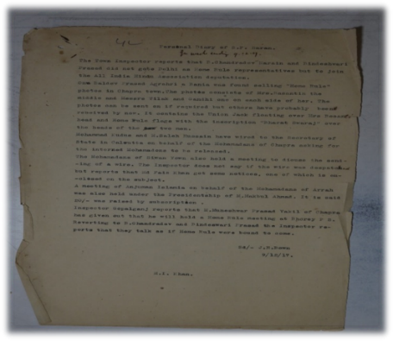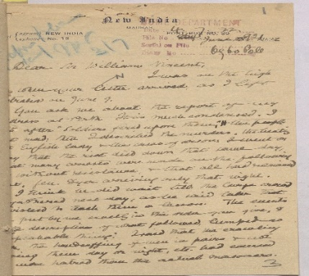
Fig: 01. December 19, 1917: Personal Journal of S.P. Saran (Bihar district) Home Rule Movement by Annie Besant (Original report from Patna Archive), Fig:02. The letter signed by Annie Besant saw here wherein she is requesting the British officer, Sir William Vincent, for an exception from the press and registration of Books Act 1867 for the esoteric school and Masonic books printed by her.

Annie Besant was a beacon of chivalry, discretion, and reason. India, according to her, deserves home rule for two reasons. First, every regular person has the right to that freedom from birth. Second, his egotism was sacrificed for the benefit of the British Empire without his consent. The achievement of self-government is, hence, their primary goal. Independence for India is a requirement for royalty, according to Annie Besant. However, today, India's independence is the condition of India's utility to the empire. Although the home rule movement had a narrow focus and attempted to meld religion and politics, it could not be ignored that it gave the movement new life by removing the direction that had been stagnant owing to the Liberal Congress's passivity. She was placed under house arrest for her call for home rule from June 1917 to September 1917. In 1916, the Congress tried and was successful in bringing together Hindus, Muslims, Sikhs, and Christians. As a result, she also rose to the position of President of the Congress Working Committee in 1917. In 1933, she passed away in Adyar at the age of 86. Tikal and Subhash Chandra Bose claimed that Dr. Annie Besant's efforts, the great fighter for Indian freedom, are the only reason we are now closer to our objectives.
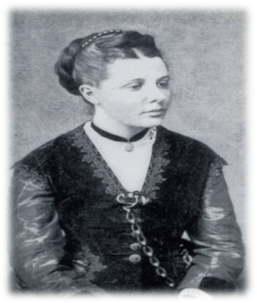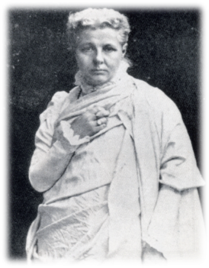
Fig:01 Annie Besant in the 1970s Fig:01 Annie Besant at the Adyar, in 1987

British women's contribution to medical science in Bihar: The following are some organizations that teach Dais or indigenous midwives as part of the contribution of British women to medical science in Bihar. One can also highlight the function of non-governmental organizations here. There were two reputable nonprofit organizations. The Dufferin Fund and the Association of Medical Women in India were the first and second, respectively. The purpose of the Dufferin Fund, aside from creating hospitals for women, was to encourage the study of medicine among women and the latter to produce doctors, nurses, and midwives (Choudhury, 2013, p.144). The Victorian Memorial Scholarship Fund was established by Lady Curzon to "perpetually remember the interest taken by the queen in the domestic problem of Indian women.
British women's contribution to the education system in Bihar: We traced the growth of education in Bihar during British rule through different channels and government acts concerned with female education. Indian National Congress showed since pre-independence time on this subject through the fundamental rights resolution in 1931. They opined- that' our primitive Society was matriarchal, women learned advance, developed the Society through education, before the role of government in the field of female education, there were certain agencies which also worked for the cause of female education. One of the most important among them was the Christian missionaries, who worked hard to spread the light of education to Indian females. At Champa Nagar (Bhagalpur district) in 1904, Mrs. Perfect established a school. In the beginning, it had only seven pupils in its role. The school was a co-educational institution. In 1909, it was converted into an upper primary school under Miss. F.E.Orme. Later, in 1912, it was raised to the middle vernacular standard. At this level, it felt that girls should be separated from boys. The church missionaries society took over the Christian mission's Orphanage at Deogarh, and all girls students, along with its patron Miss Orme, were transferred from Champanagar to Deoghar. There was another school at Deogarh, namely St. Mary’s Girls School. (Choudhury, 2013,190). Report on Mrs.P.E Sidey: - This report was about the Scouts Association at Gaya on November 7, 1942, and counting letters no of both boys and girls participated. As far as white women in Bihar are concerned, I have come across another piece of evidence of Miss Sodamini Devi; she was in charge of the Girl Guides, and Mrs. P.E Sidey was also in charge consisting of small children, primarily from the poor section railway colony at Gaya District Bihar. (Report on anti-home rule in Muzaffarpur and Darbhanga, confidential weekly report Bihar and Orissa Govt. Patna state Achieve).

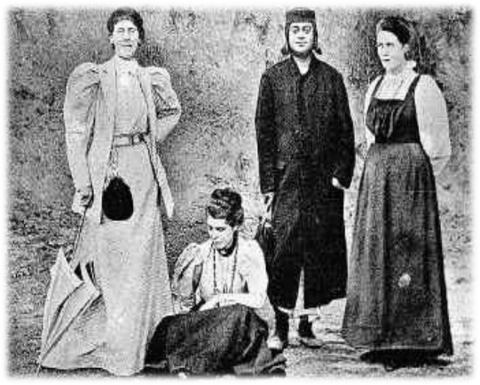
Fig: 01 Swami Vivekananda and Margaret Nobel (right)
Margaret Elizabeth Nobel: - Born in Tyrone, Ireland, in 1867, Margaret Elizabeth Nobel grew up in Ireland and went to Halifax College in England for her education with her sister Mary Noble. She was also a member of Free Ireland, an Irish revolutionary organization. She learned during this period that each country had to chalk out different paths for independence based on its condition, and knowledge helped her immensely in understanding the national Movement in India. Noble heard Swami Vivekananda, reverently known as Swamiji, speak in London 1895. When she heard him again in 1896, she decided to come to India as Swamiji's disciple. Swamiji was an Indian monk and a spiritual leader. As opposed to the Western notion of service to humanity as the goal of an individual, Swamiji put forth the emancipation of the soul as the goal for human beings. Nobel had already begun to question some Christian dogmas and how they answered the question of the soul and the inner –self, and Swamiji's speech promised a way out of her spiritual dilemma. Nobel came to India in 1898 and was soon named Nivedita, meaning dedicated to God, by Swamiji. She spent thirteen years in India working for social reforms, for Bengali women of all castes, and especially for the Indian National Movement. Noble also established the All-India Women Conference in 1927. On behalf of the Women's Association, it argued that not allowing women to participate was indicative of the division of work by sex and was not an adequate explanation; following these protests, women were allowed to participate. While the domestication of the public space and feminizing of general politics facilitated women's emergence, many women pushed further the constructed boundaries. (Bjorkert, 2006, p.30)

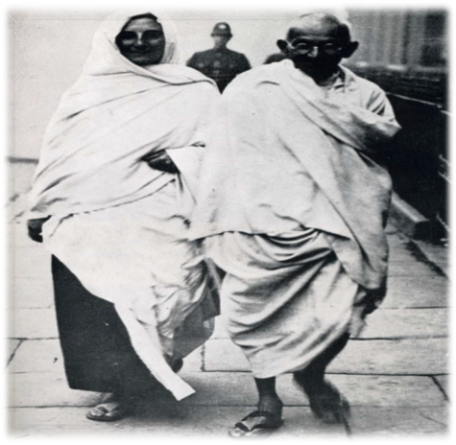
Fig:01Meera Behn with Dr Rajendra Prasad and Fig:02.Meera Behn with Mahatma Gandhiji outside the Ashram
Madeline Slade was born on November 22, 1892, to a wealthy English family and led a very comfortable life, popularly known as Mira Behan, to work for the cause of Indian independence by fully aligning herself with the life and works of Mahatma Gandhi in the freedom struggle had come to India. In the service of India, by sacrificing the life of the Association path, Bharaven also went to England with Gandhiji in 1931. Not only that, but in 1934, she also traveled to Britain and America to gather sympathy for Indians' interests. She has been successful. The truth is that from 1932 to 33 and 1942 to 44, India, she also went to jail twice for freedom. Before coming to India in 1925, Madeline Slade read about India a lot. She wanted this country to be rid of the British, who were against them and through whom the stories of exploitation of India were spread far and wide. His real name was Madeleine Slade and the well-known French romantics of the time loved him very much and called him by that name. He gave him his book Mahatma Gandhi to read. She was very impressed with this book and vowed to be like Gandhi and work for the freedom of India. Not only the Gita But Hindu culture also significantly influenced Madeline; she also adopted the path of celibacy, abandoning alcohol and non-vegetarian food; the Hindi language and the spinning wheel were her favorite things. She also read a lot about the Vedas and other precious texts expressing Indian identity, and she was very much ahead in the Quit India Movement of 1942. She also went to jail. Then, after 1944, when she gradually began to believe that India's independence was not far away, she turned his attention to social problems and initially established a Gaushala in Rishikesh of Ramjula temple. She also decided to work with Gandhi at his ashram in Sabarmati, western India. It was Gandhi who named her Mira Behan, this name adored by nationalists in the Gandhian circle. (Amrendra, 1998, p.68)

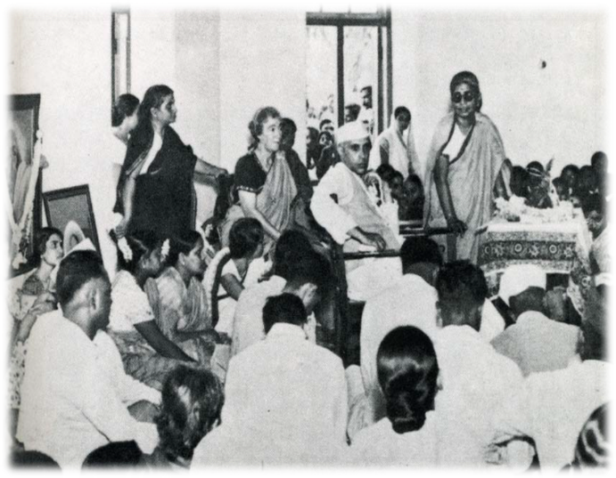
Margaret’s cousin in sari (left), with Jawahar Lal. Nehru in politics
Margaret's cousin: Margaret arrived in India in 1915; she was familiar with Gandhi's ideology of women's reform, though she also had differences with them, which she expressed in her magazine called Stree Dharma. She said that Gandhi should not divide his attention here and there and make a one-point program for the independence of India. This Irish woman created awareness among the women by writing a book titled Aaj Bhi Indin Women and served through the Indian Women's Association. (Amrendra, 1998 p.69). Margaret's cousins, on behalf of the Women's Indian Association, argued that not allowing women to participate was indicative of the division of work by sex and was not an adequate explanation. Following these protests, women were allowed to participate. While the domestication of the public space and feminizing of general politics facilitated women's emergence, many women pushed further the constructed boundaries. (Bjorkert, 2006, p.104)
Nellie Sengupta: In the context of independence, one of the names emerging on the pages of History is also of an English woman named Nelly, who later married an Indian, Nelly Sen, secretly. Hindustan and Hindustani were the two things that were his biggest weakness. She married Yatindra Mohan Das, an Indian, to fulfill her strong desire to embrace them, adopted Khadi, and started selling Khadi. In 1933, when Madan Mohan was arrested, she became the President of the National Congress Committee. He was deeply saddened that despite Gandhi's input, the government. Thousands of Indians who grew in jobs were not in front of tax on the road of independence, Margaret Fuggens and Sister Nivedita. Cousins' names are now probably only on the pages of books, but Sister Nivedita's names are still in people's memories. So far, it is very fresh. Cousins arrived in India in 1915. She was familiar with Gandhi's ideology of women's reform, though she differed from them. Neti has expressed these things in her magazine called Stree Dharma; she also said that Gandhi should not divide his attention here and there and make a one-point program for the independence of India. This Irish woman created awareness among women by writing a book titled “Aaj Bhi Indian Women" and served through the Indian Women's Association. Mother Meera Adherer was one of the Western women who traveled to India in 1914. After meeting Mahatma Aurobindo, she was working towards a lifetime of interest in and struggle for India. Many foreign women pursued their material pleasures this way and traveled to India. She battled for her life and persisted in battle to safeguard the welfare. These British women significantly contributed to the fight for independence and its underlying ideologies. The British at the time found this thing to be very striking. However, something about British culture encourages people to advocate for justice and grow their trust in emancipation. He contributed to these English-Irish women. All these foreign women served as role models for Indian women. She will continue to be revered and treated with respect.
Analysis and observation: The arrival of white women serving as Christian missionaries benefited Indian women greatly in South Asian countries. British women promoted Western lifestyles and scientific thinking, also helped them to learn indigenous scriptures and text such as Sanskrit, Mahabharata, Ramayana, eventually which influenced not only their individual domestic lives but also encouraged them to leave the house to become economically independent, strengthened them to become aware of women's rights, and encouraged them to work hard to shoulder to shoulder with their man. This was not an isolated phenomenon, for despite British women's significant and active roles during the Second World War, subjection, encroachment, and discrimination remain.
Conclusion :Thus in nut shell, it is concluded from the above discussion and various narratives on women that the arrival of numerous foreign women who lived in India sacrificed their entire lives and fought for the Indian people to improve the condition of women through social reform, sanitation, and other means.

Referring notes:
- Bhattacharjee. British Women's Views of 20th-Century India: An Examination of Barriers to Cross-Cultural Understandings, Dharitri, Thesis, Miami University Oxford, Ohio, 2007.
- Women in the Indian National Movement: Unseen Faces and Unheard Voice, 1930–42, 2006, Bjorkert Suruchi Thapar, Sage publication, New Delhi.
- Stories of Women: Gender and Narrative in a Postcolonial Nation by BOEHMER ELLEKE, Manchester University Press, 2005.
- India Since Independence,2008, Bipan Chandra, Penguin Books, New Delhi.
- Kumari Jayawardena, 2016, The White Women’s Other Burden, Western Women and South Asia During British Rule, Routledge, Taylor &Francis Group, London and New York
- Kumar. Amrendra,1998, Swatantra Sangram Mai Bihar Ki Mahila, Janki Prakashan, Patna.
- Historiography by Meher.Kyeshma Sagar, 2008, Neeraj Publication, New Delhi.
- Indian Women Throughout the Ages, 2013, Singh Choudhary, Janaki Prakashan Patna.
- Unseen and unheard women warriors of independent India, 2013, SUNDARAM BHAVANI.
- Bihar Political (Special) Department Patna Archive File No. 1916
- Bihar Political (Special) Department Patna Archive File No. 1942

