**PROSPECTS OF PROCESSING AND VALUE ADDITION IN SUPERFOODS**

**Archana Y. Kalal1, Udaykumar Nidoni2, Sharanagouda Hiregoudar2 and Pramod Katti3**

1Ph. D. (Agril. Engg.), Dept. of Processing and Food Engineering, College of Agricultural Engineering, University of Agricultural Sciences, Raichur-584102

2Professor, Dept. of Processing and Food Engineering, College of Agricultural Engineering, University of Agricultural Sciences, Raichur-584102

3Professor and Administrative Officer, University of Agricultural Sciences,   
Raichur-584102, Karnataka

**Abstract**

In our global landscape, where the quest for healthier and cleaner sources of nutrients is imperative, superfoods emerge as vital players. These remarkable foods, characterized by their exceptional concentrations of nutrients and bioactive compounds, possess outstanding nutritional and biological value. They exhibit impressive bioavailability and bioactivity within the body, making them significant contributors to overall well-being. Superfoods also align closely with the principles of sustainability, encompassing economic, environmental, and social considerations, primarily in the context of meeting nutritional requirements (Fernandez-Rios *et al.,* 2022). Although there is no official, universally accepted definition for the term "superfood" within scientific or legal realms, it is informally used to describe foods that offer abundant nutrients, hold a pivotal role in dietary health, and contribute to the optimal functioning of the human body (AESAN, 2019). These foods are typically classified using the FoodEx system proposed by EFSA (EFSA, 2011). One such superfood is quinoa (*Chenopodium quinoa* Willd.), an annual herbaceous plant, often referred to as a pseudocereal, originally cultivated in the Andes region of South America. Quinoa undergoes a multi-step processing journey, including seed separation, washing, drying, milling, crushing, and sieving, resulting in processed seeds, quinoa flour, and semolina (Hirich *et al.,* 2021). This versatile ingredient has been employed in traditional South American dishes like Phiri, Chiwa, and Qusa, as well as in contemporary industrial food products such as quinoa pasta, flakes, and noodles (Angeli *et al.,* 2020).

Teff (*Eragrostis tef*), another superfood, hails from tropical Africa. Prior to its utilization in various food items like bread, unleavened bread, cookies, cakes, and extruded products, teff seeds are meticulously processed into fine flour particles. In Ethiopia, injera, a flatbread renowned for its pancake-like texture and softness, is a widely consumed teff-based product (Bultosa, 2007). Teff seeds also undergo fermentation to produce traditional Ethiopian alcoholic beverages like Arake, Shamit, and Tella (Gebremariam *et al.,* 2014). Chia seeds (*Salvia hispanica* L.), often simply referred to as chia, originate from annual plants native to southern Mexico and Northern Guatemala. Mexico stands out as the world's leading chia producer. Chia seeds offer numerous health benefits, including support for the digestive system, skin health, enhanced bone and muscle strength, as well as a reduced risk of heart disease and diabetes (Grancieri and Martino, 2019). Queens Quinoa, a company founded by entrepreneur Ms. Monika Goyal in 2013, specializes in quinoa production and value-added products. It holds the distinction of being the first Indian brand to introduce 100% Organic, Non-GMO Project Verified, and Vegan-Friendly Quinoa products. Furthermore, the company boasts a state-of-the-art processing facility dedicated to the production of value-added quinoa products such as pasta, noodles, and flakes ([www.queensquinoa.com](http://www.queensquinoa.com)). Superfoods, primarily derived from plant sources, are known for their exceptional nutritional density and minimal calorie content. These foods exhibit robust biological activity and possess significant nutritional potential, playing a pivotal role in the prevention of chronic diseases. Exploring the extraction of bioactive components and their integration into various food applications holds promise for the development of health-promoting foods within the food processing sector.

1. **Introduction**

In recent years, the concept of "superfoods" has gained increasing recognition as a potential remedy for the urgent challenge of addressing the complex interplay between diet, the environment, and health on a global scale. It's worth noting that there is no official, scientifically defined, or legally regulated term for "superfood" within the framework of food safety regulations. Instead, it is a colloquial term used to describe foods that have the potential to provide substantial quantities of nutrients, are essential components of diets, and support overall bodily well-being (AESAN, 2019). Superfoods, characterized by their remarkable nutritional and biological value, along with their exceptional concentrations of nutrients and bioactive compounds, can play a pivotal role in the global effort to identify healthier and more sustainable sources of nutrition. These foods are intricately connected to the concept of sustainability, which entails achieving economic, environmental, and social equilibrium, primarily through the provision of nutritional requirements. Superfoods stand out as exceptional foods with the capacity to prevent various health issues, fortify the immune system, and supply essential macro- and micronutrients in significant quantities (Jagdale *et al.,* 2021). According to the Oxford English Dictionary, a superfood is described as a meal that is "considered particularly nutritious or beneficial" (Meyerding *et al.,* 2018).

Numerous studies suggest that superfoods are an excellent means of promoting overall health. They accomplish this by bolstering the immune system, increasing the production of hormones like serotonin, and supporting the smooth functioning of the body's biological systems (Proestos, 2018). Some experts liken these foods to specific products that serve similar roles, positioning them as foods that go beyond mere dietary sustenance but fall short of being categorized as medications (Fig. 1) (Santini and Novellino, 2014). For instance, they are often likened to functional foods (Samec *et al.,* 2019), which resemble regular dietary items, are consumed as part of a typical diet, and provide health benefits, such as reducing the risk of disease and positively impacting specific bodily functions beyond basic nutritional requirements (Doyon and Labrecque, 2008). Superfoods are also associated with nutraceuticals, which are defined as foods or components of a diet that deliver medicinal benefits, such as disease prevention and treatment (Santini *et al.,* 2018). On the other hand, some argue that superfoods differ from functional foods due to their discourse emphasizing 'natural' nutrient density alongside 'traditional' and 'exotic' qualities, as functional foods are often enriched with bioactive compounds known for their immune-boosting and functional properties (Picone *et al.,* 2022). Consequently, they warrant distinct consideration (Loyer and Knight, 2018). Given the ongoing debate surrounding the concept of superfoods, this review adheres to the most common informal definition, which characterizes them as food products containing unusually high levels of specific nutrients (AESAN, 2019). From this perspective, a superfood must be a unique, singular food item, not a multi-compound product, and must remain 'natural,' meaning it hasn't undergone human intervention to introduce additional ingredients, supplements, or nutrients.

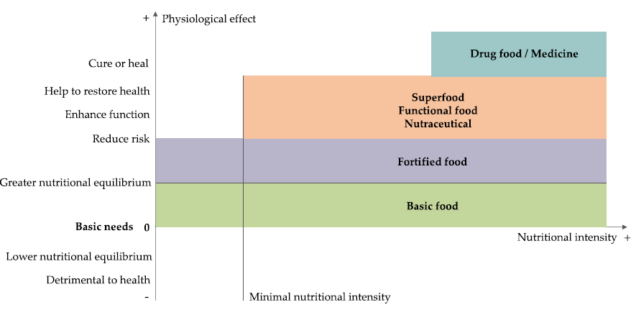

**Fig. 1. Boundaries defining food categories (Doyon and Labrecque, 2008)**

1. **Classification of Superfoods**

They were classified and organized into a list using the FoodEx classification system, which was introduced by EFSA in 2011. The FoodEx system is structured hierarchically, comprising 20 primary food categories that are further subdivided into subgroups. This system encompasses a wide range of both natural and processed foods and beverages. However, it's worth noting that the selected foods fell within only six of the 20 defined categories within the FoodEx classification system. These categories include:

1. Fruits and fruit products

2. Vegetables and vegetable products (including fungi family)

3. Grains and grain-based products

4. Starchy roots and tubers

5. Legumes, nuts, and seeds

6. Herbs, spices, and condiments.

Additionally, an additional category labelled as 'others' was introduced to accommodate food products that do not align with the existing categories in this classification system. This 'others' category was designed to encompass items like algae or bee products that may not have specific categorizations within the standard framework.

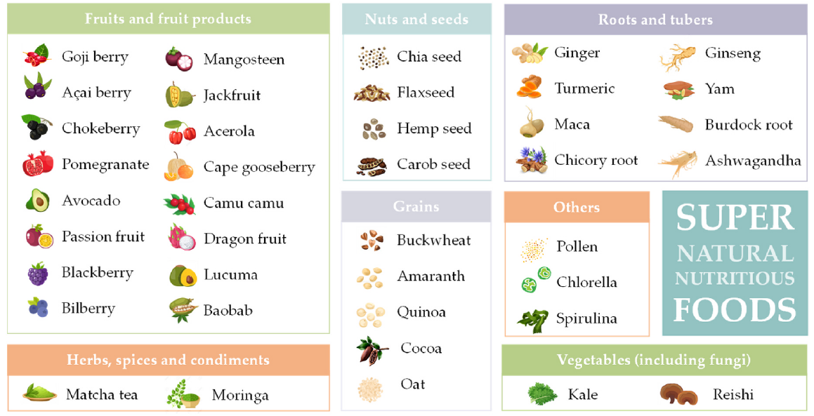

**Fig. 2. Classification of Superfoods in food categories (Fernandez-Rios *et al*., 2022)**

1. 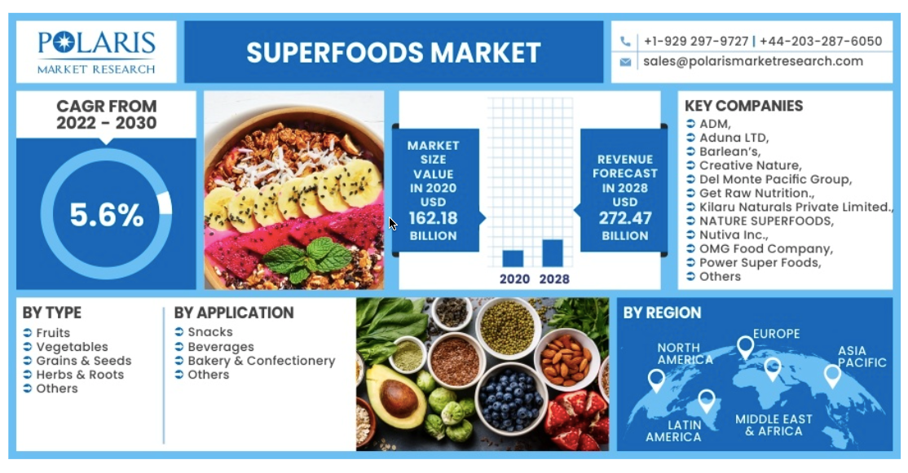**MARKET OF SUPERFOODS**

(www.polarismarketresearch.com)

**Fig. 3. Market of Superfoods (**[**www.polarismarketresearch.com**](http://www.polarismarketresearch.com)**)**

**Quinoa Production worldwide from 2010 to 2020 (MT)**

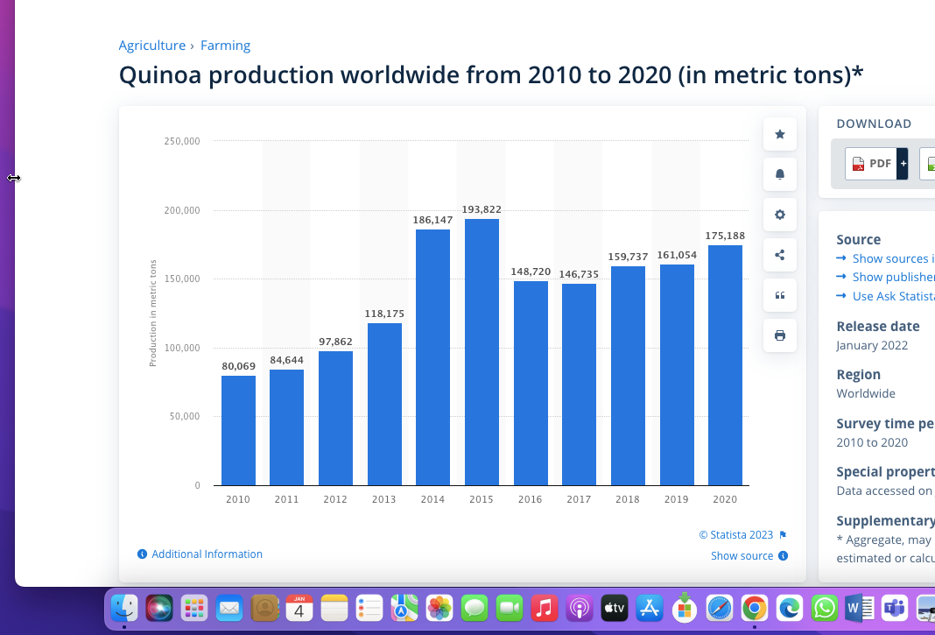

**Fig. 4. Quinoa worldwide production (www.statista.com)**

1. **DIFFERENT SUPERFOODS**

**QUINOA**

Quinoa, a highly nutritious grain, boasts a rich history of cultivation in the Andes of Bolivia and Peru, spanning back 5,000 to 7,000 years. In recognition of its significant potential, the United Nations declared the year 2013 as the International Year of Quinoa (Tang *et al.,* 2015). This exceptional grain is distinguished by its impressive nutritional profile, including a high protein content, the presence of all essential amino acids, unsaturated fatty acids, and a low glycemic index (GI). Additionally, quinoa is a source of essential vitamins, minerals, and other beneficial compounds, making it a valuable dietary choice. Notably, quinoa is essentially gluten-free, and its versatility in cooking and ease of preparation further enhance its appeal (Vega-Galvez *et al.,* 2010).

**History**

Quinoa has a remarkable history of cultivation spanning millennia in the Andean regions of Bolivia and Peru (Jancurova *et al.,* 2009). It goes by various local names, but it's commonly known as quinoa (with "quinoa" being the Quechua word) (Vega-Galvez *et al.,* 2010). In the eyes of the Incas, this plant held a special status, often referred to as the "mother grain." It was regarded as a divine gift and was even employed for medicinal purposes. Traditional uses of quinoa included roasting and cooking the seeds, incorporating them into soups, using them as a cereal, and fermenting them to create beer and chichi, a traditional Andean beverage (Vega-Galvez *et al.,* 2010). However, following the Spanish conquest of South America, quinoa faced a shift in perception. European settlers labelled it as a staple of peasants or indigenous populations, leading to a decline in its social status. Additionally, the Catholic Church frowned upon the use of quinoa as a sacred drink (mudai) in indigenous religious ceremonies and actively discouraged its cultivation. Consequently, quinoa survived only in regions inaccessible to European influence, while other cereals replaced it in more accessible areas (Vega-Galvez *et al.,* 2010).

**Botanical description and cultivation**

Quinoa, scientifically known as *Chenopodium quinoa* Willd, belongs to the Chenopodium family, which also encompasses plants like Swiss chard (Beta sp.), spinach (*Spinacia oleracea*), and lamb's quarter (*Chenopodium album*). Quinoa is classified as a dicotyledonous plant, typically reaching heights ranging from 1 to 3 meters. It's important to note that quinoa is regarded as a pseudocereal, which means it produces a fruit rather than a true seed. The seeds of quinoa are characterized by their round and flat shape, measuring approximately 1.5 to 4.0 mm in diameter. They exhibit a diverse colour spectrum, ranging from white to grey, black, and various shades of yellow, pink, red, purple, and violet (see Fig. 5) (Gordillo-Bastidas *et al.,* 2016). Quinoa displays remarkable resilience, thriving in a wide range of conditions, including salty, acidic, alkaline, and cold climates (as low as -5°C) or warm environments (up to 35°C) (Jancurova *et al.,* 2009). Furthermore, it is known for its hardiness and drought resistance, with an annual irrigation and rainfall requirement of 25 to 38 cm, significantly less than that of other crops like wheat and rice (Jacobsen *et al.,* 2003). Currently, there exist over 250 quinoa varieties, with the most widely cultivated ones including Bear, Vanilla Cherry, Cochabamba, Dave 407, Gossi, Isluga, Kaslala, Kcoito, Linares, Puno, Titicaca, Rainbow, Red lighthouse, and Red head, along with Temuco (Sobota *et al.,* 2020). Classification of these varieties is typically based on factors such as plant and fruit color or plant morphology (Jancurova *et al.,* 2009). It's worth noting that quinoa is authorized for cultivation in regions spanning Europe, North America, Asia, and Africa.

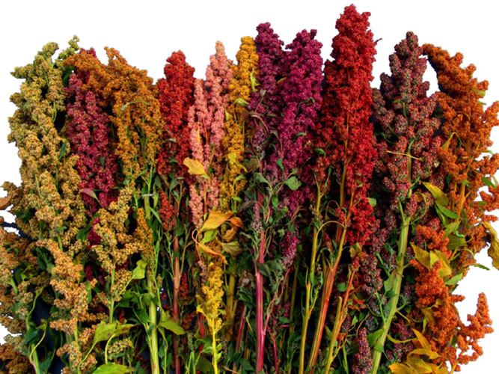

**Fig. 5. *Chenopodium quinoa* plants with varying fruit colors**

**Botanical distinction from cereal grains**

While quinoa is often mistaken for grains like rice, corn, and wheat, which belong to the Poaceae family (monocots), it is correctly classified as a "pseudograin." This distinction arises from the fact that quinoa belongs to the Amaranthaceae family (formerly known as *Chenopodiaceae*). As a result, it holds a systematic and morphological differentiation from true cereals. One of the most noticeable distinctions lies in the unique structure of quinoa's fruit and seed. Quinoa's fruit is categorized as an achene, consisting of a single seed enclosed by an outer pericarp. Within quinoa seeds, there is a central endosperm that serves as a local storage site for carbohydrates. This endosperm is enveloped by a circular region rich in both oil and protein, comprising the embryo and the seed coat (Prego *et al.,* 1998). Notably, the pericarp of quinoa fruit contains bitter saponins, which must be eliminated through mechanical grinding or washing before the seeds can be consumed (Prego *et al.,* 1998; Vega-Galvez *et al.,* 2010). This process, known as desaponification or dehusking, pearling, or milling, is essential for making quinoa palatable. From a nutritional perspective, quinoa is classified as a "whole grain. However, unlike traditional grains that are typically processed to remove the nutrient-rich germ and bran, quinoa desaponification leaves the nutrient-rich embryo and endosperm intact. These embryos, which can constitute up to 60% of the seed's weight, provide a well-balanced nutritional profile, including proteins, lipids, and carbohydrates.

**Traditional use**

Quinoa has held a significant place in the traditions of various indigenous peoples of South America, including the Quechua, Aymara, Tiahuancota, Chibcha, and Mapuche communities (Vega-Galvez *et al.,* 2010). These versatile seeds have been consumed in a multitude of ways, such as being prepared like rice, added to hearty soups, transformed into puffed grains for breakfast cereals, or ground into flour to craft a range of delectable toasted and baked goods, including cookies, bread, biscuits, noodles, flakes, tortillas, and pancakes. Quinoa leaves are enjoyed as a spinach substitute, and sprouted quinoa seedlings, known as quinoa sprouts, make delightful additions to salads. Furthermore, quinoa seeds have the potential to be fermented to create beer or a traditional South American ceremonial alcoholic beverage known as chicha.

The utility of the entire quinoa plant extends beyond human consumption, as it serves as a valuable nutrient source for livestock like cattle, pigs, and poultry. Historical records also reflect a diverse range of medicinal applications for quinoa, from its use in treating wounds and bone fractures to its role in promoting gastrointestinal health. Quinoa has long been held in high esteem for its capacity to uplift, promote health, and enhance endurance. In the Andean regions, a pungent ash created from quinoa stalks, known as "llipta," was mixed with coca leaves (*Erythroxylum coca* Lam) and chewed by local farmers to sustain their energy levels. Additionally, a mixture of quinoa and fat, known as "war balls," was prepared to provide support to Inca troops during their arduous marches through the Andes Mountains.

1. **Functional potential of quinoa for human health**

Quinoa stands out not only for its exceptional nutritional value and gluten-free nature but also for its positive impact on individuals in high-risk categories, including children, the elderly, those with lactose intolerance, anemia, diabetes, obesity, dyslipidemia, and celiac disease. These benefits stem from quinoa's rich composition of proteins, fiber, vitamins, minerals, and fatty acids, with particular emphasis on its substantial quantities of phytochemicals. These phytochemicals provide quinoa with significant nutritional and health advantages over other grains (Navruz-Varli andSanlier, 2016). Figure 6 displays the bioactive compounds found in quinoa, along with their reported bioactivity. The outer shell of quinoa seeds is notably abundant in bitter saponins, which, despite their unpalatable bitterness and impact on digestibility, exhibit a wide array of biological activities. These activities encompass antifungal, antiviral, anticancer, cholesterol-lowering, hypoglycemic, antithrombotic, diuretic, and anti-inflammatory effects (Graf *et al.,* 2015). Interestingly, the total quinoa saponin fraction has been observed to mildly inhibit the growth of *Candida albicans* (Woldemichael *et al.,* 2016). Quinoa also showcases robust antioxidant properties, primarily attributable to its high phenolic compound content (Abderrahim *et al.,* 2015). Over 20 different phenolic compounds have been identified in both free and conjugated forms, with the majority being phenolic acids like vanillic acid and ferulic acid and their derivatives. Quinoa also contains flavonoids such as quercetin, kaempferol, and their glycosides (Tang *et al.,* 2015). These compounds contribute to the overall health-promoting qualities of quinoa.

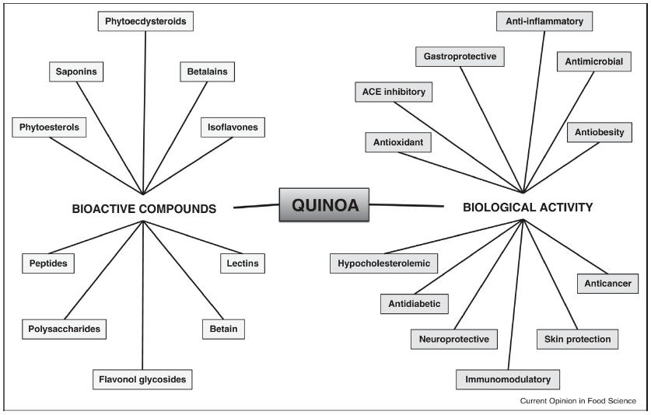

**Fig. 5 Bioactive compounds and biological activities of Quinoa (Vilcacundo and Hernandez-Ledesma, 2017)**

In addition to their antioxidant properties, these components found in quinoa have been documented to exhibit inhibitory effects on α-glucosidase and pancreatic lipase enzymes (Tang *et al.,* 2016). Another notable group of compounds in quinoa are phytoecdysteroids, which are polyhydroxylated steroids believed to play a role in plant defense due to their structural similarity to insect molting hormones. Beyond their role in plant defense, phytoecdysteroids offer a broad spectrum of health benefits, including anabolic effects, performance enhancement, anti-osteoporosis properties, anti-diabetic effects, anti-obesity attributes, and the ability to promote wound healing (Graf *et al.,* 2014). Quinoa stands out as one of the richest food sources of phytoecdysteroids, with concentrations ranging from 138 to 570 mg/g and comprising 13 different phytoecdysteroid types. Among these, 20-Hydroxyecdysone (20HE) is the most prevalent, accounting for 62-90% of the total quinoa phytoecdysteroid content (Graf *et al.,* 2015). An extract of quinoa rich in 20HE has demonstrated its potential to reduce fasting blood glucose levels in hyperglycemic obese rats (Graff *et al.,* 2014). This highlights quinoa's role in offering health benefits related to phytoecdysteroids, particularly in terms of managing blood glucose levels.

**Table 1. Composition and Nutritional Attributes (per 100 g) (USDA, 2019)**

|  |  |  |  |  |  |  |  |  |  |  |
| --- | --- | --- | --- | --- | --- | --- | --- | --- | --- | --- |
| Nutrient |  | Black  cumin |  |  |  |  |  |  |  | |
| Unit | Chia | Flax | Hemp | Perilla | Pumpkin | Quinoa | Sesame | |
| **Proximate composition** | | | | | | | | | |
| Moisture | g | 7.06 | 5.80 | 6.96 | 4.96 | 4.60 | 5.23 | 13.28 | 4.69 | |
| Energy | kCal | 430.00 | 486.00 | 534.00 | 553.00 | 530.00 | 559.00 | 368.00 | 573.00 | |
| Protein | g | 21.50 | 16.54 | 18.29 | 31.56 | 22.68 | 30.23 | 14.12 | 17.73 | |
| Lipid (fat) | g | 27.11 | 30.74 | 42.16 | 48.75 | 39.74 | 49.05 | 6.07 | 49.67 | |
| SFAs | g | 4.08 | 3.33 | 3.66 | 4.60 | 2.94 | 8.66 | 0.71 | 6.96 | |
| MUFAs | g | 5.99 | 2.31 | 7.53 | 5.40 | 4.93 | 16.24 | 1.61 | 18.76 | |
| PUFAs | g | 15.99 | 23.66 | 28.73 | 38.10 | 29.98 | 20.98 | 3.29 | 21.77 | |
| Ash | g | 3.93 | 4.80 | 3.72 | 6.06 | 3.72 | 4.78 | 2.38 | 4.45 | |
| Carbohydrates | g | 40.40 | 42.12 | 28.88 | 8.67 | 29.26 | 10.71 | 64.16 | 23.45 | |
| Dietary fiber | g | 30.67 | 34.40 | 27.30 | 4.00 | 22.00 | 6.00 | 7.00 | 11.80 | |
| Sugar | g | 3.27 | tr | 1.55 | 1.50 | 1.46 | 1.40 | tr | 0.30 | |
| Starch | g | 0.12 | – | – | – | – | 1.47 | 52.22 | – | |
| **Minerals** | | | | | | | | | |
| Calcium | mg | 477.00 | 631.00 | 255.00 | 70.00 | 391.00 | 46.00 | 47.00 | 975.00 | |
| Copper | mg | 1.07 | 0.92 | 1.22 | 1.60 | 1.21 | 1.34 | 0.59 | 4.08 | |
| Iron | mg | 14.03 | 7.72 | 5.73 | 7.95 | 7.74 | 8.82 | 4.57 | 14.55 | |
| Magnesium | mg | 285.00 | 335.00 | 392.00 | 700.00 | 254.00 | 592.00 | 197.00 | 351.00 | |
| Manganese | mg | 3.21 | 2.72 | 2.48 | 7.60 | 3.70 | 4.54 | 2.03 | 2.46 | |
| Phosphorus | mg | 697.00 | 860.00 | 642.00 | 1650.00 | 716.00 | 1233.00 | 457.00 | 629.00 | |
| Potassium | mg | 768.00 | 407.00 | 813.00 | 1200.00 | 583.00 | 809.00 | 563.00 | 468.00 | |
| Selenium | μg | 0.01 | 55.20 | 25.40 | – | 1.16 | 9.40 | 8.50 | 34.40 | |
| Sodium | mg | 10.69 | 16.00 | 30.00 | 5.00 | 1.00 | 7.00 | 5.00 | 11.00 | |
| Zinc | mg | 5.66 | 4.58 | 4.34 | 9.90 | 4.80 | 7.81 | 3.10 | 7.75 | |

1. **Quinoa Processing**

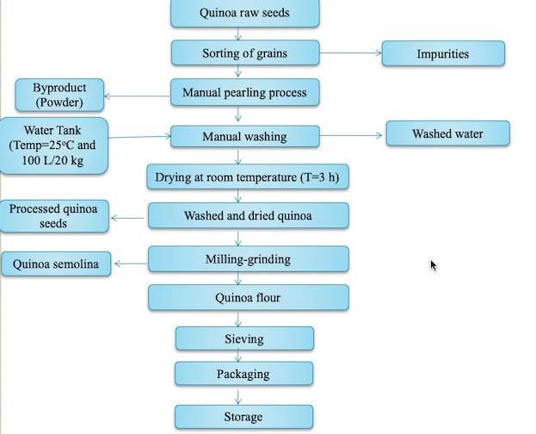

**Fig. 6 Flow chart of Quinoa Processing (Hirich *et al*., 2021)**

**Quinoa-Derived Food Items and Beverages**

**Table 2. Dishes and Beverages Made from Quinoa in Traditional Cuisine (Bojanic, 2011)**

|  |  |
| --- | --- |
| **Product** | **Description** |
| Quinoa Soup | Quinoa and meat stew with tubers and vegetables |
| Lawa | Porridge-like dish with raw flour, lime water, and animal fat |
| Pesque | Cooked quinoa grains, served with milk or grated cheese |
| Kispina | Steamed quinoa buns |
| Tacti o tactacho | Fried quinoa buns, resembling doughnuts, made from flour and fat |
| Mucuna | Quinoa flour balls, steamed and filled with seasoning |
| Phiri | Roasted quinoa flour, slightly moistened |
| Phisara | Lightly roasted and cooked quinoa grains |
| Qusa | Quinoa chicha, a chilled macerated drink |
| El Ullphu, Ullphi | Cold beverage prepared with roasted quinoa flour |
| Kaswira de quinua | Flattened bread fried in oil with lime and white quinoa |
| Kaswira de ajara | Flattened bread fried in oil with lime and black quinoa or ajara |
| Quichi quispina | Steamed and fried bread, combining katahui and quinoa flour |
| Juchcha | Andean soup prepared with ground quinoa and katahui |
| Chiwa | Young quinoa leaves used as a salad and soup ingredient |

**Table 3. Clinical trials on the effect of quinoa products in human health (Vilcacundo and Hernandez-Ledesma, 2017)**

|  |  |  |  |  |  |
| --- | --- | --- | --- | --- | --- |
| **Study participants** | **Treatment** | **Duration** | **Outcomes** | **Conclusions** | **Reference** |
| 50-65 month old boys | 100 g quinoa-added baby food | 15 days | Increase of IGF-1 | Have Potential role in reducing  childhood malnutrition | Foucault *et al*. (2011) |
| 22 students (18-45 years old) | Quinoa cereal bars | 30 days | Reduce the level of triglycerides, total cholesterol and LDL levels Reduce the (no significant) blood glucose and pressure, and body weight | Potential role in preventing  cardiovascular disease | Ruales *et al*. (2002) |
| 35 post-menopausal overweight women | 25 g quinoa flakes and cornflakes | 4 weeks | Reduction of triglycerides,TBARS and vitamin E Increase of urinary secretion of enterolignans  Decrease of total cholesterol and LDL  Increase in GSH | Beneficial effect on metabolic  parameters modulation | Farinazzi-Machado *et al*. (2012) |
| 19 celiac patients | 50 g quinoa | 6 weeks | Improve the histological and  Serological parameters, Mild hypocholesterolemic effect | Quinoa consumption is considered safe for celiac individuals | De Carvalho *et al*. (2014) |

**Quinoa protein concentrate**

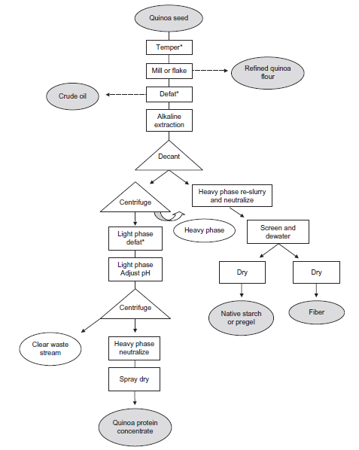

**Fig. 7 Pilot-Scale Production Process for Quinoa Protein Concentrate and Supplementary Ingredients (Crude Oil, Starch, Fiber, Refined White Flour)**

1. **TEFF**

Africa boasts a diverse array of relatively unexplored cereal species, including teff and various millet varieties. Ethiopia, a significant center for the origin and diversity of these grains, dedicates approximately 3 out of 8 million hectares of land to cereal production, resulting in an annual yield of approximately 3.8 million tons (Girma *et al.,* 2014). These grains serve as vital sources of protein, carbohydrates, fiber, vitamins, and minerals. They undergo fermentation to produce a wide range of foods and beverages, characterized by enhanced texture, flavor, aroma, extended shelf life, improved nutritional content, increased digestibility, improved microbial quality, and reduced levels of anti-nutrients (National Research Council, 1996).

Teff (*Eragrostis tef* (Zuccagni) Trotter) belongs to the tropical cereal grain category within the Poaceae family, subfamily Eragrostoidae, tribe Eragrostae, and the genus Eragrostis. While the genus Eragrostis encompasses around 350 species (Demissie, 2000), teff stands as the cultivated species of significance. Chloridoideae is a synonymous term sometimes used interchangeably with Eragrostoidae teff (Costanza *et al.,* 1980). Varieties of teff are identified and characterized based on various factors such as seed and inflorescence color, inflorescence branching, and plant size. For marketing purposes, teff is classified primarily by the color of its seeds, resulting in categories such as netch (white), gey (red/brown), and sergegna (mixed) (Tefera *et al.,* 1995).



**Fig. 8 Teff grain: Longitudinal section with germ and endosperm (SEM image) (Helbing 2009)**

Teff seeds are devoid of hulls (commonly referred to as naked seeds) and display a spectrum of colors, ranging from a creamy white to nearly a deep brown hue. The most prevalent colors include white, cream-white, light brown, and dark brown. The term "teff" is thought to have originated from the Amharic word "teffa," which translates to "lost," reflecting the small size of the seeds, making them prone to being easily misplaced if dropped. These seeds are oval-shaped, measuring between 0.9 to 1.7 mm in length and 0.7 to 1.0 mm in diameter. Each individual seed generally weighs in the range of 0.2 to 0.4 mg, possibly making teff seeds the smallest among carbohydrate-rich seeds (Belay *et al.,* 2009; Bultosa, 2007).

Teff exhibits remarkable adaptability to a wide array of environmental conditions (National Research Council, 1996) and is renowned for its high resistance to pests. When shielded from direct exposure to moisture and sunlight, teff seeds can remain viable for several years (Gamboa and Ekris, 2008). In comparison to other commonly cultivated grains, teff grains are less susceptible to infestations by weevils and other storage pests (Tadesse, 1969). Consequently, teff can be safely stored under standard storage conditions without the need for chemical preservatives.

**Climatic and soil requirements**

In Tigray, Ethiopia, teff is traditionally sown using wet seedlings during the peak rainy season, typically from the third week of July to the first week of August. This planting approach allows farmers to achieve favorable seedling establishment and helps prevent stem fly infestations. The entire growing season spans approximately 80-85 days, with the initial 40-50 days characterized by heavy rainfall. Key phases of teff growth, including flowering and crop development, usually coincide with the dry season towards the end of this period. During this dry season, teff is provided with adequate irrigation to support optimal growth (Araya *et al.,* 2010). In the United States, teff is classified as a warm-season annual crop due to its susceptibility to freezing temperatures at all stages of growth (Norberg, 2008). The ideal temperature range for teff's growth and development falls between 15-21°C. According to Yumbia's findings in 2014, teff can thrive within a temperature range of 13.2°C to 25.2°C annually. Their projections suggest that these figures may shift to 14.9°C and 26.7°C by the year 2050. Temperatures below 10°C are unsuitable for teff seed germination and seedling establishment. Teff is characterized as a short-day plant utilizing the C4 photosynthetic pathway.

Regarding rainfall, teff's growth is constrained by minimum and maximum precipitation levels of 550 mm and 1770 mm, respectively. Projections from their model indicate that in favorable climate zones, the precipitation threshold could shift to a range between 600 mm and 600 mm by the year 2050. Teff exhibits optimal growth between altitudes of approximately 1300 m to 2800 m, yet it can endure conditions up to 3400 m above mean sea level (NRC, 1996). While teff demonstrates drought tolerance, its productivity is notably higher under favorable rainfed conditions, making water availability a primary limiting factor. Tefera and Belay (2006) have indicated that neutral to slightly acidic soils are most suitable for teff cultivation. The plant is commonly grown in sandy loam soils, but with proper drainage and sufficient nitrogen fertility, it can also thrive in heavy black clay soils (Tefera and Belay, 2006).

**Table 4. The proximate (db1) and microelement compositions of teff grain compared with some gluten containing and gluten free cereals**

|  |  |  |  |  |  |  |  |  |
| --- | --- | --- | --- | --- | --- | --- | --- | --- |
| Component | Gluten rich cereals | | | Gluten-free cereals | | | | |
|  | Barley | Wheat | Rye | Teff | Maize | Brown rice | Sorghum | Pearl millet |
| Starch (%) | 60.6 | 71.0 | 69 | 73.0 | 72 | 64.3 | 62.9 | 67.0 |
| Crude protein (%) | 11.1 | 11.7 | 7.98 | 11.0 | 8–11 | 7.3 | 8.3 | 11.5 |
| Crude fat (%) | 3.2 | 2.0 | 1.98 | 2.5 | 4.9 | 2.2 | 3.9 | 4.8 |
| Moisture (%) | 10.6 | 12.6 | – | 10.5 | 14.0 | 14.0 | 14.0 | 9.5 |
| Ash (%) | 2.4 | 1.6 | 1.72 | 2.8 | 1.4 | 1.4 | 1.6 | 1.7 |
| Crude fiber (g/100 g) | 3.7 | 2.0 | 1.56 | 3.0 | – | 0.6–1.0 | 0.6 | 0.5 |
| Food energy (kJ/100 g) | – | 1105 | - | 1406 | ­- | - | - | - |
| Calcium (mg/100 g) | 3 | 39.45 | 31.5 | 165.2 | 48.3 | 6.85 | 50 | 46 |
| Copper (mg/100g) | 0.52 | 0.23 | - | 2.6 | 1.3 | 0.16 | 0.41 | 1.06 |
| Iron (mg/100 g) | 2.43 | 3.5 | 2.7 | 15.7 | 4.8 | 0.57 | 6 | - |
| Magnesium (mg/100 g) | 94.3 | 103.5 | 92 | - | 181.0 | 16.88 | 180.0 | 137 |
| Manganese (mg/100 g) | 8.97 | 0.95 | - | 3.8 | 1.0 | 0.36 | - | - |
| Phosphorus (mg/100 g) | 563 | – | 359 | 425.4 | 299.6 | 61.7 | 263.3 | 379 |
| Potassium (mg/100 g) | 507 | – | 412 | 380.0 | 324.8 | 181.71 | 225.23 | - |
| Sodium (mg/100 g) | 25.4 | – | - | 15.9 | 59.2 | 0.54 | 6.18 | - |
| Zinc (mg/100 g) | 2.2 | 1.94 | 3.0 | 4.8 | 4.6 | 2.0 | 2.0 | 3.1 |

**Food and feed utilization of Teff**

Teff seeds undergo a milling process to create fine flour particles, which are subsequently employed in the production of a diverse range of food items. These include bread, unleavened bread, cookies, cakes, macaroni, baby food, pudding, and extruded products. Moreover, in many local households, the teff grains themselves are utilized for culinary purposes, either in the form of porridge or through frying (Arnett and Zanini, 2013). One of the most prominent teff-based products in Ethiopia is injera, a flatbread known for its pancake-like texture and soft consistency (Bultosa, 2007). The preparation of injera typically involves fermenting teff flour with water and specific bacteria, resulting in a mild yeast dough. Both white and red/brown teff seeds are ground into flour to produce injera, showcasing the versatility of teff in Ethiopian cuisine.

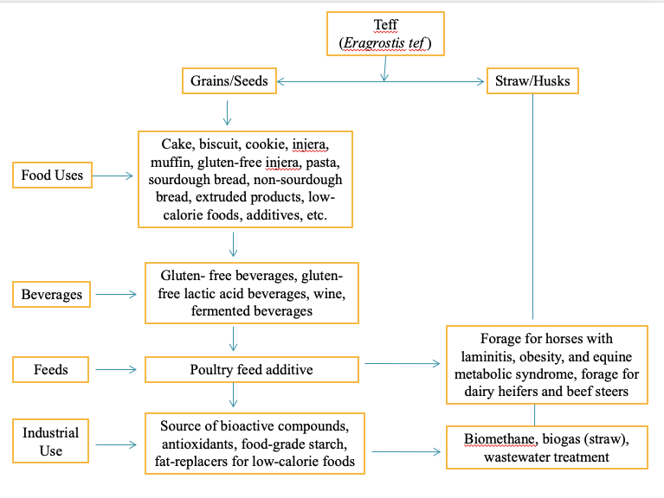

**Fig. 9 Uses of teff grain and straw (Barretto *et al*., 2021)**

White teff seeds are commonly favored for consumption due to their palatability, while red/brown teff seeds are often chosen as a healthier option (Gebremariam *et al.,* 2014). Teff confectionery products adhere to specific palatability standards to meet human consumption requirements, benefiting from teff's remarkable resistance to spoilage (Zegeye, 1997). Teff seeds undergo a fermentation process to craft traditional Ethiopian alcoholic beverages like Arake, Shamit, and Tella (Gebremariam *et al.,* 2014). Arake, also known as katikalla, is created by blending unleavened bread made from teff (known as kita) with sprouted wheat or barley (bekel). This mixture is then immersed in water that is 3 to 4 days old and infused with ground Gesho leaves. After fermenting for an additional 5-6 days, the concoction is distilled. In contrast, Shamit is an Ethiopian beer with roots in the Gurage tribe. The ground mixture of Kita and Bekel is dissolved in water, fermented for 3-4 days, and subsequently filtered. Chopped, toasted, and dehusked barley (mitad) is added to enhance flavor and aroma. Typically, it is served with cardamom, cumin, and bishop's weed. Tella, on the other hand, is known for its smoky flavor.

The popularity of teff-based products arises from their use of gluten-free ingredients and the incorporation of nutritious whole grains. In comparison to other cereals, teff is notably rich in calcium, zinc, and iron. Lactic acid fermentation in the further processing of teff-based food derivatives enhances nutrient synthesis and availability, diminishes anti-nutritional factors, and contributes to extended shelf life and improved palatability. Fermented products have the added advantage of increased nutrient availability due to the presence of beneficial bacteria and probiotics. Among its myriad health benefits, teff promotes higher hemoglobin levels in the blood, reducing the risk of developing anemia.

Teff by-products make a substantial contribution to the dairy and meat industries as valuable animal feed resources. In Ethiopia, various sources are used for animal feed production, including alfalfa, vegetable straw, pasture grass, chopped straw, and by-products. Among these sources, chopped straw (comprising 27.71%) ranks as the second most consumed animal feed following grazing (61.48%). Teff, specifically, accounts for approximately 6.93% of the total supply of chopped straw in Ethiopia. An investigation into the utilization of chopped teff straw revealed that a mere 6.68 million tons of straw were utilized nationwide for animal feed, leaving a significant straw waste volume of 860,000 tons. This waste can be attributed to various factors, including prolonged transportation from farms to livestock facilities, limited availability of vehicles, and associated transportation costs. Consequently, the livestock industry faces substantial challenges related to both quantity and quality losses, which are particularly exacerbated during the dry season. In Utah, teff serves as an essential emergency forage crop, offering a solution during periods of winter blight, crop failures, and delayed planting schedules.

**What is injera?**

Injera, a unique flatbread, boasts a distinct flavor and is characterized by its soft, spongy texture. It takes the form of a round pancake with a thickness typically ranging from 2 to 4 mm and a diameter of approximately 58 cm. While the primary ingredient for crafting injera is teff, there are instances where other grains such as sorghum and barley are incorporated. In contemporary times, some consumers opt to include a small quantity of rice flour to achieve a lighter hue in their injera. The knowledge and techniques required to prepare injera are deeply ingrained in Ethiopian culture and have been passed down through generations. A well-baked injera exhibits a particular structure, as depicted in Figure 13.

Injera is crafted from teff flour, which is combined with water, and a portion of the leftover dough from a previous cooking session is included as a starter. This mixture is allowed to ferment. To prepare injera, a fire is kindled at the base of a clay pot in the case of biomass stoves, or an electric injera cooking stove is employed. Once the mold's temperature reaches approximately 200°C, the dough is poured onto the baking surface. Due to its viscous nature, it can be poured onto the surface without requiring stretching. Finally, the cooked injera is removed from the baking surface. A significant portion of Ethiopians still employ the traditional three-stone fire method for baking injera. However, since the 1980s, endeavors have been made to enhance biomass injera ovens and introduce electric injera ovens, particularly in urban areas.

**Preparation of Injera**

Figure 13 illustrates a flowchart outlining the standard method for manufacturing injera. This process begins by grinding whole decorticated sorghum or teff into flour. Subsequently, dough preparation follows, involving the addition of a starter culture derived from the previous batch, with fermentation occurring at room temperature for approximately 48 hours. During this

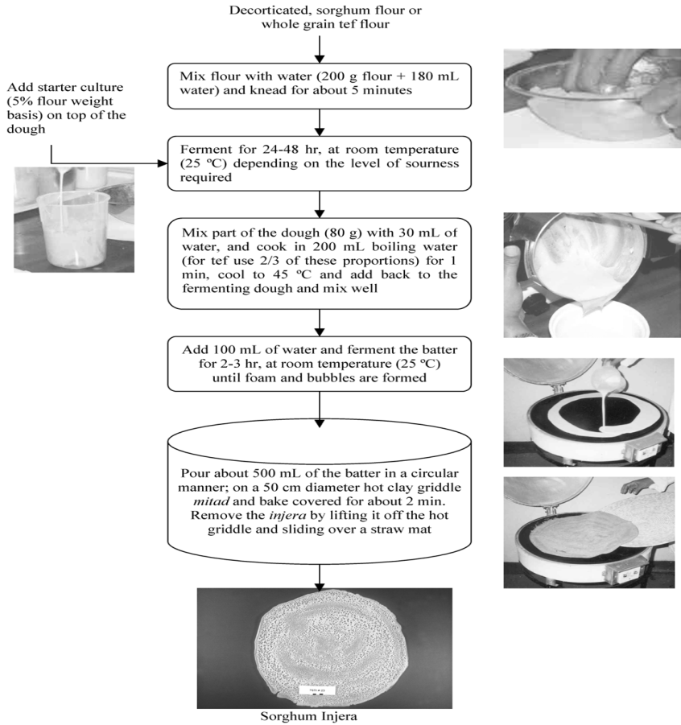

**Fig. 10 Flow diagram of standardized *injera* making procedure**

fermentation process, various microorganisms, including Gram-negative bacilli, lactobacilli, and yeasts, have been reported to participate in the transformation of teff dough.

Following fermentation, roughly 25% of the fermented dough is diluted with 30 mL of water and cooked in 200 mL of boiling water for one minute. The primary purpose of this gelatinization, or cooking, step is to ensure dough cohesion and, secondarily, to provide readily fermentable carbohydrates for the subsequent injera fermentation process. After gelatinization, the dough is cooled to approximately 45°C at room temperature and then reintroduced into the fermenting dough. After thorough mixing, an additional 100 mL of water is added, and the dough is fermented for an additional 2-3 hours at room temperature. The incorporation of warm gelatinized starch back into the fermented dough elevates the fermentation temperature to approximately 30°C, facilitating the growth of mesophilic microorganisms. The final step involves pouring around 500 grams of the fermented dough onto a heated clay griddle with a diameter of 50 cm, shaping it into a circle, covering it, and placing it in the oven for approximately 2 minutes to cook the injera.

**TELLA**

Tella acquires its distinctive smoky essence from the incorporation of darkened bread resulting from baking and the utilization of a fermentation vessel that has been exposed to the aromatic fumes of smoldering weyrawood. Alongside grains, the key component shaping the character of tella is Gesho leaves (*Rhamnus prinoides*), which imparts a unique and pleasantly bitter undertone to the beverage. Scientific studies have revealed that Gesho plays a pivotal role in regulating the microbiota responsible for the fermentation process. Furthermore, the level of bitterness in the beer is directly correlated with the quantity of Gesho added. Tella adheres to government regulations by remaining unprocessed, with its alcohol content fluctuating between 2-4% by volume. In contrast, Tella-filtered boasts a higher alcohol content, typically ranging between 5-6% by volume.

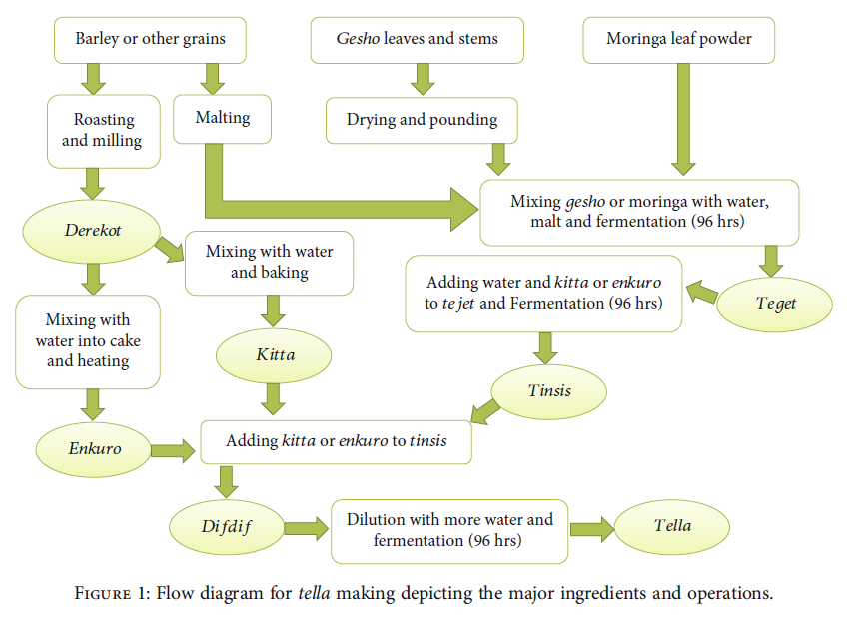

**Fig. 11 Flow diagram of for tellamaking depicting the major ingredients and operations (Birhanu *et al.,* 2021)**

**Preparation of Ingredients**

Barley seeds undergo a thorough washing and are subjected to dark roasting, resulting in transformations both in their endosperm and the development of flavor and color. These roasted barley seeds are subsequently finely ground into a flour locally referred to as "derekot," which is then carefully packed into polyethylene bags and stored at room temperature until it is ready for use in the subsequent processing stages (Birhanu *et al.,* 2021). Similarly, malted barley undergoes a washing and grinding process and is stored in the same manner as derekot. The leaves and slender branches of poppy seeds are ground to achieve the desired particle size, ensuring they are not ground too fine. This powder is also carefully packed into polyethylene bags and stored in a dry, dark location until it is required for the next step in the production of tella. Likewise, moringa leaf powder is stored under identical conditions to gesho, maintaining its quality until it is needed for further use.

**Adjunct Preparation Methods for Tella**

Tella was traditionally crafted through two distinct methods: the kitta-based and emkuro-based preparations. In the kitta-based approach, roasted oat flour was combined with an appropriate quantity of water to create a sticky dough. This dough was then baked into substantial, flatbreads on a heated metal griddle (Teferra *et al.,* 2015). After baking, the kitta was allowed to cool and subsequently broken into pieces. These kitta fragments were carefully dried and stored, awaiting their use in the difdif phase, the final mixing step in the tella fermentation process. In the emkuro-based method, roasted barley flour was mixed with a more limited amount of water compared to kitta. This mixture was then shaped into bolus cakes and similarly baked on a hot metal griddle. Following the baking process, the emkuro was allowed to cool, dried thoroughly, packed into polyethylene bags, and transported to the laboratory, where it awaited utilization in the difdif stage of tella fermentation.

**Tella Processing Phase**

Tella processing involves three fundamental fermentation stages: tejet, tinsis, and difedef, (Fentie *et al.,* 2020). To prepare three distinct types of Tejet, 100 grams of malt were mixed with 125 grams of either (i) Gesho leaf powder, (ii) Moringa leaf powder, or (iii) an equal 50:50 blend of Gesho and Moringa. These Tejet mixtures underwent a 96-hour fermentation period, covered with a clean cloth (Fig. 14). The Tejet formulation was then split into two portions, each transformed into tinsis by incorporating 225 grams of either kitta or enkuro as an adjuvant. The tinsis preparation also underwent an additional 96-hour fermentation phase, with a lid in place. The fermented tinsis was further converted into the final stage of tella fermentation, known as difdif. This transformation involved adding 900 grams of residual adjuvant (either kitta or enkuro) and diluting the mixture with 5 liters of water to create tella. The final tella concoction was covered for another 96 hours to complete the fermentation process. Following fermentation, the solutions were meticulously filtered using a clean muslin cloth to eliminate larger suspended impurities. Subsequently, they were subjected to biochemical and organoleptic characterization.

**Table 5. Studies on application of teff in of gluten-free bakery products (Nascimento *et al.,* 2018)**

|  |  |  |  |
| --- | --- | --- | --- |
| **Value added products** | **Analysis** | **Findings** | **Reference** |
| **Cookie** | Investigated the impact of replacing 25% and 50% of teff flour on the physical, textural, and sensory attributes of gluten-free sugar and peanut butter cookies. | In the case of sugar cookies, panelists expressed a preference for the control and 25% teff cookie over the one prepared with 50%. However, in the case of peanut butter cookies, no such preference was observed. These findings suggest that nutrient-rich teff flour can serve as a favorable alternative, enhancing the taste and flavor of gluten-free cookies. | Kenney *et al.,* (2011) |
| **Muffin** | This research explored how substituting rice flour (control) with teff flour at levels of 25%, 50%, 75%, and 100% affected the physical, textural, and sensory properties of gluten-free muffins. | The study illustrates that substituting 50% of rice flour with teff not only yields acceptable gluten-free muffins but also enhances their nutritional value. These muffins boast higher levels of protein (27%), iron (20.95%), calcium (25%), and fiber (22.1%). | Assefa *et al.* (2011) |
| **Injera** | Evaluated the influence of substituting grain teff flour with flaxseed on the quality and functionality of injera. | The injera containing 9% flaxseed substitution exhibited promising proximate nutritional and energy contents, showcasing its functional potential. It is notably high in dietary fiber, alpha-linolenic acid, lignans, proteins, and possesses antioxidant properties. | Girma *et al.* (2013) |

**Table 6. Phytochemical composition of teff grain**

|  |  |  |
| --- | --- | --- |
| **Parameters** |  |  |
| **Phytate** (mg/100 g dry matter) | 682-1374 | Phytates create complexes with minerals like zinc and calcium when they are secreted, rendering these minerals inaccessible for reabsorption into the body. This process can be mitigated through methods such as soaking, fermentation, and germination. |
| **Tannin** (mg CE/100 g dry matter) | 16 |  |
| **Total polyphenol** (mg gallic acid equivalent/100 g dry matter) | 140 | Polyphenols can hamper iron absorption from plant-based foods |
| **Iron-binding phenolic** |  |  |
| Galloyls (mg tannic acid equivalent/100 g dry matter) | 210.0 | These two functional groups hamper iron absorption |
| Catechols (mg catechin equivalent/100 g dry matter) | 200.0 |
| **Phenolic acid (μg/mg)** |  |  |
| Protocatechuic | 25.5 |  |
| Gentisic | 15.0 |  |
| Vanillic | 54.8 | No Galloyls and Catechols as functional groups  so doesn’t hamper iron absorption |
| Coumaric | 36.9 |
| Cinnamic | 46.0 |
| Caffeic | 3.9 |  |
| Syringic | 14.9 |  |
| Ferulic | 285.9 |  |

1. **Chia seeds**

*Salvia hispanica* L., commonly known as Chia, is an annual herbaceous plant originating from Southern Mexico and Northern Guatemala. It belongs to the Lamiales order, falls within the mint family Labiatae, and is classified under the subfamily Nepetoideae within the *Salvia* genus. The *Salvia* genus encompasses approximately 900 species and has been distributed worldwide for millennia, spanning regions like South Africa, Central America, North and South America, and South-East Asia (Ciau-Solis *et al.,* 2014). Today, chia cultivation extends beyond Mexico and Guatemala, with significant production taking place in Australia, Bolivia, Colombia, Peru, Argentina, the United States, and Europe. Mexico, in particular, stands out as the largest global producer of chia seeds, yielding an impressive 2,893.4 metric tons in 2018 (www.tradelinkinternational.com).

The term "chia" is derived from the Spanish word "chian," which means "oily." Chia indeed qualifies as an oilseed, boasting a nutritional profile characterized by fats, carbohydrates, fiber, protein, vitamins (A, B, K, E, D), minerals, and antioxidants. Chia seeds are particularly rich in healthy omega-3 fatty acids, polyunsaturated fatty acids, dietary fiber, protein, vitamins, and a variety of minerals. They are also a notable source of polyphenols and antioxidants such as caffeic acid, rosmarinic acid, myricetin, and quercetin. Incorporating chia seeds into one's diet can yield various benefits, including support for the digestive system, promotion of healthy skin, enhancement of bone and muscle strength, as well as a reduction in the risk of heart disease and diabetes (Grancieri and Martino, 2019).

Historical records reveal that *Salvia hispanica* L., commonly known as chia, held significant importance in the folk medicine and culinary traditions of ancient Mesoamerican cultures, including the Aztecs and the Mayans. Alongside staples like corn, red beans, and calendula, chia played a notable role in their dietary and cultural practices. In pre-Columbian societies, beans were the second major crop, with chia as a vital component (Ullah *et al.,* 2016). Within Aztec society, chia found versatile applications in food preparation, cosmetics, and even religious ceremonies. *Salvia hispanica* L. is primarily cultivated for its seeds, and it features small white and purple hermaphrodite flowers measuring 3 to 4 mm in thickness. The plant itself is sensitive to sunlight, can reach heights of up to 1 meter, and is characterized by toothed leaves with inverted petioles measuring 4-8 cm in length and 3-5 cm in width. Chia seeds, typically oval in shape, are very small, measuring less than 2 mm in length, 1–1.5 mm in width, and less than   
1 mm in thickness (Grancieri and Martino, 2019). These seeds exhibit a range of colors, including black, gray, blackish, and white.

**Table 7. Major constituents of chia oil**

|  |  |  |  |
| --- | --- | --- | --- |
|  | **Composition** | | **References** |
| Chia seed contains 39% oil (mass of dry seeds) | 68% of omega-3 fatty acids | 19% of omega-6 fatty acids | Ciau-Solis *et al.* (2014) |
| Polyunsaturated fatty acid (PUFAs) | Alpha-linolenic acid (ALA, an omega-3 fatty acid) | Linoleic acid (LA, an omega-6 fatty acid) | Silva *et al.* (2016) |
|  | The ratio of omega-6 to omega-3 fatty acids is 0.3:0.35 | | Luz *et al.* (2012) |
| Benefits | Lowering cholesterol levels, anti-inflammatory effects, cardioprotective and hepatoprotective properties, antidiabetic actions, and defense against cancer, arthritis, and autoimmune diseases are among the benefits of omega-3 fatty acids | On the other hand, omega-6 fatty acids offer anti-inflammatory effects, anti-thrombotic activities, and anticancer properties | Grancieri *et al.* (2019) |

**Table 8 The nutritional characteristics, vitamin content, fatty acid composition, and phenolic compound levels of chia seeds and various cereals per 100 grams (Ho *et al*., 2013)**

|  |  |  |  |  |  |  |
| --- | --- | --- | --- | --- | --- | --- |
|  | Chia seed | Rice | Corn | Wheat | Quinoa | Amaranth |
| Carbohydrate (g) | 42 | 80 | 74 | 71 | 64.2 | 71 |
| Protein (g) | 17 | 6.5 | 9.4 | 12.6 | 14.1 | 12.6 |
| Fat (g) | 31 | - | - | 1.5 | 1.92 | 1.5 |
| **Mineral (mg)** |  | | | | | | |
| Magnesium | 335 | 25 | 127 | 126 | 197 | 126 |
| Phosphorus | 860 | 115 | 210 | 288 | 457 | 288 |
| Calcium | 631 | 28 | 7 | 29 | - | 29 |
| Potassium | 407 | 115 | 287 | 363 | 563 | 363 |
| **Vitamins (mg)** |  | | | | | | |
| Vitamin A | 54 µg | 0 | 214 | 9 | 0 | n.d. |
| Vitamin E | 0.5 | 0.11 | 0.49 | 1.01 | 0.63 | 1.19 |
| Vitamin C | 1.6 | 0 | 0 | 0 | 0 | 4.2 |
| Thiamine (B1) | 0.62 | 0.07 | 0.39 | 0.30 | 0.11 | 0.12 |
| Riboflavin (B2) | 0.17 | 0.05 | 0.20 | 0.12 | 0.11 | 0.2 |
| Niacin (B3) | 8.83 | 1.6 | 3.63 | 5.46 | 0.412 | 0.92 |
| **Fatty acid content (%)** |  | | | | | | |
| Linolenic acids | 63.79 | 2.1 | 1 | 0.08 | 6.7 | 1.01 |
| Linoleic acid | 18.89 | 39.7 | 52 | 0.68 | 56.4 | 0.35 |
| Oleic acid | 7.3 | 35.1 | 31 | 0.24 | 20.4 | 22.69 |
| Palmitic acid | 7.04 | 20.8 | 13 | 3.02 | 9.7 | 18.59 |
| **Phenolic compounds (µg)** |  | | | | | | |
| Caffeic acids | 27 | n.d. | 26 | 40 | 37 | 0.90 |
| Quercetins | 0.17 | - | - | 30.1 | 43.3 | - |

**Table 9. Literature reviews on the extraction of chia seed oil**

|  |  |  |  |  |
| --- | --- | --- | --- | --- |
| **Sl. No.** | **Title** | **Parameters/Conditions** | **Results** | **Reference** |
|  | Supercritical carbon dioxide extraction of oil from Mexican chia seeds (*Salvia hispanica* L.): Characterization and process optimization | Various temperatures (40°C, 60°C, and 80°C), pressures (250 bar, 350 bar, and 450 bar), and time durations (60 minutes, 150 minutes, and 240 minutes) were employed. | A yield of 92.8% was achieved under conditions of 450 bar, 80°C, and 300 minutes. | Ixtaina *et al.* (2010) |
|  | Valorization of chia (*Salvia hispanica*) seeds cake by means of supercritical fluid extraction | Supercritical fluid extraction (SFE) was conducted across a range of pressures, spanning from 150 to 300 bar (150, 200, 250 and 300 bar), and temperatures between 40°C and 50°C. In this process, either pure CO2 was used as the solvent or CO2 was added to ethanol (EtOH) or ethyl acetate (EtOAc) as cosolvents in varying concentrations ranging from 2.5% to 7.5% w/w of the total CO2 mass. | The highest extraction yield, reaching 90.6%, was obtained using pure CO2 under conditions of 300 bar and 50°C. | Guindani *et al.* (2016) |

**Table 10. Bioactive constituents in chia seeds (*Salvia hispanica* L.)**

|  |  |  |
| --- | --- | --- |
| **Active Compounds** | **Biological Activities** | **Reference** |
| Omega-3 fatty acids | -anti-inflammatory  - antidiabetic  -anticancer | Ali *et al.* (2012) |
| Omega-6 fatty acid | -anti-inflammatory  -anticancer | Ali *et al.* (2012) |
| Flavonoids |  | |
| Mycertin | - antioxidant | Falco *et al.* (2017) |
| Quercetin | * Antioxidant * anti-cancerogenic   -anti-hypertensive | Rahman *et al.*  (2017) |
| Kaempferol | -Antioxidant | Ali *et al.* (2012) |
| Caffeic acid | * Antioxidant * anti-cancerogenic   -anti-hypertensive | Rahman *et al.*  (2017) |
| Vitamins |  | |
| A | -healthy skin | Rahman *et al.*  (2017) |
| B1 | -for synthesizing ATP |
| B2 | - To support the normal functioning of red blood cells |
| B3 | - To promote the proper operation of the nervous and digestive systems |

1. **“Superfoods”-Labelling and Regulation (Fernandez-Rios *et al*., 2022)**

Over the years, the list of so-called superfoods has expanded considerably, often accompanied by health claims lacking robust scientific backing, particularly from controlled human intervention trials (Proestos, 2018). Furthermore, the absence of clear criteria for categorizing foods as "super" and the indiscriminate marketing practices surrounding them have led some experts to label them as "food frauds" (Curll *et al.,* 2016). These concerns underscore the necessity for stricter regulations and policies to counteract false health assertions about superfoods (Smith, 2019).

Since 2007, European Regulation (EC) No. 1924/2006 (European Commission, 2006) governing nutrition and health claims on food products has prohibited the use of the term "superfood" on product packaging or in advertisements. This restriction ensures that only health properties backed by sound scientific evidence, as evaluated by the EFSA (European Food Safety Authority), can be promoted. Consequently, superfoods should be precisely defined, and specific regulations concerning their requirements and labeling, akin to those for "eco" or "bio" products, should be established. Such regulations are governed by Regulation (EU) 2018/484 on environmentally friendly production (European Union, 2018), which mandates that a product can be advertised as organic or bio only when at least 95% of its ingredients originate from environmentally friendly production practices.

**Conclusion**

Superfoods are generally plant-based foods renowned for their exceptional nutritional value, offering an abundance of essential nutrients while being low in calories. They are replete with vitamins, dietary fiber, minerals, and antioxidants. Thanks to their potent bioactivity and nutritional richness, superfoods have the potential to play a vital role in preventing chronic diseases. Extracting their bioactive components and incorporating them into various food applications could open avenues for creating health-promoting foods within the realm of food processing.

**References**

Abderrahim, F., Huanatico, E., Segura, R., Arribas, S., Gonzalez, M. C. and Hoyos, C. L., 2015, Physical features, phenolic compounds, betalains and total antioxidant capacity of coloured quinoa seeds (*Chenopodium quinoa* Willd.) from Peruvian Altiplano. *Food Chemistry,* 2015, 183:83-90.

AESAN, 2019, Information Notes of Superfoods. https://www.aesan.gob. es/SIAC-WEB/pregunta.do;jsessionid=D9Tx8HIo6JEKEW3CbDo3aiweu6YNmS8GlLXaDV6DO gwSddNia7l!1306075272?reqCode=retrieve&bean.id=3465. (Accessed on 11 January 2022).

Angeli, V., Silva, P. M., Massuela, D. C., Khan, M. W., Hamar, A., Khajehei, F., Graeff-Honninger, S. and Piatti, C., 2020, Quinoa (*Chenopodium quinoa* Willd.): An Overview of the Potentials of the “Golden Grain” and Socio-Economic and Environmental Aspects of Its Cultivation and Marketization. *Food,* 9(1): 216. doi:10.3390/foods9020216.

Assefa, K., Yu, J. K., Zeid, M., Belay, G., Tefera, H. and Sorrells, M. E., 2011, Breeding tef [*Eragrostistef* (Zucc.) trotter]: conventional and molecular approaches. *Plant Breed*, 130(1): 1-9.

Birhanu, A. M., Teferra, T. F. and Bekele, T., 2021, “Fermentation dynamics of Ethiopian traditional beer (tella) as influenced by substitution of gesho (*Rhamnus prinoides*) with Moringa stenopetala as innovation for nutrition,” in Preprint, 2021.

Bultosa, G., 2007, Physicochemical characteristics of grain and flour in 13 tef (*Eragrostistef* (Zucc.) Trotter) grain varieties. *Journal of Applied Science and Research*, 3: 2042–2051.

Ciau-Solis, N., Rosado-Rubio, G., Segura-Campos, M. R., Betancur-Ancona, D. and Chel-Guerrero, L., 2014, Chemical and functional properties of chia Seed (*Salvia hispanica* L.) Gum. *International Journal of Food Science*, 2(4): 1–5.

De Carvalho, F. G., Ovidio, P. P., Padovan, G. J., Jordao, J. A. A., Marchini, J. S. and Navarro, A. M., 2014, Metabolic parameters of post-menopausal women after quinoa or corn flakes intake-aprospective and double-blind study. *International Journal of Food Science and Nutrition,* 65(1): 380-385.

Doyon, M. and Labrecque, J., 2008, Functional foods: a conceptual definition. BFJ 110 (1): 1133–1149. https://doi.org/10.1108/00070700810918036.

EFSA, 2011. Evaluation of FoodEx, the food classification system applied to the development of the EFSA comprehensive European food consumption database. *EFSA J.*, <https://doi.org/10.2903/j.efsa.2011.1970>.

Falco, B., Amato, M. and Lanzotti, V., 2017, Chia seeds products: An overview. *Phytochemical Review*,16(1): 745–760.

Farinazzi-Machado, F. M. V., Barbalho, S. M., Oshiiwa, M., Goulart, R. and Pessan, J. O., 2012, Use of cereal bars with quinoa (*Chenopodium quinoa* W.) to reduce risk factors related to cardiovascular diseases. *Cienc Technology Aliment* *Campinas*, 32(1): 239-244.

Fentie, E. G., Emire, S. A., Demsash, H. D., Dadi, D. W. and Shin, J. H., 2020, “Cereal- and fruit-based Ethiopian traditional fermented alcoholic beverages,” *Foods,* 9(12): 1781.

Fernandez-Rios, A., Laso, J., Hoehn, D., Amo-Setien, F. J., Abajas-Bustillo, R., Ortego, C., Fullana-i-Palmer, P., Bala, A., Batlle-Bayer, L., Balcells, M., Puig, R., Aldaco, R. and Margallo, M., 2022, A critical review of superfoods from a holistic nutritional and environmental approach. *Journal of Cleaner Production*, 379. <https://doi.org/10.1016/j.jclepro.2022.134491>.

Foucault, A. S., Mathe, V., Lafont, R., Even, P., Dioh, W., Veillet, S., Tome, D., Huneau, J. F., Hermier, D. and Quignard-Boulange, 2011, A: Quinoa extract enriched in 20-hydroxyecdysone protects mice from diet induced obesity and modulates adipokines expression. *Obesity*, 20(1): 270-277.

Gebremariam, M. M., Zarnkow, M. and Becker, T., 2014, Teff (*Eragrostis tef*) as a raw material for malting, brewing and manufacturing of gluten-free foods and beverages: a review. *Journal of Food Science and Technology,* 51(11): 2881–2895.

Girma, T., Bultosa, G. and Bussa, N., 2013, Effect of grain tef [*Eragrostis tef* (Zucc.) Trotter] flour substitution with flaxseed on quality and functionality of injera. *International Journal of Food Science and Technology*, 48(2): 350-356.

Gordillo-Bastidas, E., Diaz-Rizzolo, D. A., Roura, E., Massanes, T. and Gomis, R., 2016, Quinoa (*Chenopodium quinoa* Willd*)* from nutritional value to potential health benefits: An integrative review. *Journal of Nutritional health and Food Science*, 6(1): 497-510.

Graf, B. L., Poulev, A., Kuhn, P., Grace, M. H., Lila, M. A. and Raskin, I., 2014, Quinoa seeds leach phytoecdysteroids and other compounds with anti-diabetic properties. *Food Chemistry,* 163:178-185.

Graf, B. L., Rojas-Silva, P., Rojo, L. E., Delatorre-Herrera, J., Baldeo, M. E. and Raskin, I., 2015, Innovations in health value and functional food development of quinoa (*Chenopodium quinoa* Willd.). *Comprehensive Reviews Food Science and Food Safety,*14:431-445.

Grancieri, M., Martino, H. S. D. and Mejia, E., 2019, Chia Seed (*Salvia* *hispanica* L.) as a source of proteins and bioactive peptides with health benefits: A Review. *Comprehensive Review of Food Science and Food Safety,* 18(1): 480–499.

Guindani, C., Podesta, R., Block, J. M., Rossi, M. J., Mezzomo, N. and Ferreira, S. R. S., 2016, Valorization of chia (*Salvia hispanica*) seed cake by means of supercritical fluid extraction. *Journal of Supercritical Fluids,* 112(1): 67–75.

Hirich, A.; Rafik, S.; Rahmani, M.; Fetouab, A.; Azaykou, F.; Filali, K.; Ahmadzai, H.; Jnaoui, Y.; Soulaimani, A.; Moussafir, M.; Gharous, E. L., Karboune, S., Sbai, A. and Choukr-Allah, R., 2021, Development of Quinoa Value Chain to Improve Food and Nutritional Security in Rural Communities in Rehamna, Morocco: Lessons Learned and Perspectives. *Plants,* 10: 301. [https://doi.org/10.3390/plants 10020301](https://doi.org/10.3390/plants%2010020301).

Ho, H., Lee, A. S., Jovanovski, E., Jenkins, A. L., DeSouza, R. and Vuksan, V., 2013, Effect of whole and ground Salba seeds (*Salvia Hispanica* L.) on postprandial glycemia in healthy volunteers: A randomized controlled, dose-response trial. *European Journal of Clinical Nutrition,* 67(1): 786–788.

Ixtaina, V. Y., Vega, A., Nolasco, S. M., Tomas, M. C., Gimeno, M., Barzana, E. and Tecante, A., 2010, Supercritical carbon dioxide extraction of oil from Mexican chia seed (*Salvia hispanica* L.): characterization and process optimization. *Journal of Supercritical Fluids,* 55(1): 192–199.

Jacobsen, S. E., Mujica, A. and Jensen, C. R., 2003, The resistance of quinoa (*Chenopodium quinoa* Willd.) to adverse abiotic factors. *Food Revolution International*, 19(1): 99–109.

Jagdale, Y. D., Mahale, S. V., Zohra, B., Nayik, G. A., Dar, A. H., Khan, K. A., Abdi, G. and Karabagias, I. K., 2021, Nutritional profile and potential health benefits of super foods: A Review. *Sustainability*, https://doi.org/10.3390/su13169240.

Jancurova, M., Minarovicova, L. and Dandar, A., 2009, Quinoa - A Review. *Czech Journal of Food Science,* 27(1): 71-79.

Kenney, E. S., Butler, C., Moore, C., Bhaduri, S., Ghatak, R. and Navder, K. P., 2011, The effect of substituting teff flour in gluten-free sugar cookies and peanut butter cookies. *Journal of American Diet Association*, 111(9): 63-69.

Loyer, J. and Knight, C., 2018, Selling the “Inca superfood”: nutritional primitivism in superfoods books and maca marketing. Food Culture and Society, 21 (4): 449–467. <https://doi.org/10.1080/15528014.2018.1480645>.

Luz, J. M. R., Nunes, M. D., Paes, S. A., Torres, D. P., Silva, M. D. C. S. D. and Kasuya, M. C. M., 2012, Lignocellulolytic enzyme production of pleurotuso streatus growth in agroindustrial wastes. *Brazil Journal of Microbioogy,* 43(1): 1508–1515.

Meyerding, S. G. H., Kurzdorfer, A. and Gassler, B., 2018, Consumer Preferences for Super food Ingredients - the Case of Bread in Germany. *Sustainability* 10(1): 4661-4667.

Nascimento, K. O., Paes, S. N. D., Oliveira, I. R., Reis, I. P. and Augusta, I. M., 2018, Teff: suitability for different food applications and as a raw material of gluten-free, a Literature review. *Journal of Food and Nutrition Research,* 6(2): 74-81.

Navruz-Varli, S. and Sanlier, N., 2016, Nutritional and health benefits of quinoa (*Chenopodium quinoa* Willd.). *Journal of Cereal Science,* 69:371-376.

Picone, G., Mengucci, C. and Capozzi, F., 2022, The NMR added value to the green foodomics perspective: advances by machine learning to the holistic view on food and nutrition. *Magn. Resoning. Chemistry,* 60: 590–596. https://doi.org/10.1002/ mrc.5257.

Prego, I., Maldonado, S. and Otegui, M., 1998, Seed structure and localization of reserves in Chenopodium quinoa. *Annals of Botany,* 82(1): 481–488.

Proestos, C., 2018, Superfoods: recent data on their role in the prevention of diseases. *Current Research and Nutrition Food Science.* 6 (3): 576–593. https://doi.org/10.12944/CRNFSJ.6.3.02.

Rahman, M. J., Camargo, A. C. and Shahidi, F., 2017, Phenolic and polyphenolic profiles of chia seeds and theirin vitro biological activities. *Journal of Functional Foods,* 35(1): 622–634.

Ruales, J., Grijalva, Y., Lopez-Jaramillo, P. and Nair B. M., 2002, The nutritional quality of infant food from quinoa and its effect on the plasma level of insulin-like growth factor-1 (IGF-1) in undernourished children. *International Journal of Food Science* *and Nutrition*, 53(1):143-154.

Samec, D., Urlic, B. and Salopek-Sondi, B., 2019, Kale (*Brassica oleracea* var. acephala) as a superfood: review of the scientific evidence behind the statement. *Critical Reviews in Food Science and Nutrition,* 59 (15): 2411–2422. <https://doi.org/10.1080/10408398.2018.1454400>.

Santini, A., Cammarata, S. M., Capone, G., Ianaro, A., Tenore, G. C., Pani, L. and Novellino, E., 2018, Nutraceuticals: opening the debate for a regulatory framework. *Brazalian Journal Clinical Pharmacology*, 84 (4): 659–672. https://doi.org/10.1111/bcp.13496

Santini, A. and Novellino, E., 2014, Nutraceuticals: beyond the diet before the drugs. *Current Bioactive Compounds.* 10 (1): 1–12. <https://doi.org/10.2174/157340721001140724145924>.

Silva, C., Garcia, V. A. S. and Zanette, C. M., 2016, Chia (*Salvia hispanica* L.) oil extraction using different organic solvents: Oil yield, fatty acids profile and technological analysis of defatted meal. *International Food Research Journal,* 23(1): 998–1004.

Sobota, A., Swieca, M., Gesinski, K., Wirkijowska, A. and Bochnak, J., 2020, Yellow-coated quinoa (*Chenopodium quinoa* Willd)—Physicochemical, nutritional, and antioxidant properties. *Journal of Science, Food and Agriculture*, 100(1): 2035–2042.

Tang, Y., Li, X., Chen, P. X., Zhang, B., Hernandez, M., Zhang, H., Marcone, M. F., Liu, R. andTsao, R., 2015, Characterisation of fatty acid, carotenoid, tocopherol/tocotrienolcompositions and antioxidant activities in seeds of three *Chenopodium quinoa* Willd.genotypes. *Food Chemistry*, 174:502-508.

Tang, Y., Zhang, B., Li, X., Chen, P. X., Zhang, H., Liu, R. and Tsao, R., 2016, Bound phenolics of quinoa seeds released by acid, alkaline, and enzymatic treatments and their antioxidantand a-glucosidase and pancreatic lipase inhibitory effects. *Journal of Agriculture Food**and Chemistry,* 64:1712-1719.

Teferra, T. F., H. Kurabachew, T. F. Tadesse, and G. Nigusse, 2015, “Nutritional, microbial and sensory properties of flat-bread (kitta) prepared from blends of maize (*Zea mays* L.) and orange-fleshed sweet potato (*Ipomoea batatas* L.) flours fabrication of iron and ascorbic acid nanocomposite view project nutritional, micro,” *International Journal of Food Science and Nutrition Engineering,* 5: 33–39.

Ullah, R., Nadeem, M., Khalique, A., Imran, M., Mehmood, S., Javid, A. and Hussain, J., 2016, Nutritional and therapeutic perspectives of Chia (*Salvia hispanica* L.): A review. *Journal of Food Science and Technology*, 53(1): 1750–1758.

Vega-Galvez, A., Miranda, M., Vergara, J., Uribe, E. and Puente, L., 2010, Nutrition facts and functional potential of quinoa (*Chenopodium quinoa* Willd.), an ancient Andean grain: a review. *Journal of Science Food and Agriculture*, 90: 2541-2547.

Woldemichael, G. M. and Wink, M., 2001, Identification and biological activities of triterpenoid saponins from Chenopodium quinoa. *Journal of Agriculture and Food Chemistry*, 49:2327-2332.

[www.queensquinoa.com](http://www.queensquinoa.com) (Accessed on 27 December 2022)

www.statista.com