CHAPTER: RECENT TRENDS OF NANOTECHNOLOGY IN DRUG DISCOVERY
Vijayshri Rokde* Kishor Danao
Department of Pharmaceutical Chemistry Department of Pharmaceutical Chemistry
Dadasaheb Balpande College of Pharmacy, Dadasaheb Balpande College of Pharmacy,
Besa, Nagpur-440037 Besa, Nagpur-440037
Email id- vijayshritekade@gmail.com Email id- kishordanao@gmail.com
Deweshri Nandurkar Monali Dumore
Department of Pharmaceutical Chemistry Department of Quality Assurance
Dadasaheb Balpande College of Pharmacy, Dadasaheb Balpande College of Pharmacy,
Besa, Nagpur-440037 Besa, Nagpur-440037
Email id-kerzarepritee@gmail.com Email id- mndumore@gmail.com
Diptanshu Sawai
Department of Pharmaceutical Chemistry
Dadasaheb Balpande College of Pharmacy,
Besa, Nagpur-440037

ABSTRACT
The most essential subject to come up is nanotechnology. The rational for this is that some type containing cell targeted treatment, including effective drug delivery release to a targeted cell in addition to that recognition of sickness, advantages from being in the nanoscale range in size, to making it simple to get into human body cells. In 1959, Noble prize winner Richard Feymann introduced the idea of nanotechnology. Prospective uses for nanotechnology in the biological science, notably nanobiotechnology include those for drug discovery. A variety of nanomaterials now exhibit exceptional properties because of recent advances in the fields of chemistry, physics, and material sciences that are expected to enhance the management of many tumours that are currently unresponsive to traditional therapies. Because of their intrinsic cytotoxicity activity, they are going to be able to function as nanocarriers for therapeutic molecules such pharmaceutical nucleic acids, proteins, or immunologic agents. The utilization of numerous nanotechnologies, plus nanoparticles in addition to numerous nanodevices like, nanobiosensors, nanobiochips, and nanoarrays. Nanoliter tests at the nanoscale volume contributes to cost saving. This chapter describes certain nanomaterials that can be used as drug candidates to speed up the drug development process like fullerenes.
Keywords: Nanotechnology, drug discovery, nanocarriers, nanobiosensors, nanochips, nanoarrays
- INTRODUCTION
The term "nanometer" was first used by Nobel laureate in chemistry Richard Zsigmondy, who did so in 1925. He is credited with being the first to use a microscope to gauge the size of particles like gold colloids. He is also credited with coining the term "nanometer" to characterise particle size. Nobel prize winner Richard Feynman, a scientist is credited with developing modern nanotechnology. In a speech he introduced the notion of altering matter at the atomic level. New ways of thinking were introduced with this ground-breaking idea, and Feynman's hypotheses were eventually verified. Due of these reasons, he is considered as the founder of modern nanotechnology. [Hulla, J.E] The concept of nanotechnology was cast-off by Norio Taniguchi. He was studied the development and advancement in machine technology. He was worked over three decades for the development and advancement in machine technologies. He used term nanotechnology for future reference. Between the second decade of the 1980s, a number of important discoveries and inventions were made that had a significant impact on the development of nanotechnology. The quantity of research and development being done in the field of nanotechnology has risen substantially since that time. Additionally, a sharp growth in many publications on this topic, in addition to an expansion of the use of nanotechnology in practical applications. The first National Scientific Fund nanotechnology programme launched in the USA in 1991. The United States' National Nanotechnological Initiative (NNI) was approved in 2001. The National Nanotechnological Approach was created with the following main idea by using: "In order to prioritize the development of nanotechnology, which should become the cornerstone of the American economy and national security in the first half of the 21st century, the National Nanotechnological Initiative establishes the interaction strategy between federal departments of the USA..". Xu et al. by inadvertently discovered a new class of carbon nanomaterials named carbon dots (C-dots) with size below 10 nm in 2004 while purifying single-walled carbon nanotubes. Beneficial, plentiful, and inexpensive nature, C-dots through intriguing charecteristics that have steadily become a intensifying star as a novel nanocarbon component. [Bayda, S.]
The Roman Empire during the fourth centuries AD provided fascinating instances of nanotechnology in the ancient world by using nanoparticles and structures.The Lycurgus cup, a piece of ancient glass art in the British Museum's collection, is one of its most outstanding examples. This is the first known example of dichroic glass. Dichroic glass refers to two different types of glass that can change color depending on the lighting. As a result, the Cup has two unique colors: reddish-purple when light is shining through the glass and green when it is in direct sunshine. [Zelzer, M]
. Initially, the researcher of physics and engineers were innovators of nanotechnology. Around the world, nanotechnology has gradually but significantly dominated several industries. Particularly in the industrialized world, where markets at the nanoscale have quickly displaced larger markets over the past ten years, this rapid pace of technological innovation is evident. Since it is currently a widely used technology, it is not a brand-new idea. In transdisciplinary scientific domains, active and passive nanoassemblies, general nanosystems, also small-scale molecular nanosystems are the four generations of nanomaterials that have surfaced [Anselmo, A.C.]. The fact that nanoscience is developing so quickly is evidence that soon nearly all areas of science and technology will use nano-scale manufacturing. This chapter will discuss the most cutting-edge uses of nanotechnology in a variety of sectors, with a focus on those in the chemical, mechanical, oil and gas, nourishment materials, cosmetics, healthcare, and lubricant and gas trades [Rickerby, D. and Bhushan, B]. In addition, a brief overview of nanotechnology's negative aspects will given for each trade to enable the scientific community to understand both its limitations and advantages. The process of nanotechnology combines the core elements of the physical, biologic, and chemical fields. At the nanoscale, these processes take place. The size is physically decreased and chemically, new bond and chemical characteristics are controlled, and biological effects, like drug bonding and distribution at specific places, are formed at the nano scale [Kumar, S, and McNeil, S.E,]. In a murky region known as a mesoscopic system, nanotechnology bridges the gap among classical and quantum mechanism. In the medical business, this mesoscopic technology is utilized to create nanoassemblies that are similar to those found in wildlife, such as agronomic goods, nanomedicine, and nanotools for diagnosis and therapy reasons [de Charles, P.P.].
Drugs and diagnostic tools based on nanotechnology are currently being used to treat diseases that were previously incurable. Additionally, this technique had a significant impact on industrial output and manufacturing in general. It employs the reversible engineering concept, that occurs naturally, to create materials rather than using large amounts of material that must be cut out. It permits the production of items at the micro scale, such as atoms, and subsequently grows items that function at a deeper scale [Schulte, J,]. To fully use the enormous potential of this brand-new science, many dollars and euros are being invested worldwide in nanotechnology, particularly in the industrialized nations of China, Europe, and the United States [Lemley, A.M]. However, emerging countries continue to lag behind since they cannot even keep up with the industrial advancement of the preceding era [Salamanca-Buentello, F.]. This delay is primarily attributable to the fact that these nations are currently experiencing economic hardship and require some time to advance in nanotechnology. It is important to emphasize, however, that the scientific communities of the developed and developing worlds both concur that nanotechnology will be the next stage in technological development [Roco, M.C,]. Consequently, in the upcoming years, additional industrial modernization and investment in the field of nanotechnology will become essential. Science and technology advancements lead to the adoption of technologies and goods that are more affordable, secure, and environment friendly than earlier ones. They are also concerned about the financial viability of techniques because the world's natural resources are depleting too quickly [Singh, N.A]. Thus, nanotechnology offers a solution to this issue. Comparing this technology to earlier mass bulking and expensive apparatus, it is clearer, cleaner, and more accessible. The application of nanotechnology to all facets of life is also possible. Nanomaterial sciences, Nano electronics, and nanomedicine will be primarily affected by this as they are ingrained in all facets of chemistry as well as the natural and artificial worlds [El Naschie, M.S]. Therefore, assuming that nanotechnology will become a subject that all students must learn in the future is not incorrect [Waldron, A]. The fundamental uses of nanotechnology in significant global manufacturing units and its implications for subsequent industrial advancement [Hulla, J]. A wide range of industries where nanotechnology is delivering astonishing submitted materials have been reviewed, and chosen that included in this review after rigorous and careful assessments. It should be noted that in order to expound on the extensive applications of nanotechnology in various industries, several types of industrial connections can be explored under single category. Microengineering ideas from physics and material sciences served as the foundation for nanotechnology [De Crozals, G.]. The idea of "nanoscaling" is not new to the computer business; in fact, engineers and technicians have been working on creating customized versions of computer-based technologies for a long time that take up the least amount of space while still performing the best function. As a result, replacing chips made of silicon with nanotubes is a technology that is being investigated more and more in computer hardware. Computer scientists have been immensely inspired by Feynman and Drexler's work to develop ground-breaking nanocomputers that potentially yield significant benefits [Waldron, A].
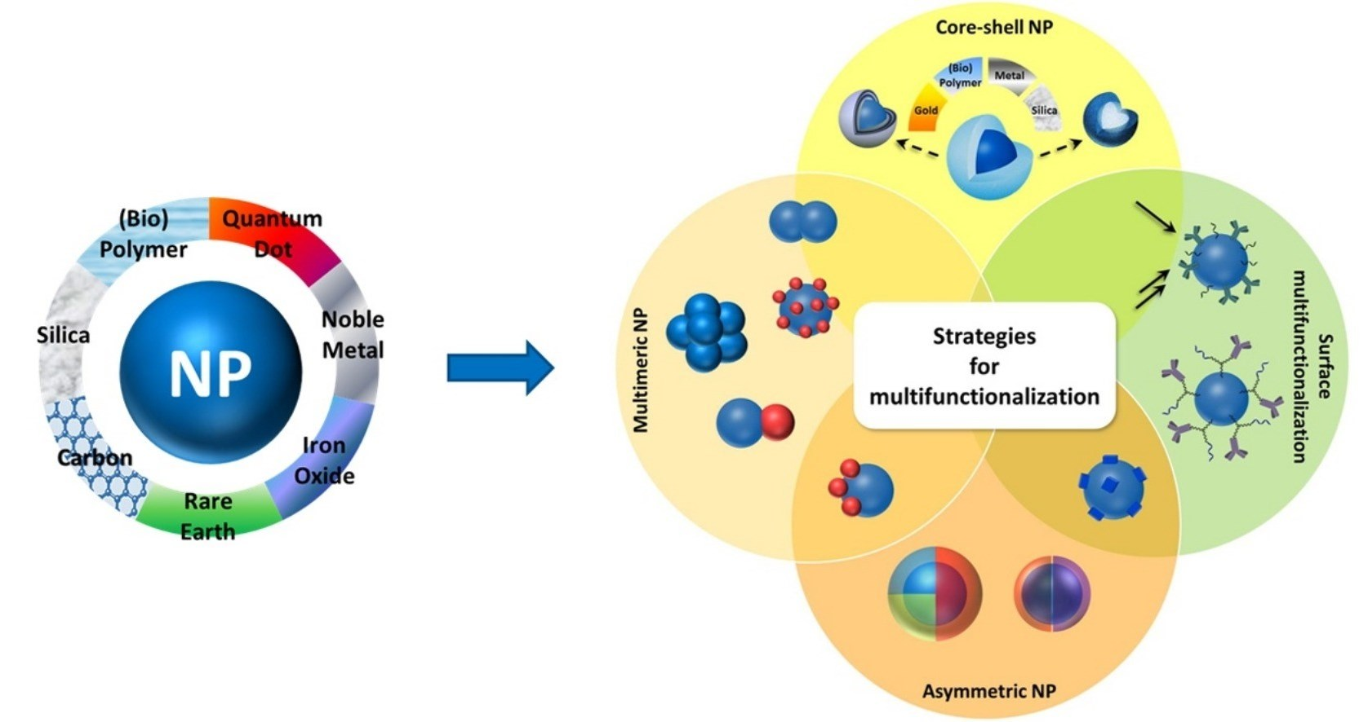

Figure 1: Multiple-featured nanoparticles for biological applications [De Crozals, G.]

- IMPORTANCE OF NANOTECHNOLOGY IN DRUG DISCOVERY
There have been many new pharma companies established that can provide expertise in creative delivery technology. Additionally, a lot of well-organized pharmaceutical companies are gearing up their efforts to develop new, more effective, and potent medicine delivery systems. By 2007, it is anticipated that the desire for medication delivery systems in only the US would increase by over 9% annually, totaling more than US$82 billion. [Sahoo, S. K]
In the area of medicine and the health sciences, nanotechnology has begun a new revolution. It's an innovative technique for both distribution and discovery of drugs. Nanoparticle applications are straightforward and effective. Though, nothing is known about the toxicity of nanomaterials. [Sahu, T.]
Proteomics is essential during the target discovery and validated phases of the drug development process. Different existing techniques, such as purifying proteins either or both display and automatic methods for identification, provide severely lesser recoveries, which restricts the process overall in terms of sensitivity, speed, and the need for vast volumes of starting material. In order to determine the peptide fragments' molecular masses, proteins that are less prevalent or that can only be separated from limited source materials (such as cell removal and body fluids) can be exposed to study of proteins at the nanoscale, nanocapture of the targeted proteins and/or multiplexes, and further sample-handling process optimization. [Jain, K]

Table 1: Different NanoTechnology with company [Jain, K]
Company | Technology | Applications
Caliper Life sciences (Hopkinton, MA, USA) | Labchips and sciclone | Molecular diagnosis
Drug Discovery CombiMatrix Corporation (Mukiteo WA, USA) | Nanoarrays By microelectrodes and electrochemical synthesis | Life- sciences research and drug discovery
Nanolytics | Biochips containg 10, 000 nanodroplets wells and computer controlled microactuator | Assay density is increased 50-200 fold compared with traditional plates
Bioforce nanosciences | Nano array spot contain 25, 000,000 spots per cm | It detects protein-protein interaction
SuNlyx | Nanostructures surfaces | Analytical biochips

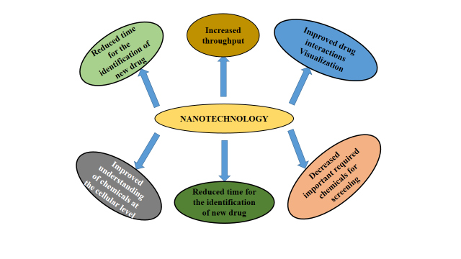

FIGURE 2: DRUG DISCOVERY PROCESS BENEFITS FROM NANOTECHNOLOGY [LaVan, D. A.]

- DIFFERENT DEVICES OF NANOTECHNOLOGY
- NANOCHIPS
A nanochip is a particular form of microchip created by the atomic and molecular level manipulation of materials known as nanotechnology. A nanochip has dimensions measured in nanometers (billionths of a meter), which are often substantially smaller than a conventional microchip. [Fu, Y] Like conventional microchips, these chips are constructed from semiconductor materials and have an electronic component network of transistors. Nanochips, on the other hand, are able to provide higher levels of performance and functionality than conventional microchips due to their small size. [Kelly, K.L.] Which are small, miniature computers, are increasingly being used to make storage components for portable electronics. [Shaoli, Z] It is a miniature electronic integrated circuit with parts that are nanometer-sized. At a nanometer scale, current technology can produce parts of a device, but not the entire thing. Every component of a chip needs to be produced at the atomic level in order to construct a whole chip. That means that in order to make microscopic components, each atom of the material needs to be changed. This procedure can cost a lot of money and take several years. [Savage, N] An extremely tiny electronic integrated circuit is known as a nanochip. A nanochip needs a very high degree of precision to function effectively due to its small size. In order to diagnose and treat a number of physiological conditions, nanochips offers diagnostic testing, sensing, and therapeutic functionality. [Hoefflinger, B.]
Nanochips (Figure 3) are still an important piece of electronics technology despite their small size. They are the little digital gadgets that are capable of doing difficult jobs. They are the most potent electronic devices ever created, and they are smaller than a human hair. Although they are not the only kind of chips, they are the smallest. As a result, smartphones and other mobile phones can store them with ease. Additionally, they use energy considerably more effectively. [Murmann, B. and Zoraida, P. A.] Numerous methods can be used to create nanochips. The fabrication procedure is often carried out using a 3D printer or other specialized equipment. [Kricka, L. J,]
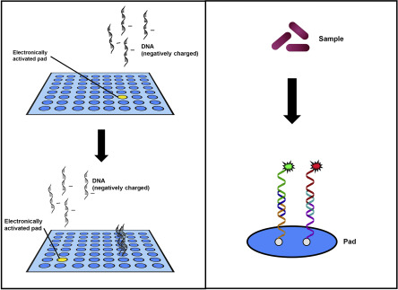
Figure 3: Nanochips [Kricka, L. J,]

There are lots of applications of these nanochips in different sectors like healthcare sector, electronic and communication centres, food science, space flight, fuel cell, healing of cell tissues, injurious and to grow organs. It can alter body cells and this procedure, known as tissue nanotransfection which can regenerate whole organs and heal damaged tissues. This innovative technology is non-intrusive and absolutely painless. Nanochips could eventually be employed during surgical procedures like the replacement of heart valves. For people who require organ transplants, this is welcome news, but there are still a lot of unanswered issues. [Vogel, H.G] The procedure of mending organs with nanochips entails introducing DNA into the damaged organ, in contrast to conventional surgery. The skin can develop and work properly owing to the new DNA. The goal of scientists is to advance this technology and make it workable in clinical situations.
The researchers have successfully transformed skin cells into nerve and muscle cells. They think that this technology could be used to treat chronic disorders as well as other types of tissus. Although it have many uses in the human body, it's vital to remember that these gadgets won't be sold right away. For implants, the technology is not yet developed sufficiently. However, scientists remain confident in their abilities and still pursue this field of study. These technologies do not, however, come without risk. Before these implants are used, a number of safety concerns must be resolved. Before the general population can accept these implantable devices, there are still a number of concerns that need to be resolved, including corrosion, infection risks, and MRI abnormalities. This technology is utilized for genetic engineering, cytogenetics, hereditary anomalies, and illness of predisposition, clinical neurology, and responsiveness to drug therapy. [Barman, J.]

B. NANOARRAY
The use of biomolecular array technology for quick screening of nucleic acid combinations is invaluable. This strategy has been incredibly effective in terms of both its commercial value and its range of applications. The human genome has been examined in its entirety using molecular array techniques. Arrays are a quick and common way to analyze expression patterns and link them to physiological conditions. The development of our fundamental understanding of the link between gene expression and organismal function, as well as our comprehension of the genetic component of disease states and the predisposition to disease, depend on such a quick, high throughput examination of cellular expression. [Martzen, M.R.] A variety of biological substances that are found in places that are micron or submicron in size are used in nanoarrays. In this approach, one microarray spot can be replaced by 100 molecular binding sites in the same space. The nanoarray can feature spots that range in size from 500 nm to 2-3 microns. [Yang, J,] They are structurally robust and have extremely specific target-binding characteristics. Additionally, because the process is almost entirely automated, less trained labor, process knowledge, and personnel expenses are required. The approach delivers biologically pertinent information as it operates in physiological contexts. [Binnig, G.] It is an array of biological molecules placed in micron or sub-micron spatial addresses, is a crucial component of this new technological platform. In order to create the NanoArrays depicted in Figure 1. The size of a single spot on a modern microarray is contrasted in the figure with that of a 10X10 spot of NanoArray. A standard microarray spot can be replaced by 100 molecular binding tests in the same space. [Mosher, C.]
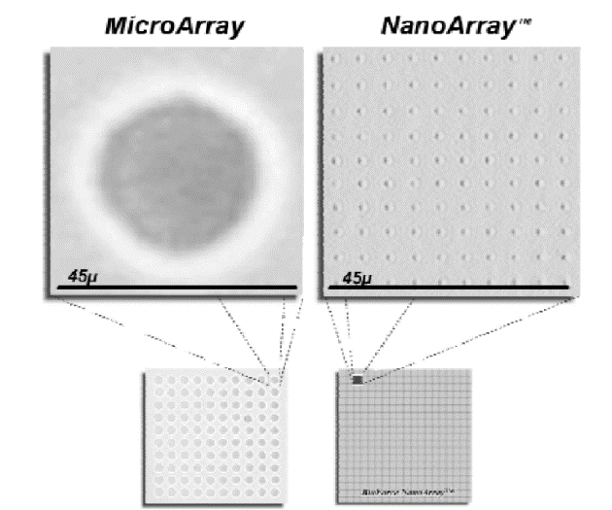
Figure 4: Nanoarray [Mosher, C. Mosher, C.]
The nanoarray technology was used in many areas of the medicine like drug discovery, diagnostics and proteomics. In this perspective, nanoarrays methodologies was used in gene activations, organelle genomics, mithocondrial DNA (mtDNA), pharmacogenetic genes depending on the actual status of encoding genes related to pharmacophore interactions or necessary treatments, HLA genes (human leukocyte antigen), analysis of Structural Variant (SV) or CNV, and density of single polymorphisms, were used for clinical applications. [Di, G.]
C. NANOCARRIERS
Over the past few decades, lot of work done on nanocarriers since they have shown great promise for medication delivery. Nanocarriers are colloidal drug delivery that typically have 500 nm sized particles. [Neubert R.H.] Because of their large surface area to volume ratio, nanocarriers can modify the fundamental characteristics and bioactivity of medicines. Some of the characteristics that nanocarriers can include in drug delivery are enhanced pharmacokinetics and biodistribution, lower toxicities, improved solubility and stability, controlled release, and site-specific delivery of therapeutic agents. Furthermore, by changing the composition of nanocarriers (organic, inorganic, or hybrid), their sizes (small or large), their shapes (sphere, rod, or cube), and their surface characteristics (surface charge, functional groups, PEGylating or other coating, attachment of targeting moieties), it is possible to modify their physiochemical properties. [Sun, T] In order to effectively cure an illness with the fewest adverse effects possible, nanocarriers are used in drug delivery. [Fakharud Din]
Nanocarriers to increase the therapeutical efficacy of drug candidates
The collaboration of medical science and drug development scientists to create more efficient delivery techniques in order to overcome the drawbacks of existing dosage forms is motivated by the number of lead compounds that repeatedly fail to develop into marketable medications. As a result, numerous types of nanocarriers have been extensively investigated to expand the in vivo performance and therapeutic outcome of drug molecules, forging a strong link between drug development and drug delivery applications of nanotechnology. [Suhair, Sunoqrot] The main
classes of nanocarriers that have been investigated and verified to increase the therapeutic efficacy of a range of medicinal molecules are summarized in the sections as follow.
- LIPOSOMES
Liposomes are the first type of nanocarriers being investigated for drug delivery. [G. Sessa] Aqueous compartments are found inside the spherical, closed lipid bilayer vesicles known as liposomes. It has been shown that these colloidal carriers, which alter the biodistribution profile of free drug molecules and greatly reduce their systemic side effects, enable the targeted delivery of chemotherapeutics. Liposomes have received a lot of interest in biomedicine during the past few decades, particularly as a way to deliver anticancer drugs. They showed a number of advantages over conventional systems, including enhanced product performance features, protection of the active ingredient from environmental factors, prevention of early encapsulated drug degradation, cost-effective formulations of expensive medications, and efficient treatment with lower systemic toxicity. The pharmacokinetic properties of free drugs in solution and drugs combined with liposomes are very different from one another. There are four primary categories for liposomes [Sunoqrot, S.] 1. conventional liposomes: These are made of an anionic, cationic, or neutral lipid bilayer that contains phospholipids and cholesterol and an aqueous core material. In this case, hydrophobic or hydrophilic substances might be utilised to fill the aqueous gap or the lipid bilayer. 2. PEGylated : Polyethylene glycol (PEG) is added to the liposome's surface to create steric equilibrium. 3. ligand-targeted type: Ligands, such as antibodies, sugars, and peptides, are linked to the liposome's surface or to the end of already connected PEG chains. 4. Theranostic liposome, which combines the first three liposome types and (4) Theranostic liposome : It combines the preceding three liposome kinds and typically includes a nanoparticle as well as targeting, imaging, and other components. [Sercombe, L, Patra, J. K.]
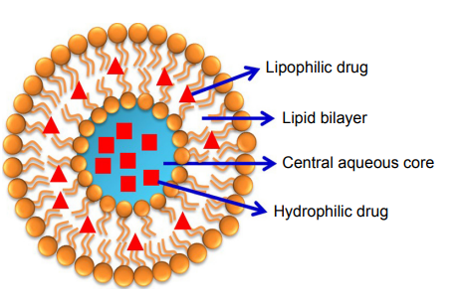

Figure 5: Structure of liposomes

- CONJUGATES OF POLYMERS AND DRUGS
Hydrophilic water-soluble polymers are widely employed in medicine to modify the surface of biomaterials and as carriers for medications, peptides/proteins, and oligonucleotides, either alone or in conjunction with other therapies. Polymer conjugates are one of the first types of nanomedicines to be used in clinical settings, along with liposomes. Low MW medications can be directed to tumours and inflammatory regions via the EPR effect by conjugating small-molecule pharmaceuticals to hydrophilic polymers like PEG and N- (2-hydroxypropyl) methacrylamide (HPMA), which has been proven to affect their biodistribution. The conjugation of peptide and protein medicines to polymers, which also increases their half-lives and lowers immunogenicity, enables passive targeting [Khandare, J., Kopecek, J.].
- PEG-DRUG CONJUGATES
PEG has become one of the most often used synthetic polymers for conjugation due to its advantageous properties, which include superior solubility, biocompatibility, minimal immunogenicity, and relatively low cost. PEGylation is presently a popular drug delivery technique for an array of macromolecules as well as small MW medications. It was first researched for the variation of peptides and proteins. The fundamental drawback of PEG as a drug carrier is its limited loading capacity, which has led to the creation of branched and multi-armed architectures. R.B. Greenwald

d)DENDRIMER-DRUG CONJUGATES
Dendrimers are extremely monodispersed, routinely hyperbranched, nanoscale (2–10 nm), and multifunctional macromolecules. Their distinctive structural characteristics have made them useful in a variety of biomedical applications [Greenwald, R.B, Suhair Sunoqrot).Different surface functional groups can be used to create dendrimers, which makes it easier to conjugate numerous therapeutic molecules and target ligands to surfaces inclusion complexes can be formed when drug molecules are alternatively enclosed inside the internal dendritic structure [Myung, J, Choi, S.K.].A further distinguishing quality of dendrimers is their deformability and flexibility, which enable the multivalent binding of surface molecules and have been shown to significantly improve the affinity of ligands for their targets .For use in drug delivery systems, numerous kinds of dendrimers have been created. The most popular of them are polyamidoamine (PAMAM) dendrimers. [Kaur A, Jain, Esfand, R] Dendrimers are now often utilized in a variety of medicinal applications, such as gene transfer, immunology, magnetic resonance imaging, vaccines, and the administration of antiviral, antibacterial, and anticancer medications. [Din, F.] A dendrimer-drug is generated when a drug is covalently bonded to a dendrimer at the core, on the terminal groups, or extremely rarely in the inner layers, i.e. at the branching sites. A drug's effective concentration at the desired location is considerably increased when it is linked to several peripheral groups in a dendrimer. Due to its structural control and monodispersed nature as macromolecules with known sizes and molecular weight, dendrimers-drug conjugates are preferred over traditional polymeric drug delivery carriers. [Esfand, R Svenson, S]
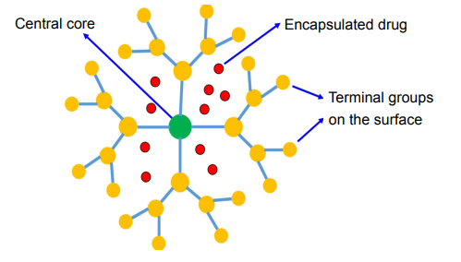

Figure 6: Structure of dendrimer

- POLYMERIC MICELLES
Amphiphilic block copolymers combine to form polymeric micelles, which are nanostructures with a core shell structure, in an aqueous solution. Hydrophobic drugs (such camptothecin, docetaxel, or paclitaxel) can be injected into the system's hydrophobic core, which can be stabilised by the hydrophilic shell, which also makes the system soluble in water. To avoid quick renal clearance, polymeric micelles are typically under 100 nm in size and have a restricted distribution. This permits them to collect in cancer tissues due to the EPR effect. Due to their polymeric coating, they also avoid common interactions with biological components. These nanostructures have a tremendous promise for the delivery of hydrophobic drugs since their interior core structure enables the assimilation of specific types of medications which can improve stability and bioavailability. [ Jayanta Kumar Patra]
e) INORGANIC NANOPARTICLES
Inorganic nanoparticles include those made of silica, gold, silver, and iron oxide. There aren't as many research on these sorts of nanoparticles as there are on the other forms of nanoparticles mentioned in this topic, despite the fact that they may have some applications. Only a tiny number of nanoparticles, however, have been authorized for use in therapeutic settings, and the majority of them are still going through clinical trials. Surface plasmon resonance (SPR), a property that liposomes, dendrimers, and micelles lack, is a characteristic of silver and gold metal nanoparticles. They showed several advantages, including as high biocompatibility and adaptability to surface functionalization. [Hong F-Y]
f) NANOCRYSTALS
Pure solid drug particles in the range of 1000 nm are known as nanocrystals. These are 100% drugs, with no carriers or other molecules linked to them. They are often stabilised by surfactants or polymeric steric stabilizers. Nano-suspension, a surfactant agent, is typically added to improve nanocrystal suspension in a poor liquid media. Water or any other aqueous or non-aqueous medium, such as liquid polyethylene glycol and oils, serve as the dispersing medium in this situation Increased saturation solubility, increased dissolution velocity, and increased glueyness to surface/cell membranes are just a few of the challenges that nanocrystals' unique properties enable them to overcome. [Junyapraser, VB, Du, J, Li, X].
- METAL NANOPARTICLES
The use of metallic nanoparticles in several medical applications, including bioimaging, biosensors, target/sustained drug delivery, hyperthermia, and photoablation treatment, has gained popularity recently [McNamara K] Additionally, these nanoparticles have been modified and functionalized with particular functional groups that enable them to bind to medicines, antibodies, and other ligands, making these systems more promising for use in biomedical applications . Although gold, silver, iron, and copper are the most studied metallic nanoparticles, a growing interest has been shown in other types of metallic nanoparticles, including cerium dioxide, zinc oxide, titanium oxide, platinum, selenium, gadolinium, and others [Kudr, J,]
- QUANTUM DOTS

Size-dependent optical properties including absorbance and photoluminescence are displayed by quantum dots (QDs), semiconductor nanocrystals with a diameter range of 2 to 10 nm. In contrast to conventional organic dyes, the QDs exhibit emission in the near-infrared region (650 nm), which is a very desirable characteristic in the field of biomedical images due to the low tissue absorption and reduction in light scattering [Volkov, Y.]. This has led to a great deal of interest in the QDs in the field of nanomedicine. The same light source can also excite QDs of different sizes and/or compositions, resulting in diverse emission colours over a wide spectrum. For multiplex imaging, QDs are a great option in this regard. QDs have received substantial study in the medical industry for use as sensors, bioimaging, and targeted medication administration. [ J. Liu and Xu]

- NANOPARTICLES OF PROTEINS AND CARBOHYDRATES
Natural biopolymers, which include polysaccharides and proteins, come from biological sources such plants, animals, microbes, and marine sources [Bassas-Galia, M]. The majority of protein-based nanoparticles may be broken down, metabolised, and easily functionalized for attachment to certain medicines and other targeted ligands. They are often synthesised using two distinct methods: (a) from insoluble proteins like zein and gliadin and (b) from water-soluble ones like bovine and human serum albumin. In directive to integrate targeting ligands that specifically identify specific cells and tissues to support and enhance their targeting mechanism, protein-based nanoparticles are chemically changed. The properties of polysaccharides' deterioration (oxidation) are major drawbacks of their usage in nanomedicine. (Lohcharoenkal, W]
- TARGETING MECHANISMS OF NANOCARRIERS
Passive Targeting
By encapsulating a medicinal material in a macromolecule or nanoparticle that passively moves to the target organ, it is achieved. The duration of circulation has an inverse relationship with the medication's effectiveness in passive targeting. [ S. Sagnella] The nanoparticle is coated in some way to do this. Polyethylene glycol (PEG), among other compounds, can achieve this. PEG can be applied to the surface of a nanoparticle to make it hydrophilic, allowing water molecules to establish hydrogen bonds with the oxygen molecules in PEG. The nanoparticle hydrates as a result of this interaction, which also forms an antiphagocytic coating around it. These interactions, which are typical of the reticuloendothelial system (RES), give the particles this feature. Consequently, the drug-loaded nanoparticle can remain in the bloodstream for a longer time. [L. E.] It has been discovered that nanoparticles between 10 and 100 nanometers in size circulate systemically for extended periods of time to cooperate with this passive targeting mechanism. [Gullotti, E]
Actively Targeting
The effects of passive targeting are enhanced by active targeting of drug-loaded nanoparticles, which increases the target site specificity of the nanoparticle. Active targeting can be achieved in a variety of ways. Knowing the characteristics of a cell's receptor for the medicine that will be used to target it is one technique to actively target just sick tissue in the body. The nanoparticle may then precisely connect to the cell that contains the complementary receptor using cell-specific ligands, which can be used by researchers. Transferrin has been proven to work well as the cell-specific ligand in this type of active targeting. Magnetoliposomes, which are often used in magnetic resonance imaging as a contrast agent, can also be used to perform active targeting. Thus, Magnetic placement could therefore help with this process by grafting these liposomes with a chosen medicine to deliver to a specific area of the body. [Galvin, P.]

Figure 7: Active and passive targeting of nanocarriers
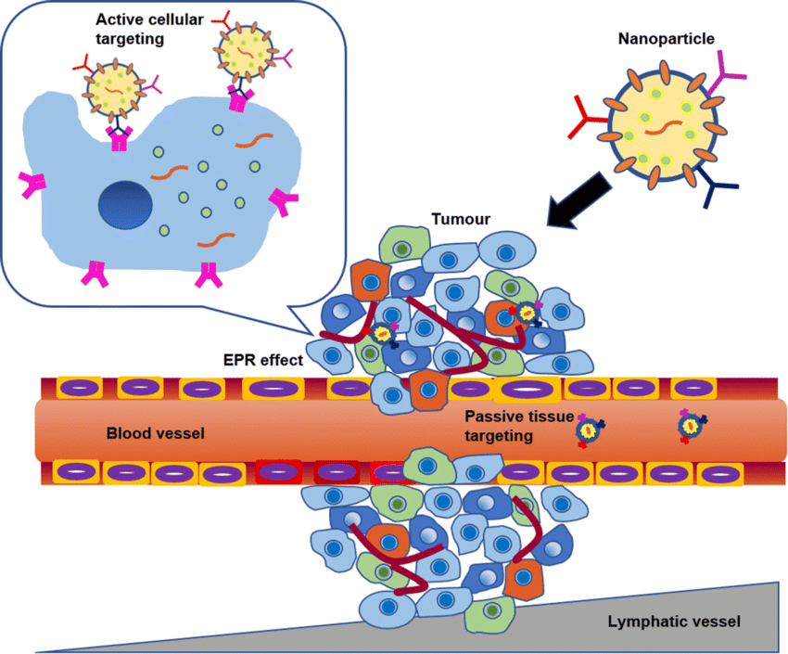

D. NANOBIOSENSORS
Nanobiosensors were created using cutting-edge nano- and biotechnology methods and are technologically sophisticated, responsive, and non-intrusive. These sensors' sensitive real-time signals are simple to collect and assess. One of the three components of the nanobiosensor is a genetic probe based on a cell-based genetic substrate, DNA, antibody-antigen, or enzyme. Additionally, a transducer converts biological data into an electrical signal, which is then loaded and transmitted by a data footage unit. Nucleic acids, antibodies, and enzymes are examples of biological elements. Biological probes connected to a range of synthesised nanomaterials, such as magnetic, metallic, graphene oxide, quantum dots, and CNTs, can be used to detect bioanalytes. Electrochemical signal transducers include fibres that measure fluorescence, colorimetry, and optical signals as well as potentiometric, amperometric, and voltammetric signals. Advanced nanoparticles come in a variety of forms and have been used in many applications. [Su, H]. The creation of the nanobiosensor entails converting biological or chemical processes into electrical output in order to detect biological, biomaterial, and electrochemical products like cholesterol, choline, dopamine, vitamin, blood glucose, creatinine, albumin, drugs, enzymes, protein, and nucleic acid. [Jain, U.] In a brief amount of time, this gives information on the composition or concentration, rheological properties, amplitude, energy, pH, polarisation, and decay time. As a result of fundamentally varied behaviours, platinum, diamond, silver, and gold nanoparticles are used in the production of nanobiosensors. Transducers can be made of several materials, including silicon, fibres, metals, ceramics, and glasses, as well as plastics, metal fibres, and ceramics. Using techniques like piezoelectricity, electrochemistry, optoelectronics, and thermal energy, they convert the medium into specialised signals. [Chadha U]. Along with sensitivity and concentration, response sample volume, sensory nanomaterials, temperature, pH, detection time, and rheological factors, the dynamic range is also considered in the optimization constraints. [Miller, C. A]

Table 2. Different types of nanomaterials are used to create nanobiosensors
Nanomaterial | Advantages | Disadvantages | Ref
Quantum dots | Excellent fluorescence, charge carrier quantum confinement, and size-tunable band energy | High toxicity using for in vitro system, Blinking effect | J. Wang
Nanowires | Incredibly adaptable, excellent electrical and sensing characteristics for bio- and chemical detection, and improved charge conduction | No Fluorescence, Large amount of surfactant | Y. Cui,
Nanorods | Good plasmonic materials that can combine sensing phenomena and size-tunable energy regulation well, can be coupled with MEMS, and cause specialized field responses. | Metabolism varies with different material, few in vivo study | R. MacKenzie
Nanoparticles | Assist in immobilisation, improve bioanalyte loading, and also have effective catalytic characteristics | Biocompatibility, Average optical signal | X. Luo,
Carbon nanotubes | enhanced electrical connectivity, enhanced aspect ratios, enhanced functionalization, and enhanced enzyme loading | Less solubility in an aqueous environment, lack of sensitivity | J. J. Davis
Metal Oxide nanomaterial | Better UV absorption, electric conductivity, antibacterial, and photocatalytic capabilities | Limited transfection efficiency | Ouyang, D

E. ADVANCEMENTS, PAST AND FUTURE APPLICATIONS OF NANOBIOSENSORS
a). Applications in Biology and Medicine
Nanobiosensors are being used extensively since they were first developed for the biological detection of serum tumor-causing agents, antigens, and and the etiologic microorganisms of a range of biochemical illnesses. The use of nanobiosensors in regular diagnostic applications is most suited for diseases including cancer, diabetes, allergic symptoms, and additional illnesses reliant on serum investigation. Clinically speaking, POCT principally enables the majority of the researched and convincing advantages of nanobiosensors, which include various therapy applications. Detecting UTI, circulatory disease (CVD), tissue regeneration, sugar level in diabetic patients, and anti-HIV are only a few of the applications [ J. C. Pickup. Bolinder, J. Kulkarni, M. B.]
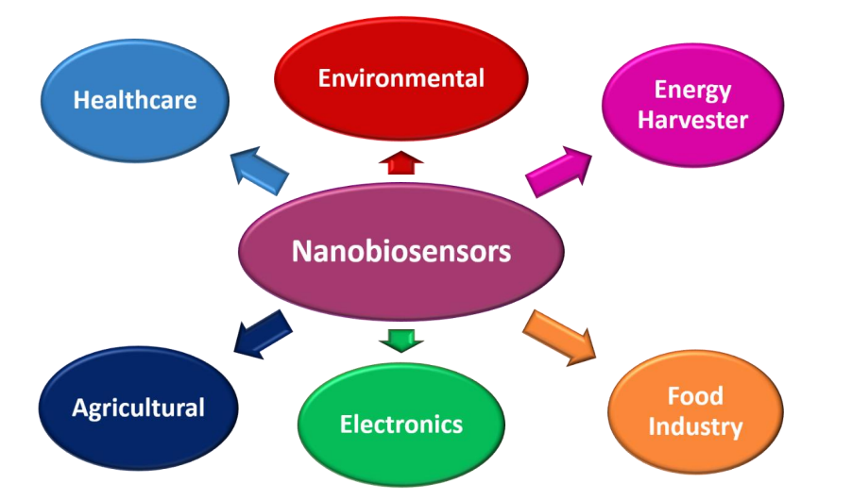
Figure 8: Application of Nano-biosensors
b. Applications in the environment
There is a broader range of applications of nanobiosensors. This is for the reason that the environment related activities, swift scale changes virtually every second. It takes a lot of time and effort to detect pollutants, hazardous intermediates, from sewage streams, heavy metals, and to check environmental factors like humidity estimation and other crucial aspects of the weather. Nanomaterial-based sensors have an extensive range of finding and monitoring capabilities. Technology is being effectively invaded by the use of tools like cantilever-based electronic probes and provisions that call for minimal amount of analyte. The specific type of detrimental amount of a material existing or predominant in can be determined using the nanomaterials-based sensing methods or dominant in the surroundings. When these applications are created using nanomaterials, they might be far more beneficial and useful. It has been shown that the substrate-specific detection technique used to develop biosensors for the detection of Nitrates and biological oxygen parameters similar to biological oxygen demand is an environmentally benign method. [Tian, J., Chen, J., and M.J. Ndolomingo]
c. Miscellaneous Applications.
Additionally, numerous other detections can be improved by the use of nanobiosensors. These sensors can be used to regulate manufacturing procedures the feeding of nutrition media and substrate combinations into the bioreactors for a variety of purposes. These sensors can improve a variety of commercial preparations and separations on an industrial scale. By experimenting with various sensing enzyme designs, nanobiosensors can be employed, for instance, in metallurgical operations that call for the selective removal of contaminants present in a complexed which coupled with the help of ores. Applications of these sensing materials include creating microorganisms and biological reactions as well as advances in bioengineering. [Kulkarni, M. B.].
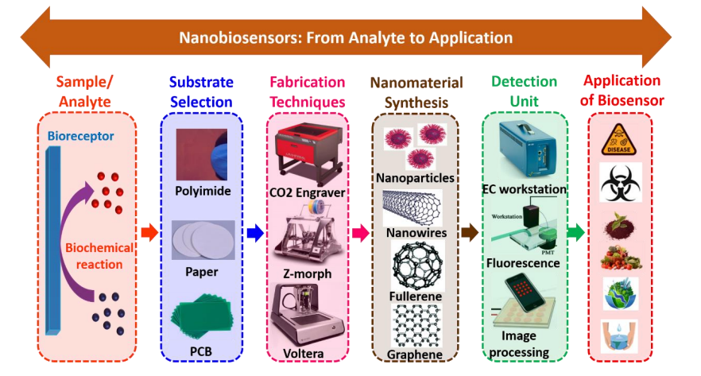
Figure 9: Analyte to application flow diagram for nanobiosensors
Table 3: Some biomedical applications of Different types of nanobiosensors

Nanobiosensors | Utilised Nanomaterial | Category of sensors | Application | Detection Limit | Ref
QD nanosensor | QDs | Florescence | Pathogens | - | Zhao, X
QD nanosensor | Quantum dots | Florescence | Pathogens and viruses | - | Efros, A.L
Nucleic acid nanosensor | CNTs | Immunosensors | Gnoderma boninse | 2mg/L | Taylor, P.
Antibiotic residue sensor | Au, Pt and SiO₂ Nps | Nano enzyme united with MIP as a Bio- Inspires body | Sulfadiazine | IC15: 0.08mg and IC50 6.1 mg/L | Ankri, S
Synthetic nasal sensor | Carbon | Volatile organic compound profile | Depending upon released organic molecules, pathogens | Sensitivity of 85%-95% | Kim, S
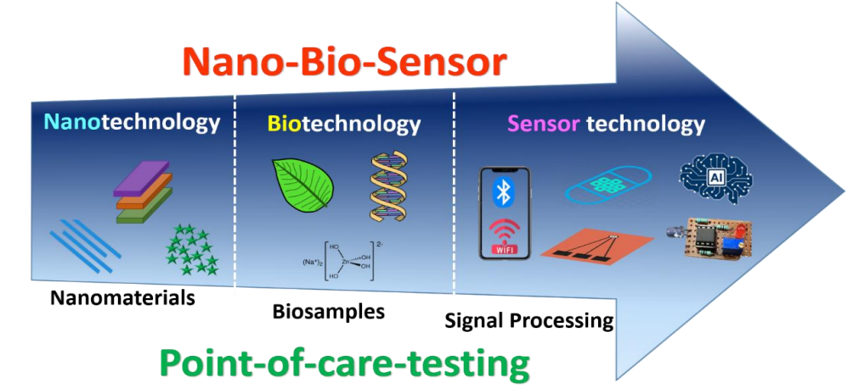
Figure 10: Future Scope of Nanobiosensors

F. CONCLUSION

Nanobiotechnology is now in its early stages of development. It is having a significant influence on many scientific and technological disciplines as a result of its widespread application and ongoing inventive research. A number of novel opportunities in medicine, diagnostics, and the biomedical sciences are being presented by nano-biotechnology. With the advent of something new as a result of nano-biotechnology innovation in drug delivery systems, it now appears viable to treat certain incurable diseases. Despite the great likelihood of advantages from nanobiotechnology, the future of nanomedicine is not yet clear. In actuality, regulatory agencies lack the proper rules to balance the aspects affecting risk and safety. It's safe to state that nano-biotechnology will play a great and distinctive function in the future.

REFERENCES
- Hulla, J.E. Hulla, S. C. Sahu, A. W.Hayes, “Nanotechnology: history and future,” human and experimental toxicology, volume 34(12), pp. 1318–1321, 2015. (references)
- Bayda, S. Adeel, M. Tuccinardi, T. Cordani, M. Rizzolio, F, “The history of nanoscience and nanotechnology: from chemical-physical applications to nanomedicine,” Molecules, volume 25(1), pp. 112, 2019. (references)
- Zelzer, M. Ulijn, R.V, “Next-generation peptide nanomaterials molecular networks, interfaces and supramolecular functionality,” Chem. Soc. Rev. 39, pp. 3351–3357, 2010. (references)
- Anselmo, A.C. Mitragotri, S, “Nanoparticles in the clinic: an update,” Bioeng. Transl. Med. Volume 4, pp. e10143, 2019. (references)
- Rickerby, D. Morrison, M, “Nanotechnology and the environment: A European perspective,” Sci. Technol. Adv. Mater. Volume8, pp. 19, 2007. (references)
- Bhushan, B, “Introduction to nanotechnology. In Handbook of Nanotechnology,” Springer Handbook of Nanotechnology: Berlin/Heidelberg, Germany, pp. 1–19, 2017. (references)
- Kumar, S, “Nanotechnology in computers,” Int. J. Inf. Comput. Technol, volume 4 pp. 974–2239, 2014. (references)
- McNeil, S.E, “Nanotechnology for the biologist,” J. Leukoc. Bio, 78, 585–594, 2005. (references)
- De Charles, P.P. Jr. Owens, F.J, “Introduction to Nanotechnology,” John Wiley & Sons: Hoboken, NJ, USA, 2003. (references)
- Schulte, J, “Nanotechnology: global strategies, industry trends and applications,” John Wiley & Sons: Hoboken, NJ, USA, 2005.
- Lemley, A.M, “Patenting nanotechnology,” Stanf. Law Rev, 58, pp. 601–630, 2005. (references)
- Salamanca-Buentello, F. Persad, D.L. Court, E.B. Martin, D.K. Daar, A.S. Singer, P.A, “Nanotechnology and the developing world,” PLoS Med, volume 2, pp. e97, 2005. (references)
- Roco, M.C, “The long view of nanotechnology development: the national nanotechnology initiative at 10 years. in nanotechnology research directions for societal needs in 2020,” Springer: Berlin/Heidelberg, Germany, pp. 1–28, 2011. (references)
- Singh, N.A, “Nanotechnology innovations, industrial applications and patents,” Environ. Chem. Lett, volume 15, pp. 185–191, 2017. (references)
- El Naschie, M.S, “Nanotechnology for the developing world,” Chaos Solitons Fractals, volume 30, pp. 769–773, 2006. (references)
- Waldron, A. Spencer, D. Batt, C, “The current state of public understanding of nanotechnology,” J. Nanopart. Res, volume 8, pp. 569–575, 2006. (references)
- Hulla, J. Sahu, S. Hayes, A, “Nanotechnology: history and future,” Hum. Exp. Toxicol, volume 34, pp. 1318–1321, 2015. (references)
- De Crozals, G. Bonnet, R. Farre, C. Chaix, C, “Nanoparticles with multiple properties for biomedical applications: a strategic guide, Nano Today, volume 11(4), pp. 435-463, 2016. (references)
- Sahoo, S. K. and Labhasetwar, V, “Nanotech approaches to drug delivery and imaging,” Drug Discovery Today, volume 8(24), pp. 1112–1120, 2003. (references)
- Sahu, T. Ratre, Y. K. Chauhan, S. Bhaskar, L. V. K. S. Nair, M. P. Verma, H. K, “Nanotechnology based drug delivery system: Current strategies and emerging therapeutic potential for medical science,” Journal of Drug Delivery Science and Technology,volume 63, pp. 102487, 2021. (references)
- Jain, K. K, “The role of nanobiotechnology in drug discovery,” Drug discovery today, volume 10(21), pp. 1435-1442, 2005.
- LaVan, D. A. Lynn, D. M. Langer, R, “Moving smaller in drug discovery and delivery,” Nature Reviews Drug Discovery, volume 1(1), pp. 77-84, 2002. (references)
- Fu, Y, “Metallic Nanoparticles-Based Biochip with Multi-Channel for Immunoassay,” J Biochips Tiss Chips, Volume 4 pp. 108, 2014. (references)
- Kelly, K.L. Coronado, E. Zhao, L.L. Schatz, G.C, “The optical properties of metal nanostructures: The influence of size, shape, and dielectric environment,” J Phys Chem B, 107, pp. 668-677, 2003. (references)
- Shaoli, Z. Fei, L. Xiangang, L. Chunlei, D. Yongqi, F, “A Localized Surface Plasmon Resonance Nanosensor Based on Rhombic Ag Nanoparticle Array,” Sensors Actuators B Chem, volume 134, pp. 193-198, 2008.
- Savage, N, “How AI and neuroscience drive each other forwards,” Nature, 571, pp. S15–S17, 2019. (references)
- Hoefflinger, B. (ed.), in CHIPS 2020—A Guide to the Future of Microelectronics (Springer Science and Business Media, ISBN 978-3-642-22399-0, 2012. (references)
- Murmann, B. Hoefflinger, B. Murmann, E, “Nano-chips, Springer International Publishing, pp. 91-192, 2020. (references)
- Zoraida, P. A, “Chapter 6 - Nanomedical Devices, Nanomaterials for Medical Applications,” Elsevier, pp. 235-292, ISBN 9780123850898, 2013. (references)
- Kricka, L. J, “Microchips, microarrays, biochips and nanochips: personal laboratories for the 21st century,” Clinica Chimica Acta, volume 307(1-2), pp. 219-223, 2001. (references)
- Vogel, H.G. Maas, J. Gebauer, A, “Nanotechnology in medicine. In Drug Discovery and Evaluation: Methods in Clinical Pharmacology,” Springer: Berlin/Heidelberg, Germany, pp. 533–546, 2020. (references)
- Barman, J. Tirkey, A. Batra, S. Paul, A.A. Panda, K. Deka, R. Babu, P.J, “The role of nanotechnology based wearable electronic textiles in biomedical and healthcare applications,” Mater. Today Commun, volume 32, pp. 104055, 2022. (references)
- Martzen, M.R. McCraith, S.M. Spinelli, S.L. Torres, F.M. Fields, S. Grayhack, E.J. Phizicky, E.M, “ A biochemical genomics approach for identifying genes by the activity of their products,” Science, volume 286 (5442), pp. 1153–1155, 1999. (references)
- Yang, J, “Nanofluidic Aptamer Nanoarray to Enable Stochastic Capture of Single Proteins at Normal Concentrations,” Small, 2023. (references)
- Binnig, G. Quate, C.F. Gerber, C, “Atomic force microscope,” Physical Review Letters, volume 56, pp. 930–933, 1986. (references)
- Mosher, C. Lynch, M. Nettikadan, S, “NanoArrays, the Next Generation Molecular Array Format for High Throughput Proteomics, Diagnostics and Drug Discover,” Journal of the Association for Laboratory Automation, volume 5(5), pp. 75-78, 2000. (references)
- Di, G. Linfei, L. Anmin, C. Huakun, L. Shixue, D. Jianmin, M, “Nanoarrays: design, preparation and supercapacitor applications,” RSC Adv, volume 5, pp. 55856-55869, 2015. (references)
- Neubert, RHH, “Potentials of new nanocarriers for dermal and transdermal drug delivery,” Eur J Pharm Biopharm, vol.77, no.1, pp.1–2, 2011. (references)
- Sun, T. Zhang, Y.S. Pang, B. Hyun, D.C. Yang, M. Xia, Y,“Engineered nanoparticles for drug delivery in cancer therapy,” Angew Chem Int Ed, vol.53, no.46, pp.12320–12364, 2014. (references)
- Din, F.U. Aman, W. Ullah, I. Qureshi, O.S. Mustapha, O. Shafique, S. Zeb, A,” Effective use of nanocarriers as drug delivery systems for the treatment of selected tumors,” International Journal of Nanomedicine, vol.5(12), pp, 7291–7309, 2017. (references)
- Sunoqrot, S. Hamed, R. Halim, H.A. Tarawneh, O, “Synergistic Interplay of Medicinal Chemistry and Formulation Strategies in Nanotechnology – From Drug Discovery to Nanocarrier Design and Development,” Current Topics in Medicinal Chemistry, vol.17, pp.1-18, 2017. (references)
- G. Sessa, G. Weissmann, “Phospholipid spherules (liposomes) as a model for biological membranes,” J. Lipid Res, vol.9, no. 3, pp. 310-318, 1968. (references)
- Sercombe, L. Veerati, T. Moheimani, F. Wu, S.Y. Sood, A. K. Hua, S,“Advances and challenges of liposome assisted drug delivery, “Front Pharm 2015; vol. 6, pp.286, 2015. (references)
- Patra, J. K, “Nano based drug delivery systems: recent developments and future prospects,” J Nanobiotechnol, vol. 16, pp.71, 2018. (references)
- Khandare, J. Minko, T, “Polymer–drug conjugates: Progress in polymeric prodrugs,” Prog. Polym. Sci., vol.31, no. 4, pp. 359-397, 2006. (references)
- Kopecek, J, “Polymer-drug conjugates: Origins, progress to date and future directions,” Adv. Drug Deliver Rev, vol. 65, no.1, pp. 49-59, 2013. (references)
- Greenwald, R. B. Choe, Y. H. McGuire, J. Conover, C. D, “Effective drug delivery by PEGylated drug conjugates,” Adv. Drug Deliver. Rev, vol.55, no.2, pp.17-250, 2003. (references)
- Myung, J. Gajjar, K. A. Saric, J. Eddington, D.T. Hong, S, “Dendrimer-mediated multivalent binding for the enhanced capture of tumor cells,” Angew. Chem. Int. Ed., vol.50, no.49, pp.11769-11772, 2011. (references)
- Choi, S. K. Myc, A. Silpe, J. E, “Dendrimer-based multivalent vancomycin nanoplatform for targeting the drug-resistant bacterial surface,” ACS Nano, vol.7, no.1, pp.214-228, 2013. (references)
- Kaur, A. Jain, K. Mehra, N. K. Jain, N, “Development and characterization of surface engineered PPI dendrimers for targeted drug delivery,” Artif Cells Nanomed Biotechnol, vol. 45, pp. 414–25, 2017. (references)
- Esfand, R. Tomalia, D. A, “Poly (amidoamine) (PAMAM) dendrimers: from biomimicry to drug delivery and biomedical applications,” Drug Discov Today, vol. 6, no. 8, pp.427-436, 2001. (references)
- Svenson, S. Tomalia, D.A, “Dendrimers in biomedical applications--Reflections on the field,” Adv. Drug Deliver. Rev, vol. 57, no. 15, pp. 2106-29, 2005. (references)
- Kong, F. Y. Zhang, J.W. Wang, R. F. Wang, W.J. Wang, W, “Unique roles of gold nanoparticles in drug delivery, targeting and imaging applications,” Molecules, vol.22, pp. 1445, 2017. (references)
- Junyaprasert, V. B. Morakul, B, “Nanocrystals for enhancement of oral bioavailability of poorly water-soluble drugs,” Asian J Pharm Sci,vol. 10, pp. 13–23, 2015. (references)
- Du, J. Li, X. Zhao, H. Zhou, Y. Wang, L. Tian, S. Wang,Y, “Nanosuspensions of poorly water-soluble drugs prepared by bottom-up technologies”, Int J Pharm, vol. 495, pp. 738–49, 2015. (references)
- McNamara, K. Tofail, S. A, ”Nanoparticles in biomedical applications,” Adv Phys. Vol, 2, pp. 54–88, 2017. (references)
- Kudr, J. Haddad, Y. Richtera, L. Heger, Z. Cernak, M. Adam, V. Zitka, O, “Magnetic nanoparticles: from design and synthesis to real world applications,” Nanomaterials, vol.7, pp.243, 2017. (references)
- Volkov, Y, “Quantum dots in nanomedicine: recent trends, advances and unresolved issues,” Biochem Biophys Res Commun, vol.468, pp. 419–427, 2015. (references)
- Liu, J. Lau, S. K. Varma, V.A. Moftt , R.A, “Molecular mapping of tumor heterogene- ity on clinical tissue specimens with multiplexed quantum dots, “ACS Nano, vol.4, pp. 2755–2765, 2010. (references)
- Xu, G. Zeng, S. Zhang, B. Swihart, M. T. Yong, K. T. Prasad, P. N, “New generation cadmium-free quantum dots for biophotonics and nanomedicine,” Chem Rev, vol. 116, pp. 12234–327, 2016. (references)
- Bassas-Galia, M. Follonier, S. Pusnik, M. Zinn, M, “Natural polymers: a source of inspiration. In: Bioresorbable polymers for biomedical applications,” New York: Elsevier, pp. 31–64, 2017. (references)
- Lohcharoenkal, W. Wang, L. Chen, Y. C. Rojanasakul, Y, “Protein nanoparticles as drug delivery carriers for cancer therapy,” BioMed Res Int, pp. 180549, 2014. (references)
- Sagnella, S. Drummond, C, “Drug Delivery: A Nanomedicine Approach. Australian Biochemist, volume 43, 5–8, pp. 20, 2012. (references)
- Vlerken, L.E. Vyas, T.K. Amiji, M.M, “Poly (Ethylene Glycol)-Modified Nanocarriers for Tumor-Targeted and Intracellular Delivery,” Pharm. Res, vol.24, pp.1405–1414, 2007. (references)
- Gullotti, E. Yeo, Y, “Extracellularly Activated Nanocarriers: A New Paradigm of Tumor Targeted Drug Delivery,” Mol. Pharm, vol. 6, pp. 1041-1051, 2009. (references)
- Galvin, P. Thompson, D. Ryan, K.B. Mccarthy, A, “Nanoparticle-Based Drug Delivery: Case Studies for Cancer and Cardiovascular Applications” Cell. Mol. Life Sci., vol. 69, pp.389–404, 2011. (references)
- Jain, U. Saxena, K. Hooda, V. Balayan, S. Singh, A. P. Tikadar, M. Chauhan, N, “Emerging vistas on pesticides detection based on electrochemical biosensors—An update,” Food Chem, vol. 371, pp.131126, 2021. (references)
- Chadha, U. Bhardwaj, P. Agarwal, R. Rawat, P. Agarwal, R. Gupta, I. Panjwani, M. Singh, S. Ahuja, C. Selvaraj, S. K, “Recent progress and growth in biosensors technology: A critical review,” J. Ind. Eng. Chem, Vol. 109, pp.21–51, 2022. (references)
- Miller, C. A. Ho, J. M. Bennett, M. R,“Strategies for Improving Small-Molecule Biosensors in Bacteri,” Biosensors, Vol. 12, pp. 64, 2022. (references)
- Wang, J. Liu, G. Polsky, R. Merkoc, A,“Electrochemical stripping detection of DNA hybridization based on cadmium sulfide nanoparticle tags,” Electrochemistry Communications, vol. 4, no. 9, pp. 722–726, 2002. (references)
- Cui, Y. Wei, Q. Park, H. Lieber, C. M, “Nanowire nanosensors for highly sensitive and selective detection of biological and chemical species,” Science, vol. 293, no. 5533, pp. 1289–1292, 2001. (references)
- MacKenzie, R. Auzelyte, V. Olliges, S, “Nanowire development and characterization for applications in biosensing,” Nanosystems Design and Technology, pp. 143–173, 2009. (references)
- Luo, X. Morrin, A. Killard, A. J. Smyth, M. R, “Application of nanoparticles in electrochemical sensors and biosensors,” Electroanalysis, vol. 18, no. 4, pp. 319–326, 2006. (references)
- Davis, J. J. Coleman, K. S. Azamian,B. R. Bagshaw, C. B. Green, M. L, “Chemical and biochemical sensing with modified single walled carbon nanotubes,” Chemistry, vol. 9, no. 16, pp. 3732–3739, 2003. (references)
- Ouyang, D. Huang, Z. Choy, W. C, “Solution-Processed Metal Oxide Nanocrystals as Carrier Transport Layers in Organic and Perovskite Solar Cells,” Adv. Funct. Mater, vol.29, pp. 1–18, 2018. (references)
- Bolinder, J. Ungerstedt, U. Arner, P, “Microdialysis measurement of the absolute glucose concentration in subcutaneous adipose tissue allowing glucose monitoring in diabetic patients,” Diabetologia, vol. 35, no. 12, pp. 1177–1180, 1992. (references)
- Kulkarni, M. B. Ayachit, N. H. Aminabhavi, T. M, “Recent Advancements in Nanobiosensors: Current Trends, Challenges, Applications, and Future Scope,” Biosensors, Vol. 12, pp. 892. 2022. (references)
- Tian, J. Li, Y. Dong, J. Huang, M. Lu, J, “Photoelectrochemical TiO2 nanotube arrays biosensor for asulam determination based on in-situ generation of quantum dots,” Biosens. Bioelectron, vol. 110, pp.1–7, 2018. (references)
- Chen, J. Fan, L. Yang, C. Wang, S. Zhang, M. Xu, J. Luo, S,“Facile synthesis of Ag nanoparticles-loaded chitosan antibacterial nanocomposite and its application in polypropylene” Int. J. Biol. Macromol, vol. 161, pp. 1286–1295, 2020. (references)
- Zhao, X. Li, M. Liu, Y, “Microfluidic-Based Approaches for Foodborne Pathogen Detection,” Microorganisms, vol. 7, pp. 381, 2019. (references)
- Efros, A. L. Delehanty, J.B. Huston, A. L. Medintz, I.L. Barbic, M. Harris, T.D, “Evaluating the potential of using quantum dots for monitoring electrical signals in neurons,” Nat. Nanotechnol, vol.13, pp, 278–288, 2018. (references)
- Taylor, P. Safarpour, H. Rad, F. Basirat, M. Shahryari, F, “Development of a quantum dots FRET-based biosensor for efficient detection of Polymyxa betae Development of a quantum dots FRET-based biosensor for efficient detection of Polymyxa betae,” Can. J. Plant Pathol, Vol. 34, pp.507–515, 2012
- Ankri, S. Mirelman, D, “Antimicrobial properties of allicin from garlic,” Microbes Infect, vol.1, pp.125–129, 1999. (references)
- S. Kim, J.Brady, F. Al-Badani, S. Yu, J. Hart, S. Jung, T.T. Tran, N.V. Myung, “Nanoengineering Approaches Toward Artificial Nose” Front. Chem., vol.9, pp.1–29, 2021. (references)

