FUTURISTIC TRENDS IN NURSING

The use of Artificial Intelligence is Streamlining Patient care delivery May replace nursing care Services: -

Introduction:
Artificial intelligence (AI) is currently being viewed as a game-changer in today's society. It would appear that artificial intelligence is set to revolutionize not just the planet but also the way people work and live.
Nurses who wish to grow in their professions need to be open to learning about and having a knowledge of new technologies. Additionally, they should engage in the development and deployment of technology to guarantee that it will aid enhance patient care while keeping safety standards. It's possible that nurses will be able to tailor patient care with the help of AI by doing the following.
- Keeping an eye on the general population's health.
- Determining which patients will have the most favourable results.
- Providing care that is individualized to the needs of each patient.
- Locating evidence that is pertinent to the specific patient in question.

The use of AI is causing a sea change in the way healthcare is delivered. With the use of AI and ML, healthcare practitioners can now collect and analyze vast amounts of patient data for use in making decisions. despite the fact that the average age of the patient population is rising. Although shortages are a major event with obvious consequences for the nursing field, other variables are also shaping the industry's future.

Terminologies:
- Artificial Intelligence: is a discipline that enables issue resolution through the combination of computer science and extensive datasets.
- Patient care delivery: The services that are offered in the health service by nurses in addition to those supplied by other professionals in the medical field and technology.
- Trends: a shift or motion in one of several predetermined directions It is also used to imply broad direction and trends, particularly of events, views, or movements in a certain direction.

Definition:
Futuristic trends in nursing: is defined as the practice of using cutting-edge medical technology and research to enhance patients' and their loved ones' quality of life from birth until death.
(or)
Futuristic nursing in 1987, and then again in 2002 with their abbreviated form. Caring for the ill and the healthy, across all age categories, social groupings, and geographical locations is what nurses do.
International Council nurses (1987)

“Sister Elizabeth Davis” defines nursing is a dynamic profession undergoing change every moment. “We are in a new place, we are not on the edge of the old place. We are not pursing the envelope, we are totally a new envelops. So the rule have changed ever fundamental premise old way of thinking is no longer applies”.

Artificial Intelligence in health care:
Businesses in the healthcare sector are increasingly turning to AI technology to improve patients' data experiences and shape policy. Artificial intelligence (AI) is being employed in all three of the conventional medical functions (diagnosis, prognosis, and treatment), although it is most common in the realm of medical diagnosis. The medical diagnosis process typically begins with the doctor seeing and examining the patient, followed by data collecting, expert interpretation, and finally the development of a diagnosis and treatment plan. All of these medical activities are now using AI; nevertheless, medical diagnosis is where it is most often applied. Medical diagnosis and the concept of an intelligent agent system have certain similarities. An intelligent agent (the doctor) processes patient data (the input) to provide a diagnosis (the output).
Artificial intelligence systems may aid in medical diagnosis in a number of ways, including by recreating the diagnostic cycle. One such approach is to make advantage of preexisting export methods.
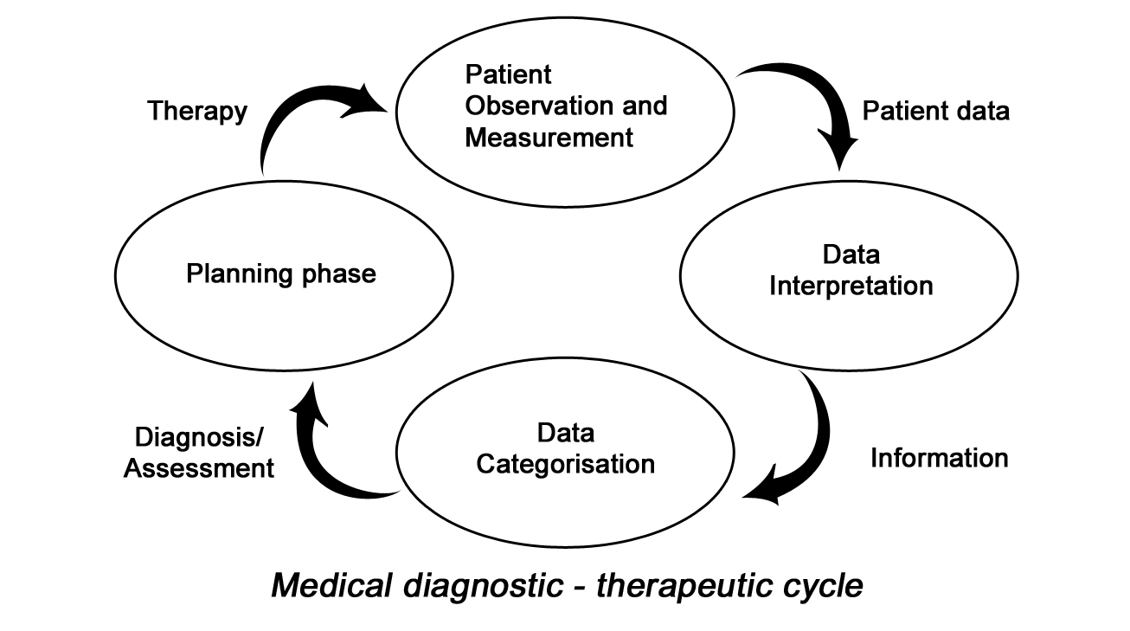

Expert system efficiency relies on a detailed definition of the knowledge area in the form of rules. Expert systems are like a cone, with the inference engine at its apex. Inputs are processed in order to provide actionable results.

Types of AI relevance to health care:
The term "artificial intelligence" refers to not just one but rather a variety of different technologies. The majority of these technologies may be directly applied to the field of health care right now. The following will outline and discuss many distinct AI technologies that are extremely important to the medical field.
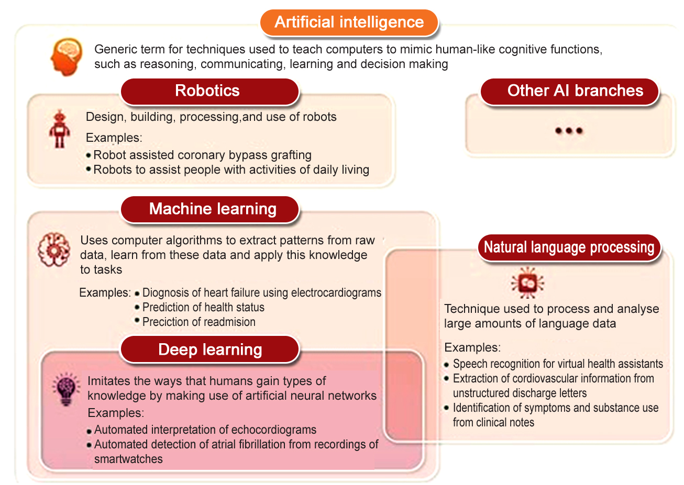

- Machine Learning: It is a subfield of artificial intelligence that makes use of algorithms to investigate historical knowledge, present data, and human interaction. This study assists in determining the most appropriate course of treatment for individual patients. In addition to this, it is an essential component in the process of improving and standardizing administrative activities related to health care. An important component of machine learning is known as data annotators. It is helpful to take CT and MRI scans, as well as mark cancer cells more precisely. It helps alleviate anxiety and recovery difficulties caused by the mismatch between a mechanical ventilator and the patient's natural breathing reflexes. When a patient's respiratory reflexes aren't in time with the ventilator, asynchrony occurs.

- Natural Processing Language: It is the process of a computer or other electronic device comprehending and interpreting written text or spoken language. The use of natural language processing (NLP) can be helpful in analyzing the medical records of patients and providing ideas to enhance the quality of the procedures that are employed and to provide better outcomes for patients. Understanding and making sense of medical information is one of the most prevalent applications of natural language processing in artificial intelligence. When the device understands what the user is attempting to say, it will function in accordance with that knowledge.

- Physical Robots: In the realm of medicine, physical robots are a common use of artificial intelligence (AI). In the beginning, researchers developed robots with the purpose of transporting medical supplies. On the other hand, there are currently available versions of robots that have been upgraded. These kinds of robots are able to work in tandem with humans and can be simply programmed to perform a variety of functions. The former, AI, generates data, while the latter, robotics, produces tangible results or actualizes physical operations. Knowledge and patient data are used by AI and robotics in a variety of tasks, including diagnosis and surgery planning.
- The surveillance of patents Wellness, both physically and mentally. o Physical treatments that are quite basic yet can increase a patient's independence throughout a period of physical or mental decline.
- Robotics may be utilized at the patient's house, for example, in order to monitor the patient's vital signs.
- The settings for palliative care include inpatient hospitals, whereas the settings for short-term care include inpatient hospitals. psychiatric hospitals and clinics.
- Home care Robots: Research and development efforts over the past few decades have been concentrated on the creation of robots that are able to aid people who are unwell or old. In particular in Japan since that nation has a huge population that is becoming older and has a longevity rate that is higher than typical. "Elder care robots" can be used in the home, where they will assist alleviate a chronic lack of nurses and specialist staff. This will be possible thanks to advances in technology. Which is a challenge that cannot be readily overcome by employing workers from other countries because of the language barrier.

- Robotic process Automation: The administrative sector has been the primary driver behind the development of this AI technology. The cost of robotic process automation is quite high in comparison to that of other forms of artificial intelligence. RPA is utilized in the healthcare industry to capture early authorizations. Bringing the medical records of patients and their bills up to date. By utilizing RPA, hospitals are able to lessen their reliance on manual labor during each step. This, in turn, lowers the likelihood of making mistakes caused by humans and improves accuracy. As a result, the workload of nurse administrators is reduced in the following ways:

- Prior Insurance Authorization: Approval of coverage for particular tests or authorisation for treatment is sought electronically, together with the cost to the patient, and the response is communicated through an email that is automatically created.

- Cost Estimates: Patients are informed of the whole cost of their surgeries and treatments prior to their initiation, and payment arrangements and efforts to collect payments are also streamlined.

- Insurance Verification & Benefits of approval: RPA will keep track of patients' appointments and request approval for them when they are scheduled, attended, or cancelled.

- Claims Management and Accounts Receivable: RPA, which makes use of bots and AI technologies, is utilized to manage the workflow of claims processing. It does so without requiring an excessive amount of repetitive manual interaction.

Artificial Intelligence in Nursing
- Practical implementation in clinical settings:
The term "artificial intelligence," or "AI," is used to describe a variety of healthcare technologies that are improving patient care and altering the roles of nurses. Commonly, when people think of artificial intelligence (AI), they think of machines that can learn on their own how to turn raw data into actionable knowledge that can guide decisions and actions. Nursing AI technologies include clinical decision support systems, mobile health and sensor based technology, voice assistants, robots, and other kinds of artificial intelligence.

- Clinical decision support: It's a tool for improving nurses' ability to assess situations and make decisions. Automatic nurse diagnoses, fall risk prediction, and guided decision making to avoid CAUTIs are all examples of how AI is being used to aid in clinical decision making.
Potential applications of AI in decision support include helping nurses better advocate for their patients and pinpointing areas where treatment is lacking or otherwise problematic..

- Mobile Health and Sensor Based Technologies:
Mobile health and sensor-based technologies have opened up new avenues for nurses to provide treatment and monitor their patients. The direct sharing of information between patients and healthcare providers is made possible by mobile health technology, which aids in the treatment of chronic conditions. Because of this, a clearer picture of the changing and stable components of a patient's health may be crafted within the context of their daily lives.
Sensor-based technologies installed in a home or hospital setting and used together aid nurses in writing text and multimedia messages (for sharing images and videos), measuring body movement, and collecting data on weight, motion, and ambient factors (temperature, light, sound, and air quality).
Patients' vital signs may be tracked from one treatment setting to another, from an inpatient facility to an outpatient clinic, using these devices.

- Voice Assistants and Robotics:
To gather data from patients at home and to administer therapies to supplement care, voice assistants may have a future in electronic health record (EHR) applications.

A nurse may use Alexa to set reminders for patients, such as elderly people, to take medications and monitor their blood pressure. Then, the nurse inputs the patient's data into the EHR for review. Patients with specific conditions, such as impaired eyesight, and the elderly may benefit greatly from these toys because to their voce-based manner of interaction. Realizing the full potential of voice assistants requires the input of nurses in the process of identifying relevant technologies, implementing those technologies in clinical settings, and delivering care to patients.

As the state of the art in robotics improves. It's being used to build telephone robots (where a nurse may control a wheeled robot through voice and video) and other remotely controlled gadgets to improve the quality of care provided to patients in healthcare facilities. The use of tele presence robots in hospitals is on the rise as a means to improve direct patient care.There is less of a chance of contamination when using robots and voice assistants. Advantages.

Reduce the length of time nurses spend on paperwork and record keeping during patient visits.

Remotely controlled robot arms that nurses may use to do tasks including feeding, medicine administration, and pushing infusion pump buttons..

Implementing Artificial Intelligence in Nursing
Although AI has been used by scientists for over four decades, its use in practical settings is relatively new. Artificial intelligence (AI) helps nurses analyze large amounts of data more quickly, which improves their ability to spot risks, provide solutions, and streamline their processes. However, certain limitations will need to be addressed with the cooperation of nurses before AI can entirely alter nursing practice. Nursing AI implementation is not an exact science; therefore you'll need to choose which technologies are best for your institution. The nurses who will be utilizing the tools have a say in how they're developed, how they're used, and how effective they are.

All in health care covers a wide range of assistance to health systems and workers, but what are the specific benefits and downfalls of its adoption?

Pros of using Artificial Intelligence in health care:
- • The number of benefits that AI has provided to both doctors and patients has grown substantially since its debut to the medical industry.
Real time access to information:
- • One of AI's greatest strengths in healthcare is its ability to transmit information during mealtimes. Because of this, a data-based diagnosis may be made considerably more rapidly, which can have a major impact on the patient's prognosis and course of treatment.

Streamlining Tasks: via means of arranging appointments, deciphering medical data, transferring files including patients' medical histories, and following up with patients who have gone missing. Artificial intelligence has greatly aided the streamlining of procedures in the healthcare industry.

Cost efficient and resourceful: Artificial intelligence (AI) has the potential to replace time-consuming human tasks with more efficient algorithms, resulting in considerable savings for healthcare institutions.

Research ability: The ability of artificial intelligence to not only provide data in real time, but also to include diverse study-based sources of knowledge, may be of significant use when assessing diseases.

Cons of using AI in health care:
The use of AI in healthcare has shown that technological advancements may also aid professionals in the hard sciences, such as medicine. As a result, below are a few explanations as to why:

Require Human Oversight:
- Because AI is not yet faultless, human supervision and monitoring of the systems' operations will still be required.
- Robotic systems used as surgical assistants, for instance, lack empathy and will blindly follow their orders as written.

Might create Social Baises:
Compatibility issues arise between the different mobile platforms and devices, which of course does not account for the whole range of capabilities out there.

Might Replace Human Employees:
There is a risk that certain hospital workers may be replaced by AI in the near future since the technology can handle the bulk of the cognitive and physical labor involved in delivering medical care.

Possible Security Risks:
One major problem of using AI in the medical industry is the evident danger to patient privacy and confidentiality that such applications pose.

The future impact of AI in nursing

Nurses can be more efficient and provide better care for patients if healthcare facilities use AI to help them. Artificial intelligence (AI) is increasingly becoming an integral element of the nursing profession as a tool for improving information synthesis, job completion, clinical decision making, and patient outcomes. Each of these emerging technologies has great promise for enhancing healthcare delivery. If we can merge these technologies and train nurses to use them effectively, the future of healthcare will be drastically revolutionized. The potential for increased productivity, output, and quality is almost limitless. Although there are challenges associated with the use of AI in nursing, nurses will play an important role in supporting health care organizations in integrating and adjusting to the resultant technological change as the technology develops.
Conclusion:
Without a doubt, AI is changing the healthcare industry and the nurse's position in it. The use of AI in healthcare might have far-reaching consequences. Research and development of AI applications in health technology should include both healthcare professionals and patients. This will ensure that the newly created apps are relevant to clinical practices and that the new era of nursing is consistent with core nursing values.

1.Book Reference:
1. Beam AI, kohane is, Translating artificial intelligence into clinical care. Jama 2016, 316(22):2368-9
2. Sandeep Reddy (2018) Text book of use of artificial intelligence in health care delivery
2. Web Reference :
- http://www.forseemed.com Artificial intelligence (AI) in healthcare & hospitals 2023
- http://www.intelligence.com Artificial intelligence in health care. AI applications & uses 2023
- http://www.ibm.com What is artificial intelligence in health care 2023
- http://www.consultantad.clevalandclinic.org.com How artificial intelligence is partenering with nursing to provide care 2022
- http://www.openaccessgovernment.org.com What are two pros and of implementing AI in health care, 2022
- https://www.managedoutsource.com main types of AI-2021

