NANOEMULSIONS: FORMULATION, COMPOSITION, AND APPLICATIONS

Priyanka Keshri*, Alagusundaram M, Vijeta Bhattacharya, Mineeta Mahra, Gaurav Bhargava , Gineeta devi , Neha Chopra

School of Pharmacy, ITM University Gwalior (M.P.) Pincode – 4704001
Gurukul Institute of Pharmaceutical Science & Research, Gwalior (M.P) Pincode-474010

Email – priyankakeshri334@gmail.com

ABSTRACT:

A film of interfacial molecules made up of surfactant and co-surfactant molecules with droplet sizes smaller than 100 nm holds together transparent or translucent dispersions of oil and water known as nanoemulsions, which are thermodynamically stable. They have beneficial properties because of their small droplet size, which leads to a high surface area per unit volume, higher stability, optical transparency, flexible fluidity, and increased bioavailability of lipophilic components. The interdisciplinary applications of nanoemulsions in consumer goods, including drugs, pesticides, cosmetics, food, paint, and environmental applications, have recently piqued the interest of researchers. This book chapter briefly discusses the creation, composition, analysis, and use of nanoemulsions as drug carriers to improve the delivery of therapeutic agents. See the list below for a variety of methods, including high- and low-energy ones, for producing nanoemulsions. Phase transition temperature, phase inversion composition, spontaneous emulsification, micro-emulsion dilution, and more recently developed methods like D phase emulsification (DPE) are examples of low energy methods. Microfluidization, high pressure homogenization, and ultrasonication are the three main high energy methods. Several techniques are used to characterise nanoemulsions, including differential scanning calorimetry, Fourier-transform infrared spectroscopy, transmission electron microscopy, particle size, polydispersity index, zeta potential, and transmission electron microscopy. Nanoemulsion stability and thermodynamic stability, shelf life, dispersibility, viscosity, surface tension, friccohesity, refractive index, percent transmittance, pH, and osmolarity are also examined

KEYWORDS:
Naonemulsion, Novel drug delivery system, Bioavailability, Homogenization, Emulsification, Characterization, entrapment efficiency, droplet size

1. INTRODUCTION
By way of the progress and advancement in time, knowledge, and tools, drug formulations have expanded from simple blend and tablets, to extremely complicated structure, which are famous as novel drug formulation systems. A perfect formulation system achieves the goals of enhanced therapeutic response with least toxicity. (Fig..1). Oral drug delivery is the most widely used method of administration because it avoids problems associated with intravenous administration, such as extravasations of drug or blood, thrombosis, and catheter infections1. However, problems with the physicochemical properties of the drug, such as poor solubility, low intestinal permeability, instability in the harsh acidic environment followed by rapid metabolism, limit oral drug delivery. All of these factors reduce oral bioavailability. [2]. Number of molecules have been developed as a result of improvements in drug design in order to facilitate potential therapeutic effects. But the majority of the recently discovered molecules or chemical molecules is, anti-inflammatory, and antipyretic. It is used to treat osteoarthritis and rheumatoid arthritis. Despite being quickly absorbed when taken orally It undergoes significant 1st pass effect, very short half-life, gastric irritation etc. To increase drug action or delivery into systemic circulation. The goal of the current study was to create or evaluate fenoprofen ointment. After that, stability tests at various temperatures were conducted to find the best formulation. [11].
Many dermatological products are available for the treatment of skin conditions [12]. Most ointments are made up of an ointment base, which acts as a container or carrier for the medication. [13] of high molecular weight (Phytochemicals) and belongs to biopharmaceutical classification system (BCS) –IV, with low water solubility and low intestinal permeation property. Consequently, these characteristics reduce the bioavailability of medications taken orally. [3] Nanoformulations have revolutionised the development of innovative devices and drug delivery systems. To address the bioavailability issues related to drug administration via oral route, numerous "lipid based formulations" (solid lipid nanoparticles, nanostructured lipid carriers, nanoemulsion, and liposomes) have been researched recently. [6]. Major mechanisms that further improve the bioavailability, effectiveness, and tunable release profile of phytomedicines in blood circulation include avoiding first pass drug metabolism, improving mucosal adhesion, improving permeation across the intestinal membrane barrier, protecting against harsh GI environments, and controlled release. NEs offer resistance to creaming or sedimentation, with Ostwald ripening serving as the primary pathway of NE degradation. The main use of NEs is in the creation of nanoparticles through the so-called miniemulsion polymerization method, in which NE droplets serve as nanoreactors and a polymerizable monomer serves as the disperse phase. Formulating NEs with active pharmaceutical ingredients (APIs), specifically for controlled drug delivery and targeting, is another fascinating application. [1]
1.1 WHAT ARE NANOEMULSIONS
Nanoemulsions are defined as thermodynamically stable, isotropic translucent or transparent dispersions of oil and water stabilized by surfactant molecules (forms an interfacial film) having the droplet size of 20-500nm [4]. The NEs are also called by other names such as mini emulsions, ultrafine emulsions as well as SMEs. NEs provide stability against sedimentation or creaming with Ostwald ripening being the pivotal pathway of NE degradation [5]. The principal application of NEs in the formulation of nanoparticles by employing a polymerizable monomer serving as the disperse phase (the so-called miniemulsion polymerization method) where NE droplets function as nanoreactors. Another fascinating application is formulating NEs containing active pharmaceutical ingredients (APIs), namely, for controlled drug delivery as well as targeting . The versatility and structural adaptability of NEs have made them useful for developing vaccines and new therapeutic platforms that use mucosal, intramuscular, subcutaneous, and intravenous delivery systems. (Fig. 4). Thus, for the development of novel, advanced NE drug delivery platforms, understanding NE composition and functional properties, along with the surrounding biological systems, is essential. [10].
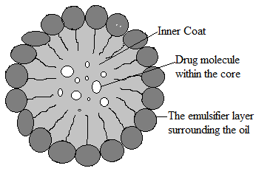
Fig. 1 Structure of nanoemulsion
1.2ADVANTAGESOF NANOEMULSION
One of the most effective methods for making lipophilic medications more water soluble is nanoemulsion. This increases the drug's bioavailability in the body's circulatory system. The transport properties of the drug are affected by the nanoscale droplets' increased interfacial areas, which is a crucial component of drug delivery. Fig.2 (sustained and targeted) 13, 14.
• Plasma concentration profiles and bioavailability of drugs when administered in nanoemulsion formulation are more repeatable. 18, 14.
• It has been observed that as the oil droplets are fine, it empty quickly from the stomach and increase proper distribution of the API throughout the intestinal tract. By doing so it minimizes irritation frequently observed with long contact of the drug and gut wall 13, 19.
• Formulations based on nanoemulsions have a higher solubilization capacity than those based on straightforward micellar solutions. In contrast to emulsions and suspensions, which are unstable dispersion systems, nanoemulsions are also thermodynamically stable. Nanoemulsions are simple to make and require little energy, i.e., less heat and mixing, in addition to having a long shelf life. [14].
• Additionally, they offer extremely low interfacial tension and sizable o/w interfacial areas. 14, 20, 21.
• In terms of quick action (no extra time for dispersion) and decreased inter-subject variability in terms of GIT fluid volume, they also provide an advantage over current self-emulsifying systems.
• Similar to microemulsions, nanoemulsions may have high kinetic stability and optical transparency. 18, 22.
• The majority of nanoemulsions appear optically transparent even at high loading because the structures in them are much smaller than the visible wavelength. 13, 18, 23.
• Nanoemulsions are also used to deliver peptides that easily undergo enzymatic hydrolysis (degradation) in GIT 14, 24, 25.
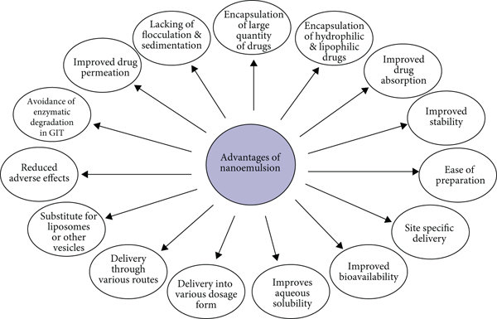
Fig. 2 Advantage of Nanoemulsion
1.3 MAJOR COMPONENTS OF NANOEMULSION
Three pivotal ingredients are necessary for NE preparation which are
1. Oil
2. Surfactant
3. Co-surfactant
Oils: The choice of an appropriate oily phase is crucial because it affects the choice of other nanoemulsion ingredients, particularly in the case of O/W nanoemulsions. For the formulation of nanoemulsions, the oil with the highest solubilizing potential for the chosen drug candidate is typically chosen. This makes it easier to load the nanoemulsions with the most drug possible. 17, 21. Since triglycerides have a high lipophilicity and the effective concentration of ester groups determines their solvent capacity for drugs, medium chain triglycerides (MCT) have a higher solvent capacity and oxidation resistance than long chain triglycerides. 17. Modified vegetable oils, oils and fats (digestible or non-digestible) such as palm oil, olive oil, corn oil, sesame oil, oleic acid, hydrogenated soybean oil, peanut oil, soybean oil and beeswax are also used as oil phase in nanoemulsion formulation 16.
Surfactants: The oily phase should be microemulsified with the aid of the surfactant, which should also have a high solubilizing capacity for the hydrophobic drug compounds. The formulation of the nanoemulsion depends on the surfactant choice. Hydrophilic surfactants that form o/w nanoemulsion include polysorbate 80, which has an HLB value of 10. To create a nanoemulsion, a combination of lipophilic (low HLB) and hydrophilic (high HLB) surfactants may be necessary. 21. Below critical micellar concentration (CMC) of the
surfactant in solution it increases drug solubility by giving regions for lipophilic drug interactions in solution. Surfactants group together above CMC to create micelles that have a lipophilic core and a lipophobic surface. The micelle's lipophilic core influences the drug's entrapment (which is primarily lipophilic in nature), increasing its solubility.
Co-surfactants: The majority of the time, a surfactant by itself is unable to sufficiently reduce the oil-water interfacial tension to produce a nanoemulsion, necessitating the addition of an amphiphillic short chain molecule or cosurfactant to achieve surface tension that is nearly zero. Cosurfactants penetrate the surfactant monolayer, adding fluidity to the interfacial film and preventing the formation of the liquid crystalline phases that result from an overly rigid surfactant film. 21. The majority of the time, a surfactant by itself is unable to sufficiently reduce the oil-water interfacial tension to produce a nanoemulsion, necessitating the addition of an amphiphillic short chain molecule or cosurfactant to achieve surface tension that is nearly zero. Cosurfactants penetrate the surfactant monolayer, adding fluidity to the interfacial film and preventing the formation of the liquid crystalline phases that result from an overly rigid surfactant film. 16, 18.
Co-solvents: The creation of the ideal nano-emulsion necessitates the use of surfactants in high concentrations, typically greater than 30% weight-for-weight. For oral drug delivery, a variety of organic solvents including glycerol, polyethylene glycol (PEG), ethanol, and propylene glycol (PG) are used. These co-solvents are effective at dissolving large amounts of water soluble surfactant or the API in the lipid base. Generally speaking, it increases the environment's lipophilicity by lowering the aqueous phase's dielectric constant. 18. In conventional SMEDDS, some co-solvents, such as alcohols and other volatile substances, have the drawback of evaporating into the soft or hard gelatin capsule shells, which causes the drug to precipitate. As a result, when designing, formulation should be free of alcohol. 18, 21, 27
1.4 Three types of NEs formed depending on the composition.
1. O/W NE: The oil droplets are dispersed in the ongoing aqueous phase in this situation.
2. W/O NEs: The oil droplets are dispersed in the ongoing aqueous phase in this situation.
3. Bi-continuous NEs: Within this system, oil and water microdomains are interspersed.
In all three categories of NEs, the interface is made stable by a required blend of surfactants and/or co-surfactants [31].
2. METHODS OF PREPARATION OF NANOEMULSIONS
Surfactants that are approved for internal human use as well as some food ingredients that have been deemed "Generally Recognised as Safe" by the Food and Drug Administration are used to create nanoemulsions. A process known as high-stress, mechanical extrusion, which is widely available, can be used to combine an aqueous phase with a water-immiscible oil phase in order to produce nanoemulsions in large quantities. Fig 3. As nanoemulsions are having very small droplet size, it can be effectively prepared by high-pressure equipment.
Mostly equipments used for the formulation of the nanoemulsion are:
- High-pressure homogenization and
- Microfluidization
Both the equipments can be used for laboratory as well as industrial scale.
Aside from ultrasonification and spontaneous emulsification, which are both suitable for laboratory use but not for commercial production, other techniques are also used in the formulation of nanoemulsions. show in Table 1 14, 21, 28.

Technique | Formulation | Conclusions | Ref
High pressure homogenization | Oral lipid nanoemulsion (primaquine) | 10-200 nm particle size, improved oral bioavailability | 29
Pseudoternary phase diagram + spontaneous emulsification method | Ramipril nanoemulsion | Enhanced bioavailability; 80.9 nm droplet size | 30
High pressure homogenization | O/W nanoemulsions | Increased hydration and elasticity of the skin | 31
Spontaneous emulsification | O/W nanoemulsion (aceclofenac) | Aceclofenac nanoemulsion with potential for transdermal delivery | 32
Spontaneous emulsification | Celecoxib nanoemulsion | Improved celecoxib physical and chemical stability in nanoemulsion | 33
High pressure homogenization | Lecithin-based nanoemulsions (progesterone) | Improved celecoxib physical and chemical stability in nanoemulsion | 34
High pressure homogenization | Prednicarbate nanoemulsion | An improved drug's chemical stability in formulation | 35
Phase inversion temperature method | Acyclovir-loaded multiple W/O/W nanoemulsions | Excellent physicochemical stability for 6 month at RT, mean droplet size of 100 nm | 36
Spontaneous nanoemulsification method | Clotrimazole nanoemulsion | Improved solubility of clotrimazole, mean globule size | 37
Ultrasonic emulsification method | Basil oil nanoemulsion | Nanoemulsions with droplet size of 29.6 nm, for food preservation | 38
High-pressure homogenizer | Dimethyl silicone dry nanoemulsion inhalation | Effective in acute lung injury, particle size of 19.8 nm | 39
Microfluidization method | Pitavastatin-containing nanoemulsions | Enhanced permeation | 40
High-pressure homogenization+ ultrasound | Nanoemulsion | Reduced energy demand for emulsification, low particle dimensions and higher stability | 41
Sonication method | Saponin-stabilized quercetin-loaded o/w nanoemulsion | Stable for 45 d at RT, mean particle size of 52±10 nm | 42
High-pressure homogenization | Paclitaxel-baicalein nanoemulsion | A plan to combat drug resistance to multiple drugs | 43
Nanoemulsion templating | PLGA nanoparticles | Imaging agents for use in biomedicine | 44
Spontaneous emulsification method | Chitosan films with cinnamaldehyde nanoemulsions | Good UV protection qualities | 45
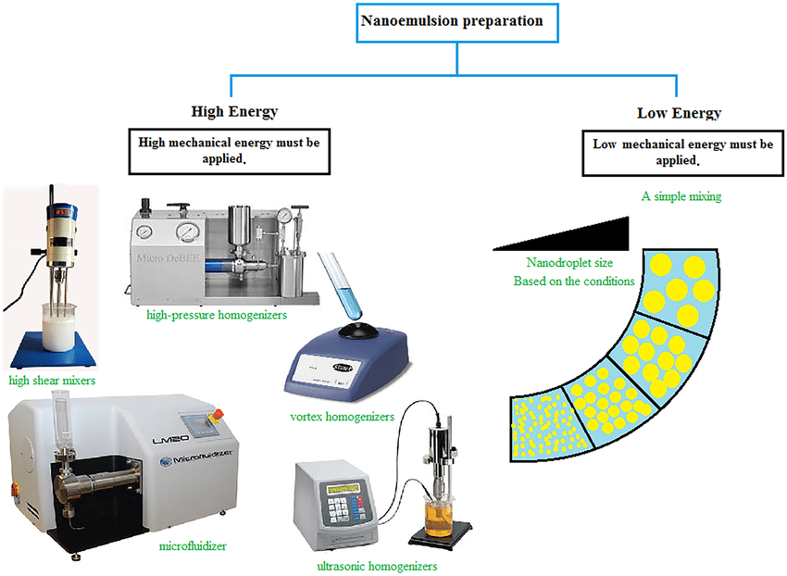
Fig.3 Preparation of Nanoemulsion

3. CHARACTERIZATION OF NANOEMULSIONS
The prepared nanoemulsions are evaluated for following parameters:
Dye Solubilization ⁴⁶
A water soluble dye is dispersible in the o/w globule but is solubilized in the aqueous phase of the w/o globule. An oil soluble dye is dispersible in the w/o globule but is solubilized in the oil phase of the o/w globule.
Measurment of Droplet Size and Polydispersity Index
Using dynamic light scattering (DLS) and a Malvern Zetasizer at 250C, the mean particle size and polydispersity index are determined. With the aid of a disposable capillary cuvette fitted with electrodes, the size of the particles is determined. Samples are 100-fold diluted with double-distilled water just prior to measurement in order to prevent multiple scattering effects from affecting the measurements 47.
Interfacial Tension ⁵⁰: The properties of a nanoemulsion can be studied by measuring the interfacial tension, and the spinning-drop apparatus can be used to measure extremely low interfacial tension. Interfacial tensions are calculated by rotating a drop of the low-density phase in a cylinder of high-density phase and measuring its shape.
Particle Size Analysis: In the case of nanoemulsion, the dynamic light scattering (DLS) method is typically used to measure particle size and their distribution. 51
Conductance Measurement ⁴⁶ Electrical conductivity measurements are very helpful in identifying the continuous phase's characteristics and spotting phase inversion phenomena, which are typically accomplished through conductance measurements. Since water is the internal or dispersed phase in an o/w nanoemulsion and not in a w/o nanoemulsion, the former is highly conducting. Dielectric measurements are an effective tool for examining the dynamic and structural characteristics of nanoemulsion systems.
Refractive Index: An Abbes type refractometer is used to calculate the nanoemulsion's refractive index. Every sample's refractive index is calculated using the mean value and standard deviation (SD) after being measured three times. Viscosity As part of the study, a Brookfield viscometer with a spindle size of 62 and a rotational speed of 60 was used to measure the viscosity of the nanoemulsions.
Percent Drug Loading: Pre-weighed nanoemulsion is extracted using a suitable solvent in 25 ml, and the extract is then analysed spectrophotometrically or using HPLC in comparison to a standard drug solution to determine the percent drug loading. By using different columns with the right porosity and a reverse phase HPLC method, the drug content is determined.
Determination of Entrapment Efficiency: Measuring the amount of free drug (unentrapped) in an aqueous medium allows for the calculation of entrapment efficiency (EE%). This is of utmost importance because it affects how a drug molecule releases. After separating the entrapped drug from the nanoemulsion formulation, the amount of drug per unit weight of the nano formulation is calculated. The entrapment efficiency is determined by following formula:-
EE= Wt of total drug in formulation –Wt of drug in a.q. phase ×100
Wt of total drug in formulation
Stability studies The stability study is a crucial factor to take into account when judging nanoemulsions. The high stability of nanoemulsions distinguishes them from other dispersed systems.
The numerous stability studies for nanoemulsions that have been done include a) Thermodynamic stability studies, and b) Accelerated stability studies.
a.Thermodynamic stability studies
The chosen formulations are put through a variety of thermodynamic stability studies tests to determine how stable they are physically. The procedure consisted of three cycles: first, heating and cooling cycles are repeated six times; next, heating and cooling cycles alternate at 40°C and 4°C; finally, centrifugation at 3500 rpm for 30 min. Phase separation-related changes in the formulation are monitored throughout each cycle.
b. Accelerated stability studies. On the improved formulation, accelerated stability studies are carried out. In glass vials, three batches of the nanoemulsions were stored at 58 percent relative humidity at 30 degrees, 40 degrees, and 60 degrees Celsius. According to the standard procedure outlined in the International Conference on Harmonisation (ICH) Q1 guidelines, the samples are withdrawn for the purpose of studying the drug content. The order of the reaction is determined by a graphical method, and the amount of the drug degraded at each time interval is calculated. For each temperature, the degradation rate constant (K) is calculated.

4. APPLICATIONS OF NANOEMULSIONS IN VARIOUS FIELDS (Fig.4)
1. Nanoemulsions in drug delivery
II. Nanoemulsions in Biotechnology
III. Nanoemulsions in Cosmeticology
IV. Nanoemulsions in Food industry
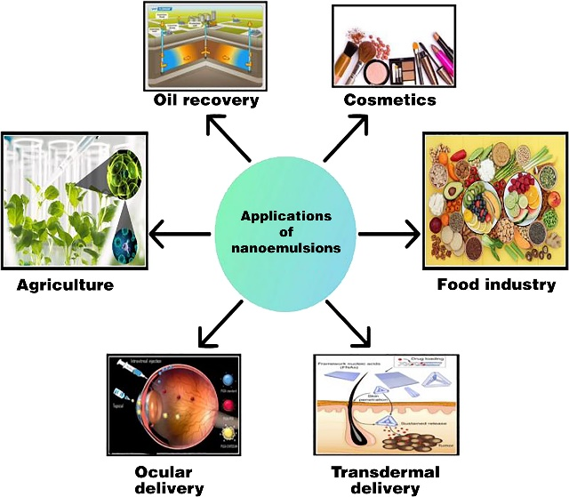
Fig.4 Application of nanoemulsion

I Nanoemulsions in drug delivery
Most topical, ocular, intravenous, internasal, and oral drug delivery methods use nanoemulsions. Fig.5. These applications affect nanoemulsions' lyphophilic properties, which help them dissolve drugs that aren't soluble in water, and their tunable charge and rheology, which help them create aqueous solutions that are simple to administer to patients. Although skin shields us from the outside world, it also serves as a transport barrier to prevent drug administration through the skin. As the dispersed phase of O/W nanoemulsions enables improved solubility of lipophilic drugs in the oil phase and the continuous phase offers a mild, skin-friendly environment that can dissolve biopolymers such as alginate for adjusting the formulation's rheology, appearance, and texture, topical medications made with nanoemulsions can offer special benefits. Numerous studies concentrated on the use of nanoemulsions for topical drug delivery. A few of the studies mentioned above used permeation tests to gauge how well topical delivery worked. According to some studies, hydrophobic drugs are delivered more effectively through nanoemulsion formulations than they are through suspensions because of their small size and low z-potential. 59 Researchers have also looked into using nanoemulsions for other drug delivery methods, including oral, intravenous, intranasal, and ocular. Ultrasound imaging agents have also been created using nanoemulsions. Perfluorocarbon-containing nanoemulsions that have been prepared for targeted therapeutics and quantitative molecular imaging. Created a multifunctional platform based on nanoemulsions to allow imaging-guided therapy. Researchers used a mouse model of colon cancer to assess the platform's usefulness. Oil-in-water nanoemulsions were used in this study to deliver hydrophobic glucocorticoid prednisolone acetate valerate for therapeutic purposes, fluorescent dye Cy7 for NIRF imaging, and iron oxide nanocrystals for MRI.
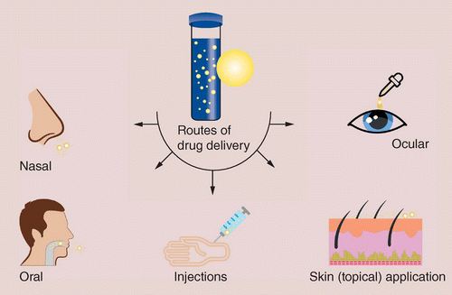
Fig.5 Route of Drug Delivery

II. Nanoemulsions in Biotechnology-
Pure organic or aqua-organic media are used for many enzymatic and biocatalytic reactions. These reactions also make use of biphasic media. Biocatalysts are denaturized when pure polar media are used, so using water-resistant media is generally advantageous. Low water content enzymes exhibit and have; ¬ Enhanced solubility in non-polar reactants. ¬ Possibility of shifting thermodynamic equilibria in favour of condensations.
¬ Improvement of thermal stability of the enzymes, thus enabling reactions to be carried out at higher temperatures.
Numerous enzymes, such as lipases, esterases, dehydrogenases, and oxidases, frequently work in hydrophobic microenvironments within cells. Numerous enzymes work at the interface between hydrophobic and hydrophilic domains in biological systems, and this interface is typically stabilised by polar lipids and other naturally occurring amphiles. For a number of rxns, including peptide and sugar acetal transesterification, esters' synthesis, and steroid transformation, enzyme-catalyzed nanoemulsions have been used. The most utilised category of enzymes is lipases.
III. Nanoemulsions in Cosmeticology An efficient transport method and vehicle for controlled delivery are both nanoemulsions. A patented system for cosmetic use, the Kemira Nanogel nanoemulsion based carrier system improves skin production and API penetration. Additionally, it gives a good skin feel. Topical administration has many benefits by itself, and this formulary may improve drug delivery by combining it with nanoemulsion. It can avoid the drug's hepatic first-pass metabolism and any associated toxicities.

IV. Nanoemulsions in Food industry Due to their compositional flexibility in a variety of fields, including the food and beverage industries, nanoemulsions have a wide range of applications. Due to their extremely small size, thermodynamic stability, continuous self-assembly with hydrophilic and hydrophobic portions, transparency, and weak light wave scattering capacity, nanoemulsions have more applications in food processing than microemulsions do. This has led to their incorporation into optically transparent products like fortified waters and soft drinks. With very low droplet concentrations, nanoemulsions can be made to be more viscous or gel-like than micro or other conventional emulsions. This makes it simple to produce products with low fat content and interesting textures. Due to the stability of the nanoemulsion droplet, stability to particle aggregation, and stability to gravitational separation, nanoemulsions can extend the shelf life of industrial products. When processing Indo-Pacific king mackerel steaks, Joe et al. used nanoemulsions made from sunflower oil and saw no microbial growth for up to 12 hours; additionally, the product's shelf life was extended to 48 hours 69.

CONCLUSION
This chapter is concerned with nanoemulsion dosage form as a means of drug delivery. Nanoemulsion has many benefits, including the ability to protect labile drugs, increase drug solubility, improve bioavailability, control drug release, and lower patient variability. Additionally, for more than 40 years, clinics have used nanoemulsions as total parenteral nutrition fluids. Because of their potential uses in the pharmaceutical, cosmetic, biotechnology, and food industries as a better delivery system due to their small droplet size, transparency, and high kinetic stability, nanoemulsions with droplet sizes of less than 100 nm have attracted a lot of attention in recent years. It is still crucial to concentrate on the toxicological evaluation of the prepared nanoemulsions, as this will likely be a significant area of future research.

REFERENCES
- Gurpreet K, Singh SK. Review of nanoemulsion formulation and characterization techniques. Indian Journal of Pharmaceutical Sciences. 2018 Sep 1;80(5).
- Shafiq S, Shakeel F, Talegaonkar S, Ahmad FJ, Khar RK, Ali M. Development and bioavailability assessment of ramipril nanoemulsion formulation. European journal of pharmaceutics and biopharmaceutics. 2007 May 1;66(2):227-43.
- Shah P, Bhalodia D, Shelat P. Nanoemulsion: A pharmaceutical review. Systematic reviews in pharmacy. 2010 Jan 1;1(1).
- Kumar M, Bishnoi RS, Shukla AK, Jain CP. Techniques for formulation of nanoemulsion drug delivery system: a review. Preventive nutrition and food science. 2019 Sep;24(3):225.
- Ghosh V, Saranya S, Mukherjee A, Chandrasekaran N. Cinnamon oil nanoemulsion formulation by ultrasonic emulsification: investigation of its bactericidal activity. Journal of nanoscience and nanotechnology. 2013 Jan 1;13(1):114-22.
- Sharma N, Bansal M, Visht S, Sharma PK, Kulkarni GT. Nanoemulsion: A new concept of delivery system. Chronicles of Young Scientists. 2010 Apr 1;1(2):2-6.
- Gué E, Since M, Ropars S, Herbinet R, Le Pluart L, Malzert-Fréon A. Evaluation of the versatile character of a nanoemulsion formulation. International Journal of Pharmaceutics. 2016 Feb 10;498(1-2):49-65.
- Jafari SM, McClements DJ, editors. Nanoemulsions: formulation, applications, and characterization. Academic Press; 2018 Feb 24.
- Fofaria NM, Qhattal HS, Liu X, Srivastava SK. Nanoemulsion formulations for anti-cancer agent piplartine—Characterization, toxicological, pharmacokinetics and efficacy studies. International journal of pharmaceutics. 2016 Feb 10;498(1-2):12-22.
- Mustafa IF, Hussein MZ. Synthesis and technology of nanoemulsion-based pesticide formulation. Nanomaterials. 2020 Aug 17;10(8):1608.
- Gurpreet K, Singh SK. Review of nanoemulsion formulation and characterization techniques. Indian Journal of Pharmaceutical Sciences. 2018 Sep 1;80(5).
- Gurpreet K, Singh SK. Review of nanoemulsion formulation and characterization techniques. Indian Journal of Pharmaceutical Sciences. 2018 Sep 1;80(5).
- Attwood D, Mallon C, Ktistis G, Taylor CJ, A study on factors influencing the droplet size in nonionic oil-in-water microemulsions. Int J Pharm, 1992; 88:417
- Arun PK, Narayanan N, Rajalakshmi G. Int .J PharmaSci Rev and Res, 2010; 3(1):130.
- Mohammed NK, Muhialdin BJ, Meor Hussin AS. Characterization of nanoemulsion of Nigella sativa oil and its application in ice cream. Food science & nutrition. 2020 Jun;8(6):2608-18.
- Laxmi M, Bhardwaj A, Mehta S, Mehta A. Development and characterization of nanoemulsion as carrier for the enhancement of bioavailability of artemether. Artificial cells, nanomedicine, and biotechnology. 2015 Sep 3;43(5):334-44.
- Rodrigues FV, Diniz LS, Sousa RM, Honorato TD, Simão DO, Araújo CR, Gonçalves TM, Rolim LA, Goto PL, Tedesco AC, Siqueira-Moura MP. Preparation and characterization of nanoemulsion containing a natural naphthoquinone. Química Nova. 2018;41:756-61.
- Chakraborty S, Shukla D, Mishra B, Singh S. Lipid-an emerging platform for oral delivery of drugs with poor bioavailability. Eur J Pharm Biopharm, 2009; 73:1-15
- . Date AA, Nagarsenker S. Parenteral microemulsions: an overview. Int J Pharm, 2008; 355:19-30.
- Gershanik T, Benzeno S, Benita S. Interaction of a selfemulsifying lipid drug delivery system with the everted rat intestinal mucosa as a function of droplet size and surface charge. Pharm. Res, 1998; 15:863-869.
- Gursoy RN, Benita S, Self-emulsifying drug delivery systems (SEDDS) for improved oral delivery of lipophilic drugs. Biomed. Pharmacotherap, 2004; 58:173-182.
- Jumaa M, Mueller BW., Formulation and stability of benodazipines in a new lipid emulsion formulation. Pharmazie, 2002; 57:740-743.
- Kale NJ, Allen LV. Studies on microemulsions using Brij 96 as surfactant and glycerin. Int J Pharm, 1989; 57:87-93.
- Carey MC, Small DM, Bliss CM. Lipid digestion and absorption. Ann Rev Physio, 1983; 45:651-677.
- Craig DQM, Barker SA, Banning D, Booth SW. An investigation into the mechanisms of self-emulsification using particle size analysis and low frequency dielectric spectroscopy. Int J Pharm, 1995; 114:103-110.
- Schwarz JC, Klang V, Karall S, Mahrhauser D, Resch GP, Shakeel F, Baboota S, Ahuja A, Ali J, Aqil M, Shafiq S. Nanoemulsions as vehicles for transdermal delivery of aceclofenac. AAPS Pharm Sci Tech, 2007; 8(4):E104.
- Shakeel F, Baboota S, Ahuja A, Ali J, Aqil M, Shafiq S. Accelerated stability testing of celecoxib nanoemulsion containing Cremophor-EL. Afr J Pharm Pharmacol, 2008; 2:179-183.
- Klang V, Matsko N, Zimmermann AM, Vojnikovic E, Valenta C. Enhancement of stability and skin permeation by sucrose stearate and cyclodextrins in progesterone nanoemulsions. Int J Pharm, 2010; 393:153-161.
- Baspinar Y, Keck CM, Borchert HH. Development of a positively charged prednicarbate nanoemulsion. Int J Pharm, 2010; 383:201-208.
- Valenta C. Optimisation of multiple W/O/W nanoemulsions for dermal delivery of acyclovir. Int J Pharm, 2012; 435:69-75.
- Borhade V, Pathak S, Sharma S, Patravale V. Clotrimazole nanoemulsion for malaria chemotherapy. Part I: Preformulation studies, formulation design and physicochemical evaluation. Int J Pharm, 2012; 431:138-148.
- Ghosh V, Mukherjee A, Chandrasekaran N. Ultrasonic emulsification of food-grade nanoemulsion formulation and evaluation of its bactericidal activity. Ultrason Sonochem 2013; 20:338-344.
- Zhu L, Li M, Dong J, Jin Y. Dimethyl silicone dry nanoemulsion inhalations: Formulation study and anti-acute lung injury effect. Int J Pharm, 2015; 491:292-298.
- Başpınar Y, Gündoğdu E, Köksal C, Karasulu E. Pitavastatincontaining nanoemulsions: Preparation, characterization and in vitro cytotoxicity. J Drug Deliv Sci Technol, 2015; 29:117-24.
- Calligaris S, Plazzotta S, Bot F, Grasselli S, Malchiodi A, Anese M. Nanoemulsion preparation by combining high pressure homogenization and high power ultrasound at low energy densities. Food Res Int, 2016; 83:25-30.
- Kaur K, Kumar R, Mehta SK. Formulation of saponin stabilized nanoemulsion by ultrasonic method and its role to protect the degradation of quercetin from UV light. Ultrason Sonochem, 2016; 31:29-38.
- Meng L, Xia X, Yang Y, Ye J, Dong W, Ma P, et al. Co-encapsulation of paclitaxel and baicalein in nanoemulsions to overcome multidrug resistance via oxidative stress augmentation and Pglycoprotein inhibition. Int J Pharm, 2016; 513:8-16.
- Fornaguera C, Feiner-Gracia N, Calderó G, García-Celma MJ, Solans C. PLGA nanoparticles from nano-emulsion templating as imaging agents: Versatile technology to obtain nanoparticles loaded with fluorescent dyes. Colloids Surf B Biointerfaces, 2016; 147:201-209.
- Chen H, Hu X, Chen E, Wu S, McClements DJ, Liu S, et al. Preparation, characterization, and properties of chitosan films with cinnamaldehyde nanoemulsions. Food Hydrocoll, 2016; 61:662-671

- Fernandes AR, Sanchez-Lopez E, Santos TD, Garcia ML, Silva AM, Souto EB. Development and characterization of nanoemulsions for ophthalmic applications: Role of cationic surfactants. Materials. 2021 Dec 8;14(24):7541.
- Sanchez A, García MC, Martín‐Piñero MJ, Muñoz J, Alfaro‐Rodríguez MC. Elaboration and characterization of nanoemulsion with orange essential oil and pectin. Journal of the Science of Food and Agriculture. 2022 Jul;102(9):3543-50.
- Abu-Huwaij RT, Hamed R, Daoud E, Alkilani A. Development and in-vitro characterization of nanoemulsion-based buccal patches of valsartan. Acta Poloniae Pharmaceutica-Drug Research. 2019 Apr 30;76(2):313-21.
- Sheth T, Seshadri S, Prileszky T, Helgeson ME. Multiple nanoemulsions. Nature Reviews Materials. 2020 Mar;5(3):214-28.
- Ma D, Tu ZC, Wang H, Zhang Z, McClements DJ. Fabrication and characterization of nanoemulsion-coated microgels: Electrostatic deposition of lipid droplets on alginate beads. Food Hydrocolloids. 2017 Oct 1;71:149-57.
- Chen H, Hu X, Chen E, Wu S, McClements DJ, Liu S, et al. Preparation, characterization, and properties of chitosan films with cinnamaldehyde nanoemulsions. Food Hydrocoll, 2016; 61:662-671.
- Savardekar P, Bajaj A. Nanoemulsions- A Review. Inter J Res Pharm and Chem, 2016; 6:312-322
- Gupta PK, Pandit JK, Kumar A, Swaroop P, Gupta S. Pharmaceutical nanotechnology novel nanoemulsion high energy emulsification preparation, evaluation and application.The Pharma Research, 2010; 3:117-138.
- Sharma N, Mishra S, Sharma S, Deshpande RD, Sharma RK. Preparation and optimization of nanoemulsion for targeting drug delivery. International Journal of Drug Development and Research, 2013; 5:37-48
- Suyal J, Bhatt G and Singh N: Formulation and evaluation of nanoemulsion for enhanced bioavailability of Itraconazole. Int J Pharm Sci & Res, 2018; 9:2927-2931
- Calligaris S, Plazzotta S, Bot F, Grasselli S, Malchiodi A, Anese M. Nanoemulsion preparation by combining high pressure homogenization and high power ultrasound at low energy densities. Food Res Int, 2016; 83:25-30
- Sukanya G, Mantry S, Anjum S. Review on Nanoemulsions. Int J Innov Pharma Sci and Res, 2013; 1:192-205.

