Nanotoxicology: Safety Assessment and Risk Evaluation of Nanomedicines

Babita Adhikary¹  Dept of Pharmaceutical Analysis & Quality Assurance,  Centurion University of Technology and Management  Rayagada-765001, Odisha  babitadhikary2017@gmail.com | Hara Gouri Mishra²  Dept of Pharmaceutical Analysis & Quality Assurance,  Centurion University of Technology and Management  Rayagada-765001, Odisha  haragourimishra@gmail.com
Bharat Bhusan Sahu³  Dept of Pharmaceutics,  Centurion University of Technology and Management  Rayagada, Odisha  sahubharat378@gmail.com | Ladi Alik Kumar⁴  Dept of Pharmaceutics,  Centurion University of Technology and Management  Rayagada, Odisha  alikkumar3@gmail.com

Abstract

The safety assessment and risk assessment of nanomedicines are the main topics of this study's investigation into the subject of nanotoxicology. Nanomedicines, which are nanoscale materials used in medicine, have the potential to revolutionise healthcare thanks to their special qualities and ability to deliver medicine precisely where it is needed. However, careful safety assessment and risk evaluation are required due to worries about their possible negative impacts on human health and the environment. The field of nanotoxicology provides crucial insights into the safety profile of nanomedicines, enabling the identification of potential risks and the development of strategies to mitigate them. The integration of toxicological studies with advanced analytical techniques, such as omics technologies and high-throughput screening, enhances our understanding of nanotoxicity and facilitates the design of safer nanomedicines. Moreover, interdisciplinary collaborations among toxicologists, engineers, clinicians, and regulators are vital for ensuring the responsible development and translation of nanomedicines into clinical practice. By addressing the challenges and uncertainties associated with nanotoxicology, we can harness the full potential of nanomedicines while ensuring their safety and minimizing potential risks to human health and the environment.

Keywords: Nano toxicology, Nanomedicines, Human Health, Omics technologies

Introduction to Nanotoxicology
The multidisciplinary area of nanotoxicology focuses on the investigation of potential negative effects and dangers related to nanoparticles. Nanomaterials are substances with particular characteristics at the nanoscale; their sizes typically range from 1 to 100 nanometers.[1] Compared to their bulk equivalents, these materials have distinctive physicochemical characteristics, such as a larger surface area, higher reactivity, and modified optical, magnetic, or electrical properties.[2] Understanding the possible dangers related to occupational exposure to nanoparticles during manufacturing and handling operations requires a thorough understanding of nanotoxicology. It aids in creating suitable safety regulations and safeguards for employees in nanotechnology industries. By examining the interactions between nanoparticles and biological systems and determining their toxicity and the possibility of negative effects, nanotoxicology seeks to close this knowledge gap. Investigating potential negative effects and dangers related to nanomaterials is an important area of study in nanotoxicology.[3] It lays the groundwork for the development and appropriate application of nanotechnology in a variety of fields, including nanomedicine.

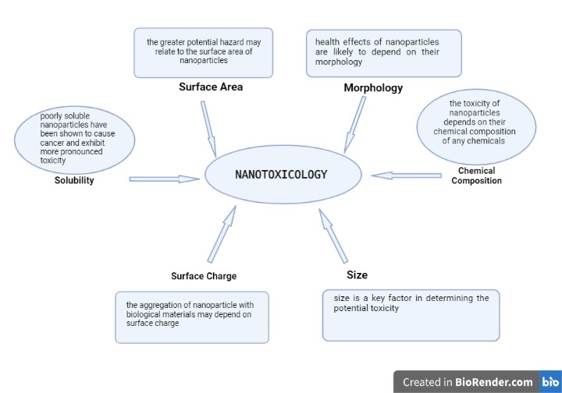

Figure1 Nanotoxicology and its application

Nanomedicines
The word "nanomedicine" is used to describe medical supplies or equipment that use nanotechnology to diagnose, treat, or prevent disease. It is also used to refer to nano pharmaceuticals or nanotherapeutics. Materials at the nanoscale, which typically has a size range of 1 to 100 nanometers, can be used to exploit unique properties and abilities. Nanomedicines provide a few benefits over conventional therapeutic techniques[4]. By using the characteristics of nanoparticles, such as their high surface area-to-volume ratio and higher reactivity, nanomedicines can be developed that have improved drug transport capacities, increased therapeutic efficacy, and lower unwanted effects. These cutting-edge medications have the potential to transform healthcare by offering targeted and personalised therapies. Numerous uses fall under the umbrella of nanomedicine, including:[5]
- Drug delivery systems
- Imaging agents
- Theranostics
- Regenerative medicine

- Drug delivery systems: Drugs can be enclosed in nanoparticles, liposomes, micelles, and other nanostructures, which prevents them from degrading and allows for targeted administration to particular cells or tissues. This focused distribution can increase medication effectiveness, lessen systemic toxicity, and boost patient compliance.[6]
- Imaging agents: Nanoparticles can be created to function as contrast agents for imaging procedures used in medicine, including computed tomography (CT), magnetic resonance imaging (MRI), and optical imaging. The better illness identification, monitoring, and characterization made possible by these imaging agents due to their higher resolution, sensitivity, and specificity[7].
- Theranostics: In a single nanomedicine, theranostics combines therapeutic and diagnostic activities. These versatile nanoparticles can deliver therapeutic chemicals while also enabling real-time imaging or treatment response monitoring. Through this connectivity, personalised medical methods are made possible, allowing for the customization of care based on real-time feedback.[8]
- Regenerative medicine: Tissue engineering and regenerative medicine both greatly benefit from nanotechnology. Nanomaterials can serve as scaffolding to promote tissue regeneration, stimulate cell proliferation, and supply bioactive chemicals to promote tissue repair. involving
A multidisciplinary approach and knowledge from disciplines like chemistry, materials science, biology, pharmacology, and engineering are needed for the creation and deployment of nanomedicines. Understanding the interplay between nanomaterials and biological systems, improving drug delivery methods, enhancing biocompatibility, and assuring safety are the main study areas.[9]
Guidelines for the assessment and authorization of nanomedicines have been established by regulatory organisations including the European Medicines Agency (EMA) and the U.S. Food and Drug Administration (FDA). These recommendations cover particular issues with nanomaterial characterization, safety evaluation, and quality control. Nanomedicines have a huge potential to improve healthcare by providing focused medications, better imaging methods, and improved diagnostics. These cutting-edge strategies have the potential to revolutionise medical treatments and enhance patient outcomes with further study and development[10].

Evaluation of Nanomedicines
Evaluation process typically follows a systematic approach and involves various steps. Here are the key aspects to consider when evaluating nanomedicines:
- Physicochemical characterization
- In vitro and In vivo studies
- Pharmacokinetics and Pharmacodynamics
- Comparative studies
- Stability& quality Control
- Safety assessment
- Regulatory Consideration
- Clinical trials

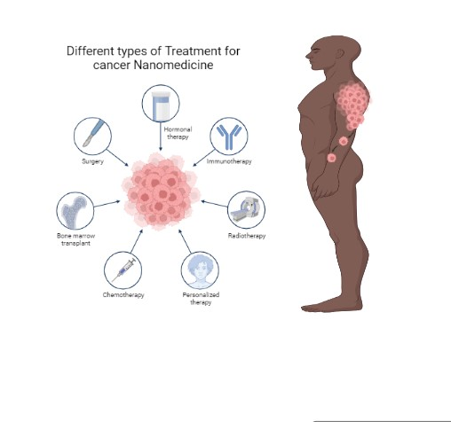

Figure 2 Types of treatment for cancer nanomedicine

- Physicochemical characterization: To understand the features of nanomedicines, such as size, shape, surface charge, stability, and composition, they should go through a complete physicochemical characterization process. Nanomaterials are characterized using methods like electron microscopy, spectroscopy, and particle sizing.

- In vitro research involves observing how nanomedicines behave in cell-based models. In this research, variables such cellular uptake, cytotoxicity, genotoxicity, and immunotoxicity are assessed. They shed light on how nanomedicines interact with biological systems and their possible drawbacks.[11]

- In vivo studies: Research on animals is done to determine how nanomedicines behave in more intricate biological systems, including their pharmacokinetics, biodistribution, effectiveness, and toxicity. Such factors as tissue distribution, clearance, therapeutic response, and potential negative effects on organs and systems are evaluated in these investigations.

- Pharmacokinetics and pharmacodynamics: For nanomedicines to be evaluated, it is essential to comprehend their pharmacokinetic profile (absorption, distribution, metabolism, and excretion) and pharmacodynamic consequences (mechanism of action, therapeutic efficacy). This knowledge aids in identifying suitable dosage plans and possible drug-drug interactions.[12]

- Comparative studies: Analyzing how well nanomedicines work in comparison to currently used conventional therapies or alternative nanomedicines might reveal important information about their efficacy and safety. Comparative research helps prove the superiority, non-inferiority, or extra advantages of nanomedicines over already available therapies.[13]

- Stability and quality control: Analyzing the durability of nanomedicines over time and in various environmental conditions (such as temperature, light, and pH) is crucial. Quality control techniques, such as batch-to-batch homogeneity, are crucial to maintaining the reproducibility and reliability of nanomedicine production.[14]

- Clinical trials: Clinical trials play a critical role in the evaluation of nanomedicines in humans. These trials assess the safety, efficacy, and optimal dosing of nanomedicines in patient populations. They provide valuable data on treatment outcomes and potential adverse effects.[15]

It is crucial to remember that the evaluation of nanomedicines may call for iterative methods, formulation improvement, and alterations based on the outcomes of preclinical and clinical investigations. A multidisciplinary approach comprising scientists, clinicians, toxicologists, regulatory specialists, and other stakeholders is necessary for the evaluation of nanomedicines. The safe and efficient transition of nanomedicines from the lab to clinical applications is made possible by cooperation and adherence to stringent evaluation methods.[16]

Risk to evaluation of Nanomedicines
Evaluating nanomedicines involves inherent risks that need to be addressed and managed throughout the process. Some of the key risks associated with evaluating nanomedicines include:
a. The potential toxicity of nanomaterials utilized in nanomedicines may be influenced by their special characteristics. For researchers and lab staff, handling and exposure to these compounds during evaluation studies might be hazardous to their health. To reduce such dangers, it is essential to follow proper safety procedures, which include wearing personal protection equipment and following good laboratory practices.[17]
b. Lack of standardized assessment procedures: The evaluation of nanomedicines can be difficult because there aren't any procedures or standardised methods for measuring nanomaterials. Nanomaterials must be evaluated using specialised methods and tests due to their specific properties, and the lack of standardised procedures can cause unpredictability and ambiguity.[18]
c. unanticipated biological interactions: Nanomedicines could have unanticipated effects on biological systems that are not expected.
d. Regulatory obstacles: Due to the rapidly evolving nature of nanotechnology and the difficulty in determining their safety and efficacy, regulatory authorities frequently encounter obstacles in analyzing and approving nanomedicines. Nanomedicines do not have established regulatory channels, which could cause delays or uncertainty in the licencing process.[19]
e. Long-term impacts and environmental impact: It can be difficult to determine how nanomedicines will affect people and the environment in the long run. To assess the overall safety and sustainability of nanomaterials, it is crucial to comprehend their persistence, degradation, and possible accumulation in the environment.[20]
Safety assessment of Nanomedicine
The safety assessment of nanomedicines involves a comprehensive evaluation of their potential risks and adverse effects to ensure their safe use in healthcare. This assessment typically follows a structured approach and involves various steps:
i. Physicochemical Characterization: To comprehend the physical and chemical characteristics of nanomedicines, they are thoroughly characterized. This entails figuring out things like their composition, stability, surface charge, and size. This sort of categorization aids in spotting any possible problems connected to these qualities.[21]
ii. Nanomedicines are tested in vitro using cell-based models in contrast to in vivo studies, which are conducted on living organisms. These investigations evaluate its possible immunotoxicity, genotoxicity, and cytotoxicity. The vitality, cellular operations, and interactions with biological elements of cells exposed to various doses of nanomedicines are assessed.[22]
iii. In vivo Studies on animals are carried out to assess the security of nanomedicines in more intricate biological systems. These investigations evaluate the biodistribution and pharmacokinetics (absorption, distribution, metabolism, and excretion) of nanomedicines in the human body. Additionally, they aid in assessing the possibility of buildup in particular organs or tissues as well as any negative consequences on organ function or systemic toxicity[23]
iv. Animals are subjected to various doses of nanomedicines over predetermined times in these tests of acute and chronic toxicity. They evaluate any potential negative effects on various organ systems, including the immune system, the liver, kidneys, lungs, and endocrine system. Clinical symptoms, changes in body weight, histological analysis, and evaluations of the biochemical and hematological processes are all examples of observations.[24]
v. Pharmacokinetics and pharmacodynamics: Analyzing the effects of nanomedicines on the body is essential for determining their safety. This entails researching their modes of action and potential therapeutic effects (pharmacodynamics), as well as their absorption, distribution, metabolism, and excretion (pharmacokinetics).[25]
vi. Evaluation of immunotoxicity: Because nanomedicines may interact with the immune system, it is crucial to evaluate their immunotoxin potential. This entails analysing their effects on cytokine production, inflammatory responses, and immune cell activity.[26]
vii. Regulatory considerations: The FDA, EMA, and other national agencies, among others, have special regulations for the safety evaluation of nanomedicines. These guidelines lay out the information needs, research plans, and standards for approving and commercializing nanomedicines.[27]
The safety assessment of nanomedicines is an iterative and dynamic process that relies on the integration of data from various studies. It aims to ensure the safe and effective use of nanomedicines, considering both the therapeutic benefits and potential risks associated with these innovative treatments.[28]
Clinical transition and perspective of nanotoxicology and nanomedicine
The growing use of nanomaterials in a variety of applications, including medicine, has drawn considerable attention to the fields of nanotoxicology and nanomedicine in recent years.
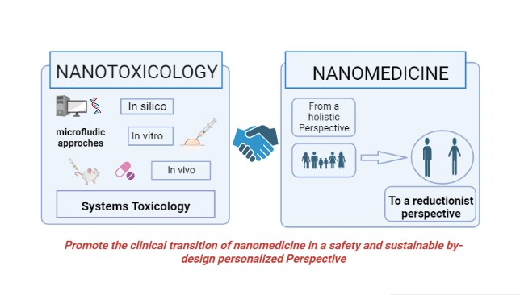

Figure 3 Clinical assessments of Nano toxicology and nanomedicine

Nanotoxicology is the study of the potentially harmful effects that nanomaterials may have on living things. In order to assure the safe use of nanomaterials in medicine and other industries, the clinical application of nanotoxicology entails translating laboratory results into practical applications. [29]
Nanomedicine: The use of nanotechnology in healthcare and medicine is referred to as nanomedicine. It entails applying nanomaterials and nanodevices to a variety of medical applications, including tissue engineering, drug delivery, and diagnostics. The following viewpoints on the application of nanomedicine in clinical settings:[30]

Conclusion
In conclusion, nanotoxicology is crucial to the evaluation of the risks and the safety of nanomedicines. Understanding the potential hazards related to the use of nanoparticles in therapeutic applications is crucial as the area of nanomedicine develops. Unique physicochemical characteristics of nanoparticles can increase drug distribution, raise therapeutic success rates, and enable tailored therapy. Their diminutive size and larger surface area, however, also raise questions about their potential toxicity.
Nanotoxicology offers important insights into the safety profile of nanomedicines through meticulous research and thorough evaluations. It examines how nanoparticles interact with biological systems to shed light on potential negative effects and inform the creation of safer nanomedicine formulations. Researchers can determine any dangers related with the use of nanomedicines by analyzing factors such nanoparticle size, shape, surface chemistry, and dose.
When evaluating a risk in nanotoxicology, it's important to take the environment into account in addition to any potential harm to human health. For sustainable development and ethical usage of nanomedicine, it is essential to comprehend the destiny and behavior of nanoparticles in the environment.
In addition, it is essential to create standardised testing procedures and regulatory frameworks to guarantee the security of nanomedicines. To create guidelines and standards for the assessment and approval of nanomedicine products, cooperation between academia, business, and regulatory organisations is required. The translation of nanomedicine research from the lab to the clinic will be made easier and less risky thanks to this multidisciplinary approach.
Even though nanotoxicology has come a long way, more study is still needed to properly comprehend the long-term consequences and potential buildup of nanoparticles in the body. In vitro and in silico models, for example, can improve the prediction capacities of nanotoxicology investigations, minimizing the need for animal testing and accelerating the safety evaluation process.
In conclusion, nanotoxicology is critical to the evaluation of the risks and safety of nanomedicines. It offers a scientific basis for comprehending the possible dangers of nanoparticles and directs the creation of secure and efficient nanomedicine formulations. By overcoming these security issues, nanomedicine can continue to transform healthcare by providing novel cures and personalised treatments with minimal hazards to people and the environment.
References
- Kohl, Y., Biehl, M., Spring, S., Hesler, M., Ogourtsov, V., Todorovic, M., ... & Knoll, T. (2021). Microfluidic in vitro platform for (nano) safety and (nano) drug efficiency screening. Small, 17(15), 2006012. https://doi.org/10.1002/smll.202006012
- Bondarenko, O., Mortimer, M., Kahru, A., Feliu, N., Javed, I., Kakinen, A., ... & Zhao, Y. (2021). Nanotoxicology and nanomedicine: The Yin and Yang of nano-bio interactions for the new decade. Nano Today, 39, 101184. https://doi.org/10.1016/j.nantod.2021.101184
- Domingues, C., Santos, A., Alvarez-Lorenzo, C., Concheiro, A., Jarak, I., Veiga, F., ... & Figueiras, A. (2022). Where is nano today and where is it headed? A review of nanomedicine and the dilemma of nanotoxicology. ACS nano, 16(7), 9994-10041. https://doi.org/10.1021/acsnano.2c00128
- Tirumala, M. G., Anchi, P., Raja, S., Rachamalla, M., & Godugu, C. (2021). Novel methods and approaches for safety evaluation of nanoparticle formulations: A focus towards in vitro models and adverse outcome pathways. Frontiers in pharmacology, 12, 612659. https://doi.org/10.3389/fphar.2021.612659
- Ahmad, F., Mahmood, A., & Muhmood, T. (2021). Machine learning-integrated omics for the risk and safety assessment of nanomaterials. Biomaterials science, 9(5), 1598-1608.
DOI https://doi.org/10.1039/D0BM01672A
- Cai, Y., Chen, X., Si, J., Mou, X., & Dong, X. (2021). All‐in‐One Nanomedicine: Multifunctional Single‐Component Nanoparticles for Cancer Theranostics. Small, 17(52), 2103072. https://doi.org/10.1002/smll.202103072
- Chen, X., Zhang, Y. S., Zhang, X., & Liu, C. (2021). Organ-on-a-chip platforms for accelerating the evaluation of nanomedicine. Bioactive Materials, 6(4), 1012-1027. https://doi.org/10.1016/j.bioactmat.2020.09.022
- Qiao, K., Xu, L., Tang, J., Wang, Q., Lim, K. S., Hooper, G., ... & Cui, X. (2022). The advances in nanomedicine for bone and cartilage repair. Journal of Nanobiotechnology, 20(1), 141. https://doi.org/10.1186/s12951-022-01342-8
- Zhang, Z., Dalan, R., Hu, Z., Wang, J. W., Chew, N. W., Poh, K. K., ... & Chen, X. (2022). Reactive oxygen species scavenging nanomedicine for the treatment of ischemic heart disease. Advanced Materials, 34(35), 2202169. https://doi.org/10.1002/adma.202202169
- Li, X., Chen, L., Luan, S., Zhou, J., Xiao, X., Yang, Y., ... & Yuan, Y. (2022, November). The development and progress of nanomedicine for esophageal cancer diagnosis and treatment. In Seminars in cancer biology (Vol. 86, pp. 873-885). Academic Press. https://doi.org/10.1016/j.semcancer.2022.01.007
- Gozzi, M., Schwarze, B., & Hey‐Hawkins, E. (2021). Preparing (metalla) carboranes for nanomedicine. ChemMedChem, 16(10), 1533-1565. https://doi.org/10.1002/cmdc.202000983
- Boix-Montesinos, P., Soriano-Teruel, P. M., Arminan, A., Orzaez, M., & Vicent, M. J. (2021). The past, present, and future of breast cancer models for nanomedicine development. Advanced drug delivery reviews, 173, 306-330. https://doi.org/10.1016/j.addr.2021.03.018
- Kaushik, A. (2021). Manipulative magnetic nanomedicine: the future of COVID-19 pandemic/endemic therapy. Expert Opinion on Drug Delivery, 18(5), 531-534. https://doi.org/10.1080/17425247.2021.1860938
- Serrano-Martínez, A., Victoria-Montesinos, D., García-Muñoz, A. M., Hernández-Sánchez, P., Lucas-Abellán, C., & González-Louzao, R. (2023). A Systematic Review of Clinical Trials on the Efficacy and Safety of CRLX101 Cyclodextrin-Based Nanomedicine for Cancer Treatment. Pharmaceutics, 15(7), 1824. https://doi.org/10.3390/pharmaceutics15071824
- Vahedifard, F., & Chakravarthy, K. (2021). Nanomedicine for COVID-19: the role of nanotechnology in the treatment and diagnosis of COVID-19. Emergent materials, 4(1), 75-99. https://doi.org/10.1007/s42247-021-00168-8
- Sharifi, S., Caracciolo, G., Pozzi, D., Digiacomo, L., Swann, J., Daldrup-Link, H. E., & Mahmoudi, M. (2021). The role of sex as a biological variable in the efficacy and toxicity of therapeutic nanomedicine. Advanced Drug Delivery Reviews, 174, 337-347. https://doi.org/10.1016/j.addr.2021.04.028
- Mast, M. P., Modh, H., Champanhac, C., Wang, J. W., Storm, G., Krämer, J., ... & Wacker, M. G. (2021). Nanomedicine at the crossroads–a quick guide for ivivc. Advanced drug delivery reviews, 179, 113829. https://doi.org/10.1016/j.addr.2021.113829
- Rastegari, E., Hsiao, Y. J., Lai, W. Y., Lai, Y. H., Yang, T. C., Chen, S. J., ... & Chien, Y. (2021). An update on mesoporous silica nanoparticle applications in nanomedicine. Pharmaceutics, 13(7), 1067. https://doi.org/10.3390/pharmaceutics13071067
- Đorđević, S., Gonzalez, M. M., Conejos-Sánchez, I., Carreira, B., Pozzi, S., Acúrcio, R. C., ... & Vicent, M. J. (2022). Current hurdles to the translation of nanomedicines from bench to the clinic. Drug delivery and translational research, 1-26. https://doi.org/10.1007/s13346-021-01024-2
- Halamoda-Kenzaoui, B., Vandebriel, R. J., Howarth, A., Siccardi, M., David, C. A. W., Liptrott, N. J., ... & Caputo, F. (2021). Methodological needs in the quality and safety characterisation of nanotechnology-based health products: Priorities for method development and standardisation. Journal of Controlled Release, 336, 192-206. https://doi.org/10.1016/j.jconrel.2021.06.016
- Miyazawa, T., Itaya, M., Burdeos, G. C., Nakagawa, K., & Miyazawa, T. (2021). A critical review of the use of surfactant-coated nanoparticles in nanomedicine and food nanotechnology. International journal of nanomedicine, 3937-3999. DOI: 10.2147/IJN.S298606
- Mahmoudi, M. (2021). The need for robust characterization of nanomaterials for nanomedicine applications. Nature communications, 12(1), 5246. https://doi.org/10.1038/s41467-021-25584-6
- Ou, L. C., Zhong, S., Ou, J. S., & Tian, J. W. (2021). Application of targeted therapy strategies with nanomedicine delivery for atherosclerosis. Acta Pharmacologica Sinica, 42(1), 10-17. https://doi.org/10.1038/s41401-020-0436-0
- Zhong, X., Wang, X., Li, J., Hu, J., Cheng, L., & Yang, X. (2021). ROS-based dynamic therapy synergy with modulating tumor cell-microenvironment mediated by inorganic nanomedicine. Coordination Chemistry Reviews, 437, 213828. https://doi.org/10.1016/j.ccr.2021.213828
- Zhang, J., Hu, K., Di, L., Wang, P., Liu, Z., Zhang, J., ... & Qiao, H. (2021). Traditional herbal medicine and nanomedicine: Converging disciplines to improve therapeutic efficacy and human health. Advanced Drug Delivery Reviews, 178, 113964. https://doi.org/10.1016/j.addr.2021.113964
- Sharifi-Rad, J., Quispe, C., Patra, J. K., Singh, Y. D., Panda, M. K., Das, G., ... & Calina, D. (2021). Paclitaxel: application in modern oncology and nanomedicine-based cancer therapy. Oxidative medicine and cellular longevity, 2021. https://doi.org/10.1155/2021/3687700
- Stater, E. P., Sonay, A. Y., Hart, C., & Grimm, J. (2021). The ancillary effects of nanoparticles and their implications for nanomedicine. Nature Nanotechnology, 16(11), 1180-1194. https://doi.org/10.1038/s41565-021-01017-9
- Milane, L., & Amiji, M. (2021). Clinical approval of nanotechnology-based SARS-CoV-2 mRNA vaccines: impact on translational nanomedicine. Drug delivery and translational research, 11, 1309-1315. https://doi.org/10.1007/s13346-021-00911-y
- Lombardo, D., & Kiselev, M. A. (2022). Methods of liposomes preparation: Formation and control factors of versatile nanocarriers for biomedical and nanomedicine application. Pharmaceutics, 14(3), 543. https://doi.org/10.3390/pharmaceutics14030543
- Liu, C., Shin, J., Son, S., Choe, Y., Farokhzad, N., Tang, Z., ... & Tao, W. (2021). Pnictogens in medicinal chemistry: evolution from erstwhile drugs to emerging layered photonic nanomedicine. Chemical Society Reviews, 50(4), 2260-2279. DOI-https://doi.org/10.1039/D0CS01175D

