Important Shrimp Viral Diseases in Aquaculture and their control
Samanthula Surya Teja¹, Ravi Chovatia², Arya Singh¹, Samad Sheikh¹, Amom Mahendrajit¹
¹ ICAR- Central Institute of Fisheries Education, Andheri West, Mumbai, Maharashtra-400061
²Kerala University of Fisheries and Ocean Studies, Panangad, Kochi- 682506, Kerala

*Corresponding author: suryatejasamanthula31@gmail.com

Abstract

Aquaculture, particularly shrimp production, has experienced rapid growth, surpassing the capture fishery, and has become a vital global industry meeting the growing demand for seafood. However, the practices involved in shrimp farming, such as displacement from natural environments, high-density stocking, exposure to stress, and transportation, create conditions conducive to pathogenic infections, leading to viral pandemics. The sustainability of shrimp aquaculture hinges on the establishment of more efficient and bio secure facilities that cultivate specific pathogen-free (SPF) shrimp, genetically enhanced for growth and disease resilience. Key requirements for SPF stock development include robust pathogen surveillance and effective disease prevention methods. Ongoing research explores shrimp-pathogen interactions, yielding promising results at the laboratory level. Potential applications involve the use of immunostimulants for "immune priming" or "trained immunity," RNA interference, and endogenous viral elements, representing innovative approaches for enhancing disease resistance in shrimp aquaculture. Utilizing a comprehensive approach that integrates various control strategies would offer more enduring and effective solutions for reducing viral infections in marine aquaculture compared to relying solely on a single disease control method, such as vaccination alone.

Keywords: Virus, shrimp, Biosecurity, SPF, control.

1.Introduction

Aquaculture, often known as "underwater agriculture," has become the most rapidly expanding food-producing industry globally. Surpassing beef and poultry production by 2013, it now accounts for a third of the world's food output, encompassing over 200 cultivated fish species (Mugimba, et al., 2021). Like other forms of aquaculture, intensive shrimp farming has faced significant consequences due to the prevalence of infectious diseases. Among these, viral infections pose a serious economic threat, leading to considerable financial losses. Furthermore, these viral diseases contribute to a decline in shrimp population by inducing various conditions that detrimentally impact the overall health of the shrimp. Such effects include diminished feed intake, abnormal swimming behaviour, increased vulnerability to predation, and negative social interactions among the fish and shell fish (Rodger, H.D. 2016). Viruses are the most predominant presence in marine ecosystems, with their quantities varying from 3 × 10⁶ mL⁻¹ viral particles (VPs) in the deep-sea environments to 1 × 10⁸ mL⁻¹ VPs in coastal waters. Despite their prevalence, only a limited number of viruses are responsible for diseases in farmed fish, leading to significant economic losses and garnering attention in many countries (Culley et al., 2002). The prevention and management of viral diseases in aquatic organisms are heavily dependent on various factors such as the characteristics, environmental resilience, reservoir hosts, susceptibility of host species, transmission patterns, and the pathogenic nature of the specific viruses that affect them. Current practices in aquaculture, which rely on very high-density stocking for increased production, heightened the transmission of viral infections among individuals. The global trade expansion of eggs and live shrimp has been associated with the widespread dissemination of shrimp diseases across continents. Although certain viruses have a broad host range across aquatic organisms, others are specific to particular host species, limiting their geographical distribution. Despite the vast variety of aquatic organisms worldwide, only a select few are utilized in aquaculture (Munang’andu, et al., 2016). Therefore, the host species utilized in aquaculture limits the present methods for preventing and managing aquatic viruses; this position is expected to change as new aquatic creatures are incorporated into farming methods. New viruses in aquaculture include the Covert Mortality Nodavirus, Abalone Herpesvirus, and Shrimp Hemocyte Iridescent Virus (Kibenge, F.S., 2019). While prevention typically refers to activities meant to stop the introduction of a disease in a susceptible group, disease control refers to actions made to reduce infection levels in groups that are already infected to manageable levels. Thus, the adage "an ounce of prevention is better than a pound of cure" is especially relevant to aquaculture virology. This chapter provides details on important shrimp viruses, their resistance to infection, and innovative methods being investigated to reduce the frequency of viral infections in shrimp aquaculture.

2. Major Challenges faced with Viral Diseases in Aquaculture

Emergence of previously undiscovered diseases or the expansion of recognized diseases to new hosts or geographical regions are the hallmarks of emerging infectious diseases, or EIDs. Figure 1. illustrates the various factors contributing to the occurrence of EIDs (Krkošek, M., 2017). These factors include
- (i) Aspects related to viruses, such the introduction of new viruses into an area or their mutagenic development of virulence.
- (ii) human activities, like introducing a susceptible fish species or virus to a new environment
- (iii) Host-related factors, such as fish stress leading to increased susceptibility to viral infections in intensive aquaculture.
- (iv) Environmental factors, such as alterations in salinity, pH, CO₂ levels, and other conditions that make fish more susceptible to infections
- Moreover it has emphasized that among vertebrates, freshwater and marine fish exhibit the highest rates of EIDs, largely due to their high species diversity (Tompkins et al., 2015). This phenomenon may also be attributed to the presence of numerous unknown viruses in aquaculture used for fish farming, some of which have the potential to infect and induce diseases in fish.
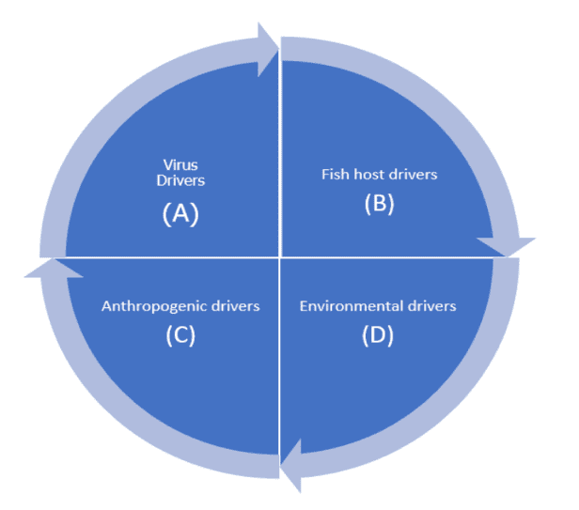

Fig 1. Drivers of emerging infectious diseases in aquaculture (source: Mugimba, et al., 2022)

2.1 Virus spread
The biggest worry for fish farming is the spreading of diseases. This is a global issue, especially as we see more trade and movement of live aquatic animals and their products between countries. Viruses can spread when we move farmed aquatic animals to new places, like bringing non-native fish for farming. This is a particular concern when the animals don't show many signs of sickness or are carriers without symptoms. Another way viruses can spread is through the shipment of fish eggs that are infected or contaminated (Gaughan, 2002; Rodgers et al., 2011). Wild fish that migrate can spread viral pathogens across vast distances, similar to migratory wild birds (Tucker et al., 1999). Additionally, scavenging wild birds can serve as carriers of diseases. Furthermore, as the aquaculture industry has expanded, the enhanced efforts in diagnostic and surveillance have led to the identification of new and emerging viral diseases that are naturally prevalent in wild fish populations (Batts et al., 2011). Some of the OIE listed important viruses are described here in this chapter.

2.2 Major pathogens of farmed shrimp
It is known that marine shrimp are infected by more than 20 viruses. A number of these viruses have not manifested well and have only been partially characterized; they are frequently only seen by electron microscopy (Table 1). Seven viral infections of marine shrimp are now recognized by the World Organization for Animal Health (OIE) as causing aquatic animal illnesses that require notification, and two more are being investigated for possible listing (OIE 2008). A global agreement mandates that member nations report illnesses on the OIE list. In order to prevent the spread of illness and guarantee the hygienic safety of the global commerce in aquatic animals and their products, they are also subject to certain health regulations. Interestingly, reports of six of the seven marine shrimp viruses on the OIE list have come from Asia.

Table 1 Major shrimp infecting viruses

Virus | Abbreviation | Family* | Genus+ | Genome
White spot syndrome virus | WSSV | Nimaviridae | Whispovirus | dsDNA
Yellow head virus | YHV | Roniviridae | Okavirus | (+)ssRNA
Taura syndrome virus | TSV | Dicistroviridae | Apavirus | (+)ssRNA
Gill-associated virus | GAV | Roniviridae | Okavirus | (+)ssRNA
Infectious myonecrosis virus | IMNV | Totiviridae | putative totivirus | (+)ssRNA
Monodon baculovirus | MBV | Baculoviridae | Nucleopolyhedrosisvirus | dsDNA
Infectious hypodermal haematopoietic virus | HPV | Parvoviridae | Brevidensovirus | ssDNA
Hepatopancreatic parvovirus | HPV | Parvoviridae | Brevidensovirus | ssDNA
Mourilyan virus | MoV | Bunavirus-like | Wenrivirus penaei | (-)ssDA
Laem Singh virus | LSNV | Leuteovirus-like | Sobemovirus | ssDNA
Baculoviral midgut gland vacuolization virus | BMNV | Baculoviridae | unassigned | dsDNA
Lymphoid organ vacuolization virus | LOVV | Togavirus-like? | unassigned | (+)ssRNA

*OIE listed
+International Committee on Taxonomy of Viruses (source: Walker et al., 2009)

3.1 White spot syndrome virus
White spot syndrome virus (WSSV) stands out as the most destructive pathogen affecting farmed shrimp. It is capable of infecting all cultivated penaeids and has significantly contributed to the economic repercussions of disease in global shrimp production. The onset of WSD was initially documented in June 1992, appearing in farmed kuruma shrimp in China's Fujian Province and neighbouring Taiwan (Zhan et al., 1998; Jiang, 2001).

Morphology & Taxonomy
The White Spot Syndrome Virus is a big oval-shaped DNA virus that measures 120–150 nm by 270–290 nm (Wongteerasupaya et al., 1995a,b). It has a lipid envelope with a characteristic tail-like appendage. According to Vlak et al. (2005), it is the only member of the Whispovirus genus in the recently formed Nimaviridae family and shows distant genetic links with other big DNA viruses. At least 45 structural proteins are arranged into three morphologically different levels within virions (Tsai et al., 2004).

Clinical signs
Usually occurring 5–10 days following the beginning of clinical symptoms, WSSV results in a death rate between 80% and 100% (Chou et al., 1995). The diseased shrimp show reddish-pink discolouration, sluggishness, stop eating, and a propensity to congregate at the pond's margins. While white patches are frequently seen under the shrimp's cuticle, these observations are not definitively indicative, as bacterial infections can also cause comparable symptoms (Wang et al., 2000b). Cells of ectodermal and mesodermal origin are the target of the White spot syndrome virus. One prominent histological characteristic is the presence of eosinophilic Cowdry A-type inclusions in hypertrophied nuclei with marginated chromatin; these inclusions become slightly basophilic in the later stages of infection (Wongteerasupaya et al., 1995b). The virus undergoes replication and assembly in the cell nucleus, and there is no occlusion as a result of the infection (Wang and Chang, 2000).

A variety of decapod crustaceans are infected with the white spot syndrome virus. The virus frequently lingers at low concentrations in marine shrimp without producing symptoms, but stress, changes in salinity, or colder temperatures can cause the virus to multiply quickly, resulting in illness and large-scale deaths in ponds (Liu et al., 2006). Higher water temperatures delay the development of illness because the virus multiplies most effectively at temperatures between 23 and 28°C (Reyes et al., 2007). Because the virus can live in saltwater at lower temperatures, it is more common in wild shrimp populations when the temperature is below 30°C (Rodriguez et al., 2003). Although White Spot disease can affect any type of farmed marine shrimp, other decapod crustaceans can harbour the disease even if they don't exhibit any symptoms for the virus. Furthermore, a variety of invertebrates, including copepods, artemia, crabs, crayfish, polychaetes, bivalves, rotifers, and some insect larvae, may collect significant concentrations of live virus, which may enable them to function as mechanical carriers of infection (Yan et al., 2004).

Mode of transmission
An infection with the white spot syndrome virus can propagate vertically or horizontally. Horizontal transmission is more successfully accomplished by ingestion in shrimp (Soto & Lotz, 2001) and is manifested by exposure to contaminated water or ingestion of contaminated tissue (Chou et al., 1998). One prevalent route of infection is vertical transmission, which occurs when diseased brood stock is passed on to younger stages of life. There is no record of sperm infection, despite indications of WSSV in the gonads' muscles and connective tissues. Through histology or in situ hybridization, oogonia and oocytes may test positive, but mature eggs do not. This suggests that the virus in developing oocytes may not survive maturation, which reduces the likelihood of transovarial transmission. Rather, it appears that WSSV is spread trans ovum by egg surface contamination (Lo et al., 1997). WSSV infection can occur both by horizontal and vertical transmission even in the absence of disease
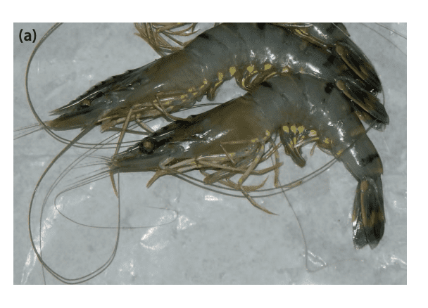
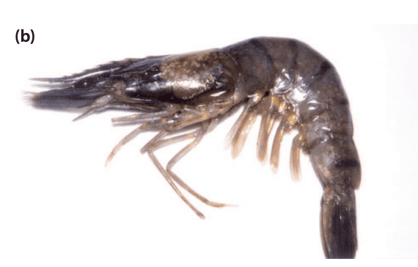
Fig 2. WSSV infection in tiger shrimp (P. monodon) (Source: Tandel et al., 2017)
- Normal tiger shrimp; (b) WSSV infected tiger shrimp (note the white spots on the carapace, broken antennae and pereopods)

3.2 Yellow head virus
In 1990, yellow head disease was initially discovered in central Thailand in cultivated black tiger shrimp (Penaeus monodon). Yellow head disease , also known as yellow head virus (YHV), has been documented in a number of shrimp-farming countries around Asia, including India, Indonesia, Malaysia, the Philippines, Sri Lanka, Vietnam, and Taiwan (Mohan et al., 1998).

Morphology and Taxonomy
The yellow head virus (YHV) is a positive-sense, rod-shaped, enveloped single-stranded RNA (ssRNA) virus that measures 40–60 nm by 150–200 nm. Its surface has unique knob-like projections and a helical nucleocapsid (Tang & Lightner 1999). This virus has a distant relationship with other big ssRNA viruses, such as coronaviruses, toroviruses, arteriviruses, and bafniviruses, that infect fish and vertebrates. Currently, YHV and GAV are classified as Gill-associated virus species of the Okavirus genus, Roniviridae family, and Nidovirales order (Walker et al., 2001).

Clinical signs
Shrimp suffering from yellow head disease often exhibit rapid feed consumption followed by cessation of eating throughout their early to late juvenile stages. Disoriented and moribund affected shrimp prefer to congregate close to the pond edge, which causes a sharp rise in death rates. Because of the colouring of the underlying hepatopancreas, the condition is termed for the pale-yellow or bleached look of the cephalothorax (Flegel et al., 1995). Both ectodermal and mesodermal tissues can become infected with yellow head virus, which can cause severe necrosis, particularly in the lymphoid organ and gills. Histological sections displaying extensive nuclear pyknosis and heterokaryosis as well as highly basophilic spherical cytoplasmic inclusions are the consequence of this (Chantanachookin et al., 1993).

Mode of transmission
By injecting, submerging, or consuming contaminated shrimp tissue, as well as by living with infected shrimp, yellow head virus (YHV) and giant amphibole virus (GAV) can migrate horizontally. Vas deferens, mature ovarian tissue, seminal fluid, and sperm have all been shown to contain high levels of GAV infection (Walker et al., 2001). Both parents may have the virus, and during reproduction, the egg surface is most likely where it is transmitted (Cowley et al., 2002). YHV complex viruses are thought to be sustained via a cycle of low-level, chronic infections that are lifelong and transmit vertically, as seen by the widespread infection in healthy P. monodon post larvae throughout the Indo-Pacific area. Stress on the body brought on by low-quality water or other environmental conditions appears to be the cause of virus multiplication and illness epidemics.
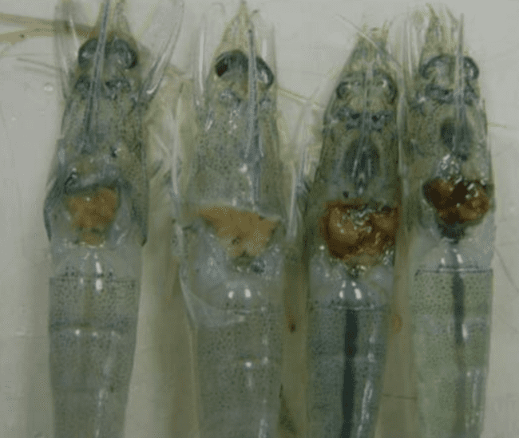

Fig 3. YHV infected shrimps showing dark yellowing of hepatopancreas (Source: Amarakoon et al., 2017)

3.3 Taura syndrome virus
Taura syndrome initially appeared in cultured P. vannamei close to the Taura river estuary in Ecuador in June 1992 (Jiminez, 1992).

Morphology & Taxonomy
The Taura syndrome virus (TSV) is an icosahedral, 31–32 nm-diameter, non-enveloped, positive-sense single-stranded RNA (ssRNA) virus. It is similar to tiny insect viruses like drosophila C virus and cricket paralysis virus that are found in the Apavirus genus of the Dicistroviridae family (Christian et al., 2005).

Clinical signs
Taura syndrome virus within 14–40 days of being stocked in nursery or grow-out ponds, mostly affects young P. vannamei (0.1–5 g), while it can also infect post larvae and adult shrimp (Lightner et al., 1995). There are three different phases to the infection: acute, transition, and chronic. Shrimp in the acute phase are reddish in colour, especially in the tail fan and pleopods, because red chromatophores are growing. During this period, shrimp usually have fragile shells, an empty stomach, and a high cumulative mortality rate—up to 95%—during molting. Due to hemoglobin buildup, surviving shrimp entering the transition phase have irregularly formed melanized lesions on the cephalothorax, tail, and appendages; otherwise, they appear and behave normally. Shrimp that are chronically infected do not exhibit any overt clinical symptoms. While there is evidence that TSV may be eliminated during the chronic phase, the condition can linger for up to a year and potentially even longer. Tissues of ectodermal and mesodermal origin are susceptible to infection by the Taura syndrome virus, namely the antennal gland, subcuticular connective tissue, striated muscle, hematopoietic tissue, lymphoid organ, and cuticular epithelium (Hasson et al., 1999).

Mode of transmission
Taura syndrome virus can spread horizontally by injection, consumption of contaminated tissue, or contact with infected shrimp or their corpses (Hasson et al., 1995). Even in the absence of symptoms, transmission can happen when exposed to chronically infected shrimp (Lotz et al., 2003). TSV vertical transmission is thought to be possible, although it hasn't been shown through experimentation. Another considered likely route for the geographically localized spread of TSV infection between farms or ponds is mechanical transmission. During illness outbreaks, sea gull feces collected from the borders of shrimp ponds have been confirmed to contain the Taura syndrome virus (Garza et al., 1997). Furthermore, some data indicate that TSV is carried in the guts of salinity-tolerant water boatmen (Trichocorixa reticulata), which may act as mechanical vectors (Dhar et al., 2004).
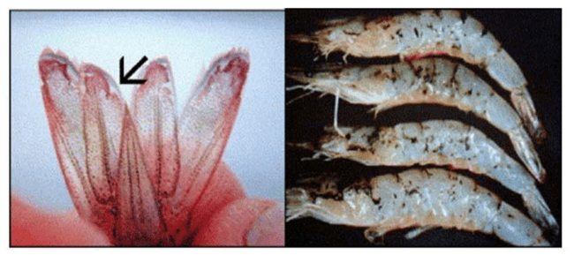

Fig 4. Visible indications of TSV include reddish necrotic areas in the tail fan of L. vannamei, as depicted in the left image. second photo illustrates black lesions on the cuticle, a distinctive feature of the recovery stage in TSV infection (source: Lightner, 1996)

3.4 Infectious hypodermal haematopoietic necrosis virus
Midway through 1981, a virus known as infectious hypodermal and hemopoietic necrosis (IHHNV) was discovered. It killed off a large number of juvenile and sub-adult P. stylirostris plants raised in extremely intense raceways in Hawaii, with fatalities approaching 90% (Lightner et al., 1983). IHHNV may cause 'runt deformation syndrome' (RDS) in P. vannamei, which is characterized by delayed, uneven development of afflicted shrimp and cuticular abnormalities (Kalagayan et al., 1991). It has been estimated that RDS in P. vannamei causes losses ranging from 10% to 50% each crop economically.

Morphology & Taxonomy
IHHNV, a 22 nm-long non-enveloped DNA virus, with icosahedral symmetry (Bonami et al., 1990). This virus is closely related to little DNA viruses that infect mosquitoes of the Aedes genus. As of right now, it is the tentative species Penaeus stylirostris densovirus (PstDNV) of the genus Brevidensovirus of the family Parvoviridae (Tattersall et al., 2005).

Clinical signs
P. stylirostris first manifests as languid surface swimming, which is followed by a stationary, inverted descent to the bottom, muscular opacity, immobility, and finally death. There are reports that indicate the sickness tends to be more severe in small animal groupings than in bigger ones. Furthermore, even in the absence of obvious symptoms of illness, living P. stylirostris specimens infected with IHHNV may develop into carriers and lifetime transmitters of the virus. When they reach the juvenile stage, vertically infected larvae and early post-larvae suffer massive fatalities. IHHNV has been associated with runt deformation syndrome (RDS) in P. vannamei, which causes a significant decrease in development rate and cuticular deformities such bent rostrums, blistering cuticles, bent telson, abdominal malformations, and curling antennae (Lightner, 1996).

Mode of transmission
The horizontal transmission of the infectious hypodermal hemopoietic necrosis virus can occur by injection, ingestion, or contact with contaminated water. Shrimp can carry the virus for the whole of their life and may not exhibit any symptoms (Lightner, 2003). Since the virus has been found in developing oocytes and ovarian tissue in infected females, vertical transmission from these individuals is potentially a possibility. Elevated infection levels have the potential to abort foetal development. A few IHHNV-resistant P. stylirostris strains have undergone selected breeding (Weppe et al., 1992).
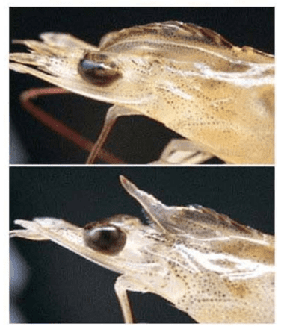

Fig 5. Runt deformity syndrome in L. vannamei. Deformed rostra of two shrimps — one curved down and the other up and both shorter than normal. (Flegel, 2006)

3.5 Infectious myonecrosis virus
Infectious myonecrosis virus (IMNV) was initially discovered in 2002 in Piauí, northeast Brazil, in Pacific white leg shrimp (Lightner et al., 2004). After the first epidemic in Brazil, the virus expanded to nations in Southeast Asia, including India (Sahul Hameed et al., 2017) and Indonesia (Senapin et al., 2007). The illness was once known as idiopathic myonecrosis, but it was subsequently dubbed infectious myonecrosis and the infectious myonecrosis virus was shown to be the cause (Poulos et al., 2006).
Morphology & Taxonomy
IMNV is a member of the family Totiviridae, genus putative totivirus and is characterized by a non-enveloped icosahedral virion that contains one double-stranded RNA (Mai et al., 2019).

Clinical signs
Apart from L. vannamei, experimental evidence has demonstrated the susceptibility of several species, including Litopenaeus stylirostris, P. monodon, and Fenneropenaeus subtilis. According to Nunes et al. (2004), the virus may infect shrimp at all three phases of their life cycle. Between 40% and 70% of deaths are cumulatively attributed to IMNV. According to Tang et al. (2005), the target tissues for IMNV include lymphoid organ parenchymal cells, connective tissues, striated muscles (skeletal and occasionally cardiac), and haemoglobin. The illness is characterized by localized to white necrotic patches in the striated muscles, especially in the distal abdominal segment and tail fan, during the acute phase of an enzootic IMNV infection. IMNV infections that are linked to high death rates might occur after traumatic situations such as being caught in a cast-net, being fed, and sudden changes in water salinity or temperature (Poulos et al., 2006).

Mode of transmission
Cannibalism has been demonstrated to be a horizontal mode of transmission for IMNV, and aquatic transmission is also possible. Acute phase histological examination indicates fibrosis, haemocytic infiltration, lymphoid organ spheroid development, coagulative muscle necrosis, significant oedema among damaged muscle fibers, and fluid build-up between muscle fibers. Accumulations of lymphoid organ spheroids (LOSs) cause substantial hypertrophy in shrimp infected with acute- or chronic-phase IMNV infections. Ectopic lung sclerosis (LOSs) is frequently seen in the heart, gills, ventral nerve cord, and the area around the antennal gland tubules (Poulos et al., 2006).
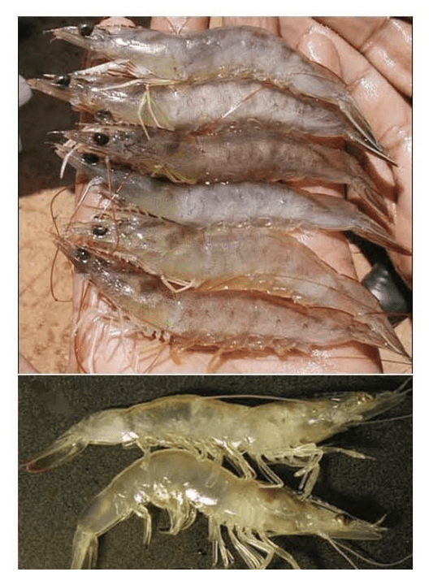

Fig 6. Gross signs of IMNV in naturally infected farmed L. vannamei, exhibiting various degrees of skeletal muscle necrosis, visible as an opaque, white discoloration of the abdomen (source: DV Lightner)
3.6 Monodon baculovirus
Spherical baculovirus, commonly called as monodon baculovirus (MBV), was first discovered in 1977 in adult P. monodon specimens being raised in laboratories in Mexico following the importation of post larvae from Taiwan. Many additional penaeid shrimp species, such as Penaeus merguiensis, Penaeus plebejus from Australia, and Penaeus indicus from Vietnam, have been shown to have variations of Monodon baculovirus, also known as MBV-like viruses. Many report have also been noted in Penaeus penicillatus from Taiwan and P. indicus, Metapenaeus monoceros, and Metapenaeus elegans from India (Walker et al., 2009).

Morphology and Taxonomy
Monodon baculovirus is a large bacilliform double-stranded DNA (dsDNA) virus. It is provisionally assigned to the species Penaeus monodon nuclear polyhedrosis virus (PemoNPV), which is a member of the Baculoviridae family and genus Nucleopolyhedrovirus (Theilmann et al., 2005).

Host range
Significant mortality rates in larvae, especially in the protozoea and mysis stages, can result from the monodon baculovirus. Although reports on MBV's effect on juvenile and adult survival are mixed, it was first connected to the demise of the P. monodon culture business in Taiwan in 1987–1988 and the deaths of juveniles raised in ponds in Indonesia and Malaysia in the middle of the 1980s (Lightner et al., 1987). Infections that recur in both juvenile and adult phases are frequent and frequently accepted without showing any symptoms of illness. The illness linked to MBV has been found to be significantly influenced by environmental or other stressors. There have also been several reports of co-infection with other viruses, such as WSSV, IHHNV, and HPV. Several infections can cause development retardation (Flegel et al., 2004).

Mode of transmission and virulence
Transmission of the monodon baculovirus can happen by cohabitation, feeding, or contact with homogenates of infected tissue (Lightner and Redman, 1981). Except for eggs and nauplii, every stage of life is prone to MBV infection. Viral particles and inclusion bodies are released into the intestinal tract through the hepatopancreatic lumen and target the epithelial cells of the hepatopancreatic tubules and anterior midgut (Chen et al., 1989a). Like other baculoviruses, the most likely mode of infection is oral-faecal transfer, and polyhedra shields virus particles produced in inclusion bodies from the environment. There is no indication of transovarial transmission, despite the fact that the Monodon baculovirus may be passed from brood stock to offspring. According to the research, infection happens when feces contaminate eggs during spawning (OIE, 2006). The transmission cycle can be broken by using proper husbandry procedures, such as washing fertilized eggs or nauplii with filtered saltwater, formalin, and iodophores (Chen et al., 1992).

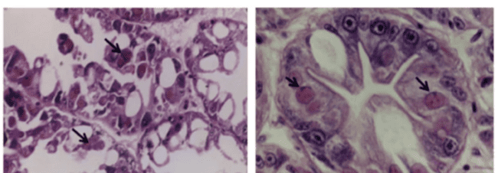
a
b
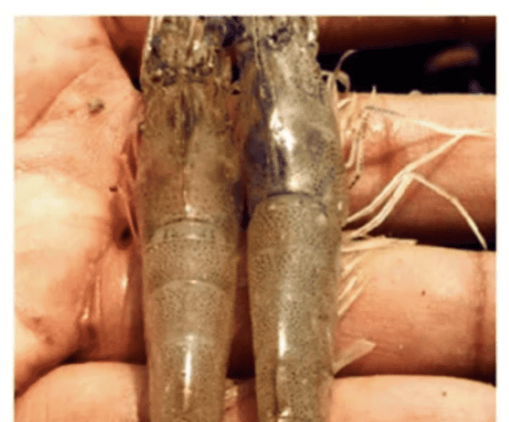

c

Fig 7. a) (H&E) staining of the Monodon baculovirus (MBV)-infected hepatopancreas in Penaeus monodon, with eosinophilic numerous MBV inclusions (shown by a black arrow).
b) H&E-stained close-up of the hepatopancreas of P. monodon that has been infected with the Monodon baculovirus. The picture shows MBV inclusions, hypertrophied nuclei, and marginated chromatin.
c) An MBV-infected animal exhibiting a pink coloration on the body (left) in comparison to a normal shrimp (Source: Rajendran et al., 2012).

3.7 Laem-Singh virus (LSNV)
Laem Singh virus (LSNV) was initially discovered in 2006 in Penaeus monodon shrimp cultivated in Laem-Singh District, Chanthaburi Province, Thailand. This identification was part of an investigation into the origins of monodon slow growth syndrome (MSGS), (Sritunyalucksana et al., 2006). Initially, it was hypothesized that LSNV might be the causative agent behind MSGS. However, subsequent confirmation revealed that LSNV is not responsible for MSGS. It was shown that in small-sized shrimp collected from ponds impacted by MSGS, LSNV was associated with retinopathy. Remarkably, neither large-sized shrimp from the same MSGS-affected ponds nor shrimp from normal ponds that tested positive for LSNV using RT-PCR were found to harbour LSNV. The underlying cause of the retinopathy remained unidentified (Pratoomthai et al., 2008a).This conclusion was drawn based on the detection of LSNV in normal monodon shrimp, and further findings indicated the presence of LSNV in L. vannamei culture stocks through real time PCR, where it did not impede the shrimp growth. This was the main reason for causing shit of cultivation from P. monodon to L. vannamei in Thailand.

Morphology and Taxonomy
LSNV is an icosahedral-shaped virion varying a size range from 25 to 30 nm, and it possesses a positive-sense single-stranded RNA (ssRNA). Notably, the virion lacks an envelope. This structural configuration is reminiscent of insect-transmitted plant viruses classified within the family Luteoviridae and genus Sobemovirus (Sittidilokratna et al., 2009).

Host Range
LSNV has been identified in P. monodon, Metapenaeus dobsoni, Fenneropenaeus merguiensis, and L. vannamei. To date, the natural host range of LSNV remains undisclosed (Kumar et al., 2011).

Mode of transmission and virulence
LSNV has been found to exhibit both vertical and horizontal transmission, as evidenced by its prevalent detection in both wild and cultured brood stock, as well as post larval shrimp in India and Thailand (Rajan et al., 2009). Stunted shrimp from MSGS ponds in Thailand were found to have retinal lesions harbouring a new integrase-containing element (ICE) together with LSNV. It has been reported that retinopathy is associated with LSNV infection and that it may be linked causally to stunting of P. monodon in MSGS ponds. Intriguingly, LSNV was found in association with WSSV, HPV, and MBV in P. monodon. Although LSNV has been reported in India, its presence does not consistently correlate with slow growth (Kumar et al., 2011).
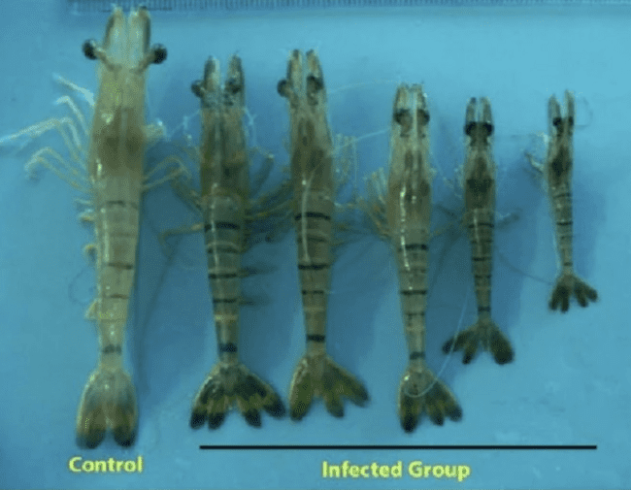

Fig 8. LSNV infected P. monodon showing dark discolouration of body and stunted growth (Source: Poornima et al., 2012).

4 Prevention and control of diseases using biosecurity measures
The term "biosecurity" refers to tactics used to stop the spread of infectious pathogens into certain areas or facilities. It also encompasses biocontainment, which is the management of illnesses that are already prevalent in a particular area with the goal of preventing their spread to other areas. Identification of possible infectious agent carriers, such as sick hosts, nonhost biological carriers, and contaminated inanimate items, is a crucial aspect of biosecurity. Biosecurity protocols should be implemented at all levels of the aquaculture production cycle, including individual farms, brood-stations, and national and international institutions that manage aquaculture imports and exports, in order to guarantee the security of aquaculture (Lotz, 1997).

4.1 Biosecurity implementation on Brood Stations
Brood-stations function as starting sites in providing spawn, live shrimp, and seed stock for shrimp farming. The following section discusses some of the standard biosecurity procedures carried out on brood stations in order to prevent and manage infectious illnesses.

4.2 Screening of Parent-stock and Eggs on routine basis
To prevent the vertical transmission of pathogens, it is essential to regularly screen parent stocks through laboratory tests, identifying and removing infected shrimps. This ensures that only disease-free shrimps are utilized for egg production in shrimp farming. Each shrimp from the parent stock should be tagged and undergo viral infection screening using sperms, ovarian fluid, and other materials for virus isolation. For viral detection, cell culture and/or reverse transcription polymerase chain reaction (RT-PCR) techniques are used (Watanabe et al., 2000). Eggs should be screened for viral infections using cell culture and RT-PCR in addition to parent stock screening. Only eggs that have been verified to be free of disease infections should be made accessible for shrimp farming; infected eggs must be removed from the breeding program. The use of specific pathogen-free (SPF) post larvae from brood-stocks that have been screened and found to be free of major viral diseases that affect shrimp, such as infectious hematopoietic and haemorrhagic necrosis virus (IHHNV), infectious myonecrosis virus (IMNV) and white-spot syndrome virus (WSSV), has greatly reduced the frequency of disease outbreaks on shrimp farms (Moss et al., 2012).

4.3 Standard Operating Procedures (SOPs) manuals for Brood Stations
The biosecurity control measures that are included into the routine operations of brood stations are outlined in Standard Operating Procedures (SOPs). The design of the facility, personnel and stock flow, the separation of areas that are restricted and unrestricted, personnel and equipment disinfection protocols, the handling of inflow water and wastewater, feeding schedules, and other relevant management procedures should all be covered in these SOPs. The protocols must specify how to screen the seed stock used to produce the specific pathogen-free (SPF) post larvae that are delivered to shrimp farmers in the context of shrimp farming. It is essential to create standardized data entry forms that are regularly completed, recording details about the state of health, the cleanliness of the facilities and equipment, the number of post larvae shrimp produced in each batch, the diseases that are screened for, the diagnostic tests that are performed, the use of immunostimulants or vaccinations, the sources of feed, feed intake, weight increase, and other pertinent biosecurity and management techniques used at the brood station (Munang'andu, et al., 2016).

4.4 National Biosecurity Regulations
Shrimp farmers must follow national regulations to ensure that biosafety precautions are implemented correctly. Regular disease inspections must to be carried out, and prompt reporting to the appropriate authorities is crucial in the event that a notifiable illness is discovered. High-risk illnesses, particularly new infections, may require stamping out entire stock, depending on the disease's features and severity. After that, the farm should be completely cleansed of all livestock before rigorous cleaning and fallowing processes are put into place. The farms which follow these regulations then can be replenished with certified disease-free livestock.

4.5 International Biosecurity
International organizations like the FAO and OIE play a crucial role in coordinating global efforts to control aquatic viral diseases. The FAO focuses on providing guidelines for food animal disease control, while the OIE, established in 1924, addresses all matters pertaining to the health of animals, especially those involving aquatic life. The OIE Aquatic Animal Health Code and the Manual of Diagnostic Tests for Aquatic Animals are two examples of papers from these organizations that provide frameworks and recommendations for nations to create biosecurity programs at different levels. By classifying illnesses according to risk and offering recommendations for management, prevention, and control, these programs seek to satisfy the health certification standards for the international commerce of aquatic animals and goods (Hastein et al., 2008).

4.6 Developing domesticated, SPF stocks
Developing domesticated, specific pathogen-free (SPF) breeding stocks should be the main goal of any cultivated species, especially if steady and consistent production is required. A great breakthrough has been achieved with the domestication of stocks that are devoid of main diseases in every species. Fish and shrimp have always prioritized selection for higher growth rates as well as disease resistance or tolerance once such stocks have been developed. For every particular species, achieving these goals is essential to increasing aquaculture's stability, production, and efficiency. SPF stocks displaying tolerance to Taura syndrome virus (TSV) have been successfully generated via the use of conventional breeding and selection techniques, and present SPF stocks of P. vannamei, which are extensively used in Asia, demonstrate high tolerance to TSV and IHHNV (Cock et al., 2009).

4.7 Shrimp vaccination against disease
DNA vaccines that include injecting a DNA preparation containing the gene for a selected pathogen antigen have been created for vertebrates. As a result, the vaccinated host produces the necessary antibodies and the protective antigen. Since shrimp are unable to create antibodies, this DNA vaccination technique may not be beneficial in theory. Although there have been reports that shrimp can be protected against some illnesses, such as white spot disease (WSD), by injecting viral DNA constructs, the specific protective mechanism is yet unknown. Many studies report employing dead bacteria, bacterial proteins, and host or viral proteins to protect shrimp against bacterial and viral diseases, even though shrimp do not have antibodies. None of these investigations, however, identify adaptive immunity—or generated, antibody-like proteins—as the foundation for defense. Rather, the terms "immune priming" or "trained immunity" have been proposed. As of right now, shrimp producers are unable to access any commonly used commercial product of this kind. (Flegel, 2019).

4.8 RNAi mechanism using dsDNA to activate the host
RNAi mechanism approach has demonstrated success against various shrimp viruses and has been valuable in exploring the functions of diverse shrimp proteins beyond immunity. Assuming cost reduction through economies of scale and the development of an efficient oral delivery route, there is potential for using dsRNA as a feed element to guard against shrimp viruses in hatcheries and farms. While it may be feasible for removing viruses from contaminated breeding stocks, further research is needed. For instance, the approach could be applied to clear viruses such as (IHHNV) or newly discovered viruses, like Laem-Singh virus (LSNV) (Saksmerprome et al., 2017). Additionally, combining the dsRNA method with the antibiotic ivermectin might enhance the clearance process, as demonstrated in the case of IHHNV. If successful, this approach may play a key role in removing viruses from premium farmed shrimp, enabling their reintroduction into selective breeding initiatives. (Nguyen et al., 2014).

5. Future perspectives
Technologies of the future could offer some relief from the problems associated with aquaculture health management. Although shrimp lack a sophisticated adaptive immune system, traditional vaccination with antibodies, cytokines, and lymphocytes is not possible. However, there is growing evidence that shrimp deploy a variety of defense mechanisms against viruses. These systems might be used to stop the spread of infections or stop sickness. Other methods include

- Development and implementation of national aquatic animal health strategies
- Proper infrastructure development
- Attitudinal change by creating awareness between farmers to policy makers
- To avoid the recurrence of previous disease emergence scenarios and to mitigate significant socio-economic and environmental impacts in the future, industry and government collaboration is essential, as is a commitment to policies and practices focused on long-term sustainability and profitability instead of short-term gains.

6. Conclusions
The global expansion of aquaculture, driven by the growing world population, increasing seafood demand, and declining yields from fisheries, raises the risk of disease occurrence and transmission. Despite advancements in shrimp farming, challenges such as emerging diseases persist, highlighting the ongoing need for comprehensive biosecurity measures. To mitigate substantial economic losses in aquaculture, definitive precautionary strategies are crucial. These should include the establishment of disease surveillance systems, enhanced molecular methods for early carrier detection, and significant research into vaccines, RNAi, probiotics, immunostimulants, and molecular techniques for improved diagnostics. These measures are essential components of effective health management in aquaculture systems.

7. References
Amarakoon, A.G.U. and Wijegoonawardane, P.K.M. (2017). A comparative analysis of Yellow Head Virus (YHD) diagnostic methods adopted in Sri Lanka to investigate the accuracy and specificity of the virus. World Scientific News. 66: 181-192.
Batts, W., Yun, S., Hedrick, R. and Winton, J. (2011). A novel member of the family Hepeviridae from cutthroat trout (Oncorhynchus clarkii). Virus Research. 158(1-2): 116-123.
Bonami, J.R., Trumper, B., Mari, J., Brehelin, M. and Lightner, D.V. (1990). Purification and characterization of the infectious hypodermal and haematopoietic necrosis virus of penaeid shrimps. Journal of General Virology, 71(11): 2657-2664.
Chantanachookin, C., Boonyaratpalin, S., Kasornchandra, J., Direkbusarakom, S., Ekpanithanpong, U., Supamataya, K., Sriurairatana, S. and Flegel, T.W. (1993). Histology and ultrastructure reveal a new granulosis-like virus in Penaeus monodon affected by yellow-head disease. Diseases of Aquatic Organisms. 17: 145-145.
Chen, S.N., Chang, P.S. and Kou, G.H. (1989). Observation on pathogenicity and epizootiology of Penaeus monodon baculovirus (MBV) in cultured shrimp in Taiwan. Fish Pathology. 24(4): 189-195.
Chen, S.N., Chang, P.S. and Kou, G.H. (1992). Infection route and eradication of Penaeus monodon baculovirus (MBV) in larval giant tiger prawn Penaeus monodon. In: Diseases of cultured shrimp in Asia and United States. Fulks, W. and Main, K.L. Eds. The Oceanic Institute, Honolulu, pp. 177–184.
Chou, H., Huang, C., Wang, C., Chiang, H. and Lo, C. (1995). Pathogenicity of a baculovirus infection causing white spot syndrome in cultured penaeid shrimp in Taiwan. Diseases of Aquatic Organisms, 23(3): 165-173.
Chou, H.Y., Huang, C.Y., Lo, C.F. and Kou, G.H. (1998). Studies on transmission of white spot syndrome associated baculovirus (WSBV) in Penaeus monodon and P. japonicus via waterborne contact and oral ingestion. Aquaculture. 164(1-4): 263-276.
Christian, P., Carstens, E., Domier, L., Johnson, J., Johnson, K., Nakashima, N., Scotti, P. and van der Wilk, F. (2005). Genus Iflavirus. In: Virus Taxonomy: Eighth Report of the International Committee on Taxonomy of Viruses. (Fauquet C.M., Mayo M.A., Maniloff J., Desselberger U., Ball. L.A. Eds). pp.779-782, Academic Press; San Diego, USA.
Cock, J., Gitterle, T., Salazar, M. and Rye, M. (2009). Breeding for disease resistance of Penaeid shrimps. Aquaculture. 286(1-2): 1-11.
Cowley, J.A. and Walker, P.J. (2002). The complete genome sequence of gill-associated virus of Penaeus monodon prawns indicates a gene organisation unique among nidoviruses* Brief Report. Archives of Virology. 147: 1977-1987.
Culley, A.I. and Welschmeyer, N.A. (2002). The abundance, distribution, and correlation of viruses, phytoplankton, and prokaryotes along a Pacific Ocean transect. Limnology and Oceanography. 47(5): 1508-1513.
Dhar, A.K., Cowley, J.A., Hasson, K.W. and Walker, P.J. (2004). Genomic organization, biology, and diagnosis of Taura syndrome virus and yellowhead virus of penaeid shrimp. Advances in Virus Research. 63, p.353-421.
Fauquet, C.M., Mayo, M.A., Maniloff, J., Desselberger, U. and Ball, L.A. eds. (2005). Virus taxonomy: VIIIth report of the International Committee on Taxonomy of Viruses (1st Eds). Academic Press.
Flegel, T.W. (1995 Progress in characterization and control of yellow-head virus of Penaeus monodon. In: Swimming Through Troubled Water, Proceedings of the Special Session on Shrimp Farming, Aquaculture '95. C.L. Browdy and J.S. Hopkins (Eds.). World Aquaculture Society, Baton Rouge, LA, USA. pp. 76-83
Flegel, T.W. (2019). A future vision for disease control in shrimp aquaculture. Journal of the World Aquaculture Society. 50(2): 249-266.
Flegel, T.W., 2006. Detection of major penaeid shrimp viruses in Asia, a historical perspective with emphasis on Thailand. Aquaculture, 258(1-4): 1-33.
Flegel, T.W., Nielsen, L., Thamavit, V., Kongtim, S. and Pasharawipas, T. (2004). Presence of multiple viruses in non-diseased, cultivated shrimp at harvest. Aquaculture. 240(1-4): 55-68.
Garza, J.R., Hasson, K.W., Poulos, B.T., Redman, R.M., White, B.L. and Lightner, D.V. (1997). Demonstration of infectious Taura syndrome virus in the feces of seagulls collected during an epizootic in Texas. Journal of Aquatic Animal Health. 9(2): 156-159.
Gaughan, D.J. (2001). Disease-translocation across geographic boundaries must be recognized as a risk even in the absence of disease identification: the case with Australian Sardinops. Reviews in Fish Biology and Fisheries. 11: 113-123.
Hasson, K.W., Lightner, D.V., Mohney, L.L., Redman, R.M., Poulos, B.T. and White, B.M. (1999). Taura syndrome virus (TSV) lesion development and the disease cycle in the Pacific white shrimp Penaeus vannamei. Diseases of Aquatic Organisms. 36(2): 81-93.
Hastein, T., Binde, M., Hine, M., Johnsen, S., Lillehaug, A., Olesen, N.J., Purvis, N., Scarfe, A.D. and Wright, B. (2008). National biosecurity approaches, plans and programmes in response to diseases in farmed aquatic animals: evolution, effectiveness and the way forward. Revue Scientifique Et Technique-Office International Des Epizooties. 27(1): 125.
International Office of Epizootics (2006). Aquatic Animal Health Standards Commission. Manual of diagnostic tests for aquatic animals. Office international des épizooties.
Jiang, Y. (2001). In: Thematic Review on Management Strategies for Major Diseases in Shrimp Aquaculture. In: Proceedings of Consortium Program on Shrimp Farming and the Environment. Subasinghe, R., Arthur, R., Phillips, M.J. and Reantaso, M. (Eds). Cebu, Philippines, pp. 74-78
Jimenez. R. (1992). Sindrome de Taura (resumen). In: Acuacultura del Ecuador. Jimenez R (ed) Revista especializada de la Camara Nacional de Acuacultura. Guayaquil, pp. 1–16.
Kalagayan, H., Godin, D., Kanna, R., Hagino, G., Sweeney, J., Wyban, J. and Brock, J. (1991). IHHN virus as an etiological factor in runt‐deformity syndrome (RDS) of juvenile Penaeus vannamei cultured in Hawaii. Journal of the World Aquaculture society. 22(4): 235-243.
Kibenge, F.S.B. (2019). Emerging viruses in aquaculture. Current Opinion in Virology. 34: 97-103.
Krkošek, M. (2017). Population biology of infectious diseases shared by wild and farmed fish. Canadian Journal of Fisheries and Aquatic Sciences. 74(4): 620-628.
Kumar, T.S., Krishnan, P., Makesh, M., Chaudhari, A., Purushothaman, C.S. and Rajendran, K.V. (2011). Natural host-range and experimental transmission of Laem-Singh virus (LSNV). Diseases of Aquatic Organisms. 96(1): 21-27.
Lightner D.V., Pantoja C.R., Poulos B.T., Tang, K.F.J., Redman, R.M., Pasos De Andrade, T. and Bonami J.R. (2004). Infectious myonecrosis: new disease in Pacific white shrimp. Global Aquaculture Advocate. 7: 85.
Lightner, D.V. and Redman, R.M. (1981). A baculovirus-caused disease of the penaeid shrimp, Penaeus monodon. Journal of Invertebrate Pathology. 38(2): 299-302.
Lightner, D.V., 2003. The penaeid shrimp viral pandemics due to IHHNV, WSSV, TSV and YHV: history in the Americas and current status. In: Proceedings of the 32nd Joint UJNR Aquaculture Panel Symposium, Davis and Santa Barbara, California, USA, pp. 17-20.
Lightner, D.V., Hedrick, R.P., Fryer, J.L., Chen, S.N., Liao, I.C. and Kou, G.H. (1987). A survey of cultured penaeid shrimp in Taiwan for viral and other important diseases. Fish Pathology. 22(3): 127-140.
Lightner, D.V., Redman, R.M., Bell, T.A. and Brock, J.A. (1983). Detection of IHHN virus in Penaeus stylirostris and P. vannamei imported into Hawaii. Journal of the World Mariculture Society. 14(1‐4): 212-225.
Lightner, D.V., Redman, R.M., Hasson, K.W. and Pantoja, C.R. (1995). Taura syndrome in Penaeus vannamei (Crustacea: Decapoda): gross signs, histopathology and ultrastructure. Diseases of Aquatic Organisms, 21(1): 53-59.
Liu, B., Yu, Z., Song, X., Guan, Y., Jian, X. and He, J. (2006). The effect of acute salinity change on white spot syndrome (WSS) outbreaks in Fenneropenaeus chinensis. Aquaculture. 253(1-4): 163-170.
Lo, C.F., Ho, C.H., Chen, C.H., Liu, K.F., Chiu, Y.L., Yeh, P.Y., Peng, S.E., Hsu, H.C., Liu, H.C., Chang, C.F. and Su, M.S. (1997). Detection and tissue tropism of white spot syndrome baculovirus (WSBV) in captured brooders of Penaeus monodon with a special emphasis on reproductive organs. Diseases of Aquatic Organisms. 30(1): 53-72.
Lotz, J.M. (1997). Viruses, biosecurity and specific pathogen-free stocks in shrimp aquaculture. World Journal of Microbiology and Biotechnology. 13: 405-413.
Lotz, J.M., Flowers, A.M. and Breland, V. (2003). A model of Taura syndrome virus (TSV) epidemics in Litopenaeus vannamei. Journal of Invertebrate Pathology. 83(2): 168-176.
Mai, H.N., Hanggono, B., Caro, L.F.A., Komaruddin, U., Nur’aini, Y.L. and Dhar, A.K. (2019). Novel infectious myonecrosis virus (IMNV) genotypes associated with disease outbreaks on Penaeus vannamei shrimp farms in Indonesia. Archives of Virology, 164: 3051-3057.
Mohan, C.V., Shankar, K.M., Kulkarni, S. and Sudha, P.M. (1998). Histopathology of cultured shrimp showing gross signs of yellow head syndrome and white spot syndrome during 1994 Indian epizootics. Diseases of Aquatic Organisms. 34(1): 9-12.
Moss, S.M., Moss, D.R., Arce, S.M., Lightner, D.V. and Lotz, J.M. (2012). The role of selective breeding and biosecurity in the prevention of disease in penaeid shrimp aquaculture. Journal of Invertebrate Pathology. 110(2): 247-250.
Mugimba, K.K., Byarugaba, D.K., Mutoloki, S., Evensen, Ø. and Munang’andu, H.M. (2021). Challenges and solutions to viral diseases of finfish in marine aquaculture. Pathogens. 10(6): 673.
Munang’andu, H.M., Mutoloki, S. and Evensen, Ø. (2016). Prevention and control of viral diseases in aquaculture. In: Aquaculture virology (Kibenge F.S.B. and Godoy M.G. Eds.). pp. 77-93. Academic Press, London, UK.
Nakai, T., Sano, M., Yoshimizu, M., Kasai, H., Itami, T. and Sudhakaran, R. (2016). Diseases caused by viral pathogens. In: Fish Diseases. (Aoki. T. Eds.). pp. 278-322, Eolss, UK.
Nguyen, K.Y., Sakuna, K., Kinobe, R. and Owens, L. (2014). Ivermectin blocks the nuclear location signal of parvoviruses in crayfish, Cherax quadricarinatus. Aquaculture. 420: 288-294.
Nunes, A.J.P., Martins, P.C.C. and Gesteira, T.C.V. (2004). Carcinicultura ameaçada. Rev. Panoram. Aquic. 83: 37-51.
Poornima, M., Seetang-Nun, Y., Alavandi, S.V. and Dayal, J.S. (2012). Laem-Singh Virus: A probable etiological agent associated with monodon slow growth syndrome in farmed black tiger shrimp (Penaeus monodon). Indian Journal of Virology. 23: 215-225.
Poulos, B.T., Tang, K.F., Pantoja, C.R., Bonami, J.R. and Lightner, D.V. (2006). Purification and characterization of infectious myonecrosis virus of penaeid shrimp. Journal of General Virology. 87(4): 987-996.
Pratoomthai, B., Sakaew, W., Sriurairatana, S., Wongprasert, K. and Withyachumnarnkul, B. (2008). Retinopathy in stunted black tiger shrimp Penaeus monodon and possible association with Laem-Singh virus (LSNV). Aquaculture. 284(1-4): 53-58.
Rajan, J.J.S., Sivakumar, S., Singaravel, R., Poornima, M., AlavandiSV, K.N. and Santiago, T.C. (2009). Detection of slow growth syndrome disease in farmed shrimp in India. In: Indian youth science congress (IYSC 2009). Rajiv Gandhi National Institute of youth development, Sriperumbudur, 23.
Rajendran, K.V., Makesh, M. and Karunasagar, I. (2012). Monodon baculovirus of shrimp. Indian Journal of Virology. 23: 149-160.
Reyes, A., Salazar, M. and Granja, C. (2007). Temperature modifies gene expression in subcuticular epithelial cells of white spot syndrome virus-infected Litopenaeus vannamei. Developmental and Comparative Immunology. 31(1): 23-29.
Rodger, H.D. (2016). Fish Disease Causing Economic Impact in Global Aquaculture. In: Fish Vaccines. Birkhäuser Advances in Infectious Diseases. (Adams, A. Eds). pp.1-34, Springer, Basel.
Rodgers, C.J., Mohan, C.V. and Peeler, E.J. (2011). The spread of pathogens through trade in aquatic animals and their products. Revue Scientifique Et Technique-Office International Des Epizooties. 30(1): 241-256.
Rodríguez, J., Bayot, B., Amano, Y., Panchana, F., De Blas, I., Alday, V. and Calderón, J. (2003). White spot syndrome virus infection in cultured Penaeus vannamei (Boone) in Ecuador with emphasis on histopathology and ultrastructure. Journal of Fish Diseases. 26(8): 439-450.
Sahul Hameed, A.S., Abdul Majeed, S., Vimal, S., Madan, N., Rajkumar, T., Santhoshkumar, S. and Sivakumar, S. (2017). Studies on the occurrence of infectious myonecrosis virus in pond‐reared Litopenaeus vannamei (Boone, 1931) in India. Journal of Fish Diseases. 40(12): 1823-1830.
Saksmerprome, V., Charoonnart, P. and Flegel, T.W. (2017). Feasibility of dsRNA treatment for post-clearing SPF shrimp stocks of newly discovered viral infections using Laem Singh virus (LSNV) as a model. Virus Research. 235: 73-76.
Senapin, S., Phewsaiya, K., Briggs, M. and Flegel, T.W. (2007). Outbreaks of infectious myonecrosis virus (IMNV) in Indonesia confirmed by genome sequencing and use of an alternative RT-PCR detection method. Aquaculture. 266(1-4): 32-38.
Sittidilokratna, N., Dangtip, S., Sritunyalucksana, K., Babu, R., Pradeep, B., Mohan, C.V., Gudkovs, N. and Walker, P.J. (2009). Detection of Laem-Singh virus in cultured Penaeus monodon shrimp from several sites in the Indo-Pacific region. Diseases of Aquatic Organisms. 84: 195-200.
Soto, M.A. and Lotz, J.M. (2001). Epidemiological parameters of white spot syndrome virus infections in Litopenaeus vannamei and L. setiferus. Journal of Invertebrate Pathology. 78(1): 9-15.
Sritunyalucksana, K., Apisawetakan, S., Boon-Nat, A., Withyachumnarnkul, B. and Flegel, T.W. (2006). A new RNA virus found in black tiger shrimp Penaeus monodon from Thailand. Virus Research. 118(1-2): 31-38.
Tandel, G.M., John, K.R., George, M.R. and Jeyaseelan, M.P. (2017). Current status of viral diseases in Indian shrimp aquaculture. Acta Virologica. 61(2):131-137.
Tang, K.F., Pantoja, C.R., Poulos, B.T., Redman, R.M. and Lightner, D.V. (2005). In situ hybridization demonstrates that Litopenaeus vannamei, L. stylirostris and Penaeus monodon are susceptible to experimental infection with infectious myonecrosis virus (IMNV). Diseases of Aquatic Organisms, 63(2-3): 261-265.
Tang, K.F.J. and Lightner, D.V. (1999). A yellow head virus gene probe: nucleotide sequence and application for in situ hybridization. Diseases of Aquatic Organisms. 35: 165-173.
Theilmann, D.A., Blissard, G.W., Boning, B., Jehle, J.A., O'reilly, D.R., Rohrmann, G.F., Thiem, S. and Vlak, J.M., (2005). Baculoviridae. In: Virus Taxonomy: VIIIth Report of the International Committee on Taxonomy of Viruses. (Fauquet, C.M., Mayo, M.A., Maniloff, J., Desselberger, U. and Ball, L.A. Eds.). pp. 177–185, Elsevier, Academic Press, London.
Tompkins, D. M., Carver, S., Jones, M. E., Krkošek, M. and Skerratt, L. F. (2015). Emerging infectious diseases of wildlife: a critical perspective. Trends in Parasitology. 31(4): 149-159.
Tsai, J.M., Wang, H.C., Leu, J.H., Hsiao, H.H., Wang, A.H.J., Kou, G.H. and Lo, C.F. (2004). Genomic and proteomic analysis of thirty-nine structural proteins of shrimp white spot syndrome virus. Journal of Virology. 78(20): 11360-11370.
Tucker, S., Pazzia, I., Rowan, D. and Rasmussen, J.B. (1999). Detecting pan-Atlantic migration in salmon (Salmo salar) using 137Cs. Canadian Journal of Fisheries and Aquatic Sciences. 56(12): 2235-2239.
Vlak, J.M., Bonami, J.R., Flegel, T.W., Kou, G.H., Lightner, D.V. and Lo, C.F. (2005). Family Nimaviridae. In: Virus Taxonomy: VIIIth Report of the International Committee on Taxonomy of Viruses. (Fauquet, C.M., Mayo, M.A., Maniloff, J., Desselberger, U. and Ball, L.A. Eds.). pp. 187–192, Elsevier, Academic Press, London.
Walker P.J., Cowley J.A., Spann K.M., Hodgson R.A.J., Hall M. and Withyachumnarnkul B. (2001). Yellow head complex viruses: transmission cycles and topographical distribution in the Asia‐Pacific region. In: The new wave, Proceedings of the Special Session on Sustainable Shrimp Culture, Aquaculture. (Browdy C.L. and Jory D.E. Eds.). pp. 227–237. The World Aquaculture Society, Baton Rouge, LA, USA.
Walker, P.J. and Mohan, C.V. (2009). Viral disease emergence in shrimp aquaculture: origins, impact and the effectiveness of health management strategies. Reviews in Aquaculture. 1(2): 125-154.
Wang, Y.C. and Chang, P.S. (2000). Yellow head virus infection in the giant tiger prawn Penaeus monodon cultured in Taiwan. Fish Pathology. 35(1): 1-10.
Wang, Y.G., Lee, K.L., Najiah, M., Shariff, M. and Hassan, M.D. (2000). A new bacterial white spot syndrome (BWSS) in cultured tiger shrimp Penaeus monodon and its comparison with white spot syndrome (WSS) caused by virus. Diseases of Aquatic Organisms, 41(1): 9-18.
Watanabe, K.I., Nishizawa, T. and Yoshimizu, M. (2000). Selection of brood stock candidates of barfin flounder using an ELISA system with recombinant protein of barfin flounder nervous necrosis virus. Diseases of Aquatic Organisms. 41(3): 219-223.
Weppe M. (1992): Demostracion de las altas cualidades de la cepa de P. stylirostris (AQUACOP SRP 43) resitente al virus IHHN. In: Proceedings of the Primero Congreso Ecuatoriano de Acuicultura. J. Calderon and L. Shartz (Eds.). Guayaquil, Ecuador, pp. 229-232.
Wongteerasupaya, C., Sriurairatana, S., Vickers, J.E., Akrajamorn, A., Boonsaeng, V., Panyim, S., Tassanakajon, A., Withyachumnarnkul, B. and Flegel, T.W. (1995). Yellow-head virus of Penaeus monodon is an RNA virus. Diseases of Aquatic Organisms. 22(1): 45-50.
Wongteerasupaya, C., Vickers, J. E., Sriurairatana, S., Nash, G. L., Akarajamorn, A., Boonsaeng, V. and Flegel, T. W. (1995). A non-occluded, systemic baculovirus that occurs in cells of ectodermal and mesodermal origin and causes high mortality in the black tiger prawn Penaeus monodon. Diseases of Aquatic Organisms. 21(1): 69-77.
Yan, D.C., Dong, S.L., Huang, J., Yu, X.M., Feng, M.Y. and Liu, X.Y. (2004). White spot syndrome virus (WSSV) detected by PCR in rotifers and rotifer resting eggs from shrimp pond sediments. Diseases of Aquatic Organisms. 59(1): 69-73.
Zhan, W.B., Wang, Y.H., Fryer, J.L., Yu, K.K., Fukuda, H. and Meng, Q.X. (1998). White spot syndrome virus infection of cultured shrimp in China. Journal of Aquatic Animal Health 10(4): 405-410.

