ANALYSIS OF TOOR DAL FOR ADULTERATION WITH METANIL YELLOW USING UV-VISIBLE SPECTROPHOTOMETER
R.N. Sabarinath¹ and Dr. Dorothy Pushparani²
¹ M.Sc., Department of Food Chemistry and Food Processing,
Loyola College, Chennai Dist., Tamil Nadu, India.
²Assistant Professor, Department of Food Chemistry and Food Processing,
Loyola College, Chennai Dist., Tamil Nadu, India.
E-mail Id: sabarinarayanan17@gmail.com

ABSTRACT

Food colours are generally categorized as permitted colours and non-permitted colours. Use of non-permitted food colours is known as “Adulteration” this leads to loss of quality of the food. Adulteration is big concern in terms of food safety these days. Metanil yellow dye is a food colourant used extensively in various foods. It is also used as an adulterant in different spices especially in Turmeric, Sweets and regular Indian foods like pulses. Metanil yellow belongs to “non-permitted” category of food colour. The objective was to detect the presence of Metanil yellow dye in Toor dal samples collected from three zones (North, Central, South) of Chennai, using a preliminary colour test and UV-Visible Spectrophotometer Continuous consumption of this toxic food colours leads to adverse life-threatening effects in humans. Serious concern and mass awareness are needed to be raised on this issue, and use of this toxic food colour need to be abandoned completely. The used methods of detection can be used in the area of food quality control to detect such harmful and banned colours in Food products. About 6.6% of Toor dal samples collected from North Zone of Chennai tested positive for adulteration using this detection methods.

Keywords: Toor dal, food colourant, Metanil yellow, Adulteration

I.INTRODUCTION
One of the protein-rich pulses grown in India is Toor dal, often known as pigeon dal and known by its botanical name, Cajanus cajan. This is extensively cultivated throughout India, particularly in Madhya Pradesh, Karnataka, Tamil Nadu, Gujarat, and Uttar Pradesh. All around India, Toor dal is a common ingredient in various dishes. Toor dal is low in calories and high in protein and fibre. Most often, Kesari dal (Lathyrus sativas), a distinct pulse with a lower price point in the marketplaces, is adulterated with Toor dal.
The most blatant forms of adulteration in food are typically present, or illegal drugs are either added or partially substituted. Food contamination can occur because of negligence and improper hygienic conditions during processing, storing, transporting, and selling as well as financial gain. This ultimately leads to the consumer being taken advantage of or frequently becoming ill as a result of the adulteration, which is typical in underdeveloped and poor nations. To begin to comprehend what adulteration is, it is necessary to first define the phrase "Adulteration," which is a legal term used to describe a food product that does not adhere to state requirements and typically relates to violations of the Food and Drug Administration's safety or health regulations. (FDA 1995, 2000 and USDA/FSIS 1999)
A large number of research publications covered the topic of adulteration and different techniques for analysing the presence of adulterants in food products. to research a few of the food adulterants that are found in various food products. The consumer's knowledge of common adulterants and their impact on health is just as crucial. Food companies are able to deceive and scam consumers because of the rising number of food producers and the extraordinary volume of imported food products.
It is quite challenging to distinguish between individuals who violate the law and those who adulterate food. Consumer awareness would be essential. Consumer health may be endangered by ignorance and unscrupulous business practices, and incorrect information can result in poisoning. Therefore, evaluation tests are required for their discovery. Food adulteration contributes to major illnesses like cancer, diarrhoea, asthma, ulcers, and more. Food adulteration lowers our morality as well as our social value. The prevention of food adulteration depends heavily on customer awareness. Unawareness and unethical business practices could threaten consumer health, and deception could result in poisoning.

Therefore, the general public should be aware of fundamental screening procedures. Foods give our bodies the nutrition it needs for growth, development, and upkeep. When food products are contaminated, mingled, or otherwise adulterated, our bodies receive inadequate nutrition, which has a variety of negative effects. Food adulteration is the act of adding or combining inferior, hazardous, poor, unnecessary, or unneeded ingredients to food in such a way as to alter its nature or quality. There are various kinds of dyes that are utilized as food colorants and additives. Since ancient times, people have known how to employ colour to make food both aesthetically and psychologically appealing foods are coloured artificially to replace natural pigments that are lost during processing, to minimize batch-to-batch fluctuation, and to create appealing goods where natural pigments are lacking.
The matter Metanil yellow is essential in lab testing, particularly for quality control, drug testing, and food handling. The qualities of Metanil yellow are compared to those of other products and it is an authenticated, uniform substance with the required level of purity for its intended application in specific chemical and physical tests. Strong, tannish yellow Metanil yellow that dissolves in methanol, alcohol, or water. Atomic number 375,38 and subatomic formula C18H14N3O3SNa for Metanil yellow, respectively. (Dhakal & Chao et al, 2016)
Yellow azo dye known as " Metanil yellow" is widely used as a food colouring. Diphenylamine and diazotized metanilic acid are used in its production. Azo dyes are also employed in laboratories as pH indicators, biological indicators, and for research purposes. In industries, the colouring of wool, nylon, silk, paper, ink, Aluminium detergent, etc. is permitted using Metanil yellow. Food-grade products cannot include the yellow colour Metanil. Foods cannot contain it since it is harmful. However, because azo-dye is an inexpensive food colouring, it is frequently employed as a colouring component in a variety of food products. According to studies, the dye is harmful to a number of physiological systems. The possible process is that Metanil yellow, when taken with food, is absorbed from the colon and travels to the bloodstream. The hazardous substance enters the bloodstream, travels to different organs, and messes with different cellular metabolic processes there. Previous research has shown that Metanil yellow causes oxidative stress in a number of critical organs, including the heart, liver, and kidneys. (Gosh D, et al ,2017)
Long-term consumption of helpful foods that have been adulterated, such as honey and turmeric, which are valued for their medical properties, has a negative influence on health. People eat those foods because they are recognized to have medical benefits. Nevertheless, they unintentionally often consume the hazardous food colouring Metanil yellow, which has a critically negative impact on their health. All of the human body's essential organs and organ systems, including the heart, liver, kidneys, neurological system, intestines, and stomach, can suffer damage from Metanil yellow. Here, pigeon pea dal/Toor dal is gathered from three separate areas in Chennai, Tamil Nadu, and evaluated using a UV-VIS Spectrophotometer for the presence of adulteration with the yellow azo dye Metanil. The Prevention of Food Adulteration Act, which was established in 1954 and set forth the regulations for providing consumers with clean and wholesome meals, is in charge of ensuring that citizens have access to safe food. The Act was last modified in 1986 to increase penalties and provide customers more control.

SPECIFIC OBJECTIVE
The main Aim is to analyse Toor dal samples to find adulteration with Metanil yellow dye using laboratory tests and UV-Visible Spectrophotometer.
OBJECTIVES OF THE STUDY
To determine the presence of colour adulterant Metanil yellow in Toor dal samples procured from the markets and stores from different geographical zones of Chennai (North, Central, South).
To quantify the Metanil yellow content using UV-VISIBLE spectrophotometer in the adulterated samples.

II. MATERIALS AND METHODS

ADULTERATION TEST FOR TOOR DAL TO DETECT THE PRESENCE OF METANIL YELLOW:

Metanil yellow is a synthetic dye which is not permitted to use as a food colour. However, it is extensively used to give yellow colour to dal and turmeric. It is toxic in nature and it has adverse effects on liver, intestine and brain. Presence of Metanil yellow can be tested in dal by adding a few drops of hydrochloric acid to a test sample. If the test solution turns pink in colour, it indicates presence of Metanil yellow.

IUPAC name of Metanil yellow dye is:
Sodium 3-[(4-anilinophenyl)diazenyl]benzenesulfonate

PREPARATION OF SAMPLE

The samples of Toor dal were collected from different markets present in different zones of Chennai. Geographically Chennai has three zones namely North, Central and South. Ten samples of Toor dal were collected from each zone and labelled respectively.
The samples from North Zone of Chennai were labelled as:
(N1, N2, N3, N4, N5, N6, N7, N8, N9, N10)
The samples from Central zone of Chennai were labelled as:
(C1, C2, C3, C4, C5, C6, C7, C8, C9, C10)
The samples from South zone of Chennai were labelled as:
(S1, S2, S3, S4, S5, S6, S7, S8, S9, S10).

PROCEDURE

- 0.005g of Metanil yellow dye is taken in a 100mL standard flask and made upto the mark with distilled water and marked as Concentration1
- 50 ml of the concentrated solution is taken and diluted with 100mL distilled water in a different standard flask and marked as Concentration2.
- The same process is followed till five different concentrations are made in five different standard flasks and are labelled.
- Different concentrations of Metanil yellow dye are run in UV-Visible Spectrophotometer with in a range of 200-800 nm the peak and absorbance values are recorded.
- The peak is absorbed between 400-500nm and plotted in a graph.
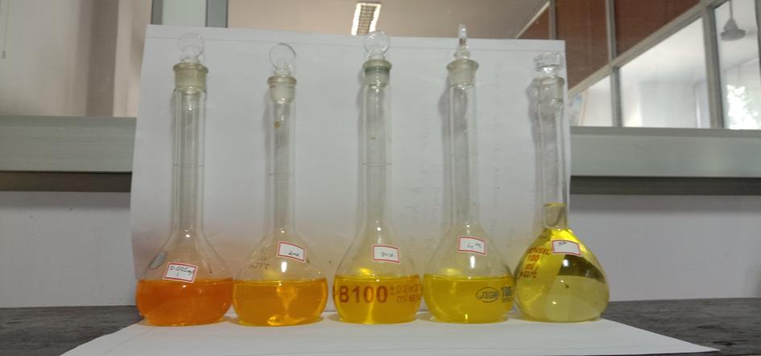
Fig.2.1

5g of Toor dal samples were taken in 10 different 100mL beakers
- 50mL of distilled water is added to it
- It is made to stand for 24hours
- Then, the distilled water sample is extracted from beaker
- The samples are run in a UV-VISIBLE spectrophotometer to record the peak absorbed.
- The same process is followed for all the ten different samples of Toor dal.

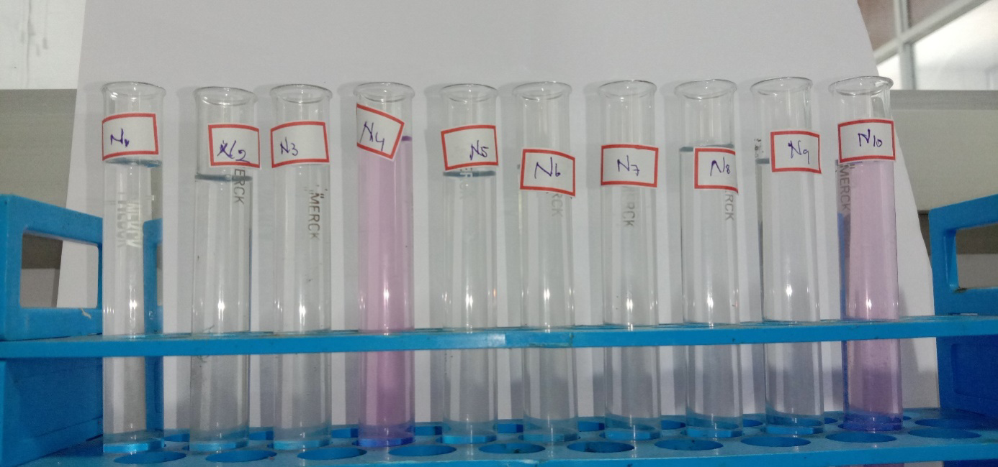

Fig.2.2. NORTH CHENNAI ZONE SAMPLES

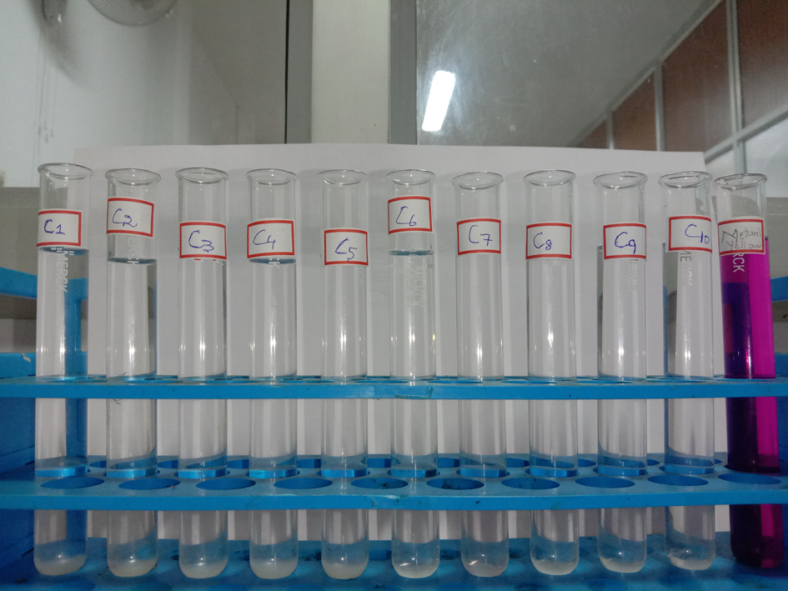
Fig.2.3. CENTRAL CHENNAI ZONE SAMPLES

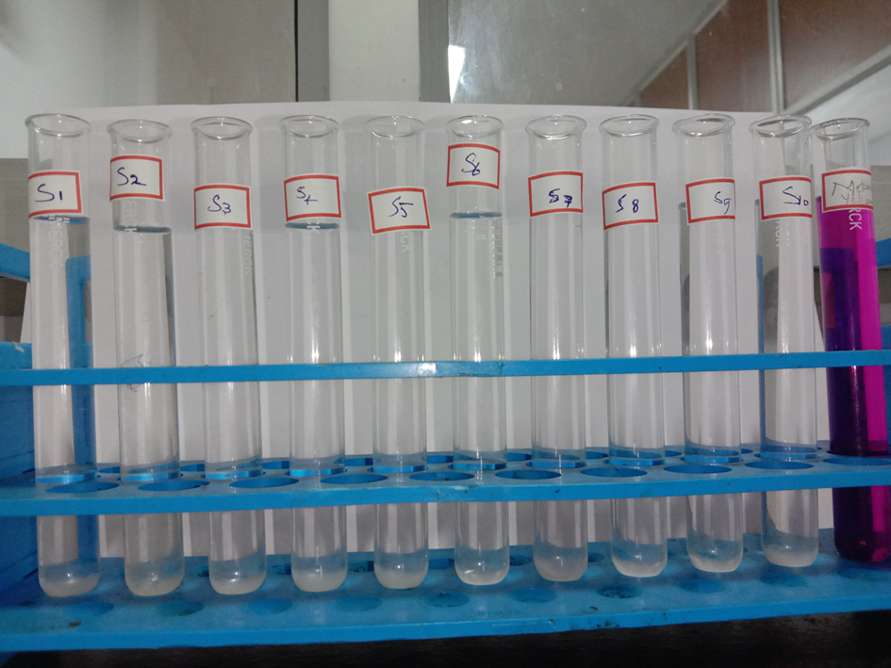
Fig.2.4. SOUTH CHENNAI ZONE SAMPLES

PROCEDURE FOR LABORATORY TEST FOR PRESENCE OF METANIL YELLOW

- 2g of Sample of Toor dal is taken in a test tube
- 2g of Con.HCL acid is added to it
- Then, 2g of Dist. Water is added to it
- It is then shaken well
- If there is the presence of Metanil yellow the solution turns into a pink colour.
- Each sample is tested using this method.

ADULTERATED | NON-ADULTERATED
6.6% | 93.4%

III. RESULT AND DISCUSSION:
Percentage of market Toor dal samples sold with Metanil Yellow is depicted below:

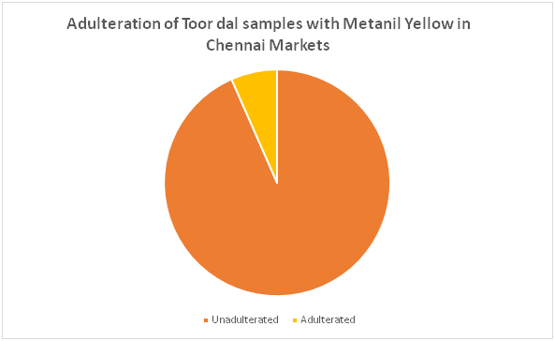
Fig.3.1 Pie Chart of Toor dal samples

The UV-Visible Spectroscopic analysis also shows the presence of Metanil yellow in samples N4 and N10. The peaks are shown in a graphical representation. Fig.3.1 represents peak of pure Metanil yellow dye. Fig 3.2,3.3 shows the presence of Metanil yellow dye in the adulterated samples.

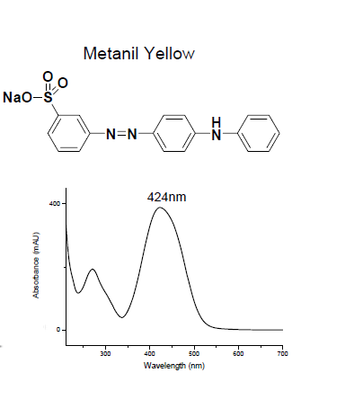
Fig.3.2 Metanil yellow peak

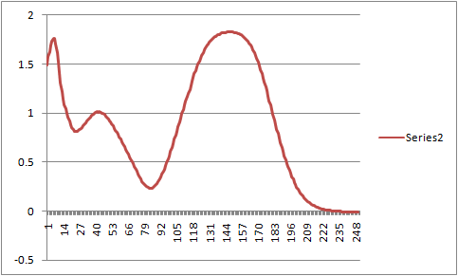
Fig.3.3.sample N4 peak

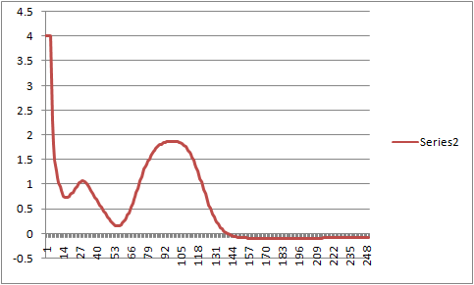
Fig.3.4.sample N10 peak

DISCUSSION
The UV-Visible spectroscopic analysis has proved the presence of Metanil yellow dye in two of the collected Toor dal samples. The Metanil yellow is an azo dye which affects the Central nervous system in humans on consumption. Out of thirty samples of Toor dal collected only two samples were adulterated using Metanil yellow dye. These two samples N4 and N10 are reportedly collected from the markets of North zone of Chennai. The Metanil yellow can also affect the Gastrointestinal tract of humans on consumption

CONCLUSION
Quantification of positive samples resulted in presence of Metanil yellow expressed as ppm:
S1 = 8.8ppm (8.8mg/Kg)
S2 = 5.99ppm (5.99mg/Kg)
On analysis for Adulteration of Toor dal sample in Chennai market reveals a very positive trend of more than 93.4% of samples being adulterated. However, 6.6% samples which were found to be adulterated with Metanil yellow dye. The adulterated range of Metanil yellow is between 5.99ppm to 8.8ppm is a cause of concern. The Food safety and Food Authority of India and Stakeholders of Food business need to create more awareness to prevent colour Adulteration in Food products. Due to the large consumption of Toor dal by a majority population and unavailability it is subjected to Adulteration. Adulteration of Toor dal with Metanil yellow increases its physical appeal in the markets. The UV-Visible spectrophotometer is effective in finding the presence of unknown compounds adulterated in foods. Only a very few samples of Toor dal present in market is subjected to Adulteration. Several studies reveal that the Metanil yellow can cause some serious damage to Human health on consumption.

FUTURE RECOMMENDATIONS

Clinical trials using animal and human models can be used to evaluate the efficacy of Metanil yellow dye on consumption. Preferred values of Metanil yellow can be added to Food products to enhance the colour of food products so that it may not affect the health.

BIBLIOGRAPHY

- Ghosh D, Singha PS, Firdaus SB, Ghosh S. Metanil yellow: The toxic food colorant. Asian Pac. J. Health Sci., 2017; 4(4):65-66.
- SagarDhakal, Kuanglin Chao, Walter Schmidt, Jianwei Qin, Moon Kim and Diane Chan. Evaluation of Turmeric Powder Adulterated with Metanil Yellow Using FT-Raman and FT-IR Spectroscopy. United States Department of Agriculture/Agricultural Research Service, Environmental Microbial and Food Safety Laboratory, 2016.
- Mara Eliza dos Santos, Ivo Mottin Demiate, Noemi N. Simultaneous determination of Tartrazine and sunset yellow in food by UV-Visible spectrophotometer and multivariate calibration methodology. Food Science and Technology, 3: 23-25, 2010.
- (FDA 1995, 2000 and USDA/FSIS 1999).
- Lakshmi V. Food Adulteration. Journal of SIT 1(2): 106-113, 2012.
- NeniIsnaeni. Metanil Yellow Reference Substance Characterization by Using Infrared and UV-Vis Spectrophotometry, TLC, and HPLC-DAD. National Quality Control Laboratory of Drug and Food (PPPOMN), Food and Drug Administration, 2020
- Ankleshwaria N. and Shah, S.R. A study on the awareness pertaining to the use of safe edible food colours amongst Indian Housewives. Applied Nutrition. 24 (2): 21-27, 1999
- Babu S, Shenolikar IS. Haeath and Nitritionalomplications of food colours. Journal of Med Res 102: 245-249, 1995
- Lancaster Frank E., Lawrence James F. Thermal decomposition of food colors amaranth, sunset yellow FCF and tartrazine in the presence of sucrose and glucose. Food Additives and contaminants, 5(4): 295-303, 1986
- MeenakshiTripathi, Subhash K. Khanna, Mukul Das. Surveillance on use of synthetic colours in eatables vis a visrevention of Foodadulterant Act of India, food Control, 211-219, 20017.
- Nital A. Zatar. Simultaneous determination of seven synthetic watersoluble food colorants by Ion-pair Reversed-phase High-performance Liquid chromatography. Journal of food technology, 5(3): 220-224, 2007.

