Basic Extraction and Fractionation Procedures for Experimental Purposes of Medicinal plants
Ria Bhar¹*, Amit Gamit²

¹Department of Biotechnology, School of Life Science and Biotechnology, Adamas University, Kolkata, India.
²ICAR-IVRI, ERS, Kolkata-700037

*Corresponding Author
Address for Correspondence:
E-mail addresses: bhar.riya89@gmail.com (R.Bhar)

Abstract:
The initial and most critical stage in achieving high-quality research outcomes is the preparation of medicinal plants for experimentation. Before conducting the intended biological tests, it is essential to extract and assess the quality and quantity of bioactive components. This study's primary objective was to assess the various techniques employed in our routine research for the production and screening of medicinal plants. While extracts, bioactive fractions, or compounds from medicinal plants find various applications, the methodologies used to obtain them are often similar, regardless of the intended biological testing. Key factors in obtaining potent bioactive compounds include selecting an appropriate solvent, utilizing various extraction methods, conducting phytochemical screening, employing fractionation techniques, and utilizing identification procedures. The choice of these treatments and their specific approaches are entirely influenced by the research design. Extraction of medicinal plants commonly involves the use of polar solvents such as water and alcohols, intermediate polar solvents like acetone and dichloromethane, and nonpolar solvents including n-hexane, ether, and chloroform. Extraction techniques encompass maceration, digestion, decoction, infusion, percolation, Soxhlet extraction, superficial extraction, ultrasound-assisted extraction, and microwave-assisted extraction. Phytochemical substances can be further separated and purified through various chromatographic methods such as paper chromatography, thin-layer chromatography, gas chromatography, and high-performance liquid chromatography. Ultimately, other techniques like nuclear magnetic resonance spectroscopy, infrared spectroscopy, ultraviolet spectroscopy, and mass spectroscopy are employed for molecule identification. These diverse approaches can be categorized and elucidated based on their relevance to expected biological tests, providing guidance and focus for aspiring researchers.
Keywords: Crude extract, Fractionation, Distillation, Separating funnel, Evaporation,
Introduction:
Medicinal plants can be prepared for experimentation or extracted and processed for direct use as herbal or conventional medicine. Preparing a medicinal plant for experimental purposes includes timely and proper plant collection, expert authentication, appropriate drying, and grinding. The bioactive element is subsequently removed, separated, and isolated as needed.Medicinal plants can be prepared for experimentation or extracted and processed for direct use as herbal or conventional medicine. Preparing a medicinal plant for experimental purposes includes timely and proper plant collection, expert authentication, appropriate drying, and grinding. The bioactive element is subsequently removed, separated, and isolated as needed. In cases involving significant side effects and drug resistance, herbal medicines can serve as a viable alternative to conventional medication. The process of extracting medicinal plants involves the isolation of active plant components or secondary metabolites, such as alkaloids, flavonoids, terpenes, saponins, steroids, and glycosides, from inert or inactive components. This is accomplished using the appropriate solvent and extraction techniques. Medicinal plants rich in phenolic and flavonoid compounds have demonstrated antioxidant properties and are therefore employed in the treatment of age-related conditions like Alzheimer's disease, Parkinsonism, anxiety, and depression (25). The choice of extraction procedure depends on several factors, including the type of plant material, solvent selection, pH, temperature, and solvent-to-sample ratio. Additionally, the intended use of the final products plays a crucial role in determining the optimal extraction method. This research aimed to compare various aspects, including extraction solvents, methods, fractionation, purification techniques, phytochemical screening, and the identification of bioactive compounds in medicinal plants.
Isolation of plant materials by extraction:
Using a mechanical grinder, coarse powder was created from the dried barks. 20 grams of dry powder were extracted using a magnetic starring machine in 200 ml of organic solvents at 50–60°C, including acetone and methanol. For 48 hours, the extractions went on as usual. The extracts were removed from the solvents using a rotary evaporator, and the resulting crude extracts were kept in sterile amber-colored vials kept at 4°C in a refrigerator until further investigation.
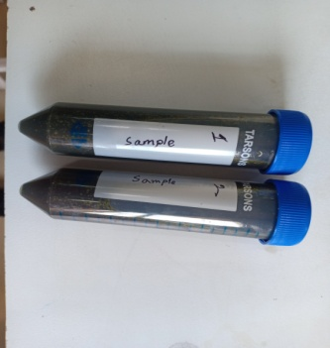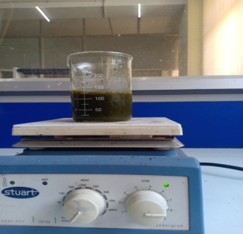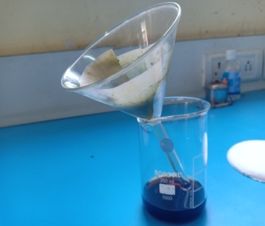
Figure 1: Plant dry Extract Figure 2: Mixed by magnetic Figure 3: Filtration
starring machine
Separation by Fractional Distillation:
The distillation separation method can be used to extract a combination of solids in a liquid. The liquid is heated to create vapours, which are then condensed to create the liquid once more. The liquid that comes from vapour condensation is known as the distillate. Two miscible liquids, like ethanol and water, can be mixed to form a solution. Immiscible liquids do not combine well. Take the contrast between oil and water. Any two liquids that are miscible in any feasible ratio with each other are called binary mixtures. This technique is used to separate the constituents of a combination of two miscible liquids that may be heated without disintegrating if there is a sufficient difference in their boiling points (B.P.). A volatile substance evaporates when heated, but it can be reconstituted by cooling the vapours and condensing them (https://www.geeksforgeeks.org/separation-by-fractional-distillation/).
Fractional Distillation:
To separate miscible liquids that are naturally volatile, fractional distillation is performed. These liquids' boiling points are reasonably near. To mimic the separation, fractionating column equipment is employed. Since the vapor is partially condensed and then returned as a liquid, it is sometimes referred to as rectification. It consists essentially of vaporizing a liquid combination to produce a mixture of elements, which is then followed by the extraction of the desired constituent in its purest form.
Fractionating Column:
The equipment employed in this method deviates from the one utilized in regular distillation due to the inclusion of a fractionating column positioned between the distillation flask and the condenser. A typical fractionating column consists of a tube packed with glass beads. The presence of these beads allows for the vapor to undergo multiple cooling and condensation cycles.
The partial condensation of the vapour takes place in a fractionating column during the distillation of the liquid mixture.
vapour from the still that is moving up the column interacts with condensing vapour that is returning to the still. As a result, the more volatile component becomes more enriched in the vapour(1, 9).

Separating Funnel:
When two immiscible liquids need to be separated, a separating funnel is utilized. This unique funnel has a stop-cock in the stem that controls the flow of liquid into or out of it. The separating funnel's ability to separate two immiscible liquids is determined by the various densities of the composing liquids. The lighter liquid stays on top, while the heavier liquid sinks to the bottom.
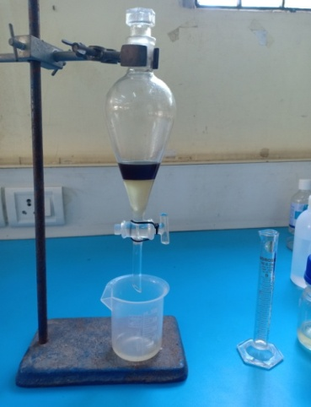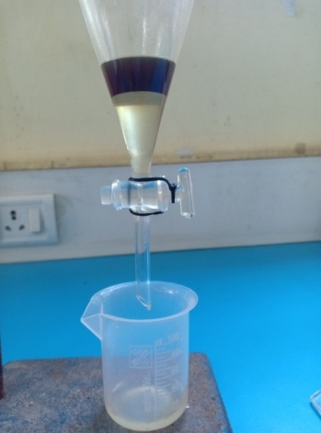
Figure 4:Separating funnel Figure 5:Separated between two immiscible liquid phases.
A separating funnel is used to divide a combination's ingredients into two immiscible liquid phases. One phase is an aqueous phase, and the other is an organic solvent phase. This separation is based on the disparities in densities of the liquids. The denser liquid is found in the upper layer, while the denser liquid is found in the lower layer.
When the mixture is introduced into a separation funnel, the liquid possessing the lower density rises to the upper layer. Upon opening the tap, the liquid with the higher density starts flowing into a separate container through the separation funnel. As soon as the liquid with the lower density starts to pass through, the tap is promptly closed. The two non-mixable liquids can then be segregated by transferring the remaining liquid with the lower density from the separation funnel into a fresh container (1, 5, 9).
Application:
The following mixes can be separated using fractional distillation:
- Acetone and water
- Chloroform and benzene
- Separation of gases of air
Applications of Separating Funnel:
- Removing kerosene and water from a combination.
- separating a gasoline and water combination.
- nut or mustard oil derived from water.
- Chloroform, benzene, mercury, and carbon disulfide from water
Table 1: Difference between Simple Distillation and Fractional Distillation:
Simple Distillation | Fractional Distillation
To separate mixtures of miscible liquids with sufficiently substantial differences between their boiling points, simple distillation is utilized. | When there is little variation between the boiling points, fractional distillation is used.
It comprises of a condenser, two flasks, and a simple equipment. | It is made up of more complicated machinery with a fractionating column.
Example: To purify seawater | Example: Crude oil refining
Separation by Evaporation:
Evaporation is the process of taking a substance that has dissolved in water and extracting it. The idea behind the application is that liquids evaporate more quickly than solids. During evaporation, the solid substance is eliminated and left as a residue. It is a method of vaporization where the liquid transforms into the gaseous phase and leaves behind surface residue. Up until the point of equilibrium, evaporation continues. However, in an enclosed space, a liquid will not stop vaporizing until air saturation is achieved. In actuality, only a tiny percentage of molecules possess the thermal energy required to evaporate. (https://www.geeksforgeeks.org/separation-by-fractional-distillation/).
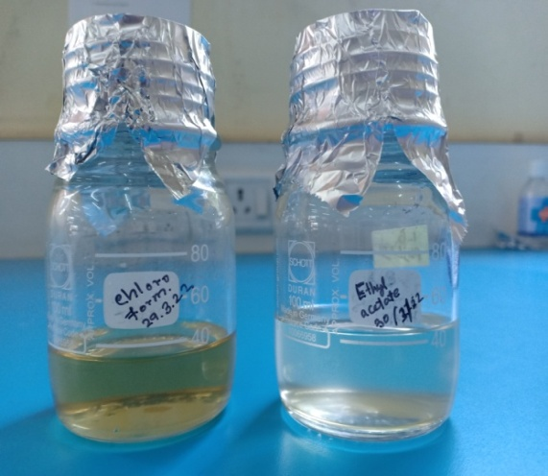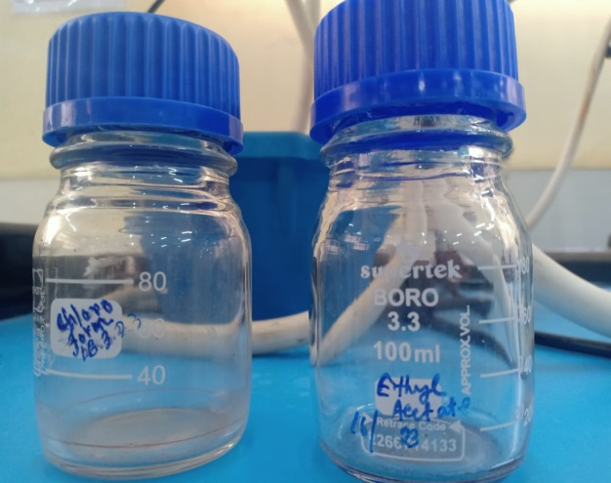
Figure 6: Mixture of a solid dissolves Figure 7: Only solid remains
in a liquid

Conclusion:
Many studies on medicinal plants have been conducted, either to look into and support a claim of biological activity or to replicate its historic medical use based on ethnomedical survey. Successfully extracted, fractionated, and isolated chemicals from numerous therapeutic plants. Additionally, the produced compounds were examined for biological or pharmacological action, and they were typically found to be active. The accuracy, with which solvents are chosen, methods are chosen and executed, phytochemical screening, fractionation, and identification procedures are used, however, determines the rate of success and the reliability of these findings. Finally, proper comprehension and use of these tactics is required. The research process will be sped up and the final product will be improved if these strategies are improved and adjusted on a regular basis.
Acknowledgments: This work was supported by a grant of the Adamas university seed grand letter no. AU/R&D/SEED/28/03-2020-21.
Reference:
1. Ingle K.P, Deshmukh A.G, Padole D.A, Dudhare M.S, Moharil M.P, Khelurkar V.C. Phytochemicals: Extraction methods, identification, and detection of bioactive compounds from plant extracts J Pharmacogn Phytochem. 2017; 6:32–6.

2. Azwanida N.N. A review on the extraction methods uses in medicinal plants, principle, strength, and limitation Med Aromat Plants. 2015; 4:196.

3. Pandey A, Tripathi S. Concept of standardization, extraction, and pre-phytochemical screening strategies for herbal drug J PharmacognPhytochem. 2014; 2:115–9.

4. Doughari J. H, Venketeshwer R. Phytochemicals: Extraction methods, basic structures, and mode of action as potential chemotherapeutic agents, phytochemicals––a global perspective of their role in nutrition and health A Global Perspective of Their Role in Nutrition and Health.2012.

5. Sasidharan S, Chen Y, Saravanan D, Sundram K. M, Yoga Latha L. Extraction, isolation and characterization of bioactive compounds from plants’ extracts Afr J Tradit Complement Altern Med. 2011;8:1–10.

6. Rungsung W, Ratha K.K, Dutta S, Dixit A.K, Hazra J. Secondary metabolites of plants in drugs discovery World J Pharm Res. 2015;4:604–13.

7. Sofowora A. The present status of knowledge of the plants used in traditional medicine in western Africa: A medical approach and a chemical evaluation J Ethnopharmacol. 1980; 2:109–18.

8. Rimando A.M, Olofsdotter M, Dayan F.E, Duke SO. Searching for rice allelochemicals: An example of bioassay-guided isolation Agron J. 2001;93:16–20.

9. Das K, Tiwari R.K, Shrivastava D.K. Techniques for evaluation of medicinal plant products as antimicrobial agents: Current methods and future trends J Med Plants Res. 2010;4:104–11.

10. Altemimi A, Lakhssassi N, Baharlouei A, Watson D.G, Lightfoot D.A. Phytochemicals: Extraction, isolation, and identification of bioactive compounds from plant extracts Plants. 2017; 6:42.

11. Majekodunmi S.O. Review of extraction of medicinal plants for pharmaceutical research MRJMMS. 2015; 3:521–7.

12. Tiwari P, Kumar B, Kaur M, Kaur G, Kaur H. Phytochemical screening and extraction: A review Int Pharm Sci. 2011: 1:98–106.

13. Cowan M.M. Plant products as antimicrobial agents Clin. Microbiol Rev.1999;12:564–82.

14. Bhan M. Ionic liquids as green solvents in herbal extraction Int J Adv Res Dev. 2017;2:10–2.

