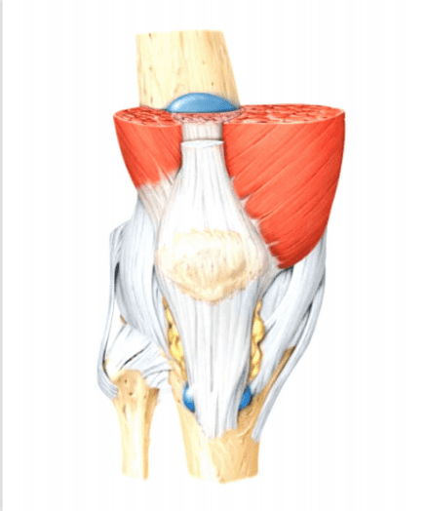
JOINTS

  - PREFACE-
- Introduction to joints
- Classification of joints
- Types of movement
- Structure of joints
- Disorders of joints

1.2 INTRODUCTION
A part of the body that allow the movement by connecting two or more bones. Except for the hyoid bone in the throat, every bone in the body connects to another bone at a joint. The function of a bone determines its shape. It is either called as an articulation.
Greater movement of the joints leads to the higher risk of injury and reduced strength.
CLASSIFICATION OF JOINTS-
The number of joints depends on sesamoids ( bone embedded within the tendon or a muscle).
Joints are mainly classified structurally and functionally. Structural classification is determined how the bones connect to each other, while functional classification is determined by degree of movement between the articulating bones.
Clinical and numerical classification:
- Monoarticular- concerning one joint
- Oligoarticular or pauciarticular- concerning 2-4 joints
- Polyarticular- concerning 5 or more joints
STRUCTURAL CLASSIFICATION (BINDING TISSUES)
Structural classification divides according to the type of binding tissues that binding tissue that connects the bones to each other, there are four structural classification of joints.
- Fibrous joints- here the connective tissues are rich with collagen fibers, they are dense and irregular.
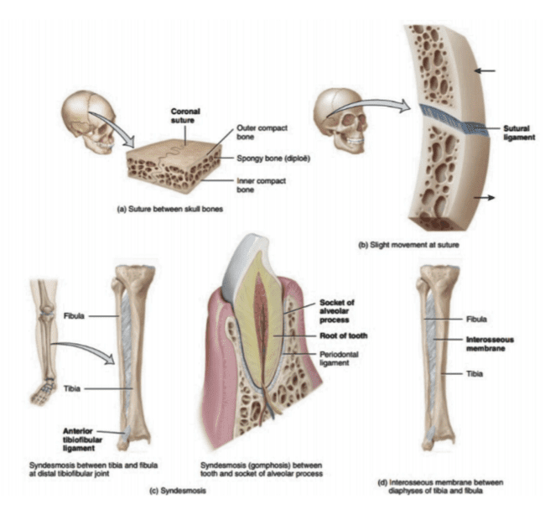
Fig 1. The presence of fibrous joints

- Cartilaginous joint- joined by cartilage. There are two types:
- Primary cartilaginous joints composed of hyaline cartilage.
- Secondary cartilaginous joints composed of hyaline cartilage covering the articular surface of the involved bones with fibrocartilage connecting them.
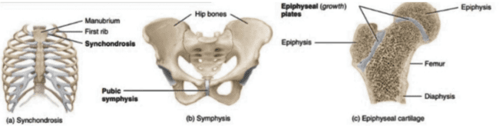
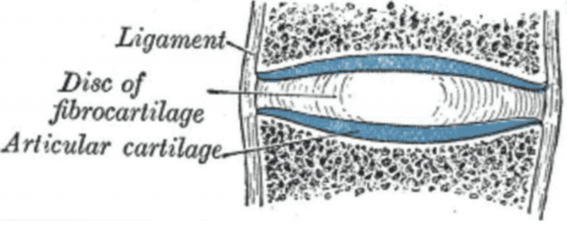
Fig 2. Structure and presence of cartilaginous joints and the structure of vertebral disc.
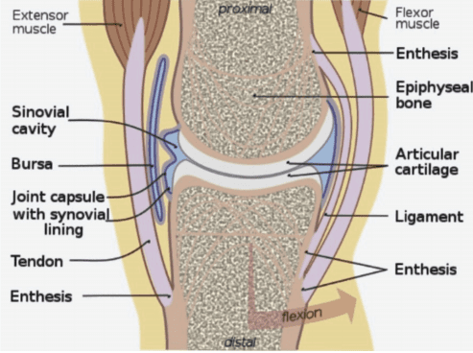
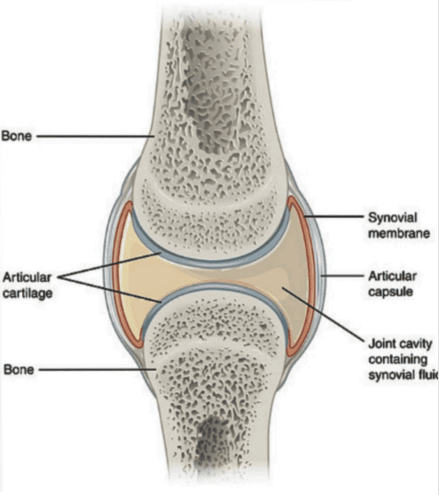
- Synovial joint- not directly joined- the bones have synovial cavity and are united by the dense irregular connective tissue that forms the articular capsule that is normally associated with accessory ligaments.

Fig 3. Structure of synovial joints
- Face joint- joint between two articular processes between two vertebrae.

FUNCTIONAL CLASSIFICATION (MOVEMENT)
Joints are classified functionally according to the type and degree of movement they allow; joint movement are described with reference to the basis anatomical planes.
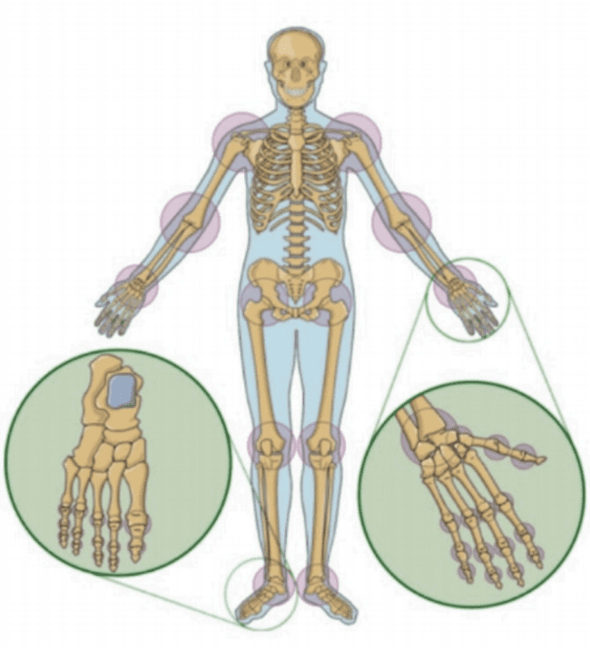
Fig 4. Presence of joints according to anatomical classification.

Based on the allowance of the movement joints are broadly classified into three classes this include as follows:
- Immovable- no movement occur in such joints because they are in close contact with each other. This are fibrous joints
- Slightly movable- this type of joints permit very little or restricted movement in which they are held together tightly. This allows the body to twist, or bend to front, back, or side e.g. intervertebral disc.
- Freely movable or synovial joint- most of the joints in human body are of this type. Hence the main purpose of joint is motion.
TYPES OF FREELY MOVABLE JOINTS:
The following are the six different categories of freely moveable joints:
- Ball and socket joint- Joint in which head of the bone fits within the socket of the another bone, this include hip joint or shoulder joint. Movement in all direction is allowed.
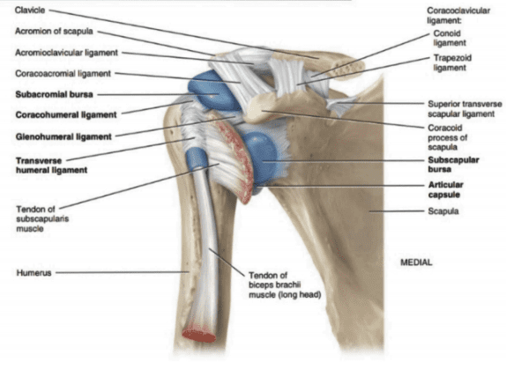
Fig 5. Ball and socket joint in shoulder

- Saddle joint- this permits the movement back and forth and from side to side, but doesn’t allow rotation, such the joint at the base of the thumb.
- Hinge joint- This involves unidirectional opening and closing of the two bones in one plane e.g. knee and elbow joints.
- Condyloid joint- this permits movement without rotation, such as the joint between the first and second vertebrae in the neck.
- Gliding joint- or plane joint. Smooth surfaces slide over one another, permitting a certain amount of movement, like the wrist joints.
- Pivot joint- one bone swivels around the ring formed by another bone, such as joint between the first and second vertebrae in the neck.
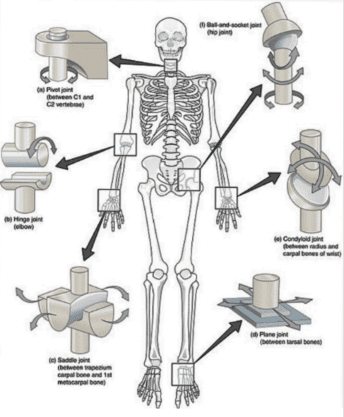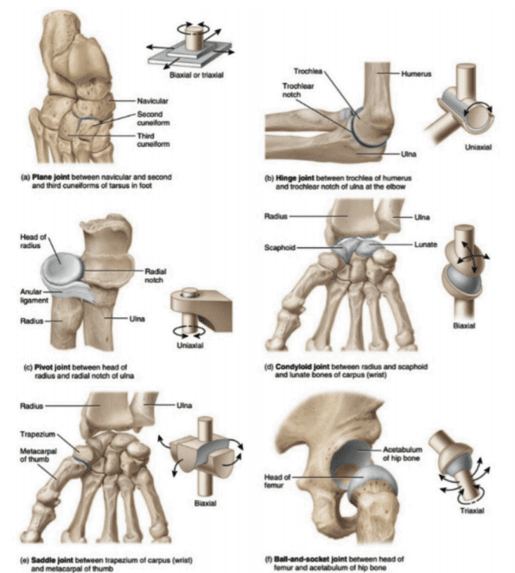
Fig 5a. The structure of different types of synovial joints.

CLASSIFICATION BASED ON NUMBER OF AXES
- Monoaxial (uniaxial)
- Biaxial
- Multiaxial
CLASSIFICATION BASED ON THE NUMBER AND SHAPES OF THE ARTICULAR SURFACES:
- Flat surface
- Concave surface
- Convex surface
BIOMECHANICAL CLASSIFICATION-
Depending on the number of the bones the joints are anatomically classified as follows-
- Simple joint: joint involving two articulation surfaces (e.g. shoulder joint, hip joint)
- Compound joint: three or more articulation surfaces (e.g. radiocarpal joint)
- Complex joint: an articular disc or meniscus, two or more articulation surfaces (e.g. knee joint)
JOINTS may be anatomically classified into following groups:
- Joints of the hand
- Elbow joint
- Wrist joint
- Axillary joint
- Sternoclavicular joints
- Vertebral articulations
- Temporomandibular joints
- Sacroiliac joints
- Hip joints
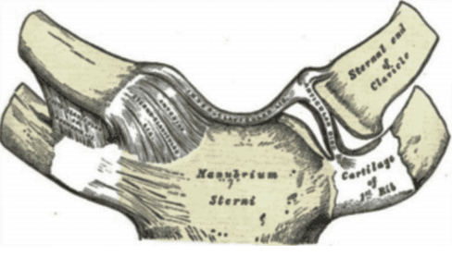
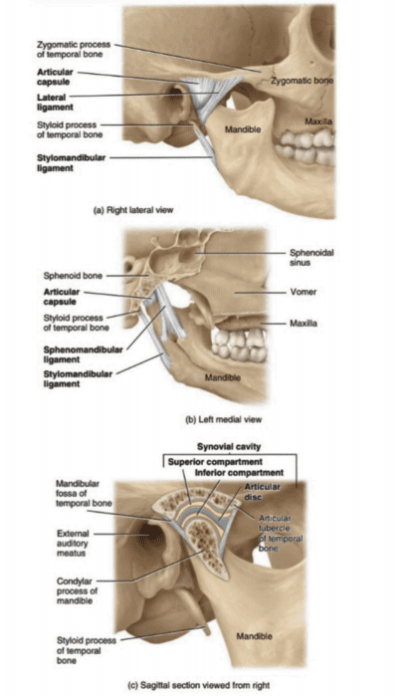
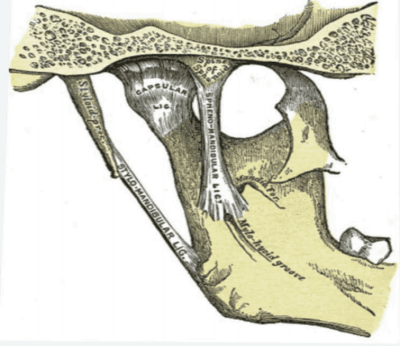
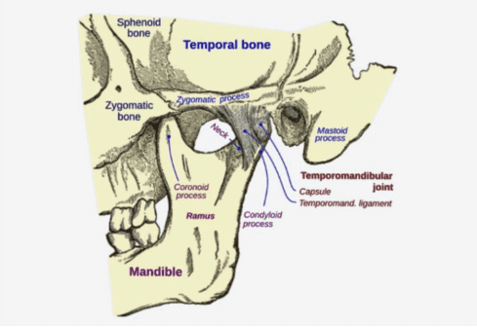
- Knee joints or tibiofemoral joint
d.
a.

b.

c.
Fig 6: a. Temporomandibular joints, b.Temporomandibular inner view, c. Strenoclavicular joints, d. Joints present in the jaw.

NOTE- Unmyelinated nerve fibers are abundant in joint capsules and ligaments, as well as in the outer part of the intra-articular menisci. This nerve fibers are responsible for pain perception when a joint is strained.
TYPES OF MOVEMENT
To achieve movement, the joint may:
- Change the angle between the bones
- Sliding of the two different surfaces on each other
- No displacement of the bone from location only has rotatory motion.
TYPES OF MOVEMENT IN SYNOVIAL JOINT
- Gliding- simple movement in which nearly flat bone surfaces move back and froth and from side to side with respect to one another.
- Angular movements- increase or decrease in the angle between articulating bones, these movements are limited in the range due to the structure of the articular capsules and associated with ligaments and bones.
- Flexion, Extension, Lateral Flexion, and Hyper- extension- flexion and extension movements are opposite movements, in flexion there is decrease in the angle between articulating bones; extension (stretch out) increase in the angle between articulating bones often used to restore the body postures.
- Abduction, Adduction, and Circumduction-
Abduction- radial deviation is the movement of the bone away from the midline.
Adduction- it is a type of the movement were the bone moves near the midline, also called as ulnar deviation.

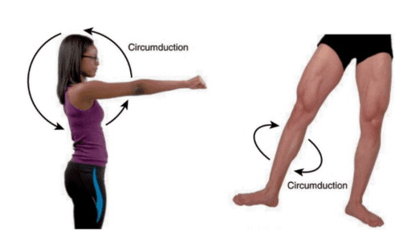
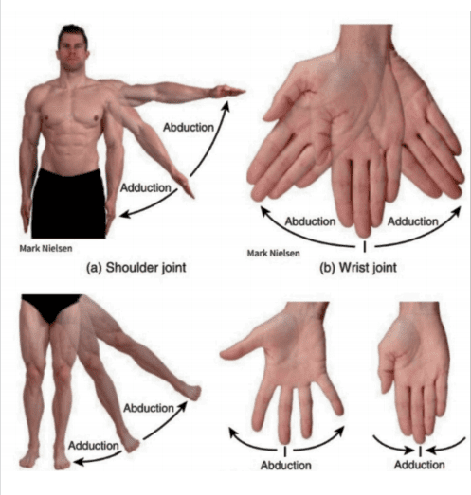
Circumduction- movement of distal end of body part in circle e.g. movement of the humerus at the shoulder point in circular motion.

Fig 7. The abduction and adduction and circumduction.
- Depression- inferior movement of part of the body, such as opening the mouth to depress the mandible or returning of shrugged shoulders back to its position.
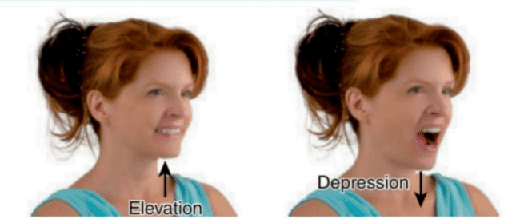
Fig 8. Elevation and Depression
- Protraction- movement of the part of the body anteriorly in the transverse plane. Its opposite movement is retraction.
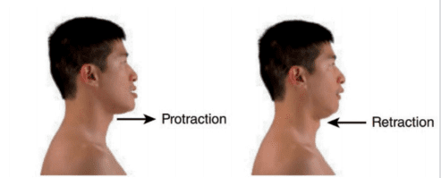
Fig 9. Protraction and Retraction
- Inversion- movement of the sole medially at the intertarsal joints (between the tarsals). Its opposing movement is called as eversion.
- Eversion- movement of the sole laterally at the intertarsal joints.
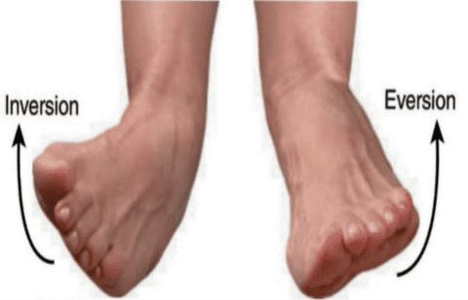
Fig 10. Inversion and Eversion.
- Dorsiflexion- bending of foot at the ankle or talocrural joint (between the tibia, fibula and talus) in the direction of dorsum (superior surface), this occurs when you stand on your heels. Its opposing movement is plantar flexion.

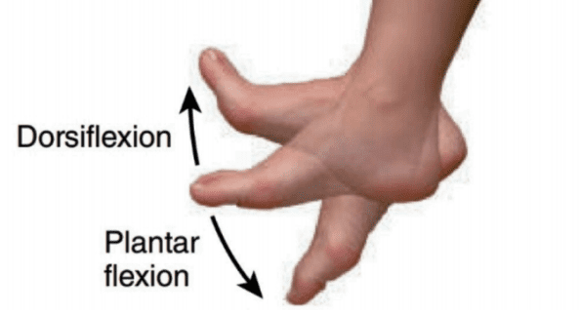
Fig 11. The movement of Dorsiflexion and plantar flexion.
- Plantar flexion- bending of the foot at the ankle joint in the direction of the plantar or inferior surface.
- Supination- movement of forearm at the proximal and distal radioulnar joints in which the palm is turned anteriorly.
- Pronation- movement of forearm at the proximal and distal radioulnar joints in which the distal end of the radius covers over the distal end of the ulna and palm is returned to posteriorly.
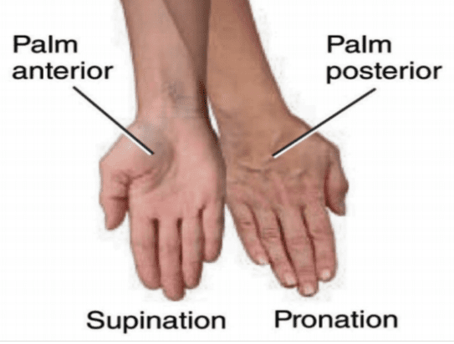
Fig 12. The movements of Supination and Pronation
- Opposition-the movement of the thumb at the carpometacarpal joint (between the trapezium and metacarpal of the thumb) in which thumb moves across the palm to touch the tips of the fingers on the same hand.
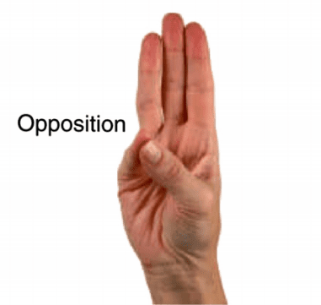
Fig 13. The movement in opposition.

STRUCTURE OF A JOINT

Ligaments are the tough connective bands that hold the joints. Smooth cartilage prevent friction as the bones move against one another one another.
Tendons are the structure which are thick and tough that connect the the muscle to bone.
DISORDERS OF JOINTS

- Arthritis- inflammation that causes stiffness and pain in the joints ( rheumatoid arthritis or gout) or degeneration (osteoarthritis)

- Osteoporosis- a condition in which bones become weak and brittle, this is usually caused due to low intake of calcium.

- Osteoarthritis- degenerative disorder of joints, usually accompanied by pain and stiffness. It causes great pain and discomfort to large population and effects both male and female.

- Bursitis- inflammation of the bursae (fluid filled sacs that cushion and pad bones)

- Tendonitis- inflammation, irritation and swelling of a tendon that is attached to the joint.

- Ankylosing Spondylitis- disease of spine in which there is gradual loss of mobility in the joints between the vertebrae. It mainly occurs in the male between the ages of 20 and 40.

- Gonococcal arthritis- it is an infection of joints, tendons and muscles that occurs in those suffering from gonorrhea. Usually women are more affected than men and this occurs at the age of 30.

- Gout- it is a chemical defect which causes the accumulation in the bloodstream of the waste product of metabolism also known as uric acid. Deposition of uric acid in the skin, joints and kidneys.

- Juvenile Rheumatoid Arthritis (JRA)- refers to childhood arthritis for children under the age of sixteen affected by inflammatory arthritis.

QUESTIONS
5 marks-
- Define joints and classify them with examples?
- Write the different types of movements occurring in the synovial joint?

2 marks-
- Define osteoporosis and arthritis?
- What is gout?
- Write in general about the structure of joint?
- Classify joints based on movement?
- Define the following:
- Ball and socket joint.
- Hinge joint.
- Pivot joint

