Study of Climate Change Impact on the Global Food Supply

DaljeetKaur Husnara Khan
Department of Computer Science Department of Computer Science
Gyan Ganga College of Technology Gyan Ganga College of Technology
Jabalpur, M.P, India - 482002 Jabalpur, M.P, India - 482002
Email: daljeetkaurkalsi83@gmail.com Email: husnarakhn@gmail.com

ABSTRACT

India is under pressure to reduce its GHG (Greenhouse Gas) emissions into the atmosphere as a result of its climate change. The industrialized world bears the majority of the responsibility for reducing greenhouse gas emissions, even though it is anticipated that developing nations will contribute an increasing share of future emissions. The impact would be particularly severe in tropical areas, where developed countries like India.I. The effects of greenhouse gas emissions on climate change are currently worsening than we could have predicted ten years ago. India, a developing nation, was unable to implement any strategies due to its focus on social and economic growth. In the western Liaoning Province, which is in the northern hemisphere, this research focuses on examining the energy resources and precipitation trends in the context of global warming over the past 60 years.

INTRODUCTION
Given that India is a subcontinent, the effects of climate change must be considered globally. Climate change poses problems for, among other things, production of food, supply of water, coastal communities, ecosystems of forest, health, and energy related security. Despite the fact that climate change is a global problem, we are facing pressure because of how seriously it affects us. India, a developing country, is now believed to be able to offer a worldwide answer to this issue. Lessening the impact of changes in climate on our planet is now required. India has the ability to provide substantial mitigation at an affordable price. This work captures an additional risk to India. Even while conversations on decreasing GHGs among various industrialized nations have not led to the intended results, action is being taken to address the problem related to climate change. India currently carries a sizable share of the responsibility for cutting GHG and CO2 emissions. The need to use green technologies across its industrialized nation is growing in India. Many environmentalists have volunteered their time to assist with the "Green Revolution" that is taking place in the industrialized world. They failed to secure the backing of their superiors or the Indian political system, therefore their attempts were ineffective. Climate change is influenced by natural variables, including variations in the world's temperature or human actions. production of food for humans. Climate change describes substantial, ongoing are the implications and views on change in climate from the Indian context point of view. Changes in climate may be a threat climatic changes on a worldwide scale.
Climate change might stymie efforts towards a hunger-free society. A strong and consistent global pattern can be seen in the effects of changes in climate on productivity of crops, which can affect availability of food. The stability of healthy food systems can be threatened by short-term fluctuations in supply due to climate change. However, the potential impacts are less clear at the regional scale, but it is likely that climate change and change will worsen food security in areas that are currently vulnerable to hunger and malnutrition. It can also be assumed that the loss of drinking water availability and health risks can weaken the indirect spillover effects of food availability and use on household and individual persons incomes and consumption of food. Evidence supports the need for major investment in adaptation and mitigation initiatives to develop a "climate-smart food system" that is more robust to the food security implications of climate change.
Fighting against hunger is critical issues now days. Hunger has many causes and dimensions, from macronutrient and micronutrient deficiencies to short-term nutritional disorders and chronic deficiencies. The causes range from limitations in the adequate quality as well as quantity of food and the complicated linkages of diet with sanitation and infectious illnesses that contribute to poor health are exacerbated by a lack of purchasing power. Several of these factors have been addressed in recent decades, with substantial progress achieved in lowering the share of the world's undernourished population from an estimated 980 million in 1990-1992 to around 850 million in 2010-2012. (2). But other important nutritional indicators, like underweight as well as short stature in children and health studies, about 2 billion people still suffer from micronutrient deficiencies.

In this study, we examine the anticipated impacts of climate change on the world's supply food system under various scenarios for socioeconomic development in the future expressed in terms of the population and income level described by the Intergovernmental Panel on Climate Change (IPCC) in its Special Report on Emissions Scenarios (SRES). Different rates of population growth and economic development will have an impact on the degree of climate change in the future, as well as how agriculture adapts to changing climate conditions on a regional and global level. Understanding the nature of these complex systems is the study's main objective.

The agricultural sector will face numerous obstacles in the ensuing decades as a result of the expanding world population, urbanization has resulted in land degradation and farmland loss. Although global food supply has kept up with population expansion, there are substantial regional shortfalls. and close to a billion people worldwide suffer from nutritional deficiencies caused by poverty. In this century, climate change is important factor that may have an high impact on food availability and production in many regions of the world, especially those that are most vulnerable to famine and drought.

Here, we provide a summary of the evidence supporting the high impact of changes in climate on global food security, with a focus on the world's less developed regions. We purposefully take a broad view of the intricate relationships that exist between global food security and climate change, expressing what we work can be done confidence while also acknowledging areas where there is little to no evidence. We conclude by putting forth a number of guidelines for those deciding on practical or policy matters regarding the effects of climate change.

The sun, the earth, the oceans, the wind, rain, snow, forests, deserts, savannas, and human activities all contribute to the global climate. The climate of New York, for example, may be defined by yearly temperature changes, rainfall, and other elements. However, as seen in figure 1, the global climate is more than just the "average" of climates in different areas.

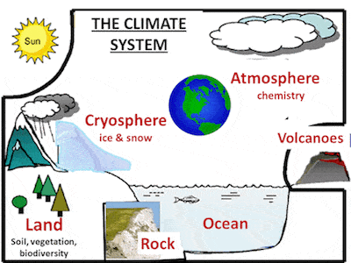
Figure-1:The Climate System

RELATED WORK

Over many centuries, ecosystems and human societies have adjusted to the rather constant Holocene climate conditions[1]. Agricultural techniques created for these conditions are the foundation of the majority of the food production[2]. There are indications that many significant crops all across the world are already being impacted by the recent, increasing global environmental change. [3] Frequently, the change shows up in a number of indicators. This also holds true for climate change, which is predicted to affect both aridity and patterns of rainfall and temperature. These crucial variables have a direct impact on society and the activities that support human life, such as maintaining water availability and food production.

Several studies have analysed the changes in agricultural circumstances caused by climate change[4] by analysing climatic conditions[5] and their possible influence on yields. However, understanding which locations may experience a really unique environment in which no major agriculture exists now, along the lines of safe operating space (SOS) and climatic niche notions for human societies, would be crucial.[6] By definition2, SOS refers to the Earth system circumstances that would allow human existence to continue as we know it. Despite the fact that the planetary boundary framework incorporates a climate change SOS.

Although the potential consequences of climate change on present livestock systems across the world are a serious problem, international publications such as those issued by the Intergovernmental Panel on Climate Change only briefly touch on the subject. We investigate the threat of climate-related consequences along the food supply chain for land-based animals in this research. Although a quantification of the net effects of climate change on the livestock sector is beyond the scope of our current understanding, there is strong evidence that there will be impacts along the entire supply chain, from farm production to processing operations, transport, retailing, storage, and human consumption [7].

Food production affects climate change, and we also clarify the impact of climate change on food production. In order to provide such an overview, we consider the relationship between different parts of the food supply chain continuum (agricultural production, processing food, animal husbandry, food transportation and storage, food waste management, food retail,) and climate change. (Reciprocal) relationships were explored through bibliometrics. analysis [8].

Food security is defined by the Food and Agriculture Organization (FAO) as "the ability to live an active and healthy life." This concept encompasses four critical factors of food supply. Stability, access, availability, and utilization are all important factors. The first dimension is the availability of adequate nourishment. H. On agricultural systems' total capacity to supply food demand. The agro climatic base of plant and pasture agriculture is one of its sub dimensions

CASE STUDY OF Climate Change Impact on the Global Food Supply

According to the United Nations Food and Agriculture Organization (UNFAO), “Food safety is at risk due to climate change, and the food system needs to be ready for the challenges that lie ahead" (FAO). According to a recent report of FAO, "Climate change: Unpacking the burden on food safety," climate change is endangering the safety of food that is obtained from both the land and the sea. The paper also describes how exposure to various food-borne dangers may rise globally.
This study concludes that climate change is directly impacting food through chemicals such as heavy metals, mycotoxins, pesticides and algae biotoxins. Like Microbiological hazards such as food borne parasites and pathogens. Further, it is also expected with climate change, to reduce the nutrition value of important staple foods by decreasing levels of micro and macro nutrients.
Malnutrition tends to reduces immunity and makes people more susceptible to food-borne diseases; combined with the increased risk of exposure to food-borne risks brought on by change in climate; this creates a dire condition that demands immediate worldwide attention. Making a circumstance. He is an FAO food safety and quality specialist, and he stated that this is significant since hazardous food not only jeopardizes people's food security and health, but also threatens national economies, livelihoods as well as international trade.
The climate has a great influence on both agriculture and fishing. Carbon dioxide (CO2) and rising temperatures may boost harvests in some areas. For these benefits to be realized, other conditions like as soil moisture, nutrient levels, and water availability must also be met. Farmers and ranchers may face difficulties as a result of changes in the frequency and intensity of floods and droughts, which might jeopardize global food security. In the meanwhile, warming waters are changing the habitats of several fish and shellfish. and the ecology might fail. In general, change in climate may make it more difficult to cultivation of crops, rear animals as well as fish in the same manner and locations. Together with other changing elements impacting agricultural productivity, the influence of climate change must be consider. A. Modifications to agricultural methods

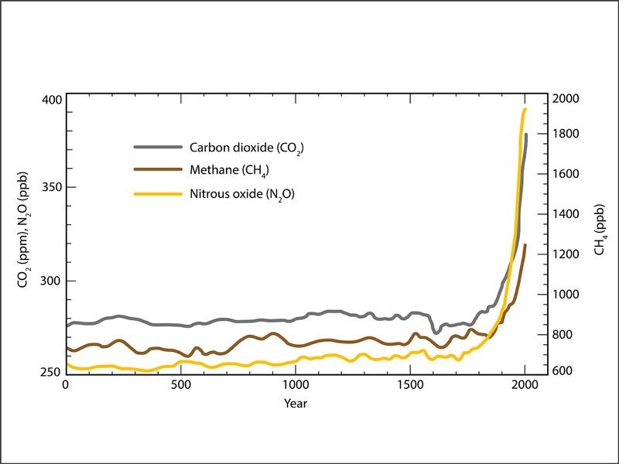

Figure 2: Change of climate impact on crops

Climate change impact on Crops

Crops grown in the United States are essential to the nation's and the world's food supply. US farmers produce around 25% of all the grains (including wheat, maize, and rice) that are sold on the international market. Changes in temperature, atmospheric carbon dioxide (CO2), and the frequency and severity of extreme weather can all have a substantial impact on crop production.
The impact of increased temperature on a given culture will vary depending on the temperature required for the culture's development and reproduction. Warming in certain areas could help the crops that are typically cultivated there or enable farmers to varies the crops that are now grown in warmer areas. Also, when temperatures rise above the crop's ideal range, yields are reduced.

Crop production can be impacted by elevated CO2 levels. Increased CO2 content has been demonstrated to improve plant growth in several lab trials. These potential production improvements, however, are hampered by other elements including temperature variations, ozone, and water and nutrient scarcity. If, for instance, temperatures are higher than what is ideal for the crop and there is inadequate water and nutrition available, yield gains may be diminished or even reversed. Decreased quality is brought on by lower nitrogen levels. Low-quality grain and feed can make pastures and rangelands less suitable for supporting livestock grazing. Precipitation and extremely high temperatures inhibit plant development. Extreme weather, especially droughts and floods, can damage crops and reduce harvests. For instance, in the U.S. maize belt in 2010 and 2012, high evening temperatures had an effect on corn output.

In locations where the soil is dried up by hotter summer temperatures, coping with drought can be difficult. The water supply may be limited in certain areas, leaving little water available for the purpose of irrigation when more is required, while in others it may be feasible to expand irrigation.
Warm, humid temperatures and high Many weeds, bugs, and fungi can thrive well in environments where CO2 levels are high. Now, American farmers spend more than $11 billion a year to eradicate weeds that rob crops of light, w nutrients and water. With climate change, it is anticipated that weeds and pests would spread and grow in size. Farmers who have never dealt with these species before may experience new crop issues as a result.

The development of plants is accelerated by increased CO2, but most crops lose some of their nutritious value. Most plant species, including wheat, soybeans, and rice, experience a decrease in protein and vital minerals as a result of elevated atmospheric CO2 levels. Potentially endangers the health of people. Due to rising insect pressure and declining pesticide efficiency, growing pesticide usage also poses a hazard to human health.As shown in Figure 2 , Impact of change in Climate on crops

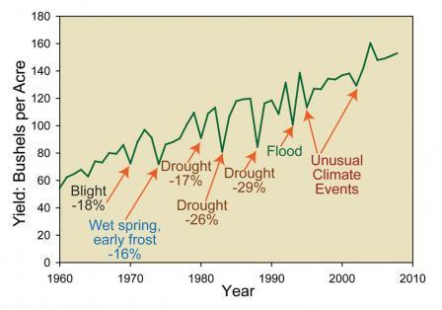
Figure 3: Impact of change in Climate on crops

Impact of climate change on Livestock

More than 36 million tones of poultry and meat are consumed yearly in the United States. More than half of stream of agricultural revenue in the United States, frequently in excess of $100 billion yearly, comes from livestock and poultry. Animals are impacted by climate change both indirectly and directly. Heat waves, which are anticipated to get worse due to climate change, might endanger animals. In 2011, a farmer lost more than $1 billion as a result of heat-related disasters. Heat stress has an effect on animals both directly and tangentially. Heat stress has the potential to decrease milk output, lower fertility, and increase illness susceptibility over time.
Droughts can pose a hazard to forage and grazing resources. The quantity of high-quality feed available to graze livestock is reduced by drought. Due to rising summer temperatures and less rainfall, certain regions may endure longer and more severe droughts. Drought-related changes in crop output can also cause issues for animals that mainly depend on grains. The incidence of illnesses and parasites that affect cattle may rise as a result of climate change. Certain parasites and diseases may find it easier to survive in early spring and mild winters. Pathogens that depend on moisture can flourish in regions with heavy rainfall.
The usage of parasitic ides and other animal health treatments to maintain the health of cattle may be increased as a result of changes in parasites, pests and microorganisms brought on by the changing environment. Due to the increased risk of pesticides entering the food chain or the development of pesticide resistance, this may have an impact on the distribution, security, and the majority of consumption of livestock and aquaculture goods.. Carbon dioxide (CO2) augmentation boosts pasture output but degrades pasture quality. The production of crops used to feed cattle can rise due to the increasing CO2 in the environment. However part of the fodder present in pastures deteriorates due to elevated CO2. Cows must thus consume more food in order to receive the same nutritional advantages.

Climate change is currently affecting food security in four ways
1. People with the lowest emissions suffer the most
Unprecedented droughts and floods are already being brought on by more severe weather conditions in emerging nations. A severe El Nio event this month alone poses a danger to Papua New Guinea's four million residents' access to water. One of the world's poorest nations is this one. In the United States, 83% of food is produced, therefore inclement weather may be terrible for food security.

2. Poor women bear the brunt of this suffering
Extreme weather conditions increase women's vulnerability to poverty since they are seen as owners of crops rather than land in many of the world's poorest nations. For instance, a flood may entirely destroy a crop but not the land on which it is grown, leaving the landowner even more penniless but maintaining his or her fortune. shall be
Moreover, women lack access to current climate knowledge. For instance, a woman managed the household finances when El Nio struck Peru in 2002, but only fishermen were informed since it would have an impact on seafood supply.

3. It affects the number of fish in the sea
A latest report by the United Nations Climate Commission found that extreme weather and sea conditions have reduced fish catches by 40-60% in some tropical regions.

4. Prices are rising, that tends to political instability
Food prices are already becoming more unpredictable globally due to decreased water availability brought on by changes in climate, as well as unpredictably occurring floods and droughts. With the increased expense of international shipping, many developing nations rely on importing food, which is particularly expensive.
Many have argued that recent political uprisings like the Arab Spring were caused by rising food costs. Political change isn't always negative, but there are hazards involved. Food price increases and the "collapse of democratic institutions" were found to be closely related in a research by the IMF that tracked food prices in the 1970s.
. The trend became worse, with the Food Policy Institute predicting that the price of certain foods such as maize and sorghum, staples of most sub-Saharan Africans, will rise by more than 100% by 2050. I'm assuming it's possible.

Impact of Climate, which affects food production now

Farmers and the wider populations who rely on them for food face several challenges as a result of change in climate. Think about the impact of the following five main climatic changes on the supply of food both now and in the future, from irregular rainfall to seasonal shifts.
There might be more harsh weather occurrences that harm livestock and crops. Farms have traditionally suffered from powerful storms. This is either due to storm-related wind damage or landslides and erosion that may continue to develop even after the storm has passed. Yet they are now more prevalent than ever. For instance, in the Midwest on the side of the United States in the spring of 2018, extremely strong rains and snowstorms created significant floods, burying some regions with almost 3m deep sand.
Farmers lost livestock worth an estimated $440 million in Nebraska alone. Several farmers have been forced to delay spring planting as a result of severe flood conditions. Farmers experience stress due to the delayed development of crops like maize and soybeans, which can also result in volatile food prices and even food insecurity.
The upkeep of crops and cattle is tough and expensive in the southern United States due to water limitations. In the western United States, a prolonged drought is anticipated because a lack of snow cover makes it more difficult to sustain reservoir levels over the summer. Lack of water may quickly ruin crops, dry up the soil and it is danger for livelihoods. As an illustration, it is predicted that California lost $3.8 billion in direct economic activity between 2014 and 2016.

The seasons have changed from what they once were. In temperate areas, the growth season begins earlier and grows hotter. Theoretically, a prolonged growing season would have certain advantages over time, but it would also present greater challenges right now. B. Pest populations might grow, increasing the number of incidences each year. Early spring can also destroy fruit trees that sprout early and then experience spring frost. It can also lead plants to flourish before the soil has received adequate water and nutrients. Other agricultural techniques, such the storing of grain, may also be impacted by warmer winters.
A farm can be destroyed by a wildfire even if the flames never reach it. Because to the intensifying wildfire season, western ranchers have recently suffered significant losses, ranging from outright fatalities to burned pastures and diminished hay stands. However, there are several "second-order consequences," such as the smokey smell that taints wine and the difficulties of maintaining a farm while surrounding fires are raging and evacuation orders are about to be issued. They all result in increased costs. Farms may be obliged to send workers home during the busiest harvest season since working in a hot, smoke-filled atmosphere is hazardous to respiratory health.
Increased CO2 levels and warmer temperatures have an influence on food availability, safety, and quality. 25–30% of the food produced globally is wasted, although not all for the same causes, according to the 2019 IPCC Land Use Report. For instance, even if it occasionally appears abandoned, customers in industrialized nations often just toss away food that they perceive to be "surplus" or "extra". Lack of refrigeration facilities in poor nations contributes significantly to waste since goods degrade between producers and consumers. According to an IPCC analysis, food waste costs around $1 trillion yearly and is responsible for 10% of the food system's greenhouse gas emissions. Over 1 billion people globally are now undernourished, while roughly 2 billion are overweight or obese, underlining the inefficiencies and injustices of current systems.

Factors-The vulnerability and sensitivity of food production systems to climate change varies by area.

Level of exposure, adaptation, and resilience, as well as geographic location, are two characteristics that affect how vulnerable and susceptible food production systems are to climate change in various places. Large losses and damages as a result of climatic shocks frequently result in disaster.

Lower degrees of adaptation make areas more vulnerable to the effects of the climate. Increasing resilience can open up more space for flexible food systems and chances to mitigate the effects of climate change. For instance, the use of seeds that are resistant to drought and flooding, better water management techniques, and advancements in postharvest technology (better drying and storage infrastructure) can significantly reduce rice losses in Southeast Asia, offsetting the decline in yields brought on by climate change. The limitations of adaptability are established by biological variables like crop heat tolerance. The 2030, 2050, and 2080/2100 climate scenarios are used to describe future climatic patterns. Based on worldwide patterns in greenhouse gas emissions and climate sensitivity, the time periods enable one to evaluate climatic consequences throughout time.
For the world's present livestock systems, climate change is a big threat. Animal health, production, and feed and water supplies are all impacted by global warming and the concomitant changes in average climatic factors. The effects of change in climate on the supply chain for animal feed are depicted in Figure 3. The linkages between actual climatic systems, exposures, and vulnerabilities that endanger cattle supply networks are depicted schematically in this diagram.

The connection between vulnerability, exposure, and the actual climate system. In order to create the risk of climate related consequences, climate-related hazards, such as hazardous occurrences and trends, interact with people's sensitivity and exposure as well as the exposure and vulnerability of natural systems. Although shifting risk patterns also play a part, socioeconomic trends and societal factors have a significant impact on determining vulnerability and exposure. Changes in the climatic system as well as in the socioeconomic processes (right), which are depicted on the left and right, respectively, are the fundamental forces behind the numerous crucial components (exposure, vulnerability and hazards) that make up risk.

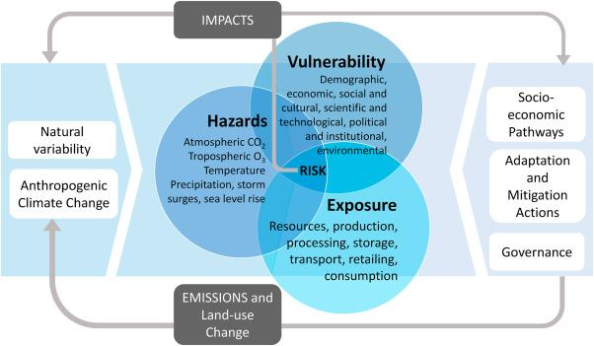

Figure 4- schematic of the interaction of the physical system of climate variation

Crop yield change estimates
Uncertainty comes from a variety of factors when estimating yield changes. At the site level, the use of crop models to estimate yield functions is a significant source of uncertainty. There are numerous simplifications built into the crop model. For instance, it is thought that pests, illnesses, and weeds are managed. absence of troublesome soil issues (such as salinity or acidity). Deposition of acid's negative effects and how this impacts yield levels have not been studied. A significant research problem continues to be the challenging and unclear assessment of the direct impacts of CO2 on agricultural crops. Although the plant model can replicate the impacts of drought, it cannot simulate the effects of flooding (Rosenzweig et al., 1999). Features may not accurately reflect the diversity of agricultural systems within similar regions when seen at a regional level.

The ability of agricultural production systems to adapt to climate change will be increased by understanding the interaction between climate and crops. To this goal, numerous studies that analyse how culture reacts to environmental conditions have been conducted, stressing also decades and climatic shifts. Climate variability, 1, 2, 3, climatic extremes, 5, 6, 7, vapour pressure hands, 8, and atmospheric CO2 concentration. Negatively, crop productivity has been impacted by extreme weather occurrences like drought, which have been trending upward 11, 12, and 13. 6, 1 . Key information for early warning and mitigation is intended to be provided through the Drought Monitoring and Prediction System. strategies. increases agricultural output and tolerance to drought15,16,17. Adaptive actions, such as shifting planting dates, switching to an existing crop type, and creating new varieties, are also taken.

Impacts on Production of food and its availability

The impact of climate change on food production and agriculture will be extensive. It influences the demand for agricultural products indirectly through effects on growth and income both indirectly through changes in agroecological conditions and immediately through distribution, which directly affect food production. Many studies have quantified effects under various assumptions (3). In quantifying factors effecting the food security, a selection of these results is shown. Below, a summary of the most significant agroecological environment changes caused by climate change is helpful.

Impact Continued greenhouse gas emissions will cause changes in precipitation and temperature, which will affect the suitability of the land and crop output. Namely, the Special Reports on Emission Scenarios (SRES) A2, B2, A1, and B1 families of emission scenarios linked to socioeconomic development have been discovered by the Change (IPCC) (4). I'm thinking about. Business as usual scenario A1 relates to the greatest emissions in the context of this review, while SRES scenario B1 corresponds to the lowest emissions. There are other possibilities between these two. SRES A2 assumes the highest projected population increase of the four (UN high projection), which is significant for agriculture and world nutrition because it is linked to the biggest food demand. Based on the possibilities for SRES emissions and the
. Area A longer growing season, better soil quality, and perhaps a larger crop yield. In some moist temperate grasslands, moderate progressive warming could boost grazing output and lessen the requirement for housing and complex feeds. The increased frequency of extreme events cancels out these improvements. B. An increase in heat waves, droughts, and floods in temperate zones or in the Mediterranean region. This may lead to a rise in coastal storms (6). Additionally, they must be compared to the likelihood that semi-arid and dry pastures may lower livestock productivity and raise animal mortality (3). Climate models project higher evapotranspiration and lower soil moisture in dry places (5, 8). As a result, some agricultural areas and other tropical grasslands may become less productive.
It is anticipated that extreme weather occurrences like droughts, hailstorms, hurricanes, and floods will become more frequent and severe, and that regional and worldwide weather patterns will become more unpredictable than they currently are (3, 8). The stability and security of the food supply can be impacted by significant variations in crop yields and regional food sources, as well as a rise in the danger of landslides and erosion damage.
Impacts of Climate Change on Food Utilization.
Climate change will have an effect on how safe food is to eat, as well as the stresses that diseases face from carriers, watery pathogens, and foodborne pathogens. IPPC Working Group II provides a comprehensive summary of the impacts of climate change on health in Chapter 8 of its Fourth Assessment Report (3). We look into how various diseases, especially those brought on by vectors like malaria, might spread or disappear as a result of climate change. This piece concentrates on a select few diseases that have an immediate bearing on food safety. H. Food- and water-borne infections.
The vicious cycle of infectious diseases generating and intensifying hunger, making affected populations more susceptible to infectious diseases, is a key problem in the context of climate change and food security. As a result, there may be a large decline in labour productivity, which would increase mortality and poverty. There is mounting evidence that the effects of climate change on food and nutrition security are also having an impact on disease pressures. This includes droughts, rising temperatures, and heavy rains. Here I am.
Impacts of Climate Change on Access to Food.
The ability of people, communities, and nations to receive food in an adequate amount and quality is referred to as access to food. Falling real food prices and rising real incomes over the past three decades have significantly increased access to food in many developing nations. More individuals are consuming nutrient-dense foods with higher levels of protein, micronutrients, and vitamins in addition to basic foodstuffs as a result of rising purchasing power. East Asia, as well as the Middle East and North Africa to a lesser amount It has benefited especially from a mix of declining real food prices and rapid income growth. According to the FAO Malnutrition Index, between 1970 and 2001, the rates of hunger in these regions declined from 24% to 10.1% and from 44% to 10.2%, respectively. It was endogenous income growth in East Asia.
Global food insecurity has increased, and a big part of the reason lies with climate change. Global warming is creating heat waves, torrential rain, and droughts, which is altering the weather. A further 30 million individuals in low-income nations would experience food insecurity in 2021 as a result of increased food commodity prices. However, a substantial percentage of the problem is caused by the way food is normally produced in the modern world. Only the energy sector is believed to be responsible for more greenhouse gas emissions than the global food system, which is also the primary source of methane and biodiversity loss.
Only a few of the numerous interrelated models that make up macro models include economic, agricultural, and climate models. The results of this approach to the

Impacts on Food Prices.
In essence, all SRES development pathways indicate a world with rapid economic development and a long-term reduction in the importance of agriculture, maintaining decades-old patterns in many emerging countries. Here I am. According to the SRES scenario, as global incomes rise, the majority of people will be able to find solutions to problems related to food security and stability while also addressing potential production gaps locally through imports. is rendering The share of income spent on food should decrease in a society where real earnings are rising faster than food prices, yet even in this world, when food prices are high, a significant portion of the marginalised poor's expenses still go towards food. Likely to have little effect. Yet not all parts of the world are equal.

Secondly, food prices are expected to rise on average somewhat if temperatures rise significantly (by 2050). By 2050, real prices may even slightly drop, according to some analyses. Second, when temperatures continue to climb after 2050, prices are anticipated to increase much more dramatically. Price increases of up to 80% are predicted by some research and certain commodities (such as sugar and rice). without taking into account climate change. Third, the predicted price increases brought on by the effects of global warming are often much smaller than those brought on by socioeconomic trends. For instance, the SRES A2 scenario predicts an increase in real grain prices of nearly 170%. According to Hadley Center Coupled Model, Version 3, Climate Change Case, the (extra) price rise caused by climate change is just 14.4%. Overall, it seems like

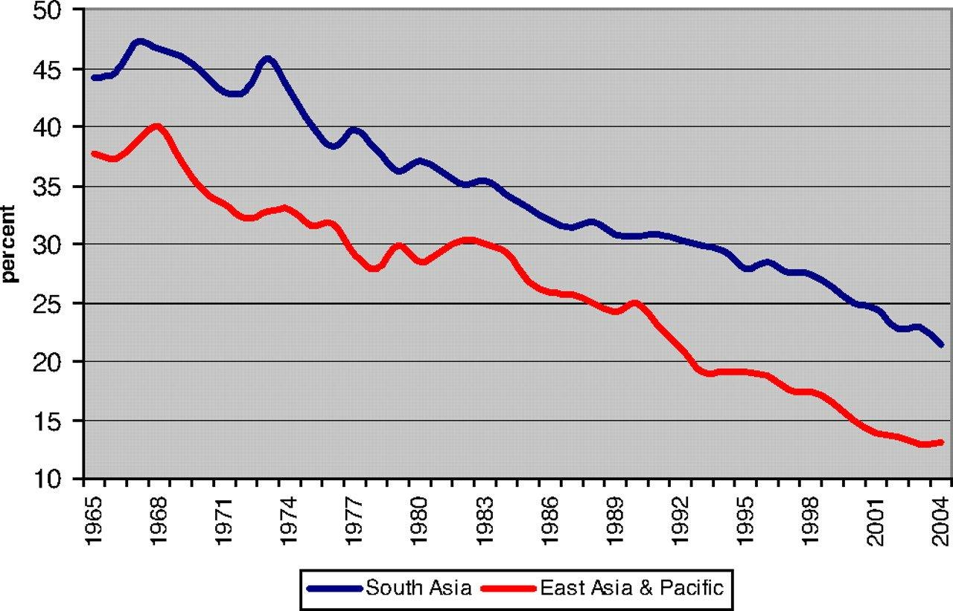

Figure-5 Schematic graphical representation of climate change impact with year by year

Several studies have recently measured the effects of climate change on food security. These studies use the IIASA-Basic Linked System (BLS) economic model to analyse the economic ramifications and rely on either the Decision Support System for Agrotechnology Transfer suite of crop models or the AEZ tools developed by the IIASA analysis to calculate projected changes in agronomic yield. These methods have been used by others to carry out similar evaluations and provide sensitivity analyses for a range of SRES and general circulation model (GCM) forecasts, with some adjustments to the simulation of agricultural output changes. Numerous additional models have also been performed to examine the effects of climate change, both with and without response (induced technological progress, domestic policy change, international trade liberalization, etc.), provide impact analyses for various rates of climate change, both with and without mitigation (e.g., CO2 stabilisation, variations for temperature, rainfall change, and distribution). The quantitative results for food security are the main focus of this part, which aims to highlight some of the discrepancies and glean the key takeaways from the numerous research. All simulation results presented below, unless otherwise noted, take into account the combined effects of climate change and rising CO2 emissions to crops.
Uncertainties and Limitations
It is not recommended to take the findings, at least not solely as probabilistic projections, that socioeconomic growth pathways are predicted to have significant implications for future food security and beyond the effects of climate change. This is due to the fact that SRES scenarios offer numerous potential outcomes "without any sense of likelihood." The SRES scenarios, like all scenarios, are unable to fully account for how the economy, emissions, and climate will develop in the future.

Second, the substantial effects of climate change on food security and vulnerability have not been quantified in current worldwide evaluations of climate change and food security, which has reduced food availability (stability). could only concentrate on the effect on access and sex. This means that the prevalence of foodborne infections and additional effects from extreme occurrences like droughts and floods (for similar concerns) are not taken into account in these analyses. The possible effects of rate alterations have not been quantified (both positive and negative). Or the interaction between changes in the incidence of vector-borne illnesses like malaria and affects on nutrition and health, as well as the potential effects of sea-level rise on agricultural production or marine life on food availability. We also disregard impacts.

Despite the very real uncertainties in current knowledge and future trends, policymakers and practitioners facing the prospect of climate change impacts on food security are still making decisions. not down. For decision makers, we propose six principles regarding the impact of climate change on food security, placing a reasonable level of confidence in the evidence.
1) Climate change impacts on food security are worst in countries already suffering from high levels of hunger and will worsen over time.
2) Actions to address global malnutrition and climate change The malnutrition impact of not taking
3) Due to the fact that the impact of climate change will vary from region to region, community to community, and between rural and metropolitan regions, there will be a rise in food inequalities on a local to worldwide scale.
4) Communities and individuals who are already at risk from severe weather conditions will be less able to withstand climate disruptions in the future.
5) As a result of previous greenhouse gas emissions, there is a commitment to climate change over the next 20–30 years. Additionally, there is a need for urgent response measures to handle global food shortages over the next 20–30 years.
6) Extreme weather is likely to occur more frequently in the future, increasing risk and uncertainty in the global food system. .

All of these principles support the need for substantial investment in adaptation and mitigation steps to avoid the effects of climate change from slowing down the progress being made to end global hunger and under nutrition. Resilience and adaptation strategies come in a wide variety, and new ones are constantly being developed. These must be incorporated into global agricultural growth and address food security in the broadest way possible. Increasing farming resilience, or "climate-smart agriculture," through improvements in technology and management systems is an important part of this, but it won't be sufficient to ensure world food security on its own. In addition to giving careful attention to commerce, stocks, nutrition, and social policy choices, the complete food system must adapt to climate change.
Conclusions
Climate change will affect all four dimensions of food security: food availability (production and trade), food access, food security and food use. The importance of various aspects and the overall impact of climate change on food security varies by region and over time, mainly due to the overall depends on your socioeconomic status.
Essentially all quantitative assessments show that climate change affects food security. Climate change will increase the dependence of developing countries on imports and reinforce the existing focus of food insecurity in sub-Saharan Africa and, to a lesser extent, South Asia. In developing countries, the adverse impacts of climate change will disproportionately hit the poor. A number of quantitative assessments also indicate that the socioeconomic environment in which climate change is expected to occur is more important than the expected impacts from biophysical changes of climate change.

References

[1] Scheffer, M., Carpenter, S., Foley, J.A., Folke, C., and Walker, B. (2001). Catastrophic shifts in ecosystems. Nature 413, 591–596.
[2] . Rockstro¨ m, J., Steffen, W., Noone, K., Persson, A., Chapin, F.S., Lambin, E.F., Lenton, T.M., Scheffer, M., Folke, C., Schellnhuber, H.J., et al. (2009). A safe operating space for humanity. Nature 461, 472–475.
[3] Smith, B.D., and Zeder, M.A. (2013). The onset of the Anthropocene. Anthropocene 4, 8–13.
[4] Ramankutty, N., Foley, J.A., Norman, J., and mcsweeney, K. (2002). The global distribution of cultivable lands: current patterns and sensitivity to possible climate change. Glob. Ecol. Biogeogr. 11, 377–392.
[5] Zabel, F., Putzenlechner, B., and Mauser, W. (2014). Global agricultural land resources – a high resolution suitability evaluation and its perspectives until 2100 under climate change conditions. PLoS One 9, e107522.
[6] Xu, C., Kohler, T.A., Lenton, T.M., Svenning, J.-C., and Scheffer, M. (2020). Future of the human climate niche. Proc. Natl. Acad. Sci. U S A 117, 11350–11355.
[7] Impacts of climate change on the livestock food supply chain; a review of the evidence,ScienceDirect- Volume 28, March 2021, 100488.
[8] An overview of the interactions between food production and climate change, Science Direct, Volume 838, Part 3, 10 September 2022, 156438.

