RISK AND RETURN ANALYSIS OF NSE NIFTY BANK STOCKS
DEIVA VEERALAKSHMI R  Doctoral Research Scholar-Part Time Internal  Department of Management Studies  Manonmaniam Sundaranar University  Abishekapati  Tirunelveli 627012  e-mail: profdeiva@gmail.com | Dr. M. BHOOPAL  Assistant Professor  Department of Management Studies  Manonmaniam Sundaranar University  Abishekapati  Tirunelveli 627012  e-mail: bhoopalmsu@msuniv.ac.in
ABSTRACT

Investing in stock market is very much rewarding though it is associated with more risk among the various other investment opportunities. Most of the investors’ make investment decision based on their emotions without analyzing the performance of the stocks. The changes in stock prices of Banks will definitely affect the investment pattern of investor and also affects the economy of the country. The study analyses the risk and return of the Banking stocks listed under Bank NIFTY. The research design is analytical and descriptive in nature. The sample size is top 12 Banks listed under the NSE NIFTY Bank index. Secondary data was collected from reports published by the NSE, Journals and Books. The tools used for data analysis are: Returns, Average Returns, Standard deviation, Variance, Coefficient of variation and Correlation. 12 Banks were found to have positive returns. Among all the stocks, AU Small Finance Bank and ICICI Bank were found to have the most positive percentage of average returns. Under the NIFTY Bank index, 7 out of 12 Bank stocks have beta value greater than 1, showing the riskiness of the Bank stocks. All the Bank stocks are positively correlated with the NIFTY Bank index. Hence, the stocks are moving together with Bank NIFTY. It is found that the higher risk stocks are yielding negative returns while lower risk stocks are yielding positive returns. Hence, it is important for the investors to analyse the stock market on a continuous basis to pick the right stocks to invest in.

Keywords – risk ;average returns; NIFTY; bank stocks

I. INTRODUCTION

Investing in stock market is very much rewarding though it is associated with more risk among the various other investment opportunities. Most of the investors’ make investment decision based on their emotions without analyzing the performance of the stocks. Since the risk is high in stock market, the investors need to analyze the risk and returns of the stocks before making their investment decision. This will help the investors to identify the nature of the stocks and to pick a good stock to invest their money.
National Stock Exchange of India (NSE) is the leading stock exchange of India, located in Mumbai, Maharashtra. NSE was established in 1992 as the first dematerialized electronic exchange in the country. NSE was the first exchange in the country to provide a modern, fully automated screen-based electronic trading system that offered easy trading facilities to investors spread across the length and breadth of the country.
The NIFTY Bank Index which is also known as the ‘Bank NIFTY’ index,
comprises of the most liquid and large Indian Banking stocks. The Bank NIFTY index was created by the NSE in September 2003, to gauge the capital market performance of one of the critical service sectors in India, Banking. An index represents the performance of a segment of the financial market by tracking a group of diversified but representative constituent securities from the market, in a certain weightage ratio. The Bank NIFTY share price is basically the value of the index at a particular point in time. It provides investors and market intermediaries a benchmark that captures the capital market performance of the Indian Banks. The Index comprises of maximum 12 companies listed on National Stock Exchange of India (NSE). It consists of 2 Public Sector Banks and 10 Private Sector Banks.
Risk refers to the possibility that the actual outcome of an investment will differ from its expected outcome. In another term, the risk is expressed in terms of variability of return. Investor has to decide about his risk tolerance level, to get the expected return by the way of investment. The return from the stock includes both current income and capital gain caused by the appreciation of the stock values.

II. STATEMENT OF THE PROBLEM
The Bank plays a major role in building the economy of an individual as well as the nation. So, the changes in stock prices of Banks will definitely affect the investment pattern of investor and also affects the economy of the country. Therefore, before taking an investment decision, it is good for investors’ to analyse the risk and return. The study analyses the risk and return of the Banking stocks listed under Bank NIFTY.

III. REVIEW OF LITERATURE
Ch V Rao and Krishna Banana (2016), studied risk and return with reference to selected stocks of NIFTY. The aim of this study was creating awareness about stocks return pattern to invest by the investors in the particular stock. The researchers discussed the trade-off using beta and standard deviation tools and provided a method for quantifying risk.
Suresh A.S. & Sai Prakash L. (2018), compared the risk-return analysis of Public and Private Sector Banks listed on Bank NIFTY. Only 12 stocks listed on Bank NIFTY were considered for the study and the study was based on secondary data collected from NSE website. The authors used standard deviation and beta tools to measure risk and they concluded that Yes Bank and IndusInd Bank has higher returns with high risk, while HDFC Bank has low risk with moderate return.
Rohith U.J (2018), studied the volatility and return with reference to stocks of Bank NIFTY. The data used in this study was secondary in nature collected from the official website of NSE. The tools used in this study were mean, standard deviation, correlation and beta. The researcher found that the Bank NIFTY was in the 3rd position followed by NIFTY financial services when comparing the performance of sector indices and stocks in the Bank NIFTY have higher volatility. He also concluded that the market risk of Punjab National Bank, Canara Bank and Bank of India were higher compared to other selected Banks.
Ruchi Nityanand Prabhu (2018), analysed risk & return of NIFTY stock in Indian capital market. The sample for the study was 50 stocks listed under NIFTY and it was based on secondary data extracted from reliable sources. The research tools used in this study were mean, beta, standard deviation, covariance and coefficient of correlation. The major findings of this study was that during 2010-2015 the Market Returns & Market Volatility are negatively co-related to the degree of -0.51. That is, they are inversely proportional to each other.
Amit Agarwal (2020), conducted an analytical study on the risk and return scrutiny by using selection of equity and NIFTY. The sample size of the study was 11 industries selected from NSE NIFTY index and the study based on secondary data collected from the website www.nseindia.com. The statistical tools used in this study were return, average return, standard deviation, variance, correlation coefficient, and multiple regression. The author suggested that the investors who wish to take high risk can invest in Automobile industry, moderate risk can invest in FMCG, IT and Mining & Metal industries and low risk can invest in Banking & Finance, Cement & Construction and Pharmacy and Energy & Power industries.

IV. OBJECTIVES
1. To analyse the risk and return of share prices of Banks listed in Bank NIFTY.
2. To study the relationship between the share prices of Banks in Bank NIFTY
and Bank NIFTY.
3. Based on risk and return, to identify the best share to invest among the Banks constituting Bank NIFTY.
V. RESEARCH METHODOLOGY
Research methodology is a systematic way of conducting a study. The research design is analytical and descriptive in nature. The sample size is top 12 Banks listed under the NSE NIFTY Bank index. They are:
1. AU Small Finance Bank
2. Axis Bank
3. Bandhan Bank
4. Federal Bank
5. HDFC Bank
6. ICICI Bank
7. IDFC First Bank
8. IndusInd Bank
9. Kotak Mahindra Bank
10. Punjab National Bank
11. Ratnakar Bank Limited
12. State Bank of India
Data Collection Method
Secondary data was collected from reports published by the NSE, Journals and Books.
Tools used for Analysis
The tools used for data analysis are: Returns, Average Returns, Standard deviation, Variance, Coefficient of variation and Correlation.

VI. DATA ANALYSIS AND INTERPRETATION
1. Average Returns of Index / Stocks

Table No .1
Average Returns of Index / Stocks
S. No. | Index / Stocks | Average Returns (%)
1. | NIFTY Bank | 0.0604
2. | AU Small Finance Bank | 0.1311
3. | Axis Bank | 0.0814
4. | Bandhan Bank | 0.0283
5. | Federal Bank | 0.0195
6. | HDFC Bank | 0.0111
7. | ICICI Bank | 0.1314
8. | IDFC First Bank | 0.0632
9. | IndusInd Bank | -0.0166
10. | Kotak Mahindra Bank | 0.0916
11. | Punjab National Bank | -0.0887
12. | Ratnakar Bank Limited | -0.0504
13. | State Bank of India | 0.0821

Chart No. 1 Average Returns of Index / Stocks
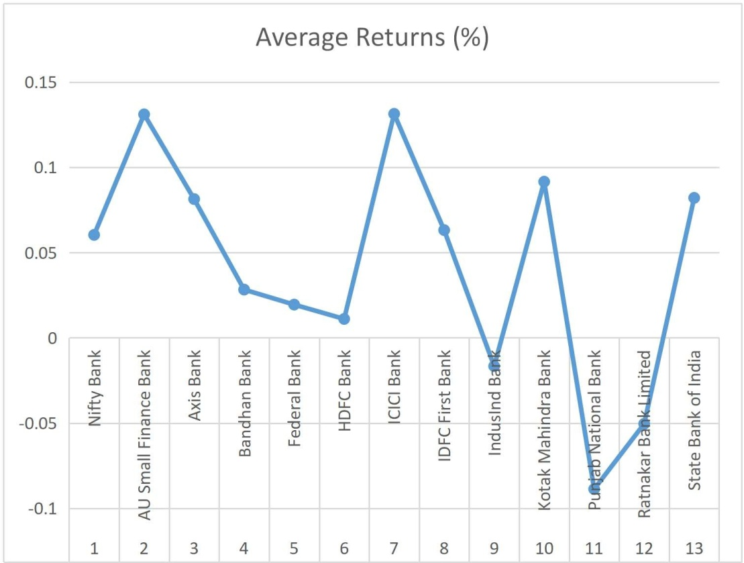

Interpretation:
The table no. 1 shows that the mean of the 12 Banks selected from NSE namely AU Small Finance Bank, Axis Bank, Bandhan Bank, Federal Bank, HDFC Bank, ICICI Bank, IDFC First Bank, IndusInd Bank, Kotak Mahindra Bank, Punjab National Bank, Ratnakar Bank Limited and State Bank of India. The average daily returns of the Bank stocks are mostly similar to the NIFTY Bank Index average daily returns. 9 Banks out of 12 Banks listed under the NIFTY Bank Index yields positive average returns. IndusInd Bank (-0.0166), Punjab National Bank (-0.0887) and Ratnakar Bank Limited (-0.0504) have the negative percentage of average returns. AU Small Finance Bank and ICICI Bank have the most positive percentage of average return of 0.1311 and 0.1314 respectively, among all the 12 stocks in the Bank NIFTY.

2. Standard Deviation of Index / Stocks

Table No.2
Standard Deviation of Index / Stocks

S.No. | Index / Stocks | Standard Deviation
1. | NIFTY Bank | 1.8782
2. | AU Small Finance Bank | 2.7750
3. | Axis Bank | 2.7793
4. | Bandhan Bank | 3.8263
5. | Federal Bank | 2.8586
6. | HDFC Bank | 2.5892
7. | ICICI Bank | 2.5321
8. | IDFC First Bank | 2.8706
9. | IndusInd Bank | 3.7468
10. | Kotak Mahindra Bank | 2.1168
11. | Punjab National Bank | 2.8132
12. | Ratnakar Bank Limited | 3.4873
13. | State Bank of India | 2.5079

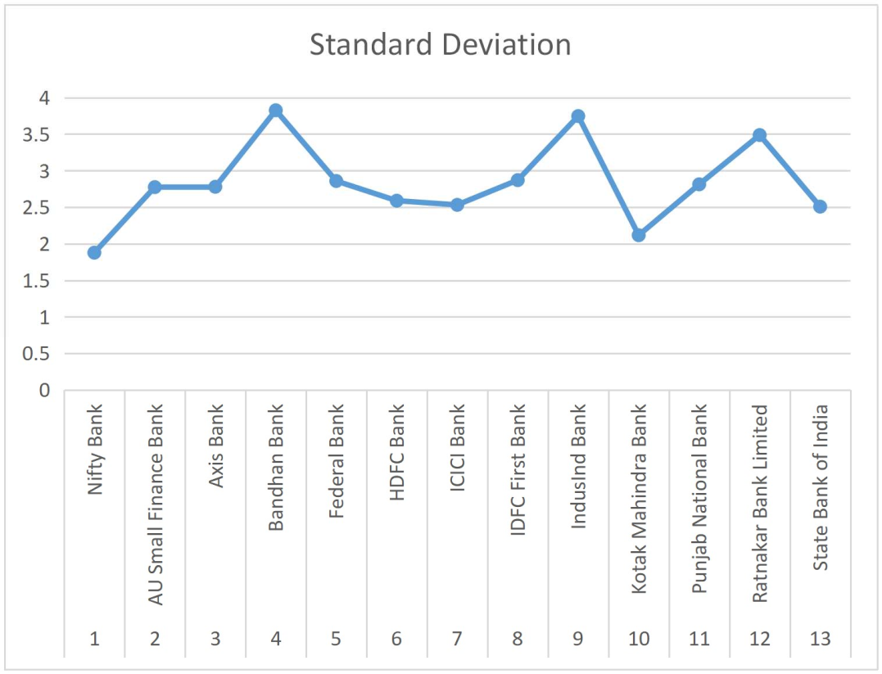
Chart No. 2

Interpretation:
The table no.2 shows that the standard deviation of the 12 Banks selected from NSE namely AU Small Finance Bank, Axis Bank, Bandhan Bank, Federal Bank, HDFC Bank, ICICI Bank, IDFC First Bank, IndusInd Bank, Kotak Mahindra Bank, Punjab National Bank, Ratnakar Bank Limited and State Bank of India. From this table, we can see that the Bank stocks have high standard deviation when compared to their benchmark index. Among all these Bank stocks, Bandhan Bank (3.8263), IndusInd Bank (3.7468) and Ratnakar Bank Limited (3.4873) have the high standard deviation, it reflects that they have high volatility, whereas, Kotak Mahindra Bank (2.1168) has the less standard deviation, indicating less volatility compared to other stocks.

3. Beta of Stocks

Table No.3 Beta of Stocks

S.No. | Stocks | Beta
1. | AU Small Finance Bank | 0.6287
2. | Axis Bank | 1.2128
3. | Bandhan Bank | 1.0943
4. | Federal Bank | 1.0978
5. | HDFC Bank | 0.8474
6. | ICICI Bank | 1.1731
7. | IDFC First Bank | 0.9329
8. | IndusInd Bank | 1.3532
9. | Kotak Mahindra Bank | 0.8245
10. | Punjab National Bank | 0.7649
11. | Ratnakar Bank Limited | 1.1497
12. | State Bank of India | 1.0336

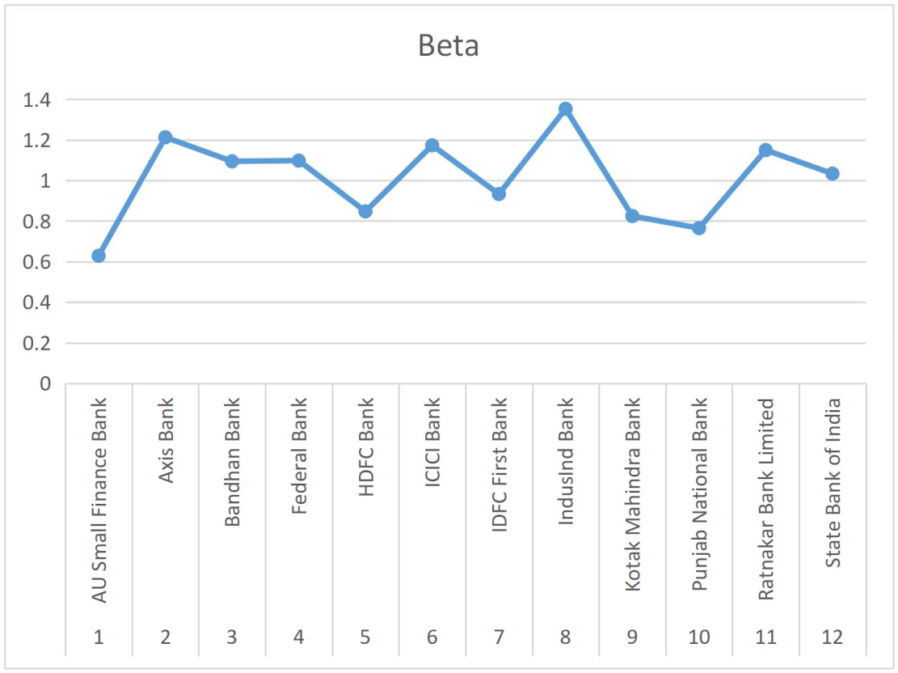
Chart No. 3

Interpretation:
The table no.3 shows that the beta of the 12 Banks selected from NSE namely AU Small Finance Bank, Axis Bank, Bandhan Bank, Federal Bank, HDFC Bank, ICICI Bank, IDFC First Bank, IndusInd Bank, Kotak Mahindra Bank, Punjab National Bank, Ratnakar Bank Limited and State Bank of India. The table shows that 7 stocks out of 12 stocks listed in the Bank NIFTY have beta value greater than 1, showing the riskiness of the stocks in Bank NIFTY. IndusInd Bank has the high beta value of 1.3532 among the 12 stocks, indicating high risk. The stocks which have beta value less than 1 are considered as less risk stocks. AU Small Finance Bank has the lowest beta value of 0.6287 among the stocks, having less risk.
4. Variance of Index / Stocks
Table No. 4 Variance of Index / Stocks

S.No. | Index / Stocks | Variance
1. | NIFTY Bank | 3.5275
2. | AU Small Finance Bank | 7.7006
3. | Axis Bank | 7.7248
4. | Bandhan Bank | 14.6407
5. | Federal Bank | 8.1714
6. | HDFC Bank | 6.7038
7. | ICICI Bank | 6.4114
8. | IDFC First Bank | 8.2406
9. | IndusInd Bank | 14.0383
10. | Kotak Mahindra Bank | 4.4809
11. | Punjab National Bank | 7.9143
12. | Ratnakar Bank Limited | 12.1615
13. | State Bank of India | 6.2895

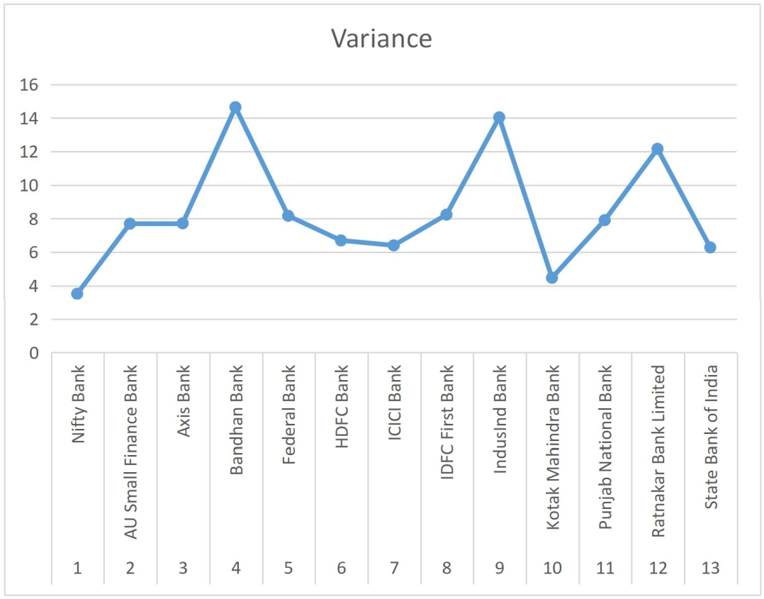
Chart No. 4

Interpretation:
The table no. 4 shows that the variance of the 12 Banks selected from NSE namely AU Small Finance Bank, Axis Bank, Bandhan Bank, Federal Bank, HDFC Bank, ICICI Bank, IDFC First Bank, IndusInd Bank, Kotak Mahindra Bank, Punjab National Bank, Ratnakar Bank Limited and State Bank of India. The table shows that, all the stocks have high variance when compared to the index. Among the 12 stocks, Bandhan Bank (14.6407), IndusInd Bank (14.0383) and Ratnakar Bank Limited (12.1615) have the higher variance, hence contains higher risk and Kotak Mahindra Bank has the lowest variance of 4.4809 among all the stocks. Hence, it is found that Kotak Mahindra Bank has the lowest risk.

5. Coefficient of Variation of Index / Stocks

Table No. 5
Coefficient of Variation of Index / Stocks

S.No. | Index / Stocks | Coefficient of Variation
1. | NIFTY Bank | 31.0848
2. | AU Small Finance Bank | 21.1666
3. | Axis Bank | 34.1481
4. | Bandhan Bank | 135.2417
5. | Federal Bank | 146.4626
6. | HDFC Bank | 233.4681
7. | ICICI Bank | 19.2699
8. | IDFC First Bank | 45.3867
9. | IndusInd Bank | -225.3809
10. | Kotak Mahindra Bank | 23.1113
11. | Punjab National Bank | -31.7023
12. | Ratnakar Bank Limited | -69.2067
13. | State Bank of India | 30.5511

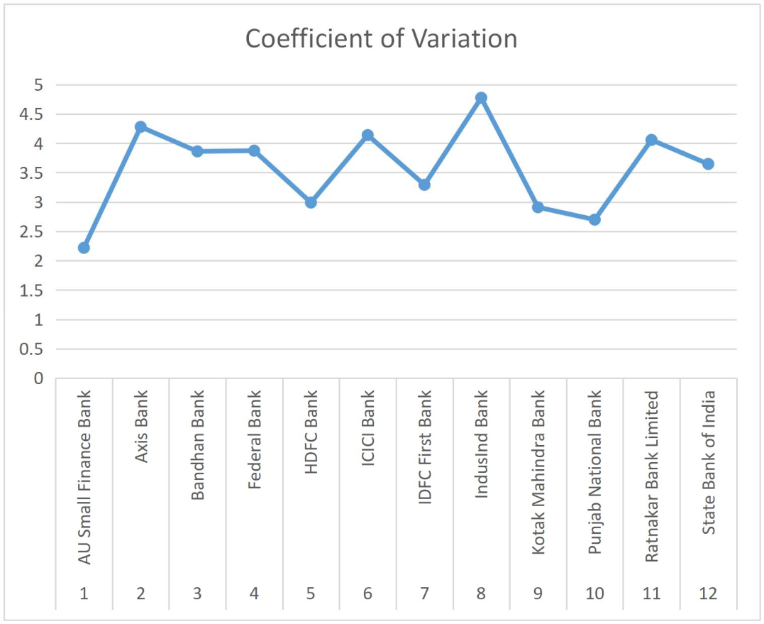
Chart No. 5

Interpretation:
The table no. 5 shows that the coefficient of variation of the 12 Banks selected from NSE namely AU Small Finance Bank, Axis Bank, Bandhan Bank, Federal Bank, HDFC Bank, ICICI Bank, IDFC First Bank, IndusInd Bank, Kotak Mahindra Bank, Punjab National Bank, Ratnakar Bank Limited and State Bank of India. All the Banks have positive coefficient of variation. Among these, IndusInd Bank (-225.3809), Punjab National Bank (-31.7023) and Ratnakar Bank Limited (-69.2067) have negative coefficient of variation, where HDFC Bank has the highest coefficient of variation of 233.4681.

6. Correlation of Stocks with Bank NIFTY

Table No.6
Correlation of Stocks with Bank NIFTY

S.No. | Stocks | Correlation
1. | AU Small Finance Bank | 0.4255
2. | Axis Bank | 0.8196
3. | Bandhan Bank | 0.5372
4. | Federal Bank | 0.7213
5. | HDFC Bank | 0.6147
6. | ICICI Bank | 0.8702
7. | IDFC First Bank | 0.6104
8. | IndusInd Bank | 0.6783
9. | Kotak Mahindra Bank | 0.7315
10. | Punjab National Bank | 0.5106
11. | Ratnakar Bank Limited | 0.6192
12. | State Bank of India | 0.7741

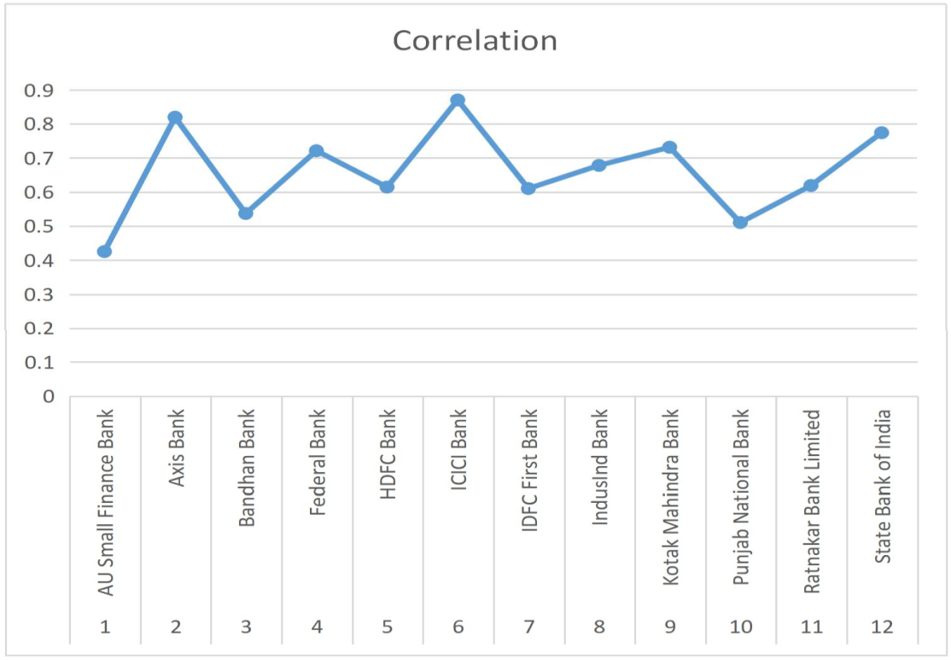

Chart No.6
Correlation of Stocks with Bank NIFTY

Interpretation:
The table no.6 shows that the correlation of the 12 Banks selected from NSE namely AU Small Finance Bank, Axis Bank, Bandhan Bank, Federal Bank, HDFC Bank, ICICI Bank, IDFC First Bank, IndusInd Bank, Kotak Mahindra Bank, Punjab National Bank, Ratnakar Bank Limited and State Bank of India. All the stocks listed under the Bank NIFTY have positive correlation values. Hence, all the Banks are positively correlated with their benchmark index. The correlation is highest for Axis Bank and ICICI Bank compared to other stocks, i.e., 0.8196 and 0.8702 respectively. The correlation is lowest for AU Small Finance Bank (0.4255).
VII. FINDINGS
The average daily returns of the Bank stocks are mostly similar to the NIFTY Bank index average daily returns. During the study period, from 1st April 2018 - 31st March 2021, 9 Banks out of 12 Banks have positive returns. IndusInd Bank (-0.0166), Punjab National Bank (-0.0887) and Ratnakar Bank Limited (-0.0504) have negative average returns. Among all the stocks, AU Small Finance Bank and ICICI Bank have the most positive percentage of average returns of 0.1311 and 0.1314 respectively. The Bank stocks listed under the NIFTY Bank index, have high volatility when compared to the index, it is because they have high standard deviation than the index. Bandhan Bank, IndusInd Bank and Ratnakar Bank Limited have high standard deviation of 3.8263, 3.7468 and 3.4873 respectively, having high volatility. Kotak Mahindra Bank (2.1168) has less standard deviation indicating low volatility. Under the NIFTY Bank index, 7 out of 12 Bank stocks have beta value greater than 1, showing the riskiness of the Bank stocks. IndusInd Bank has the higher risk of 1.3532 while AU Small Finance Bank (0.6287) has the lower risk. All the Bank stocks have high variance when compared to their benchmark index. Bandhan Bank (14.6407), IndusInd Bank (14.0383) and Ratnakar Bank Limited (12.1615) have higher variance among the stocks, hence found they have high risk. Kotak Mahindra Bank has less variance of 4.4809 among the stocks, hence it has less risk. IndusInd Bank, Punjab National Bank and Ratnakar Bank Limited have negative coefficient of variation of -225.3809, -31.7023 and -69.2067 respectively. HDFC Bank has the highest coefficient of variation of 233.4681. All the Bank stocks are positively correlated with the NIFTY Bank index. Hence, the stocks are moving together with Bank NIFTY.

VIII. SUGGESTIONS
The investors may invest in AU Small Finance Bank and ICICI Bank as they both give maximum positive returns among all other stocks in Bank NIFTY. And also AU Small Finance Bank has low risk and ICICI Bank is highly correlated with Bank NIFTY, so it is better to invest in these two stocks. Kotak Mahindra Bank is favour for long term investment as it has low volatility. It is suggested not to go for Bandhan Bank, IndusInd Bank and Ratnakar Bank Limited as they have high volatility, having higher risk, also IndusInd Bank and Ratnakar Bank Limited have negative returns too.

IX. CONCLUSION
The investors, need to consider both risk and returns combined with the stocks, in order to make good investment decision. In this study, the risk and returns of Bank stocks listed under the Bank NIFTY are analysed. Thus in a conclusion, it is found that the higher risk stocks are yielding negative returns while lower risk stocks are yielding positive returns. Punjab National Bank and State Bank of India, the only two public sector banks listed in bank nifty, seem to perform an average. The Private Sector Banks, AU Small Finance Bank and ICICI Bank are performing well during the study period. Hence, it is important for the investors to analyse the stock market on a continuous basis to pick the right stocks to invest in.

REFERENCES
- Vikkraman , P., & Varadharajan, P. (2009). A Study on Risk & Return analysis of Automobile Industry in India (2004-2007). Journal of Contemporary Research in Management, 35-40.
- Jeyachitra, A., Selvam, M., & Gayathri, J. (2010). Portfolio Risk and Return Relationship - An Empirical Study. Asia Pacific Business Review, 6(4), 57-63.
- Marisetty & Sudha, M. (2011). An Empirical Study on CAPM with respect to NSE NIFTY Stocks. Presented Paper in International Conference on Quality Management System.
- Sridhar, S., & Dr. Pandian. (2012). Return and Volatility Analysis of National Stock Exchange (NSE) NIFTY Junior Companies. Management Journal of Siva Sivani Institute of Management, 4(2), 5-13.
- Rangotra. (2015). Risk and Return on Investment in Auto and Banking Sectors of Indian Economy. Asian Journal of Research in Banking and Finance. 5(3), 143-154.
- Naveen & Mallikarjunappa, T. (2016). A Study on Comparative Analysis of Risk and Return with reference to stocks of CNX Bank NIFTY. International Journal of Scientific Research and Modern Education, 1(1), 737-743.
- Guha, Dutta and Bandyopadhyay. (2016). Measurement of Risk Vs Return of Indian Sectoral Indices. Journal of Advanced Management Science, 4(2), 106-111.
- Rao, V., & Banana. (2016). A Study of risk and return with reference to selected stocks of NIFTY. ZENITH International Journal of Business Economics & Management Research, 6(3), 30-40.
- Dr. Gopalakrishnan, M., & Mr. Akarsh, K. (2017). Equity Analysis of Automobile Industry in Indian Stock Market. International Journal of Advance Research and Development, 2(5), 166-171.
- Rohith, J. (2018). A Study on the Volatility and Return with reference to stocks of Bank NIFTY. International Journal of Advance Research, Ideas and Innovations in Technology, 4(1), 66-76.
- Prabhu, R. (2018). Risk and Return Analysis of NIFTY Stock in Indian Capital Market. International Journal of Multidisciplinary Research and Development, 5(3), 8-12.
- Venkatesh, Vikas & Charithra, M. (2018). A Study on Risk and Return Analysis and Data Envelopment Analysis of Public and Private Sector Banks. Srusti Management Review, 11(2), 10-18.
- Singh & Seth. (2018). Performance of Indian National Stock Exchange Indices : A Comparative Analysis. Indian Institute of Finance, 32(4), 1209-1226.
- Rajesh, E. (2019). NSE NIFTY Bank Stocks: Risk and Return Analysis. Journal of Emerging Technologies and Innovative Research, 6(5), 252-255.
- Perikala & Reddy. (2019). Risk Return Analysis of Indian Equity Markets. International Journal of Research and Analytical Reviews, 6(1), 135-143.
- Bantwa & Ansari. (2019). Risk Return Analysis of Equity Stocks: A Study of Selected Indian IT Companies. Journal of Finance and Accounting, 6(1), 31-44.
- Naveenan, R. (2019). Risk and Return Analysis of Portfolio Management Services of Reliance Nippon Asset Management Limited (RNAM). Global Journal of Management and Business, 6(1), 108-117.
- Rao, Podile & Navvula. (2020). Risk and Return Analysis of selected NIFTY Banking Stocks. European Journal of Molecular and Clinical Medicine, 7(4), 1010-1018.
- Angaraju & Murthy, B. (2020). Risk and Return Analysis of selected Indian Banks in NSE Market. Alochana Chakra Journal, 9(4), 2671-2674.
- Agarwal. (2020). An Analytical Study on the Risk and Return Scrutiny by using Selection of Equity and NIFTY. European Journal of Molecular & Clinical Medicine, 7(4), 638-645.
- Jogheel, Kanagatharani, B., Gayathri, S., & Devi, R. (2021). A Study on Risk and Return Analysis of Selected Banking Securities. Turkish Journal of Computer and Mathematics Education, 12(11), 122-127.
- Begum & Lavanya, K. (2021). Equities Risk and Return of SBI and Axis Bank. International Journal of Scientific Development and Research, 6(3), 153-158.

