Bioremediation of organic Wastes using Different Earthworms
C. Birundha* and N.Uma Maheswari
PG and Research Department of Microbiology,
Sengamala Thayaar Educational Trust Women’s College (Autonomous),
Sundarakkottai, Mannargudi,Thiruvarur (dist),Tamilnadu-614016.
*Corresponding author Email: binthuyoga1699@gmail.com.
Abstract
Vermicomposting is among the most plausible and climate cordial method for the biotransformation of biodegradable squanders into a valuable and great compost. Vermiculture of wild worms in particular Eisenia fetida, Eudrilus eugeniae, Perionyx excavates and vermicomposting of various natural squanders, for example, Dairy cattle manure, plant trash, paper waste, and food squander utilizing both wild and refined types of night crawlers are examined. The waste is changed over into valuable excrement by decreasing the unsafe impacts of waste. These bioassays are delicate and financially savvy for the checking of ecological tainting. The vermicompost delivered from natural squanders contains higher measures of humic substances, which assumes a significant part in development of plants. The detoxification of biodegradable squanders by night crawlers and the job of last vermicompost in plant development and improvement. Night crawlers can be utilized to biodegradable natural waste and the worm cast delivered can go quite far to increment soil richness for most extreme yield during horticultural movement. Vermicomposting by Eisenia fetida can eﬀectively decrease the harmfulness and all out convergence of weighty metals, as well as bacterial arrangement and variety are extraordinarily different during the vermicomposting system. Vermicompost is most of the supplement rich natural excrement on the planet and plays favorable part in development and improvement of the plant growth.
Keywords: Vermiculture, Organic wastes, Worm cast, Vermicomposting, Earthworms.
Introduction
The executives of strong natural squanders has become quite possibly of the most concerning issue emerging countries are confronting today. The fast expansion in the volume of waste is one part of the natural emergency going with ongoing worldwide turn of events. Squander is a significant material in an off-base spot. Natural squanders contain house hold food squanders, rural squanders, human squanders and creature squanders (Appelhof, 2007). As worldwide populace keeps on expanding, more natural squanders will undoubtedly be created causing expansion in their ecological and rural difficulties. These difficulties are more awful in agricultural nations because of unfortunate waste administration strategies. Thus, the waste ends up causing medical issues and the colossal supplements in it get lost consequently the requirement for proficient waste administration strategy.
Aristotle said about quite a while back that "Worms are digestive organs of the earth," which was viewed as right and confirmed exclusively in the 20th hundred years. Darwin likewise expressed that "No other animal has added to the structure of earth as worm." The study of raising and it is designated "Vermiculture," which is by and large performed to gather the capability of night crawlers for squander decrease and compost creation (Sinha et al., 2010 to raise worms). The most common way of vermicomposting includes the development of a natural manure, otherwise called vermicompost, by biodegradation of natural waste with the assistance of night crawlers to stay away from garbage removal and to deliver excellent fertilizer.
The job of worms in malfunction of natural garbage on soil surface and soil turn over process was first featured by Darwin in 1881 (Kale and Bano, 2008). Farming waste is the most squandered type of energy and is generally accessible in non-industrial nations where around 70% of the provincial populace principally relies upon horticulture (Jimenez-Lopez et al., 2020).It remaining parts disputable whether vermicomposting is effective in decreasing the quantity of human microorganisms in modern and agrarian waste. Vermicomposting is a mesophilic cycle where the temperatures are by and large kept underneath 35EC to keep the worms from biting the dust. In any case, as per the guidelines of Natural Security Organization (EPA), the fertilizer ought to be presented to high temperature (55-70EC) for no less than 72 h (Edwards et al., 2010).Vermicomposting, a biodegradation cycle in which worms are utilized to change over natural waste materials into humus-like material known as verimcompost, fills in for of recuperating natural waste supplements through an effective means creating natural compost for farming reason (Lazcano et al., 2008; Berkelaar, 2009; Rhonda, 2011).The objective of vermicomposting is to deal with natural substance as fast and proficiently as conceivable utilizing the result of vermiculture which it will probably ceaselessly expand the quantity of worms to get a supportable reap (Glenn, 2006; Asha-Aalok, and Soni, 2008).The course of vermicomposting includes an aggregate activity of microorganisms and night crawlers to change over squander into valuable excrement. Vermicomposting has been really used to remove modern squanders, switching them over completely to a compost wealthy in humic substances and advancing plant development (Bhat et al., 2018). In spite of the fact that microorganisms are answerable for the decay of natural waste, night crawlers are the drivers for this cycle by molding the substrate and changing its organic action. The last vermicompost contains various mixtures like nitrogen, phosphorus, potassium (NPK), natural carbon, micronutrients, and microflora (Iqbal et al., 2015).Microorganisms like microscopic organisms, actinomycetes, and parasites are the main microorganisms that assume a significant part during vermicomposting (Liu et al., 2021). The microbial populaces of night crawler's stomach and cast creates a broad assortment of regular materials like polysaccharides, including cellulose, sugar, lignin, chitin, starch, and polylactic corrosive, subsequently speeding up the most common way of fertilizing the soil (Aira et al., 2007). An extensive variety of stomach-related catalysts like amylase, cellulase, chitinase, protease, lipase, and urease are available in worms and the microorganisms in light of decay of natural matter (Munnoli et al., 2010). Presently there is an overall acknowledgment that reception and double-dealing of vermiculture biotechnology, other than capturing environmental debasement, could go quite far towards meeting the supplement needs of the horticultural area incredibly.
Vermiculture and Vermicompost
Vermiculture is the counterfeit raising or development of night crawlers, and the innovation is the logical course of involving them to improve individuals. Vermicompost, additionally called worm fertilizer, vermicast, worm projecting, worm crap or worm compost, is the dropping of night crawler which is wealthy in humus. Night crawlers ingest animal droppings or ranch yard excrement alongside other homestead squanders and pass them through their body, changing over them into vermicompost or worm humus. In this manner, night crawlers convert natural squanders into important fertilizer as well as keep the climate sound (Anon, 2017).Vermiculture should effortlessly be possible in any suitable space: overhang of a condo, in the storm cellar of a house or even in a warmed carport on the off chance that the worm canister utilized is reasonable and very much kept up with to stay away from smells. This method can eventually be utilized to treat home nursery and produce a more prominent standard and amount of harvests for the family. Worm cultivating is a valuable practice in emerging countries where manure is challenging to be gotten to by worker ranchers, as long as it can without much of a stretch be utilized to change over animal waste, food waste and other dead natural material into a supplement rich compost. Vermicomposting, a change of the natural squanders or trash by worms into vermicompost and the increase of night crawlers are basic interaction as it may be taken care of balanced little ranchers.
Advantages of vermicomposting
1) Vermicompost is an eco-accommodating normal compost ready from biodegradable natural squanders liberated from compound data sources.
2) It meaningfully affects the dirt, plant and climate.
3) It further develops soil air circulation, surface and slant, consequently lessening soil compression.
4) It further develops water maintenance limit of soil in view of its huge natural matter substance.
5) It advances better root development and supplement retention.
6) It works on supplement status of soil - both contain as macronutrients and micronutrients.
Vermicomposting of agricultural waste procedure:
Rural lignocellulosic waste can be effectively vermicomposted to deliver a decent standard excrement (Fig. 1). This lignocellulosic squander when blended in various extents in with cows compost and vermicomposted by adding Eisenia feotida worms showed diminished all out natural carbon (268-320 g/kg) and expanded NPK content in the loss following 105 days of vermicomposting. It likewise expanded the weighty metal substance with their advantage proportion running somewhere in the range of 0.06 and 5.1 (Sharma et. al., 2019).

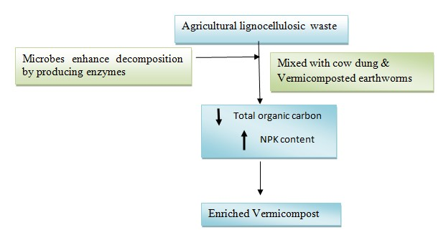
Figure: 1 Vermicomposting and microbial decomposition of agricultural wastes.
Collection of waste materials and earthworms
- Collected the biodregradable waste such as cattle dung , paper waste, plant debris, food waste were collected from in and a land the Mannargudi, Thiruvarur district Tamilnadu, India.(Fig:2)
- Using by the three types of earthworm species Eisenia fetida, Eudrilus eugeniae and Perionyx excavates for preparation of vermicomposting (Fig:3).

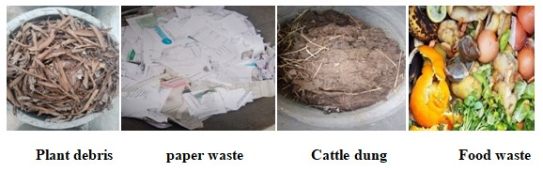
Figure.2 Collection of waste materials
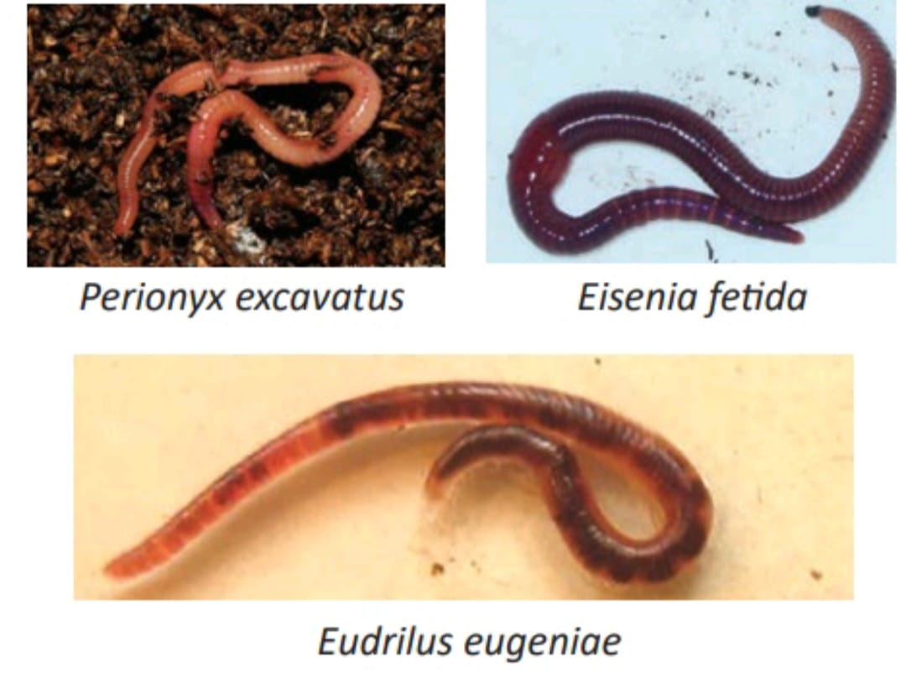
Figure: 3 Potential species for Earthworms vermiculture
Processing of Vermicomposting
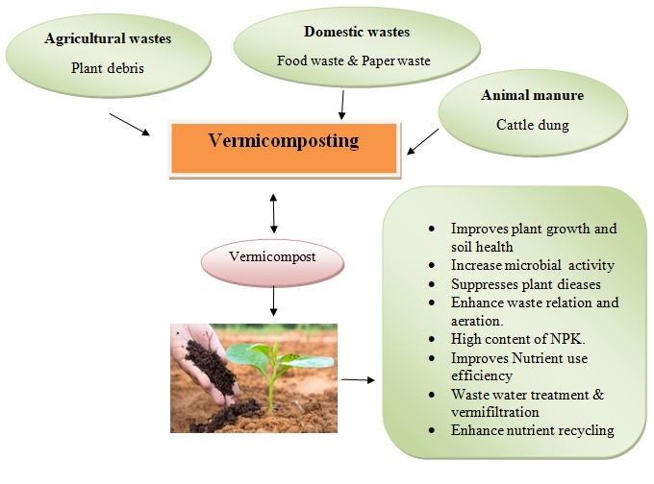
Figure: 4 The process of vermicomposting of different types of organic wastes.
"Vermicomposting is a cycle wherein the worms convert the regular waste into manure fat in high healthful substance." Vermicomposting is a business considering night slowpokes and microorganisms, whose joint activity gives debasement and detoxification of natural waste as well as change into an item to be utilized for agronomic purposes. This eco-accommodating technique is savvy and is awesome among other remediation processes. (Fig: 4). Following of handling step beneath stream visit. (Fig: 5).

Figure: 5 The process of vermicomposting

Benefits of vermicomposting:
Vermicompost with great physicochemical properties and strengthened with all supplements and plant development advancing microbes are natural corrections for improving soil ripeness, advancing plant development, and controlling microorganism contamination for supportable horticulture. Vermicompost has a lot of benefits, specifically as follows:
(1) It goes about as biofertilizers, reestablishes soil supplements, settles soil, and improves soil ripeness at a drawn out period;
(2) It takes care of social issues and reuses squander; and
(3) Being a beneficial venture as a roundabout economy is shown.
The process of bioremediation:
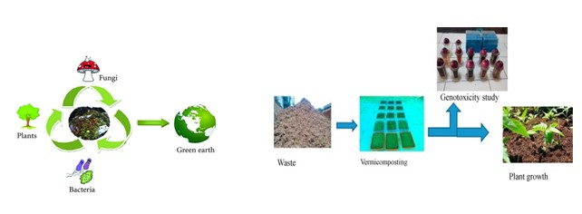
Figure: 5 Bioremediation of vermicomposting process
Bioremediation compain the vermicompost processs following steps flow chat below:
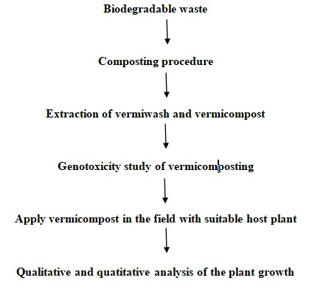
Role of vermicompost in plant growth
Composting is fat in microbial crowd (spongers, microorganisms and actinomycetes) which makes it fit for factory development (Tomati etal., 1987). Compost also hold proteins and hormones that supplements factory development and diminishes factory infections (Abbasi and Ramasamy, 1999); multitudinous specialists have detailed factory development chemicals( auxin, cytokinins, humic substances) created by organisms from vermicompost (Muscolo etal., 1999; Atiyeh etal., 2002). umerous scientists; (Masciandaro etal., 1997; Elvira etal., 1998) have seen that the last vermicompost got from dairy cattle ordure, sewage and paper plant slime contains enormous quantities of humic substances, which assumes a significant part in factory development and enhancement. Hence composting and vermiculture invention are financially strong and naturally safe invention for strong waste administration. India, where a great deal of natural strong waste is open could produce million tons of vermicompost and will limit the application of inorganic coprolites, shows that underneath. (Tab: 1)
Table: 1 Details of waste substrate composted by earthworms and analysis of the tomato plant
S.NO. | Waste  Substrate | Earthworms | Duration | Physio chemical analysis and heavy metals | Plant name | Plant growth
1. | Cattle dung | Eisenia foetida | 120 days | There was a decrease in complete natural carbon, electrical conductivity while the higher substance of nitrogen, phosphorous and pH was accounted for in the ﬁnal feed blends. | Tomato  (Lycopersicum esculentum L.) | Germination percentage of tomato seeds was found maximum at 15% vermicompost treatments than higher treatments. All the growth, and yield parameters increased
2. | Plant debris
3. | Paper waste
4. | Food waste |  |  | There was a decrease in pH, Total carbon , organic matter, C:Nratio & increase in ash content, electrical conductivity, NPK content in post vermicompost

Advantages of bioremediation:
- Practical
- Bioremediation is a characteristic cycle
- Climate Agreeable
- Less energy and oversight
- Low capital consumption
Conclusion
One of the recognized night crawlers (Eisenia fetida) is introduced in the steers waste vermicompost. Among the most well-known types of night crawler that has been recognized overall as having the best potential for separating natural material. It addresses an elective methodology in squander the board since it is a cycle for taking care of natural squanders. During vermicomposting, the collaborations between detritivorous night crawlers and microorganisms change the biochemical and actual properties of the natural waste and speed up the adjustment of natural matter. Understanding the components of microbial changes that happen during vermicomposting of natural matter can likewise help in creating methodologies for proficient removal of natural squanders. Thusly, non-industrial countries, for example, Nigeria can utilize the upside of vermitechnology in civil waste administration as well as its application in crop creation to improve farming produce since it tends to be gotten going on a limited scale with minimal modest materials and gear. The unloading of squanders/mucks in a climate without legitimate treatment might defile the dirt and other creature which causes numerous wellbeing perils. The consequences of many creators showed that the vermitechnology is a helpful procedure in limiting the poisonousness of squanders/slops. The joint effort among night crawlers and microorganisms in its helps in decrease of natural waste and creation of the last compost which is all around balanced out and finely separated material with best physicochemical and organic elements. Microorganisms and night crawlers associate at different levels to process the natural waste and convert it to helpful excrement, and the created compost contingent upon the microbial inoculum utilized show various properties and gainful impacts on plant development. At last that the vermicompost could go about as a reasonable plant development media as it contains a elmeasure of soil catalysts and advancement of synthetic compounds.
Reference
- Abbasi, S.A., Ramasamy, E.V., 1999. In: Biotechnological Methods of Pollution Control. Orient Longman, Universities Press India Ltd., Hyderabad, pp. 168. https://doi.org/10.1007/s11270-005-0722-y.
- Anon, (2017). Vermiculture and Vermicompost, Department of Agriculture, Andaman and Nicobar Administration, Port Blair. diragri@and.nic.in.
- Atiyeh, R.M., Subler, S., Edwards, C.A., Bachman, G., Metzger, J.D., Shuster, W., 2002. Effect of vermicompost and compost on plant growth in horticulture container media and soil. Pedobiologia 44, 579–590 https:// doi:10.1078/S0031-4056(04)70073-6.
- Appelhof, M. (2007). Worms eat my garbage, 2nd Edition. Kalamazoo: Mich Flowerfield Enterprises.
- Asha-Aalok, A. K., & Soni, P. (2008). Vermicomposting: A better option for organic solid waste management”. Journal of Human Ecology, 24(1), 59-64. DOI:10.1080/09709274.2008.11906100
- Edwards C.A., Arancon N.Q., Sherman R.L. (2019) Vermiculture technology: earthworms, organic wastes, and environmental management. CRC press; 2019 Jan 23.
- Garcia, C., Ceccanti, B., Masciandaro, G., Hernandez, T., 1995. Phosphatase and β-glucosidase activities in humic substances from animal wastes. Bioresour. Technol. 53, 79–87.
- Glenn, M. (2006). Manual of on-farm vermicomposting and vermiculture. Organic Agriculture Center of Canada (OACC).
- Ghosh, C. (2004). “Integrated vermi- Pisciculture – an alternative option for recycling of solid municipal waste in rural India,” Bioresource Technology, 93, 71-75
- Hussain, N., Abbasi, T., Abbasi, S.A., 2017. Enhancement in the productivity of ladies finger (Abelmoschus esculentus) with concomitant pest control by the vermicompost of the weed salvinia (Salvinia molesta, Mitchell). Int. J. Recycl. Org. Waste Agric. 6, 335–343.
- Jimenez-Lopez C., Fraga-Corral M., Carpena M., García-Oliveira P., Echave J., Pereira A.G., Lourenço-Lopes C., Prieto M.A., Simal-Gandara J. (2020) Agriculture waste valorisation as a source of antioxidant phenolic compounds within a circular and sustainable bioeconomy. Food Func. 11(6): 4853–4877. https://doi.org/10.1039/D0FO00937G.
- Kale, E. D., & Bano, K. C. (1988). Earthworm cultivation and culturing techniques for production of vermicompost. Agricultural Science Colorado, 22, 339-344.
- Lazcano, C., Gomez-Brandon, M., & Dominguez, J. (2008). Comparison of the effectiveness of composting and vermicomposting for the biological stabilization of cattle manure. Chemosphere, 72(7), 1013-1019.
- Liu X.C., Chen L., Li S.Q., Shi Q.H., Wang X.Y. (2021) Effects of vermicompost fertilization on soil, tomato yield and quality in greenhouse. [Ying Yong Sheng tai xue bao] J. Appl. Ecol. 32(2): 549–556. https://doi.org/10.13287/ j.1001-9332.202102.022.
- Senesi, S., Saiz, J.C., Miano, T.M., 1992. Spectroscopic characterization of metal humic acid like complexes of earthworms composed organic wastes. Sci. Total Environ. 117, 111–120.
- Sinha R.K., Valani D., Chauhan K., Agarwal S. (2010) Embarking on a second green revolution for sustainable agriculture by vermiculture biotechnology using earthworms: reviving the dreams of Sir Charles Darwin. J. Agricult. Biotech. Sustain. Develop. 2(7): 113–128. https://doi.org/ 10.5897/JABSD.9000017.
- Sharma K., Garg V.K. (2019) Recycling of lignocellulosic waste as vermicompost using earthworm Eisenia fetida. Environ. Sci. Pollut. Res. Int. 26(14): 14024–14035. https://doi.org/10.1007/s11356-019-04639-8.
- Tomati, U., Grappelli, A., Galli, E., 1987. The presence of growth regulators in earthworm-worked wastes. In: Bonvieini Paglioi A.M., Omodeo, P. (Eds.) On Earthworms. Proceedings of International Symposium on Earthworms: Selected Symposia and Monographs, Unione Zoologica Italiana, Mucchi, Modena, Italy, pp. 423–435.

