UNIVERSITY OF AGRICULTURAL SCIENCES
COLLEGE OF AGRICULTURAL ENGINEERING RAICHUR

REPORT
on
“RESISTANT STARCH-A PROMISING FUNCTIONAL INGREDIENT”

SUBMITTED BY
ARCHANA Y. KALAL
ID. No. PHD20AEG10040
IIInd year, PhD (Ag. Engg.)

Dept. of Processing and Food Engineering
UNIVERSITY OF AGRICULTURAL SCIENCES
COLLEGE OF AGRICULTURAL ENGINEERING
RAICHUR-584102

CONTENT
Sl. No. | Particulars | Pg. No
I | List of Figures | 3
II | List of Tables | 4
1 | Synopsis | 5
2 | Introduction | 7
3 | Classification of starch | 9
4 | Why Resistant starch? | 12
5 | Global Resistant Starch market size | 14
6 | Types of Resistant Starch | 15
7 | Methods of RS determination | 17
8 | Properties of RS | 20
9 | RS production technologies | 20
10 | RS from different sources | 26
11 | Commercially Available RS Products | 32
12 | Applications of RS | 33
13 | Potential Physiological effects | 36
14 | Conclusion | 37
15 | References | 37

LIST OF FIGURES
Sl. No. | Particulars | Pg. No.
1 | Structure of amylose and amylopectin in starch | 7
2 | Schematic representation of starch hydrolysis and absorption of different starch fractions | 8
3 | Mechanism of in vivo starch hydrolysis and various factors affecting it | 10
4 | Global Resistant Starch market size | 13
5 | Schematic representation of different resistant starch fractions | 15
6 | Protocol for the determination of total starch (TS) as per Englyst et al. (1992) | 18
7 | Protocol for the determination of rapidly digestible starch (RDS) and slowly digestible starch (SDS) as the preliminary step in the estimation of RS in a food sample (Englyst et al., 1992). | 18
8 | Protocol for the determination of resistant starch (RS) in foods (Goni et al.,1996) | 19
9 | Megazyme method of determination of resistant starch (RS) (Megazyme, 2008) | 19
10 | Grain statistics. A. World production share of different grains for the year 2018 in million metric tonnes, B. Geographical distribution of millet production for the year 2018 in million tones (FAO, 2019) | 26
11 | Comparison of expected glycemic index from different raw grains | 26
12 | Schematic representation of protein-starch gel restricting the entry of amylase into the starch granules | 29
13 | Schematic representation of lipid-amylose inclusion complex | 30
14 | Technological aspects of using resistant starch in wheat-based foods | 34
LIST OF TABLES
Sl. No. | Particulars | Pg. No.
1 | Classification of starch | 9
2 | Classification of types of resistant starch (RS), food sources and factors affecting their resistance to digestion in the colon | 16
3 | Classification of food materials according to the range of resistant starch content (% dry matter) | 17
4 | Comparison of starch fractions of different raw millets from different localities | 27
5 | Comprehensive description of various literature available for millet RS preparation | 27
6 | Influence of millet constitutes on starch digestibility and its mode of action | 29
7 | Resistant starch concentrations in Pulses as influenced by genetics, processing method and RS analytical protocol | 30
8 | Resistant starch concentrations in Cereal starches as influenced by processing | 31
9 | Commercially manufactured resistant starch commonly used in various foods | 33
10 | Summary of the main findings of testing RS in starchy, wheat-based foods | 35
11 | Summary of the main findings of testing RS in starchy, gluten-free foods | 36
12 | Physiological properties of resistant starch | 36

- Synopsis
Polysaccharides in foods consist of starch and plant cell wall constituents. Carbohydrates are the main energy source for our body and their energy is used first in the body before protein and fat. Starch is the main form of carbohydrate present in most of the foods. Starch is made up of two major components, i.e., amylose and amylopectin. Starch is indigestible in its raw form and its digestibility improves to great extent during cooking. Most of the part of starch becomes digestible after cooking; however, some parts remain resistant to digestion (Raigond et al., 2015). On the basis of its digestibility, starch is classified into three groups, namely readily digestible starch, partially resistant starch and resistant starch. A part of starch present in the diet that escapes digestion and absorption in the small intestine and is fermented in the large intestine of humans, with the production of short chain fatty acids (SCFA), is termed as “resistant starch” (RS). On the basis of their X-ray diffraction patterns, starch can be classified into four main categories as Type A, Type B, Type C and Type V. According to the definition and the physical characteristics of RS which exist, it can be divided into four subtypes as RS1, RS2, RS3, RS4 and RS5 (Englyst et al., 1992; Nugent, 2005, Sajilata et al., 2006).
RS is the part of consumed starch that is digested incompletely and in the intact form or as products of its partial hydrolysis, escapes the small intestine and enters the large bowel. It is measured from the difference between the amount of starch subjected to the activity of amylolytic enzymes and the amount of glucose (as starch equivalent) produced as a result of hydrolysis with those enzymes. The food materials are classified on the basis of RS content range from negligible (<1.0%) to very high (>15.0%) which includes various cereals, pulses, fruits, vegetables and its by-products (Goni et al., 1996).
Determination of RS in food ingredients and processed foods has become vital to the provision of nutritional information to consumers and others. To enable effective use of the research output on RS for food processing and nutritional applications, analytical procedures for the determination of RS need to be compared. The standardized protocols are developed for the estimation of total starch and resistant starch from the food products (Englyst et al., 1992). RS has gained importance because of its nutritional aspects as well as functional properties (Raigond et al., 2014). RS can be used in a variety of foods due to numerous desirable properties such as swelling, viscosity increase, gel formation and water-binding capacity (Fausto et al., 1997).
To fulfill the growing demands for functional foods, food industry is investigating ways to produce innovative functional food products with additional health benefits. Due to various health benefits such as positive influence on digestive tract functioning, gut microbial flora, blood cholesterol, GI as well as on diabetes control, and being low calorie ingredient RS can be used for fortification of high GI foods to convert them to low GI (Raigond et al., 2015). Several techniques are available to alter the GI as well as rate of starch digestion. These techniques involve modification of key functional ingredients using low or no calorie sugars, formation of starch lipid-complexes, or through processing techniques such as heat moisture treatment and extrusion. RS is included in the food to combine physical characteristics of the food such as texture, water holding capacity, processing stability and nutritional functionality. To preserve the nutritional functionality of RS-containing food, stability of RS during processing is of utmost importance (Thompson, 2000). Various techniques such as heat, enzymatic, heat with enzyme, and chemical treatment are available for manufacture of RS.
Starch Australia Ltd., introduced the first commercial RS, i.e., Hi-maize. Other commercial RS are namely, CrystaLean® (RS3), Novelose®240 (RS2), Novelose®260 (RS2), Novelose®330 (RS3), Eurylon® (RS2), Amylomaize VII (RS2), and Neo-amylose (RS3) (Raigond et al., 2014).
Many of the research works have been reported on different thermal treatments to improve RS content in the foods and addition of RS in food formulations as fortificant. RS is an ideal fortificant in ready to eat cereals, snacks, pasta, noodles, baked foods and fried foods. RS has assumed great importance due to its physiological properties that can reduce the risk of several diseases, including colon cancer and also is useful in controlling obesity and diabetes. RS-fortified products have better consumer acceptability due to its unique physiochemical properties. The understanding of the production of RS and its utilization in development of novel foods can ensure nutritional security in India.

- Introduction
Carbohydrates are the main energy source and their energy is used first in the body before protein and fat. Starch is the main form of carbohydrate present in most of the foods. Starch is made up of two major components, i.e., amylose and amylopectin. These components are present in different ratios in different plants/foods. Quality of starch depends on the ratio and organization of these two molecules in starch granules (Bello-Perez and Paredes-Lopez, 2009). Starch is indigestible in its raw form and its digestibility improves to great extent during cooking. Most of the part of starch becomes digestible after cooking; however, some parts remain resistant to digestion. A part of starch present in the diet that escapes digestion and absorption in the small intestine and is fermented in the large intestine of humans, with the production of short chain fatty acids (SCFA), is termed as “resistant starch” (RS).
Starch
Starch (amylon in Greek) is the most abundant storage polysaccharide present in form of granules in cereals or legume seed endosperm, tubers (potato and sweet potato), unripe fruits (banana and mango), and in many other plant reserve organs. Depending on the botanical source, starch is present in diverse shapes such as round, oval, lenticular, and angular and the granule size generally range between 1 and 100 μm. A starch granule is made up of a number of monosaccharide or glucose molecules that are linked together with α 1–4 and α 1–6 linkages. Starch is made up of two components namely amylose and amylopectin. Amylose is a linear chain of glucose with 6000 degree of polymerization, whereas, amylopectin is highly branched and its degree of polymerization is up to two million.
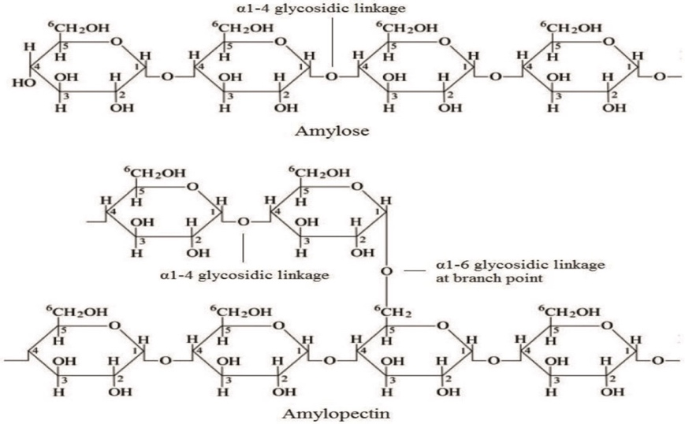
Fig. 1: Structure of amylose and amylopectin in starch

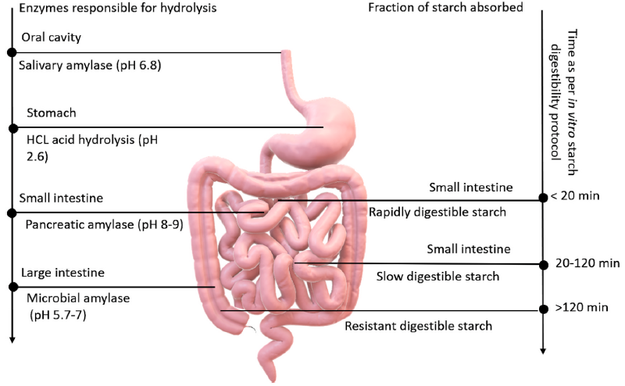
Fig. 2. Schematic representation of starch hydrolysis and absorption of different starch fractions (Kaimal et al., 2021)
Diagrammatic representation of in vitro starch hydrolyzation kinetics simulating the in vivo human digestive system. Starch fractions are divided into three – rapidly digestible starch (RDS), slowly digestible starch (SDS) and resistant starch (RS). Starch digestion starts in the oral cavity where salivary amylase breaks down it into maltose units, the bolus moves down to the stomach where the enzyme is inactivated (due to the acidic environment). There is no carbohydrate breakdown in the stomach and the bolus moves to the small intestine. RDS fraction completely digests in the jejunum of small intestine, while SDS further continues till ileum. The pancreatic amylase breaks down the RDS and SDS fractions in the small intestine. RS after escaping digestion from mouth, stomach and intestine, moves to the large intestine (colon) where the RS granules are solubilized or fermented or bio-transformed into short chain fatty acids (SCFA) by the gut microbiome SCFAs.
3. Classification of starch
I) Based on the action of enzymes
The activity of amylolytic enzymes of the gastrointestinal tract, starch undergoes hydrolysis. Starch is classified based on its rate and extent of digestion and physiological properties. The three types of starches viz., Rapidly Digestible Starch (RDS), Slowly Digestible Starch (SDS) and Resistant Starch (RS) (Englyst et al., 1992).
Table 1: Classification of starch (Englyst et al., 1992)
Starch fraction | RDS | SDS | RS (Type 1-4)
Digestion timeline in vitro/place | Within 20 min, mouth and small intestine | 20-120 min, small intestine | >120 min, not in the small intestine, main action in colon
Examples | Freshly cooked food | Native waxy maize starch, millet, legumes | Raw potato, stale bread
Amount (g/100 g dry matter) | Boiled hot potato: 65 | Boiled millet: 28 | Raw potato starch: 75
Main Physiological property | Rapid source of energy | Slow and sustained source of energy and sustained blood glucose | Effects on gut health (i.e., prebiotic, fermentation to butyrate with hypothesized anticarcinogenic effects)
Structure | Mainly amorphous | Amorphous/crystalline | Depending on the type, mainly crystalline
II) Based on X-ray diffraction
On the basis of their X-ray diffraction patterns, starch can be classified into four main categories. Type A: This type of structure has chain lengths of 23–29 glucose units in amylopectin. A type has densely packed double helices and contains 4 water molecules per 12 glucose residues (Lebail et al., 2000). A-starch is found chiefly in cereals. Type B: This type of structure has chain lengths of 30–44 glucose units in amylopectin. B type has loosely packed double helices and contains 36 water molecules per 12 glucose residues (Lebail et al., 2000). This is the usual pattern of starches in tuber and banana. Type C: The type C structure is made up of amylopectin of chain lengths of 26–29 glucose molecules. This type is found in peas and beans. Type V: An additional type which is a single helical structure initiated in amylose complexed with lipids or other agents (Zobel, 1988; Lebail et al., 2000). It is found in swollen granules.
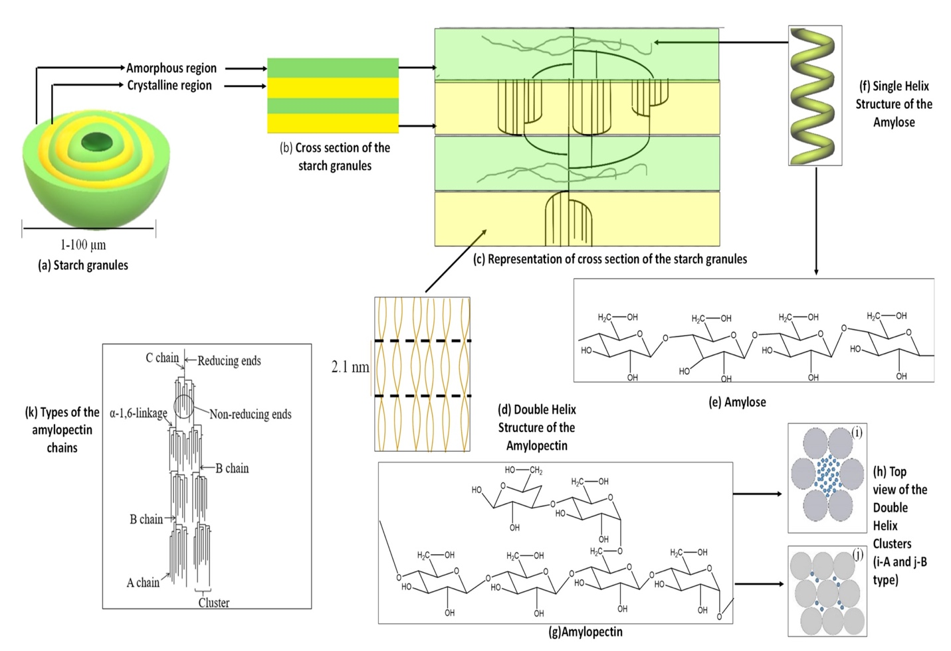
Fig. 3: Schematic representation of the (a) Starch granules; (b) Cross section of the starch granule; (c) Representation of the cross section of the starch granules; (d) Double helix structure of amylopectin; (e) Structure of amylose; (f) Single helix structure of amylose; (g) Structure of amylopectin; (h) Top view of the double helix clusters: (i) A type, (j) B type, and (k) Types of amylopectin chains.
Starch is mainly composed of amylose (80%), amylopectin (20%), lipid, protein (0.6%), and a small quantity of minerals (<0.4%) (Alcazar-Alay et al., 2015). The amount of amylose and amylopectin varies according to the source of starch (Bertolini, 2009). Amylose is insoluble in water, whereas amylopectin is soluble in water (Bertolini, 2009). Starch also contains a small fraction of compounds known as “intermediate compounds,” which have intermediate properties of both amylose and amylopectin (Vilaplana et al., 2012). The molecular weight of amylose is around 105–107 Da, while amylopectin has a molecular weight of 107–109 Da. Moreover, the molecular weight of the intermediate compound is less than amylopectin and higher than amylose (Vilaplana et al., 2012). Starch granules are made of alternating layers of the amorphous and crystalline lamellae with thicknesses between 100 and 400 nm (BeMiller and Whistler, 2009). The starch granules have a density of about 1.5 g/cm3. The diameter of the granules generally ranges from 1 to 100 μm (see Figure 3a), and the shapes can be regular such as spherical, oval, angular, or quite irregular (Bertolini, 2009). Moreover, the shape, size, structure, and composition of starch granules are dependent on their botanical source (Alcazar-Alay et al., 2015). However, starch granules are not soluble in either cold water or water at room temperature due to the strong hydrogen bonds between the starch chains (BeMiller and Whistler, 2009). There are alternating layers of the crystalline and amorphous lamella, as shown in Figure 3b. The crystalline lamella of starch granules consists of double-helical amylopectin side-chain clusters, while amorphous lamella consists of amylopectin branching regions and amylose chains (Bertolini, 2009), as can be seen in Figure 3c, d. Amylose is composed of D-glucose units linked by α-1,4-glycosidic bonds and consists of small branches, as shown in Figure 3e (Bertoft, 2017).
Usually, amylose forms a single helical complex (see Figure 3f) in the presence of complexing agents (BeMiller and Whistler, 2009). Amylopectin is composed of α-D-glucose units linked by α-1,4 and α-1,6-glycosidic bonds (See Figure 3g) (Bertolini, 2009). The linear amylopectin chains are relatively shorter compared to amylose chains. Moreover, amylopectin is highly branched compared to amylose (Bertolini, 2009). Furthermore, the degree of polymerization (DP) of those external chains is around 10–20 as two chains unite into a double-helix with six glucose units per turn of each strand and a pitch of 2.1 nm, as shown in Figure 3d (Bertoft, 2017). The length of these double-helices is about ~4–6 nm and crystallizes either into one of the two polymorphs, called A- or B-types (Bertoft, 2017). A-type is known as the monoclinic unit cell with eight (8) water molecules, while B-type is a hexagonal unit cell with thirty-six (36) water molecules (Bertolini, 2009) as shown in Figure 3h,i and 3h,j. The amylopectin structure contains three types of chains known as A, B, and C, as illustrated in Figure 3k (Bertolini, 2009). The A-chain is linked to the α-d-glucose units only by a reducing end without bonding to other chains. The B-chains are bonded to either A-chain or other A- or B- chains via one or more hydroxyl groups (-OH) present in the amylopectin chains. The reducing end groups generally are carried by the C types of the chain (Bertolini, 2009). The physicochemical properties of starch mainly depend on the amylose and amylopectin ratio. The glass transition temperature (Tg) is one of the physical properties of the polysaccharides, which describes the temperature that transforms from an amorphous state to a viscous state (Alcazar-Alay et al., 2015). At Tg, polymer material transits from a glassy, brittle state to a soft and flexible state. Since starch consists of both amorphous and crystalline regions, Tg of starch cannot be detected easily (Alcazar-Alay et al., 2015).
- Why Resistant starch?
Most of carbohydrate-rich foods are known to be high glycemic. Glycemic index (GI) ranks food according to their effect on blood glucose level and high GI food cause fatal health problems such as diabetes and obesity. Development of carbohydrates-based functional foods with low GI is need of the hour. Due to the inverse relation between GI and RS, food nutritionists are looking for use of RS as food fortificant to lower the GI of food. For development of functional foods, fortification is an economically feasible way to deliver the desired component such as RS, in targeted population group. RS is naturally available in different botanical sources, which provides opportunity of its use as a functional ingredient (Raigond et al., 2015).

Resistant Starch
The term “resistant starch” was coined by Englyst et al. to describe a small fraction of starch that resist hydrolysis by α-amylase and pullulanase treatment in vitro (Englyst et al., 1992). RS resists digestion and absorption in the small intestine and is fermented in the colon. RS is a linear molecule of α 1, 4 D-glucan and is mainly derived from retrograded amylose in cooked starchy food. Large number of factors influences the rate and extent of starch digestion and all of these factors are interlinked which complicate the understanding of resistant nature of starch.
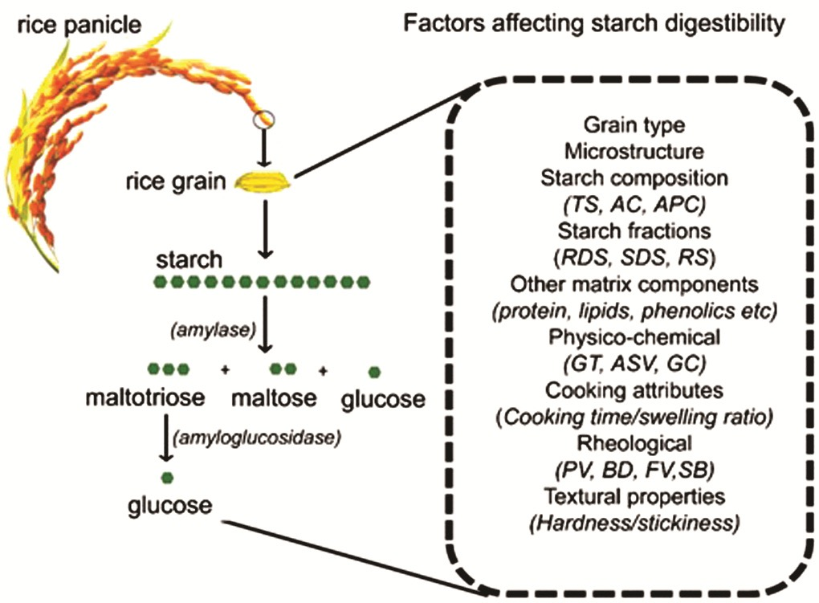
Fig. 4: Mechanism of in vivo starch hydrolysis and various factors affecting it (Rahaman
et al., 2020)
Mechanism of in vivo starch hydrolysis and various factors affecting it. Rice contains about 78-89% starch and its hydrolysis occurs in two steps in human body. The illustration (left side) represents the action of carbolytic enzymes like amylase and amyloglucosidase. Step 1 in the digestion of starch is catalysed by salivary and pancreatic amylases which produce maltotriose, maltose and glucose. Step 2 of hydrolysis to glucose is carried out by brush bordered disaccharidases or glucosidases. Inherent factors which often interplay and affects the starch digestibility is presented on the right side of the illustration.
- Global Resistant Starch market size
Fig. 5: Global Resistant Starch market size (www.gminsights.com)
Types and structure of RS
RS is the part of consumed starch that is digested incompletely and in the intact form or as products of its partial hydrolysis, escapes the small intestine and enters the large bowel. It is measured from the difference between the amount of starch subjected to the activity of amylolytic enzymes and the amount of glucose (as starch equivalent) produced as a result of hydrolysis with those enzymes (Sajilata et al., 2006).

- Types of Resistant Starch
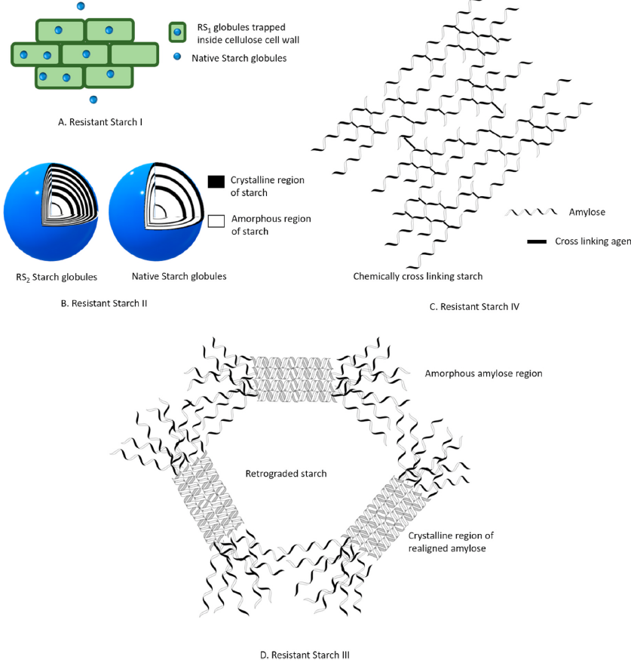
Fig. 5. Schematic representation of different resistant starch fractions (Kaimal et al., 2021)
Numerous literatures suggest several factors responsible for resistance of RS against enzymatic hydrolysis. According to these factors, RS can be classified as RS1, RS2, RS3, RS4, RS5. RS1 is a portion of RS which is embedded inside food matrix. This engulfed structural material restricts enzymatic hydrolysis of starch, thus making it resistant (Fig. 5). These are generally present in partially milled grains and are heat resistant in most cooking operations (Sajilata et al., 2006). Therefore, intensive milling operation can reduce RS1 content by releasing physically protected starch. RS2 starch fraction is native, ungelatinized starch granules present in raw food commodities such as green banana, raw potatoes. Radial compact crystalline structure of these starch fraction restricts enzymatic hydrolysis and impart resistance (Fig. 5) (Sajilata et al., 2006). RS3 is a major portion of RS fraction. RS3 is also known as retrograded starch. Retrogradation of starch is a recrystallization phenomenon of coiled amylose, that occurs upon cooling after gelatinization. These random coiled amylose, leached out during gelatinization, realigns to form compact double helical crystalline structures (Fig. 5) (Doppert and Staverman, 1966). These impenetrable dense structures restrain the entry of amylolytic enzyme and hinders digestion. (Sajilata et al., 2006). RS4 can be classified as chemically modified starch. Chemical modification is usually performed in native starch to impart improvised physicochemical, thermal, functional properties (Dupuis et al., 2014). Chemical modifications such as substitution, cross-linking, esterification produce atypical chemical linkages (Fig. 5). This in turn changes the structure and solubility of starch, thereby delaying rate of hydrolysis (Sajilata et al., 2006). RS5 is a complex form RS formed as a result of amylose-lipid interactions. Interaction between lipid compounds such as long chain fatty acids, glycerol monostearin (Eliasson, 1994) and amyloses imparts hydrophobicity to starch, thus making it resistant towards enzyme hydrolysis and gelatinization (Meenu and Xu, 2019).
Table 2: Classification of types of resistant starch (RS), food sources and factors affecting their resistance to digestion in the colon (Raigond et al., 2014)
RS type | Description | Food sources | Resistance minimized by | Digestion in small intestine
RS1 | Physically protected | Whole-or partially milled grains, seeds, legumes | Milling, Chewing | Slow rate, partial degree, totally digested if properly milled
RS2 | Ungelatinized resistant granules with type B crystallinity, slowly hydrolysed by α-amylase | Raw potatoes, green banana, some legumes, high amylose corn | Food processing and cooking | Very slow rate, little degree, totally digested when freshly cooked
RS3 | Retrograded starch | Cooked and cooled potatoes, bread, cornflakes, | Processing  conditions | Slow rate, partial degree, reversible digestion, digestibility improved by reheating
RS4 | Chemically modified starches due to cross-linking with chemical reagents | Foods in which modified starches have been used (e.g. breads,cakes) | Less susceptible to digestibility in vitro | A result of chemical modification, can resist hydrolysis
RS5 | Amylose-lipid complexes | Foods with high amylose content | Not susceptible to hydrolysis by α-amylase | Can resist digestion

Table 3: Classification of food materials according to the range of resistant starch content (% dry matter) (Goni et al., 1996)
Sl. No. | RS Range | Food materials
1 | Negligible (<1.0%) | Boiled potato (hot), boiled rice (hot), pasta, breakfast cereals containing a high proportion of bran, wheat flour
2 | Low (1.0–2.5%) | Breakfast cereals, biscuits, breads, pasta, boiled potato (cooled), boiled rice (cooled)
3 | Intermediate (2.5–5.0%) | Breakfast cereals (corn flakes, rice flakes), fried potatoes, extruded legumes
4 | High (5.0–15.0%) | Cooked legumes (lentils, chickpeas, beans), peas raw rice, autoclaved and cooled starches (wheat, potato, maize), cooked and frozen starchy foods
5 | Very high (> 15.0%) | Raw potatoes, raw legumes, amylo-maize, unripe banana, retrograded amylose
- Methods of RS determination
Determination of RS in food ingredients and processed foods has become vital to the provision of nutritional information to consumers and others. To enable effective use of the research output on RS for food processing and nutritional applications, analytical procedures for the determination of RS need to be compared. At present, significant differences exist among procedures with respect to sample preparation, the enzymes used, and the establishment of experimental conditions that mimic gastrointestinal digestion of starch.
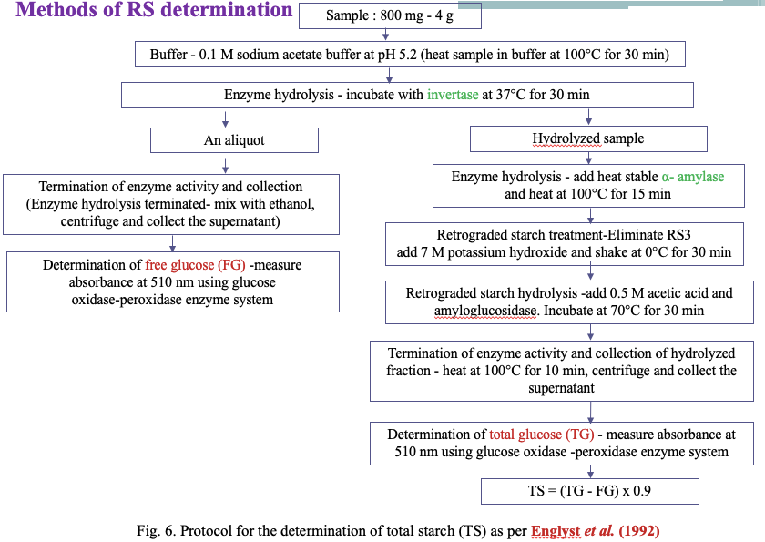
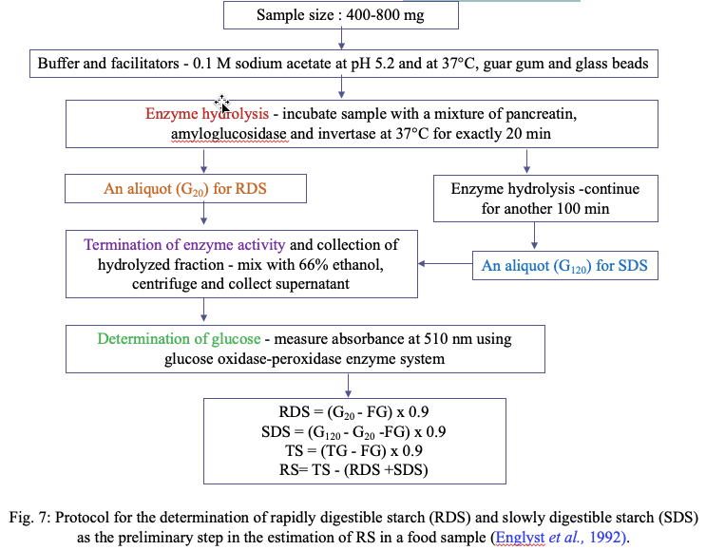
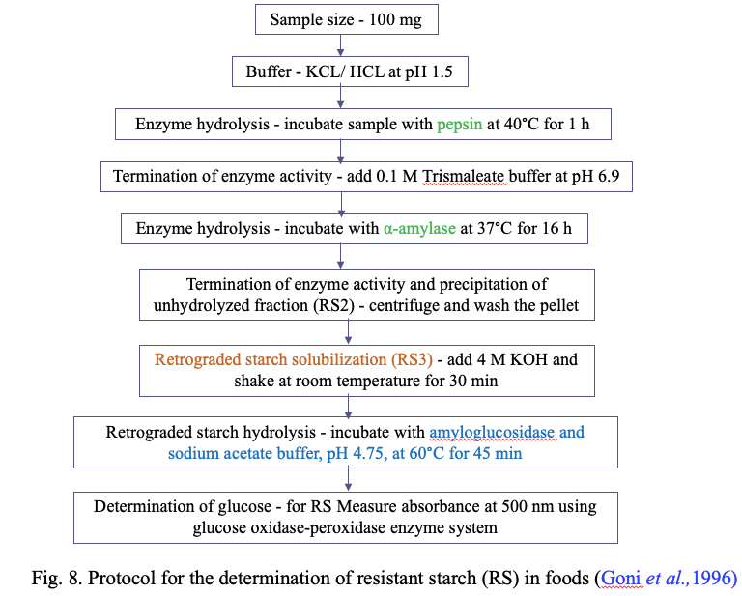
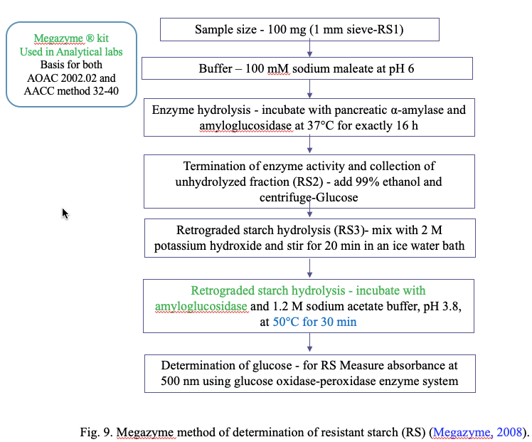
- Properties of RS
RS has gained importance because of its nutritional aspects as well as functional properties (Raigond et al., 2014). RS can be used in a variety of foods due to numerous desirable properties such as swelling, viscosity increase, gel formation, and water-binding capacity (Fausto et al., 1997).
- White in color
- High gelatinization temperature
- Fine particle size (which causes less interference with texture)
- Good extrusion and film-forming qualities
- Lowering the calorific value of foods
- Increase coating crispness of products
- Allow the formation of low-bulk high-fiber products with improved texture, appearance, and mouth feel (such as better organoleptic qualities) when compared with traditional high-fiber products (Raigond et al., 2015).
- RS Production Technologies
To fulfill the growing demands for functional foods, food industry is investigating ways to produce innovative functional food products with additional health benefits. With increasing awareness about health and nutrition among consumers, researchers and producers are aiming to develop functional foods with supplementary health merits (Aung et al., 2010). Researchers and nutritionists are working together for development of functional foods with low GI. Due to various health benefits such as positive influence on digestive tract functioning, gut microbial flora, blood cholesterol, GI as well as on diabetes control, and being low calorie ingredient RS can be used for fortification of high GI foods to convert them to low GI (Raigond et al., 2015). Presence of natural sources of RS makes it suitable functional ingredient for fortification purposes (Bello-Perez and Paredes-Lopez, 2009). In order to increase the intake of dietary fiber, consumers are ready to pay more for RS-fortified food products. Several techniques are available to alter the GI as well as rate of starch digestion. These techniques involve modification of key functional ingredients using low or no calorie sugars, formation of starch lipid-complexes, or through processing techniques such as heat moisture treatment and extrusion. RS is included in the food to combine physical characteristics of the food such as texture, water holding capacity, processing stability, and nutritional functionality. To preserve the nutritional functionality of RS-containing food, stability of RS during processing is of utmost importance (Thompson, 2000). Various techniques such as heat, enzymatic, heat with enzyme, and chemical treatment are available for manufacture of RS.
1) Heat Treatment
1.1 Heating Cooling Cycles
Repeated heating and cooling cycles for RS production are being used since long. Another method for RS production involves starch gelatinization followed by enzymatic debranching of gelatinized polymer, deactivation of the debranching enzyme, and isolation of the resultant product by drying/extrusion/cocrystallization. RS produced by using heating-cooling cycles is RS3. Raigond et al. (2014) studied the effect of cooking (boiled, microwave cooked, pressure cooked) followed by low temperature storage (4 and 12°C) for different durations (12 and 48 hour) on starch content. RS content increased up to 63% after boiling and cooling of potatoes at 4°C for 48 h for boiled hot potatoes.
  - Hydrothermal Treatment
Hydrothermal treatment involves physical modifications that change the physico- chemical properties of starch without altering its granular structure. Annealing (ANN) and heat moisture treatment (HMT) are the main hydrothermal treatments where the temperature and heating time need to be controlled. These treatments are based on the starch to moisture ratio. In ANN treatment, a combination of excess of water (>40%) and temperature below gelatinization is used, whereas HMT takes place under controlled moisture content (10–30%) with high temperature (90–120°C) (Zeng et al., 2015). Partial acid hydrolysis enhances the effect of hydrothermal treatment and can result in heat stable granular RS (Brumovsky and Thompson, 2001). HMT is natural physical modification technique that is safer than chemical modification of starch. In ANN treatment temperature must be held below gelatinization temperature to retain the initial granular structure of starch. Granular structure is lost due to combination of gelatinization and melting at 40–60% moisture level. Enhanced granular stability due to hydrothermal treatment results in high RS content (Thompson, 2000). ANN treatment is known to enhance the degree of starch crystallinity, strengthen crystalline form of granules, and order starch chains in crystalline as well as amorphous layers. All of this increases granule stability with decreased solubility and swelling capability and hence, in turn, increase resistance of starch granules to amylolytic enzyme (Hoover and Vasanthan, 1994). Lee et al. (2012) used different combinations of moisture (20–25%) treatment, duration (1, 5, and 9 h), and temperatures (110°C, 130°C, and 150°C) to treat waxy potato starch (0% amylose) and achieved maximum RS yield, i.e., 66.8% with the combination of 20% moisture, 110°C temperature, and 5-h treatment.
  - Extrusion
Extrusion technique is widely used in food processing industry to prepare food products with different shapes. This is a high temperature short time process (HTST) and has the potential to increase the RS content of food product up to certain extent. During extrusion high shear force causes depolymerization followed by thermal cleavage of the starch molecule. As a result straight chains are produced which are more prone for retrogradation into RS3 (Agustiniano-Osornio et al., 2005). RS content of normal corn starch increased from 11% to 20% after acid hydrolysis followed by low or high shear extrusion (Hasjim and Jane, 2009). Extrusion conditions such as barrel temperature, screw speed and shear force have more impact on RS yield as compared to starch moisture content (Dupuis et al., 2014). Extrusion of maize starch with 12–18% moisture did not show significant increase in RS content, whereas at 20% moisture level, RS content increased significantly. Origin of starch affects the RS yield during extrusion. Because of high gelatinization temperature and amylose content banana starch is most efficient for production of RS through extrusion, compared to other starches (Bello-Perez and Paredes-Lopez, 2009).
  - Heat and Enzyme Treatment
RS production can be increased by using a combination of heat and enzymatic or chemical and enzymatic modification. Enzymes or chemicals can be used to remove amorphous region of retrograded starch. Example of simultaneous heat and enzyme treatment is pullulanase treatment of gelatinized starch and isolation of the product by drying/extrusion. RS production is also achieved by controlled heat treatment of starch, followed by debranching with the help of enzymes, annealing, and drying (Haralampu and Gross, 1998). Treatment of gelatinized starch with debranching enzyme such as isoamylase or pullulanase results in debranched amylopectin starch. Debranched amylopectin starch is used in formation of reduced-fat food products and can be prepared from any starch containing amylopectin such as common corn and waxy maize starch. In high amylose maize starch, RS content is increased by enzymatic debranching followed by extrusion or drying, where the addition of an inorganic salt or debranched starch before the isolation further increases the RS content (Sajilata et al., 2006). Debranching of potato amylopectin with pullulanase before repeated heating-cooling cycles as well as maize starch debranching increase the RS3 yield (Zhang and Jin, 2011). However, to get high yield of RS3 from maize starch autoclaving of starch at 121ºC for 1 h before debranching is required.
2) Enzymatic Treatment
Lower molecular mass of starch and amylopectin debranching play a role in enhanced RS production and enzymes are used for both of these purposes (Reddy et al., 2013). Debranching enzymes such as pullulanase and isoamylase act only on α 1,6 glycosidic bonds at branch points of amylopectin and break these bonds. As a result amylose content of the starch increases which in turn forms tightly packed crystalline structures which is responsible for the resistant nature of starch. Enzymes such as α- and β-amylase can also be used to break the α-1,4 glycosidic bonds. Both enzymes act on different areas of starch molecules, where α- amylase breaks all α-1,4 glycosidic bonds leaving those near the branch points and releases glucose monomers. Whereas β-amylase breaks every other α-1,4 glycosidic bond from nonreducing end of amylopectin or amylose and releases maltose units. In practice, pullulanase and isoamylase are commonly used for RS production compared to α- and β-amylase. As α-amylase breaks almost all the α-1 ! 4 glycosidic bonds of starch, it lowers the starch paste viscosity and as a result adversely affects crystal formation. In low viscosity starch pastes fast movement of linear chains causes difficulty in crystal formation (Gao et al., 2011). Optimization of α-amylase is required to obtain sufficient yield of RS. Measurement of total dietary fiber content of RS samples through enzyme treatment revealed that the concentration of α-amylase is more critical compared to amyloglucosidase (McCleary, 2000).
The α- amylase activity showed inverse relationship with RS content. Poly 1,4-α-D- glucan can also be used for production of readily fermentable heat stable RS of optimal chain length. Pullulanase enzyme can also be used to produce RS with the same cooking quality as that of untreated rice starch or flour. Starches from potato, oat, barley, sago, corn, wheat, tapioca, and arrow root can be used to produce RS through pullulanase treatment (Sajilata et al., 2006).
3) Chemical Treatment
Chemical reagents are used to block the enzyme access and as a result modified starch escapes digestion after chemical treatment. Chemical treatment changes the molecular structure of starch which results in high RS production. Acidification, esterification, and cross-linking are the major forms of chemical modification of starch.
  - Acidification
The purpose of acidification is to first hydrolyze the amorphous parts of starch granules followed by hydrolysis of crystalline region. This process generates short chains of amylopectin which are disorganized by autoclaving followed by acidification. During retrogradation, these chains reorient to form more ordered double helix structures which resist enzyme hydrolysis (Hoover, 2000). Acid modification followed by autoclaving and retrogradation to increase RS yield is reported by several researchers (Shin et al., 2004). Acids such as hydrochloric acid, orthophosphoric acid, and sulfuric acid can be used for starch modification (Wurzburg, 1995). Tester et al. (2004) obtained 49.5% RS by treatment of lima bean (Phaseolus lunatus) with hydrochloric acid at 1/60 parts of native starch at 90ºC for 1 h.
  - Cross-Linking
Food industry is using cross-linking to improve functional property, freeze thaw stability, and cold storage stability of starch pastes. Cross-linking stabilizes and strengthens starch by randomly adding inter- and intramolecular bonds (Acquarone and Rao, 2003). Woo and Seib (2002) have described the use of various cross-linking techniques for increasing RS yield in normal starches derived from several botanical sources. Starches are chemically modified by treating with multifunctional reagents that form ether or ester linkage between hydroxyl groups of starch molecule (Singh et al., 2007). Chemically modified starches show resistance to enzyme hydrolysis in both raw as well as gelatinized form (Lehmann and Robin, 2007). During chemical modification, starch resistance is improved by substitution of starch hydroxyl group with citryl, acetyl, octenyl succinyl, and hydroxypropyl (Xie and Liu, 2004). Cross-linking of starch with phosphate showed contradictory results as some authors (Woo and Seib, 2002) reported decrease in digestibility of starch and some authors (Chung et al., 2008) reported either slight or no change in the digestibility of starch. These contradictions could be due to the difference in the origin and property of starch and the conditions used to modify starch. For production of cross-linked starches bi-or-polyfunctional reagents such as sodium trimetaphosphate, phosphorous oxychloride, or mixed anhydrides of acetic acid and dicarboxylic acid like adipic acid are used. Kahraman et al. (2015) reported use of reagents such as sodium triphosphate or its mixture with sodium tripolyphosphate for cross-linking glucans for RS production. Factors such as source of starch, reaction conditions like time, temperature, pH, and type and concentration of cross-linking reagent affect the chemical and functional properties of cross-linked starches (Singh et al., 2007).
Chemically modified starches have been utilized as food additives, thickening or gelling agents, and fat replacers. Hydrothermal treatments increase the accessibility of chemically modified starches to the amylolytic enzymes. However, the level of digestion is determined by the origin of starch and degree of substitution with chemical groups. Di-starches are modified RS with high dietary fiber content (70% w/w) and their resistance to the activity of amylase show direct correlation with degree of chemical substitution (Woo and Seib, 2002). Acetylated retrograded starches also come under chemically modified starches and their quality is influenced by degree of substitution and raw material used for esterification (Zeiba et al., 2013). Hydroxy propylation, roasting with glycine, and cross-linking with epichlorohydrin also increase starch resistance to amylolytic enzymes (Juansang et al., 2012).
4) Hydrostatic Pressure Treatment
Hydrostatic pressure treatment (HPT) is a nonthermal food processing method where food is processed at high hydrostatic pressure (HHP) ranging from 200 to 600 MPa. Water is used as a pressure transmitting medium in this process (Martin et al., 2002). During HPT, starch microstructure is influenced by factors such as pressure level, method of pressure application, time, temperature, constitution of food, and phase state of food (Katopo et al., 2002). Li et al. (2012) carried out work where rice starch-water suspension (20%) were subjected to HPP treatment at 120 to 600 MPa (120, 240, 360, 480 and 600 MPa) for 30 min converted the A-type X pattern of starch to B-type at 600 MPa which led to complete gelatinization of starch granules.
- RS From Different Sources
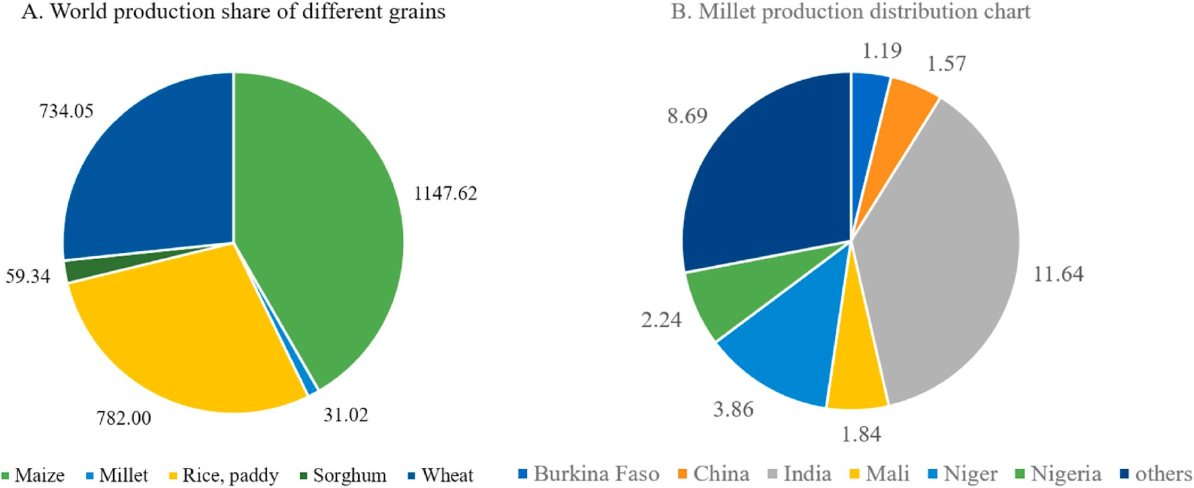
Fig. 10. Grain statistics. A. World production share of different grains for the year 2018 in million metric tonnes, B. Geographical distribution of millet production for the year 2018 in million tones (FAO, 2019).
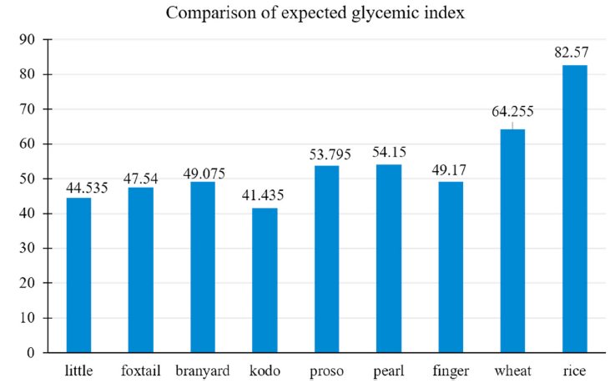
Fig. 11 Comparison of expected glycemic index from different raw grains (Bora et al., 2019; Sharma and Gujral, 2020)
Table 4: Comparison of starch fractions of different raw millets from different localities
(Kaimal et al., 2021)
Sl.  No | Grain | Country  of origin | Starch  (g/100g dry wt.) | Amylose  (g/100g starch) | Amylopectin (g/100g starch) | RDSª (g/100g starch) | SDSª  (g/100g starch) | RSª  (g/100g starch) | Reference
1 | Finger millet | India | 55.00–65.00 | 15.20–16.00 | 83.80–84.20 | 21.28–20.94 | 67.69–66.60 | 1.89–2.05 | Thippeswamy et al. (2016)
2 | Finger millet | Sri Lankan | 59.03–65.00 | 19.61–21.47 | 38.72–45.03 | 17.54–18.52 | 75.00–75.42 | 6.35–7.02 | Jayawardana et al. (2019)
3 | Pearl millet | India | 53.00–68.00 | 13.61–18.12 | 81.88–86.39 | 46.30–50.10 | 37.20–38.70 | 9.00–16.50 | Sandhu and Siroha (2017)
4 | Foxtail millet | Taiwan | 56.2–73.1 | 1.38–12.35 | 87.65–98.62 | 13.10–26.80 | 32.20–43.10 | 35.2–51.2 | Yin et al. (2019)
5 | Proso millet | China | 58.0–77.87 | 2.24–38.67 | 25.44–69.00 | 31.13–40.09 | 47.56–51.04 | 8.12–19.00 | Shen et al. (2018)
6 | Barnyard millet | India | 48.20–60.20 | 8.90–18.50 | 81.50–91.10 | 24.8–36.56 | 21.99–30.7 | 41.45–44.6 | Sharma and Gujral (2020)
7 | Little millet | India | 42.00–57.30 | 11.90–17.90 | 82.10–88.10 | 20.20–33.58 | 19.87–32.10 | 46.54-47.70 | Sharma and Gujral (2020)
8 | Kodo millet | India | 47.60–60.30 | 15.30–17.50 | 82.50–84.70 | 19.20–21.80 | 29.60–33.20 | 37.5–51.20 | Annor et al. (2013)
ª wt.: Weight, RDS: rapid digestible starch, SDS: slow digestible starch and RS: resistant starch.

Table 5: Comprehensive description of various literature available for millet RS preparation

Sl.  No. | Millet | Treatment | Parameters |  | Initial RS content  (g/100g) starch | Final RS  content  (g/100g) starch) | Inference |  | Reference
Thermal treatments
1 | Foxtail millet | Annealing | 50◦C for 24 h followed by cooling to 4◦C within 24 h |  | 18.2 | 42.33 | Annealing was found to be effective in increasing RS content of foxtail millet by 2.3-fold |  | Babu et al. (2019)
2 | Foxtail millet | Hydro-thermal  treatment | 110◦C for 16h |  | 13.1 | 32.93 | Hydrothermal treatment could  effectively increase the RS content of foxtail millet by 2.5-fold |  | Amadou et al. (2014)
3 | Proso millet | Autoclaving | 100°C and  121°C for 30 min |  | 11.5 | 15.5 | They also conferred that RS formation can be promoted by increasein temperature |  | Ming-zhu et al. (2020)
Chemical treatments
4 | Pearl millet | Octenyl succinate  esterification | Esterified by 3% octenyl succinate anhydride for  2–5 h |  | 2.1 | 13.7 | The highest RS content was observed for samples with reaction time of 5 h |  | Sharma et al. (2016)
5 | Different varieties of pearl millet | Crosslinking by chlorohydrin | Crosslinking by epichlorohydrin (0.5%) for 5 h |  | 9.7 | 19.4 | The crosslinking could efficiently increase the RS content (15.3–19.4%) of all pearl millet varieties |  | Siroha and Sandhu (2018)
Novel technologies
6 | Barnyard millet | Microwave  drying | Drying at 110°C and  120°C for 10–20 min |  | 1.03 | 26.89 | Optimized parameters for RS enhancement was 180◦C for 20 min. |  | Kanagaraj et al. (2019)
7 | Foxtail millet | Ultrasound | 33khz for 30 min at  50°C |  | 18.2 | 20.14 | Ultrasound treated sample showed a marginal 10.6% increase in RS |  | Babu et al. (2019)
Combined treatments
8 | Finger millet | Thermo-  chemical  approach:  Sono-chemical  approach:  Acid pretreated  Chemical  approach: | Annealing:  110ºC for 6 h  Sonication: 33 khz for 1 h at 40ºC  Acidhydrolysis: citric acid(1m)for 6 h at 45ºC  Succination: succinic anhydride (4%) for 2 h | 7.04 |  | Thermo-  chemical:  10.49  Sono-chemical: 15.53  Acid pretreated  chemical:  18.19 |  | Samples pretreated with acid prior to succination was superior in RS content compared to other approaches |  | Babu et al. (2019)
9 | Foxtail millet | Thermo-  sonic  approach  Sono-thermal  approach | Annealing: 50ºC for 24 h followed by cooling to 4ºC within 24 h  Sonication: 33 khz for 30 min at 50ºC | 18.2 |  | Thermo-Sonic:  29.64  Sono-thermal:  45.59 |  | Synergistic correlation in RS content (150% increase) of ultrasound pre-treated annealed sample |  | Babu et al. (2019)

Influence of food constituents on millet RS
Starch can interact with various food components during processing and storages. The influence of food constitutes of millet in RS formation

Table 6: Influence of millet constitutes on starch digestibility and its mode of action (Annor et al., 2017; Bae et al., 2016)

Sl. No. | Millet constituent | Effect on starch digestibility | Mode of action
1 | Protein | Reduces | The protein-starch gel encapsulates  starch globules resulting in reduced gelatinization and enzyme permeability
2 | Lipid | Reduces | Lipophilic amylo-lipid inclusion complex refrains the entry of amylase
3 | Dietary fiber | Nominal effect | Reduces gelatinization by binding water
4 | Polyphenols | Reduces | Millet polyphenols act as amylase inhibitor
5 | Organic acid | Increases | Facilitates starch hydrolysis at higher  concentrations

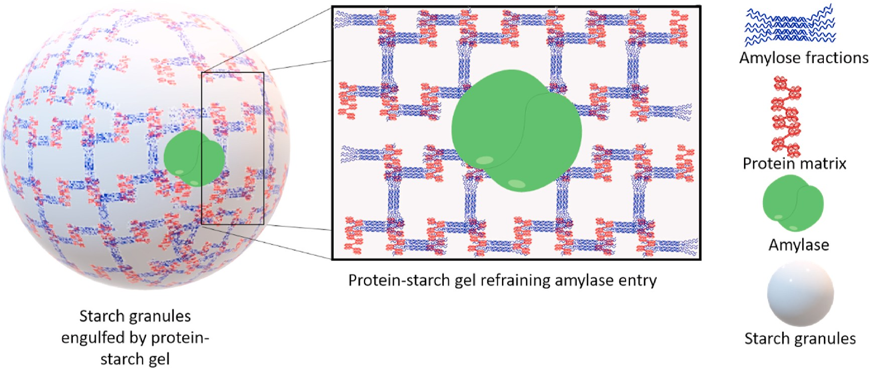

Fig. 12 Schematic representation of protein-starch gel restricting the entry of amylase into the starch granules

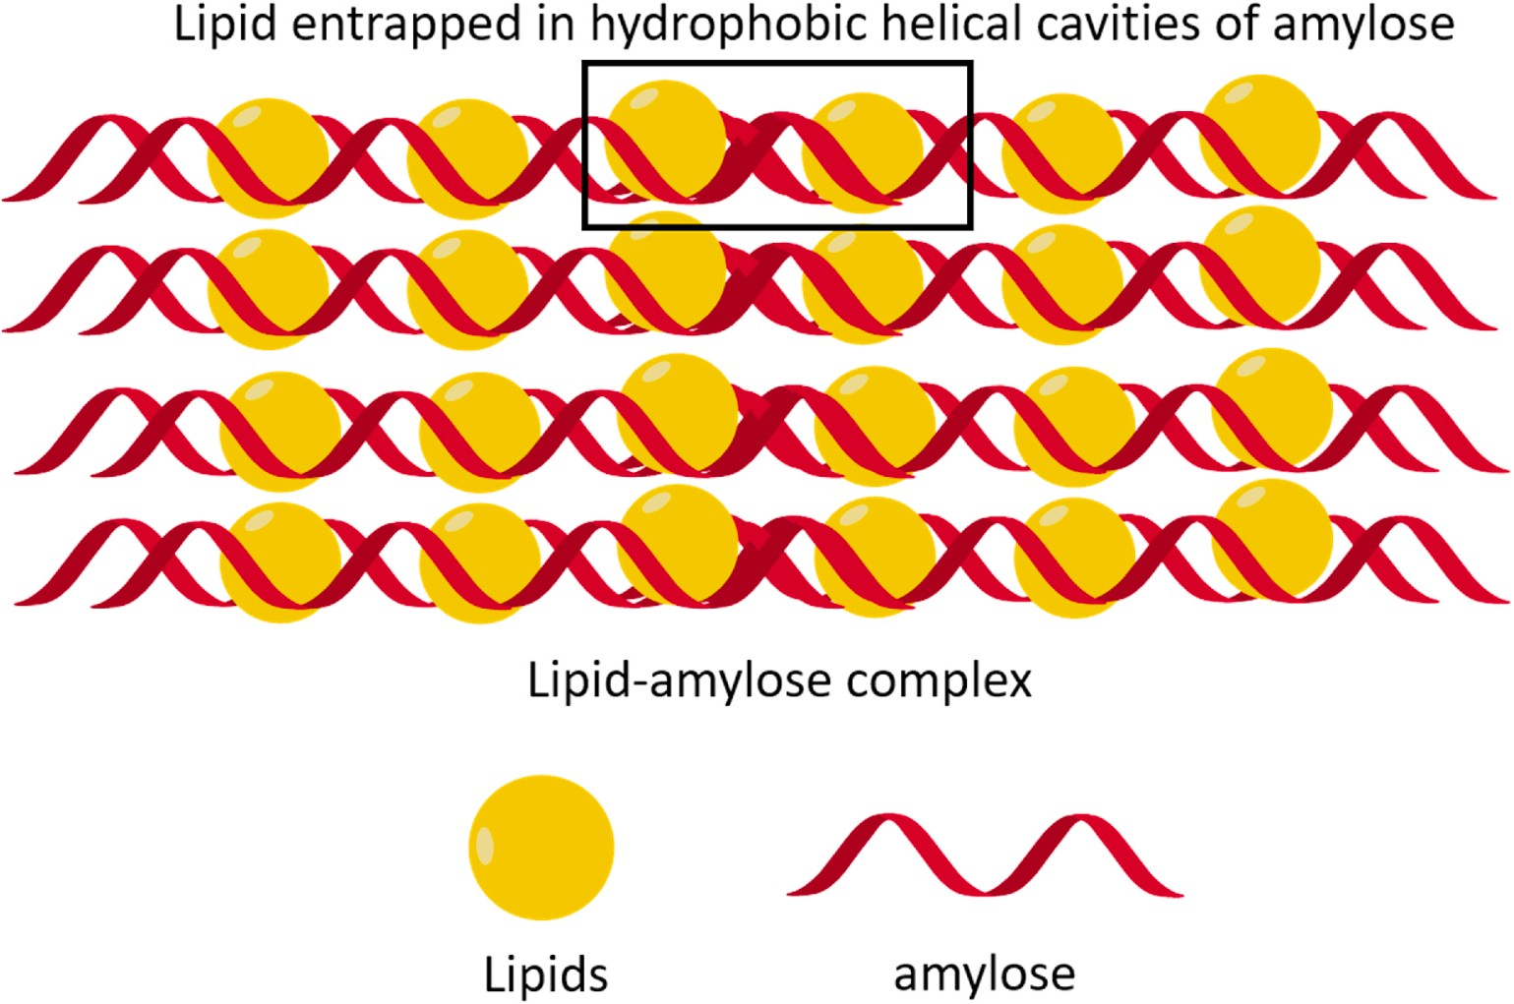
Fig. 13 Schematic representation of lipid-amylose inclusion complex

Table 7: Resistant starch concentrations in Pulses as influenced by genetics, processing method and RS analytical protocol (Perera et al., 2010)

Starch source | Treatment |  | RS | Method of RS analysis | Author
Pea | Raw, flour | Cultivar — 1674–13 | 13.3% | AACC method 32–40 (2000) with modifications | Chung et al. (2008)
 |  | Cultivar — 1215–33 | 14.7%
Pea | Raw | Cultivar — 1674–13 | 10% | Englyst et al. (1992) with modifications | Chung et al. (2009)
 | Annealed (15°C; 70% moisture; 24 h) |  | 10.9%
 | Heat-moisture treatment (100°C; 30% moisture; 2 h) |  | 13.3%
 | Heat-moisture treatment  (120°C; 30% moisture; 2 h) |  | 14.5%
Lentils | Raw flour | Cultivar — CDC Meteor | 14.9% | AACC method 32–40 (2000) with modifications | Chung et al. (2008)
 |  | Cultivar — CDC Robin | 14.4%
Lentils | Starch | Cultivar — CDC Meteor | 13% | AACC method 32–40 (2000) | Chung et al. (2008)
 |  | Cultivar — CDC Robin | 13.2%
Chickpea | Raw flour | Cultivar— Myles | 6.4% | AACC method 32–40 (2000) with modifications | Chung et al. (2008)
 |  | Cultivar — FLIP 97-101C | 4.7%
Chickpea | Starch | Cultivar — Myles | 8.4% | AACC method 32–40 (2000) | Chung et al. (2008)
 |  | Cultivar — FLIP 97-101C | 18.4%
Moth bean | Raw |  | 12.2% | Goni et al. (1996) | Bravo et al. (1998)
 | Freshly cooked |  | 3.9%
 | Cooked; stored at 4°C for 24 h |  | 4.8%
Horse gram | Raw |  | 26.4% | Goni et al. (1996) | Bravo et al. (1998)
 | Freshly cooked |  | 5.2%
 | Cooked; stored at 4°C for 24 h |  | 5.8%

Table 8. Resistant starch concentrations in Cereal starches as influenced by processing (Perera et al., 2010)
Starch source | Treatment | RS | Method of RS analysis | Author
Japonica brown rice | Pre-soaked in water at 25 or 50°C to reach 20% moisture + cooked | 29.2–32.4% | Englyst et al. (1992) | Han and Lim (2009)
 | Pre-soaked in water at 25 or 50°C to reach 30% moisture + cooked | 20.7–25.9% | Englyst et al. (1992) | Chung et al. (2006)
Corn | Acid modified with 1.64 M HCl at 40°C for 4 h + gelatinized+ autoclaved + lyophilized | 5% | AOAC 991.43 (1998) | Koksel et al. (2008)
 | Acid modified with 1.64 M HCl at 40°C for 4 h + gelatinized + autoclaved + Stored at 95°C for 48 h + lyophilized | 12%
Pastry wheat flour | Extruded at 20% moisture; 150/200/250 rpm; 40–120°C; stored at 4°C/0 days | 0.48–0.52% | Megazyme® assay | Kim et al. (2006)
 | Extruded at 20% moisture; 150/200/250 rpm; 40–120°C; stored at 4°C/7-14 days | 1.21–1.35%
 | Extruded at 40% moisture; 150/200/250 rpm; 40–120°C; stored at 4°C/0 days | 0.63–0.67%
 | Extruded at 40% moisture; 150/200/250 rpm; 40–120°C; stored at 4°C/7-14 days | 1.52–1.86%
 | Extruded at 60% moisture; 150/200/250 rpm; 40–120°C; stored at 4°C/0 days | 2.54–2.65%
 | Extruded at 60% moisture; 150/200/250 rpm; 40–120°C; stored at 4°C/7-14 days | 3.55–4.25%

- Commercially Available RS Products

Starch Australia Ltd. introduced the first commercial RS, i.e., Hi-maize. Later other companies introduced new commercial starches to market using different preparation technologies. The commercial RS prepared by different companies vary in percent RS content. Other commercial RS are CrystaLean® (RS3), Novelose®240 (RS2), Novelose®260 (RS2), Novelose®330 (RS3), Eurylon® (RS2), Amylomaize VII (RS2), and Neo-amylose (RS3) (Table 9). CrystaLean is RS3 produced by starch retrogradation of high amylose maize starch ae-VII hybrid. National Starch and Chemical Co. (USA) introduced Hylon-VII, a natural high amylose maize starch. Most of the above RS3 products are prepared by amylose retrogradation of high amylose corn starch using repeated heating and cooling cycles under controlled moisture and temperature conditions. These processes lead to manufacture of granular form of concentrated RS containing up to 47–60% RS content. A highly crystalline RS3 namely Actistar Act*-RS3 has also been prepared using maltodextrins as starting material. Due to the starting material and process used for the production, Act*-RS3 tastes very natural.
High amylose corn starch is also being used for the production of Fibersym HA, which is being used in a wide array of lower-net-carbohydrate food products. Fibersym HA provides more than 70% dietary fiber and is used in the preparation of food products such as pizza crust, breads, tortillas, cookies, muffins, breakfast cereals, snack products, and nutritional bars. Potato starch is used for the production of Fibersym 80ST. Fibersym 80ST has slightly higher water holding property which influences the properties of finished food products like cookie spread and muffin volume. Nutriose FB06 and Fibersol-2 also contain high RS content and provide 85% and 90% fiber content, respectively. Fibersym 80ST, Fibersym RW, Fibersym HA, and Fibersol-2 are all RS4 preparations and are available in the market. RS preparations without altering the organoleptic properties of food products reduce the availability of some saccharides. RS fortification does not alter the quality of product and organoleptic properties of extruded, baked products and confectionary remains unchanged (Raigond et al., 2014).

Table 9. Commercially manufactured resistant starch commonly used in various foods (Raigond et al., 2014)
Brand name  of commercial RS | Type | RS/TDF% content | Physiological and/or health  benefits | Manufacturer
Hi-maize | RS2 | 30-60%  TDF | Prebiotic properties. Lowers fecal pH. Increases the level of SCFA. (in particular butyrate which may reduce cancer risk). Increases bowel action with its mild laxative effect. Increases the bowels beneficial microflora | National Starch Chemicals co.,  USA
CrystaLean | RS3 | 19.2-41%  RS | Prebiotic effect. Increases proportion of butyrate. Increases cell proliferation in proximal colon (in rats). Provides soluble dietary fiber and prebiotic effects. Low glycemic index | Opta food  ingredients Inc., USA
Novelose 240 | RS2 | 47% RS | Lowers glycemic response when used as a substitute for flour and other rapidly digested carbohydrates | National Starch  and chemicals  co., USA
C*Actistar | RS3 | 53% RS | Health benefit potential. Prebiotic effect. Source of butyrate. Supports the immune system. Reduced glycemic response. Low calorific value. Easily fermentable RS. Very well tolerated. | Cerestar (Cargill company), US
Nutriose FB | - | 85% TDF | Low calorific value | Roquette, Freres, France
HylonR VII | RS2 | 23% TDF | Increases level of SCFA | National Starch and chemicals co., USA.

- Applications of RS
Potential physiological benefits and unique functional properties of RS have attracted the attention of nutritionists and food processors. With ever increasing awareness of consumers towards health and nutritious food, they are concerned with supplementary health merits derived from regular ingestion of RS along with traditional nutritional aspects of food (Aparicio-Saguilan et al., 2007). RS is one such ingredient which is being used for fortification of food products to enhance the nutritional value and health merits of food. RS being naturally present in broad range of starchy foods makes it convenient to use it as a functional ingredient for fortification purposes. RS fortified food products are gaining popularity among consumers and consumers are even ready to pay more for such food products to increase their dietary fiber intake (Buttriss and Stokes, 2008). At commercial level, RS containing starch ingredients are available in name of “resistant starch.” Most of these RS-enriched products are fully digestible and act as RS supplier (Xie and Liu, 2004).
RS is being used in the preparation of moisture-free food products. Cross-linked RS prepared from starches of maize, tapioca, and potato are being used for formulation requiring pulpy texture, smoothness, flowability, and low pH and high temperature storage (Sajilata and Singhal, 2005). Baked products, pasta products, as well as beverages are fortified with RS to improve their textural properties and nutritional quality. Most of the fat in imitation cheese was successfully replaced with RS, without adversely affecting the meltability or hardness of RS. In such cases, RS provides dual benefits, one being reduction of fat in a food product and another being health benefits conferred by RS itself. Nowadays large number of RS/fiber-fortified products such as high fiber breads, biscuits, and breakfast cereals are available in the market. The availability of techniques to prepare RS tolerant to processing made it possible to prepare RS-rich food products. Dry pasta products containing up to 15% RS can be prepared, without affecting dough rheology during extrusion. In comparison to unfortified pasta, RS-fortified pasta appears light in colour and has a firm texture in the same time as that of unfortified pasta (Sajilata et al., 2006). RS added opacity to the beverages. It is being used in thickened opaque health drinks in which insoluble fiber is desirable. RS is superior to other fibers, due to its bland taste, which imparts less gritty mouthfeel and masks flavour to much lesser extent. However, other fibers have a strong flavour, coarse texture, and poor and dry mouth feel (Raigond et al., 2014).
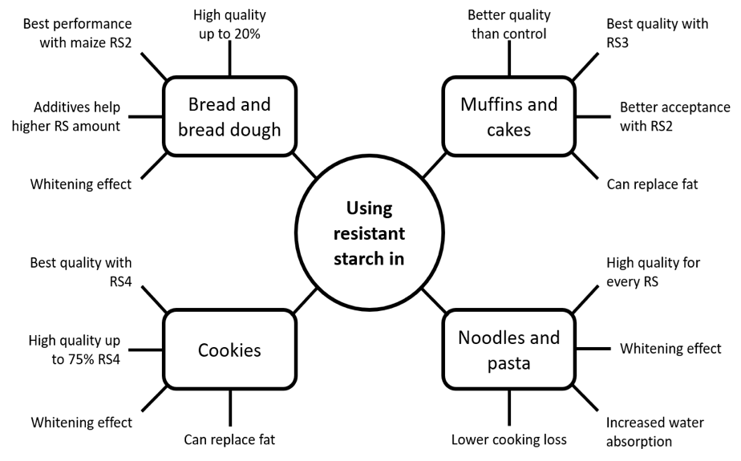
Fig. 14 Technological aspects of using resistant starch in wheat-based foods

Table 10: Summary of the main findings of testing RS in starchy, wheat-based foods (Arp et al., 2021)
Sl. No. | Product | Type and amount of RS | Results | Reference
1 | Bread dough | - Commercial maize RS2 up to 30% -  - Commercial maize RS3 up to 30%  - Lab-scale pea RS3 up to 30% | - ↑ water absorption, ↑ softening degree, ↑ resistance to extension  - ↓ development time, ↓ stability, ↓ extensibility Concentration effect  - Modified celluloses or enzymes can mitigate negative effects of RS2 | Arp et al., 2021
2 | Muffins | - Commercial tapioca RS3 15% | = volume and height and color  ↓ crumb hardness  ↑ RS (13.5%)  ↓ performance in sensory tests | Sanz et al., 2008
3 | Cakes | - Commercial maize RS2, RS3, and RS4  - Commercial potato RS3 | As fat replacers:  ↓ up to 50% of shortening addition  = or ↑ volume than full- or low-fat controls ↓hardening  = sensory scores than full-fat control | Serinyel and Ozturk, 2017
4 | Noodles and pasta | - Commercial maize RS4 up to 50%  - Commercial wheat RS4 up to 50% | ↑ water absorption  ↑ water absorption while cooking  ↓ extensibility and resistance to extension (raw and cooked samples)  = hardness (up to 40% RS)  ↓ cohesiveness (up to 20% RS)  ↓springiness (up to 30% RS)  ↓ GI estimated in vitro | Hsieh et al., 2020

Table 11: Summary of the main findings of testing RS in starchy, gluten-free foods
(Arp et al., 2021)
Sl. No. | Gluten-free product | Amount and type of RS (base or additional gluten-free ingredients) | Results | Reference
1 | Bread | Commercial maize RS2 up to 20%  Commercial tapioca RS3 up to 20%  (Base: maize and potato starch) | Good overall quality  ↓ volume at higher RS content  = (maize) or ↓ (tapioca or combination) hardness  = springiness and cohesiveness (20% RS)  ↑ dietary fiber up to 6.3% (maize), 4.3% (tapioca), 5.2% (combined) at 20% RS level | Korus et al., 2009
2 | Cakes | Commercial maize RS2 up to 20%  (Base: 20:80 tapioca starch and rice flour mix) | ↑volume  = or ↓ surface porosity and cell density  = or ↑ pore diameter  = cake color  = or ↓ elasticity  ↓ crumb firmness and firming rate  = overall acceptability scores | Tsatsaragkou et al., 2015
3 | Noodles and pasta | Commercial maize RS2 up to 20%  (Base: rice flour) | ↑ cooking time  ↓↓ cooking loss  ↑ firmness of cooked pasta  ↓ softness of overcooked pasta ↓ stickiness  ↑ RS loss after manufacturing | Foschia et al., 2017

- Potential Physiological effects
Table 12: Physiological properties of resistant starch (Brown, 2004; Champ, 2004)
Sl. No. | Potential Physiological effects | Conditions where there may be a protective effect
1 | Improve glycemic and insulinaemic responses | Diabetes, impaired glucose and insulin responses, the metabolic syndrome
2 | Improved blood lipid profile | Cardiovascular disease, lipid metabolism, the metabolic syndrome
3 | Improved bowel health | Colorectal cancer, ulcerative colitis, inflammatory bowel disease, diverticulitis, constipation
4 | Prebiotic and culture protagonists | Colonic health
5 | Increased satiety and reduced energy intake | Obesity
6 | Increased micronutrient  absorption | Enhanced mineral absorption, osteoporosis
7 | Adjunct to oral rehydration  therapies | Treatment of cholera, chronic diarrhoea
8 | Synergistic interaction with other dietary component, e.g. dietary fibers, proteins, lipids | Improved metabolic control and enhanced bowel health

- Conclusion
RS is ideal for fortification of ready to eat cereals, snacks, pasta, noodles, baked foods, and fried foods. These products can be labelled simply as “starch conferring additional nutraceutical benefits.” Processing conditions can be altered to increase its content in food. Products prepared with RS incorporation have better crispness, mouthfeel, colour, and flavour compared to those prepared with traditional fibers. RS has assumed great importance due to its physiological properties that can reduce the risk of several diseases, including colon cancer and diabetes and also is useful in controlling obesity and diabetes. RS-fortified products have better consumer acceptability because of its unique physiochemical properties.

- References
Acquarone, V. M. and Rao, M. A., 2003, Influence of sucrose on the rheology and granule size of cross-linked waxy maize starch dispersions heated at two temperatures. Carbohydrate Polymers, 51:451–458.
Agustiniano-Osornio, J. C., Gonzalez-Soto, R. A., Flores-Huicochea, E., Manrique-Quevedo, N., Sanchez-Harnandez, L., Bello-Perez, L. A., 2005, Resistant starch production from mango starch using a single-screw extruder. Journal of Science Food Agriclture, 85:2105–2110.
Alcazar-Alay, S. C., Meireles, M. A. A., 2015, Physicochemical properties, modifications and applications of starches from different botanical sources. Food Science Technology, 35: 215–236.
Amadou, I., Gounga, M. E., Shi, Y.-H. and Le, G.-W., 2014, Fermentation and heat- moisture treatment induced changes on the physicochemical properties of foxtail millet (Setaria italica) flour. Food and Bioproducts Processing, 92(1): 38–45.
Annor, G. A., Marcone, M., Bertoft, E. and Seetharaman, K., 2013, In vitro starch digestibility and expected glycemic index of kodo millet (Paspalum scrobiculatum) as affected by starch–protein–lipid interactions. Cereal Chemistry, 90 (3): 211–217.
Annor, G. A., Tyl, C., Marcone, M., Ragaee, S. and Marti, A., 2017, Why do millets have slower starch and protein digestibility than other cereals? Trends in Food Science & Technology, 66: 73–83.
Aparicio-Saguilan, A., Sayagoayerdi, S., Vargastorres, A., Tovar, J., Ascencioatero, T. and Belloperez, L., 2007, Slowly digestible cookies prepared from resistant starch-rich lintnerized banana starch. Journal of Food Components Annuals, 20 (4):175–181.
Arp, C. G., Correa, M. J. and Ferrero, C., 2021, Resistant starches: a smart alternative for the development of functional breads and other starch-based foods, Food Hydrocolloids.
Aung, K. H., Surjani, U., Udayasika, P., Ingrid, A. M. A., Amparo, L.R. and Elliot, P. G., 2010, The effect of acid dextrinisation on enzyme-resistant starch content in extruded maize starch. Food Chemistry,120:140–149.
Babu, A. S., Mohan, R. J., & Parimalavalli, R., 2019, Effect of single and dual- modifications on stability and structural characteristics of foxtail millet starch. Food Chemistry, 271, 457–465. https://doi.org/10.1016/j.foodchem.2018.07.197
Bae, I. Y., Jun, Y., Lee, S. and Lee, H. G., 2016, Characterization of apple dietary fibers influencing the in vitro starch digestibility of wheat flour gel. Food Science and Technology, 65:158–163.
Bello-Perez, L. A. and Paredes-Lopez, O., 2009, Starches of some food crops, changes during processing and their nutraceutical potential. Food Engineering Reviews, 1:50–65.
BeMiller, J. N. and Whistler, R. L., 2009, Starch: Chemistry and Technology; Academic Press: Cambridge, MA, USA.
Bertoft, E., 2017, Understanding starch structure: Recent progress. Agronomy, 7: 56.
Bertolini, A., 2009, Starches: Characterization, Properties, and Applications; CRC Press: Boca Raton, FL, USA.
Bora, P., Ragaee, S. and Marcone, M., 2019, Characterisation of several types of millets as functional food ingredients. International Journal of Food Sciences & Nutrition, 70 (6): 714–724.
Brown, I. L., 2004, Applications and Uses of Resistant Starch. Journal of Association of Official Analytical Chemists, 87 (3): 727–732.
Brumovsky, J. O. and Thompson, D. B., 2001, Production of boiling-stable granular resistant starch by partial acid hydrolysis and hydrothermal treatments of high-amylose maize starch. Cereal Chemistry, 78(6):680–689.
Buttriss, J. L. and Stokes, C. S., 2008, Dietary fiber and health: an overview. British nutrition foundation. Food and Nutrition Bulletin, 33:186–200.
Champ, M. J., 2004, Physiological Aspects of Resistant Starch and in vivo Measurements. Journal of Association of Official Analytical Chemists, 87 (3): 749–755.
Chung, H. J., Shin, D. H. and Lim, S. T., 2008, In vitro starch digestibility and estimated glycemic index of chemically modified corn starches. Food Research International, 41:579–585.
Doppert, H. L., and Staverman, A. J., 1966, Kinetics of amylose retrogradation. Journal of Polymer Science - Part A-1: Polymer Chemistry, 4(10): 2353–2366.
Dupuis, J. H., Liu, Q. and Yada, R. Y., 2014, Methodologies for increasing the resistant starch content of food starches: A review. Comprehensive Reviews in Food Science and Food Safety, 13 (6): 1219–1234.
Eliasson, A. C., 1994, Interactions between starch and lipids studied by DSC. Thermochimica Acta, 246 (2): 343–356.
Englyst, H. N., Kingman, S. M. and Cummings, J. H., 1992, Classification and measurement of nutritionally important starch fractions. European Journal of Clinical Nutrition, 46:33–50.
Fausto, F.D, Kacchi, A.I. and Mehta, D., 1997, Starch products in confectionery. Beverage and Food World 24(4):4–16.
Gao, Q., Suling, L., Jian, H. and Liang, S., 2011, Preparation and properties of resistant starch from corn starch with enzymes. African Journal of Biotechnology, 10 (7):1186–1193.
Goni, I., Garcia-Diz, L., Manas, E. and Saura-Calixto, F, 1996, Analysis of Resistant Starch: A Method for Foods and Food Products. Food Chemistry, 56 (4): 445–449.
Haralampu, S. G. and Gross, A., 1998, Granular RS and method of making. U.S. Patent 58.49.090.
Hasjim, J. and Jane, J., 2009, Production of resistant starch by extrusion cooking of acid-modified normal-maize starch. Journal of Food Science, 74 (7): 556–562.
Hoover, R., 2000, Acid-treated starches. Food Reviews International, 16 (3): 369–392.
Hoover, R. and Vasanthan, T., 1994, The effect of annealing on the physicochemical properties of wheat, oat, potato and lentil starches. Journal of Food Biochemistry, 17: 303–325.
Jayawardana, S. A. S., Samarasekera, J. K. R. R., Hettiarachchi, G. H. C. M., Gooneratne, J., Mazumdar, S. D. and Banerjee, R., 2019, Dietary fibers, starch fractions and nutritional composition of finger millet varieties cultivated in Sri Lanka. Journal of Food Composition and Analysis, 82 (363): 103249.
Juansang, J., Puttanlek, C., Rungsardthong, V., Puncha-arnon, S. and Uttapap, D., 2012, Effect of gelatinisation on slowly digestible starch and resistant starch of heat-moisture treated and chemically modified canna starches. Food Chemistry, 131:500–507.
Kahraman, K., Koksel, H. and Ng, P. K. W., 2015, Optimisation of the reaction conditions for the production of cross-linked starch with high resistant starch content. Food Chemistry, 174:173–179.
Kaimal, A. M., Mujumdar, A. S. and Thorat, B. N., 2021, Resistant starch from millets: Recent developments and applications in food industries. Trends in Food Science & Technology, 111: 563–580.
Kanagaraj, S. P., Ponnambalam, D. and Antony, U., 2019, Effect of dry heat treatment on the development of resistant starch in rice (Oryza sativa) and barnyard millet (Echinochloa furmantacea ). Journal of Food Processing and Preservation, 43(7): 1–7.
Katopo, H., Song, Y. and Jane, J., 2002, Effect and mechanism of ultrahigh hydrostatic pressure on the structure and properties of starches. Carbohydrate Polymers, 47:233–244.
Lebail, P., Bule, A., Shiftan, D. and Marchessault, R. H., 2000, Mobility of lipid in complexes of amylose-fatty acids by deuterium and 13C solid state NMR. Carbohydrate Polymers, 43, 317–326.
Lee, C. J., Kim, Y., Choi, S. J. and Moon, T. W., 2012, Slowly digestible starch from heat moisture treated waxy potato starch: preparation, structural characteristics, and glucose response in mice. Food Chemistry, 133(4):1222–1229.
Lehmann, U. and Robin, F., 2007, Slowly digestible starch – its structure and health implications: a review. Trends Food Science and Technology, 18:346–355.
Martin, S. M., Barbosa-Canovas, G. and Swanson, B., 2002, Food processing by high hydrostatic pressure. Critical Reviews Food Science and Nutrition, 42: 627–645.
McCleary, B. V., 2000, Importance of enzyme purity and activity in the measurement of total dietary fibre and dietary fibre components. Journal of Association of Official Analytical Chemists, 83(4):997–1005.
Meenu, M. and Xu, B., 2019, A critical review on anti-diabetic and anti-obesity effects of dietary resistant starch. Critical Reviews in Food Science and Nutrition, 59 (18): 3019–3031.
Nugent, A.P., 2005, Health Properties of resistant starch. British Nutrition Foundation. Nutrition Bulletin, 30 (1): 27–54.
OECD/FAO., 2019, OECD-FAO agricultural outlook 2019-2028. OECD. https://doi.org/ 10.1787/agr_outlook-2019-en.
Perera, V., Meda, R. T. and Tyler, 2010, Resistant starch: A review of analytical protocols for determining resistant starch and of factors affecting the resistant starch content of foods. Food Research International 43:1959–1974.
Rahaman, S., Singh, A., Praveen, S. and Krishnan, V., 2020, Low digestible starch and food industry: A changing paradigm. Indian Journal of Experimental Biology, 58: 830-841.
Raigond, P., Ezekiel, R. and Kaundal, B., 2014, Starch fractions of cooked potatoes at low temperature. Potato Journal, 41 (1):58–67.
Raigond, P., Ezekiel, R., Singh, B., Dutt, S. and Joshi, A., 2015, Resistant starch production technologies – a review. Potato Journal, 42 (2):81–94.
Reddy, C. K., Suriya, M. and Haripriya, S., 2013, Physico-chemical and functional properties of resistant starch prepared from red kidney beans (Phaseolus vulgaris. L) Starch by enzymatic method. Carbohydrate Polymers, 95: 220–226.
Sajilata, M. G. and Singhal, R. S., 2005, Specialty starches for snack foods. Carbohydrate Polymers, 59: 131–151
Sajilata, M. G., Singhal, R. S. and Kulkarni, P. R., 2006, Resistant starch - a review. Comprehensive Reviews Food Science, 5:1–17.
Sandhu, K. S. and Siroha, A. K., 2017, Relationships between physicochemical, thermal, rheological and in vitro digestibility properties of starches from pearl millet cultivars. Food Science and Technology, 83, 213–224.
Sharma, B. and Gujral, H. S., 2020, Modifying the dough mixing behavior, protein & starch digestibility and antinutritional profile of minor millets by sprouting. International Journal of Biological Macromolecules, 153, 962–970.
Sharma, M., Singh, A. K., Yadav, D. N., Arora, S. and Vishwakarma, R. K., 2016, Impact of octenyl succinylation on rheological, pasting, thermal and physicochemical properties of pearl millet (Pennisetum typhoides) starch. Lebensmittel-Wissenschaft & Technologie, 73, 52–59.
Shen, R., Ma, Y., Jiang, L., Dong, J., Zhu, Y. and Ren, G., 2018, Chemical composition, antioxidant, and antiproliferative activities of nine Chinese proso millet varieties. Food and Agricultural Immunology, 29(1): 625–637.
Shin, S., Byun, J., Park, K. H. and Moon, T. W., 2004, Effect of partial acid hydrolysis and heat-moisture treatment on formation of resistant tuber starch. Cereal Chemistry, 81 (2):194–198.
Singh, J., Kaur, L. and McCarthy, O. J., 2007, Factors influencing the physico-chemical, morphological, thermal and rheological properties of some chemically modified starches for food applications – a review. Food Hydrocolloids, 21:1–22.
Tester, R. F., Karkalas, J. and Qi, X., 2004, Starch structure and digestibility. Enzyme-substrate relationship. World Poultry Science Journal, 60 (2):186–195.
Thippeswamy, T. G., Junna, L. and Shinde, M., 2016, Proximate composition, resistant starch and other phytochemical constituents of native finger millet cultivar. International Journal of Food and Nutrition Science, 5(3), 67.
Thompson, D. B., 2000, On the non-random nature of amylopectin branching. Carbohydrate Polymers, 43: 223–239.
Vilaplana, F., Hasjim, J. and Gilbert, R. G., 2012, Amylose content in starches: Toward optimal definition and validating experimental methods. Carbohydrate Polymers, 88: 103–111.
Woo, K. and Seib, P. A., 2002, Cross-linked resistant starch: preparation and properties. Cereal Chemistry, 79 :819–825.
Wurzburg, O. B., 1995, Modified starches. In: Stephen AM (ed) Food polysaccharides and their applications. Marcel Dekker Inc, New York, pp 67–97.
www.gminsights.com
Xie, X. and Liu, Q., 2004, Development and physicochemical characterization of new resistant citrate starch from different corn starches. Starch 56 (8):364–370.
Yin, S. Y., Kuo, S. M., Chen, Y. R., Tsai, Y. C., Wu, Y. P. and Lin, Y. R., 2019, Genetic variation of physicochemical properties and digestibility of foxtail millet (setaria italica) landraces of Taiwan. Molecules, 24 (23). https://doi.org/10.3390/ molecules24234323
Zeiba, T., Kapelko, M. and Szumny, A., 2013, Effect of preparation method on the properties of potato starch acetates with an equal degree of substitution. Carbohydrate Polymers, 94:193–198.
Zeng, F., Ma, F., Kong, F., Gao, Q. and Yu, S, 2015, Physiochemical properties and digestibility of hydrothermally treated waxy rice starch. Food Chemistry, 72:92–98.
Zhang, H. and Jin, Z., 2011, Preparation of resistant starch by hydrolysis of maize starch with pullulanase. Carbohydrate Polymers, 83:865–867.
Zobel, H.F., 1988, Starch crystal transformations and their industrial importance. Starch, 40, 1–7.

