Role of Functional Foods in Human Health: An Overview
Meenu Sirohi¹ and Shikha Singh²
¹Department of Home Science, Rani Bhagyawati Devi Mahila Mahavidyalaya, Bijnor UP, India
²Department of Home Science, Government Girls P.G. College, Gazipur, U.P, India
*Corresponding author email: meenusirohi22jan@gmail.com

Abstract
Food and health are directly related, and this has inspired several scientific investigations to determine the impact of dietary substances on particular bodily functions. In recent years a number of studies have been done on functional characteristics which have direct association to the health benefits of diverse foods made from plants and animals. Certain food ingredients are essential for improving our health and wellbeing. In addition to supplying essential nutrients, these foods, sometimes referred to as Functional Foods, assist in lowering the risk of specific illnesses and other ailments. An entire ingredient or a portion of food that is used as food for specific therapeutic purposes is referred to as a functional food. Due to the presence of various types of physiologically active functional components it has various beneficial healthy functions in the body beyond nutrition. Functional foods fall into two groups based on their functional components: Traditional or conventional functional foods made with natural or whole foods and nonconventional or modified functional foods with extra additives for certain health benefits. On the basis of sources functional foods are obtained from plants like fruits, vegetables, herbs, spices, nuts, beans, cereals, millets, etc; animal sources like dairy products, sea foods, fortified products, etc, microbial sources like good microorganisms such as Lactobacillus casei or numerous Bifidobacter species, which are also referred as probiotics and other sources like algae, mushrooms etc. Due to the presence of various types of nutrients and non nutrients in them like vitamins, minerals, essential fatty acids like omega-3 fatty acids (ALA, EPA and DHA), antioxidants, phenolic compounds, etc; the dietary substances are considered as functional and can provide protection to the people against risk of various degenerative conditions like diabetes, uncontrolled cell division, cardiovascular disease, and others.
Keywords: Antioxidants, degenerative diseases, functional foods, health, nutrition
1: Introduction
Foods having a variety of dietary bioactive substances with significant health advantages, providing a great opportunity to improve public health and wellbeing (Gul et al., 2018). The connection between nutrition and health has dramatically increased over the past few years as a result of growing evidence that a balanced diet can help reduce the risk of acquiring a range of degenerative disorders (Henson et al., 2008). Dietary substances having functional properties not only contain nutrients but may also have additional health advantages that could improve people's quality of life. They present a chance to lower the direct and indirect medical expenses linked to several common chronic diseases like high blood sugar, heart ailments, uncontrolled cell division, etc. Beyond providing appropriate nutrition, functional foods have positive effects on one or more target bodily processes that either improve general health and wellbeing or reduce the likelihood that an illness may occur (Alzamora et al., 2005). A widespread belief in the health advantages of food has given rise to the interesting term "functional foods" (Milner, 2002). Bioactive ingredients are abundant in functional foods. According to Martirosyan and Singharaj (2016), it has been observed that when dietary substances having functional properties are administered in reliable, non toxic and defined amounts show scientifically proved health benefits by preventing, controlling or treating chronic disorders. The idea of functional food is improved by the inclusion of bioactive substances, which are biochemical molecules that boost health through physiological processes in the body. Functional foods or bioactive components have a number of physiological benefits that are frequently linked to improved health, including improved bodily and cognitive performance, organs functionality, soundness of emotions, and the prohibition and cure of degenerative disorders (Granado-Lorencio and Hernandez Alvarez, 2016).
2: Concept and definition of functional foods
The concept of functional food was first suggested by a Japanese scholarly society. FOSHU, or "Foods for Specified Health Use," is the acronym for the law governing functional foods, which was initially adopted in the 1980s. Functional foods were first defined as being able to improve bodily functions and so help in the preventing and treating various disease ailments (Shimizu, 2003). Various national and international organisations revealed about functional foods in various ways.

- According to the International Life Sciences Institute (ILSI), ‘A functional food is one that offers health advantages above and beyond basic nutrition due to the presence of physiologically active dietary components” (Crowe and Francis, 2013).
- According to European Food Safety Authority (EFSA) “Beyond the nutritional impacts, functional food has positive effects on one or more specific bodily functions that are related to either an enhanced state of health and well-being or a decreased risk of disease”. A functional food must exhibit its benefits in doses that are consistent with what would typically be taken in the diet. It might be a substance that is naturally occurring or one that has had a component added or removed using biotechnological or technological methods (Martirosyan and Singharaj, 2016).
- According to Goldberg (1994) “Any food or food component that, in addition to its nutritional worth, benefits a person's health, physical performance, or mental state is called as functional food”.
- According to Institute of Food Technologists (IFT) “In addition to providing essential nutrients, food and food additives it also provides health advantages. In addition to providing essential nutrients in quantities that are frequently greater than those required for normal operation, health, and production, these products also contain other pharmacologically active ingredients that promote good health (MacAulay et al., 2005).
- According to Functional Food Centre (FFC) “Prescribed, appropriate, and non-toxic levels of natural or processed foods containing known or unidentified biologically active substances containing a documented health benefit for the management, prevention, or treatment of chronic disorders are called functional dietary substances” (Martirosyan and Pisarski, 2017).
- Food and Nutrition Board of the National Academy of Sciences defines functional food as any modified food or food substance that can provide health benefits in addition to the ordinary nutrients it contains” (Committee on Opportunities in the Nutrition and Food Sciences, Food and Nutrition Board, Institute of Medicine, 1994).
- In 1999 the American Dietetic Association's defined Functional foods as those that are whole, fortified, enriched, or enhanced. More importantly, however, the ADA notes that these foods must be regularly consumed as part of a balanced diet at appropriate amounts (American Dietetic Association, 1999).
3: Foods having functional components
Various types of health promoting substances which are also called as functional components are found in plant foods like vitamins likeAscorbic acid, tocopherol, etc, minerals like selenium, zinc, etc, phenols, phytosterols, carotenoids, phytoestrogens, dietary fibre, tocotrienols, organo-sulphur compounds, essential fatty acids, antioxidants and phytochemicals (Cartea, 2011).These secondary metabolites produce chemicals that are beneficial to the human body and are physiologically active. Functional foods found in plants, such as broccoli and other cruciferous vegetables, fruit, grapes, tomatoes, soybeans, oats, oranges, flaxseed, walnuts, garlic, wine, tea, whole grains, and millets, among others, have a purpose in the body that helps to promote health. The animal foods like fermented and non-fermented dairy products, freshwater fish etc contain essential fatty acids like polyunsaturated fatty acids (omega 3 and 6), various minerals having antioxidant properties like selenium, etc (Abuajah, 2015).

Figure 1: Components of functional foods

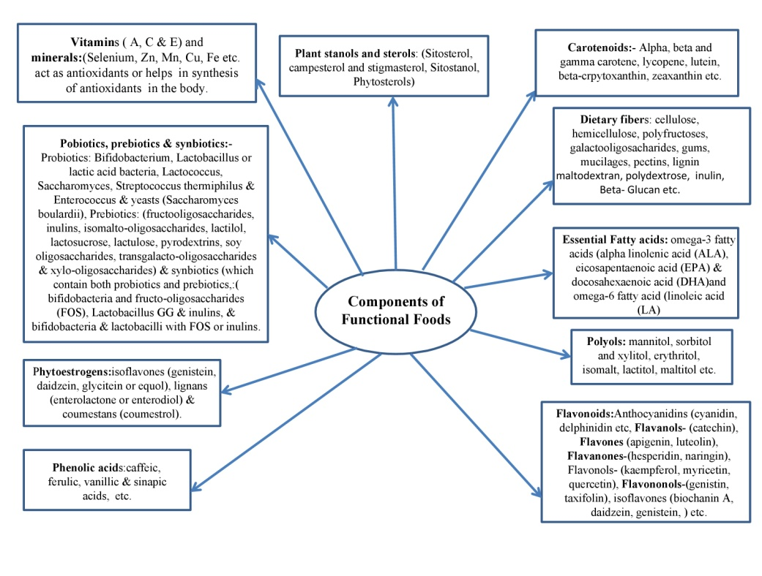
Source: Guine et al. (2011)
Table 1: List of dietary substances along with their functional components
Component | Source | Physiological Role
α and β-carotene | Different varieties of coloured veggies and fruits | Neutralize the free radicals which causes destruction of cells
Lutein, Zeaxanthin etc. | Green vegetables (kale, spinach, broccoli, asparagus), corn, carrots | Lowering the likelihood of developing muscle degeneration and maintaining eye health
Lycopene | Tomatoes, watermelon, red/pink grapefruit | Reduce the risk of development of prostate cancer
Anthocyanins like  Cyanidin, Delphinidin, Malvidin, Pelargonidin, etc. | Found in fruits like berries, cherries, red grapes etc. | Control neurological and degenerative diseases because of antimicrobial and ant oxidative properties
Flavanols - such as catechins, epicatechins, epigallocatechin etc. | Found in apples, cocoa, chocolate, tea leaves, grapes, etc. | Controls hyperglycemia, obesity, various cardiovascular diseases etc.
Flavones | Fruits and vegetables contain flavones | Lower the threat of uncontrolled cell division by reducing oxidative stress
Flavanones: (Hesperetin, Naringenin etc.) | Citrus fruits | Inhibit chronic diseases and neurodegenerative diseases like Alzheimer
Flavonols such as  Isorhamnetin, Kaempferol, Myricetin, Quercetin, etc. | Found in onions, apples, tea, broccoli etc. | Maintain the integrity of cells and functioning of cellular antioxidant defences by counteracting free radicals.
Tannins | Fruits, vegetables, seeds from legumes, grains from cereal, and nuts | Maintain the health of kidney and lower the possibility of heart disorder
Quercetin | Cherries, citrus fruits, onions, red grapes, & others. | Boost hepatic system and avoid chubbiness.
Phenolic acids like caffeine acid & ferulic acid | Citrus fruits, some vegetables, whole grains, coffee, apples, pears, blueberries, pomegranates etc. | Lower risk of cardiovascular illness and strengthen neurons
Prebiotics-  Oligocasscharides like Fructo, isomalto, soy, transgalacto and xylo, lactilol, lactosucrose, lactulose, pyrodextrins inulins, etc | Fortified foods and beverages, grains, millets, Alium cepa ,Allium sativum, honey, fruits like banana | Maintains intestinal health,  improves calcium  absorption, etc.
Bifidobacterium, Lactobacillus, Lactococcus, Saccharomyces, Streptococcus thermiphilus, Enterococcus, yeasts (Saccharomyces boulardii), and other particular types of helpful bacteria are examples of probiotics. | Found in fermented dairy  products like curd and  other non - dairy products also. | Maintain  digestive & immune health,  reduce colon cancer
Phytoestrogens like Isoflavones (genistein, daidzein, glycitein, or equol), lignans (enterolactone or enterodiol), and coumestans (coumestrol). | Soybeans and soy-based products,  flax, pumpkin, and rye seeds,  as well as triticales and other  seeds and nuts. | Maintain Bone Mineral Density, immune health, cardiovascular system, cognitive functions, supports health of menopausal women etc
Diallyl sulfide, Allyl methyl trisulfide, and dithiolthiones are thiols and sulfides. | Garlic, onions, cruciferous vegetables etc. | Enhance the elimination of harmful substances and aid in maintaining digestive, immunological, and cardiovascular health
Vitamins and minerals | Found in all food groups | Nutritional importance as well as antioxidant properties
Fatty acids: Monounsaturated fatty acids (MUFAs) | Canola oil, olive oil, and tree nuts | Lowers the chance of heart problems
Polyunsaturated fatty acids (PUFAs) like α- linolenic acid (ALA) and EPA and DHA | Α- linolenic acid found in walnuts, flaxseeds, flaxseed oil, mustard oil, rice bran oil, etc.  EPA and DHA found in sea foods | supports the maintenance of heart & eye health & cognitive function, maintain antioxidant defence system in body
Dietary Fibre (Soluble & Insoluble) | Peas, beans, apples, citrus fruits, psyllium seed husk, wheat bran, corn bran, fruit peel, etc. | Maintain gut health and lowering the risk of cancer and CHD
Source: Abdel-Aal et al. (2013); Baldi et al. (2020); Benvenutti et al, (2021); Buscemi et al. (2018); Chen et al. (2020); Choi et al.(2011); Girard and Awika, (2018); Granato et al. (2018); Goni et al. (2006) ; Guine et al. (2011); Ilic et al. (2011); Karatas et al. (2017); Khoo et al. (2017); Kozlowska and Wegierek, (2017); ); Lange et al. (2014); Laparra and Sanz, (2010); Li. et al. (2014); Lutz et al. (2019); Montes-Avila et al. (2017); Oakley, (2010); Oliveira et al. (2018); Oviasogie et al. (2009); Panche, et al, (2016); Shankar et al. (2015); Rodriguez et al. (2019); Sharma et al. (2019); Silva and Alcorn, (2019); Xia et al. (2020).
4: Functional food categories
Dietary substances containing functional properties have been classified into two parts namely traditional or conventional food and nonconventional or modified food, based on the wide range of health benefits provided by them. Such functional properties which are present in almost all food categories must be designed with consumer demands in mind. Prebiotics, probiotics, synbiotics, symbiotic foods, isoflavones, phytosterols, anthocyanins, antioxidants, and foods with lower levels of both fat and sugar are examples of functional food groups. Although product preferences differ, and their distribution across consumer segments is not uniform (Siro et al., 2008). Among other food markets, dietary substances with functional properties have mostly been developed in industries or plants related to milk, baby-food, carbonated drinks, bakery and confectionery. Fortified foods are made with vitamins like ascorbic acid, tocopherol, and minerals like Zn, Fe, & Ca, etc. After afterwards, attention turned to foods having inclusion of various micronutrients along with soluble dietary fiber, phytosterol, and omega-3 fatty acids, to promote wellness and ward against diseases like cancer (Bigliardi and Galati 2013).

Figure 2: Conventional food and modified food are forms of functional foods.

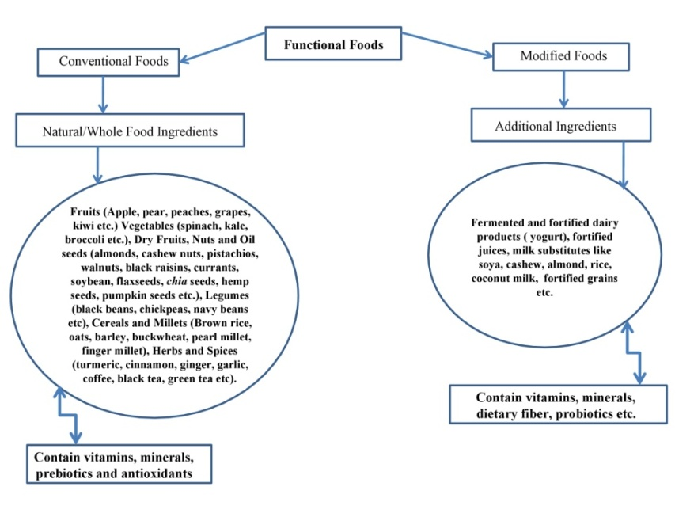
Source: Arshad et al. (2021)
5: Health benefits of functional foods
Some people have found it to be an interesting challenge to categorize which foods are considered to have health benefits and which are not, especially since a variety of factors, such as the quantity consumed, foods that are consumed with it, the length of exposure, physiological state, etc., can affect the body's overall response to a food. It is best to say at this time that all foods likely serve some purpose and that, depending on the situation, some may have immediate or long-term advantages.
Figure 3: Health Benefits of Functional Foods
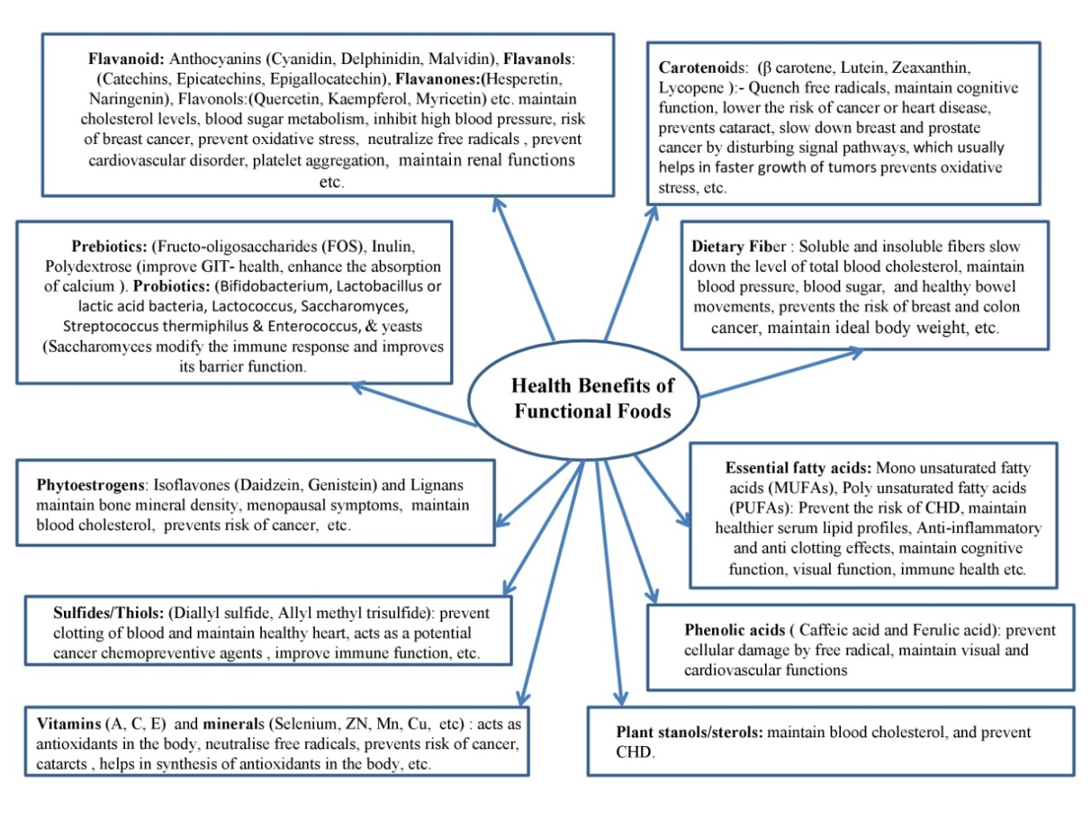
Source: Jalgaonkar et al. (2019)
6: Classification of dietary substances having functional properties on the basis of origin & mechanism of action
Functional foods are categorized according to their origins, which include plant, animal, microbial, and other sources like algae and mushrooms. Aside from source of origin, the objective of such dietary substances is to control oxidative stress in the body to manage various degenerative diseases like cardiovascular diseases (CVDs), uncontrolled cell division, immune boosting, health of the gut, health of menopausal women, premature aging, high blood glucose level, anxiety, etc.

Figure 4: Origin of Functional Foods
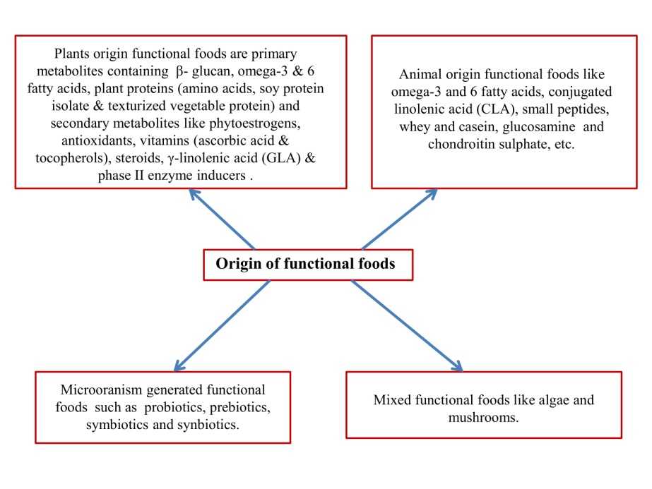
Source: Arai et al, (2016); Arai, (2005); Hasler, (2002)
6.1: Plants originated functional foods
Dietary substances having functional properties which are obtained from plants are categorised into primary and secondary metabolites. β glucan, omega-3 and 6 fatty acids, and plant proteins come in the category of primary metabolites and whereas phytoestrogens, vitamins like ascorbic acid & tocopherols, plant steroids, γ-linolenic acid (GLA) having antioxidant like properties and phase II enzyme inducers are known as secondary metabolites. Examples of plant proteins are amino acids, soy protein isolate, and texturized vegetable protein. The secondary metabolite such as β-glucan which is found in oats shows its functional properties by reducing the absorption of cholesterol in the body. Soybean and flaxseed contain substances having oestrogen like properties which are known as phytoestrogens. Due to the presence of these substances they have functional properties which are helpful in reducing the risk of breast cancer and other menopausal symptoms like hot flushes, night sweats, dryness of vagina, etc. among women having menopause (Arai et al., 2016).
Colouring pigments like anthocyanins, vitamins such as ascorbic acid and tocopherol found in fruits, vegetables, oilseeds, etc have functional properties. They act as antioxidants by quenching reactive oxygen species, and controls oxidative stress. Additionally present in oilseeds, steroids compete with cholesterol for absorption and serve as functional foods. γ-linolenic acid (GLA) involves in the synthesis of prostaglandins and prevent the occurrence of inflammation (Hasler, 2002). Phase II enzyme inducers are found in vegetables belong to Brassica family like cabbage, broccoli, cauliflower, brussels sprouts etc which assist in glycosylating insoluble toxins to soluble toxins for their easy excretion from the body. They also prevent the detoxification system of the phase I enzyme and reduce oxidative stress.
6.2: Animal originated functional foods
Some animal foods which contain polyunsaturated fatty acids (α-linolenic acid, docosahexaenoic acid (DHA), eicosapentaenoic acid (EPA), linoleic acid, conjugated linolenic acid), small peptides, milk protein (whey and casein), etc act as functional foods in animals body (Arai, 2005). A sea food especially salmon is a rich source of EPA and DHA. Linoleic, γ-linolenic acid (GLA), and arachidonic fatty acids come under the category of omega-6 fatty acids (Hasler, 2001). Omega-3 and omega-6 fatty acids aid in boosting immunity, prevent swelling in the body and maintain the functioning of nervous system. Although a fatty liver could form as a side consequence, CLA, a fatty acid found in milk, functions as a functional food by lowering risk of uncontrolled cell division, and adipose differentiation (Hassler, 2002). Small peptides perform similarly to whey and casein, milk proteins that operate as functional foods by being readily absorbed and digested and aid in the development of lean muscle mass (Arai et al., 2016).
6.3: Microoranisms originated functional foods
Good microflora is called as probiotics. Probiotics are healthy, naturally occurring microorganisms that are found in the gastrointestinal tract (GUT), such as Lactobacillus casei, Bifidobacter species, etc (Hassler, 2002). Such dietary components which assist probiotic bacteria to grow in the gut are known as Prebiotics. When probiotics and prebiotics work together in combination in the body are called as synbiotics while when prebiotics and probiotics come together at random basis are called as symbiotics. The mechanism of action of functional food is to encourage the growth of good microflora (Probiotics) so that the growth of harmful bacteria can be controlled to some extent.
6.4: Mixed functional foods
Some functional foods are made from various substances, including algae and mushrooms. Algae synthesise PUFA which helps in strengthening immune system, prevent ailments related to functioning of nervous system, and prevent inflammation in the body due to the presence of antioxidant like properties in it. Mushrooms have functional properties as they act against virus, bacteria and reduce cause of inflammation.
Conclusion
In this way it can be concluded that functional foods obtained from natural or modified sources have a vital role in maintaining human health and wellness. Various studies showed that functional foods having bioactive components not only maintain human health but also reduce the chance of various degenerative disorders by suppressing/neutralising formation of free radicals and maintains oxidative stress under control due to antioxidant defence mechanism in the body. Various studies reported that natural origin foods like some plant (fruits, vegetables, nuts, oilseeds, etc), animal (fermented and non fermented dairy products, sea foods, etc), microorganisms, algae or mushroom contain functional properties. The bioactive substances present in them are vitamins (ascorbic acid, tocopherol), probiotics, preciotics, synbiotics, symbiotics, anthocyanins, antioxidants, phenols, phytochemicals, phytoestrogens, complex carbohydrates, polyunsaturated fatty acids (Omega-3 and 6 fatty acids) etc. Modified foods are enriched or fortified with such substances (nutrients or non-nutrients) which contain antioxidant properties and act as functional foods in the body. A number of studies have showed that the functional substances present in these foods continue to play a distinct functional role in protecting human health from various degenerative disorders.
References
Abuajah, C.I., Ogbonna, A. C., and Osuji, C. M. (2015). Functional components and medicinal properties of food: a review. Journal of food science and technology, 52(5), 2522-2529.
Abdel-Aal, E. S. M., Akhtar, H., Zaheer, K., and Ali, R. (2013). Dietary sources of lutein and zeaxanthin carotenoids and their role in eye health. Nutrients, 5(4), 1169-1185.
Alzamora S M., Salvatori D, Tapia M S, Lopez-Malo A and Chanesc. (2005). Novel functional foods from vegetable matrices impregnated with biologically active compounds, Journal of Food Engineering, 67(1-2), 205-214.
American Dietetic Association. (1999). Position of the American Dietetic Association: functional foods. Journal of the American Dietetic Association, 99:1278–1285
Arai, S. (2005). Perspective functional food science. Journal of the Science of Food Agriculture, 85:1603–1605.
Arai, S., Vattem, D.A., and H. Kumagai, H. (2016). Functional Foods-History and Concepts. Functional foods, nutraceuticals and natural products. 1-18.
Arshad, M.S.; Khalid, W.; Ahmad, R.S.; Khan, K.M.; Ahmad, M.H.; Safdar, S.; Kousar, S.; Munir, H.; Shabbir, U.; Zafarullah, M.; Nadeem, M.; Zubia Asghar, Z. and Suleria H.A.R. (2021). Functional Foods and Human Health: An Overview, Functional Foods-Phytochemicals and Health Promoting Potential, pp-1-14 doi: http://dx.doi.org/10.5772/intechopen.99000.
Baldi A., Abramovic H., Poklar Ulrih N. and Daglia M. (2020) Tea Catechins. In: Xiao J., Sarker S., Asakawa Y. (eds) Handbook of Dietary Phytochemicals. Springer, Singapore.
Benvenutti, L.; Zielinski, A.A.F.and Ferreira, S.R.S. (2021). ‘Jaboticaba (Myrtaceae cauliflora) fruit and its byproducts: Alternative sources for new foods and functional components’. Trends in Food Science & Technology 112, 118-136.doi:10.1016/j.tifs.2021.03.044.
Bigliardi, B., and Galati, F. (2013). Innovation trends in the food industry: The case of functional foods. Trends in Food Science & Technology, 31(2), 118-129.
Buscemi, S., Corleo, D., Di Pace, F., Petroni, M. L., Satriano, A., and Marchesini, G. (2018). The effect of lutein on eye and extra-eye health. Nutrients, 10(9), 1321.
Cartea, M. E., Francisco, M., Soengas, P., and Velasco, P. (2011). Phenolic compounds in Brassica vegetables. Molecules, 16(1), 251-280.
Choi, S. H., Kim, D. H., and Kim, D. S. (2011). Comparison of ascorbic acid, lycopene\beta-carotene and alpha-carotene contents in processed tomato products, tomato cultivar and part. Culinary science and hospitality research, 17(4), 263-272.
Committee on Opportunities in the Nutrition and Food Sciences, (1994). Food and Nutrition Board, Institute of Medicine.
Chen, D., Ding,Y., Chen, G., Sun, Y., Zeng, X. and Ye., H. (2020) Components identification and nutritional value exploration of tea (Camellia sinensis L.) flower extract: Evidence for functional food. Food Research International 132, 109100. doi: 10.1016/ j.foodres.2020.109100.
Crowe, K. M., and Francis, C. (2013). Position of the academy of nutrition and dietetics: functional foods. Journal of the Academy of Nutrition and Dietetics, 113(8), 1096-1103
Girard, A.L. and Awika, J.M. (2018). ‘Sorghum polyphenols and other bioactive components as functional and health promoting food ingredients’. Journal of Cereal Science. pp.112–124. doi: 10.1016/j.jcs.2018.10.009.
Goldberg I. (1994). Functional Foods: Designer Foods, Pharmafoods, and Nutraceuticals. An Aspen Publication, Chapman and Hall, London, UK. pp. 3-4.
Goni, I., Serrano, J., and SauraCalixto, F. (2006). Bioaccessibility of β-carotene, lutein, and lycopene from fruits and vegetables. Journal of agricultural and food chemistry, 54(15), 5382-5387.
Granado-Lorencio, F., and Hernandez Alvarez, E. (2016). Functional foods and health effects: a nutritional biochemistry perspective. Current Medicinal Chemistry, 23(26), 2929-2957.
Granato, D.Santos., J.S., Escher., G. B., Ferreira., B.L. and Maggio., R.M. (2018). ‘Use of principal component analysis (PCA) and hierarchical cluster analysis (HCA) for multivariate association between bioactive compounds and functional properties in foods: A critical perspective’. Trends in Food Science and Technology. Elsevier, Ltd, pp.83-90. doi: 10.1016/j.tifs.2017.12.006.
Guine, R.; Lima, M.J. and Barroca, M.J. (2011) ‘Role and health benefits of different functional food components’. International Journal of Medical and Biological Frontiers ,17
Gul, K., Singh, A.K. and Jabeen, R. (2016). Nutraceuticals and Functional Foods: The Foods for the Future World. Critical Reviews in Food Science and Nutrition, 56:2617–2627.
Hasler, C. (2002). Functional Foods: benefits, concerns and challenges-a position paper from the American Council on Science and Health. The Journal of Nutrition. 132:3772–3781.
Hasler, C.M. (2001). Functional Foods. In: Bowman, B.A., Russell, R.M., editors. Present Knowledge in Nutrition. Washington (DC): ILSI Press.
Henson S, Masakure O. and Cranfield J, (2008). The propensity for consumers to offset health risks through the use of functional foods and nutraceuticals: The case of lycopene, Food Quality Prefer, 19(4), 395-406.
Ilic, D., Forbes, K. M., and Hassed, C. (2011). Lycopene for the prevention of prostate cancer. Cochrane database of systematic reviews, (11).
Jalgaonkar, K.; Mahawar, M.K.; Bibwe, B.; Nath, P. and Girjal, S. (2019). Nutraceuticals and Functional Foods, Trends & Prospects in Processing of Horticultural Crops. 231-250.
Karatas., C. S.; Gunay, D., and Sayar, S. (2017). ‘In vitro evaluation of whole faba bean and its seed coat as a potential source of functional food components’, Food Chemistry 230, 182–188. doi: 10.1016/ j.foodchem.2017.03.037
Kozlowska, A., and Szostak Wegierek, D. (2017). Flavonoids-food sources, health benefits, and mechanisms involved. “Bioactive Molecules in Food”. Springer. Cham, 1-27.
Khoo, H. E., Azlan, A., Tang, S. T., and Lim, S. M. (2017). Anthocyanidins and anthocyanins: colored pigments as food, pharmaceutical ingredients, and the potential health benefits. Food & nutrition research, 61(1), 1361779.
Lange, M. (2014). ‘Determining Functional Properties and Sources of Recently Identified Bioactive Food Components: Oligosaccharides, Glycolipids, Glycoproteins, and Peptides’, in Encyclopedia of Agriculture and Food Systems. Elsevier, pp.441–461. doi: 10.1016/B978-0-444-52512-3.00067-X.
Laparra, J.M., and Sanz, Y. (2010). ‘Interactions of gut microbiota with functional food components and nutraceuticals’. Pharmacological Research. Academic Press, pp.219-225. doi: 10.1016/j.phrs.2009.11.001.
Li, S., Wang, Z., Ding, F., Sun, D., Ma, Z., Cheng, Y., and Xu, J. (2014). Content changes of bitter compounds in ‘Guoqing No. 1’Satsuma mandarin (Citrus unshiu Marc.) during fruit development of consecutive 3 seasons. Food chemistry, 145, 963-969.
Lutz, M., Fuentes, E., Avila, F., Alarcon, M., and Palomo, I. (2019). Roles of phenolic compounds in the reduction of risk factors of cardiovascular diseases. Molecules, 24(2), 366.
Mac Aulay, J., Petersen, B., and Shank, F. (2005). Functional foods: Opportunities and challenges. Institute of Food Technologists (IFT) Expert Report. Institute of Food Technologists.
Martirosyan, D. M., and Singharaj, B. (2016). Health claims and functional food: The future of functional foods under FDA and EFSA regulation. Functional Foods for Chronic Diseases; Food Science Publisher: Dallas, TX, USA, 410-424
Martirosyan, D., and Pisarski, K. (2017). Bioactive compounds: Their role in functional food and human health, classifications, and definitions. Bioactive Compounds and Cancer. Edited by Danik Martirosyan and Jin-Rong Zhou. San Diego: Food Science Publisher, 238-277.
Milner, J.A., (2002). Functional foods and health: a US perspective. British Journal of Nutrition , 88 (2), 151-158.
Montes-Avila, J., Lopez-Angulo, G., and Delgado-Vargas, F. (2017). Tannins in fruits and vegetables: chemistry and biological functions. Fruitand Vegetable Phytochemicals, 221-268.
Oakley, G.P. (2010). ‘Global prevention of all folic acidpreventable spina bifida and anencephaly by 2010’. Community Genetics 5 (1), 70-77. doi: 10.1159/000064633.
Oliveira, A.; Amaro, A.L., and Pintado, M. (2018). ‘Impact of food matrix components on nutritional and functional properties of fruit-based products’. Current Opinion in Food Science.153-159.doi: 10.1016 / j.cofs.2018.04.002.
Oviasogie, P. O., Okoro, D., and Ndiokwere, C. L. (2009). Determinationof total phenolic amount of some edible fruits and vegetables. African journal of biotechnology, 8(12).
Panche, A. N., Diwan, A. D., and Chandra, S. R. (2016). Flavonoids: an overview. Journal of nutritional science, 5.
Rodriguez-Garcia, C., Sanchez Quesada, C., Toledo, E., Delgado Rodriguez, M., and Gaforio, J. J. (2019). Naturally lignan-rich foods: a dietary tool for health promotion. Molecules, 24(5), 917.
Shankar, G. M., Antony, J., and Anto, R. J. (2015). Quercetin and tryptanthrin: two broad spectrum anticancer agents for future chemotherapeutic interventions. In The enzymes (Vol. 37, pp. 43-72). Academic Press.
Sharma, K., Kumar, V., Kaur, J., Tanwar, B., Goyal, A., Sharma, R., and Kumar, A. (2019). Health effects, sources, utilization and safety of tannins: A critical review. Toxin Reviews, 1-13.
Shimizu, T. (2003). Health claims on functional foods: the Japanese regulations and an international comparison. Nutrition research reviews, 16(2), 241-252.
Siro, I., Kapolna, E., Kapolna, B., and Lugasi, A. (2008). Functional food. Product development, marketing, and consumer acceptance-A review. Appetite, 51(3), 456-467.
Xia, T., Zhang, B., Duan, W., Zhang, J., and Wang, M. (2020). ‘Nutrients and bioactive components from vinegar: A fermented and functional food’. Journal of Functional Foods. p.103681. doi: 10.1016/j.jff.2019.103681.

