“ Meta Analysis of Hotel Employees Balanced Score Card Effects - A Case Study”

Dr. Salla Vijay Kumar
Senior Lecturer & Academic Incharge
Institute of Hotel Management Ahmedabad, India
sallavijaykumar75@gmail.com

ABSTRACT

Background: Hospitality is the act of kindness in welcoming and looking after the basic needs of customers. The hospitality industry is a broad group of businesses that provide services to customers. Hospitality is actually one facet of the service industry. It primarily involves addressing customer satisfaction and catering the needs of guests.
Significance: Hotels that practiced Performance Management according to the employees and management perspectives understand the system and are achieving expected outcomes whilst other hotels could not effectively manage the system because of their level of understanding in its implementation.

Method: This study used conventional statistical methods were used to determine if observed differences were statistically significant. And with this research, readers should exercise caution when generalizing results and take individual circumstances and experiences into consideration when making decisions based on these data to identify, encourage, measure, evaluate, improve, and reward. The study involves all the formal and informal measures adopted by the hotel to increase individual and team effectiveness. Management and employees should be enabled continuously to develop knowledge, skill and capabilities employee performance at work.

Results: The results show effective performance management systems boost ongoing communication between the individual and leadership teams. It allows for trusted sources of conversation to be established, therefore giving employees an opportunity to express concern, discuss obstacles and brainstorm ways to improve.

Conclusion: The review indicates that none of the studies has systematically examined the variables of Performance Management based on the prior literature in the field concerned. Similarly, the design of the research model is developed to evaluate how Performance Management influences employee commitment is based entirely on the random selection of variables including the moderator (i.e. company type), with no theoretical underpinning.

Keywords: Performance, Management, Consideration, Communication, Conversation, Underpinning

“ Meta Analysis of Hotel Employees Balanced Score Card Effects - A Case Study”

INTRODUCTION

The provided report revolves around Pullman-Novotel Aerocity New Delhi and of a detailed study on how Performance Management is used as a strategy according to the employees and management perspectives. The two hotels with a combined inventory of 670 rooms were inaugurated by the Union Minister of Civil Aviation, Ashok Gajapathi Raju. Both the hotels have been developed under a strategic partnership between Inter Globe Enterprises Ltd, APHV India Investco Pte Ltd and Accor Hotels. Both the hotels represent the finest amalgamation of legendary Indian and French hospitality and culture.
Performance Management is gaining momentum as a strategic Human Resource Management tool that facilitates the performance of employees, teams, departments to achieve their strategic goals. The aim of the study is to examine the extent to which Performance Management is practiced in hotels through the review of relevant literature.
The study indicates that hotels that practiced Performance Management according to the employees and management perspectives understand the system and are achieving expected outcomes whilst other hotels could not effectively manage the system because of their level of understanding in its implementation. It is identified that Pullman-Novotel Aerocity New Delhi is practicing Performance Management using the same process (goal setting, feedback, performance assessment etc.) and had similar challenges. The variations are the implementation strategies, the cultural diversity and practical delivery of the system.
Hospitality is the act of kindness in welcoming and looking after the basic needs of customers. The hospitality industry is a broad group of businesses that provide services to customers. Hospitality is actually one facet of the service industry. It primarily involves addressing customer satisfaction and catering the needs of guests. This can be addressed by dealing with issues such as lodging, amenities and travel arrangements. Guinness World Records officially recognised Japan’s Nishiyama Onsen Keiunkan, founded in 705, as the oldest hotel in the world. During the Middle Ages, various religious orders at monasteries and abbeys would offer accommodation for travellers on the road.
Luxury hotel statistics shows there are over 4,400 4 and 5-star hotels around the world. The leading group in the world is the Wyndham Hotel Group with over 9157 properties. Followed by Choice Hotels International which have over 7,045 and Marriot International with 7,003.As per the Federation of Hotel & Restaurant Associations of India (FHRAI), in FY21 the Indian hotel industry has taken a hit of >Rs. 1.30 lakh crore (US$ 17.81 billion) in revenue due to impact of the COVID- 19 pandemic.

Scope of the Study:
The main aim of the study is to identify, encourage, measure, evaluate, improve, and reward. The study involves all the formal and informal measures adopted by the hotel to increase individual and team effectiveness. Management and employees should be enabled continuously to develop knowledge, skill and capabilities employee performance at work.
The scope of the study covers the following parts:

Job performance:
Considers meeting goals and developing mutually decided standards.

Working relationships:
This aspect focusses on maintaining professional relationships with co-workers, subordinates, and managers.

Need of the Study:
Human Resource is the real resource for any organization. All other resources in the organization are utilized by human resource and so fullest utilization of all resources depends on employee performance of the organization. Today the globalization of the world economy and several other factors are again generating changes in how organizations organize, manage and use their Human Resource. Technology is also changing the nature of work. Knowledge-intensive techniques, industrial automation, reengineering with optimum utilization of resources sets the current working environment. To add to this the personal life of the individual employees also affect hisprofessional work, aims & ambitions and decisions. Hence managing employee’s performance continuously is becoming critical to the policies and planning of the top management.
Performance management has attracted the attention of all organizations as the information provided by PMS can be utilized for taking various important HR decisions related to Human Resource Planning, Recruitment and selection, Training and Development, compensation Management, career planning, talent management, performance based pay etc.

LITERATURE REVIEW

Helm et al. (2007) says that PMS is important tool to improve an organization’s performance; it facilitates the organization to achieve its goals and objective. It can develop a performance-oriented culture within the organization. It helps the individual employee to have the clarity about what exactly is expected from him as there will be proper performance planning of each employee. PMS can also identify talented individuals for promotion and it also establishes linkage between pay and performance. It means various important HR decisions can be accurately taken with the help of PMS.
Bhattacharjee and Sengupta (2011) emphasized in their study that employees are the most crucial and valuable assets of an organization. If an organization wants to gain competitive advantages, it is very important to bridge the gap between the actual competence of human resource working in the organization and the desired competence expected from them. It is with the help of well- established Performance management system the organization can bridge this gap between actual performance and expected performance.
Sunil Kumar Pradhan and Dr. Suman Kalyan Chaudhury (2012), This study found that the main objective of performance management system is to align the individual and organizational goals in such a way that to give best possible platform to the employees to perform with 100% efficiency which will lead to organizational development, employee satisfaction and increased employee retention.

OBJECTIVES OF STUDY
- To understand clear role definitions, expectations and goals
- To understand the employees towards achievement of superior standards of work performance.
- To Learn That How to Boost productivity through improved performance.

RESEARCH METHODOLOGY

A sample of hospitality professionals was randomly selected at Pullman and novotel . These professionals were the employees of the hotel. In January 2023, an e-mail that included a link to the performance Management Survey was filled by 10 employees, yielding a response rate of 100%. The survey was fielded for a period of three weeks, and weekly reminders were sent to sample members in an effort to increase the response rate.
Analysis: Throughout this report, analyses by respondents organization staff size, the existence of performance management initiatives, organization sector and HR department staff size are presented and discussed, when applicable.
Differences: Conventional statistical methods were used to determine if observed differences were statistically significant.
Generalization of results: As with any research, readers should exercise caution when generalizing results and take individual circumstances and experiences into consideration when making decisions based on these data.

TABULATION AND DATA ANALYSIS
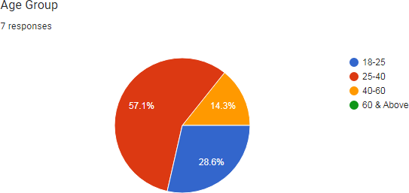
Mostly the response came from 25-40 age group which is 57.1% followed by the age group 18-25 which is approx 28.6%.
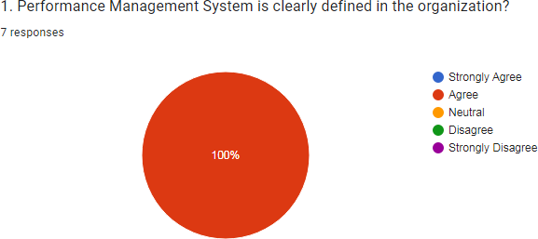
100 % respondents agreed that the performance management system is clearly defined in the organization .
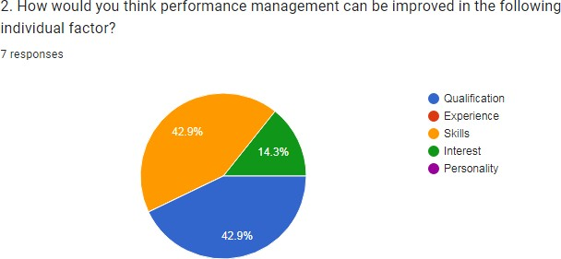
42% response believe that the performance management system can be as in thr skills of the person in the property.
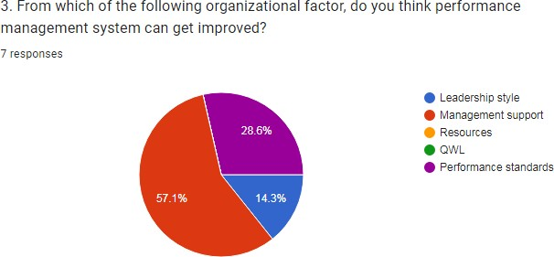
57.1% response believe that through the management support the performance management system can be improved .
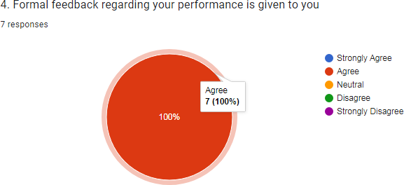
100%respondents agrees that their formal feedback is given in their organization .

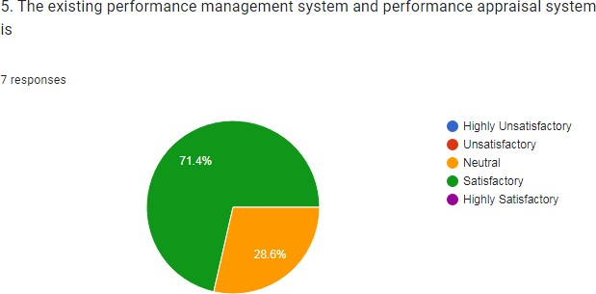
71.4% employees says that their performance management system and performance appraisal system is satisfactory and 28.6% says it is neutral
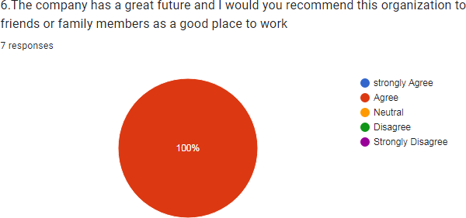

100% respondents says that their company has a great future and they would recommend the work culture and workplace to the family and friends .
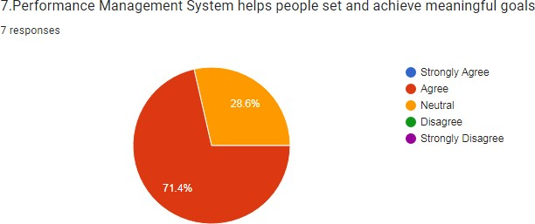

71.4 % respondents says that their performance management system helps to achieve meaningful goals followed by 28.6% who says that it is neutral they could not comment any of the thoughts
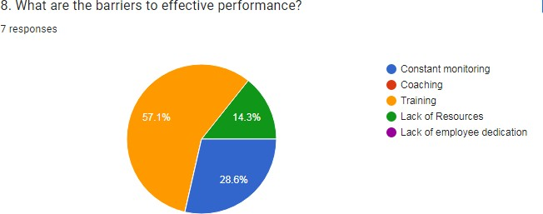

57.1 % respondents says that training is an barrier to effective performance followed by the 14.3% who says lack of resources and 28.6% says that barriers are through constant monitoring
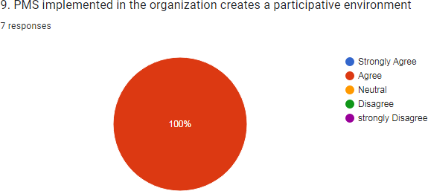
100% respondents agrees that PMS implemented in their organization creates an participative environment .

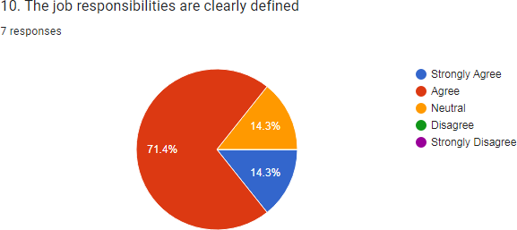
71.4 % people agrees that their job responsibilities are clearly defined whereas 14.3% have an neutral approach towards it and the mix of 14.3% strongly agrees to the given statement
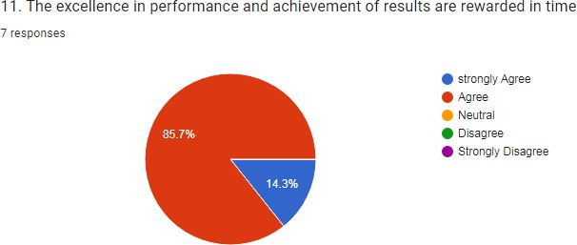
85.7 % respondents agrees that their performance and their achievements are rewarded in time followed by the 14.3% strongly agree .
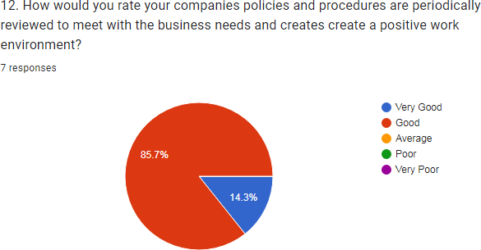

85.7% respondents says that their company policies are good in terms of business needs and positive work environment .followed by 14.3% says its very good
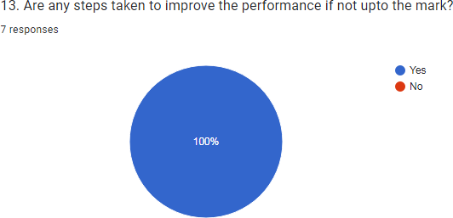

100% respondents agrees that steps are taken to improve performance management by the organization
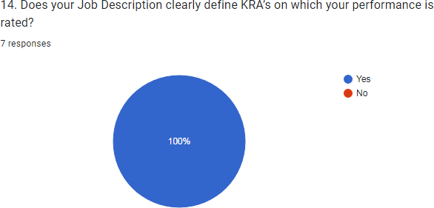
`100 % people agreed that that their job description clearly define KRA on which performance is rated
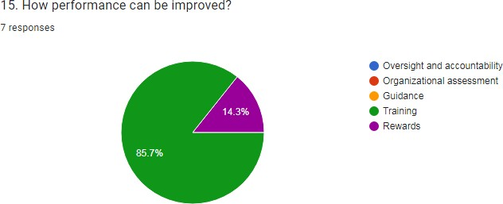
85.7% respondents says that the performance can be improve with the training factor and 14.3% says by the reward systems
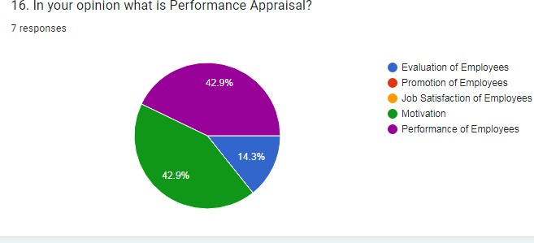
Both 42.9 % says that performance of employees and motivation are performance appraisals . and rest 14.3% says it is evaluation of employees .

Some feedback and suggestions in the given questionnaire:
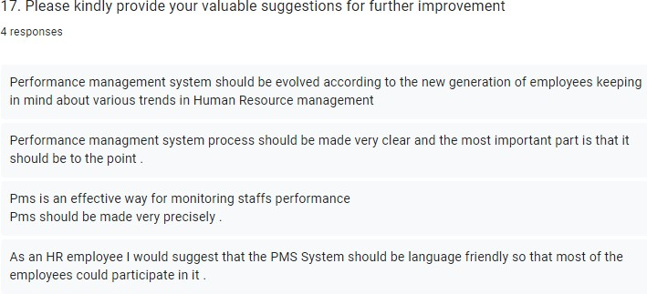

FLOWCHART OF VARIABLES
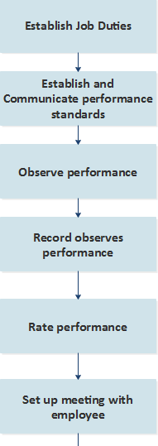
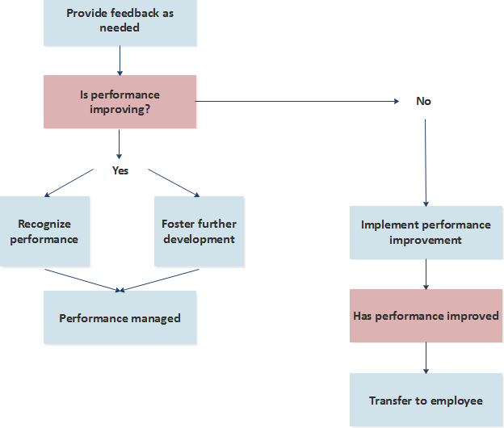

FINDINGS
- All respondents have aware about the current performance management systems.
- Majority of HR professionals told that they are comfortable with conducting performance review but some of the HR professionals are felt comfortable while conducting the performance review
- All HR professionals and majority of respondents told that they were satisfied with the current performance management systems work well and no need for change
- Majority of respondents are told the checklist techniques used in organization for accesing the performance
- Most of the respondents are sure in current performance and in improving in their performance
- Majority of HR professionals are not satisfied that performance management techniques used in accessing employees performance more effective
- Some HR professionals are told that performance review techniques have more impact in employees performance employees incentives and morals but some of them are not agreed with that.

CONCLUSION
With this study it can be said that Performance Management System is the important strategic tool of Human Resource management. A well-designed PMS can help the organization to maximize employee performance and encourage organizational climate of trust, collaboration, communication, team work etc. It is important for an organization to have such system which not only identify to high performer but also helppoor performer to improve his performance with well-designed Training program and personalized counseling. The performance management system is the strategic tool that can be used to transform people’s talent and motivation into a strategic business advantage.
It is concluded from the survey that all the respondents are aware about the current performance management and does not need to change current performance management system works well and that improves the performance of the employees
This study has shown that performance management is a comprehensive approach to planning and sustaining improvements in the performance of the employees so as to meet the standards
Most of the HR professionals are not feel comfortable with conducting performance review. So, create a trust in them. About performance review techniques and maintaining good relation with the employee’s for improving their performance and accomplishing goals and objectives of the organization.

RESULTS
Effective performance management systems boost ongoing communication between the individual and leadership teams. It allows for trusted sources of conversation to be established, therefore giving employees an opportunity to express concern, discuss obstacles and brainstorm ways to improve.
Improved organizational performance, employee retention and loyalty, improved productivity, overcoming the barriers to communication, clear accountabilities, and cost advantages. Saves time and reduces conflicts, ensures efficiency and consistency in performance.

LIMITATIONS
The analysis indicates that the majority reported that the outcomes of the research were difficult to generalize. The limitations include a sample drawn from only one or specific contexts, a limited or small sample size, a cross-sectional or snapshot approach to data collection, self-selection bias or a convenience sampling approach, lack of empirical research, the lack of more specific variables and exploratory or ongoing research.
The future research can address the limitations including small sample size, limited empirical research, exploratory analysis and lack of suitable variables.
The limited extent of empirical research can be dealt with by using quantitative analysis to understand the turnover intention of talent using structured equation modelling. Moreover, as this research is based on a comprehensive reviewof the available literature on performance Management, it can be said to have overcome the issue of identifying the most suitable variables.
The review indicates that none of the studies has systematically examined the variables of Performance Management based on the prior literature in the field concerned. Similarly, the design of the research model is developed to evaluate how Performance Management influences employee commitment is based entirely on the random selection of variables including the moderator (i.e. company type), with no theoretical underpinning.

REFERENCES
- https://www.sap.com/insights/performance-management-process.html
- https://www.researchgate.net/publication/331329634_Performance_Management_Methods_ A_Case_Study_from_International_Industrial_Companies
- https://www.slideshare.net/ShaikhIrshad/project-report-on-performance-management-system
- https://www.google.com/search?q=09.+flowchart+of+variables+of+performance+manageme nt&sxsrf=AJOqlzWYByelXVIggzII6Txg5bZDcFr3w:1678797937081&source=lnms&tbm=i sch&sa=X&ved=2ahUKEwjGy8HVudv9AhVocGwGHcw_CD8Q_AUoAXoECAEQAw&bi w=1600&bih=757&dpr=1#imgrc=3yNECo3_2WvOvM
- https://support.sas.com/content/dam/SAS/support/en/books/case-studies-in-performance- management/excerpt.pdf
- https://www.researchgate.net/publication/331329634_Performance_Management_Methods_ A_Case_Study_from_International_Industrial_Companies
- https://www.studocu.com/row/document/jagannath-university/strategic-management/pdf- performance-management-system-case-study-assignment-1-converted/9027181
- https://www.scribd.com/document/352349818/Performance-Management-Case-Studies
- https://www.shrm.org/hr-today/trends-and-forecasting/special-reports-and-expert- views/documents/performance%20management.pdf
- https://www.academia.edu/38396027/Performance_Management_System_PMS_In_Indian_S mall_and_Medium_Enterprises_SMEs_A_Practical_Framework_A_Case_Study

