TELEHEALTH
Abstract
Telehealth is a new approach to connect with the health care provider in an online mode conveniently and availing health care services from home. During the Covid pandemic telehealth emerged as a worldwide boon providing optimum health care services to the needy people still in use. Telehealth is receiving health care via video chat, mobile phone, whatsapp or text messaging. In case mode of clinical care and consultation is in person by a physician then telehealth opportunities can provide access to health care from the comfort zone at home.

Keywords: Telehealth, healthcare, clinical care, nursing, pharmacy

Introduction
Telehealth is a new approach to connect with the health care provider in an online mode conveniently and availing health care services from home. During the Covid pandemic telehealth emerged as a worldwide boon providing optimum health care services to the needy people still in use.
What is telehealth?
Telehealth is receiving health care via video chat, mobile phone, whatsapp or text messaging. In case mode of clinical care and consultation is in person by a physician then telehealth opportunities can provide access to health care from the comfort zone at home. Telehealth involves application of telecommunications technologies and electronic information and provide distant clinical health care services, education of clients/patient and health-related information for professionals, public health care and several services for health care delivery. Telemedicine pertains to the clinical services delivered at a distant place via different telecommunications.
Objectives of telehealth
Objectives of telehealth are mentioned in the Figure 1.
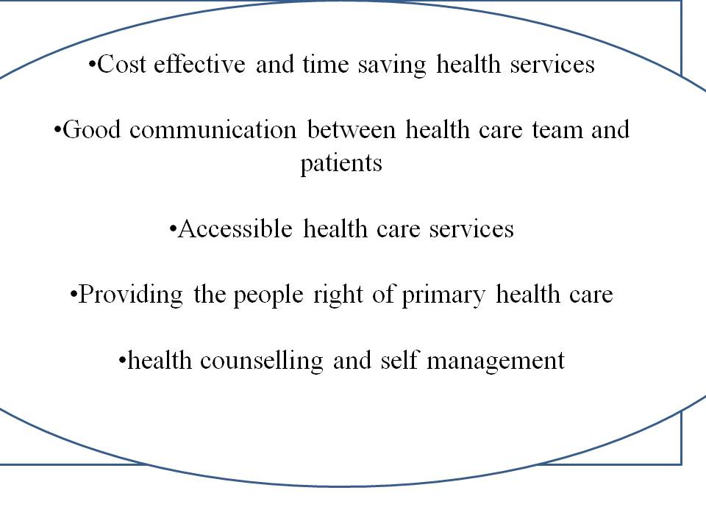
Figure 1: Objectives of telehealth

Telehealth has its own applications in several fields like medicine, nursing and pharmacy.
Telehealth in Medicare
It is possible to get various specialized medical health care facilities through telemedicine. For instance:-
- Most of communication takes through video chat with rare use of mobile phone calls and messages.
- Telehealth gives treatment opportunity at home.
- It is safe and protects privacy and confidentiality of patients.
- Telehealth may be covered under Medicare, insurance.
Telehealth in nursing
Being integral part of health care system, nurses utilize different tools of telehealth to deliver health care as mentioned below:
- Primary care – initial client assessment, promoting health care, diagnosis of cases, management of diseases.
- Patient education and counselling, remote patient monitoring.
- Telenursing in case of community health programme in schools.
- Telenursing to prevent transmission of diseases during pandemics.
- Accessible to those unable to afford services such as rural areas, vulnerable patients elderly patients.
- Unable to travel alone.
Telehealth in pharmacy
Telehealth in pharmacy means application of telecommunication technology and electronic information by pharmacists to provide clinical services. It includes:
- Initial assessment, clinical consultation and outcomes assessment.
- Medication selection and dispensing of medicine.
- Comprehensive medication management.
- Provision of drug information.
- Chronic disease management.
- Sterile and nonsterile compounding verification.
- Adverse drug reaction (ADR) detection and monitoring.
- Counselling of patients and drug reconciliation.
- Healthcare data analysis.
- Healthcare personnel supervision.
- Interacting with other healthcare practitioners.

Telehealth pharmacy practice applications
These applications are proven beneficial in supporting health care facilities which perform medication-use activities in the absence of a pharmacist or in case of deficient pharmacy resources like geographically isolated healthcare facilities and ambulatory clinics. Telehealth pharmacy practice has several roles such as patient counselling and monitoring, medication selection, review of medication order and drug dispensing, verification of intravenous (IV) admixture; and clinical services. These services are useful in tertiary health care centres where staff is deficient as in case of attrition or staff turnover and to provide day night pharmacy services. Most importantly telehealth acts as a tool for virtual assessment, detection, monitoring decision-making and management of adverse drug events (ADE).
Benefits of Telehealth
Since there are individual benefits of personal visits, but telehealth has its own advantages like:-
- Patients from diverse geographical location can avail telehealth services with good continuum of care and routine health check up and good patient compliance.
- Cost effective health services, no need to frequently travel.
- Less human resources required.
- Less work space required.
- Health management in a fast and smooth pattern.
- Efficient digital health services in a streamlined way.
- Increased load of patients.
- Provides virtual education and information sessions.
- Time effective services.
- Provides remote patient monitoring and information sharing.
- Easy and accessible general as well as special healthcare services.
- No logistical barriers like travel distance or mobility from home, physical barrier like risk of injury and psychological barriers like stress.
- Reminding patients for regular checkups and follow up visits.
- Decreased chances of hospital acquired diseases.
Limitations of Telehealth: Whenever there are benefits then there are limitations:
- Reimbursement issue – as this facility is not applicable on telehealth so people in some isolated places cannot benefit due to deficiency of reimbursement opportunities.
- Patient resistance – another limitation is patient’s myth of direct consultation, not able to accept changes in medical services in the form of telemedicine.
- Deficient health care provider skills and competencies.
- Lack of computer proficiency – another major issue in the use of telehealth e.g. unable to accept technology, and inefficiency in electronic devices.
- Age and socioeconomic distribution – elderly aged patients and those living in villages with poor internet connectivity, illiterate and lower socioeconomic status.
Modern need of Telehealth: As telehealth is very much popular mode of health care services. It gives opportunities to a patient sitting at home to avail health care services. Modern need of telehealth relies with ethical aspects of patient data. Data confidentiality should be protected. Incomplete care could be due to no face-to-face interaction which can be resolved by visit to patient area once in a while.
Conclusion
Telehealth may prove to be a game changer platform providing healthcare facilities to many residing in distant locations. It provides facility of treatment monitoring, reminding patients about their follow ups and the progress of treatment. Though it has some limitations as well but upcoming trends may withhold its position steadily in the healthcare sector providing and fulfilling health care needs of patients globally.

