ANTIMICROBIAL ACTIVITY OF SILVER NANOPARTICLES AND ACTION AGAINST MICROBS
Yukti Dewangan^{1*} Dr Radha Krishnan^{2*} Dr Piyush Kumar Thakur^{3*}
^{1&2*} School of Sciences, MATS University, Raipur (CG) India
^{3*}Faculty of Science and Technology, ICFAI University, Raipur (CG) India
Email: yuktidewangan99@gmail.com¹, radhakrishnan2200@gmail.com² piyush.thakur25@gmail.com³

Abstract -Currently, treating infectious diseases caused by microorganisms resistant to antibiotics is a huge concern for the entire globe. Finding alternate methods to cure diseases caused by resistant infections are urgently needed. And the Well-known and effective antibacterial agents are silver nanoparticles. This summary includes a retrospective of earlier reviews that have been written as well as recent unique addition on the development of research on the antibacterial activity of silver nanoparticles. The important subjects covered include bacterial resistance, cytoplasmic swelling (damage), Deoxyribonucleic acid (DNA) interaction, free radical production, release of Ag nanoparticles and Ag ions, and the link between resistance to Ag ions and resistance to AgNPs. The overview's main objective is to present a concise summary of the current idea of research on the antibacterial properties of AgNPs.
Keywords: Silver nanoparticles, nanotechnology, antimicrobial activity, antimicrobial mechanism, Bacterial resistance.

- Introduction

By manipulating structure and diameter at a nanoscale (1 nm to 100 nm), nanotech is described the characterization, pattern and application of structures, devices, and systems. It is a novel area of study with many scientific and technological uses, especially for developing new materials¹. Recent years have seen the emergence of nanotechnology as a fast expanding subject with several biomedical research applications. Ag (Silver) has also been used as antibacterial agent that is generally devoid of side effects. A several types of Antimicrobial activities are present in AgNPs. AgNPs typically have dimension of less than 100 nm and consists 20 to 15,000 Ag atoms. even at low concentrations Silver nanoparticles have unique antibacterial action due to a high surface-to-volume ratio². Additionally, they have minimal costs, low cytotoxicity, and immunological response³. As a result, there are several potential biomedical uses of AgNPs. They are utilised for molecular diagnosis, medical imaging, and medication administration⁴. AgNPs have been promoted as an effective antibacterial agent that can fight bacteria that cause illnesses both in vitro and in vivo. Gram -ve and Gram +ve bacteria, having multidrug resistant strains, are all covered by AgNPs' antibacterial ability. The capacity of AgNPs to kill different kinds of bacteria is a result of their varied modes of action, which permit them to target germs in many structures at once. AgNPs exhibit several simultaneous modes of action, and when combined with antibiotics or other biological substances that fight bacteria, they have a synergistic impact on pathogens like E. coli and Staphylococcus aureus⁵. AgNPs have received a great deal of interest, as shown by the considerable demand for related research. based on an expected 500 tonnes of nanoparticles yield each year in order to satisfy the requirement of various sectors, the market for AgNPs has been continuously expanding over the past 15 years⁶. The research of their biological process and the explanation of their precise mode of action in microbes and animal cells, has become a topic of concern because of the rise of the nanoparticle market globally and present offer of goods with included nanoparticles⁷. This analysis aims to identify factors that affect the antimicrobial and toxic effect of AgNPs, and highlight the benefits of make use of Silver NPs as new antimicrobial agents in addtion with antibiotics, which deduct the dose necessary and prevent secondary effects.

2. Antimicrobial Mechanism of Silver Nanoparticle –
AgNPs have been demonstrated powerful antibacterial properties in opposition to both Gram +v &Gram -ve bacteria⁸. Silver nanoparticles can enter outer membrane of bacterial cell walls, affecting the composition of cellular membranes and potentially causing cell death⁹. They can create reactive oxygen species, make cellular membranes more permeable, and inhibit the duplication of DNA by releasing Ag ions⁹. Respiratory enzymes may become inactive and taking up of free silver ions into cells, producing reactive oxygen species (ROS) but inhibiting adenosine triphosphate (ATP) production¹⁰. Reactive oxygen species ( ROS) have the potential to play a significant role in the damage of cellular membranes and DNA alteration. Since sulphur and phosphorus are crucial DNA building blocks, the dealing of Ag ions with sulphur and phosphorus can interfere with DNA replication, inhibit cellular growth, or kill the microorganisms. Ag ions can stop the formation of proteins by unfolding protoplasmic ribosomes¹¹.
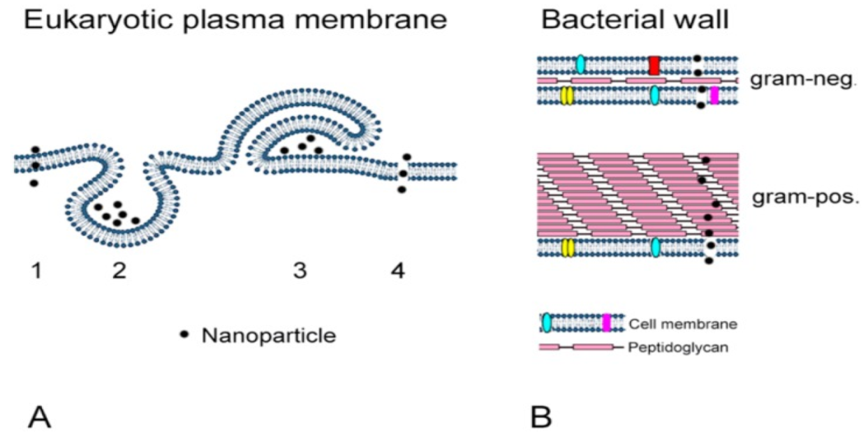

Fig 1. – taking up of AgNPs by Animal cells (A) and by Microorganism( Bacteria) (B). (Source - Bactericidal and Cytotoxic Properties of Silver Nanoparticles by Chengzhu Liao, Yuchao Li et;al)

Denaturation of the cellular membrane can potentially split cell nucleus, centriole, mitochondria, ribosome and possibly cause cell distruction. AgNPs also perform major role in the transduction of bacterial signals. Protein phosphorylation of the substrate affected transmission of bacterial signal, and nanoparticles have the potential to dephosphorylate tyrosine residue on peptide substrate,Cell apoptosis and interruption of cell divisions are result from signal transduction disruption¹². The level of Ag nanoparticle dissolution in exposure medium significantly impacts the antibacterial action and mechanism. The intrinsic features of AgNPs and the medium in which they are dispersed affect how well they dissolve¹³. Due to their increased surface area, smaller round or quasi-spherical AgNPs are more probably to release silver¹⁴. The surface of AgNPs is modified by capping agents, which can impact their dissolution behavior¹⁵. The existence of organic or inorganic components in the media impact how well silver nanoparticle dissolve. because they can aggregate with AgNPs or mix with Ag ions. In an acidic solution, AgNPs release Ag ions more quickly than in a neutral solution¹⁶.
AgNPs are high effective against Gram -ve bacteria. Gram -ve bacteria have a unthicked cell wall than gram +ve ones. The strong plasma (cell) membrane may prevent NPs from entering cells¹⁷. The distinct antibacterial responses of both gram+ve and gram -ve bacteria to AgNPs show that the uptake of AgNPs is essential to the antimicrobial action¹³. It is known that Ag nanoparticle smaller than 10 nm have the potential to penetrate microbial cells, change cell permeability directly & harm cells.
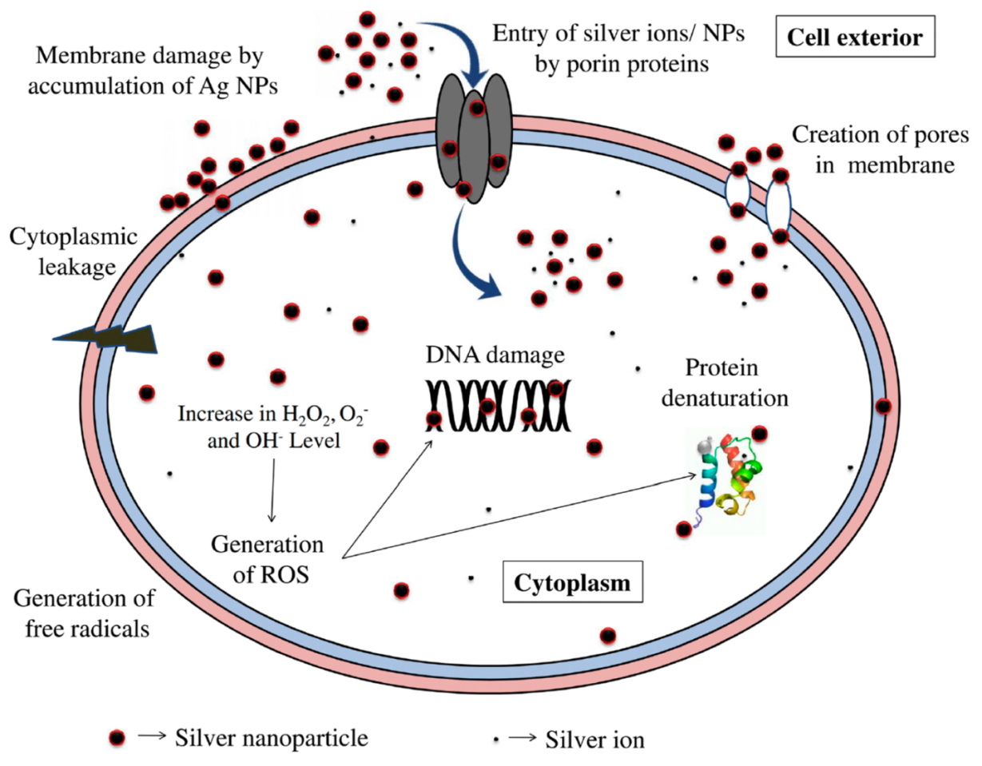

Fig 2. - Bactericidal mechanisms of Silver nanoparticle because they make direct contact with the bacterial cell wall and release Ag ions. ( Source -Bactericidal and Cytotoxic Properties of Silver Nanoparticles by Chengzhu Liao, Yuchao Li et;al)

AgNPs as a Distinct Method of Fighting Human Pathogenic Bacteria;

Silver NPs have demonstrated a viable choice for killing certain bacteria. Additionally to being capable to stop the development of multidrug-resistant strains, Silver nanoparticle have certain qualities that make them effective against these bacteria¹⁸⁻¹⁹. Silver is the most effective metallic NPs against microorganisms. Additionally, silver is very biocompatible and simple to use in medicinal applications²⁰. Another feature is that its antibacterial effect has been suggested to be mediated by a variety of mechanisms, some of which are thought to act on the cellular membrane, influence inside the cell components, and change the electron transport chain²¹. This final one is viewed as important for bacteria to become resistance against Silver nanoparticles, They would've been able to engage in numerous concurrent attacks. These reasons are why silver nanoparticles further been marketed as an alternative to antibiotics.²²⁻²³.

Using AgNPs in addition with antibiotics, functionalizing or conjugating AgNPs with other molecules has also been suggested as a successful option to achieve significant bactericidal activity without causing the development of bacterial resistance²⁴. Ashmore et al. [74] investigated the antibacterial efficiency of uncoated Silver nanoparticles vs coated Silver nanoparticles with PVP (Ag + PVP) and with a synthetic polymer (Ag + Polymer) against E. coli with the aim of testing this concept. Growth inhibition and MIC test findings revealed that Ag + Polymer was twice as effective as Silver nanoparticles²⁵⁻²⁶ . Given the history described above, which is summarised in Table 1, there are still a number of benefits to using nanoparticles to combat germs.

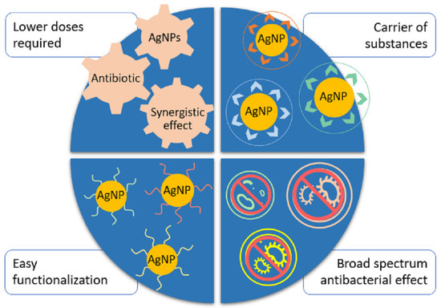

Fig 3.- Significance of utilising AgNPs in combination or as an alternative to antibiotics.(Source; Tamara Bruna , Francisca Maldonado-Bravo, Paul Jara and Nelson Caro; Silver Nanoparticles and Their Antibacterial Applications)

Antibiotic used with AgNPs | Bacteria tested | Antibacterial parameters | Reference
Erythromycin, ampicillin, cephalothin | Multiresistant S. aureus, S.mutans, S.oralis, S. gordonii, Enterococcus faecalis, E. coli | When coupled with AgNPs, antibiotics' antibacterial activity inhanced synergistically from no growth inhibition into the vulnerable range | 27
Vancomycin, ampicillin, penicillin | S. aureus, E.coli, K pneumoniae | Ampicillin combine with AgNPs is efficient opposed to all microorganisms. When conjugated with AgNP, all antibiotics will have increased antibacterial activity. | 28
Azlocillin | P. aeruginosa | The antibacterial activity of silver NPs combine with azlocillin increased from MIC = 8 ppm for azlocillin alone to MIC = 4 ppm AgNPs + azlocillin. | 29
Vancomycin, amikacin | E. coli, S. aureus | Antibiotic-functionalized AgNPs shown synergistic antibacterial activity. Vancomycin resistance to susceptibility in the instance of E. coli. | 30

Table 1. AgNPs combined with Antibiotics and their antibacterial parameters.

Antimicrobial AgNPs in healthcare application - The fields of medicare and health are those where antimicrobial nanoparticle technology is being researched and developed the most³¹⁻³². Silver nanoparticle may be applied to many products with bactericidal properties due to their biocompatibility and rapid functionalization. The usage of AgNPs in face masks to enhance their level of protection is one of their primary uses. The face mask invented by Y. Li et al.³³ that was coated with nanoparticles made from titanium dioxide and silver nitrate shown the capacity to eliminate up to 100% of E. coli and S. aureus Colony Forming Unit ( CFU) within 24 hours. Same research involved treating a industrially obtainable mask with compound of AgNPs at 50 and 100 ppm concentration, producing masks with intigrated NPs that may stop the development of E. coli and S. aureus³⁴. These findings are extremely encouraging since face masks enhanced with silver nanoparticles might prevent from infections in settings like hospitals where harmful bacteria are persistent in high levels³⁵. additionally the silver's antibacterial action, studies on its healing characteristics and its NPs have led to the expansion of a variety of wound dressings with improved healing and antimicrobial affects. In order to treat superficial wounds, Tian et al.³⁶ applied a compound of AgNPs. They discovered that this therapy helped the wounds heal more quickly and with greater skin regeneration. Due to this identical characteristic, research led to the synthesis of a topical AgNPs solution for treatment on burns and other skin lesions. The outcome was a establishment antibacterial activity without harmful side effects and the capacity to accelerate the healing of wounds³⁷. Additionally, research has been done on the possibility of improving antibacterial action by combining AgNPs with organic compounds. For instance, lignin and polyvinyl alcohol were used to formulate a hydrogel which contained in-situ synthesised AgNPs. The synthesised compound shown strong antimicrobial activity against S. aureus and E. coli, after 10 hours of treatment, practically all bacteria had been killed³⁸.

Conclusion - AgNPs are an amazing antibacterial agent and currently have excellent antibacterial properties. They address a number of requirements that are thought to be necessary for new antimicrobial technologies to meet in must be in order to effective, including antibacterial performance, fast action, and lower cytotoxicity. Moreover, Nps can be altered to attain delivery & selectivity to certain targets. Their usage opposed to microorganisms must be controlled & assessed to prevent inappropriate exposure of pathogens to sublethal dosages that may encourage the emergence of toleration to this against. Utilising AgNPs minimises the dosages of antibiotic and nanoparticle needed to exert efficient antibacterial activity opposed to variety of bacteria, reducing the possibility of adverse effects. In addition, NPs have antimicrobial action against a range of different bacterial species ( gram +ve and gram - ve) as well as resistant strain and may be functionalized with various compounds to increase their antibacterial efficacy. Nanoparticles can form complexes can operate as drug carriers or antibiotics. This research highlights the antibacterial mechanism, potential, and possible medicinal uses of silver nanoparticles and offers an overview of their antibacterial usage.

Reference –
- Kesharwani P, Gorain B, Low SY, et al. Nanotechnology based approaches for anti-diabetic drugs delivery. Diabetes Res Clin Pract. 2018;136:52–77. doi:10.1016/j.diabres.2017.11.018
- Oves M, Aslam M, Rauf MA, et al. Antimicrobial and anticancer activities of silver nanoparticles synthesized from the root hair extract of Phoenix dactylifera. Materials Science and Engineering: C. 2018;89:429–443. doi:10.1016/j.msec.2018.03.035
- Samuel MS, Jose S, Selvarajan E, Mathimani T, Pugazhendhi A. Biosynthesized silver nanoparticles using Bacillus amyloliquefaciens application for cytotoxicity effect on A549 cell line and photocatalytic degradation of p-nitrophenol. J Photochem Photobiol. 2020;202:111642
- Pugazhendhi A, Edison TNJI, Karuppusamy I, Kathirvel B. Inorganic nanoparticles: a potential cancer therapy for human welfare. Int J Pharm. 2018;539(1–2):104–111. doi:10.1016/j.ijpharm.2018.01.034.
- Bruna, T.; MaldonadoBravo, F.; Jara, P.; Caro, N. Silver Nanoparticles and Their Antibacterial Applications. Int. J. Mol. Sci. 2021, 22, 7202. https://doi.org/10.3390/ ijms22137202.
- Yaqoob, A.A.; Umar, K.; Ibrahim, M.N.M. Silver nanoparticles: Various methods of synthesis, size affecting factors and their potential applications—A review. Appl. Nanosci. 2020, 10, 1369–1378.
- Ferdous, Z.; Nemmar, A. Health impact of silver nanoparticles: A review of the biodistribution and toxicity following various routes of exposure. Int. J. Mol. Sci. 2020, 21, 2375.
- Cavassin, E.D.; de Figueiredo, L.F.P.; Otoch, J.P.; Seckler, M.M.; de Oliveira, R.A.; Franco, F.F.; Marangoni, V.S.; Zucolotto, V.; Levin, A.S.S.; Costa, S.F. Comparison of methods to detect the in vitro activity of silver nanoparticles (AgNP) against multidrug resistant bacteria. J. Nanobiotechnol. 2015, 13, 1–16.
- Iris Xiaoxue Yin, Jing Zhang, Irene Shuping Zhao , May Lei Mei, Quanli Li, Chun Hung Chu; The Antibacterial Mechanism of Silver Nanoparticles and Its Application in Dentistry 2020:15 2555–2562.
- Ramkumar VS, Pugazhendhi A, Gopalakrishnan K, et al. Biofabrication and characterization of silver nanoparticles using aqueous extract of seaweed Enteromorpha compressa and its biomedical properties. Biotechnol Rep. 2017;14:1–7. doi:10.1016/j.btre.2017. 02.001.
- Durán N, Nakazato G, Seabra A. Antimicrobial activity of biogenic silver nanoparticles, and silver chloride nanoparticles: an overview and comments. Appl Microbiol Biotechnol. 2016;100(15):6555–6570. doi:10.1007/s00253-016-7657-7
- Li L, Li L, Zhou X, et al. Silver nanoparticles induce protective autophagy via Ca 2+ /CaMKKβ/AMPK/mTOR pathway in SHSY5Y cells and rat brains. Nanotoxicology. 2019;13(3):369–391. doi:10.1080/17435390.2018.1550226.
- Noronha VT, Paula AJ, Durán G, et al. Silver nanoparticles in dentistry. Dent Mater. 2017;33(10):1110–1126. doi:10.1016/j.dental.2017.07.002
- . Shanmuganathan R, MubarakAli D, Prabakar D, et al. An enhancement of antimicrobial efficacy of biogenic and ceftriaxone-conjugated silver nanoparticles: green approach. Environ Sci Pollut Res Int. 2018;25 (11):10362–10370. doi:10.1007/s11356-017-9367-9
- . Khorrami S, Jafari F, Zarrabi A, Zarepour A. Is Astragalus gossypinus honey a natural antibacterial and cytotoxic agent? An investigation on A. gossypinus honey biological activity and its green synthesized silver nanoparticles. Bionanosci. 2018;9(3):603–10
- Jacob JM, John MS, Jacob A, et al. Bactericidal coating of paper towels via sustainable biosynthesis of silver nanoparticles using ocimum sanctum leaf extract. Bactericidal Coat Pap Towels Sustainable Biosynth Silver Nanopart Ocimum Sanctum Leaf Extr. 2019;6(4):045401.
- Meikle T, Dyett BP, Strachan JB, White J, Drummond CJ, Conn CE. Preparation, characterization, and antimicrobial activity of cubosome encapsulated metal nanocrystals. ACS Appl Mater Interfaces. 2020;12(6):6944–6954. doi:10.1021/acsami.9b21783.
- Lee, N.Y.; Ko, W.C.; Hsueh, P.R. Nanoparticles in the treatment of infections caused by multidrug-resistant organisms. Front. Pharmacol. 2019, 10, 1153.
- Saeb, A.T.M.; Alshammari, A.S.; Al-Brahim, H.; Al-Rubeaan, K.A. Production of silver nanoparticles with strong and stable antimicrobial activity against highly pathogenic and multidrug resistant bacteria. Sci. World J. 2014
- Ivask, A.; Elbadawy, A.; Kaweeteerawat, C.; Boren, D.; Fischer, H.; Ji, Z.; Chang, C.H.; Liu, R.; Tolaymat, T.; Telesca, D.; et al. Toxicity mechanisms in Escherichia coli vary for silver nanoparticles and differ from ionic silver. ACS Nano 2014, 8, 374–386
- Dakal, T.C.; Kumar, A.; Majumdar, R.S.; Yadav, V. Mechanistic basis of antimicrobial actions of silver nanoparticles. Front. Microbiol. 2016, 7, 1831
- Baptista, P.V.; McCusker, M.P.; Carvalho, A.; Ferreira, D.A.; Mohan, N.M.; Martins, M.; Fernandes, A.R. Nano-strategies to fight multidrug resistant bacteria—“A Battle of the Titans”. Front. Microbiol. 2018, 9, 1141.
- Cheeseman, S.; Christofferson, A.J.; Kariuki, R.; Cozzolino, D.; Daeneke, T.; Crawford, R.J.; Truong, V.K.; Chapman, J.; Elbourne, A. Antimicrobial Metal Nanomaterials: From Passive to Stimuli-Activated Applications. Adv. Sci. 2020, 7, 837–842
- Brown, A.N.; Smith, K.; Samuels, T.A.; Lu, J.; Obare, S.O.; Scott, M.E. Nanoparticles functionalized with ampicillin destroy multiple-antibiotic-resistant isolates of Pseudomonas aeruginosa and Enterobacter aerogenes and methicillin-resistant Staphylococcus aureus. Appl. Environ. Microbiol. 2012, 78, 2768–2774
- Ashmore, D.; Chaudhari, A.; Barlow, B.; Barlow, B.; Harper, T.; Vig, K.; Miller, M.; Singh, S.; Nelson, E.; Pillai, S. Evaluation of E. coli inhibition by plain and polymer-coated silver nanoparticles. Rev. Inst. Med. Trop. Sao Paulo 2018, 60, 1–11.
- Rezazadeh, N.H.; Buazar, F.; Matroodi, S. Synergistic effects of combinatorial chitosan and polyphenol biomolecules on enhanced antibacterial activity of biofunctionalaized silver nanoparticles. Sci. Rep. 2020, 10, 1–13.
- Ipe D.S., Kumar P. T. S., Love R.M., Hamlet S.M. Silver Nanoparticles at Biocompatible Dosage Synergistically Increases Bacterial Susceptibility to Antibiotics. Front. Microbiol. 2020;11:1074.doi:103389/fmicb.2020.01074.
- Ashmore, D.; Chaudhari, A.; Barlow, B.; Barlow, B.; Harper, T.; Vig, K.; Miller, M.; Singh, S.; Nelson, E.; Pillai, S. Evaluation of E. coli inhibition by plain and polymer-coated silver nanoparticles. Rev. Inst. Med. Trop. Sao Paulo 2018, 60, 1–11.
- Alizadeh, A.; Salouti, M.; Alizadeh, H.; Kazemizadeh, A.R.; Safari, A.A.; Mahmazi, S. Enhanced antibacterial effect of azlocillin in conjugation with silver nanoparticles against Pseudomonas aeruginosa. IET Nanobiotechnol. 2017, 11, 942–947.
- Kaur, A.; Kumar, R. Enhanced bactericidal efficacy of polymer stabilized silver nanoparticles in conjugation with different classes of antibiotics. RSC Adv. 2019, 9, 1095–1105.
- Yaqoob, A.A.; Umar, K.; Ibrahim, M.N.M. Silver nanoparticles: Various methods of synthesis, size affecting factors and their potential applications—A review. Appl. Nanosci. 2020, 10, 1369–1378
- Vimbela, G.V.; Ngo, S.M.; Fraze, C.; Yang, L.; Stout, D.A. Antibacterial properties and toxicity from metallic nanomaterials. Int. J. Nanomed. 2017, 12, 3941–3965
- Li, Y.; Leung, P.; Yao, L.; Song, Q.W.; Newton, E. Antimicrobial effect of surgical masks coated with nanoparticles. J. Hosp. Infect. 2006, 62, 58–63
- Hiragond, C.B.; Kshirsagar, A.S.; Dhapte, V.V.; Khanna, T.; Joshi, P.; More, P.V. Enhanced anti-microbial response of commercial face mask using colloidal silver nanoparticles. Vacuum 2018, 156, 475–482.
- Valdez-Salas, B.; Beltran-Partida, E.; Cheng, N.; Salvador-Carlos, J.; Valdez-Salas, E.A.; Curiel-Alvarez, M.; Ibarra-Wiley, R. Promotion of Surgical Masks Antimicrobial Activity by Disinfection and Impregnation with Disinfectant Silver Nanoparticles. Int. J. Nanomed. 2021, 16, 2689–2702
- Tian, J.; Wong, K.K.Y.; Ho, C.M.; Lok, C.N.; Yu, W.Y.; Che, C.M.; Chiu, J.F.; Tam, P.K.H. Topical delivery of silver nanoparticles promotes wound healing. ChemMedChem 2007, 2, 129–136
- Jain, J.; Arora, S.; Rajwade, J.M.; Omray, P.; Khandelwal, S.; Paknikar, K.M. Silver Nanoparticles in Therapeutics. Mol. Pharm. 2009, 6, 1388–1401
- Li, M.; Jiang, X.; Wang, D.; Xu, Z.; Yang, M. In situ reduction of silver nanoparticles in the lignin based hydrogel for enhanced antibacterial application. Colloids Surf. B Biointerfaces 2019, 177, 370–376

