A Study On Hydraulic Fracturing Analysis Using FRACPRO

Devanandan Gogoi and Dhrubajyoti Neog
Department of Petroleum Technology, Dibrugarh University, Dibrugarh, India

ABSTRACT
One of the most promising and economic-stimulating operations in the hydrocarbon industry is hydraulic fracturing. The size and concentration of proppants, fracture geometry, conductivity, and pump rate are just a few of the many variables that affect how hydraulic fracturing operations are designed. Other important parameters are the depth and thickness of reservoirs, faults, and natural fractures, which can vary significantly from location to location. All play a significant role and affect the reservoir's properties. The current work presents an extensive study on Hydraulic Fracturing design, which is based on the selection of proppants, hydraulic fracturing fluid, fracture model, and treatment size. Also, this study incorporates an analysis of the induced fractures using FracPro software to study the induced fracture conductivity for enhancing crude oil production.

Keywords—hydraulic fracturing; FRACPRO, stimulation; sandstone; formation; conductivity

INTRODUCTION

Hydraulic fracturing is employed in the economically viable production of crude oil and natural gas from unconventional reservoirs like shale gas, tight gas, or low-permeability reservoirs. Hydraulic Fracturing typically involves fracturing the formation first and then keeping it open using proppants. The formation rock is broken in the process by the use of fracturing fluids, which primarily comprise water, chemical additives, and particles (proppant). One of the key elements that controls the fracture's conductivity is the proppants [1]. To keep the fracture open and maintain fluid flow into the wellbore, the proppants are moved inside the formation. Additionally, the choice of an appropriate proppant material and the design of the hydraulic fracturing fluid are both essential and can differ greatly from formation to formation. Increases in the productivity index of a producing well or the injectivity index of an injection well are achieved through hydraulic fracture treatments. Hydraulic fracturing may increase the flow rate of low-permeability reservoirs, restore damaged formation productivity, and reduce the pressure drop in the wellbore. Testing proppant is essential to determining when the proppant may fail and the effect of closure pressure on proppant during hydraulic fracturing [2] and [3]. This is also required to ensure that proppants provide better conductivity or pore channels after fracturing [4].

SELECTION OF PROPPANTS
In the current work, the selection of proppant followed the standard ISO 13503-2 requirements for the sand sample procured from Gujarat, India. Crush resistance, sphericity and roundness, turbidity, acid solubility, densities, and sieve analysis make up the foundation of this standard [1, 2].

Characterisation of Proppants by Sieve Analysis
The top sieve in a stack of sieves with progressively smaller sieve opening sizes from top to bottom is where the sample of sand is placed. The Granulometer is used to calculate the grain size as well as its cumulative weight percentage [1, 5].

Sphericity & Roundness
Sphericity and Roundness are two important parameters for characterising the proppants. The proppants should have a higher roundness and sphericity so that a tighter throat of lesser porosity is not formed in the induced fractures. The Krumbein-Sloss chart is the most popular tool for assessing sphericity and roundness. In order to compare each randomly chosen particle's sphericity and roundness to the chart, the proppant particles are placed in the field of vision of a 40x magnification microscope. The average particle sphericity and roundness are then determined for the reported data using the arithmetic average. For precision in determining how closely a particle of proppant resembles the shape of a sphere, the sphericity factor is calculated using the formula below [1, 5].
$Ψ=\frac{6}{d.a}$ ……… (Eq. 1)
where, d= mean volume diameter,
a= specific surface area

Acid Solubility
The acid solubility test is used to determine whether a proppant is appropriate for use with acids. Dry proppant (5 g/100 mL) is mixed with a solution of hydrochloric acid (HCl), ammonium bifluoride (NH₄F₂), and distilled water. Calculating solubility (S) through filtering is done [1, 5].

Bulk Density
Proppant and porosity are both included in the mass that makes up a unit of volume, which is referred to as bulk density. It is used to calculate how much proppant will be required to fill a fracture. Toluene, a low-viscosity fluid, is used to wet the particle surface and quantify the particle's pore space as well [1, 5].

Crush Resistance
This test, carried out on a Universal Testing machine, assesses the amount of proppant as well as determines and compares the crush resistance. The amount of proppant material that is crushed is calculated for each stress level [1, 5]. In a test cell with an inner diameter of 50.8 mm, the proppant needs to occupy a volume of 24.7 cm³. Use the formula to calculate the required mass for this test, m_{p}, in grams.
$m_{p}=24.7 x q_{bulk}$ ……. (Eq. 2)
where qbulk is the bulk density.

Turbidity
Turbidity tests measure a suspension's optical quality, which is based on how the suspended particles in the wetting fluid reflect and absorb light. Using a MERCK TURBIQUANT 1500 T calibrated turbidimeter, the results are presented in nephelometric turbidity units (NTU) [1, 5].

EXPERIMENTAL WORK

The physical characteristics of proppants and sand samples were investigated in the current work in accordance with ISO 13503-2 standards [1, 2].

Sieve analysis
With the aid of shakers and ASTM sieves with mesh numbers ranging from 20 to 230, a granulometric examination was conducted. The sand sample was sorted, and mesh sizes 20/40 and 30/50 were found in the sample considered for the study. The diameter (mm) of the sand sample mesh sizes was given as below:

Table 1. Results for Sieve Analysis

Sand Type | Mesh Size | Range Size (µm)
Sand Based | 20/40 | 600 to 800
 | 30/50 | 300 to 600
Ceramic based | 20/40 | 600 to 800
 | 30/50 | - 600

B. Sphericity and Roundness
The tested sand sample for Roundness and Sphericity was found to be as per the recommended ISO requirement. So based on its sphericity and roundness, the sand sample in the current work can be recommended for use in hydraulic fracturing operations.

Table 2. Results for Roundness & Sphericity
Sand Type | Mesh Size | Roundness/Sphericity | ISO  requirement
Sand Based | 20/40 | 0.64-0.72 | 0.6
 | 30/50 | 0.62-0.7 | 0.6
Ceramic based | 20/40 | 0.80-0.95 | 0.6
 | 30/50 | 0.78-0.95 | 0.6
C. Acid Solubility
The equation used for measuring acid solubility is referred to in equation 3.
$S=\frac{\left(m_{s}+m_{f}-m_{fs}\right)x100}{m_{s}}$ .. (Eq. 3)
where m_{s}: sample mass,
m_{f}: mass of the filter, and
m_{fs}: dry mass of the filter, expressed in grammes.
The tested sand sample for Acid Solubility was within the recommended ISO requirement. So based on its Acid Solubility, the sand sample can be recommended for use in hydraulic fracturing operations [1, 3, 4].

Table 3. Results for Acid Solubility

Sand Type | Mesh Size | Acid Solubility
Sand Based | 20/40 | 2
 | 30/50 | 2
Ceramic based | 20/40 | 1
 | 30/50 | 1

D. Proppant Bulk density & Proppant grain density
Proppant Bulk density and Proppant grain density were determined using a pycnometer in the current work.

E. Crush Resistance
The current work finds that, as per the API recommendations, the proppant sand can be used to withstand closure pressures until the proppant produces less than 10% fines. If at a depth the proppant sand produces >10% fines due to high closure pressures, the proppant sand type is not recommended. The amount of fines produced at varying pressures for our sand sample is given as below [1, 2, 4, 6]:

Table 4. Results for Crush Resistance

Sand Type | Mesh Size | % Fines at 4000psi | % Fines at 6000psi
Sand Based | 20/40 | 8.3 | 14.3
 | 30/50 | 8 | 13.8
Ceramic based | 20/40 | 2 | 6.1
 | 30/50 | 2 | 6

F. Turbidity
The results of the experimental work found that the tested sand sample for Turbidity was within the recommended ISO requirement. So based on its turbidity test results, it is preferable for use in hydraulic fracturing operations.

Table 5. Results for Turbidity

Sand Type | Mesh Size | Turbidity [NTU]
Sand Based | 20/40 | 250
 | 30/50 | 250
Ceramic based | 20/40 | <100
 | 30/50 | <100

The findings of the experimental work highlight the following:
- The analyzed samples from Gujarat had two proppant mesh sizes: 20/40 and 30/50.
- The proppant sands are appropriate for use in an acidic environment.
- Fracturing can be done using proppant.
- The proppants used in the current work are appropriate for fracturing shallow reservoirs with less than 5000 psi closing pressure.
From all the tests done on the sand samples and when compared to those of ceramic proppants, it is observed that the ceramic proppants have performed better than the sand proppants; however, the price of ceramic proppants is almost five times the price of sand proppants, as ceramic proppants are designed in the lab specifically to withstand higher closure pressures and impart better porosity in the induced fractures. Due to economic reasons, sand proppants are preferred over ceramic proppants unless extremely high closure pressures are encountered.

FRACTURING FLUID & FRACTURE MODEL
According to earlier research, there are two different types of data needed to develop the fracture model and the reservoir simulation. The first kind is the primary data, which includes information about wells, fluids, and different forms of proppant. Secondary data is measured or estimated and contains formation properties [7, 8, 9].

RESULT AND ANALYSIS
Carbo FracPro provides data regarding fracturing fluid and proppant types. The formation lithology should also be compatible with the procured sand sample from Gujarat, India, for recommendation for use in hydraulic fracturing operations below 5000 psi. Next, the performance of the fractures is analysed, i.e., fracture ` conductivity, and the results are compared with those of other proppants.
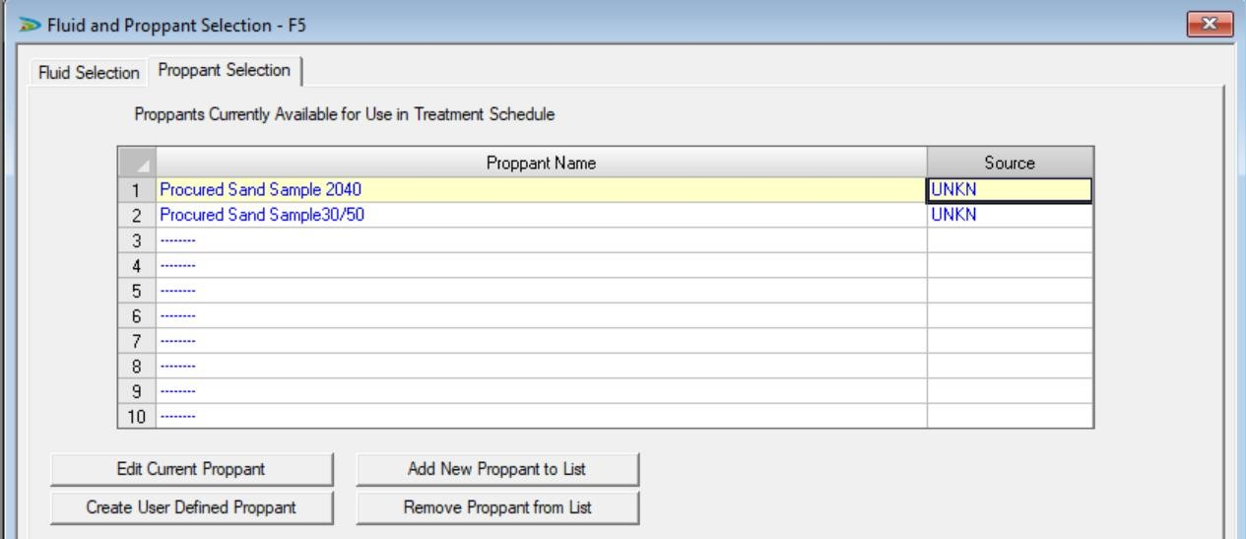
Figure 1: Fluid & Proppant Selection
For the fracture simulation, a case wherein a sandstone formation with 100 feet of thickness was between two shale formations was considered. The reservoir has ceased production due to the presence of a 60-foot layer of skin or formation damage near the wellbore, requiring hydraulic fracturing operations. Based on the situation, the KGD fracture model best fits the purpose. After defining the formation, wellbore configuration, fracturing fluid, and proppant, the FracPro study was performed.

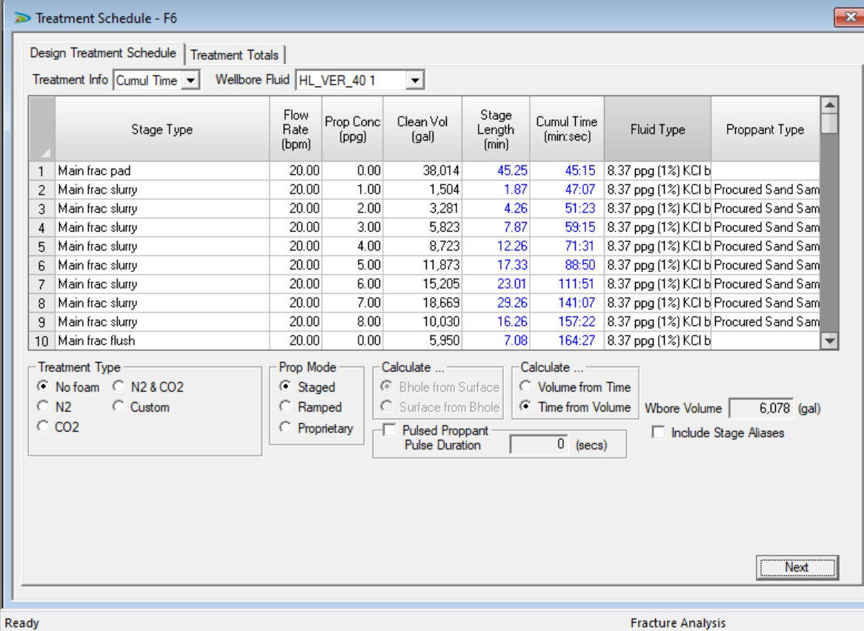
Figure 2: Treatment Schedule

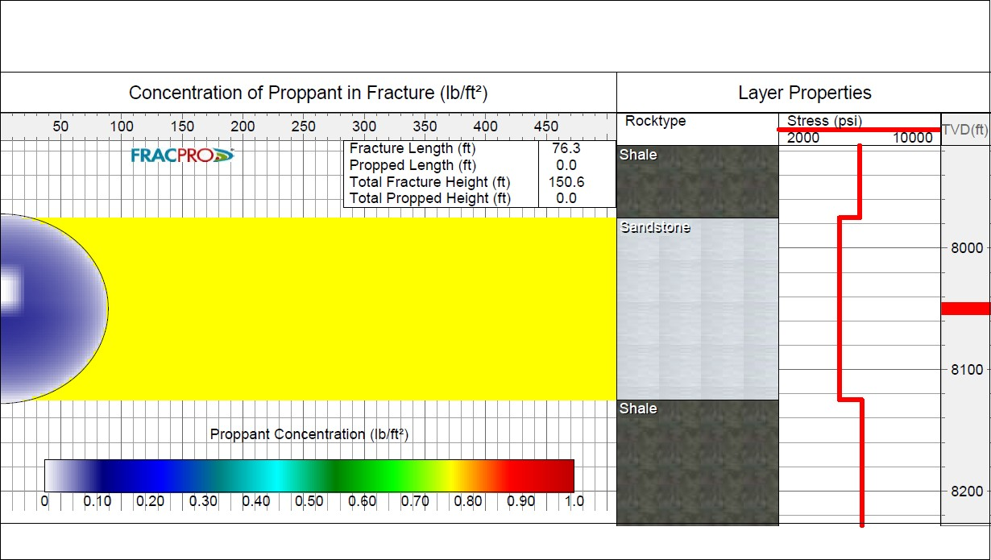
Figure 3: Fracture Profile after Pad stage
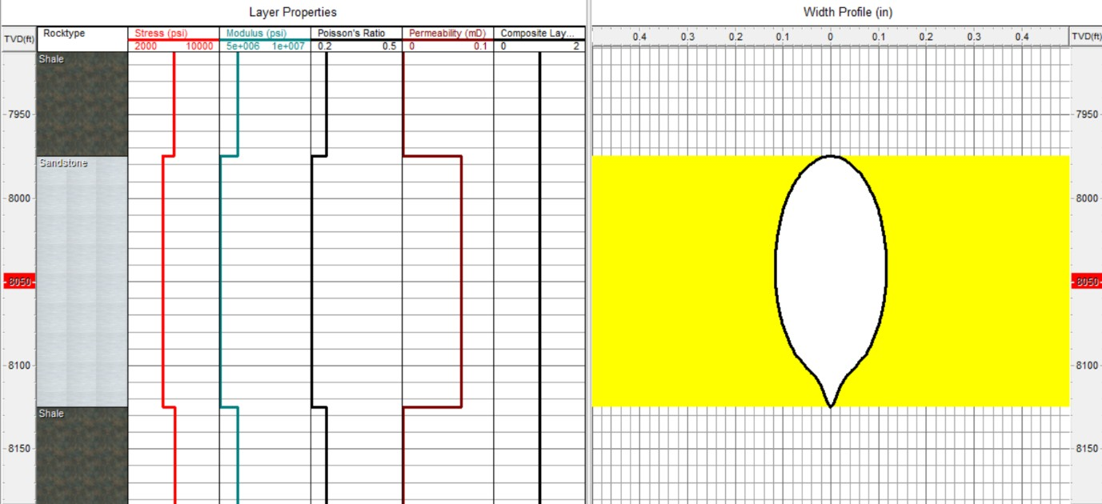

Figure 4: Width Profile after Padstage

The outcome of the current work reflects (Fugure 1-4) that post-pad stage, the slurry goes in and places the proppants into the fracture. With the obtained proppant sample, the post-fracture conductivity was analysed in the produced fractures and compared with various propping materials, from sand-type to ceramic-type proppants. For this, three different proppants were considered: Accupak 20/40 (a medium-strength resin-coated proppant), Ceramax 20/40 (a medium-strength ceramic proppant), and Bauxlite 20/40 (a high-strength ceramic proppant) from the FracPro library, and the fracture conductivity for the procured sand sample was compared. The fracture simulation and test were done for a sandstone formation with a depth of 8000ft and an in-situ stress of approx. 5000 psi, which was earlier recommended as the maximum permissible stress for the procured proppant sand.

Fig 4.8 Comparison of Fracture Conductivity with different proppants

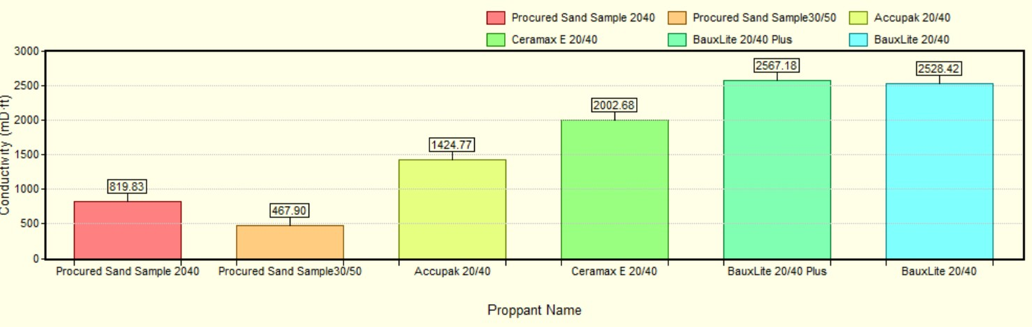
Figure 5: Fracture Conductivity versus proppant types

Figure 5 shows the fracture conductivity for the fractures with different proppants. From this, the significance of the crush resistance, or crushing strength, of the proppant sand can be understood. There is a reduction in conductivity noticed when used with the finer mesh grade "procured sand sample 30/50," which might be due to lower crushing strength and blocking of the pore spaces and fines produced due to the extreme high pressures. The resin-coated and ceramic proppants, on the other hand, offer superior conductivity in the induced fracture, resulting in more stable conductive pathways under the same conditions.
In contrast to other proppant kinds used in the current work, the present study observes that sand-based proppants are significantly less expensive. Sand-based proppants cost Rs. 8 per kilogram. At Rs. 33/kg and Rs. 75/kg, respectively, resin-coated and ceramic proppants were priced four to nine times higher than sand-based proppants. For these economic reasons, for shallow reservoirs with lesser crushing pressure, sand-based proppants are recommended; however, at greater depths with high crushing strength, resin-coated or ceramic proppants are to be used.

CONCLUSION
Through field work and experience, one can gain a thorough understanding of hydraulic fracturing design. Based on a combined experimental and analytical study, the current work concludes the following:
1. The proppant mesh sizes of 20/40 and 30/50 are preferable for fracturing the formation.
2. Fracturing shallow reservoirs with less than 5000 psi closure is preferable with the above proppant types.
3. From the analysis of the fracture conductivity on the sand samples and when compared to that of ceramic proppants, it is seen that the ceramic proppants have performed better than the sand proppants. But the ceramic proppants are expensive. Due to this, in shallow reservoirs with lesser crushing pressure, sand-based proppants are used.

REFERENCES

[1] Api, A. (1995). Recommended Practices for Testing Sand Used in Gravel Packing Operations, API RP 58. API RP, 58.
[2] Api, A. (1995). Recommended Practices for Testing High- Strength Proppants Used in Hydraulic Fracturing Operations, API RP 60. API RP, 60.
[3] Liang, F., Sayed, M., Al-Muntasheri, G. A., Chang, F. F., & Li, L. (2016). A comprehensive review on proppant technologies. Petroleum, 2(1), 26–39. https://doi.org/10.1016/j.petlm.2015.11.001
[4] Simo, H., Pournik, M., & Sondergeld, C. H. (Eds.). (n.d.). Proppant Crush Test: A New Approach”.
[5] Hydraulic fracturing proppants (Propantes para fraturamento hidráulico)”. (n.d.).
[6] EI-Sayed, A. A. H., Hemeida, A. M., & AI-Blehed, M. S. (Eds.). (n.d.). Testing of Saudi Sand-dunes for Potential Use in Hydraulic Fracturing of Hydrocarbon Reservoirs”.
[7] Coulter, G. R., & Wells, R. D. (1972). The advantages of high proppant concentration in fracture stimulation. Journal of Petroleum Technology, 24(06), 643–650. https://doi.org/10.2118/3298-pa
[8] Howard, G. C., & Fast, C. R. (1970). Monograph 2 - Hydraulic fracturing.
[9] Gidley, J. L., Penny, G. S., & McDaniel, R. R. (1995). Effect of proppant failure and fines migration on conductivity of propped fractures. SPE Production & Facilities, 10(01), 20–25. https://doi.org/10.2118/24008-pa

