Visual Feature Based Recognition and Segregation System for Industrial Intelligence Using Deep Learning and Robotics
Dr. Bahubali M. Akiwate
Department of Computer Science and Engineering
K.L.E. College of Engineering & Technology Chikodi, India
bahubalimakiwate@gmail.com

Dr. Sanjay B. Ankali
Department of Computer Science and Engineering
K.L.E. College of Engineering & Technology Chikodi, India
sanjayankali123@gmail.com

Dr. Shantappa G. Gollagi
Department of Computer Science and Engineering
K.L.E. College of Engineering & Technology Chikodi, India
shantesh1973@rediffmail.com

Dr. Shashidhar Gurav
Department of Artificial Intelligence and Data Science Sharad Institute of Technology College of Engineering Ichalkaranji, India
gurav.shashidhar@gmail.com

ABSTRACT

It is crucial part of any manufacturing process, either using manual inspection or using today’s modern approaches, to detect the defects at the earlier stages to minimize the risks of failure at later stages. Detecting defective products is crucial in the manufacturing of industrial products. The quality control system performs quality checks of the manufactured products in most of the industries post production using quality control department. The manual inspection of quality is an error-prone and repetitive task that requires precision. The proposed system uses robotics and deep learning to detect industrial defects through visual feature inspection.
Index Terms: Defect Detection, Industry 4.0, Deep Learning, Robotics

INTRODUCTION
Defect detection in physical components has been a specialized task since ancient times. Defects are common in manufacturing and parts must be quality checked before dispatch or completion of orders. Everyday usage can cause products to corrode and deteriorate quickly. Nonetheless, if a product can endure its surroundings and perform with utmost precision and efficacy for an extended period, it can be highly advantageous to its users. Manufacturers can benefit greatly by investing in defect-detection technologies as they can cut down production expenses, enhance production efficiency and product quality, and establish a firm footing for the future of manufacturing. An essential component of the industrial production process is quality control. Currently, other strategies are employed to bring about the results of a procedure. Quality control techniques or strategies can be categorized as destructive or non- destructive testing depending on the technique utilized to find a flaw on a surface of the specific product. NDTs (non-destructive testing) are used to find flaws in a component without taking samples from it. One of the most used methods in industry, out of all, is the visual-based approach to fault detection. Traditional visual inspection, however, is a laborious and immeasurable process. Advanced automatic defect detection systems have been developed by researchers to address the intricate and distinct nature of each problem. These systems have stringent requirements that must be met with precision.
This proposed approach deals with the concept of visual feature-based recognition and segregation system

for industrial intelligence using deep learning and robotics. In this proposed approach deep learning based techniques were used for defect detection in industrial intelligence and robotic system is used for automatic segregation of the defective parts over the hardware setup develop.

RELATED WORKS
We conducted a literature review to analyze various approaches, identify challenges, and understand the limitations of current research to define the problem at hand. A study conducted by Xu et al. in 2017 used an image filter and threshold values to identify defects on metal cylindrical surfaces. The error rate for 600 samples was only 2.3%. However, the researchers noted a significant amount of overfitting, which they addressed and improved upon in subsequent research [7]. In 2018, Li et al. [9] utilized various techniques to detect and analyze defects on metal spoons' surfaces. These techniques included image filtering to reduce noise, histogram equalization, and the Laplace operator to enhance defect features. They also implemented edge detection algorithms such as Canny, Shovel, and Log to obtain images of the spoon and defect edges. In 2017, Soukup and Hubra-Mork [12] successfully captured images of rail surface defects using a line scan camera and two different colored light sources. The method used by the researchers involved a classic convolutional neural network (CNN) framework, resulting in an impressive error rate of only 1.108%. They emphasized that their study was conducted with minimal data and recommended using various data augmentation techniques to prevent the model from overfitting. In 2019, Song and a team of researchers successfully developed a fully convolutional network (FCN) using a U-net framework to accurately detect minor surface defects on metal plates with inconsistent grayscale distributions. For this purpose, they used a lighting system comprising of strong white LED bars [15].

VISUAL FEATURE BASED RECOGNITION AND SEGREGATION SYSTEM FOR INDUSTRIAL INTELLIGENCE USING DEEP LEARNING AND ROBOTICS
The proposed approach involves creating a recognition and segregation system for industrial intelligence using visual features, deep learning, and robotics. As shown in the figure 1 below, the proposed system consists of the camera module which is attached to the industrial conveyor for visual defect inspection. The material to be inspected for surface defects is left over the conveyor. The camera mounted on the top captures the image when the material is detected on the conveyor and feeds it to the deep learning model. The model is trained on the defect and non-defect dataset using transfer learning which detects if the part on the conveyor is defective using inference on the image. If the industrial part to be inspected is non defective it will be accepted. The forward kinematics Robotic arm is also incorporated on the system which will automatically segregate the defective parts from the flow if the part is found to be defective in visual inspection using deep learning.

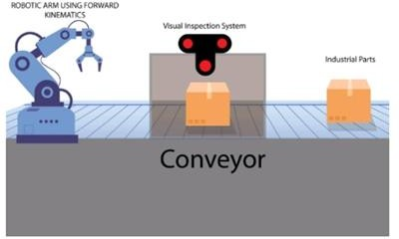

Figure 1: The Conceptual Diagram of the Proposed Approach

- Methodology
This section details the methodology followed as given below:
- Literature Survey and Problem Definition:
This involves studying the literature on the existing topic and then arriving at the problem definition.
The current research works were studied and the problems in the current research works were outlined.
- Selection of most suitable materials:
Here the market study is done and the most suitable materials for the implementation are chosen.
- Dataset Collection:

To train the deep learning model the transfer learning approach is used. This phase involves dataset collection of the different industrial objects in which the defects are to be detected. The dataset is collected manually by collecting the images of defective classes.
- Data pre-processing:
In this phase the data pre-processing is done to sort the dataset collected and converted it into the compatible format for training the model. After the dataset is collected the train-test-split is done. The data collected is annotated using the annotation tool to mark the Region of Interest (ROI).
- Training the Model:
In this phase the model is trained using transfer learning approach. The model training procedure requires a GPU and is trained on NVIDIA GPU.
- Development of Raspberry Pi based system capable of detecting defects:
Once the trained model is ready the next step is to develop a Raspberry Pi based framework for detection and location of defects in industrial parts is developed. This involves interfacing the camera from the Raspberry Pi to capture the data from the camera and feed it to the trained model. The image is fed to the model which is deployed on raspberry pi to get the location of the defective parts. If the product is found to be defective same is returned by the python script.
- Fabrication of conveyor:
The conveyor is driven from the raspberry pi using the DC geared motors interfaced to the raspberry pi using DC motor drivers. The conveyor will carry the parts to be inspected to the camera detection station.
- Robotic Arm Development:
In this phase the robotic arm is developed which will be used to segregate the defective parts from the normal products. The Robotic arm is developed by interfacing servo motors to the raspberry pi and controlling using the command signal generated when the trained deep learning model detects defective parts.
- Programming:
The complete program for the interaction with the trained model and the inference to detect the industrial defects as well as driving the conveyor is programmed in this phase.
- Assembly and Optimization

System Design
The system consists of development of visual feature-based recognition and segregation system for Industrial intelligence using deep learning and robotics. The overall system development is divided into different modules which can be complete phase wise to be delivered as a final product. The different modules in the proposed system are:
- Deep Learning based Visual Defect Recognition system:
The deep learning based visual defect detection module uses a neural network to classify the defect data using camera present on the system. The camera is interfaced to the raspberry pi which runs a deep learning based trained model for the defect detection. The model used is trained using transfer learning approach which involves following sub modules:
  - Data Collection: In this phase the data regarding defect and non-defect is collected which will be used for training the neural network. The data set is collected manually using camera
  - Train Test split and Image labelling: In this phase the image data collected is split into training and testing sets and then annotation of the data will be done.
  - Model Training for Minimum loss function: Once the dataset is annotated, the model training will be done using transfer learning approach. The model will be trained till the loss function reaches minimum.
Once the model training is done the model is converted to compatible format and deployed to the Raspberry Pi which can take image data as input and give defect detection as output.

- The Conveyor system development:
In this module the hardware part of the proposed work is developed. In this module the conveyor part is developed which can be used to continuously and autonomously detect the defect using deep learning. The part to be inspected with defect is left over the conveyor and the camera from module 1 will capture the image of the part detected on the conveyor and perform defect detection using raspberry Pi.

- The Robotic Arm based Automatic Defective Part Segregation system:
In this module the Robotic Arm is developed using forward kinematic theory. The Robotic arm is controlled using raspberry Pi. If the part is found to be defective after visual inspection the robotic arm will automatically separate it from the flow of the materials. The system will keep a track of the defective parts and automatically separate it using robotic segregation system. The below figure 2 shows the system architecture.

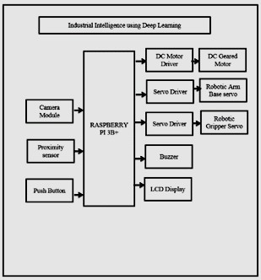

Figure 2: The system architecture

- HARDWARE AND SOFTWARE REQUIREMENTS
The following table 1 shows the list of hardware components used in the proposed scheme.

Table 1: Hardware components Used

Sl. No. | Component | Remark
1 | Raspberry Pi 4 | Will Be used for running the deep learning Module
2 | Camera Module | Capture the image data and feed it to the deep learning model
3 | Servo Motors | Robotic arm
4 | Servo Driver | Controlling Robotic Arm using Raspberry Pi
5 | LCD display | Status Update and Visualization
6 | Geared DC motor | Driving the Conveyor
7 | DC motor Driver | Controlling DC motor using Raspberry
8 | Buzzer | Status Indicator
9 | Power Supply | Powering the entire system

- The Hardware Specifications
  - Raspberry Pi
Raspberry Pi is an ARM based credit card sized SBC (Single Board Computer) and is like a minicomputer which is having ARM CPU architecture and having Linux Debian operating system with all related software libraries. In addition to the enhanced processing power provided by its ARM CPU and clock speed boost, it is worth noting that the Broadcom BCM2837 SoC integrated into the Raspberry Pi3 also incorporates a vast majority of the same components as its second-generation predecessors. This consistency in design not only ensures a seamless transition for those familiar with earlier models but also highlights the continued reliability and efficiency of the Raspberry Pi line of products. It is having fixed RAM and storage can be increased by using micro-SD card. Below figure 3 shows the Raspeberry Pi kit used in proposed scheme.
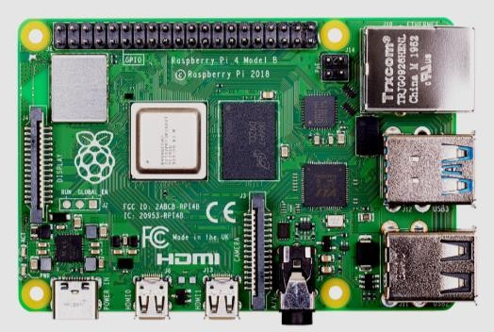

Figure 3: Raspberry Pi

  - Raspberry Pi Camera module
Along with Raspberry Pi we are using Raspberry Pi camera for outstanding photos and also shoot video as shown in below figure 4.
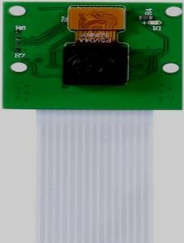

Figure 4: Raspberry Pi Camera
  - Motor Driver Module
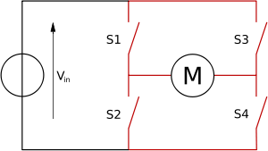
The motor driver consists of four drivers’ switches as shown in below figure 5.

Figure 5: Motor Driver
3.1 H Bridge
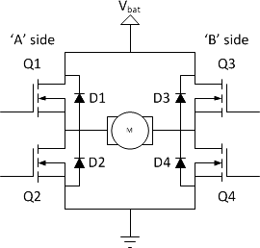
The primary component of a motor driver is known as an H-bridge, owing to its H-shaped structure. To rotate the motor in a clockwise direction, switches s1 and s4 should be turned on while switches s2 and s3 are turned off. To rotate the motor in a counterclockwise direction, switches s2 and s3 should be turned on while switches s1 and s4 are turned off. An H-bridge is a basic circuit with four switching elements that are arranged in an H-shape around the center load. Figure 6 offers an example of an H-bridge configuration.

Figure 6: H Bridge
In this proposed system we are using 5A motor driver module is used. The designed PCB layout is as shown in the figure 7 below.
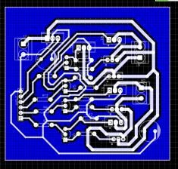

Figure 7: PCB layout
  - Buzzer
We are using Buzzer power to supply and produce continuous high-decibel alarm sound up to 85dB, shown in below figure 8.

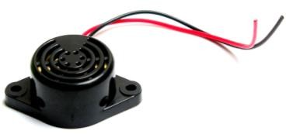

Figure 8: Buzzer
  - LCD display
LCD display is used in this approach. It is a 16x2 character LCD display which displays 16 characters per line and there are 2 such lines. Each character is displayed in 5x7 pixel matrix in this display as shown in below figure 9.
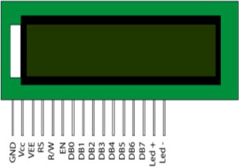

Figure 9: LCD display
Below table 2 shows 16 pins with their functions.

Table 2: Pin Functions
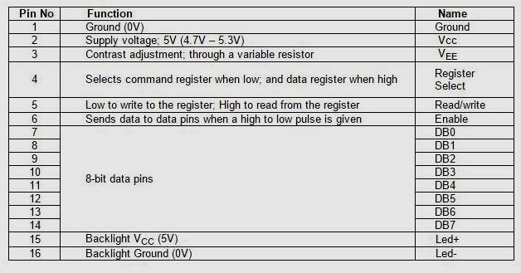
  - DC geared Motors
We are using 10 rpm side shaft DC gear motor. i.e. Side Shaft DC metal gear motor having 10 RPM is used as shown in below figure 10.
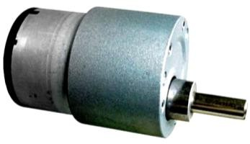

Figure 10: DC geared Motor
Features of 10 RPM Side Shaft Gear DC Motor:
      - It has shaft diameter of 6mm with internal hole.
      - It has weight of 125 gm.
      - Torque of 5 kg cm.
      - No-load current = 60 mA (Max), Load current = 300 mA (Max).
  - Power Supply
A 12 V 450 Watt SMPS (Switched Mode Power Supply) shown in following figure 11 is used in this approach.

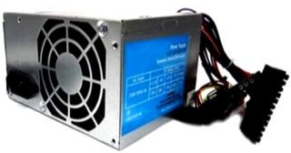

  - Relay

Figure 11: Power Supply

Relays are switches which are electromechanical in nature. They have very high current rating and both

AC and DC motors can be controlled through these switches. Two common available SPDT (Single Pole Double Throw) relays are shown in the figure 12 below.
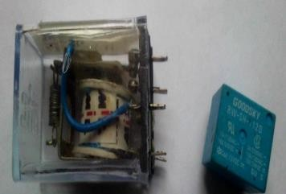

Figure 12: Relay
  - Proximity sensor
This is an infrared transmitter and receiver which together from a photoelectric sensor shown in figure 13 below. This sensor has a capacity to detect long distance. It uses modulated infrared light hence it has less interference by visible light. This sensor gives a digital output when it senses something within that range. This sensor does not return a distance VALUE.
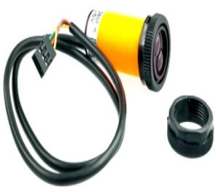

Figure 13: Proximity sensor
Following are the electrical characteristics of proximity sensor:
Power Supply 5VDC
Supply current DC <25mA
Maximum load current 100mA (Open-collector NPN pulldown output)
Response time <2ms
Diameter 17MM
Pointing angle <=15⁰, effective from 3-80cm adjustable
Detection of objects transparent or opaque
Working environment temperature -25⁰C+55⁰C
Case material Plastic
Lead length 65cm
  - Servo Motors
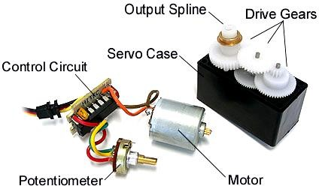

Figure 14: Servo Motors
The servo motor used in our proposed approach is 9-gram and MG 996 R servo as shown in above figure 14.

Software Requirements
The following are software requirements:
- Python Thonny IDE
- Tensorflow
- Python 3.7
- Serial Monitor
  - Python Programming Language
The proposed scheme uses python language for the purpose of programming the system.
  - Python IDLE
In programming, we opted to utilize Python 3 IDLE, which is an integrated development environment (IDE) that combines a program editor and a language environment for the convenience of the programmer. This IDE offers various features that make programming tasks easier and more efficient. As illustrated in Figure 15, it provides a user-friendly interface that allows users to navigate through the different options with ease.

Figure 15: IDE for Python
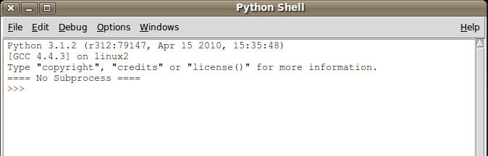Upon selecting the IDLE option, IDLE is initiated, and the Python Shell window, as shown in Figure 16, is displayed. The Python Shell window has two primary functions. Firstly, it enables the use of Python commands, allowing programmers to interact with the Python interpreter. Secondly, it provides access to a program editing window, which is essential in creating and modifying Python programs.

Figure 16: Python Shell
Overall, Python 3 IDLE is a highly recommended IDE for programmers due to its user-friendly interface, efficient features, and ease of use.
  - PhotoScape
PhotoScape is a photo editing software that allows users to fix and enhance their photos, as demonstrated in Figure 17 below.
- Viewer will view the photos in the folder and can create a slideshow.
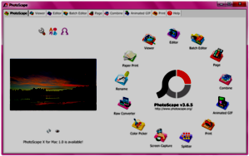
- Batch editor: Enables to edit multiple photos.

Figure 17: PhotoScape photo editing software

- RESULTS AND ANALYSIS
Below figure 18 shows the collected data of particular samples. The collected data is split into train and test. Four output features were expected. No of output visual inspection features: 4(Part 1, Part 2, Defect 1, Defect 2)
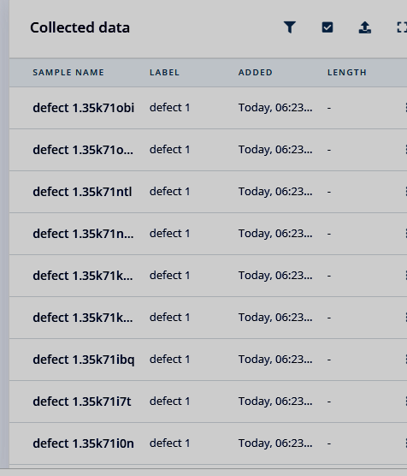

Figure 18: Collected data

The output features generated on the sample image size is as shown in the below figure 19.
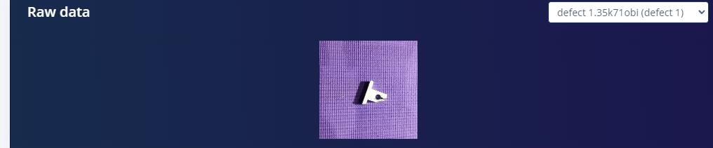

Figure 19: Raw data
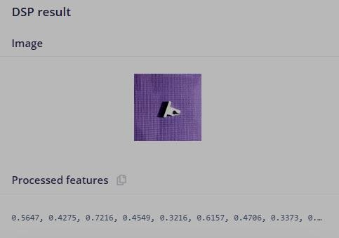
Figure 20 : DSP result

DSP (Digital Signal Processing) is used to improve accuracy and relability of the objects as shown in above figure 20. After DSP results we get the IMAP values such as average, mean and distance between clusters.
Below figure 21 shows the feature plots for different input classes. The clusters of defect 1, defect 2, part 1 and part 2 will be gathered together.

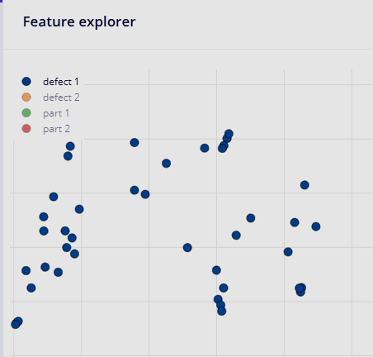 | 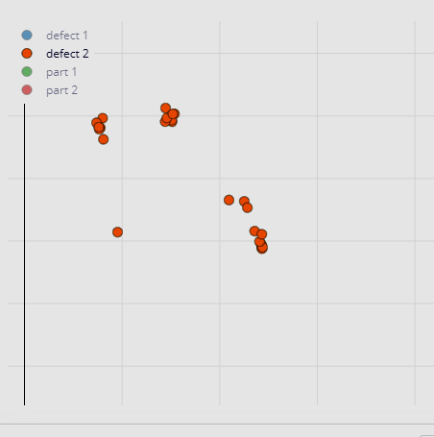

a. Defect 1 b. Defect 2
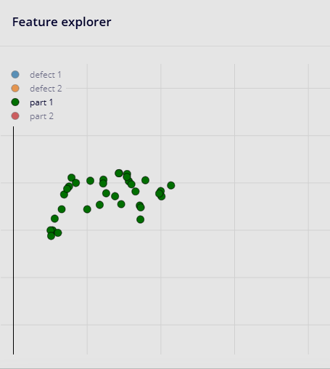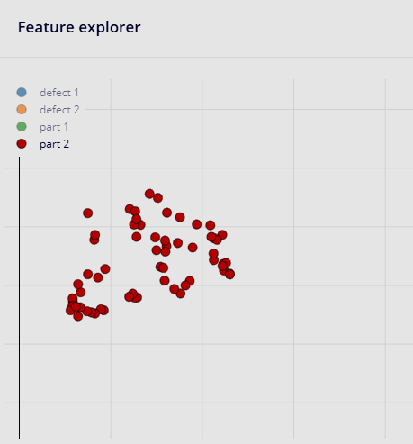

c. Part 1 d. Part 2

Figure 21: Feature Plots
For training the following parameters shown in below figure 22 were finalized and the model was trained.
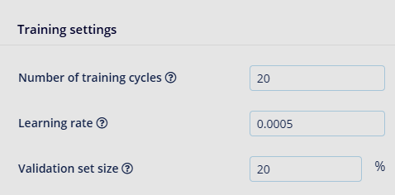

Figure 22: Training Parameters
The overall accuracy after training is 87.9 percent and the loss of 0.34 was achieved which is satisfactory. Figure 23 below shows the confusion matrix on the validation dataset.

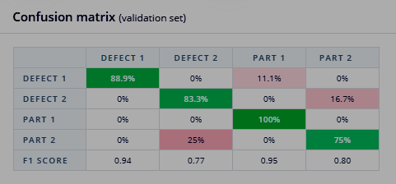

Figure 23: Confusion Matrix

A crucial tool in evaluating the performance of machine learning models is a confusion matrix. Figure 23 shows a confusion matrix, a table used to visualize classification performance metrics such as recall, specificity, accuracy, and precision.. In particular, it is widely used for assessing classification models, which aim to predict categorical labels for each input instance. This matrix summarizes the number of true positives (TP), true negatives (TN), false positives (FP), and false negatives (FN) generated by the model during testing. Typically, binary classification models are evaluated using a 2x2 table while multi-class classification models require a matrix of shape n×n for n classes. In our present scenario, the confusion matrix features four distinct categories: Defect 1, Defect 2, Part 1, and Part 2. However, the relationships between the defects are such that no entries (0%) appear in the matrix. This situation underscores the importance of carefully considering the underlying structure of the data when interpreting the results of a confusion matrix. It is used to visualize important predictive analytics like recall, specificity, accuracy and precision.
To determine accuracy, we look at the diagonal labeled "correct" and divide that total by the number of observations. If all values fall into the true positive or true negative categories, accuracy is 100%. The accuracy formula is [(TP+TN)/(TP+TN+FP+FN)]. Precision is calculated by [(TP/(TP+FP)], with a good classifier having a precision of 1 (high). Sensitivity, also known as recall, is measured by (TP/TP+FN). The F1 score is the harmonic mean of precision and recall scores, calculated as [(2*(Precision*Recall)/Precision+Recall)].
To identify incorrect predictions, we use the error rate (ERR). ERR is calculated by dividing the number of incorrect predictions by the total dataset. The best error rate is 0.0, while the worst is 1.0. The formula for ERR is the total number of two incorrect predictions (FN + FP) divided by the total dataset (P + N). The results after the full training cycle are plotted as shown in below figure 24.
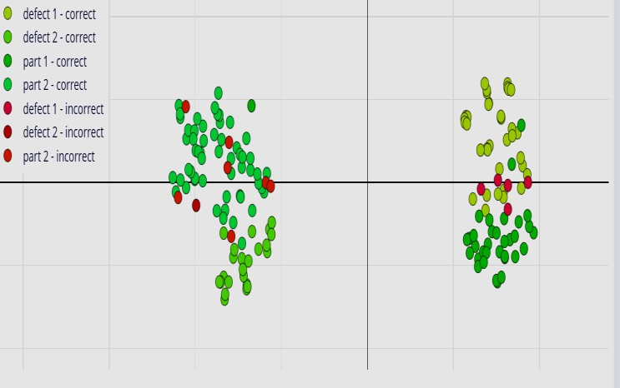

Figure 24: Results after full training cycle
The results of inference after performing on the trained neural network on the selected images from the test directory are as shown below images of Figure 25.

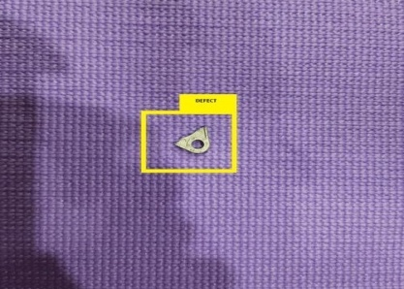 | 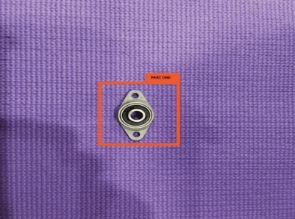 | 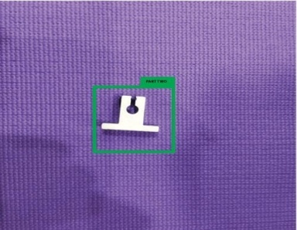
(a) (b) (c)

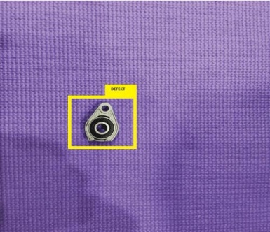  (d) | 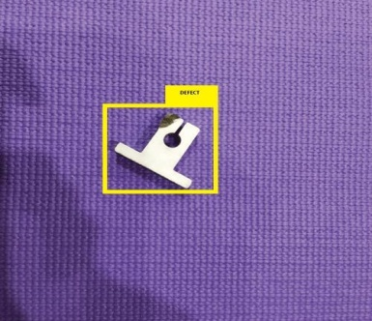  (e)

Figure 25: The yellow bordered images ((a) (d) & (e)) describe those materials are defective. And the red and green color bordered images ((b) & (c)) describe those materials are non-defective. The results are plotted on the images taken on the conveyor belt material.

- How the trends of AI will lead to redesign and deployment your systems of quality control?
- Artificial Intelligence (AI) has become a powerful tool for businesses across various industries, and manufacturing is no exception. With the ability to automate the testing and inspection process, AI has revolutionized the way manufacturers detect and identify defects in their products. By analyzing extensive datasets of manufacturing processes, AI-powered systems can be trained to recognize patterns and anomalies that may indicate manufacturing defects, providing businesses with valuable insights to make informed decisions.
- One of the key benefits of utilizing AI-powered solutions in manufacturing is the ability to enhance product quality while reducing waste associated with faulty products. By identifying and addressing defects in real-time, manufacturers can optimize their production processes and minimize the risk of defective products reaching the market. Additionally, AI can provide real-time analysis of machine performance and other potential issues, helping businesses to proactively address problems before they become major concerns.
- In summary, AI has the potential to transform the manufacturing industry by offering data-driven insights and automating critical processes. As businesses continue to adopt AI-powered solutions, we can expect to see improvements in product quality, increased efficiency, and reduced waste across the manufacturing supply chain.

VII. CONCLUSION
Industrial product quality is a key aspect of manufacturing, and research into defect-detection technology is crucial for ensuring product quality. In this approach we have not only used deep learning for classification of defects but also used a robotic based system for automatically separating defective parts. This approach successfully automated defect detection with a model optimized for low power devices. This approach involves creating a new system that can detect and separate defects in industrial parts. This will be achieved through visual feature recognition and segregation, using both deep learning and robotics. Proposed system achieved the accuracy of 87.9%. This system can solve the problems of industrial quality control and slow manual inspection techniques by providing them with a deep learning based visual inspection system and robotic separation system in compliance with industry 4.0. The proposed system can not only save the time by automating the process of inspection of surface defects and quality control but also provide a solution to small and medium scale industries with high efficiency and degree of repeat.

REFERENCES

- F. C. Campbell, Inspection of Metals: Understanding the Basics. Geauga County, Ohio: ASM International, 2013.
- B. Ganovska, M. Molitoris, A. Hosovsky, J. Pitel, J. B. Krolczyk, A. Ruggierio, G. M. Krolczyk, and S. Hloch, ‘‘Desi gn of the model for the on-line control of the AWJ technology based on neural networks,’’ Indian J. Eng. Mater. Sci., vol. 23, pp. 279–287, Aug. 2016.
- F. Jia, Y. Lei, N. Lu, and S. Xing, ‘‘D9eep normalized convolutional neural network for imbalanced fault classification of machinery and its understanding via visualization,’’ Mech. Syst. Signal Process., vol. 110, pp. 349–367, Sep. 2018.
- S. Dodge and L. Karam, ‘‘Understanding how image quality affects deep neural networks,’’ in Proc. 8th Int. Conf. Qual. Multimedia Exper. (QoMEX), Jun. 2016, pp. 1–6.
- H.-I. Lin and P.-Y. Lin, ‘‘An image quality assessment method for surface defect inspection,’’ in Proc. IEEE Int. Conf. Artif. Intell. Test. (AITest), Aug. 2020, pp. 1–6.
- I. Jahr, ‘‘Lighting in machine vision,’’ in Handbook of Machine and Computer Vision: The Guide for Developers and Users. Weinheim, Germany: Wiley, 2017, pp. 63–178.
- L. M. Xu, Z. Q. Yang, Z. H. Jiang, and Y. Chen, ‘‘Light source optimization for automatic visual inspection of piston surface defects,’’ Int. J. Adv. Manuf. Technol., vol. 91, nos. 5–8, pp. 2245–2256, Jul. 2017.
- M. Senthikumar, V. Palanisamy, and J. Jaya, ‘‘Metal surface defect detection using iterative thresholding technique,’’ in Proc. 2nd Int. Conf. Current Trends Eng. Technol. (ICCTET), Jul. 2014, pp. 561–564.
- Z. Li, J. Zhang, T. Zhuang, and Q. Wang, ‘‘Metal surface defect detection based on MATLAB,’’ in Proc. IEEE 3rd Adv. Inf. Technol., Electron. Autom. Control Conf. (IAEAC), Oct. 2018, pp. 2365–2371.
- Q. Li and S. Ren, ‘‘A real-time visual inspection system for discrete surface defects of rail heads,’’ IEEE Trans. Instrum. Meas., vol. 61, no. 8, pp. 2189–2199, Aug. 2012.
- J. P. Yun, D.-C. Choi, Y.-J. Jeon, C. Park, and S. W. Kim, ‘‘Defect inspection system for steel wire rods produced by hot rolling process,’’ Int. J. Adv. Manuf. Technol., vol. 70, nos. 9–12, pp. 1625–1634, Feb. 2014
- D. Soukup and R. Huber-Mörk, ‘‘Convolutional neural networks for steel surface defect detection from photometric stereo images,’’ in Proc. Int. Symp. Vis. Comput. Cham, Switzerland: Springer, 2014, pp. 668–677.
- Z. Xue-Wu, D. Yan-Qiong, L. Yan-Yun, S. Ai-Ye, and L. Rui-Yu, ‘‘A vision inspection system for the surface defects of strongly reflected metal based on multi-class SVM,’’ Expert Syst. Appl., vol. 38, no. 5, pp. 5930–5939, May 2011.
- K. Kurokawa, M. Morimoto, and K. Fujii, ‘‘On-stream defect detection of metal artifacts from line CCD image,’’ Int. J. Intell. Comput. Med. Sci. Image Process., vol. 3, no. 2, pp. 97–107, 2009.
- L. Song, W. Lin, Y.-G. Yang, X. Zhu, Q. Guo, and J. Xi, ‘‘Weak microscratch detection based on deep convolutional neural network,’’ IEEE Access, vol. 7, pp. 27547–27554, 2019.

