The Genomic Frontier - Revolutionizing Cancer Therapy through Personalized Medicine
Sharagesh R¹, Vishal Kumar, Hindhusha S¹, Harini S¹, T. Tamilanban^{1*}
¹Department of Pharmacology, SRM College of Pharmacy, SRM Institute of Science and Technology, Kattankulathur, Chengalpattu, Tamil Nadu - 603203, India.

*Corresponding author: Dr. T. Tamilanban,
Associate Prof.,
Dept. of Pharmacology,
SRM College of Pharmacy,
SRM Institute of Science and Technology
India.
tamilant@srmist.edu.in

Abstract:
Cancer, a leading cause of death worldwide, has been targeted using conventional cytotoxic treatments. Traditionally, chemotherapy and radiation have been the primary treatment options for nonsurgical cancer. However, some cancers resist these therapies and develop resistance to treatment over time. Thus, alternative approaches, such as immunotherapy, particularly chimeric antigen receptors (CARs), have gained attention. CAR T-cell therapy is being entrenched as a treatment approach that intrinsically modifies T-cells to effectively identify and selectively attack specific antigens found on cancer cells, and has shown promise in treating various cancers. Nevertheless, challenges persist in optimizing CAR T-cell therapy, inclusive of antigen selection, dosage determination, rehabilitant variability, and manufacturing processes. This Review focuses on the mechanisms and structure of CAR-T cells in addition it explores the various clinical applications of CAR-T cell therapy in oncology and other relevant fields. Addressing obstacles and approaches linked to practical deployment.
Keywords: CAR T-Cell therapy, Cancer, Personalized medicine, Immunotherapy.
1. Introduction:
Despite medical advances, cancer remains a global health problem. Conventional cytotoxic therapies for instance chemotherapy & radiation therapy are backbones of treatment. However, the search for better treatments continues. Immunotherapy, particularly CAR-T cell therapy, has shown potential as an immune-based strategy to selectively attack cancer. CAR T cell therapy internally modifies a patient's T cells with chemical antigen receptors (CARs), enabling them to recognize & actively target patients. ^{1,2} This pioneering approach has shown significant efficacy against certain groups of hematologic malignancies, together with B-cell lymphoma & acute lymphoblastic leukemia. However, struggles are on the way to optimize CAR T cell therapy, including patient heterogeneity, antigen selection, dosing strategies, and manufacturing processes.
2. Overview mechanism of CAR T cells:
Immunotherapy, also known as CART-cell therapy, uses intrinsically altered T cells to treat cancer. CAR aids T cells by adhering to a particular antigen on the cancer cells. The following features of the CAR mechanism are discussed in the search results.
CAR T-cell therapy comprises, Introduction of a gene encoding a CAR into the patient's blood in a laboratory setting with the purpose of modifying the T cells extracted from the patient. CAR has single-chain variable fragment (scFv) recognition purview that aids it to fix to target cell surface antigens. A transmembrane domain and an intrinsic T cell activation site are both present of CD3, and an extracellular antigen recognition domain make up the CAR structure.³
Activation and signalling pathways: CAR T-cells utilize a recognition domain to enable the binding of a scFv antigen on the apparent of the target cell, resulting in the elimination of tumor cells without MHC restriction. When CAR T cells are activated, they produce cytokines and other mediators that are soluble that may help in the recovery phase of the targeted cells that express the antigen and healthy cells. CAR T cells can only recognize structures that are expressed on the surface and can recognize antigens regardless of MHC presentation. ⁴Research is ongoing to determine the ideal structure of the intracellular region of CARs, because changes in the number and length of these domains can pointedly affect the tumor-fighting effects of CAR-T cells.
Antigen recognition and binding: CAR T cells initiate cancer cell elimination by stimulating T cells to attach to specific antigens on the surface of target cells through which it identifies the region composed of a scFv. The creation of scFvs that attach to the intended receptors can be achieved using autologous elements, Fabs obtained from libraries, or naturally existing ligands. CARs can differentiate between TCRs to align with a patient's genetic makeup, and work with antigens present in any HLA background.
Cytotoxic mechanisms and killing of cancer cells: When CAR T cells are activated, they expel mediators and other mediators that are soluble that might help in the demise of target cells that express the antigen and healthy cells. ^{3,5} In response to cognate antigens on cancer cells, CAR-T cells activate cytotoxic signalling, releasing granzyme, perforin, and cytokines, which results in the destruction of the transformed cells. CAR T cells be able to only recognize surface-expressed structures and can detect antigens independently of MHC presentation.
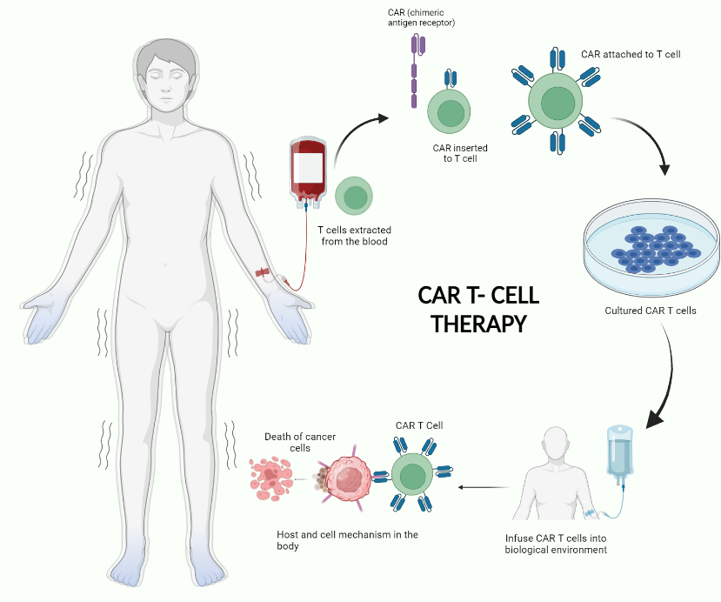
Fig. 1 - Overview of CAR T-Cell Therapy
3. Clinical approach of CAR T cells over the malignant tumor cells.
CAR cell therapy has surfaced as a novel and effective treatment option for haematological cancers, most notably B-cell lymphoma, acute lymphoblastic leukaemia (ALL), and multiple myeloma.^{6–8} This method entails genetically modifying CAR T cells. Cells derived from the patient's own blood are infused with a CAR that specifically targets an antigen on cancer cells. CAR-T cells are injected into patients, where they cause immune responses.
CAR T-cell therapy produces modest clinical results, with complete remission rates ranging from 30% to 40% in patients with advanced B-cell lymphoma. This success has sparked renewed interest in investigating the potential of CAR T-cell therapy for other haematological malignancies, as well as solid tumours.^{9,10}
Current clinical trials are diligently looking into the safety and efficacy of CAR T-cell therapy for various cancer types. One notable area of research involves BAFFR-CAR T cells, which hold promise for managing B-cell hematologic malignancies and even autoimmune rheumatologic diseases, potentially expanding the therapeutic reach of this cutting-edge therapy.
Another intriguing avenue of investigation is the combination of CAR-T cell therapy with mRNA vaccines in the context of solid tumors. This innovative approach seeks to harness the power of both modalities, with CAR T-cells targeting tumor cells directly and the mRNA vaccine priming the patient's immune system for a more robust and sustained antitumor response.
While the clinical outcomes of CAR T-cell therapy have been encouraging, challenges persist in the realm of hematological malignancies.^{11–13} Severe and potentially life-threatening toxicities, along with modest antitumor activity in some cases, necessitate further research and innovative strategies to augment the overall efficacy and safety of the therapy.
To overcome these obstacles, researchers are looking for new engineering approaches to increase the effectiveness of CAR cells against tumor cells while minimizing side effects. In addition, a comprehensive long-term study is being conducted to assess the length of treatment and late side effects to provide valuable insight to improve and optimize its use in the treatment of hematologic malignancies.
The journey of use of CAR T cells for solid tumours is now available. complex & marked by significant challenges. Factors such as antigen heterogeneity, limited tumor infiltration, and restricted trafficking have hindered their success in this domain. However, this setback has not deterred researchers, as well as a large number of clinical trials, which includes preliminary phase I and phase 2 studies, are actively assessing the use of CAR T-cell therapy in solid tumor treatment.
Encouragingly, the preliminary findings of a phase I/II study were encouraging for a novel CAR T-cell product when used either as a standalone treatment or in combination with an mRNA vaccine. This suggests that there is still hope to expose the full potential of CAR T-cell therapy in the battle against solid tumors.
Finally, with remarkable efficacy and transformative potential, CAR T-cell therapy has transformed the landscape of cancer treatment, particularly for haematological malignancies. Ongoing research and clinical trials are continuously expanding the horizons of this promising immunotherapy, aiming to overcome challenges, optimize its safety and efficacy, and extend its application to a broader range of cancer types. As the field of CAR T-cell therapy continues to evolve, it holds the promise of offering new hope to countless cancer patients.

3.1Applications of CAR T-Cell Therapy beyond Oncology:
CAR T-cell therapy has exhibited clear evidence of its potential effectiveness, now addressing autoimmune diseases and viral infections by selectively targeting cells involved in the disease process. For instance, through genetic engineering, CAR T-cells can be modified to target and eliminate autoreactive T-cells responsible for attacking healthy tissues in Conditions such as multiple sclerosis and insulin-dependent diabetes are examples of autoimmune diseases. Moreover, CAR T cells can be designed to target and eliminate cells infected with viruses similar to HIV and hepatitis B and C. Clinical trials are currently underway to assess the efficacy and safety of the use of CAR T cells over the management of autoimmune conditions and viral infections. Although preliminary, the findings from these studies demonstrate the promising prospects of CAR T-cell therapy in these fields.
4. Accepted CAR T-cell Therapies through the FDA & Their Indications:
Presently, FDA has granted regulatory approval to six distinct CAR T-cell therapies for treating different forms of cancer:¹⁴
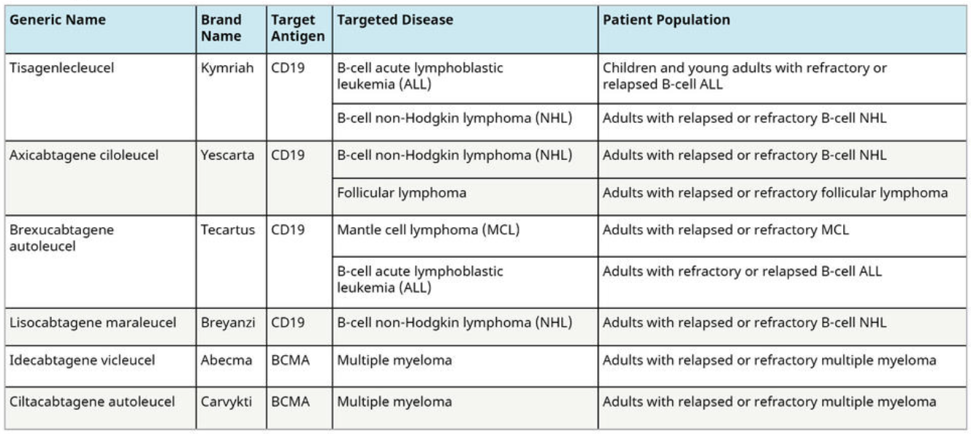

5. Addressing Adverse Events in CAR T-Cell Therapy:
Despite its promising outlook, CAR T-cell therapy is accompanied by distinct immediate adverse effects that require dedicated monitoring and management. Here are vital factors to consider when handling adverse events in CAR T-cell therapy:
5.1 Cytokine Release Syndrome (CRS) & Neurotoxicity:
CRS & neurotoxicity are the prevailing toxicities frequently encountered after CAR-T cell therapy. CRS is defined by symptoms such as an increase in body temperature, decreased BP, tachycardia, and respiratory distress and can be life-threatening if not promptly managed. Neurological side effects related to CAR T-cell therapy can manifest as confusion, delirium, seizures, and cerebral edema. While the pathophysiology and management of cytokine release syndrome (CRS) are relatively well established, our understanding and approaches to neurotoxicity are continuously evolving.
5.2 Diagnosis, Grading, and Treatment Algorithms:
Accurate identification and classification of ADRs related to CAR-T cell therapy are critical for efficient control. The Common Terms Standards for Adverse Events measure falls short of accurately grading cytokine release syndrome (CRS) associated with cellular therapy. As a result, clinical expertise has been used to develop grading scales specific to CAR T cell therapy. Tocilizumab, with or without corticosteroids, may be used to treat patients with CAR T-cell therapy-related CRS. Grade 2 and 3 neurological events can be addressed with dexamethasone or methylprednisolone. The importance of early intervention in providing aggressive compassionate care for patients with CAR T-cell toxicities cannot be overstated.
5.3 Long-Term Monitoring and Follow-Up Care:
Analysis of extended follow-up information concerning the effectiveness and adverse effects of CD19- or BCMA-targeting CAR T-cell therapies reveals their potential to add lasting absolution in individuals with B-cell malignancies, often accompanied by minimal long-term toxicities. Nonetheless, CAR T-cell therapy patients require regular and ongoing monitoring to detect and address possible long-term toxicities such as B-cell aplasia. It is imperative to devise strategies to maximize response durability following CAR T-cell therapy, which may involve refining patient selection methods, introducing innovative CAR designs, and adjusting the manufacturing process.^{15–17}
5.4 Resistance Mechanisms and Relapse in CAR T-Cells.
Despite its remarkable effectiveness in specific cancer types, CAR T cell therapy has shown substantial competence and resistance, and relapse remains a significant challenge. A comprehensive understanding of the mechanisms that drive resistance and relapse is vital for enhancing CAR-T cell therapy & devising effective strategies for conquering these obstacles.
CAR T-cell therapy can encounter resistance due to many factors, including CAR T-cell-related elements, tumor-related elements, and elements within the tumor microenvironment. One of the main reasons for resistance is antigen-negative relapse, which accounts for a significant proportion of relapse cases in B-cell ALL (B-ALL). Antigen-negative relapse may occur due to antigen loss or modulation, permitting tumor cells to bypass detection aside from CAR T-cells. Additional resistance mechanisms include insufficient CAR T-cell persistence, tumor heterogeneity, and challenges related to the manufacturing process.
Disease relapse experienced during CAR T-cell therapy refers to the reappearance of tumor cells following initial complete remission achieved through CAR T-cell infusion. Recurrence poses a substantial conquers, particularly in patients with B-cell malignancies. This can be attributed to factors such as the persistence of CAR-T cells and the loss or downregulation of the targeted antigen, which hamper disease control. Furthermore, within the context of CAR T-cell therapy, relapse may arise due to intrinsic resistance mechanisms such as antigen loss, inhibitory receptor expression, insufficient costimulatory ligands, and resistance to immune-mediated elimination. These factors collectively pose challenges to achieving long-term remission.
Accurate diagnosis and proper grading of ADRs linked to CAR-T cell therapy are pivotal for effectively managing resistance and relapse. Specifically designed grading scales have been established to assess CRS associated with CAR T-cell therapy. The management of patients experiencing prolonged or severe CRS associated with CAR T-cell therapy may involve treatment with tocilizumab with or without corticosteroids. Neurological events in grades 2 and 3 can be addressed using dexamethasone or methylprednisolone. Methods for Overcoming Resistance to CAR T-cell therapy include enhancing CAR T-cell fitness to improve proliferation, persistence, and cytotoxicity; developing innovative CAR designs; and investigating combination therapies.
Methods to Overcome Resistance and Enhance CAR T-Cell Persistence:
Overcoming CAR T-cell resistance and improving CAR T-cell persistence are crucial for enhancing the efficiency of CAR T-cell therapy. Various stratagems are currently being investigated.
I. Selecting a suitable cell source, like naive and memory T-cells, to enhance CAR T-cell persistence and function.
II. Optimisation of in vitro cultivation conditions to enhance CAR T-cell immunotherapy for longevity.
III. Coalescing CAR T cells with conventional drugs, for instance checkpoint inhibitors, strengthens their persistence and functionality.
IV. Modifying CAR structure and controlling CAR T-cell differentiation to optimize the clinical impact of therapy
V. Salvage therapies such as polatuzumab, vedotin, and tafasitamab, in addition to standard salvage chemotherapy and autologous hematopoietic cell transplantation (CT), are used to manage relapsed/refractory diffuse large B-cell lymphoma (DLBCL).
VI. Implementing salvage radiotherapy (SRT) as a post-CAR T-cell progression as a Medical care for patients suffering from relapsed/refractory non-Hodgkin lymphoma.
IV. Modifying the CAR structure and controlling CAR T-cell differentiation to optimize the therapy's clinical impact.
V. In addition to typical salvage chemotherapy & autologous hematopoietic cell transplantation (CT), salvage therapies such as polatuzumab, vedotin, and tafasitamab are used to treat relapsed/refractory diffuse large B-cell lymphoma (DLBCL).
6. Conclusion.
Cancer treatments include chemotherapy and CAR-T cell therapy. The process of changing a patient's T cells to spot and target cancer cells is known as CAR T cell therapy, while chemotherapy uses drugs to kill cancer cells.
Clinical trials of CAR T-cell therapy have shown promising results in terms of efficacy. About one-third of these patients achieve long-term remission, with complete remission rates ranging from 35% to 70% for Hodgkin's lymphoma and chronic lymphocytic leukemia. Another study showed that CAR T-cell therapy was better than standard therapy in patients with this type of leukemia. It should be noted that not all cancers are candidates for CAR T cell therapy, and chemotherapy has successfully treated all cancers. However, chemotherapy can cause serious side effects such as hair loss, nausea, and fatigue, and approximately 30-40% of patients treated with CAR T cells achieve long-term remission without the need for additional treatment. A patient's ability to respond to chemotherapy depends on the type, stage, and other factors of the cancer. Chemotherapy has many side effects, including hair loss, nausea, vomiting, and fatigue. In contrast, CAR T-cell therapy has its own unique set of side effects such as neurological issues, cytokine release syndrome, fever, chills, headaches, dizziness, and pain in the muscles or joints, both of which have their own advantages and disadvantages in terms of safety profiles. Antigen escape, limited persistence, severe life-threatening toxicities, low antitumor activity, high rates of toxicity, some fatalities, and high rates of toxicity have all been linked to CAR T-cell therapy. Chemotherapy, on the other hand, can cause damage to healthy cells and tissues, leading to various side effects.
Overall, despite the fact that CAR T-cell therapy has demonstrated positive outcomes in research studies, it is not yet widely used and is not considered for all cancer patients. Chemotherapy, on the other hand, has been used for many years and has been clinically shown that it's effective in the treatment of a variety of cancers but can also have significant side effects. The success rates of both treatments vary depending on the type of cancer being treated, as well as other factors. The safety profiles of both the treatments have their own risks and benefits. It is important to discuss with your doctor which treatment option is best based on your individual circumstances.
REFRENCES:
1. Ahmad A. CAR-T Cell Therapy. Int J Mol Sci. 2020;21(12):4303. doi:10.3390/ijms21124303
2. Sermer D, Brentjens R. CAR T-cell therapy: Full speed ahead. Hematol Oncol. 2019;37(S1):95-100. doi:10.1002/hon.2591
3. National Cancer Institute. CAR T Cells: Engineering Patients’ Immune Cells to Treat Their Cancers.
4. Miliotou AN, Papadopoulou LC. CAR T-cell Therapy: A New Era in Cancer Immunotherapy. Curr Pharm Biotechnol. 2018;19(1):5-18. doi:10.2174/1389201019666180418095526
5. Benmebarek MR, Karches C, Cadilha B, Lesch S, Endres S, Kobold S. Killing Mechanisms of Chimeric Antigen Receptor (CAR) T Cells. Int J Mol Sci. 2019;20(6):1283. doi:10.3390/ijms20061283
6. Fesnak A, O’Doherty U. Clinical Development and Manufacture of Chimeric Antigen Receptor T cells and the Role of Leukapheresis. Eur Oncol Haematol. 2017;13(01):28. doi:10.17925/EOH.2017.13.01.28
7. Garfall AL, Maus M V., Hwang WT, et al. CAR T Cells against CD19 for Multiple Myeloma. New England Journal of Medicine. 2015;373(11):1040-1047. doi:10.1056/NEJMoa1504542
8. Trad R, Warda W, Alcazer V, et al. Chimeric antigen receptor T-cells targeting IL-1RAP: a promising new cellular immunotherapy to treat acute myeloid leukemia. J Immunother Cancer. 2022;10(7):e004222. doi:10.1136/jitc-2021-004222
9. Marofi F, Motavalli R, Safonov VA, et al. CAR T cells in solid tumors: challenges and opportunities. Stem Cell Res Ther. 2021;12(1):81. doi:10.1186/s13287-020-02128-1
10. Liu G, Rui W, Zhao X, Lin X. Enhancing CAR-T cell efficacy in solid tumors by targeting the tumor microenvironment. Cell Mol Immunol. 2021;18(5):1085-1095. doi:10.1038/s41423-021-00655-2
11. Zhao Z, Chen Y, Francisco NM, Zhang Y, Wu M. The application of CAR-T cell therapy in hematological malignancies: advantages and challenges. Acta Pharm Sin B. 2018;8(4):539-551. doi:10.1016/j.apsb.2018.03.001
12. Zhang X, Zhu L, Zhang H, Chen S, Xiao Y. CAR-T Cell Therapy in Hematological Malignancies: Current Opportunities and Challenges. Front Immunol. 2022;13. doi:10.3389/fimmu.2022.927153
13. Huang J, Huang X, Huang J. CAR-T cell therapy for hematological malignancies: Limitations and optimization strategies. Front Immunol. 2022;13. doi:10.3389/fimmu.2022.1019115
14. https://hillman.upmc.com/mario-lemieux-center/treatment/car-t-cell-therapy/research-clinical-trials.
15. Rafiq S, Hackett CS, Brentjens RJ. Engineering strategies to overcome the current roadblocks in CAR T cell therapy. Nat Rev Clin Oncol. 2020;17(3):147-167. doi:10.1038/s41571-019-0297-y
16. Liu Y, An L, Huang R, et al. Strategies to enhance Chimeric Antigen Receptor -T persistence. Biomark Res. 2022;10(1):86. doi:10.1186/s40364-022-00434-9
17. Sterner RC, Sterner RM. Chimeric Antigen Receptor -T cell therapy: current limitations and potential strategies. Blood Cancer J. 2021;11(4):69. doi:10.1038/s41408-021-00459-7

