BIOFUELS: A SUSTAINABLE PATH TOWARDS ENERGY INDEPENDENCE
Athena Joseph ¹ Neha D Ullal¹, S. Abhinaya ¹, Suparna K ²
¹Department of Zoology, Jyoti Nivas College Autonomous, Bengaluru, Karnataka, India
²Department of Chemistry, NMKRV College for Women, Jayanagar, Benagaluru, Karnataka, India
Corresponding author: suparnak89@gmail.com

INTRODUCTION
Biofuels are strength-fortified chemical substances generated via organic procedures or deduced from the biomass of dwelling organisms, inclusive of microalgae, foliage, and microorganism. The adding transnational population requests lesser power rudiments for perfecting the high- quality of cultures. Biofuels may be one of the sources to satisfy the worldwide energy call for energy demand. Reactionary energies are getting used as a major force of power for decades; but, their use of them is unsustainable and reasons environmental problems associated with reactionary gas combustion. Biofuels have turned out to be a popular manner to use renewable biomass electricity and point surfaced as a doubtlessly major volition to energy and diesel transportation energies deduced from petroleum. Interest has been developing within the big- scale mileage of biofuels to address the binary worldwide challenges of worldwide climate exchange, and transferring far down from decreasingly scarce and environmentally and politically unpredictable petroleum substances [1].The four most important energies may be products of biomass ethanol, methanol, biodiesel, and hydrogen — despite the fact that different energies(e.g., biobutanol and dimethyl ether) also can be made from biomass [1].
The current ways for microbial biofuel manufacturing are well explored and honored, and an occasion for microalgal civilization ways for direct strength conversion to supply biofuels has been supported. For case, biofilm civilization of microalgae or cyanobacteria may be the brand-new platform of biomass product pathways that in the long run explored for biofuel processing pathways. The fashion of biofilm civilization is promising for biofuel product with the aid of microalgae or cyanobacteria. For the once several a long time, the nice- conceded force of biofuels is factory biomass. Presently, the growing pieces of substantiation verified that algal biomass is a positive force for biofuel. A high characteristic identifying factory life and algae from other coffers is their capability to photosynthesize [5]. The operation of photosynthetic organisms as a force of biofuel is nicely- priced and doable, i.e., atmospheric CO2 serves as a force of carbon and sun serves as a strength force. Photosynthesis proceeds in two stages mild- structured and mild- unprejudiced. For the duration of the light-dependent position, mild electricity is absorbed, converted right into a charge separation, and in the long run converted into the conflation of ATP and NADPH. Predominant photosynthetic colors bothered inside the immersion of mild are chlorophyll in foliage and bacterial chlorophyll in bacteria. In the course of the light unprejudiced degree, the power and electrons from ATP and NADPH, independently, are used to supply sugars [5].
On one hand, photosynthesis is a fashion of biomass accumulation. Factory biomass is a raw fabric for the conflation of bio alcohol, biodiesel, and turmoil- deduced biohydrogen. Also again, underneath tremendous situations, photosynthetic outfit serves as a source of biohydrogen. Indeed though shops and algae have analogous photosynthetic outfit, algae have several benefits over advanced factory life in respects to biofuel manufacturing. As we realize, the most vital biofuels- biodiesel, triglycerides, adipose acids, lipids, carbohydrates, ethanol, alcohols, cellulose, or the biomass of organisms can be produced by way of several species of algae, microorganisms, or incentive [5].
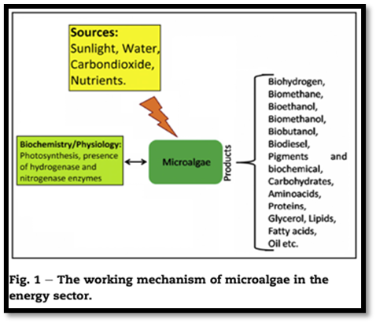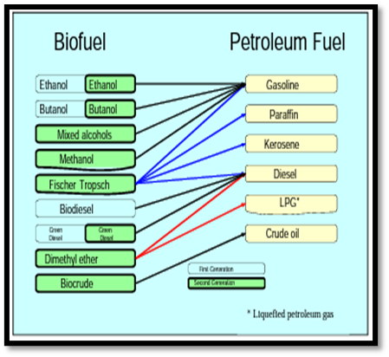
Figure 1: The working mechanism of microalgae Figure 2: Sustainability of biofuels with common petroleum

Based on contemporary-day expertise, the use of microalgae is being considered as an appealing feedstock for biofuels manufacturing. Relying on species and cultivation methods, microalgae can produce biohydrogen, bio methanol, bioethanol, biodiesel, carbohydrates, proteins, or different compounds that are being utilized in pharmaceutical businesses. The algal-derived biofuel production requires the best daytime, CO2, and water and generates a couple of renewable strength products primarily based definitely biofuels manufacturing are about a hundred instances better than that of higher plants. The algal biomass can be further processed to provide biofuels in the course of fermentation by microorganisms. Presently several microorganisms were determined to supply biofuels efficiently with the aid of the use of[5]:
- Genetic engineering of cyanobacteria to enhance hydrogen production.
- Optimization of hydrogen production and metabolic engineering for biofuel manufacturing in bacteria.
- Darkish fermentation by way of bacteria to convert carbohydrates to biohydrogen and other bio fuels.
- Photobiological strategies to supply biohydrogen thru microalgae.
- Genetic engineering of the yeast to increase ethanol manufacturing through tolerating excessive alcohol recognition.
- Genetic engineering of microorganisms that could ferment carbohydrates to grow bioethanol and biobutanol manufacturing.
- Screening the microalgae which could produce more oil for biodiesel production.
- Fermentation of plant cell wall carbohydrates with the resource of yeast or different microorganisms to provide biofuels.[5]
TYPES OF BIOFUELS
In 1973, over 86% of the sector’s overall primary energy delivery came from fossil fuels. At the same time as the electricity supply has elevated due to the fact then the proportion of fossil fuels stays high. In 2007, nevertheless over 81% came from fossil fuels the EU community is strongly dependent on fossil fuels for its transport needs and is an internet importer of crude oil. Numerous specialists are expecting that oil production will reach a ceiling by using 2020, at the same time as the demand will keep growing, pulled via China and India. Dealing with this demand calls for locating alternatives in petroleum products. At the equal time, worries are increasing approximately weather change and the potential financial and political impact of limited oil and fuel resources. To cope with these issues and reduce our dependency on fossil fuels the EC has adopted measures to encourage the manufacturing and use of sustainable biofuels [3].
Biofuels additionally called ‘agrofuels’ are renewable fuels composed with the aid of biological feedstock. Otherwise from fossil fuels, their manufacturing does now not entail the discharge of dangerous compounds. Biofuels may be in the form of 3 out of 4 fundamental states of topics strong (firewood), liquid, and gasoline (methane, biogas, bio-hydrogen) and can be produced by using converting the biomass through chemical, biochemical, and thermal conversion tactics. Currently, there are a number of unsolved troubles concerning biofuels and their sustainability, linked to technological, monetary, and policy questions [2]. The existing evidence shows that, if no land-use trade (LUC) is worried, first-generation biofuels can—on common—have lower GHG emissions than fossil fuels, however the discounts for maximum feedstocks are inadequate to fulfill the GHG financial savings required through the EU Renewable strength Directive (purple). However, second-generation biofuels have, in widespread, a greater potential to lessen the emissions, provided there may be no LUC. 0.33-generation biofuels do not constitute a feasible alternative at the gift state of improvement as their GHG emissions are better than the ones from fossil fuels.[6]
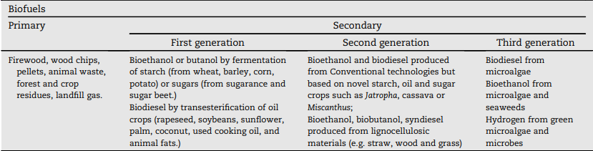
Figure 3: Classification of biofuels
Biofuels can be discerned constantly with some of the crucial traits, which include feedstock kind, conversion system, specialized specification of the gas, and its use. Two generally used typologies are ‘ first, second, and technology ’ and ‘ traditional and superior ’ biofuels. Biofuels created from refections or beast feed shops are known as first- generation biofuels. Since first- technology biofuels are produced via duly- mounted technology and approaches, conforming of turmoil, distillation, and transesterification, they may be also generally known as ‘conventional biofuels’. A crucial function for alternate- technology biofuels is that they may be deduced from non-meal feedstocks, which include devoted electricity crops (e.g., Miscanthus, switchgrass, short gyration covert (SRC), and different lignocellulosic foliage), agrarian remainders, timber remainders and other waste substances (e.g., UCO and external stable waste). Biodiesel constructed from microalgae via conventional transesterification or hydro- remedy of algal oil painting is generally known as third- technology biofuel. 2nd- and 3rd- generation biofuels are constantly appertained to as ‘ superior biofuels ’ as their manufacturing ways or pathways are still within the exploration and enhancement, airman, or demonstration member[ 6].
First generation bioethanol, biodiesel, and other biofuels
First- generation biofuels, and maximum specially bioethanol and biodiesel, must now not be regarded as technological niches presently; they're a part of the socio-specialized governance and their prolixity is sizable and consolidated all through the world. [ 2]
1. Bioethanol
Bioethanol is a veritably well- known biofuel in the world as it may be used in gasoline machines. In chemistry, it's also known as ethylic alcohol (ethanol CH3eCH2eOH, the equal organic emulsion employed in alcoholic liquids) and it's constituted of the turmoil of colorful foliage, including sugarcane, sludge, and other shops with inordinate content material of sugar or bounce. After microbial turmoil, bioethanol is distilled, dehydrated, and latterly denatured. It's suitable to be combined with energy and be ranked, grounded completely on the content material of ethanol, from E5 (ethanol and 95 gas) to E100 (one hundred ethanol) [2]. Sugar is the abecedarian molecular substrate for the product of bioethanol and memoir methanol[5]. Bioethanol is especially employed in vehicle machines; still, it could also be employed in tractors, aeroplanes, and boats. In flexible- gas or flex- energy vehicles, it's used as a drop- in biofuel; in this illustration the energies for the propulsion of the machine are exchangeable. Because of the specially low freezing factor, it can not be used as spurt energy [2].
Bio alcohol is considered anon-fossil occasion transport to date the main force of memoir alcohols is factory material containing generous bounce and sugars which includes grain foliage and sugarcanes, but these days interest has shifted to imperishable meadows which include switchgrass and Miscanthus. Those leafages don't contend with food application but the turmoil and distillation styles call for former conversion of the cellulosic biomass into sugars. Ethanol is the maximum common memoir alcohol, indeed as bio propanol and biobutanol are much less common. These alcohols are produced by way of turmoil of carbohydrate- amended feedstock by means of microorganisms[ 5].
Presently, the biggest manufacturer of bioethanol is the USA, observed with the aid of Brazil, the European Union (led by using Germany), and China. Since the Nineteen Eighties, Brazil has performed a pioneering part in the area of biofuel technology and it's far presently tone- sufficient, with bioethanol account for further than 50 of the home business of transportation energies. This generous chance of bioethanol in Brazil is acquired especially from sugarcane, nine while within the USA., It's produced especially from sludge and plutocrat is owed for roughly one-1/3 of sludge product and for roughly 6 of the gas [2].
2. Biodiesel
The alternate most common biofuel is biodiesel, which is entered from vegetable canvases or beast fat containing lengthy- chain esters. The chemical shape of biodiesel is different from that of ordinary diesel, as it contains carbon, hydrogen, and oxygen, while petroleum diesel is composed of hydrocarbons only (hydrogen and carbon without oxygen). Biodiesel may be employed in ordinary diesel machines, both natural or mixed in any proportion. The most common composites are B2, B5, B20, and B100 (pure biodiesel). It may be used now not stylish for traction vehicles but also as heating oil painting in addition to for road locomotives[2]. At present, the product of biofuels is substantially related to ethanol and biodiesel. They bear an agrarianbio-resource similar as sugar club, sludge, or rapeseed, as well as a considerable quantum of water and diseases, not to mention fungicides [3]. Also, biodiesel may be produced by the use of waste cuisine oil painting, oil painting accrued and reclaimed from diligence that use it for cuisine or different artificial purposes. Else from virgin vegetable oil painting comprised of devoted shops, waste cuisine oil painting is a outgrowth that if not reclaimed would be in any other case wasted. In this regard, waste cuisine oil painting is a cheap occasion feedstock for the manufacturing of biodiesel, and its low prices can bedeck the overall competitiveness of biodiesel [2].
During the period 2008 to 2018, biodiesel product increased further than threefold, from 12 to 41 billion liters. presently, biofuels regard for about3.4 of total transportation energies worldwide [6].
3. Other biofuels
Different biofuels with much lower giant effect and prolixity encompass biogas, different bio alcohols (e.g., bio methanol, biobutanol, and so forth.), wood, vegetable oil painting, memoir ethers, dried ordure, and agrarian waste (Guo etal., 2015). Methanol is the stylish alcohol (CH3OH) and, like ethanol, it may be used as a energy. Presently, methanol is a reactionary gas that's made from herbal gasoline, but it can also be acquired from the gasification of biomass (memoir methanol), whose financial and marketable viability remains under evaluation. From a specialized point of view, memoir methanol can be used for multitudinous purposes:
- In internal combustion machines as an volition to gas and indeed if with the stylish half of the energy viscosity of the ultimate.
- Rather of diesel, while dehydrated to dimethyl ether, or for the product of biodiesel through the transesterification of vegetable oil painting.
- In motive- constructed memoir methanol- powered buses , or in draw- heft and mongrel motorcars.
- For energy manufacturing in gas manufactories or energy cells; and
- As a home gas. [2]
Butanol (C4H9OH) is an alcohol made from bounce through “ABE turmoil ”( i.e., using acetone, butanol, and ethanol). It may be employed in energy machines without changes. Biogas is composed with the aid of multitudinous feasts (e.g., methane, carbon dioxide, nitrogen, hydrogen) created from the breakdown of organic accoutrements (in the absence of oxygen) through turmoil or anaerobic digestion. Like herbal gas, biogas can be compressed and employed in motor vehicles, and plenitude of different locales like reactionary herbal gasoline. In another way from biogas, syngas is entered via the partial combustion (with the presence of oxygen) of organic calculate [2].
Before the combustion, the feedstock Biofuels period, economics, and content problems sixty- seven is dried or undergoes pyrolysis. After partial combustion, the preceding biomasses are an total of carbon monoxide, hydrogen, and different hydrocarbons. also, syngas can be used within the transportation quarter and for the manufacturing of warmth and electricity. Green diesel is produced using the same feedstocks as biodiesel (especially beast fats or vegetable oil painting), but the product manner differs vastly. Whilst biodiesel is produced through transesterification, as mentioned over, green diesel is produced thru hydrocracking (i.e., the catalytic cracking system at inordinate temperature and stress with the presence of delivered hydrogen) thirteen or hydrogenation (including hydrogen motes) [2].

ADVANTAGES | DISADVANTAGES
1. Simple and well-known production methods | 1. Feedstocks compete directly with crops grown for food
2. Familiar feedstocks | 2. Production by-products need markets
3. Scalable to smaller production capacities | 3. High-cost feedstocks lead to high-cost production (except Brazilian sugar cane ethanol)
4. Fungibility with existing petroleum-derived fuels | 4. Low land-use efficiency
5. Experience with commercial production and use in several countries | 5. Modest net reductions in fossil fuel use and greenhouse gas emissions with current processing methods (except Brazilian sugar cane ethanol)

Table 1- Advantages and Disadvantages of First-Generation Biofuels[4]

Second - generation biofuels
These biofuels are deduced from non-fit-for-human consumption factory accoutrements, farming leftovers, and committed energy foliage together with switchgrass, miscanthus, and jatropha. They give a further sustainable volition with the aid of using waste products and non-food foliage, lowering the opposition to food product.
The first- generation biofuels (in particular made of bounce, sugars, and vegetable oil painting) have some bad rudiments and essential failings both from an profitable and technological angle. This puts them in a poor aggressive position whilst compared to fossil energies. This will address these problems, in the rearmost times there were massive investments in the development of technology for the product of recent biofuels in addition to the development of the primary- technology bones. The primary purpose right then has been to ameliorate conversion performance as a way to reduce feedstock musts [2].
Exploring the occasion of producing biofuels, and substantially bioethanol, from nonfood crops, substantially lignocellulose biomasses, which might be commercially doable. Exemplifications are lignocellulose feedstock, which includes colorful agrarian by- wares inclusive of cereal straw, sugarcane bagasse, forestland remainders, and waste (organic factors of external stable waste [2].
Experimenters are presently wearing out multitudinous trials in an trouble to discover new styles for the manufacturing of biofuels pyrolysis, anaerobic digestion, gasification, enzymatic hydrolysis, and bettered incineration. still, producing ethanol from cellulose is alternately hard because the sugars for the turmoil are trapped in a complicated chemical structure. Cellulose has a remarkable hydrolytic balance and structural robustness, inferring from thecross-linking among the polysaccharides( cellulose and hemicellulose) and the lignin thru ester and ether liaison. These liaison need to be damaged to open up the cell structure for posterior hydrolysis. In this situation, the feedstock( lignocellulose) is by way of some distance cheaper than the mess shops used inside the first- technology biofuels[2].
still, 2nd- period bones
bear borderline farmland as they may be constituted of biomass no longer grown in pastoralist shops and/ or the operation of innovative biotechnologies[2] If the primary- technology biofuels bear top spreads for feedstock manufacturing.
There are several different new- period biofuel technologies that can be explored, including biohydrogen, and the so- appertained to as fourth- generation biofuels, which can do without the burning of the feedstock. Indeed though veritably promising, those technological niches are at a completely original position and are nonetheless far from being commercially possible
Alternate- generation biofuels can be also distributed in expressions of the fashion used to transfigure the biomass to gasoline biochemical or thermochemical.
Second-generation biochemical biofuels
2nd- generation biochemically- produced alcohol energies are constantly appertained to as “ cellulosic ethanol ” and “ cellulosic biobutanol ”. The way for producing those encompasses pre-treatment, saccharification, turmoil, and distillation. Pretreatment is designed to help separate cellulose, hemicellulose, and lignin in order that the complicated carbohydrate motes constituting the cellulose and hemicellulose may be damaged by means of enzyme-catalyzed hydrolysis( water addition) into their constituent easy sugars. Cellulose is a crystalline chassis of lengthy chains of glucose( 6- carbon) sugar motes. Its crystallinity makes it delicate to unbundle into simple sugars, still, as soon as unbundled, the sugar motes are painlessly instigated to ethanol with the operation of well-known micro-organisms, and some micro-organisms for turmoil to butanol are also regarded. Hemicellulose consists of polymers of 5- carbon sugars and is distinctly painlessly broken down into its constituent sugars including xylose and pentose. still, the turmoil of 5- carbon sugars is harder than that of 6- carbon sugars. Many fantastically recently advanced microorganisms are suitable to raise 5- carbon sugars to ethanol. Lignin includes phenols, which for practical purposes are not fermentable. But lignin can be recovered and applied as energy to offer system lukewarmness and energy at an alcohol product installation[4].

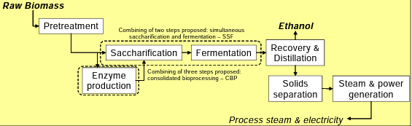

Figure 4-Process of production of second-generation fuel ethanol
Thermochemical biomass conversion includes strategies at a lot of advanced temperatures and generally better pressures than those located in biochemical conversion systems. crucial natural characteristics distinguishing thermochemical from biochemical biofuels are the inflexibility in feedstocks that may be accommodated with thermochemical processing and the range of finished energies that may be produced. The thermochemical product of biofuels starts off evolving with gasification or pyrolysis. The former is generally further capital-in-depth and calls for large scale for first-rate economics, but the final product is a clean completed energy that can be used incontinently in machines. In the course of gasification, biomass( with 10 – 20 harmonious with cent humidity content) is heated generally by way of burning a part of the biomass in oxygen) to reason it to be converted into a total of ignitable and non-combustible feasts. pollutants inside the energy are removed, followed in some cases by way of adaptations( the operation of the “ water- gasoline shift ” response) of the composition of the gasoline( also called conflation gasoline, or syngas) to put together it for also downstream processing. Carbon dioxide( CO2) is a diluent in the syngas and so is also removed to grease posterior responses downstream. The predominant complements of the now-smooth and focused syngas are carbon monoxide( CO) and hydrogen( H2), generally with a small volume of methane( CH4). The CO and H2 reply whilst surpassed over a catalyst( the CH4 are inert) to produce liquid gas. The layout of the catalyst determines what biofuel is produced. In maximum factory designs, now not all of the syngas passing over the catalyst might be converted to liquid energy. The unconverted syngas generally would be burned to make energy to offer many or all of the electricity had to run the power and, in many cases, to export strength to the grid. An alternate volition for changing syngas to liquid gasoline. With this selection, particularly- designed microorganisms raise the syngas to ethanol or butanol[4].

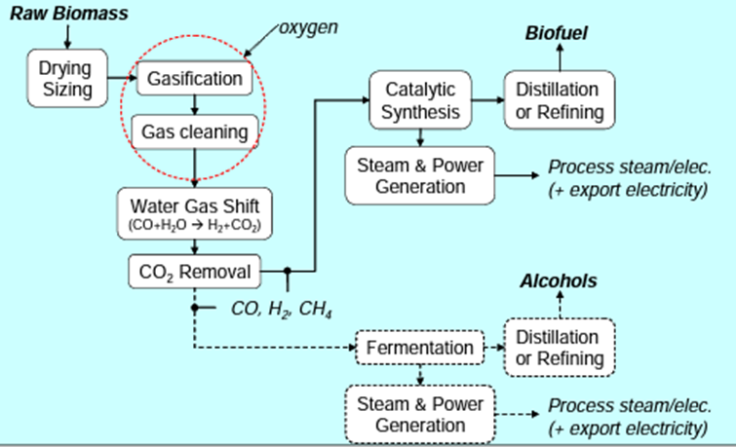
Figure 5-Process of production of thermochemical biofuels

Three thermochemically- produced energies are getting considerable attention in different parts of the world are FTL, DME, and alcohol.
- Fischer- Tropsch liquid ( FTL) is a blend of large straight-chain hydrocarbon composites( olefins and paraffin) that act as semi-delicate crude oil painting. The total can either be packed to a traditional petroleum refinery for processing or enhanced the point into “ clean diesel, ” spurt Gas, naphtha, and other fragments. By using FTL catalytically it can be synthesized . As a consequence, any feedstock that can be converted into CO and H2 may be used to produce FTL. In Specific, coal, natural energy, or biomass may be used as a feedstock for FTL products.
2. Dimethyl ether( DME) is a title energy having ordinary temperatures and pressures, with a moderate Airy odor. It liquefies underneath moderate strain, analogous to propane. It's especially inert, noncorrosive,non-carcinogenic, nearly non-toxic, and doesn't form peroxides by way of prolonged hype to Air. These parcels make it an applicable relief( or blending agent) for thawed Petroleum gasoline( LPG, an admixture of propane and butane). still, fusions of DME and LPG may be used with a combustion contrivance designed for LPG without changes to the device, If the DME blending position is confined to 15 – 25 Percent via extent. DME is likewise a fantastic diesel machine gas due to its High cetane volume and absence of soot manufacturing all through combustion. It is not possible to admixture DME with traditional diesel energy in machines, because DME ought to be stored under moderate Pressure to keep a liquid state.

3.Alcohol that can be made via syngas processing is drawing attention in the United States at present. One similar energy is ethanol( or butanol); an alternate is an admixture of alcohols that includes a significant bit of ethanol plus lower fragments of several advanced alcohols. Butanol and the “mixed-alcohol” energy have the eventuality to be used much the way ethanol is used moment for blending with gasoline. These are characterized by advanced volumetric energy consistency and lower vapor pressures than ethanol, still, making them more seductive as energy or blending agent. Syngas can be converted into an admixture of alcohol by catalytic conflation. The process steps act those for making FT liquids. Clean syngas is passed over a catalyst, forming an admixture of alcohol motes. A number of different catalysts for mixed alcohol products from syngas were patented in the late 1970s and early 1980s, but utmost development sweats were abandoned after oil painting prices fell in the mid-1980s [4].
CHALLENGES AND IMPLICATIONS
Microalgae and its challenges
The search for alternative, environmentally friendly renewable energy sources has been driven by the global energy crisis and rising emissions of greenhouse gases. One of the major renewable energy sources for sustainable development, microalgae biofuel has the potential to replace fossil-based fuels, as determined by life cycle analysis. Microalgae biofuel was without any trace of the significant downsides related to oil crops and lignocellulose-based biofuels. Green growth-based biofuels are in fact and monetarily feasible and cost cutthroat, require no extra land, require negligible water use, and moderate barometrical CO2. The reasonability of microalgae biodiesel creation can be accomplished by planning progressed photobioreactors and creating minimal expense advances for biomass reaping, drying, and oil extraction. [7] Business creation can likewise be achieved by further developing hereditary designing methodologies to control ecological pressure conditions and by designing metabolic pathways for high lipid creation. Furthermore, new arising innovations, for example, algal-bacterial associations for an upgrade of microalgae development and lipid creation are additionally investigated. Although microalgae are possible hotspots for bioenergy and biopharmaceuticals by and large, a few restrictions and challenges should be defeated to redesign the innovation from the pilot stage to the modern level. The most difficult and vital issues are upgrading the microalgae development rate and item combination, dewatering green growth culture for biomass creation, pre-treating biomass, and improving the maturation cycle in the event of algal bioethanol creation. The current survey portrays the benefits of microalgae to deliver biofuels and different bioactive mixtures and also, talks about refined boundaries. [8]

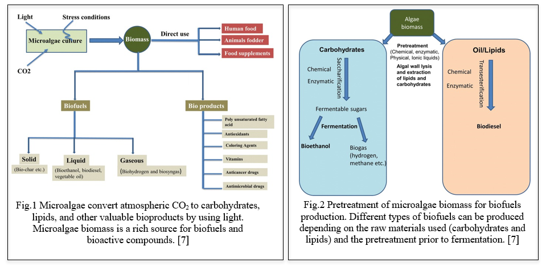

LAND USE AND FOOD SECURITY
The significant test in biofuel creation is to oversee productive land use and bringing down GHGs discharges to guarantee it doesn't prompt food versus energy struggle, environmental change, and other natural annihilation. Be that as it may, utilizing different land types to develop crops raises natural issues that are something similar, whether the harvests are developed for food or modern and fuel applications. Monoculture cultivation in forestry or field crop production can put biodiversity, pests, and pathogens at risk. At the same time, land use for developing blended crops and woody species, for example, perpetual grasses or trees could be utilized in inclination to improve biodiversity, without compromising yield. Legislatures overall are advancing the advancement of biofuels to moderate the environment effect of utilizing energizes. Notwithstanding the intricacies of the ecological and mechanical frameworks that influence environmental change, land use, and water use, and the hardships of building valuable measurements, it is feasible to make a few subjective by and large evaluations. All things considered, biofuels created from crops utilizing regular farming practices won't moderate the effects of environmental change and will worsen weights on water supplies, water quality, and land use, contrasted and petrol powers. Approaches ought to advance the improvement of reasonable biofuel programs that have very low contributions of petroleum products and synthetic substances that depend on precipitation or bountiful groundwater, and that use land with practically no financial or environmental worth in elective purposes. Despite this, that's what existing proof recommends, if no land-use change (LUC) is involved, original biofuels can on normal have lower GHG (Ozone depleting substances) outflows than non-renewable energy sources, yet the decreases for most feedstocks are lacking to meet the GHG investment funds expected by the EU Sustainable power Order (RED). However, if there is no LUC, second-generation biofuels generally have a greater potential for emission reduction. Third-age biofuels do not address a practical choice at the current situation with improvement as their GHG emanations are higher than those from fossil fuels. [9]

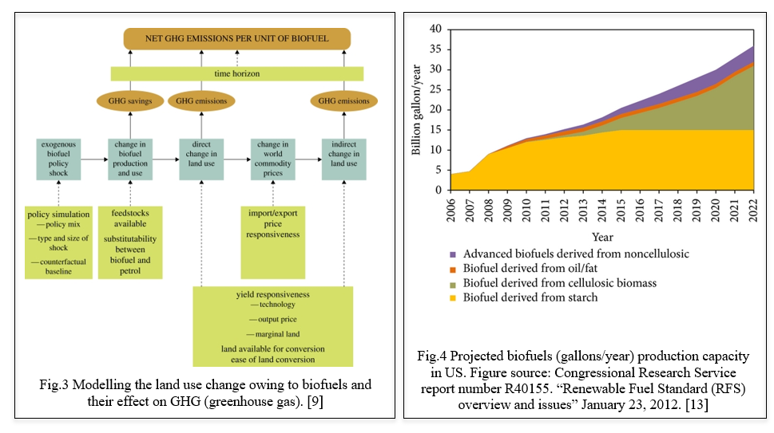
FEEDSTOCK AVAILABILITY AND SUSTAINABILITY
Manageable energy is the issue of the 21st 100 years. Biofuels must accept a level of scrutiny never seen in the development of a new industry if they are to be a part of the solution. Biofuels sustainability has typically been evaluated using the life cycle assessment (LCA) framework. These evaluations show that corn ethanol has a barely lower fossil energy and ozone depleting substance impression contrasted with oil fuel. Ethanol made from sugarcane and some kinds of biodiesel have significantly smaller carbon footprints. New biofuels may offer low impressions. The science of LCA is being extended as far as possible as policymakers consider the immediate and circuitous impacts of biofuels on worldwide land and water assets, worldwide environments, air quality, general wellbeing, and civil rights. The current biofuel markets are overwhelmed by U.S. ethanol creation in view of cornstarch, Brazilian ethanol creation in view of sugarcane, and European biodiesel creation in view of rapeseed oil. The accessibility of appropriate feedstock for biofuel creation is another test. Corn and sugarcane, two of the crops used in the production of biofuel, require climatic conditions and may not be cultivable in all regions. Additionally, depending on a set number of feedstock choices can make production network weaknesses and increment the gamble of cost changes. [10] Life Cycle Evaluations Fig.5 An outline of feedstocks and creation processes for various biofuels, likewise showing the existence pattern of energizes from support to door (well to tank) and support to grave (well to wheel). The figure has been rearranged and different feedstocks, creation courses, items/side-effects, and uses are conceivable. The italic text style signifies the focal point of this audit, i.e., bioethanol and biodiesel utilized for transportation. [12]
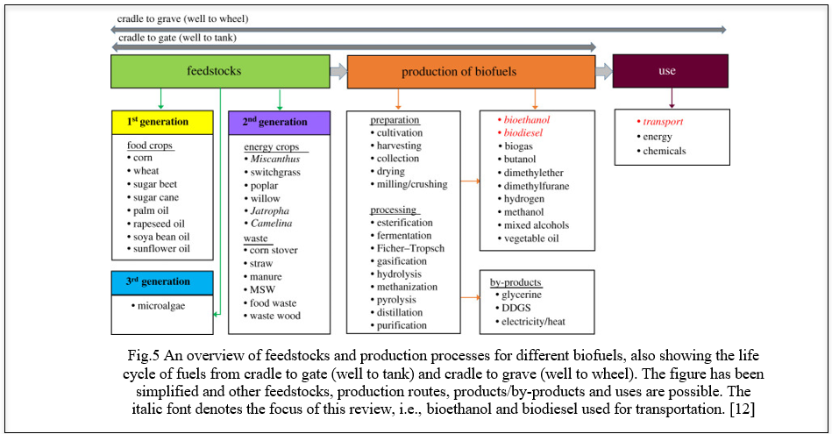

LIFE CYCLE ASSESSMENT
Life Cycle Evaluation (LCA) is a technique used to assess the ecological effects of an item or interaction all through its whole life cycle, from the extraction of unrefined components as far as possible of its valuable life. LCA is usually applied to biofuels to evaluate their by and large ecological execution and contrast them and ordinary non-renewable energy sources. One of the essential inspirations for utilizing biofuels is the possibility to diminish ozone depleting substance (GHG) emanations contrasted with fossil fills. LCA measures the outflows related with each phase of the biofuel life cycle, including feedstock creation, transportation, handling, and burning. It thinks about direct outflows (e.g., fuel burning) as well as circuitous outflows (e.g., land use change, manure creation). The net GHG discharges of biofuels rely upon variables, for example, feedstock type, development rehearses, transformation advances, and land-use change impacts. By giving new data on biogeochemistry and plant physiology, biologists and establish researchers can increment the exactness of LCA for biofuel creation frameworks [14].
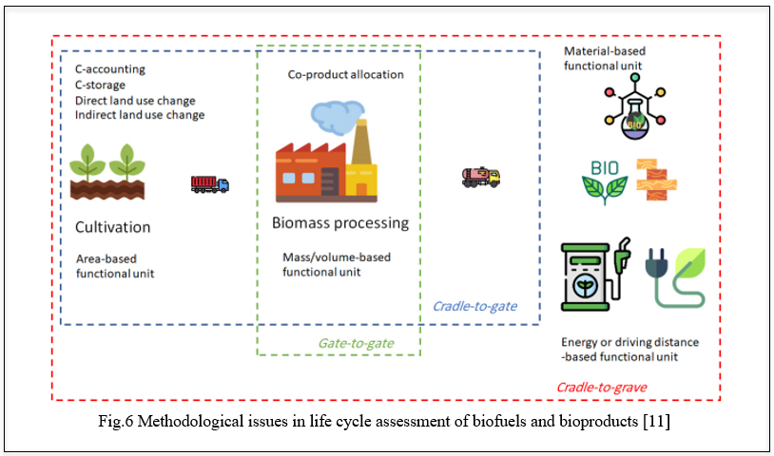

TECHNOLOGICAL AND INFRASTRUCTURAL CHALLENGES
There are several technological and infrastructural obstacles to overcome before biofuels are widely used as an alternative to fossil fuels. Numerous biofuel creation advancements are still in the beginning phases of improvement and are not yet increased for enormous scope business creation. The development of biofuels from various bioresources utilizing different arising advancements and organic cycles is expanding worldwide. The production of biofuels from agricultural crop residues and biomass waste is likely to reduce environmental impact and address numerous environmental issues, including waste disposal issues. Maintaining a consistent supply of feedstock, maximizing process efficiency, and ensuring economic viability are among the difficulties associated with scaling up biofuel production. It requires significant interest in exploration, improvement, and framework to progress from pilot-scale offices to full-scale creation. Biofuels are not always compatible with the existing infrastructure for storing, transporting, and distributing conventional fossil fuels. Biofuels have various properties and may require separate capacity tanks, transportation pipelines, and dissemination frameworks. Adjusting the foundation to oblige biofuels, incorporating mixing them with regular fills or laying out committed dissemination organizations, can be a critical test, particularly in districts with restricted biofuel request or accessibility. The expense of biofuels is significant considering their reception. Biofuel creation processes frequently include various advances, which can be capital-escalated and require continuous functional expenses. When considering the availability of subsidies or incentives to support their production and market penetration as well as fluctuating feedstock prices, economies of scale, and cost competitiveness with fossil fuels, biofuels face a significant challenge. Tending to these mechanical and infrastructural challenges requires supported innovative work endeavours, public and confidential ventures, steady strategies, also, joint effort between industry partners, specialists, and government substances. Beating these difficulties is fundamental for understanding the maximum capacity of biofuels as a economical and low-carbon energy source. As the world and financial and social turn of events rely upon energy, this request will develop to around 37% in 2040. Over 80% of the energy request source on the planet is getting from petrol and related field. To meet the world's energy needs, scientists have had to look into more sustainable, alternative, and efficient renewable energy sources like biofuels because of natural resources. Utilization of non-edible feedstock like lignocellulosic biomass and other organic waste feedstock, production logistics, energy-efficient pretreatment, enzyme hydrolysis, and fermentation technologies, efficient co-product utilization, establishment of biofuel standards, distribution logistics, acceptance of its social and economic benefits, and minimization of its impact on the environment are the primary technological obstacles to the production of biofuels. These difficult areas need infrastructure, expertise in science and related fields, and financial support. [15]
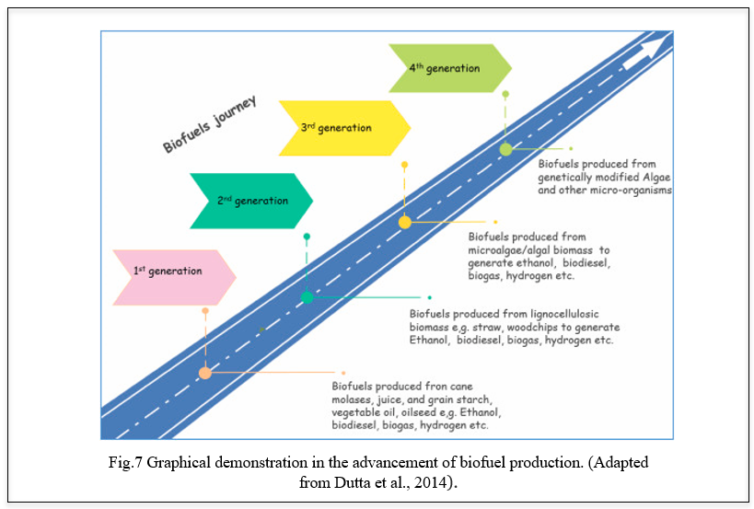
BENEFITS OF BIOFUELS
Biomass can be converted into liquid energies directly called biofuels. In present’s times, the most generally used biofuels are ethanol and biodiesel. Ethanol is one of the renewable energies that can be made from colorful factory sources which is inclusively called biomass. A blend of ethanol along with gasoline would increase the octane resulting in decrease of carbon monoxide and other agents caused by gauze. Flexible energy vehicles are designed to run on E85 which is an alternate energy with much advanced ethanol than gasoline. Biodiesel is produced from renewable sources like vegetable canvases, and beast fats which are important cleaner than petroleum- grounded diesel. Biodiesel is biodegradable and non-toxic and it's produced by mixing alcohol with vegetable oil painting or beast fats. Gas, spurt energy, and diesel are burned to produce energy. Biofuels are much preferred than any other as it can be grown indefinitely and it produces almost no damage to our environment. numerous of the world's major oil painting companies are now investing millions of bones in advanced biofuel exploration. Indeed, though there are numerous graces of using biofuels, there have to be technological advancements and scientific improvements which will help in biomass optimization and processing of biomass into feasible energies. Some companies are counting on the water- grounded result in the form of algae product. Algae could potentially yield lesser volumes of biofuels per acre than other sources. The other massive advantage of using algae over other bio sources is that it can manufacture biofuels analogous in composition to moment’s transportation energies. By doing this it would go a long way in replacing the conventional reactionary energies of gasoline and diesel [19], thus using biofuels is an effective way of combating global climate by reducing carbon emigrations. Recent advances in biotechnology have made the product of renewable coffers more feasible. Bioethanol as a cover is gaining attention due to environmental enterprises. For the development of mortal society, energy is important. We're living in times when the earth is going through global warming and the nonstop decline of fossil energies. This is an important suggestion that requirements to be addressed by all the countries and start the development of renewable new energy [18]. One of the most important renewable coffers is biofuel. It has broad prospects for development and it's anticipated to gradationally the current energy coffers. The application and development of biomass contribute to energy conservation and emigration reduction. This is an important way to achieve a low- carbon frugality. Biofuels have gained important attention in recent times due to their capability to alleviate climate change and global warming, reduce dependence on fossil energies, and promote a further sustainable living. Liquid biofuels are vital as they replace petroleum energies. The cost of biofuels varies grounded on their dependence on feedstock, cost of product, the conversion process, and region. Biodiesel is better than diesel in terms of its sulfur content, flash point, and sweet content. Biofuels are attained from organic accoutrements similar as algae and shops which can be replenished through civilization or natural processes. Biofuels produce a renewable and sustainable source of energy, unlike finite reactionary energies. Biofuels can reduce hothouse gas emigrations compared to fossil energies. There’s eventuality for pastoral development with the product of biofuels as it involves exercising crops which can be a fresh request for growers. By using biofuels we're also indulging in bettered air quality as biofuels have the eventuality to reduce air pollution. They produce lower dangerous air pollution compared to fossil energies. Using biofuels in transportation also contributes to better air quality and reduces respiratory and environmental health pitfalls. When biofuels are used, they can stimulate profitable growth and also produce new job openings, especially in pastoral areas. Biofuels reduce dependence on imported reactionary energies which enhances the energy security for countries. In the last two decades, sweats have been concentrated on the development of processes to produce biofuel with further emphasis on those used in the transport sector. There are a wide variety of biomasses and conversion routes to produce them and each bone has different energy conditions and yield. Specialized feasibility has been demonstrated but its profitable competitiveness remains a challenge. In order to achieve the profitable feasibility of biofuels, the operation of process intensification strategies is a promissory volition [15]. Renewable energy is the future. Sustainable bioenergy product can be considered a crucial issue in the global trouble for the mitigation of hothouse gas (GHG) emigrations and the goods of climate change. A holistic disquisition of the force chain and the product routes of biofuels i needed in order to negotiate sustainable processes. This analysis should consider specialized, profitable, and environmental issues regarding the product of raw biomass, the applied conversion technologies, as well as end- product distribution and use [16]. The use of biofuels is one way to ameliorate our earth. By making a transition to druthers that are sustainable like biodiesel, we produce a terrain that's stable and will remain healthy for times to come. It's also a cost- benefit. According to RFA (Renewable Energies Association), “ethanol remains the loftiest octane, smallest cost motor energy on the earth.” biofuels are easy to reference. Gasoline is meliorated from crude oil painting which is a non-renewable source. The current force of gas that we've will sustain for numerous times but they will run out after a point. Numerous of the world's major oil painting companies are now investing millions of bones in advanced biofuel exploration. Indeed, though there are numerous graces of using biofuels, there have to be technological advancements and scientific improvements which will help in biomass optimization and processing of biomass into feasible energies. Some companies are counting on the water- grounded result in the form of algae product. Algae could potentially yield lesser volumes of biofuels per acre than other sources. The other massive advantage of using algae over other bio sources is that it can be used to manufacture biofuels analogous in composition to present’s transportation energies. By doing this it would go a long way in replacing the conventional reactionary energies of gasoline and diesel. The performance of biodiesel in cold rainfall depends on the mix of biodiesel, the feedstock, and the petroleum diesel characteristics. Biodiesel is also called B100[21]. There are biofuels in Spain that produce biofuels from recycled raw accoutrements and have a periodic product capacity of 250,000 tons of hydro biodiesel, memoir spurt, and propane to be used in exchanges, aircraft, and exchanges. Co2 doesn't increase when biofuels are used, which refers to the conception of carbon impartiality. Thus, using biofuels is an effective way of combating global climate by reducing carbon emigrations [23]. Rice straw, sludge stover, and timber thinning remainders are non-food-based biomass that are some of the promising offers for biofuel product. Dragged exercise of cooking oil painting for preparing food, especially in deep frying is an implicit health hazard and can lead to numerous health conditions. habituated cuisine oil painting is an implicit feedstock for biodiesel and its use for making biodiesel will help the diversion of used cuisine oil painting in the food acidity. Seaweed civilization in the coastal regions is very suitable for biofuel- making styles like anaerobic digestion to make biogas and fermentation to make ethanol. India has a high potential of biomass about 500 metric tons per time vacuity. As per MNRE (Ministry of New and Renewable Energy) around 17500MW of power can be generated by this available biomass. Punjab and Maharashtra have formerly taken the lead to set up biomass shops but other states like Uttar Pradesh, Haryana, Gujrat, and Madhya Pradesh which contribute half of India’s annual agricultural waste worth rupees 50,000 crores are lagging because of low tariffs. India is on track to surpass China as the world's third- largest ethanol consumer by 2026. Biofuels have a lot of advantages but all of them come with a cost. They're relatively expensive to produce in the current request. Biofuels are more expensive to produce than fossil fuels and this is because biofuels are derived from renewable resources like crop and waste materials and the process of inferring energy from them is more expensive. And as time passes, the demand for this will increase and the supply becomes a long- term operation that will be very precious. Monoculture is a process of producing the same crops time after time rather than producing colorful crops through a planter's field over time. Economically it's desirable to growers but growing a single crop over large tracts of land can beget a lot of problems. Biofuels are produced from crops that need diseases to grow better. Diseases beget a lot of damage to the terrain and cause water pollution. Biofuels are uprooted from shops and crops that have high levels of sugar in them. One of the major solicitude people faces is that the growing use of biofuels may also mean a rise in food prices. The carbon footmark of biofuels is lower than the other energies when they're burnt but the process by which they're produced makes up for it. The product for this largely depends on lots of water and oil painting. Diligence meant to churn out biofuels are known to release large quantities of emigrations and contribute to water pollution. The technology that's presently being used to produce biofuels isn't as effective as it has to be. The cost of exploration and installations means that biofuels will see a significant shaft in the price of biofuels. In the northwest, A readily available biomass for biofuels is wood from rent and energy treatments. Some case studies have shown that transporting biomass to a installation is more provident than converting energies into biofuels. Pyrolysis is a system of converting wood into heat and energy. Although Europe and the USA are still the main consumers of fossil energies, these developments are also set to profit the fleetly growing husbandry of Asia as further people, particularly in China and India, are suitable to go a auto. transnational cooperation to increase and encourage exploration into biofuel product and use, thus, benefits all countries because it helps to drop the emigration of hothouse feasts. Jorge Sanchez from The Agricultural Attaché at the Embassy of the United States of America in Beijing, China, explains that the Chinese National Reform and Development Commission (Beijing, China) is developing programs, “for a country that can consume like an advanced country, but still needs to nearly foster the requirements of the 800 million plus peasants living in China [22].” China is the second largest consumer of oil painting behind the USA and the third largest patron of first- generation biofuels behind the USA and Brazil. Over the times, fire repression has changed the northwest's structure and composition of timbers. In fire-prone timbers, fires burn both lower and larger trees when there's too important energy in the timber, performing in too important energy in the timbers high- inflexibility fires can beget severe environmental issues which impact mortal health, damage wildlife niche, destroy homes and communities, crippling natural coffers- grounded husbandry, and destroy a natural carbon store. Tree branches, covers, and imperfect logs which are left after timber crop is another implicit biofuel source. According to the 2016billion ton report from the US Department of Energy if all the timber residue were made into ethanol it could make roughly1.3 billion gallons of energy [21] If the rent is left unburnt it can lead to increased fire hazards. Reducing our demand for petroleum could also lower its price and which can induce profitable benefits for guests. Demand for biofuels can also increase ranch income. Domestically produced biofuels lead to lower reaction energy imports. However, It's important to note that biofuel product and consumption in itself won't reduce GHG or accessible adulterants emigration, lessen petroleum significances, If biofuel product and use reduce our consumption of imported reactionary energies.[24]

REFERENCES

[1]. Barry D Solomon – BIOFUELS AND SUSTAINABILITY
[2]. Handbook of Biofuels production edited by Rafael Luque, Carol Sze Ki Lin, Karen Wilson and James Clark
[3].Biofuels - Markus Schmidt , Manuel Porcar , Vincent Schachter , Antoine Danchin , and Ismail Mahmutoglu
[4].Biofuel production technologies: status, prospects and implications for trade and development by Dr. Eric D. Larson
[5].Rodionova MV, et al., Biofuel production: Challenges and opportunities, International Journal of Hydrogen Energy (2016), http://dx.doi.org/10.1016/j.ijhydene.2016.11.125
[6].Environmental sustainability of biofuels: A review by Harish K. Jeswani Andrew Chilvers and Adisa Azapagic https://doi.org/10.1098/rspa.2020.0351
Figure 2,4,5 - Biofuel production technologies: status, prospects and implications for trade and development by Dr. Eric D. Larson
Figure 3- Rodionova MV, et al., Biofuel production: Challenges and opportunities, International Journal of Hydrogen Energy (2016), http://dx.doi.org/10.1016/j.ijhydene.2016.11.125
Figure 1- : Rodionova MV, et al., Biofuel production: Challenges and opportunities, International Journal of Hydrogen Energy (2016), http://dx.doi.org/10.1016/j.ijhydene.2016.11.125
REFERENCES:
[7] Khan MI, Shin JH, Kim JD. The promising future of microalgae: current status, challenges, and optimization of a sustainable and renewable industry for biofuels,
feed, and other products. Microb Cell Fact. 2018 Mar
[8] Medipally SR, Yusoff FM, Banerjee S, Shariff M. Microalgae as sustainable renewable energy feedstock for biofuel production. Biomed Res Int.
2015;2015:519513. doi: 10.1155/2015/519513. Epub 2015 Mar 22.
[9] Delucchi MA. Impacts of biofuels on climate change, water use, and land use. Ann N Y Acad Sci. 2010 May;1195:28-45.
[10] Sheehan JJ. Biofuels and the conundrum of sustainability. Curr Opin Biotechnol. 2009 Jun;20(3):318-24
[11] Jeswani HK, Chilvers A, Azapagic A. Environmental sustainability of biofuels: a review. Proc Math Phys Eng Sci. 2020 Nov;476(2243):20200351. doi:
10.1098/rspa.2020.0351. Epub 2020 Nov 25. PMID: 33363439; PMCID: PMC7735313.
[12] Gnansounou, E., Dauriat, A., Villegas, J., &amp; Panichelli, L. (2009). Life cycle assessment of biofuels: Energy and greenhouse gas balances. Bioresource
Technology, 100(21), 4919-4930
[13] Current Challenges in Commercially Producing Biofuels from Lignocellulosic Biomass by Venkatesh Balan
[14] Davis SC, Anderson-Teixeira KJ, Delucia EH. Life-cycle analysis and the ecology of biofuels. Trends Plant Sci. 2009 Mar;14(3):140-6
[15] Singhania RR, Patel AK, Singh A, Haldar D, Soam S, Chen CW, Tsai ML, Dong CD. Consolidated bioprocessing of lignocellulosic biomass: Technological
advances and challenges. Bioresour Technol. 2022 Jun;354:127153.
[ 16] Fokaides, P., & Christoforou, E. (2016). Life cycle sustainability assessment of biofuels. Handbook of Biofuels Production (Second Edition), 41-60. https://doi.org/10.1016/B978-0-08-100455-5.00003-5

[17] Hernández, S. (2022). Process intensification in biofuels production. Biofuels and Biorefining, 1-40. https://doi.org/10.1016/B978-0-12-824117-2.00001-6
Anderson, R.B. 1984. The Fischer–Tropsch synthesis, Academic Press, New York.

[18] Shan, Y., & Lü, X. (2021). Ending fossil fuels addiction: Prospects for biofuels. Advances in 2nd Generation of Bioethanol Production, 229-242. https://doi.org/10.1016/B978-0-12-818862-0.00008-X

[19] https://www.conserve-energy-future.com/advantages-and-disadvantages-of-biofuels.php

[20] Bukur, D.B., Nowicki, L., Manne, R.V., Lang, X. 1995. Activation studies with a precipitated iron catalysts for the Fischer–Tropsch synthesis. J Catalysis 155:366–375.

[21] S. Paulson, Ph.D. (2013). Biodiesel Fuel [Online]. Avaliable: http://www.environment.ucla.edu/reportcard/article7320.html
[22] EMBO Reports. (2008). Bio Or Bust? The Economic and Ecological Cost of Biofuels [Online]. Avaliable: http://www.ncbi.nlm.nih.gov/pmc/articles/PMC2246417/
[23] epsol.com/en/sustainability/circular-economy/our-projects/renewable-fuels-from-waste/index.cshtml
[24] https://www.epa.gov/environmental-economics/economics-biofuels

