AI-Powered Teacher Assistant for Student Problem Behaviors'
Contents
1. Introduction
2. Theoretical Framework for System Design
2.1 Need Deficiency
2.2 Problem Behavior
2.3 External Environmental Factors
2.4 Individual Factors
3. System Design
3.1 Diagnose Module
3.2 Question Answering Module
3.3 Case search Module
4. Discussion and Conclusion
References

- Introduction

Student problem behavior has been since decades a research topic with the aim how to help students with their undesirable conduct and actions (Jessor 2016). Students’ problems cause concerns in schools and require help and guidance from teachers. In this chapter, we present how artificial intelligence (AI) technologies can be employed to help teachers diagnose students’ problem behaviors. Task-oriented dialogue system technology is utilized to develop an AI-powered assistant for problem behavior diagnosis. Task-oriented dialogue systems have been widely adopted in many other fields, including ticket booking (Li et al. 2017), restaurant searching (Wen et al. 2016), and online shopping (Yan et al. 2017). Furthermore, the dialogue system has been used for automatic diagnosis of disease in the medical field as well.

Inspired by the wide usage of the task-oriented dialogue system in other fields, we design and develop a task-oriented dialogue system for the automatic identification of students’ need deficiencies and targets helping teachers to handle student problem behaviors. Maslow (1943) states that people’s behaviors are driven by their psychological needs, and thus the problem behaviors are often caused by unfulfilled psychological needs, which are termed as need deficiencies. The students’ problem behaviors thus can be handled by identifying their need deficiencies (Harper et al. 2003), timely diagnosing the reasons behind them, and conducting necessary interventions. The system design is based on a theoretical framework that summarizes the relevant psychology finding for student need deficiency and utilizes natural language processing techniques to enable the natural communication between teachers and the system.

- Theoretical Framework for System Design

Studies have been conducted to analyze the causes underlying students’ problem behaviors. According to the classical theory of Maslow (1943), people’s behaviors are driven by psychological needs, which implies need deficiencies are the reasons for problem behaviors. Jessor (2014) finds that students’ behaviors are influenced by the interactions between students’ personality systems and their perceived environment systems. Harper and Stone (2003) show that the students’ psychological needs can be affected by different factors like natural disasters, violence, abuse, poverty, lack of school and community resources, and emotional deprivation. Dennis et al. (2005) finds that the interaction between individual characteristics and environmental factors influences student development.

Fig 1: Theoretical Framework for System Design

Those research findings are informative and useful but are too scattered for systematic applications. Hence, a theoretical framework summarizing all the relevant factors is necessary, and the designed system explicitly considers difference classes of need deficiencies, problem behaviors, external environmental factors, as well as individual factors.

2.1 Need Deficiency

Fig 2: Classification of Student basic needs

We define and classify students’ need deficiency into five categories: physiological needs, safety needs, belongingness and love need, esteem needs, and cognitive needs. The list of the classification of students’ basic needs is summarized in Fig 2.
2.2 Problem Behavior
Problem behaviors are classified into three categories: externalization problems, internalization problems, and other problems.
Table 1: Classification of Student Problem Behavior
Problem Behaviors | Category | Specific factor
 | Externalization problems | Aggressive behavior, rule-breaking behavior
 | Internalization problems | Social withdrawal, depression, anxiety
 | Other problems | Learning problem, Egocentricity, special problem

2.3 External Environmental Factors
External environmental factors mainly refer to factors that affect students’ growth and therefore significantly affect the formation of problem behavior.
Table 2: Classification of External Environmental factors
External environmental factors | Category | Specific factor
 | Family factors | Family structure, parenting style, education background, health condition, delinquent behaviors, socioeconomic status
 | School factors | Teacher leadership style, peer acceptance, peer influence
 | Society factors | Mass media, cultural custom

2.4 Individual Factors
External environmental factors mainly refer to factors that affect students’ growth and therefore significantly affect the formation of problem behavior.
Table 3: Classification of individual factors
Individual factors | Category | Specific factor
 | Demographic information | Grade, gender, health condition, social group
 | Personality | Neuroticism, extraversion, openness, agreeableness, conscientiousness

3. System Design
Our dialogue support system consists of three main modules, namely, the diagnosis module, the question-answering module, and the case search module. We will elaborate on them in this section, respectively.

Fig 3: Classification of System Design

3.1 Diagnosis Module
This module adopts the technology of a task-oriented dialogue system to conduct a diagnosis. The task-oriented dialogue system is designed to complete a specific task through natural language interaction with users (Gao et al. 2019). The diagnosis process considers both external environmental factors and individual factors.
Table 4: Uses of Dialogue System
Dialogue System | Movie-ticket booking
 | Help users search and reserve restaurants
 | Solve information-searching tasks
 | Automatic diagnosis of medical disease

As shown in Fig. 4, it consists of four main functional components:
  - natural language understanding,
  - dialogue state tracking,
  - dialogue policy learning, and
  - natural language generation.

The natural language understanding component interprets the teacher’s utterance to extract the intent as well as task-related semantic information. Specifically, it processes a teacher’s reply to extract the student’s information, such as whether he has aggressive behaviors. In this teacher’s assistant, the long short-term memory (LSTM) (Hochreiter and Schmidhuber 1997) network is adopted to interpret the teacher’s utterances. An LSTM network is a typical recurrent neural network that has been widely used in natural language processing recently. The dialogue state tracking component tracks the dialogue state that represents all of the task-related information captured. This dialogue state represents students’ information acquired to that point and is utilized to determine the next system action. Specifically, this module updates the dialogue state with another LSTM network based on the output of natural language understanding component.

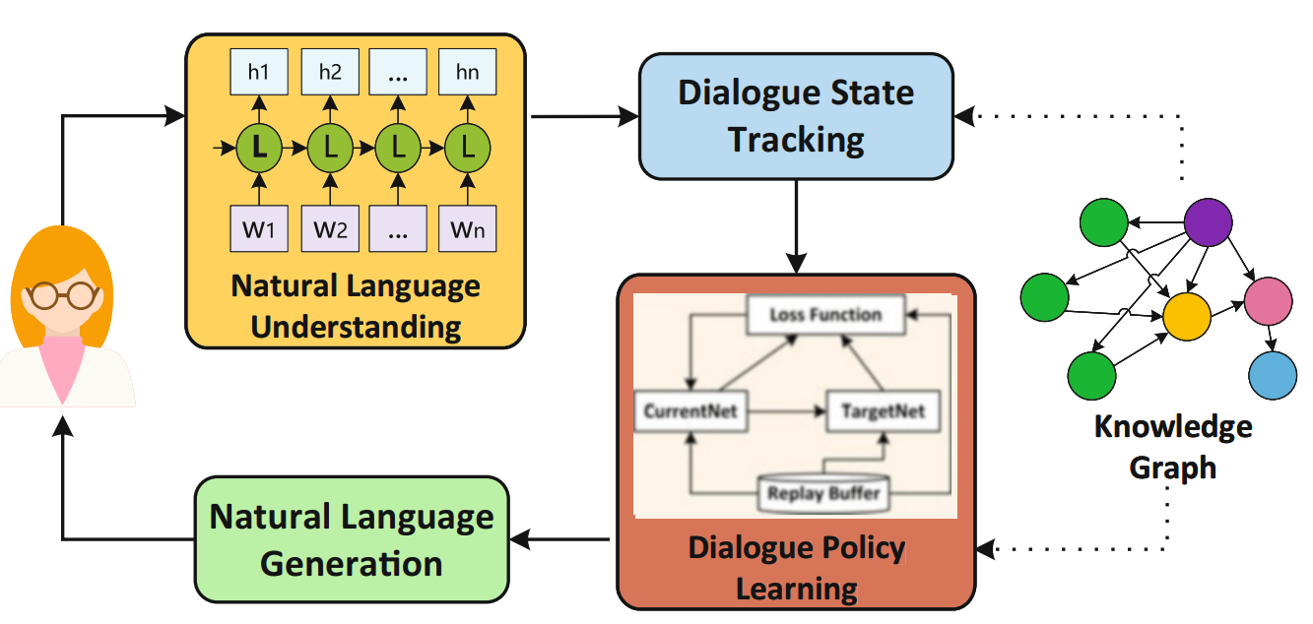
Fig 4. Diagnosis module for analyzing student problem behavior

The dialogue policy learning module takes charge of making decisions on the next system action based on the current dialogue state, such as requesting information or informing certain results. Based on the current dialogue state, we adopt a reinforcement learning model, specifically a deep Q-learning network (DQN) model (Mnih et al. 2015), to learn the dialogue policy that decides whether to request more information from the teacher or to present the derived need deficiency to the teacher. The DQN is a typical deep reinforcement learning model that utilizes a deep neural network to calculate the Q-value in the model. Finally, the natural language generation component utilizes a template-based model to transform system action into text response.

3.2 Question Answering Module
Unlike the diagnosis module that targets analyzing the problem behaviors for the specific student, this module aims to provide general guidelines on typical problem behaviors by answering questions like “What are the typical problem behaviors for high school girls?”. The community question answering (CQA) technology is employed to answer such questions. CQA is a web-based service to help people seek information by answering their questions based on knowledge shared by others in the community (Srba and Bielikova 2016). Unlike the diagnosis module that targets on analyzing the problem behaviors for the specific student, this module aims to provide general guidelines on typical problem behaviors through answering questions like “What are the typical problem behaviors for high school girls?” The community question answering (CQA) technology is employed to answer such questions. CQA is a web-based service to help people seek information by answering their questions based on knowledge shared by others in the community (Srba and Bielikova 2016). CQA system aims to pick out the most appropriate answer from multiple answers of the given question, and typically includes two main tasks: finding the similar questions and finding the relevant answers (Joty et al. 2018). Traditional approach focuses on the syntactic analysis on the text of questions and answers. For example, Cui et al. (2005) proposed a general tree-based method calculating tree-edit distance to match question and answer. Recently, with the development of deep learning, various deep neural network models have been proposed. For example, Zhou et al. (2018) proposes a recurrent convolutional neural network (RCNN) to capture both the semantic matching between question and answer and the semantic correlations embedded in the sequence of answers. Hence, we are inspired to develop our CQA model with deep learning algorithms. The structure of the designed CQA model is illustrated in Fig. 5. Specifically, the model provides a two-phase processing. The first one is the question selection phase aiming to find the candidate questions similar to the incoming question. The second one is the answer selection phase which ranks all the answers of the candidate questions generated by phase I, and then selects the most appropriate answer as output.

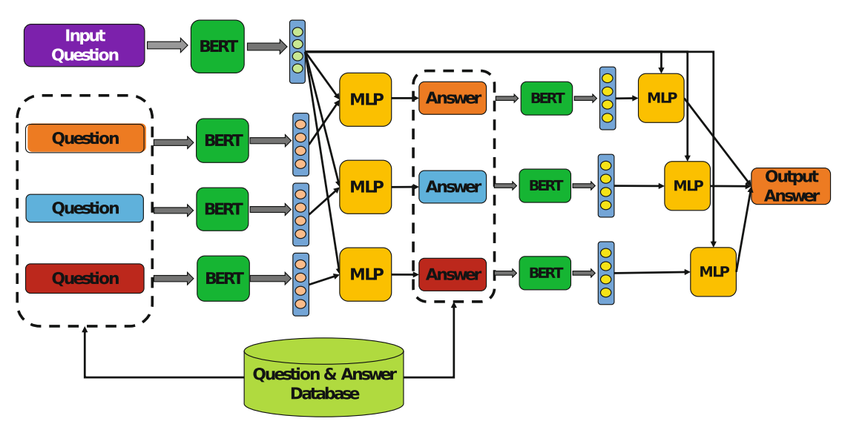
Fig 5: The CQA model used in question answering module
The first phase identifies the candidate questions similar to the incoming question from the existing ones. We used the pretrained BERT (Devlin et al. 2018) model for natural language processing to analyze the semantics of questions and answers. It first learns the semantic vectors of the existing questions, and creates a database for all the question semantic vectors. Whenever a new incoming question arrives, the same BERT framework is adopted to learn its semantic vector. Subsequently, the model is fine-tuned by a multilayer perceptron (MLP) network to compute the similarity between incoming question and each existing question. Accordingly, it computes a similarity value for each existing question. With a predefined similarity threshold value, a set of similar questions are selected as candidates.
The second phase then starts to identify the most appropriate answer. Firstly, a set of candidate answers is generated based on the best answer of each candidate question in the first phase. Secondly, the semantic vector of each candidate answer is learned using the BERT framework like the first phase. Thirdly, by concatenating the question vector and answer vector, an MLP network is employed to fine-tune the model to compute the matching level between a question and an answer. Finally, the candidate questions are ranked according to the multiplication of question similarity and answer matching level, and the one with the biggest calculated value is chosen as the final output.

3.3 Case Search Module
This module is developed with the technology of information retrieval. As a typical natural language processing task, information retrieval aims to find the closely related information according to user requirements. It explores how to represent, store, organize, and access information properly for information searching (Chowdhury 2010). Various models have been proposed to conduct information retrieval. This module utilizes a deep natural language processing model to compute the similarity between teacher’s text description and case documents. Unlike the semantic similarity calculation in question answering module targeting on computing similarity between two sentences, this case engine computes the similarity between two different documents in the form of a sequence of sentences. As illustrated in Fig. 6, a hierarchical BERT model is designed and implemented to compute the semantic similarity between teacher’s text description and each case document.
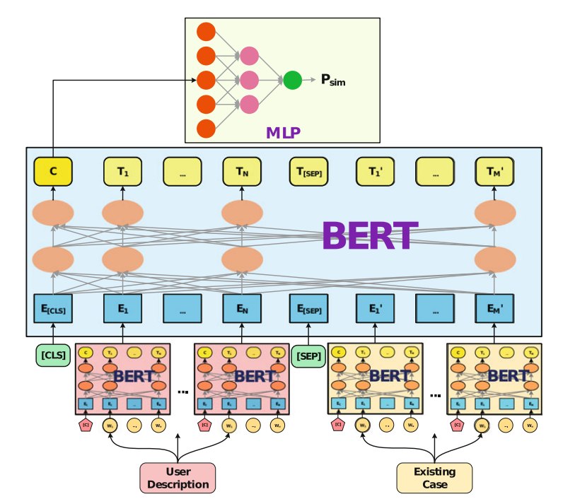
Fig. 4 The hierarchical BERT model used in case search module
In this mode, the bottom layer mainly learns the semantic vector of each sentence in teachers’ text description and case documents. Specifically, parameters of pretrained BERT model are adopted directly for this bottom layer BERT. The top layer targets on learning the semantic similarity between teacher’s text description and each case document. By taking the semantic vectors of sentences generated with bottom BERT layer as input, we add in the special token “[CLS]” at the beginning and “[SEP]” in the middle to concatenate the two sequences into one sequence. Subsequently, the model can process it like a normal sequence, and generate a semantic similarity vector at the beginning position. After generating the semantic similarity vector, one MLP network model is employed to compute the similarity between the teacher text description and the case document. Similar to the question answering module, all cases are ranked according to the computed semantic similarity and then return back to the teacher.

4. Discussion and Conclusion
The main idea of current AI algorithms is the combination of the data-driven paradigm with the knowledge-driven paradigms. Based on the knowledge-driven paradigm, the principles and theories in psychological studies are employed to build the theoretical framework, which guides the machines to solve the targeted student behavior problem in a theoretical manner. By leveraging on the data-driven paradigm, the rich and precious teacher experiences embedded in the text data can be extracted and utilized. The integration of these two paradigms provides the solution, and it aims to ensure the reliability and validity of the developed teacher assistant for student problem behaviors. Specifically, the system can analyze students’ need deficiencies behind their problem behaviors and identify the corresponding external environmental and individual factors that result the deficiencies. It also helps teachers find answers or similar resolved cases in many typical student problem behaviors. By taking these answers and cases as references, the teachers can learn how to help their students. The system interacts with teachers through natural language, which greatly improves the usability as well.

References
- Achenbach, T. M., & Rescorla, L. A. (2014). The Achenbach system of empirically based assessment (ASEBA) for ages 1.5 to 18 years. In The use of psychological testing for treatment planning and outcomes assessment, 179-214, Routledge.
- Chen, P., Lu, Y., Peng, Y., Liu, J., & Xu, Q. (2020). Identification of Students’ Need Deficiency Through a Dialogue System. International Conference on Artificial Intelligence in Education, 59-63. https://doi.org/10.1007/978-3-030-52240-7_11
- Chen, P., Lu, Y., Yu, S., Xu, Q., Liu, J. (2021). A dialogue system for identifying need deficiencies in moral education. Journal of Pacific Rim Psychology, 15. https://doi.org/10.1177/ 1834490921998589
- Chowdhury, G. G. (2010). Introduction to modern information retrieval. Facet publishing.
- Cui, H., Sun, R., Li, K., Kan, M. Y., Chua, T. S. (2005). Question answering passage retrieval using dependency relations. The 28th ACM SIGIR Conference on Research and Development in Information Retrieval, 400-407. https://doi.org/10.1145/1076034.1076103
- Dake, J. A., Price, J. H., & Telljohann, S. K. (2003). The nature and extent of bullying at school. Journal of School Health, 73, 173-80. https://doi.org/10.1111/j.1746-1561.2003.tb03599.x
- Devlin, J., Chang, M. W., Lee, K., Toutanova, K. (2018). Bert: Pre-training of deep bidirectional transformers for language understanding. arXiv preprint arXiv:1810.04805.
- Dennis, J. M., Phinney, J. S., & Chuateco, L. I. (2005). The role of motivation, parental support, and peer support in the academic success of ethnic minority first-generation college students. Journal of College Student Development, 46(3), 223-236. https://doi.org/10.1353/ csd.2005.0023
- Fomby, P., & Christie, A. S. (2013). Family structure instability and mobility: The consequences for adolescents’ problem behavior. Social Science Research, 42(1), 186-201. https://doi.org/ 10.1016/j.ssresearch.2012.08.016
- Gao, J., Galley, M., & Li, L. (2019). Neural Approaches to Conversational AI: Question Answering, Task-oriented Dialogues and Social Chatbots. Now Foundations and Trends. https:/ /doi.org/10.1561/1500000074
- Harper, F. D., Harper, J. A., & Stills, A. B. (2003). Counseling children in crisis based on Maslow’s hierarchy of basic needs. International Journal for the Advancement of Counselling, 25(1), 11- 25. https://doi.org/10.1023/A:1024972027124
- Harper, F. D., & Stone, W. O. (2003). Transcendent counseling: An existential, cognitivebehavioral theory. Culture and counseling: New approaches, 233-251.
- Hochreiter, S., & Schmidhuber, J. (1997). Long short-term memory. Neural computation, 9(8), 1735-1780. https://doi.org/10.1162/neco.1997.9.8.1735
- Hoffmann, J. P. (2006). Family structure, community context, and adolescent problem behaviors. Journal of Youth and Adolescence, 35(6), 867-880. https://doi.org/10.1007/s10964-006-9078-x
- Jessor, R. (2014). Problem Behavior Theory: A half century of research on adolescent behavior and development. In R. M. Lerner, A. C. Petersen, R. K. Silbereisen, & J. Brooks-Gunn (Eds.), The Developmental Science of Adolescence: History Through Autobiography, 239-256. Psychology Press.
- Jessor, R. (2016). The origins and development of problem behavior theory. Advancing Responsible Adolescent Development.https://doi.org/10.1007/978-3-319-40886-6.

