AI-Powered Teacher Assistant for Student Problem Behaviors'
Contents
1. Introduction
2. Theoretical Framework for System Design
2.1 Need Deficiency
2.2 Problem Behavior
2.3 External Environmental Factors
2.4 Individual Factors
3. System Design
3.1 Diagnose Module
3.2 Question Answering Module
3.3 Case search Module
4. Discussion and Conclusion
References

- Introduction

Scholar trouble conduct has been taken into consideration for decades of research subject remember with the aim of the way to assist college students with their undesirable conduct and moves (Jessor 2016). University students’ problems cause issues in colleges and require assistance and steering from teachers. On this bankruptcy, we gift how synthetic intelligence (AI) technology may be employed to assist instructors in diagnosing college students’ hassle behaviors. The mission-oriented talk system generation is applied to expand an AI-powered assistant for trouble-behavior prognosis. Challenge-oriented speech structures were broadly followed in lots of other fields, together with rate ticket booking (Li et al. 2017), restaurant looking (Wen et al. 2016), and online buying (Yan et al. 2017). Moreover, the talk system has been used for the automated prognosis of issues within the clinical region well.

Stimulated by the large utilization of the undertaking-orientated talk machine in different fields, we format and increase a mission-oriented verbal exchange device for the automatic identity of college students’ need deficiencies and dreams supporting instructors to address scholarly problem behaviors. Maslow (1943) states that human beings’ behaviors are pushed by using their intellectual wishes, and for that reason, the trouble behaviors are frequently because of unfulfilled intellectual wishes, which are probably termed as need deficiencies. The scholars’ trouble behaviors thus may be treated by identifying their need deficiencies (Harper et al. 2003), well-timed diagnosing the motives at the back of them, and tasty in important interventions. The tool format is based on a theoretical framework that summarizes the applicable psychology locating for scholar need deficiency and makes use of natural language processing techniques to enable natural communique among teachers and the device.

- Theoretical Framework for System Design

Studies have been performed to investigate the causes underlying students’ hassle behaviors. Steady with the classical idea of Maslow (1943), human beings’ behaviors are driven by the useful resource of intellectual needs, this means that want deficiencies are the reasons for problem behaviors. Jessor (2014) finds that students’ behaviors are stimulated with the aid of the interactions between college students’ character systems and their perceived surrounding structures. Harper and Stone (2003) display that the scholars’ psychological desires may be tormented by various factors like herbal screw-ups, violence, abuse, poverty, lack of school and community sources, and emotional deprivation. Dennis et al. (2005) finds that the interaction between man or woman trends and environmental elements influences scholarly development.

Fig 1: Theoretical Framework for System Design

Those research findings are informative and useful however are too scattered for systematic programs. Ultimately, a theoretical framework summarizing all of the applicable elements is crucial, and the designed gadget explicitly considers distinction instructions of need deficiencies, problem behaviors, and external environmental factors, further to non-public elements.

2.1 Need Deficiency

Fig 2: Classification of Student basic needs

We define and classify university college students’ need deficiency into 5 classes: physiological desires, safety dreams, belongingness and love wants, esteem goals, and cognitive goals. The listing of the class of university college students’ simple goals is summarized in Fig 2.

2.2 Hassle Behavior
Problem behaviors are categorized into 3 categories: externalization troubles, internalization troubles, and other troubles.

Table 1: Classification of Student Problem Behavior
Problem Behaviors | Category | Specific factor
 | Externalization problems | Aggressive behavior, rule-breaking behavior
 | Internalization problems | Social withdrawal, depression, anxiety
 | Other problems | Learning problem, Egocentricity, special problem

2.3 External Environmental Elements
External environmental factors mainly talk over with factors that have an impact on students’ increase and consequently extensively affect the formation of hassle behavior.
Table 2: Classification of External Environmental factors
External environmental factors | Category | Specific factor
 | Family factors | Family structure, parenting style, education background, health condition, delinquent behaviors, socioeconomic status
 | School factors | Teacher leadership style, peer acceptance, peer influence
 | Society factors | Mass media, cultural custom

2.4 Character Factors
Outside environmental elements in particular speak to elements that have an effect on students’ boom and consequently notably have an effect on the formation of hassle conduct.

Table 3: Classification of individual factors
Individual factors | Category | Specific factor
 | Demographic information | Grade, gender, health condition, social group
 | Personality | Neuroticism, extraversion, openness, agreeableness, conscientiousness
3. System Design
Our communication assist system includes the 3 most important modules, mainly, the prognosis module, the query-answering module, and the case are seeking for module. We're capable of intricate on them on this segment, respectively.

Fig 3: Classification of System Design

3.1 Diagnosis Module
This module adopts the technology of an undertaking-oriented communication system for conducting evaluation. The undertaking-orientated communique gadget is designed to complete a particular venture via herbal language interplay with customers (Gao et al. 2019). The diagnosis method considers each outside environmental factor and personal elements.
Table 4: Uses of Dialogue System
Dialogue System | Movie-ticket booking
 | Help users search and reserve restaurants
 | Solve information-searching tasks
 | Automatic diagnosis of medical disease

As shown in Fig. 4, it consists of four main functional components:
  - Natural language understanding,
  - Dialogue state tracking,
  - Dialogue policy learning, and
  - Natural language generation.

The herbal language know-how component interprets the trainer’s utterance to extract the reason as well as assignment-associated semantic data. Particularly, techniques in a trainer’s reaction to extract the student’s statistics, together with whether or not he has aggressive behaviors. In this trainer’s assistant, the lengthy quick-term memory (LSTM) (Hochreiter and Schmidhuber 1997) community is observed to interpret the teacher’s utterances. An LSTM network is a regular recurrent neural community that has been extensively applied in natural language processing. The speak state monitoring factor tracks the communication U.S.A. that represents all of the challenge-related facts captured. This speak kingdom represents college students’ facts received to that factor and is utilized to determine the subsequent device motion. Mainly, this module updates the speaking us off with another LSTM community based totally on the output of the natural language knowledge detail.

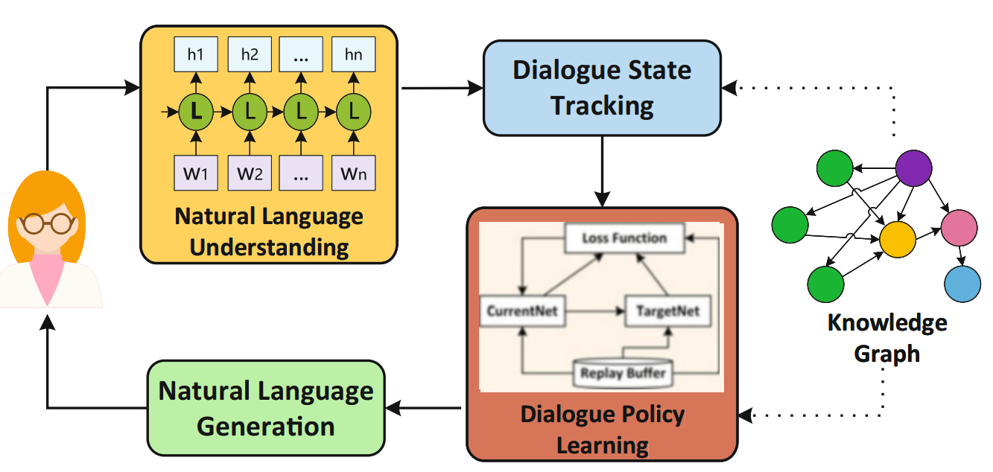
Fig 4. Diagnosis module for analyzing student problem behavior

The talk coverage getting to know module takes the price of making picks on the following system motion based totally on the cutting-edge speak nation, which incorporates asking for facts or informing certain effects. Based on the present-day communication, we undertake a reinforcement analyzing version, especially a deep Q-learning community (DQN) model (Mnih et al. 2015), to learn the communique policy that makes a choice whether to request greater statistics from the teacher or provide the derived want deficiency to the trainer. The DQN is a median deep reinforcement getting-to-recognize model that ="hide">makes use of="tipsBox"> a deep neural community to calculate the Q-value inside the model. In the long run, the natural language era thing ="hide">makes use of="tipsBox"> a template-based version to transform system motion into a textual content response.

3.2 Question Answering Module
Now not like the diagnosis module that studies the trouble behaviors for the precise student, this module tries to provide sizable pointers on standard hassle behaviors by using the use of answering questions like “What are the same old problem behaviors for high school girls?”. The community query answering (CQA) generation is employed to answer such questions. CQA is a web-based company to assists human beings who are seeking out information by answering their questions based totally on bdd5b54adb3c84011c7516ef3ab47e54 shared via others inside the network (Srba and Bielikova 2016). Unlike the analysis module that targets studying the trouble behaviors of the unique pupil, this module aims to provide well-known hints on typical hassle behaviors through answering questions like “What are the standard trouble behaviors for excessive college women?” The community question answering (CQA) generation is employed to answer such questions. CQA is an internet-based company to assists people seeking records by answering their questions primarily based totally on information shared with the resources of others in the community (Srba and Bielikova 2016). CQA machine pursuits to choose the maximum suitable solution from a couple of solutions to the given query and generally consists of two most crucial duties: finding the same questions and locating the applicable answers (Joty et al. 2018). The conventional approach makes an area of expertise in the syntactic analysis of the text of questions and solutions. For instance, Cui et al. (2005) proposed a great tree-based general technique calculating tree-edit distance to healthy questions and solutions. In recent times, with the improvement of deep learning, various deep neural community fashions have been proposed. For example, Zhou et al. (2018) advise a recurrent convolutional neural network (RCNN) to capture every semantic matching between query and answer and the semantic correlations embedded within the collection of answers. For this reason, we're stimulated to extend our CQA model with deep studying algorithms. The form of the designed CQA version is illustrated in Fig. 5. In particular, the version gives phase processing, the primary one is the question selection section which aims to locate the candidate questions similar to the incoming query. The second one is the solution selection phase which ranks all of the answers to the candidate questions generated by means of segment I after which selects the most suitable answer as output.

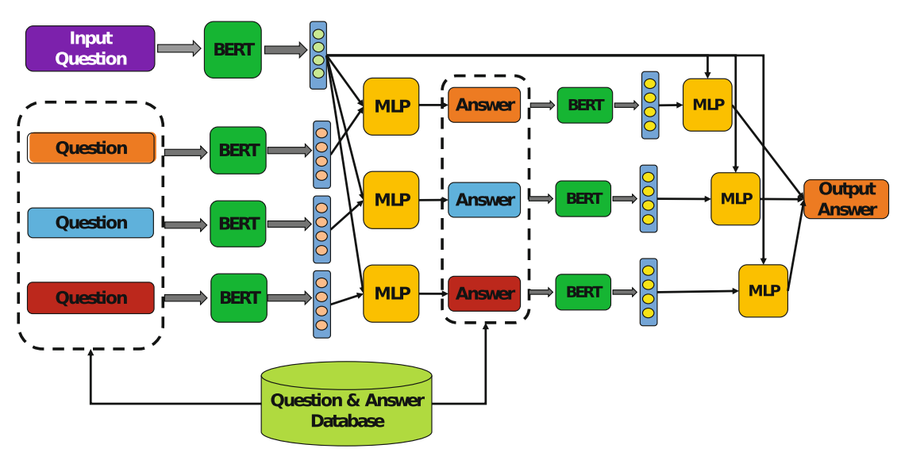
Fig 5: The CQA model used in question answering module

The first section identifies the candidate questions similar to the incoming query from the existing ones. We used the pre-skilled BERT (Devlin et al. 2018) model for herbal language processing to research the semantics of questions and solutions. It first learns the semantic vectors of the prevailing questions and creates a database for all the question semantic vectors. each time a brand-new incoming question arrives, the equal BERT framework is followed to examine its semantic vector. ultimately, the version is ="hide">exceptional="tipsBox">-tuned by way of way of a multilayer perceptron (MLP) network to compute the similarity among incoming questions and every current query. consequently, it computes a similarity fee for each contemporary query. With a predefined similarity threshold value, a difficult and speedy of comparable questions are decided on as candidates.
The second segment then starts offevolved to end up privy to the maximum suitable answer. first of all, a hard and fast of candidate solutions is generated primarily based totally on the 7339ff1fc90882f8f31ca1efdd2ac191 answer of each candidate query in the first section. Secondly, the semantic vector of every candidate solution is determined by using the BERT framework like the first phase. Thirdly, through concatenating the query vector and solution vector, an MLP network is employed to first-class-tune the version to compute the matching degree between a query and a solution. sooner or later, the candidate questions are ranked in steps with the multiplication of question similarity and solution matching level, and the one with the largest calculated value is selected because of the very last output.

3.3 Case Search Module
This module was developed with the generation of data retrieval. As a mean herbal language processing undertaking, records retrieval objectives to discover the cautiously related information in step with customer necessities. It explores the manner to represent, shop, prepare, and get entry to records nicely for facts looking (Cknow-howdhury 2010). numerous fashions were proposed for behavior records retrieval. This module ="hide">makes use of="tipsBox"> a deep natural language processing model to compute the similarity among the trainer’s textual content description and case documents. unlike the semantic similarity calculation in the question-answering module targeting computing similarity among sentences, this situation engine computes the similarity amongst two one-of-a-type files in the shape of a sequence of sentences. As illustrated in Fig. 6, a hierarchical BERT model is designed and carried out to compute the semantic similarity between the instructor’s textual content description and each case record.
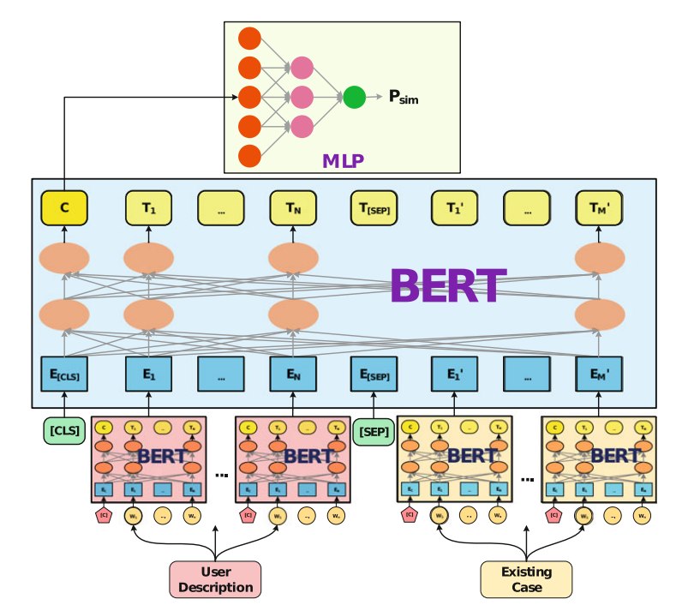
Fig. 6 The hierarchical BERT model used in the case search module
In this mode, the lowest layer especially learns the semantic vector of every sentence in teachers’ text descriptions and case files. In particular, parameters of the pre-educated BERT version are adopted without delay for this bottom layer BERT. The top layer targets on gaining knowledge of the semantic similarity among the trainer’s text description and every case document. With the aid manner of taking the semantic vectors of sentences generated with the backside BERT layer as enter, we add within the specific token “[CLS]” at the start and “[SEP]” in the center to concatenate the 2 sequences into one series. Finally, the model can method it like an ordinary sequence, and generate a semantic similarity vector at the start role. After generating the semantic similarity vector, one MLP community model is hired to compute the similarity between the instructor’s text description and the case document. Just like the query answering module, all instances are ranked in keeping with the computed semantic similarity after which go back again to the teacher.

4. Discussion and Conclusion
The main concept of gift-day AI algorithms is the mixture of the statistics-driven paradigm with the understanding-pushed paradigms. Primarily based on the understanding-driven paradigm, the thoughts and theories in psychological research are hired to construct the theoretical framework, which publications the machines to remedy the centered pupil behavior trouble in a theoretical manner. By leveraging the data-driven paradigm, the wealthy and treasured teacher reports embedded inside the textual content information may be extracted and applied. the combination of those two paradigms gives the solution, and its ambitions to make certain the reliability and validity of the developed instructor assistant for scholar hassle behaviors. In particular, the gadget can have a look at college students’ want deficiencies at the back of their problem behaviors and understand the corresponding out of doors environmental and character factors that result in the deficiencies. It additionally permits teachers to discover solutions or similar resolved times in many ordinary scholarly problem behaviors. By taking these answers and instances as references, teachers can discover ways to knowledge help their university college students. The device interacts with instructors through natural language, which significantly improves its usability as properly.

References
- Achenbach, T. M., & Rescorla, L. A. (2014). The Achenbach system of empirically based assessment (ASEBA) for ages 1.5 to 18 years. In The use of psychological testing for treatment planning and outcomes assessment, 179-214, Routledge.
- Chen, P., Lu, Y., Peng, Y., Liu, J., & Xu, Q. (2020). Identification of Students’ Need Deficiency Through a Dialogue System. International Conference on Artificial Intelligence in Education, 59-63. https://doi.org/10.1007/978-3-030-52240-7_11
- Chen, P., Lu, Y., Yu, S., Xu, Q., Liu, J. (2021). A dialogue system for identifying need deficiencies in moral education. Journal of Pacific Rim Psychology, 15. https://doi.org/10.1177/ 1834490921998589
- Chowdhury, G. G. (2010). Introduction to modern information retrieval. Facet publishing.
- Cui, H., Sun, R., Li, K., Kan, M. Y., Chua, T. S. (2005). Question answering passage retrieval using dependency relations. The 28th ACM SIGIR Conference on Research and Development in Information Retrieval, 400-407. https://doi.org/10.1145/1076034.1076103
- Dake, J. A., Price, J. H., & Telljohann, S. K. (2003). The nature and extent of bullying at school. Journal of School Health, 73, 173-80. https://doi.org/10.1111/j.1746-1561.2003.tb03599.x
- Devlin, J., Chang, M. W., Lee, K., Toutanova, K. (2018). Bert: Pre-training of deep bidirectional transformers for language understanding. arXiv preprint arXiv:1810.04805.
- Dennis, J. M., Phinney, J. S., & Chuateco, L. I. (2005). The role of motivation, parental support, and peer support in the academic success of ethnic minority first-generation college students. Journal of College Student Development, 46(3), 223-236. https://doi.org/10.1353/ csd.2005.0023
- Fomby, P., & Christie, A. S. (2013). Family structure instability and mobility: The consequences for adolescents’ problem behavior. Social Science Research, 42(1), 186-201. https://doi.org/ 10.1016/j.ssresearch.2012.08.016
- Gao, J., Galley, M., & Li, L. (2019). Neural Approaches to Conversational AI: Question Answering, Task-oriented Dialogues and Social Chatbots. Now Foundations and Trends. https:/ /doi.org/10.1561/1500000074
- Harper, F. D., Harper, J. A., & Stills, A. B. (2003). Counseling children in crisis based on Maslow’s hierarchy of basic needs. International Journal for the Advancement of Counselling, 25(1), 11- 25. https://doi.org/10.1023/A:1024972027124
- Harper, F. D., & Stone, W. O. (2003). Transcendent counseling: An existential, cognitivebehavioral theory. Culture and counseling: New approaches, 233-251.
- Hochreiter, S., & Schmidhuber, J. (1997). Long short-term memory. Neural computation, 9(8), 1735-1780. https://doi.org/10.1162/neco.1997.9.8.1735
- Hoffmann, J. P. (2006). Family structure, community context, and adolescent problem behaviors. Journal of Youth and Adolescence, 35(6), 867-880. https://doi.org/10.1007/s10964-006-9078-x
- Jessor, R. (2014). Problem Behavior Theory: A half century of research on adolescent behavior and development. In R. M. Lerner, A. C. Petersen, R. K. Silbereisen, & J. Brooks-Gunn (Eds.), The Developmental Science of Adolescence: History Through Autobiography, 239-256. Psychology Press.
- Jessor, R. (2016). The origins and development of problem behavior theory. Advancing Responsible Adolescent Development.https://doi.org/10.1007/978-3-319-40886-6.

