**Study of Structural and Optical Properties of NiO-CuO Nanocomposite**

B. S. Satavekar

Department of Chemical Engineering

Tatyasaheb Kore Institute of Engineering and Technology, Warananagar.

Warananagar, MS-India - 416113

Email: [bhushans7676@gmail.com](mailto:bhushans7676@gmail.com)

S. V. Anekar

Department of Chemical Engineering

Tatyasaheb Kore Institute of Engineering and Technology, Warananagar.

Warananagar, MS-India-416113

Email: [yesanekar@yahoo.com](mailto:yesanekar@yahoo.com)

B. S. Shirke

Department of Chemistry

Yashwantrao Chavan Warana Mahavidyalaya, Warananagar,

Warananagar, MS-India-416113

Email: [bss_chemistry@yahoo.com](mailto:bss_chemistry@yahoo.com)

**ABSTRACT**

A novel NiO-CuO nanocomposite has been synthesized by a sol-gel method using nickel chloride hexahydrate, copper chloride hexahydrate, ammonia and ethylene glycol as a precursors. The material was characterized by XRD, SEM, EDAX, FTIR, TGA and UV–Visible techniques. XRD analysis revealed all the relevant Bragg’s reflections for face-centered cubic and monoclinic structure of NiO-CuO. The average particle size was obtained 25 nm from the Scherrer equations. The value of particle size determined from XRD was in good agreement with the SEM and TEM results. The direct optical band gap was found to be 3.3 eV. Thermal behaviour mixed salts has been studied using thermal analysis (TG and DTA). The purity of the composites and elemental composition of the constituent oxides checked by FTIR and EDAX.

**Keywords -** Sol-gel; Metal Oxide; Nanocomposite; semiconductors; Thermal

**Corresponding Author**: Dr. B. S. Shirke, Material Science Laboratory, Department of Chemistry, Y.C. Warana

Mahavidyalaya, Warananagar, Maharashtra, India-416113.

**I. INTRODUCTIONS**

Materials science is a very active area of research. It finds widespread application in engineering, technology and science. These materials include ceramics, polymers, semiconductors, magnetic materials, biomaterials, and nanomaterials. Nanotechnology is a rapidly emerging scientific subject in materials science that produces and constructs gadgets that are valuable to society for technical improvement [1]. Materials that have at least one dimension smaller than 100 nanometers in diameter are considered nanoparticles. These have special qualities include enhancing the electrical conductivity, ductility, toughness, and formability of ceramics, enhancing the hardness and strength of metals and alloys, and enhancing the luminous efficiency of semiconductors. It utilized to produce lightweight industrial applications with a high surface area to volume ratio, enhancing the functionality of electronics and information technology, enabling the use of more sustainable energy sources, and playing a crucial role in environmental remediation applications [2].

A composite material is a mixture made up of at least two phases with differing chemical compositions. A significant class of materials in the field of nanotechnology is going to be metal-polymer or metal oxide-polymer nanocomposites. From a theoretical and practical perspective, it has been really interesting. Such materials' properties can be combined to create materials that respond as desired. When particle sizes are reduced to extremely small dimensions, optical or magnetic characteristics may alter. These properties are generally of great interest in the field of nanocomposite materials. Composites have excellent properties like high hardness, high melting point, low density, low coefficient of thermal expansion, high thermal conductivity, good chemical stability, and improved mechanical properties like higher specific strength, better wear resistance, and specific modulus. They also have good potential for various industrial fields like sensors, energy conversion, and environmental remediation [3].

Hybrid nanostructured materials' performance is primarily influenced by their size, shape, composition, structure, crystal phases, and crystal facets. Controlled synthesis of hybrid metal oxide nanostructures is therefore crucial in order to achieve the required size, shape, and structure of the hybrid nanostructure [4]. There are several ways for preparing nanocomposites, including homogeneous precipitation, co-precipitation, thermal decomposition, and hydrothermal processes, but the sol-gel method has been widely employed for preparing inorganic oxide nanocomposites [5]. The conventional approach for preparing the oxide is usually the ceramic route; however, the sol-gel route offers numerous advantages, such as good homogeneity, fewer process steps, ease of remote operation, low sintering temperature, and so on [6].

Nanoscale transition metal oxide semiconductors are very much in demand, due to their physical, biological, and chemical properties. This increases their application in a number of modern science and technology disciplines, as well as their ability to improve the environment and human health [7]. Mixed transition metal oxide (MTMO) has gained popularity in recent years as a potential material for numerous applications in electro catalysis, sensing, charge storage, and catalysis. The active surface area and charge transfer efficiency of MTMO nanocomposites are increased, which enhances the electrochemical performance [8]. The development of metal oxide nanoparticles using green synthesis techniques is the subject of current study, which also offers a low-cost, economical method [9]. Researchers have looked into mixed catalysts in heterogeneous catalysis, which may be more effective than their individual parts [10].

Among the various transition metal oxides, cupric oxide (CuO) is an intrinsically p-type semiconductor with a narrow band gap ranging from 1.2 eV to 3.57 eV. It has monoclinic structure and unique properties such as super thermal conductivity, photovoltaic properties, high stability, and antimicrobial activity. CuO is used in a variety of applications, including photodetectors, photocatalysis, gas sensors, and solar cells. Because of its low cost, high solar absorbance, and simple manufacturing process [11-13].

Nickel Oxide (NiO) is a green crystalline solid with ferromagnetic properties and with a Neel temperature of 523 K. NiO nanostructures are p-type semiconductors with unusual magnetic and electric properties that vary with particle size. The band gap NiO semiconductor is in between 3.6-4.0 eV with extreme chemical stability. Because of its low cost and excellent ion storage property, it has become an attractive research material [14-16].

There are several reports in the literature of NiO-CuO powder preparation by microwave processing. Samreen Zahra et al. revealed that crystals of NiO and CuO nanoparticles aggregated to form spheres of variable sizes were successfully embedded in the amorphous silica matrix composed of silica particles agglomerated to form clusters [17]. Sujit Chatterjee et al. reported the particle dimension can be reduced and porosity may be increased by suitable modification of the synthesis protocol and better fabrication for more efficient devices [18]. L. Argueta-Figueroa reported that, good alternative metal oxide materials such as nickel oxide (NiO), copper oxide (CuO), manganese oxide , and cobalt oxide for highly costly noble metals such as gold (Au), platinum (Pt), lead (Pb), and palladium (Pd). Among these relatively low-cost metal oxides, NiO and CuO are of particular importance owing to their good electrochemical stability and activity [19].

In the present study, we synthesized NiO-CuO nanocomposite by cost effective sol-gel route and characterized using techniques XRD, SEM, TEM, TGA, UV-DRS and FT-IR.

**II. EXPERIMENTAL DETAILS**

**A. Materials and chemicals**

All chemicals used in this experiment were of reagent grade and used without any further purification. Nickel chloride hexahydrate (NiCl2.6H2O), copper chloride hexahydrate (CuCl2.6H2O), ammonia (NH4.OH) and ethylene glycol procured from Sigma Aldrich were used as the precursors. Deionized water has been used as the solvent throughout the synthesis.

**B. Synthesis of NiO-CuO Nanocomposites**

CuO doped NiO nanocomposite were prepared according to the formula NiXCu1-X O (X = 0.1). After mixing the appropriate amounts of (0.1M*)* precursor’s solutions, the mixture was stirred with constant heating at 80°C. The mixture was allowed to cool down at room temperature and (0.1M) aqueous ammonia was added drop wise to adjust the pH value at 10-11. After adjusting pH, the mixture was subjected to 6 hours stirring followed by 24 hours settling down of particles. The obtained green precipitate washed with deionized water to remove formed by products during the reaction process and dried at 60oC temperature for 24 hr. The solution was washed several times to make it neutral (pH = 7). When the solution became neutral, it was dried at 100°C for 24 hours. The grinding of particles into a fine powder using agate pestle mortar followed complete drying. The fine powder was subjected to 4 hours annealing at 400°C to obtain NiO-CuO nanocomposites.

**C. Characterization of nanocomposite material**

The X-ray diffraction of the powder materials was measured on Siemens, D-500 diffractometer with Cu-Kα (λ = 1.5406 Å) operating at 45 kV and 100 mA over a range of 2θ angle from 10o to 80o, at a scanning rate of 5°/min. The UV-Visible (UV-Vis) absorption spectra were recorded in a ‘Jasco (model V-770) UV-Vis-NIR Spectrophotometer' in the wavelength range 200 to 800 nm. Transmission Electron Microscope (TEM) studies of the powder sample was carried out by using model: JEOL JEM 2100 plus, Japan. Themogravimetric analysis/ Differential thermal analysis/ Differential scanning calorimetry were recorded by using model: SDT Q600, make: TA Instrument USA. A Fourier transform infrared spectroscopy (FTIR) of sample carried by using model: Agilent Technology Cary 630 FTIR.

**III. RESULT AND DISCUSSION**

**A. X-ray diffraction**

The nature and the particle size were characterized by x-ray diffraction method. Figure.1 shows XRD pattern of sample, it clearly indicating the formation of crystalline NiO-CuO nanocomposite material. The diffraction peaks of NiO-CuO nanocomposite at 32.46º, 35.52º, 38.72º, 48.80º, 53.42°, 58.23º, 61.57º, 66.12º , 68.08º, and 72.35º closely match the crystalline planes (110), (002), (111), (-202), (020), (202), (022), (-113), (-311) and (113) good agreement with ( JCPDS No. 89–5899) corresponds to the end-centered monoclinic structure of CuO and the diffraction peaks at 37.19º, 43.23º, 62.80°, 75.24° and 79.28° closely match with the (111), (200), (220), (311) and (222) crystalline planes and were indexed to face-centered cubic structure of NiO as per the (JCPDS No. 78- 0429).



**Figure 1. XRD pattern for of NiO-CuO nanocomposite**

The effect of CuO nanoparticles on the microstructural properties (like size, strain etc.) of the NiO, we have estimated the average crystallite size (D) and the strain (ε) present in NiO sample from the full width at half maximum (FWHM) of the XRD peaks by using the following Scherrer equations,

D = $\frac{kλ}{βcosθ}$

ε = $\frac{βcosθ}{4}$

where D is the average crystallite size, ε the strain , λ = 1.54056 Å is the wavelength of Cu kα, β is the full width at half-maximum (FWHM) intensity, θ is Bragg’s diffraction angle, and K is a constant taken as to 0.94.

The values ofD and ε estimated from XRD line width were about 25.26 nm and 0.24 % respectively for the NiO-CuO nanocomposites. The lattice constants comprisinga, b, and c for the monoclinic structure, and a for the cubic structure were calculated using the following relationships, respectively.

$\frac{1}{d^{2}}$ = $\frac{1}{\sin^{2}β}$ ($\frac{h^{2}}{a^{2}}$ + $\frac{k^{2}\sin^{2}β}{b^{2}}+ \frac{l^{2}}{c^{2}}-\frac{2hlcosβ}{ac})$

$\frac{1}{d^{2}}$ = ($\frac{h^{2}+k^{2}+l^{2}}{a^{2}}$)

The lattice parameters calculated from the present data are a =4.68 Å, b = 3.43 Å, and c = 5.14 Å for CuO, and a = 4.19 Å for NiO.

**B. Scanning Electron Microscopy (SEM)**

The morphology of nanocomposite is studied by scanning electron microscopy. The SEM image of NiO-CuO nanocomposite is shown in figure 2, from the image particles are revealed as relatively agglomerated and it shows nanoflower like morphology.

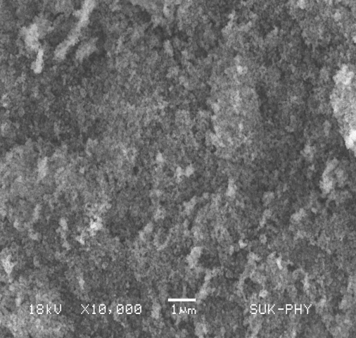

**Figure 2. SEM image for of NiO-CuO nanocomposite**

**C. Transmission electron microscopy (TEM)**

To gain more information on the interior microstructure and crystallographic properties of the nanocomposites, TEM analysis was carried out on NiO-CuO and the obtained TEM as shown in figure 3. The TEM image shows the existence of spherical and cubic structure. The interconnection between nanoparticles is an indication of the formation of mesoporous structure. It shows spherical agglomerated nanoparticles. TEM image shows aggregated but two definitely separated black and gray parts which might be called Janus-type nanostructure of NiO-CuO nanocomposite. The results clearly show that the mean particle size estimated by TEM is in good agreement with the average crystallite size determined from the XRD data.

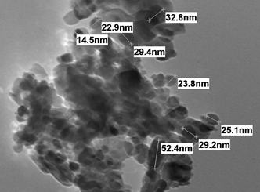

**Figure 3. TEM image for of NiO-CuO nanocomposite**

**D. Energy-dispersive X-ray spectroscopy**

EDX analysis was used to investigate the chemical composition of the synthesized samples. The obtained EDX spectra are shown in figure 4. The EDX spectrum of pristine NiO-CuO confirms the presence of Ni, Cu and O elements in this sample are confirmed without any other impurity species.

The EDX spectrum present the high content of oxygen in the nanocomposites which are further confirmed by the C=O and C–O vibrational peaks in FTIR spectra.

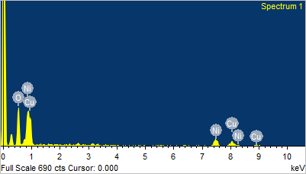

**Figure 4. EDX image for of NiO-CuO nanocomposite**

**E. UV–Vis DRS Spectral Study**

Diffuse reflectance spectrum of the prepared sample was investigated using UV-Visible optical spectroscopy in the range of 200 nm to 800 nm. It is shown in figure 5 a. Diffuse reflectance spectroscopy (DRS) analysis of absorbing material is based on Tauc formula as given below,

αhυ = B (hν - Eg)n

where, α (2.303A/d) is the coefficient of absorption, A is the absorbance, d is the optical path length, B is proportionality constant, Eg is the band gap energy, hυ is the energy of photon and n is a constant which is found to be ½ for direct allowed transitions and 2 for indirect allowed transitions. The value of optical band gap of the prepared sample was calculated using Tauc plot by plotting (αhʋ)2 versus (hʋ) is 3.3 eV shown in figure

5 b.



**Figure 5 a. UV–Visible absorption spectrum of NiO-CuO nanocomposite**



**Figure 5 b. Tauc plot of NiO-CuO nanocomposite**

**F. Fourier transform infrared spectroscopy (FTIR)**

Fourier transform infrared spectroscopy (FTIR) was used to identify the characteristic functional groups in the samples. The FTIR spectra of wt% NiO-CuO composites are shown in figure 6. The prepared photocatalysts reveal the presence of some absorption bands in the ranges from 400 cm-1 to 4000 cm-1.

The broad absorption peak was observed at around 3443cm-1 corresponding to O–H stretching. The bands at 2922.78 and 2856.74 cm-1 are due to bending vibrations of C-H bond. The peaks at 1629 cm-1 and 1387 cm-1 are attributed to the symmetric and asymmetric C=O stretching vibration modes, In the wavenumber region of 1107-1033 cm-1, the observed peaks may be attributed to the presence of carbonates. The intensity of these peaks was found to increase with the increase in Cu doping. The small peak at 801cm-1 is attributed to C–H stretching. The dip at 657cm-1 shows the vibrations of metal oxygen metal bond. The peak was observed at 657.13 cm−1 for NiO-CuO nanocomposite due to the presence of Cu–O bond. The strong band observed at 482.40 cm-1 is the stretching vibrational peak of NiO. The observed broad band assigned at 574.62- 482.40 cm-1 of the mixed oxides may be attributed to the M-O vibration. In addition, this broadness is a proof of the existence of nano-particles exists in the mixed system.

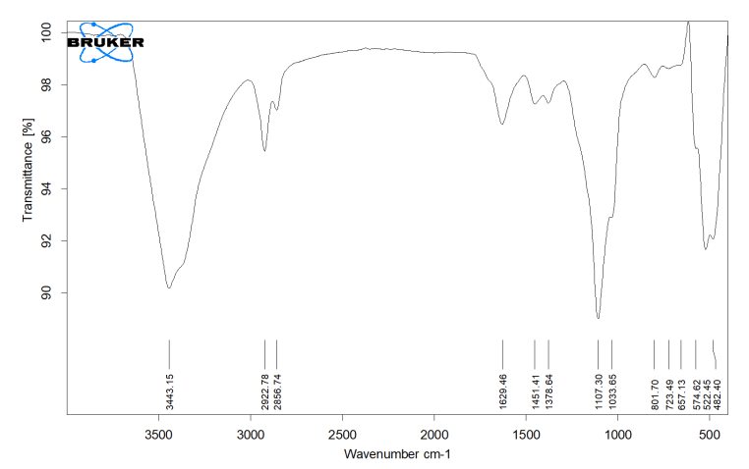

**Figure 6. FTIR image of NiO-CuO nanocomposite**

**G. Thermo Gravimetric analysis (TGA)**

The thermal analysis of NiO-CuO preparation process was directly towards the oxidation and cracking-combustion behaviour and even further kinetic analysis, which were determined using differential scanning calorimetry (DSC) and thermo gravimetric analysis-differential thermal analysis (TGA-DTA) shown in figure 7.

The NiO-CuO nanocomposites thermal behaviour was examined with TGA. In weight per temperature loss with different steps, first step evaporation temperature ranges from 21°C to 159 °C, with a maximum at 60°C. It was accompanied by a mass loss of about 0.7508%, which was about 0.06466 mg. The second stage observed thermal decomposition in the temperature range of 159°C to 299.60°C. It was accompanied by a mass loss of about 0.8689 % which was about 0.07484 mg. The third stage observed the desorption  of two carbon dioxide and two nitrogen dioxide molecules at temperature range of 299.60°C to 337.94ºC. It was accompanied by a mass loss of about 0.8689 % which was about 0.07484 mg. The fourth stage  observed reduction  hydroxides to the oxides by losing two molecules of water between a temperature range 337.94ºC to 567ºC  with maximum at 400ºC, was exothermic. It is accompanied by a mass loss of about 0.4133 % which was about 0.03560 mg. The last thermal stable in the temperature range of 567 and 782°C was defined as the region, where the residual polymer chains were burned.

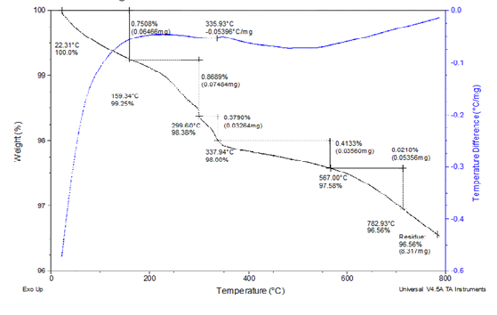

**Figure 7.TGA/DSC image of NiO-CuO nanocomposite**

**IV. Conclusion**

In summary, NiO-CuO nanocomposite was prepared by the Sol-Gel method. The XRD pattern indicates the formation of the mixed coupled phase (cubic-monoclinic) of NiO-CuO having particle size about 25 nm. The SEM results have shown that the average crystallite size and agglomeration increase with an increase in the calcination temperature, which can be attributed to the improvement in the crystallinity of the samples. TEM analysis shows the existence of spherical and cubic structure of NiO-CuO nanocomposite. It is also clear that the mean particle size estimated by TEM is in good agreement with the average crystallite size determined from the XRD data. The EDX spectra confirm the presence of Ni, Cu and O of elements without any other impurity species. UV-Visible study indicated the occurrence of both direct optical transition and indirect optical transition. Our study confirms that by making composite with CuO has influenced significantly on the crystallite size and strain of NiO nanoparticles. FTIR spectra have confirmed the establishment of CuO nanoparticles. The peak of Cu-O stretching was observed at 657.13 cm−1 for NiO-CuO nanocomposite due to the presence of Cu–O bond. The thermal analysis of NiO-CuO was directly towards the oxidation and cracking-combustion behaviour and even further kinetic analysis were determined by using differential scanning calorimetry (DSC) and thermo gravimetric analysis-differential thermal analysis (TGA-DTA).

**ACKNOWLEDGMENTS**

The authors are gratefully acknowledges to the Institute of Tatyasaheb Kore Institute of Engineering and Technology Warananagar, and Yashwantrao Chavan WaranaMahavidyalaya, Warananagar, Maharashtra, India for providing laboratory facilities.

##### REFERENCES

1. U. J. Tupe, M. S. Zambare, A. V. Patil and P. B. Koli, “The Binary Oxide NiO-CuONanocomposite Based Thick Film Sensor for the Acute Detection of Hydrogen Sulphide Gas Vapours,” Mat. Sci. Res. India, 2020, Vol. 17(3), pp. 260-269.
2. T. T. Bhosale, H. M. Shinde, N. L. Gavade, S. B. Babar, V. V. Gawade, S. R. Sabale  · R. J. Kamble, B. S. Shirke, K. M. Garadkar, “Biosynthesis of SnO2 nanoparticles by aqueous leaf extract of Calotropisgigantea for photocatalytic applications,” J. Mater. Sci. Mater. Electron, 2018, vol. 29(8).
3. A. Sharma, S. Kumar, N. Budhiraja, S. Dahiya and Mohan, “Effect of calcination on optical properties and morphology of NiO-CuONanoComposites,” Singh Arch. Appl. Sci. Res., 2013, vol.5 (3), pp.122-128.
4. K. Ghanbari, Z. Babaei, “Fabrication and characterization of non-enzymatic glucose sensor based on ternary NiO/CuO/polyanilinenanocomposite,” Analytical Biochemistry,2016.
5. B. S. Shirke , A. A. Patil , P. P. Hankare , K. M. Garadkar, “Synthesis of cerium oxide nanoparticles by microwave technique using propylene glycol as a stabilizing agent,” J. Mater. Sci: Mater Electron. 2011, vol. 22, pp. 200–203.
6. K. M. Garadkar, B. S. Shirke, Y. B. Patil and D. R. Patil, “Nanostructured ZrO2 Thick Film Resistors as H2-Gas Sensors Operable at Room Temperature,” Sensors & Transducers J., 2009, vol.110(11), pp.17-25.
7. P. Mallick, C. S. Sahoo, “Effect of CuO Addition on the Structural and Optical Properties of NiO Nanoparticles,” Nanoscience and Nanotechnology, 2013, vol. 3(3), pp.52-55.
8. A.O. Juma, E.A.Arbab, C.M. Muiva, L.M. Lepodise, G.T. Mola, “Synthesis and characterization of CuO-NiO-ZnO mixed metal oxide nanocomposite,” J. Alloy.Comp., 2017.
9. T. T. Bhosale, A. R. Kuldeep,  S. J. Pawar,  B. S. Shirke, K. M. Garadkar, “Photocatalytic degradation of methyl orange by Eu doped SnO2 nanoparticles,” J.Mat. Sci. Mat. Elect. 2019, vol. 30(20), pp.18927-18935.
10. Abd El-Aziz A.Said, Mohamed M. Abd El-Wahab, Soliman A. Soliman, Mohamed N. Goda “Synthesis and Characterization of Nano CuO-NiO Mixed Oxides,” Nanoscience and Nanoengineering 2014, vol. 2(1), pp.17-28.
11. G. K. Weldegebrieal, “Photocatalytic and antibacterial activity of CuO nanoparticles biosynthesized using Verbascumthapsus leaves extract,” Optik-International J.Light and Electron Optics, 2020, vol. 204, pp.164230.
12. T. H. Tran and V. T. Nguyen, “Copper Oxide Nanomaterials Prepared by Solution Methods, Some Properties and Potential Applications: A Brief Review,” International Scholarly Research Notices Volume 2014, Article ID 856592, pp.14.
13. X. Zhao, P. Wang , Z. Yan, N. Ren, “Room temperature photoluminescence properties of CuO nanowire arrays,” J. Opt. Mater. 2015, vol.42, pp.544-547.
14. M. Bonomo, “Synthesis and Characterization of NiO Nanostructures: a Review “J.Nanoparticle Res 2018, vol.20(8), pp.222.
15. A. Rahdar, M. Aliahmad and Y. Azizib, “NiO Nanoparticles: Synthesis and Characterization,” JNS 2015, vol.5, pp.145-151.
16. Shamim, Z. Ahmad, S. Mahmood, U.Ali, T. Mahmood and Z. Nizami, “Synthesis of nickel nanoparticles by sol-gel method and their characterization,” Open J. Chem. 2019, vol. 2(1), pp.16-20.
17. S. Zahra, N. Naz, M. Zia-ur-Rehman, M. Irfan, A. Sheikh andS.Izhar, “Characterization of Sol-gel Prepared Silica Supported NiO-CuO Composites,” J. Chem. Soc. Pak., 2020, vol.42(2), pp.164-170.
18. S. Chatterjee, A. Ray, M. Mandal, S. Das, and S. K. Bhattacharya,“Synthesis and Characterization of CuO-NiO Nanocomposites for Electrochemical Supercapacitors,”JMEPEG 2020, vol.29(12), pp.8036-8048.
19. L. Argueta-Figueroa, “Synthesis, characterization and antibacterial activity of copper, nickel and bimetallic Cu–Ni nanoparticles for potential use in dental materials,” Progress in Natural Science: Materials International 2014, vol.24(4), pp.321-328.