**TOPIC: “Urban Flooding and its both Agriculture as well as Engineering Mitigation measures”**

**Author Name: Adil Majeed1, Nuzhat Bint Nazir1, Naveed Najam1 and Dr. Purshotam Singh2**

**1Ph.D Soil and Water Conservation Engineering, COAE&T, SKUAST-KASHMIR**

**2Professor Agronomy, Directorate of Extension, SKUAST-K, Shalimar**

**ABSTRACT**

Urbanization has sealed natural soils with sidewalks, roofs, and other impervious surfaces, limiting natural infiltration and evapotranspiration and converting precipitation to runoff (Recanatesi et al. 2017). Heavy rainfall can lead to flooding if the urban drainage system is unable to convey runoff to the outdoors. Urban flooding is flooding of land or property in a built environment, especially in more densely populated areas, caused by rainfall that exceeds the capacity of the drainage systems. Several large cities in India have experienced a series of devastating urban floods over the past decade. Urban flooding differs significantly from rural flooding because urbanization leads to built-up catchments, increasing flood peaks by 1.8 to 8 times and flood volumes by up to 6 times (NDMA guidelines). The challenges of urban flooding were examined using the example of Srinagar, the city selected for related considerations. Srinagar is flooded due to unplanned urbanization. Common techniques to mitigate urban flooding include green roofs, non-planted roofs, trees, permeable sidewalks, water-retaining sidewalks, infiltration trenches, rain barrels, stormwater tanks, detention basins, seepage paths, and underground tanks (Liu et al. 2019).

**Keywords:** Urbanization, Urban-flooding**,** urban storm water management; green roofs; permeable pavements; low-impact development; bio-retention.

**Introduction**

**Urbanization**

Urbanization means a shift of population from rural to urban settlements. Urbanization has replaced naturally permeable surfaces with roofs, roads, and other sealed surfaces that convert precipitation into runoff. Nearly 50% of the world’s population lives in cities, and this is expected to increase to 68% by 2050.

The definition of flood in engineering is a water level in a river, drain, or tributary, or in a body of water, such as a lake, pond, reservoir, sea, ocean, or other low-lying area, that is so high that the water overflows its banks and floods adjacent areas. Urban flooding is influenced by various human interventions in addition to natural factors, i.e., rainfall, river flow and tides, and topography. Such catastrophic events have occurred throughout the country for many years. Urban flooding differs significantly from rural flooding because urbanization results in built-up watersheds, increasing flood peaks by 1.8 to 8 times and flood volumes by up to 6 times. A distinctive feature of urban flooding is that its primary cause is surface water runoff. Surface runoff is the excess water from rain or snowmelt that flows over the earth’s surface without being absorbed. In the urban landscape, it is artificially controlled and managed by sewers that flush runoff out of the city, as opposed to rural areas where runoff is naturally absorbed by farmland and ponds. Urban flooding has reached unprecedented levels in these times.

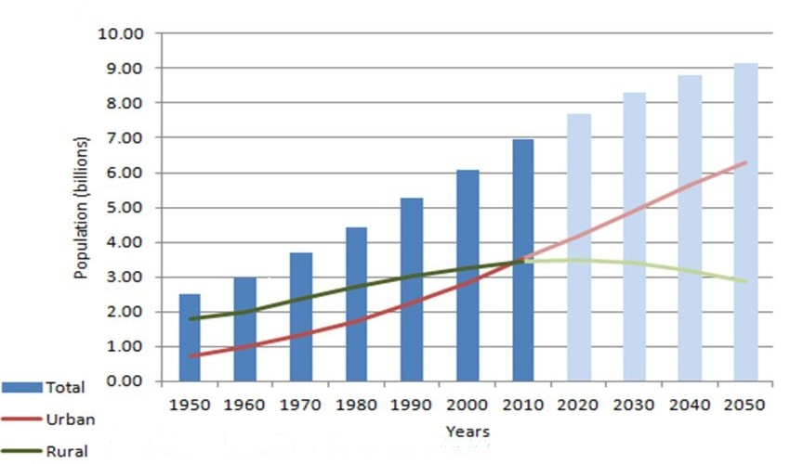

**Root Causes**

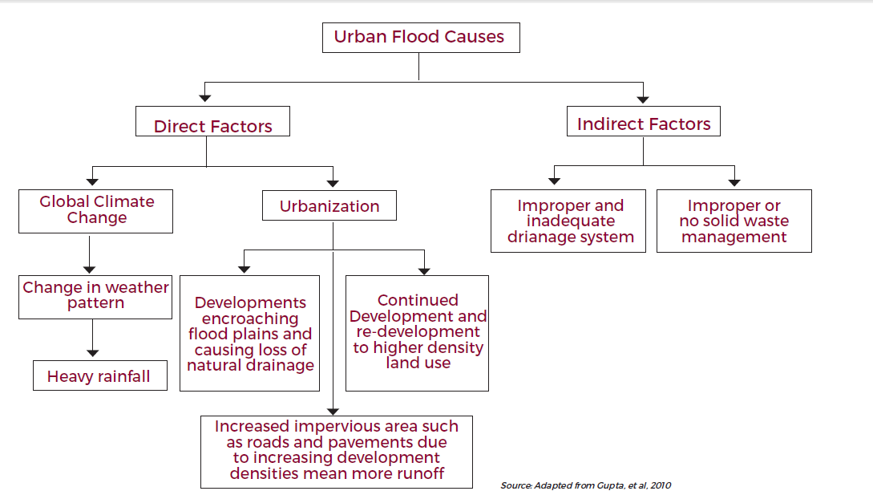

**Case study 1**

Rapid and uncontrolled urbanisation is the cause of flooding and related damage in Srinagar. In 1994–2004 alone, Asia was responsible for one-third of the 1562 flood disasters. Urbanisation in developing countries has doubled from less than 25% in 1970 to more than 50% in 2006. It is estimated that at least 13 cities in the world that are vulnerable to natural disasters will have populations between 10 and 25 million, nine of them in Asia. In 2001, India had 285 million people living in 35 metro cities. It is estimated that by 2021, there will be more than 600 million living in over 100 metropolitan areas, and the number is growing. These facts confirm that man-made causes are responsible for recurrent and prolonged flooding in cities like Kashmir.

**Climate Change so overlooked**

The year 2005 was recorded as the hottest year of the century, and at the same time the worst urban floods were reported in Mumbai on July 26and 27. On those two days, an unprecedented 944 mm of rain fell in 24 hours in the city. In the same year, 10 severe urban floods were reported from across the country. More than 500,000 people were affected. In 2006, 22 cities reported flooding again, and in 2007, the number of floods increased to 35. Minimum temperatures in the Himalayan region are expected to increase by 1 degree Celsius to 4.5 degrees Celsius. The intensity of rainfall is expected to increase by 1-2 mm per day. These factual indicators show that climate change has a direct impact on the frequency of floods.

**City Prelude**

Kashmir is a valley in the northernmost state of India, Jammu & Kashmir. This state is a region that is particularly vulnerable to natural disasters such as earthquakes, floods, landslides, avalanches, strong winds, snowstorms, etc. Most of the valley regions of the state are fed by rivers like Jhelum, Indus and Chenab.

**Flooding Chronology**

It all began on August 30, 2014, when a cyclonic circulation associated with a new westerly disturbance moved toward the state. On September 1, the rains began. Landslides claimed 10 lives over the next two days. The next day, a cloudburst occurred in the catchment area of the Doodh Ganga, a tributary of the Jhelum River. The river breached the dams and reached a height of 7-8 metres on September 6.

On September 5 alone, 156.7 mm of rainfall fell in the city. In September 2016, Srinagar received a 10-year high of 151.9 mm of rainfall in 24 hours. Floodwaters began receding on Sept. 11, but by Sept. 13, more than 70 percent of Srinagar was still underwater, and tens of thousands of people were stranded. The centre called the flood a "national disaster." By September 9, the death toll had risen to 215. [5] The worst-hit areas were Bandipora, Gandipur, Srinagar, Poonch, etc., and some areas were cut off from the rest of the region. [Refer Map ]



**Causes**

**Degraded Catchment Area**

Lake Dal has a highly degraded drainage basin through which the main tributaries, Nullah Erin and Madhumati, drain into the lake. The Jhelum is like a saucer (bowl) that has no outlet for the water. Silt has accumulated in all the major tributaries and the flood channels are blocked.



**Location Map of J&K –Wetlands and Riverstream.**

**Reduced Wetlands**

The municipal area of the city was 83 km² in 1971, increased to 103.3 km² in 1981, and now covers more than 230 km² (37% increase). The wetlands of Nadru, Nambal, Narkara Nambal and Hokarsar have been replaced by housing developments. Dal Lake, Anchar Lake, Manasbal Lake and Wular Lake are the major wetlands of the region. Since 1911, the area of Wular wetland has shrunk from 157 km² to 86 km² (45%). The area of Dal Lake had shrunk to nearly one-third by the 1980s and has continued to shrink to one-sixth. It has lost nearly 12 meters in depth.

In addition, wetlands such as Batamaloo-Nambal, Rekh-i-Gandakshah, Rakh-i-Arat and Rakh-i-Khan, and the Doodh Ganga and Mar Nalla rivers have also shrunk significantly.

**MITIGATION MEASURES FOR FUTURE**

Green roofs are increasingly being studied to determine how they can improve the quality of the urban environment. In addition to their ability to address problems with the quantity (Mentens et al., 2006) and quality (Berndtsson et al., 2006) of urban stormwater runoff, green roofs also have the following benefits: Helping to keep buildings cool in the summer and reducing a building’s energy consumption (Del Barrio, 1998; Eumorfopoulou and Aravantinos, 1998; Theodosiou, 2003; Wong et al, 2003a; Liu and Baskaran, 2005), reducing temperature fluctuations in the roof membrane (Liu, 2003), improving air quality by trapping a range of polluting air particles and gases, and smog.

|  |  |
| --- | --- |
| **Runoff-Control Sites** | **Facilities** |
| On the ground | trees, pervious pavements, water-retaining pavements, infiltration trenches |
| Above the ground | green roofs, non-vegetated roof |

**Ground Surface Techniques**

**Permeable Pavements:** Rainwater that falls on a permeable pavement infiltrates into the subsoil, which serves as a storage and infiltration basin for stormwater.

**Water-Retaining Pavements**: It is a cement-based pavement that stores water in the top layer and drains it by evaporation, retaining about 15 kg/m2 of rainwater. (Yamagata etal.2008).

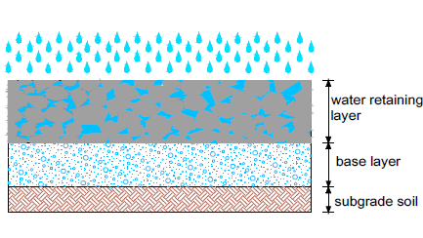

***Rainwater Barrels:***A small manhole has been installed near a building to collect rainwater from the gutter. The overflow can be discharged to the rain garden.235-L rain barrels can reduce –runoff from a conventional roof by 3-44%, depending on local weather and rainfall depth. (Litofsky et al. 2014). 189-L rain barrels storing rainwater from a 186 m2 roof are sufficient to irrigate a 14 m2 garden, reducing –annual runoff from the roof by 1.4-3.2% (Jennings et al. 2013).

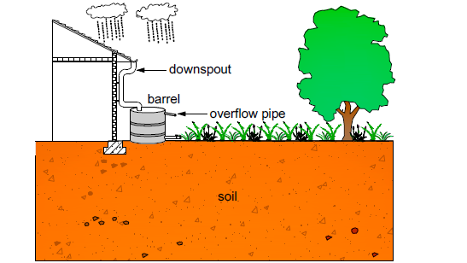

***Rain Gardens****:* Rain gardens or biological retention are used in urban areas to reduce stormwater volume, mitigate peak runoff, and infiltrate stormwater. (Yang et al. 2013)

In a rain garden consisting of 0.6 m deep, well-drained soil with an underlying perforated pipe, it was found that only 0.8% of the inflow left the garden as overflow, meaning that most of the inflow (99.2%) was eventually discharged as subsurface runoff. (Dietz et al. 2005).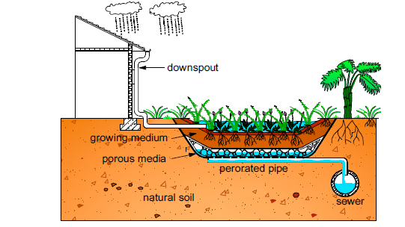

***Vegetated Filter Strips:***

A vegetative filter strip is typically placed near an impervious surface to allow runoff from the impervious surface to flow uniformly through the strip to intercept and slow runoff. The strip has been found to prevent runoff from 20 out of 23 rain events and to reduce the total runoff volume by 85% (Hunt et al. 2010)

**Above the ground**

**Non-Vegetated Roofs:**

Non-green roofs such as gravel roofs or earth roofs also reduce runoff: gravel-covered roofs and earth roofs can delay the onset of runoff by a quarter to a half hour, depending on precipitation depth and intensity (VanWoert et al. 2005)

**Green roofs**:

Rainwater falling on a green roof is retained and held back by plants and soils; additional raincauses overflow.

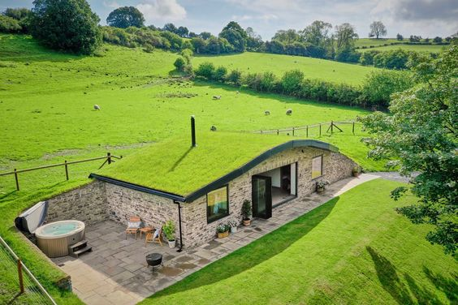

* **Materials and methods**
* **Site description**
* The studied greenroof was established in May 2003 and is situated near the city centre of Tartu, Estonia.
* **Material:**
* Green roof consists of the following layers:
* Modified bituminous base roof,
* Plastic wave drainage layer (8 mm),
* Rock wool for rainwater retention (80mm)
* Substrate layer (100mm) with LWA (66%),
* Humus (30%)
* Clay (4%).
* Distance between roofs is approximately 350 m.
* The length of the greenroof is 18 m, and its width 6.60 m; its height from the ground is 4.5 m.
* Plant cover was 45% of the whole roof area.
* The most common plant species were
* *Sedum acre (planted and seeded; cover percent 55%),*
* *Thymus serpyllum* (20%),
* *Dianthus carthusianorum (5%)*
* *Cerastiumtomentosum* (all seeded; 3%);
* *Veronica filiformis (occasional species; 7%).*
* The reference roof is a modified bituminous membrane roof.
* **Sampling and analysis**
* The measuring period was from June 2004 to April 2005.
* Stormwater runoff was measured for two similar light rain events and for one heavy rain event.
* Storm water runoff was manually measured on an hourly basis with 20-l canisters.
* If the canister filled with water in less than 1h, then water volumes were added.
* The greenroof had two outflows (gr1 and gr2), and there was one outflow for the reference roof (rr).
* Roof runoff samples were taken during light rain runoff (21 September 2004), during heavy rain runoff (31 August 2004) and after the melting of the snowcover (26 March 2005, 27 March 2005, and 30 March 2006).

**Results**

* The key parameters of measured rain events and roof runoff results (gr1 and gr2 greenroof outflows; rr—reference roof) ,nr—no runoff

|  |  |  |  |  |  |  |  |  |  |
| --- | --- | --- | --- | --- | --- | --- | --- | --- | --- |
| **Runoff measurement time** | Rain (mm) | Rain duration (min) | Runoff volume (mm) | | | | | | |
| gr1 | | gr2 | | Gr (gr1+gr2) | | rr |
| 2 August, 16.30h to  3 August,  23.00h | 0.8 | 100 | 0.1 | 0.2 | | 0.3 | | 1.9 | |
| 1.3 | 80 |
| 14 September 18.00h to  16September, 15.00h | 1.4 | 35 | 0.04  0.03  0.07 | 0.04  0.04  0.08 | | 0.08  0.07  0.15 | | 1.3  1.0  2.3 | |
| 1.0 | 20 |
| 31 August, 21.00h to 06  September, 11.00h | 6.8 | 60 | 5.3 | 5.9 | | 11.2 | | 11.9 | |
| 5.3 | 85 |
| 3.7 | 130 | 1.9 | 3.0 | | 4.9 | | 4.4 | |
| 0.8 | 75 |
| 1.0 | 170 | 0.6  nr  7.8 | 1.1  nr  10.0 | | 1.7  nr  17.8 | | 1.1  0.1  17.5 | |
| 0.5 | 60 |
| 0.1 | 195 |

Melting of the snow cover (gr1 and gr2—greenroof outflows, rr—reference roof), median temperature of air and substrate (at a depth of 100mm in the substrate layer), and sunshine conditions of studied roofs

|  |  |  |  |  |  |  |  |
| --- | --- | --- | --- | --- | --- | --- | --- |
| Day | Runoff volume (mm) | | | | Median temperature (◦C)  Air substrate | | Sunshine description |
| gr1 | gr2 | gr(gr1+gr2) | rr |
| 22.03 | 0.7 | 1.0 | 0.8 |  | −1.0 | −1.6 | Sunny |
| 23.03 | 0.03 | 0.05 | 0.08 |  | −0.3 | −1.2 | Cloudy |
| 24.03 | 1.6 | 2.7 | 4.3 | 0.4 | 3.5 | −0.3 | Sunny/cloudy |
| 25.03 | 3.5 | 5.5 | 9.0 | 14.6 | 5.8 | 0.3 | Sunny |
| 26.03 | 0.7 | 1.9 | 2.6 | 9.9 | 3.4 | 0.4 | Sunny/cloudy |
| 27.03 | 0.2 | 0.3 | 0.5 | 1.6 | 0.2 | 0.1 | Sunny/cloudy |
| 28.03 | 0.07 | 0.1 | 0.17 | 0.2 | −0.5 | 0.1 | Sunny/cloudy |
| 29.03 | 0.05 | 0.03 | 0.08 | 0.02 | −2.5 | −0.1 | Cloudy |
| 30.03 | 0.02 | 0.04 | 0.06 | 0.06 | 0.1 | 0.1 | Sunny |
| 31.03 | 0.2 | 0.6 | 0.8 | 2.0 | 2.8 | 0.3 | Sunny |
| 01.04 | 0.1 | 0.4 | 0.5 | 1.8 | 1.2 | 0.2 | Sunny/cloudy |
| 02.04 | 0.4 | 1.1 | 1.5 | 1.4 | 3.4 | 0.5 | Sunny |
| 03.04 | 0.8 | 2.1 | 2.9 | 0.8 | 8.9 | 1.5 | Sunny |
| 04.04 | 0.4 | 1.2 | 1.6 |  | 7.6 | 1.5 | Sunny |
| 05.04 | 0.1 | 0.5 | 0.6 |  | 11.5 | 2.4 | Sunny |
| 06.04 | 0.07 | 0.05 | 0.12 |  | 6.0 | 1.8 | cloudy |
| 07.04 | 0.02 | 0.02 | 0.04 |  | 5.8 | 3.0 | cloudy |
| Sum | 9.0 | 17.6 | 26.6 | 32.8 |  |  |  |

***Conclusions***

- The cause of flooding in Srinagar has pulverized both man and nature's perennial flood misery.

- Flooding in Srinagar is due to topography, reduced watershed, uncontrolled urbanization and siltation of the main water body. Since migration and development are interdependent, an increased need for resources is imperative.

- There are so many remedies, but a green roof can effectively retain light rainfall events that do not occur in too close succession if the substrate layer is not fully saturated.

- The green roof can retain rainfall more efficiently if the previous days were rain-free and the substrate layer is dry.

- The green roof can retain moderate rain even when the substrate layer is wet from previously fallen rain

- The green roof can spread runoff over a longer period of time.

- The snow cover of the green roof melted within one day, while the melting of the substrate layer took 12 days.

**References**

Agarwal, S., Fulzele, T.U. and Aggarwal, G., 2014. Flood recovery management in jammu and kashmir: A tool for Resilience. *Asian Journal of Environment and Disaster Management*, *6*(3):215-229.

Dar, M.U.D., Shah, A.I., Bhat, S.A., Kumar, R., Huisingh, D. and Kaur, R., 2021. Blue Green infrastructure as a tool for sustainable urban development. *Journal of Cleaner Production*, *3(18):*128-474.

Gupta, A.K. and Nair, S.S., 2010. Flood risk and context of land-uses: Chennai city case. *Journal of Geography and Regional Planning*, 3(12):365-372.

Gupta, A.K. and Nair, S.S., 2011. Urban floods in Bangalore and Chennai: risk management challenges and lessons for sustainable urban ecology. *Current Science*, pp.1638-1645.

Qin, Y., 2020. Urban flooding mitigation techniques: A systematic review and future studies. *Water*, 12(12):35-79.

Richa, A., Gupta Anil, K. and Mohammad, Y., 2012. Flood resilience through climate-change adaptation: A case of Gorakhpur, Eastern Uttar Pradesh in India. *International Research Journal of Environment Sciences*, 1(2):25-28.