COMPUTER-GUIDED IMPLANT PLACEMENT: THE NEXT STEP IN IMPLANT DENTISTRY

INTRODUCTION

The placement of endosseous implants presents several challenges. These include patient mobility, the limited time available for surgery when using local anesthesia, a constrained view of the surgical site, and the need to mentally translate two-dimensional preoperative radiographs into a three-dimensional surgical context(1). These challenges encompass various considerations, such as aesthetics, biomechanics, and functional requirements for prosthetic treatment. Consequently, within a limited timeframe and with a restricted field of vision, the surgeon must make multiple critical decisions while ensuring the patient's comfort and maintaining aseptic conditions.(2)Therefore, comprehensive preoperative planning regarding the number, size, position, and orientation of implants can alleviate the surgeon's cognitive load, enabling them to focus on patient care and tissue management.
Ideal preoperative planning is conducted using three-dimensional images (3D). This can be achieved through techniques like multi slice or cone beam computed tomography.(3) The introduction of cone beam computed tomography, which offers low-dose imaging at a relatively affordable cost, has significantly expanded the feasibility and reinforced the rationale for three-dimensional-based presurgical planning.(4) Consequently, surgeons can collaborate with dentists who provide templates representing the intended prosthesis, enabling precise virtual placement of implants in a virtual reality environment. By incorporating the planned prosthesis into these computed tomography images, the planning process can consider both the jawbone's anatomy and the intended superstructure. This approach aims to enhance biomechanical stability and aesthetic outcomes. Furthermore, it has the potential to optimize collaboration between the surgical and prosthetic teams.(5)
Today, there are specialized software applications available for implant surgery planning. Consequently, the reformatting programs mentioned earlier are no longer necessary. These dedicated software tools convert the initial dataset into the Digital Imaging and Communication in Medicine (DICOM) format(6). Following the secondary reformatting of images, these software applications facilitate the incorporation of implants of various sizes into jawbone images. The placement of implants within this virtual environment typically mirrors the intuitive approach used during actual surgery, commencing from the coronal aspect of the jawbone and progressing apically. This process is primarily conducted using cross-sectional views, allowing visualization of both the cortex and trabecular bone. Simultaneously, the implant's position is cross-verified in other planes and within the three-dimensional virtual model.(7) Depending on the software's capabilities, these views may be presented in a split-screen format or fully visualized in three dimensions, incorporating integrated cross-sectional views. In the latter case, all three spatial planes are simultaneously visible without requiring additional calculations.(8)
The use of cone beam computed tomography (CBCT) involves exposing patients to a relatively high dose of radiation. Nevertheless, this exposure is generally considered acceptable due to the significant clinical value offered by the resulting images . Furthermore, despite the use of advanced preoperative planning software, achieving precise and legally defensible accuracy during transfer to the surgical field remains essential .

There are several methods available for such transfer: computer-guided (static) surgery or computer-navigated (dynamic) surgery . In computer-guided surgery, a static surgical guide is employed to translate the virtual implant positions derived from computed tomography data to the actual surgical site. These guides are fabricated using computer-aided design/computer-assisted manufacturing technology, such as stereolithography, or manually in a dental laboratory using mechanical positioning devices or drilling machines (13).

On the other hand, computer-navigated surgery continuously displays the position of surgical instruments within the surgical area on a screen alongside a three-dimensional image of the patient. This real-time feedback system facilitates the seamless transfer of preoperative planning to the surgical procedure, enhancing precision and providing visual guidance on the screen.(9)

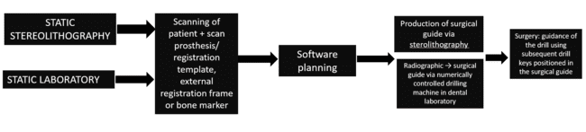

STATIC SURGICAL GUIDES:

Stereolithography:

In addition to assessing bone volume, achieving the ideal tooth position is crucial, and this is facilitated through the use of a scan prosthesis. This approach enables the positioning of implants while considering both anatomical and prosthetic factors. Standard resin prostheses, due to their density similarity with surrounding soft tissues, are challenging to distinguish from computed tomography (CT) images. Therefore, a specialized scan prosthesis is necessary, and there are several methods to create one.(11)
The first method involves crafting a duplicate of the prosthesis using radiopaque resin. A single CT scan is then conducted with the patient wearing this prosthesis in their mouth.(10)
A second method, developed in the mid-1990s by a research team at the University of Leuven, involves a double-scan procedure. This process comprises one scan with the patient wearing the scan prosthesis and a separate scan of the prosthesis by itself.(12) Following these scans, the data from the scan prosthesis, which contains small gutta-percha spheres (approximately 1 mm in diameter) is integrated with the craniofacial model as planned by the dentist. Consequently, the craniofacial images display the gutta-percha markers in relation to the bone, without visualizing the prosthesis itself. The scan prosthesis is scanned independently, with modified exposure parameters to ensure proper visualization while minimizing interference with the bone structures.
Regardless of the chosen method, precise positioning of the scan prosthesis is of utmost importance. Therefore, it is highly recommended to use an index to accurately place and stabilize the template in the patient's mouth during the scanning process (15). Achieving an optimal fit of the scan prosthesis with the patient's soft tissue is critical. It's essential to confirm that there is no visible gap between the scan prosthesis and the soft tissue, especially when dealing with mucosa-supported guides, where the foundation of the future surgical guide matches that of the scan prosthesis.(17)

The Digital Imaging and Communication in Medicine (DICOM) images are then imported into a software program, and the fusion of the scan prosthesis via the markers is performed. This allows for the selection of the ideal surgical site and optimal implant dimensions (14). Once the planning phase is complete and approved, the digital plan is sent to the manufacturer for the production of the guide using a process called stereolithography. Stereolithography is an additive manufacturing technique that utilizes a vat of liquid photopolymer resin. This resin is curable through ultraviolet light and an ultraviolet laser selectively solidifies the resin layer by layer to form the desired three-dimensional object. For each layer, the laser traces a specific cross-section pattern on the liquid resin surface.(16) Exposure to the ultraviolet laser cures the traced pattern, attaching it to the layer below. After finishing a layer, the object descends by one layer's thickness, and a new layer of liquid material is applied on top. The laser then traces the pattern for the subsequent layer on this new surface, joining it to the previous one. This process continues until the object is fully formed. Following the completion of the object, any necessary supports are manually removed once the product is removed from the stereolithography machine (19). After this stage, the sleeves for the drill keys are positioned within the guide.
Once the surgical guide is finished, it is sent to the surgeon (23). Depending on the system, a list detailing the planned implants and a patient-specific manual may be included. Before the actual surgery, the surgical guide is inserted into the patient's mouth. After applying slight compression, the soft tissues beneath the guide should become pale.(18)
The drilling procedure involves the utilization of drill keys, which are inserted into the sleeves within the surgical guide. These keys play a crucial role in guiding the consecutive drills of varying diameters to the correct position and angle. Depending on the system in use, the drill key can be attached directly to the drills themselves (20) or designed in a spoon-like shape (27). A range of keys with increasing diameters is typically available to align each drill properly. The drills may incorporate either a physical or visual stop to prevent over-drilling. Depending on the specific system, guidance for implant placement may also be provided. It's worth noting that part of the inherent inaccuracy in guided surgery can be attributed to the tolerances in the fit of the drills within the key, the key within the sleeve, or the implant driver within the sleeve(29)
Static guided surgery can be challenging when there is limited interocclusal space. Consequently, some guide systems are equipped with drill guides featuring lateral tube openings. These openings enable the drills to enter from either the buccal (cheek side) or lingual (tongue side) aspect, thus reducing the necessary interocclusal space.(21)
Guides can be categorized as tooth-supported, bone-supported, or mucosa-supported. The choice among these options is typically determined by the specific clinical circumstances and requirements of the case.(22)

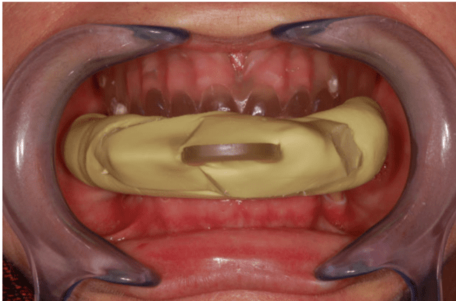
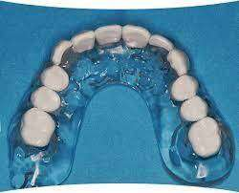

RADIOGRAPHIC GUIDE PATIENT WITH RADIOGRAPHIC GUIDE
Courtesy: Dr T. Fortin
Courtesy: Burbank Dental Lab
LABORATORY FABRICATION:
The surgical guide can also be fabricated in a dental laboratory. This process involves the transformation of the scan prosthesis into a surgical guide using a mechanical system.(24) The restorative dentist initiates the process by creating a study prosthesis on a diagnostic cast, which replicates the final restorative prosthesis. After successful testing within the patient's oral cavity, this prosthesis is duplicated using acrylic resin, subsequently serving as a scanning template. To ensure clear visibility on cone beam computed tomography (CBCT) images, the prosthesis incorporates teeth made from radiopaque resin. Additionally, a prefabricated acrylic resin cube known as an "X-cube" (Keystone Dental, Boston, MA) is affixed to the scan prosthesis before CBCT examination. This cube is positioned outside the mouth, typically in front of the patient's lip. The X-cube plays a crucial role in transferring the planned implant positions onto the scan prosthesis using a drilling machine. It includes two titanium tubes placed precisely in a perpendicular and uncrossed manner.(28)
CBCT scans are acquired with the template in the patient's mouth, and the resulting images are directly inputted into a dedicated imaging computer system. The implants' planning process is carried out using custom-designed software, such as Easyguide TM (Keystone Dental). The software visualizes the implant positions in a three-dimensional view and on three planes, including the axial slice and two reformatted views.(25)
Once the final implant positions are defined, they need to be transferred to the scan prosthesis. To achieve this, the scan prosthesis is securely attached to a drilling machine via the X-tube. The titanium tubes within the X-cube serve as reference points for the system, establishing a mathematical link between the computed tomography images and the drilling machine. This precision enables the drilling of the planned implant positions on the guide with high accuracy and at the desired diameter. The level of accuracy is notably high, as supported by findings from in-vitro studies. Subsequently, the X-cube is detached from the template, which reverts to a conventional state.(26)
Metal tubes, which serve as drill sleeves, are inserted through the holes previously generated by the drilling machine in the surgical guide. Various guides with different diameters are prepared and must be placed either sequentially or with the assistance of drill keys. In cases involving partially edentulous patients, the guide is stabilized by the presence of remaining natural teeth. However, in situations where patients are fully edentulous in the maxillary arch, the guide relies on support from the mucosa, primarily in the hard palate region.(30)
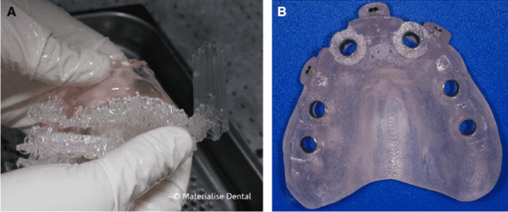

(A) Finished guide with the supports, which are removed manually (Courtesy of Materialise TM, Leuven, Belgium). (B) Fully developed surgical guide, with the internal sleeves.
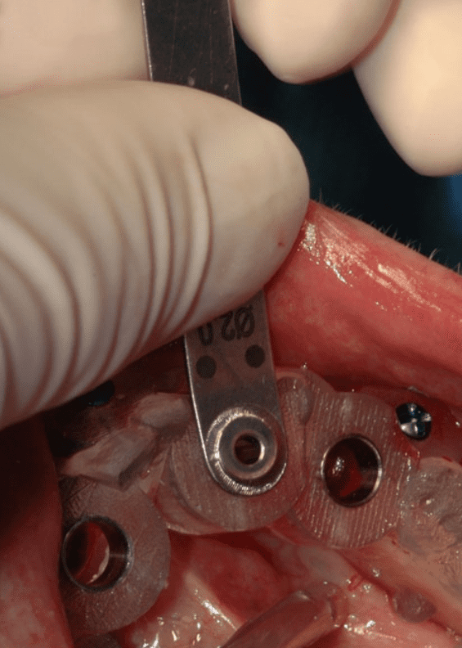
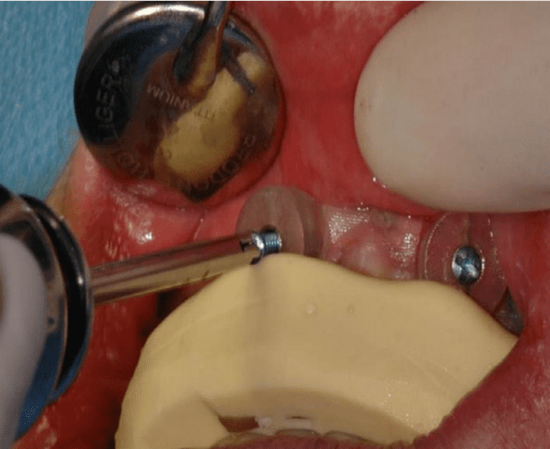

Fixation of the guide with screws. The guide is stabilized with the surgical index
The drill key placed in the sleeve of the guide, here to guide the 2.0-mm-diameter drill.

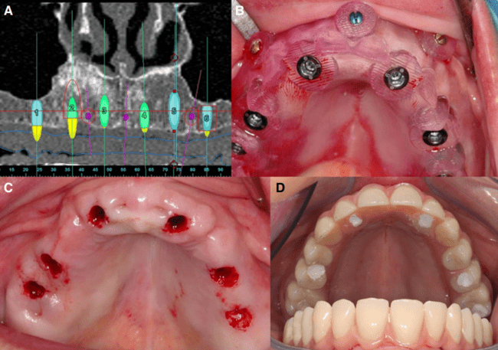
- Software planning. (B) Flapless surgery (punch technique). (C) Surgical guide with implant drivers in the sleeves. (D) Immediate loading with the temporary bridge in place.
Cpourtesy: Dr. R. Jacobs

SUMMARY OF WORKFLOW

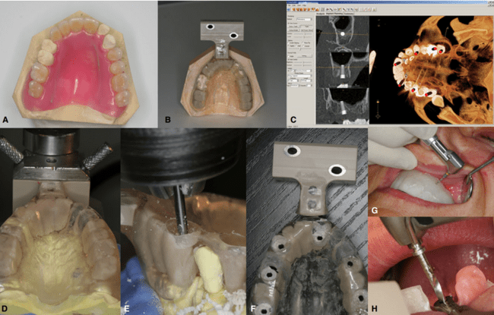
- The study prosthesis is created on a diagnostic cast, which represents the final restorative prosthesis. (B) Duplicate of the study prosthesis in acrylic resin. A prefabricated cube is attached to the scan prosthesis so that when the prosthesis is in the mouth the cube is outside and in front of the lip. (C) Planning software with implant planning on a three-dimensional view and on three planes: axial, tangential and perpendicular. (D) The scan prosthesis is firmly attached to a drilling machine by placing the resin cube on a dedicated device and by passing two metal shafts through the two titanium tubes. (E) The scan prosthesis is drilled according to the planned implant position by a drilling machine. (F) For the surgical procedure, the cube is removed. The scan prosthesis becomes the surgical guide. (G) For completely edentulous patients, the guide is secured, under occlusal pressure, to the bone with fixation screws to avoid movement of the guide. (H) Drilling is performed using subsequent drill keys with increasing diameter.
Courtesy: Dr. R. Vercruyssen

CONCLUSION:
Based on the available literature, it can be concluded that there is currently no decisive evidence suggesting that computer-assisted surgery is inherently superior to conventional procedures concerning safety, treatment outcomes, morbidity, or efficiency.(31) Many studies have reported high levels of inaccuracies associated with the application of these techniques. Notably, this imprecision appears to be more pronounced when bone-supported guides are utilized. The accuracy of these systems is contingent on various cumulative and interactive errors that occur throughout the process, ranging from data-set acquisition to the actual surgical procedure.

However, it is reasonable to anticipate that emerging developments, such as digital impression techniques, and improvements in technology, such as real-time navigation and enhanced integration of radiographic and clinical data, will positively influence the field of guided surgery.(33) Nevertheless, it is essential to underscore that even with these advancements, there remains no substitute for meticulous case selection, thorough patient preparation, and sound surgical planning and execution. To truly grasp the different factors influencing the accuracy of these techniques, it is imperative to rely on long-term clinical data and randomized clinical trials. These studies will help shed light on the complex dynamics surrounding guided surgery and its potential benefits.(32)

REFERENCES

1.Ambrose J, Hounsfield GN. Computerized transverse axial tomography. Br J Radiol 1973: 46: 148–149.

2. Arisan V, Karabuda CZ, Ozdemir T. Implant surgery using bone- and mucosa supported stereolithographic guides in totally edentulous jaws: surgical and post-operative outcomes of computer-aided vs. standard techniques. Clin Oral Implants Res 2010: 21: 980–988.

3. Arisan V, Karabuda CZ, Ozdemir T. Implant surgery using bone- and mucosa supported stereolithographic guides in totally edentulous jaws: surgical and post-operative outcomes of computer-aided vs. standard techniques. Clin Oral Implants Res 2010: 21: 980–988.

4. Becker W, Goldstein M, Becker BE, Sennerby L, Kois D, Huipel P. Minimally invasive flapless implant placement: follow-up results from a multicenter study. J Periodontol 2009: 80: 347–352.

5. Brodala N. Flapless surgery and its effect on dental implant outcomes. Int J Oral Maxillofac Implants 2009: 24: 118–125.

6. Brown RA. A stereotactic head frame for use with CT body scanners. Invest Radiol 1979: 14: 300–304.

7. Buser D, Bornstein MM, Weber HP, Grutter L, Schmid B, € Belser UC. Early implant placement with simultaneous guided bone regeneration following single-tooth extraction in the esthetic zone: a cross-sectional, retrospective study in 45 subjects with a 2- to 4-year follow-up. J Periodontol 2008: 79: 1773–1781

8. Buser D, Halbritter S, Hart C, Bornstein MM, Grutter L, € Chappuis V, Belser UC. Early implant placement with simultaneous guided bone regeneration following singletooth extraction in the esthetic zone: 12-month results of a prospective study with 20 consecutive patients. J Periodontol 2009: 80: 152–162.

9. Cassetta M, Giansanti M, Di Mambro A, Calasso S, Barbato E. Accuracy of two stereolithographic surgical templates: a retrospective study. Clin Implant Dent Relat Res 2013: 15: 448–459.

10. Cosyn J, Hoogde N, De Bruyn H. A systematic review on the frequency of advanced recession following single immediate implant treatment. J Clin Periodontol 2012: 39: 582–589.

11. D’haese J, Van de Velde T, Komiyama A, Hultin M, De Bruyn H. Accuracy and complications using computerdesigned stereolithographic surgical guides for oral rehabilitation by means of dental implants: a review of the literature. Clin Implant Dent Relat Res 2012a: 14: 321– 335.
12. D’haese J, Van De Velde T, Elaut L, De Bruyn H. A prospective study on the accuracy of mucosally supported stereolithographic surgical guides in fully edentulous maxillae. Clin Implant Dent Relat Res 2012b: 14: 293–303.

13. Dario P, Carrozza MC, Marcacci M, D’Attanasio S, Magnami B, Tonet O, Megali G. A novel mechatronic tool for computer-assisted arthroscopy. IEEE Trans Inf Technol Biomed 2000: 4: 15–29.

14. De Bruyn H, Atashkadeh M, Cosyn J, Van de Velde T. Clinical outcome and bone preservation of single TiUnite implants installed with flapless or flap surgery. Clin Implant Dent Relat Res 2011: 13: 175–183

15. Dyer PV, Patel N, Pell GM, Cummins B, Sandeman DR. The ISG viewing wand: an application to atlanto-axial cervical surgery using the Le fort I maxillary osteotomy. Br J Oral Maxillofac Surg 1995: 33: 370–374.

16. Fortin T, Bosson JL, Isidori M, Blanchet E. Effect of flapless surgery on pain experienced in implant placement using an image-guided system. Int J Oral Maxillofac Implants 2006: 21: 298–304.

16. Gallucci GO, Benic GI, Eckert SE, Papaspyridakos P, Schimmel M, Schrott A, Weber HP. Consensus statements and clinical recommendations for implant loading protocols. Int J Oral Maxillofac Implants 2014: 29: 287–290.

17. Geng W, Liu C, Su Y, Li J, Zhou Y. Accuracy of different types of computer-aided design/computer-aided manufacturing surgical guides for dental implant placement. Int J Clin Exp Med 2015: 8: 8442–8449.

18. Gunkel AR, Freysinger W, Thumfart WF. Experience with various 3-dimensional navigation systems in head and neck surgery. Arch Otolaryngol Head Neck Surg 2000: 126: 390– 395.

19. Hermann JS, Schoolfield JD, Schenk RK, Buser D, Cochran DL. Influence of the size of the microgap on crestal bone changes around titanium implants. A histometric evaluation of unloaded non-submerged implants in the canine mandible. J Periodontol 2001: 72: 1372–1382.

20. Hounsfield GN. Computerized transverse axial scanning (tomography). 1 Description of system. Br J Radiol 1973: 46: 1016–1022.

21. Hounsfield GN. Computed medical imaging. Science 1980: 210: 22–28.

22. Joda T, Gallucci GO. The virtual patient in dental medicine. Clin Oral Implant Res 2014: 26: 725–726.
23. Johansson B, Friberg B, Nilson H. Digitally planned, immediately loaded dental implants with prefabricated prostheses in the reconstruction of edentulous maxillae: a 1-year prospective, multicenter study. Clin Implant Dent Relat Res 2009: 11: 194–200.

24. Jung R, Schneider D, Ganeles J, Wismeijer D, Zwahlen M, Hammerle CH, Tahmaseb A. Computer technology applica- € tions in surgical implant dentistry: a systematic review. Int J Oral Maxillofac Implants 2009: 24: 92–109.

25. Keevil GM. The roentgen rays. Br Med J 1833: 1896: 433– 434.

26. Komiyama A, Klinge B, Hultin M. Treatment outcome of immediately loaded implants installed in edentulous jaws following computer-assisted virtual treatment planning and flapless surgery. Clin Oral Implants Res 2008: 19: 677–685.

27. Landázuri-Del Barrio RA, Cosyn J, De Paula WN, De Bruyn H, Marcantonio E Jr. A prospective study on implants installed with flapless-guided surgery using the all-on-four concept in the mandible. Clin Oral Implants Res 2013: 24: 428–433.

28. Lin GH, Chan HL, Bashutski JD, Oh TJ, Wang HL. The effect of flapless surgery on implant survival and marginal bone level: a systematic review and meta-analysis. J Periodontol 2014: 85: e91–e103.

29. Linkevicius T, Puisys A, Vindasiute E, Linkeviciene L, Apse P. Does residual cement around implant-supported restorations cause peri-implant disease? A retrospective case analysis. Clin Oral Implants Res 2013: 24: 1179–118
30. Marsh H. A case of Roentgen photography. Br Med J 1848: 1896: 1318–1320.
31. Meloni SM, De Riu G, Pisano M, Cattina G, Tullio A. Implant treatment software planning and guided flapless surgery with immediate provisional prosthesis delivery in the fully edentulous maxilla. A retrospective analysis of 15 consecutively treated patients. Eur J Oral Implantol 2010: 3: 245–251.
32. Moraschini V, Velloso G, Luz D, Porto Barboza E. Implant survival rates, marginal bone level changes, and complications in full-mouth rehabilitation with flapless computerguided surgery: a systematic review and meta-analysis. Int J Oral Maxillofac Surg 2015: 44: 892–901.
33. Nikzad S, Azari A. A Custom-made radiographic template, computed tomography, and computer-assisted flapless surgery for treatment planning in partial edentulous patients: a prospective 12-month study. J Oral Maxillofac Surg 2010: 68: 1353–1359.

