Pest management with integrated intelligence: computer-based attack detection and prevention system
Monika Kalia1 and Sonika Kalia2*
1College of Agriculture, CSKHPKV, Palampur, Himachal Pradesh, 176062
2*Department of Biotechnology, School of Applied and Life Sciences, Uttaranchal University, Dehradun, 248001

Abstract:
The Food and Agriculture Organization (FAO) estimates that agricultural pests cut crop yields around the globe by 20 to 40% yearly. The main causes of crop loss are the pests and diseases that exist in the fields. In populous nations like India, it's important to get the most bang for your buck. If we can manage the insect attack in the fields, we can increase the efficiency of farming. In this digital age, many cutting-edge technologies are at our disposal to combat insect attacks. Because of this, smart agriculture is the best approach for farmers to apply artificial intelligence techniques along with modern information and communication technologies to get rid of these deadly insect pests. They can increase their agricultural productivity as a result. This article suggests cutting-edge smart phone software that employs deep learning to automatically categorize bugs in order to help specialists and farmers. By using these technologies, we can anticipate a pest attack, identify the pest that has struck, and prepare the appropriate measures in advance to reduce the damage. These technologies range widely and include computer vision, deep learning, machine learning, AI (Artificial intelligence), and many more. In this article, we will examine several innovative strategies that scientists might use to fight off insect attacks.
Keywords: Pest Management, GIS, Remote sensing, models, IPM.
Content
- Introduction
- Pest forecasting
- Remote sensing
- Studies on incidence of insects through RS
- Geographic Information System (GIS) and its applications
- Pest Simulation models and decision support systems
- Integration of Pest and crop Simulation models
- Conclusion

Introduction:
Nearly 28% of the Gross Domestic Product (GDP) in India is attributed to agriculture, which is crucial to the country's economic development. The potential agricultural productivity is severely damaged by weeds (14% of losses), illnesses, and insect pests. To achieve sustainability in agriculture, technologies based on plant protection research for serious pests are crucial (Pratap et al., 2000). If the incidence or appearance of pest populations is recognized well in advance, it will be feasible to take corrective action in a timely manner, which will reduce production losses caused by pest populations to a greater extent. This gave rise to the idea of "forecasting," which is a prediction or estimate of a future trend that includes all the activities involved in figuring out and informing the community's growers that conditions are conducive for specific insect pests, that putting control measures into place will result in financial gain. Additionally, it is crucial for farmers because the amount they anticipate earning is unlikely to be sufficient to warrant the investment of their time, effort, and money. The pest forecast is a crucial component of the IPM strategy. Crop loss can be reduced, pest control can be improved, and cultivation costs can be brought down as a result. Early alerts and predictions based on biophysical methods provide time to prepare for impending insect infestations. Current and anticipated weather data is useful for planning spraying and agricultural operations to maximize crop yields and profits. Because of this, protective measures for plants can be put in place before any damage occurs. It provides current information on the transmission of diseases and pests.
Thus, an insect forecasting service might be used to forecast the pest's level of impending infestation. To determine the crucial point at which the use of insecticides would provide the best level of protection. The prediction of pests informs farmers on the biology and timing of insect outbreaks, allowing them to avoid blanket pesticide applications, use less of them, and still get high-quality outcomes. The farmers can take prompt action by implementing various pest management strategies to reap the most rewards.

Pest forecasting
Pest forecasting is the perception of potential biotic agent activity that would have a negative impact on crop yield. In other words, the ability to estimate how seriously the insect population will affect the crop's ability to generate revenue is crucial. In order to predict the incidence of a pest, it may be useful to use long-term, consistently collected data on the pest's population or damage, as well as other variable elements that can affect the pest's growth.
Several inherent characteristics of the insects as well as the governing environmental and host conditions must be taken into account in pest forecasting. Most pest forecast models take into account the phenology of the herbivore and its host. The combination of near real-time pest incidence data with remote sensing and GIS techniques enables a fast and spatially precise early warning of oncoming pest buildup. It is necessary to take into account the relevant host and environmental factors. Another essential part of model input is gathering and analyzing weather data from pest-affected areas.
The use of computers in agricultural research began with the transfer of statistical formulas or intricate models into digital form for quick, precise calculations that were comparatively laborious to perform manually. In recent years, remote sensing and geographic information systems have become increasingly important in agriculture research, particularly in the areas of yield prediction, soil suitability for various crops, and site-specific resource allocation of agricultural inputs, among other things.
In order to better understand an object or phenomenon, remote sensing science entails analyzing data gathered by a device that is not in close proximity to the object or phenomenon being investigated. Remote sensing is the process of looking at or acquiring data about a location from a distance. For such an assessment, a ground-based device (such as a camera) as well as sensors or cameras mounted on boats, airplanes, satellites, or other spacecraft may be employed (Prabhakar et al., 2012).

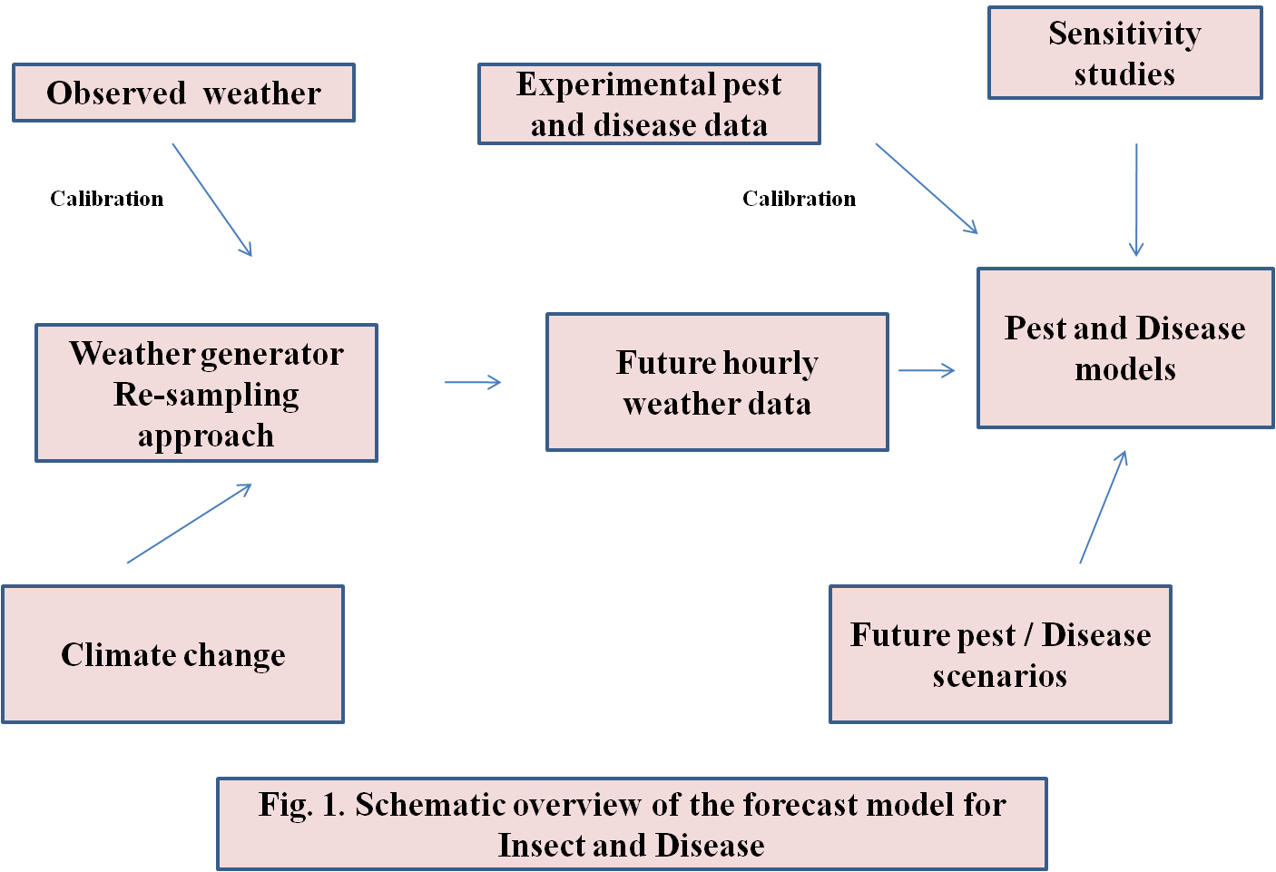

Remote sensing
Fundamentals of remote sensing
Every object reflects or scatters a portion of the electromagnetic energy that strikes it depending on its physical qualities.Objects also emit radiation based on their emissivity and temperature. Any object has a spectral signature, which is a pattern that appears in its reflectance or emission at various wavelengths and is unique to that thing.
The use of remote sensing (RS) techniques in pest control includes:
• Observing insects directly
• Spotting their impacts (symptoms); and
• Tracking environmental variables that could affect bug occurrence, abundance, and potential harm
- Pest damage can be predicted using a variety of techniques, including spectrum indices based on leaf pigments, optical and video imaging in the near-infrared and microwave ranges, multi-spectral remote sensing (MRS), and area identification using portable GPS devices.
Studies on incidence of insects through RS
Due to lower levels of chlorophyll and wavelengths of 500–525 nm, 625–635 nm, and 685–695 nm, Russian wheat aphids and green bugs have a detrimental effect on leaf reflectance in wheat seedlings (Riedell and Blackmer, 1999).
• BPH-induced stress in rice can be detected by remote sensing. The canopy measurement level of 1813–1836 nm may be the most vulnerable to BPH infection, claim Zhou et al. (2010).
• It has been successful to characterize damage from two major pests, hemlock loopers and bark beetles, using aerial color and color-infrared photography using standard cameras. By mapping the Mississippi River delta and using remote sensing to identify the most likely locations where insects may attack the wheat crop, the stress brought on by aphid species is discovered (Yang et al., 2016).

Studies on distribution of insects through RS
- In Hawaii, El Salvador, and Mexico, the distribution of host plants for tropical fruit flies was investigated using aerial photography (Hart et al., 1978). Milkweed (Asclepias spp.) is a prominent host plant for monarch butterflies (Danaus plexippus), which are depicted on the map (Malcom et al., 1993).
- High resolution data from SPOT and Landsat 5 has been used to pinpoint rice-growing regions in northern Luzon, the Philippines, that may serve as hosts for the brown planthopper, Nilaparvata lugens.

Geographic Information System (GIS)
A GIS is a tool for gathering, storing, manipulating, and displaying data that is pertinent to a specific geographic area. It consists of a database of attributes, some means of linking to both, and spatial information in the form of coordinates. GIS abstracts the world into layers of spatial and attribute data, with each layer representing a distinct characteristic or theme. Layers are then used to connect several themes.

GIS implementation in pest management
Characterization of habitat susceptibility to outbreaks and compilation of census data.
Historical maps produced by Shepherd et al. in 1988 show defoliation brought on by the Douglas-fir tussock moth in British Columbia between 1924 and 1986. Then, by overlaying maps of forest type and biogeoclimatic conditions over the map of epidemic frequency, the association between climate and outbreak frequency was investigated.
GIS and insect census data
In order to interpolate gipsy moth trap counts and egg mass densities, which aid in insect census, Liebhold (1996) claims that a GIS is employed in an IPM demonstration program. The data map compilations are useful for planning suppressive activities. Using GIS, the management of desert locusts.
FAO monitoring of Locust
The Desert Locust Information Service (DLIS) uses rainfall estimates acquired from METEOSAT, notably from infrared and visible channels, to better understand the geographical and quantitative distribution of rainfall in the breeding areas of the Desert Locust. SPOT-VGT and MODIS imagery are made available every 10 and 16 days, respectively, in countries where lupines are an issue. These objects can be used to point teams performing nationwide surveys in the direction of potential habitats for desert locusts.
Pest Simulation models and decision support systems
Simulation models that use mathematical descriptions of biological data that are affected by the environment can be used in a variety of settings and habitats with greater ease. In order to understand population dynamics and disseminate pest forecasts for timely pest control choices, computer programs or software to execute these models are helpful (Coulson and Saunders, 1987). The flexibility of simulation methodologies allows for the testing, improvement, sensitivity analysis, and field validation of produced models under a variety of environmental conditions and situations. To understand the interactions between pests, plants, and the environment, comprehensive descriptions of cropping systems that are managed or studied are required (Colbach, 2010). Systems models or other prediction methods can be used with the necessary biological, environmental, economic, or other inputs to analyze the most successful management actions based on acceptable control, sustainability, and assessment of economic or other risks (Strand, 2000).
In an effort to enhance Helicoverpa management in Australia, a detailed population dynamics model (HEAPS: Helicoverpa armigera and Punctigera Simulation) has been created (Fitt et al., 1995). This model specifically simulates adult mobility within a regional cropping system. It accounts for the habitat's spatial organization as well as the pest population. This model determines the population in each grid cell by incorporating modules for adult migration, oviposition, development, survival, and host phenology (Dillon and Fitt, 1990).
The SIRATAC decision support system, used by the Australian cotton industry from 1976 to 1993 to lower the risk associated with pest management using chemical pesticides, served as the foundation for the EntomoLOGIC decision tool. This was created by the University of Western Sydney and the Commonwealth Scientific and Industrial Research Organization (CSIRO) in Australia (Hearn and Bange, 2002).
Trnka et al. (2007) were able to account for 70% of the diversity in the timing of important developmental phases using a multi-generational phenology model, ECAMON. The European corn borer's presence or absence over a study zone in the Czech Republic between 1961 and 1990 was accurately predicted using ECAMON simulations.
In the middle of the 1990s, a network of automated sensors was used to gather weather data in real-time, which was then retrieved using the CIPRA (Computer Centre for Agricultural Pest Forecasting) software. The user can view forecasts for 13 insects, two diseases, and two storage issues in addition to the phenology of the apple crop. Over the past 13 years, a variety of bioclimatic models have been developed, tested, and refined. These models range from the simple degree-day method based on air temperature to more complex epidemiological models based on air temperature, relative humidity, and the amount of time that leaves are moist.
Many field professionals are employing these model forecasts in conjunction with field pest scouting to offer useful extra information for decision-making in pest control and apple storage strategies (Bourgeois et al., 2008).
SOPRA has a wide range of possible applications in the alpine valleys and north of the Alps, where it is now employed as a decision support system for eight key insect pests of fruit orchards in Switzerland and southern Germany. Using time-varying distributed delay approaches, phenology models were developed, with solar radiation, air temperature, and soil temperature acting as hourly drivers. The age structure of pest populations is simulated using local meteorological data, and the SOPRA system forecasts crucial times for management activities. Phenology has a close connection to a thorough decision-support system, extensive information regarding pest insects, and registered plant protection products.

Integration of Pest and crop Simulation models
With the help of pests, the growing environment, and other management techniques, crop system models can be used to gather information on the crop's state. There aren't many examples of these models in use that properly take into account everything needed for making decisions in the actual world. Establishing different crop and pest components that may be studied simultaneously to provide information that will enhance decisions has proven to be a more effective technique.
The creation of decision support systems for agrotechnology transfer (DSSAT 4), which was supported by the United States Agency for International Development (USAID), has eased decision-making at the farm and policy levels. A modular approach is being used to construct crop system models more frequently now (http://www.icasa.net). The development of autonomous decision support systems for pest components might lead to their actual use.

CONCLUSIONS
The foundation for early warnings, the development and validation of pest forecast models, and decision support systems, all of which are necessary for the formulation and implementation of successful IPM programmes, is provided by pest monitoring. Models are potentially effective instruments for synthesizing the data and information on the population dynamics of pests in agroecosystems and natural habitats. The gaps in our understanding of the relationships between crop, pest, and weather will be filled through the development of long-term monitoring spatial data. The use of computer-based technologies has made forecasting easier, quicker, and less expensive.
The widespread broadcast and use of pest forecasts is greatly facilitated by recent advancements in information and communication technologies. Greater crop diversity on tiny plots of land with constantly changing weather are characteristics of agroecosystems in the tropics. For improved accuracy, it is necessary to evaluate the existing generic simulation models with location-specific inputs. For specific crop sectors in poor nations, agro-meteorological networks must be established with the primary goal of pest forecasting using models and decision support systems.

REFERENCES
- Miller, P.R., and O'Brien, M.J. 1952. Plant disease forecasting. The Botanical Review, 18: 547- 601
- Prabhakar, M., Prasad, Y.G., and Rao, M.N. (2012). Remote sensing of biotic stress in crop plants and its application for pest management. In: Venkateswarlu, B. et al., (eds. ), Crop Stress and its Management. Springer Science, Dordrecht. pp. 517–545
- Riedell, W.E., and Blackmer, T.M. (1999). Leaf reflectance spectra of cereal aphid damaged wheat. Crop Science. 39:1835–1840
- Zhou, Z., Zang, Y., Zhao, Z., Luo, X, and Zhou, X. 2010. Canopy hyperspectral reflectance features of rice caused by rice brown planthopper (Nilaparvata lugens) infestation. American Society for Agriculture and Biological Engineering, Pittsburgh, Pennsylvania, June 20 - June 23, 2010
- Yang, Z., Rao, M.N., Elliott, N.C., Kindler, S.D., and Popham, T.W. 2009. Differentiating stress induced by green bugs and Russian wheat aphids in wheat using remote sensing. Computers and Electronics in Agriculture, 67: 64–70
- Hart, W.G., and Meyers, V.I. 1978. Infrared aerial color photography for detection of populations of brown soft scale in citrus groves. Journal of Economic Entomology, 61(3): 617–624
- Malcolm, S.B., Cockrell, B.J., and Brower, L.P. 1993. Spring recolonization of eastern North America by the monarch butterfly: successive brood or single sweep migration? In S.B. Malcolm and M.P. Zalucki, editors. Biology and Conservation of the Monarch Butterfly, 253-267. Natural History Museum of Los Angeles Country.
- Liebhold, A., Luzader, E., Reardon, R., Bullard, A., Roberts, A., Ravlin, F.W., DeLost, S., and Spears, B. 1996. Use of a geographic information system to evaluate regional treatment effects in a gypsy moth (Lepidoptera: Lymantriidae) management program. Journal of Economic Entomology, 89: 1192–1203
- Coulson, R.N., and Saunders, M.C. (1987). Computer-assisted decision making as applied to entomology. Annual Review of Entomology, 32, 415–437
- Colbach, N. (2010). Modeling cropping system effects on crop pest dynamics: how to compromise between process analysis and decision aid. Plant Science 179, 1–13
- Strand, J.F.(2000). Some agrometeorological aspects of pest and disease management for the 21st century. Agricultural and Forest Meteorology, 103: 73–82
- Dillon, M.L., and Fitt, G.P. (1990). HEAPS: a regional model of Heliothis population dynamics. In: Proceedings of the Fifth Australian Cotton Conference, 8–9 August, Broadbeach, Queensland, Australia. Australian Cotton Grower’s Research Association, Australia, pp. 337–344
- Hearn, A.B., and Bange, M.P. (2002). SIRATAC and CottonLOGIC: Persevering with DSSs in the Australian Cotton Industry. Agricultural Systems, 74:27–56
- Trnka, M., Muska, F., Semeradvoa, D., Dubrovsky, M., Kocmankova, E., and Zalud, Z. (2007). European corn borer life stage model: regional estimates of pest development and spatial distribution under present and future climates. Ecological Modelling, 207: 61–84
- Bourgeois, G., Plouffe, D., Chouinard, G., Beaudry, N., Choquette, D., Carisse, O., and DeEll, J. (2008). The apple CIPRA network in Canada: using real-time weather information to forecast apple phenology,insects, diseases, and physiological disorders. Acta Horticulturae, 803: 29–34

